Supplementary Material

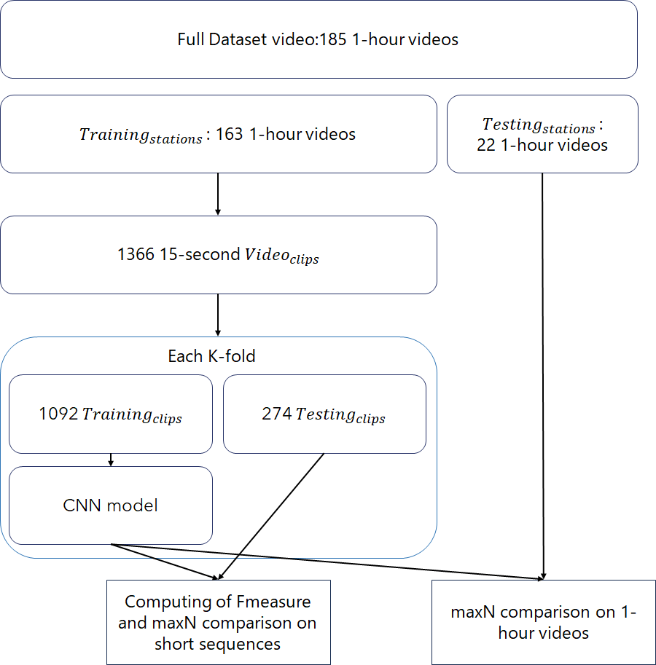
Supp. Fig 1: Workflow of our method and the k-fold dataset creation

Supp. Table 1: Detailed representation of recall, precision, and F-measure for our 5 models
Dataset | Species | Recall | Precision | F-measure
A | Carcharhinus amblyrhynchos | 0.90 | 0.88 | 0.89
 | Triaenodon obesus | 0.84 | 0.85 | 0.84
 | Carcharhinus melanopterus | 0.22 | 0.56 | 0.31
B | Carcharhinus amblyrhynchos | 0.93 | 0.78 | 0.85
 | Triaenodon obesus | 0.62 | 0.87 | 0.72
 | Carcharhinus melanopterus | 0.47 | 0.32 | 0.38
C | Carcharhinus amblyrhynchos | 0.93 | 0.76 | 0.83
 | Triaenodon obesus | 0.59 | 0.84 | 0.69
 | Carcharhinus melanopterus | 0.57 | 0.57 | 0.57
D | Carcharhinus amblyrhynchos | 0.93 | 0.82 | 0.87
 | Triaenodon obesus | 0.86 | 0.76 | 0.81
 | Carcharhinus melanopterus | 0.31 | 0.24 | 0.27
E | Carcharhinus amblyrhynchos | 0.88 | 0.81 | 0.85
 | Carcharhinus melanopterus | 0.53 | 0.44 | 0.50
 | Triaenodon obesus | 0.50 | 0.67 | 0.57
Supp. Table 2 Automated classification confusion matrix for our testing dataset #5
Model Prediction | Carcharhinus amblyrhynchos | Triaenodon obesus | Carcharhinus melanopterus | Other
Carcharhinus amblyrhynchos | 1586 | 48 | 5 | 118
Triaenodon obesus | 102 | 162 | 0 | 85
Carcharhinus melanopterus | 3 | 2 | 15 | 9
Other | 271 | 33 | 14
Supp. Table 3 Semi-automated classification confusion matrix for our testing dataset #5
Model Prediction | Carcharhinus amblyrhynchos | Triaenodon obesus | Carcharhinus melanopterus | Other
Carcharhinus amblyrhynchos | 1639 | 0 | 0 | 118
Triaenodon obesus | 0 | 264 | 0 | 85
Carcharhinus melanopterus | 0 | 0 | 20 | 9
Other | 0 | 0 | 0

