G-cubed
Supporting Information for
Preservation of hydrothermal fluid copper isotope signatures in chalcopyrite-rich chimneys: a case study from the PACMANUS vent field, Manus Basin
Apolline Samin¹ *, Desiree L. Roerdink¹, Eoghan P. Reeves^{1,2}, Johannes Scheffler¹, Wolfgang Bach², Andreas Beinlich^{1,5}, John W. Jamieson³, Olivier Rouxel⁴
¹ Department of Earth Science and Centre for Deep Sea Research, University of Bergen, Norway
² MARUM-Center for Marine Environmental Sciences & Department of Geosciences, University of Bremen, Germany
³ Department of Earth Science, Memorial University of Newfoundland, St. John’s, Canada
⁴ Department of Marine Geosciences, IFREMER, 29280 Plouzané, France
⁵ Institute of Geological Sciences, Freie Universität Berlin, Germany

Contents of this file

Figures S1 to S4
Table S1

Introduction
This supplementary information contains back-scattered electron images with spot locations of the electron microprobe analyses and tables with geochemical compositions of sulfide minerals in the studied chimney fragment.

Electron microprobe analyses – analytical conditions
Electron microprobe analyses were conducted using a JEOL JXA 8200 electron probe micro analyser (EPMA) housed at the Institut für Geologische Wissenschaften, Freie Universität Berlin, Germany. The EPMA is equipped with five tunable wavelength dispersive spectrometers (WDS). Operating conditions were 40 degrees take-off angle, and a beam energy of 15 keV. The beam current was 20 nA and the analyses were carried out with a fully focused beam. The counting time was 20 s on peak for all elements. The standards used were an assortment of synthetic and natural minerals and metals.
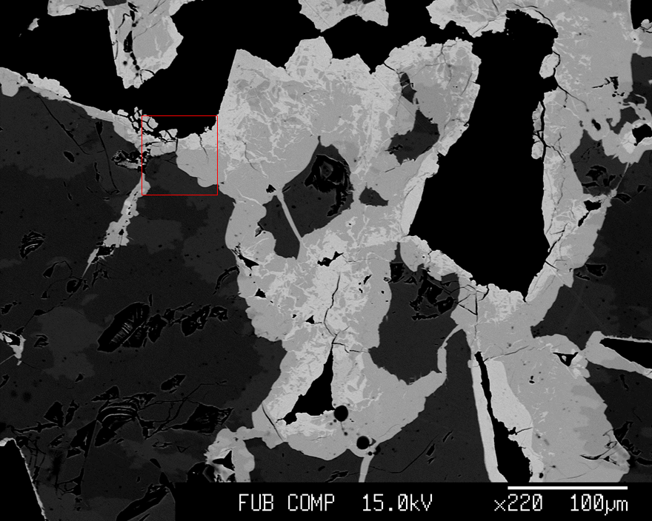
a
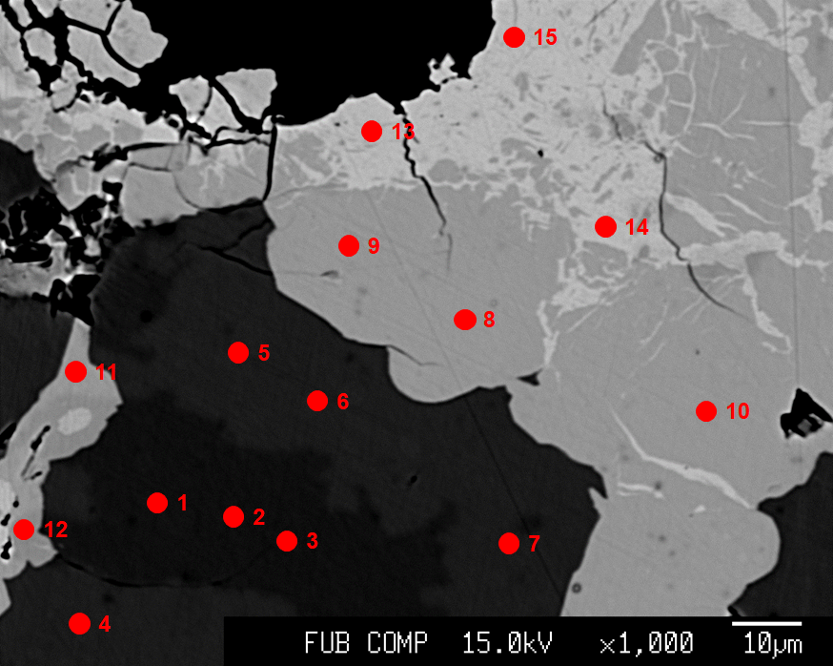
b

Figure S1. Back-scattered electron image from Zone 4 in the chimney, with (a) overview image with red box indicating the location of panel b; and (b) detailed spot locations for analyses (as listed in Table S1). Images show replacement textures of chalcocite (light-grey) and bornite (middle-grey), as well as primary chalcopyrite minerals (dark-grey).

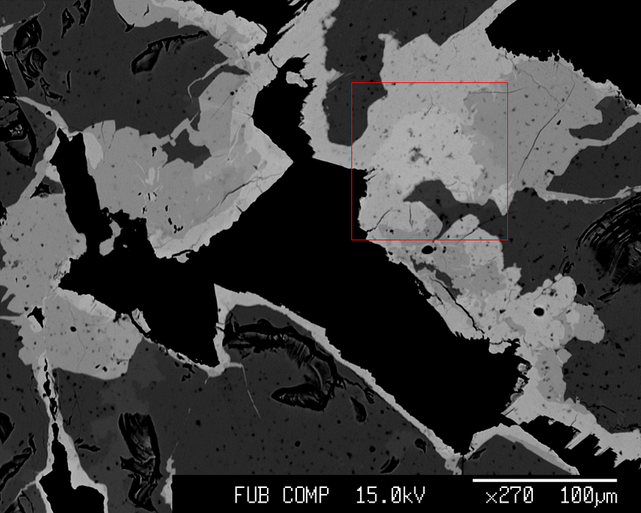
a

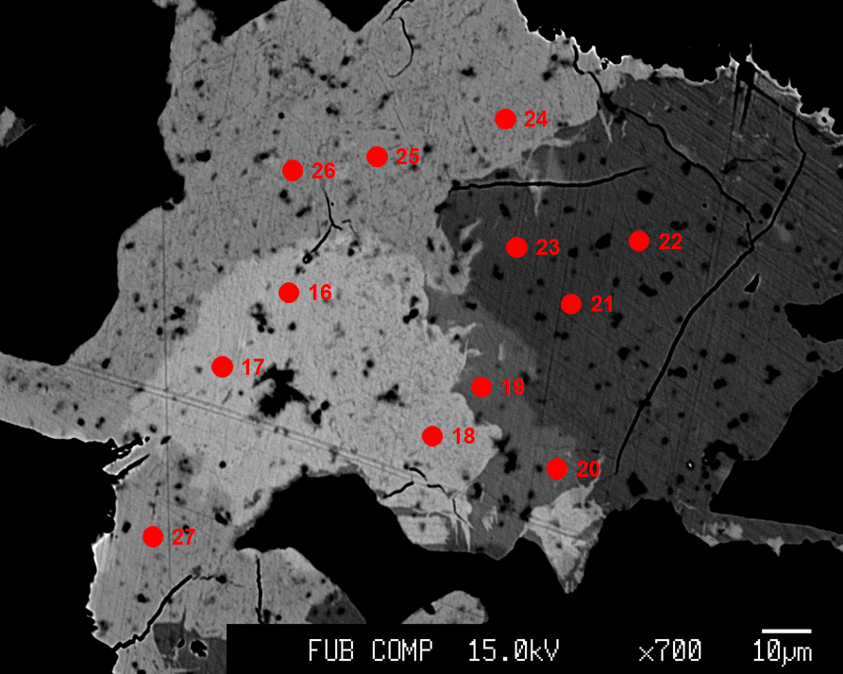
b

Figure S2. Back-scattered electron image from Zone 4 in the chimney corresponding to Figure 4c, with (a) overview image with red box indicating the location of panel b; and (b) detailed spot locations for analyses (as listed in Table S1). Images show replacement textures of chalcocite (light-grey) and bornite (middle-grey), as well as primary chalcopyrite minerals (dark-grey).

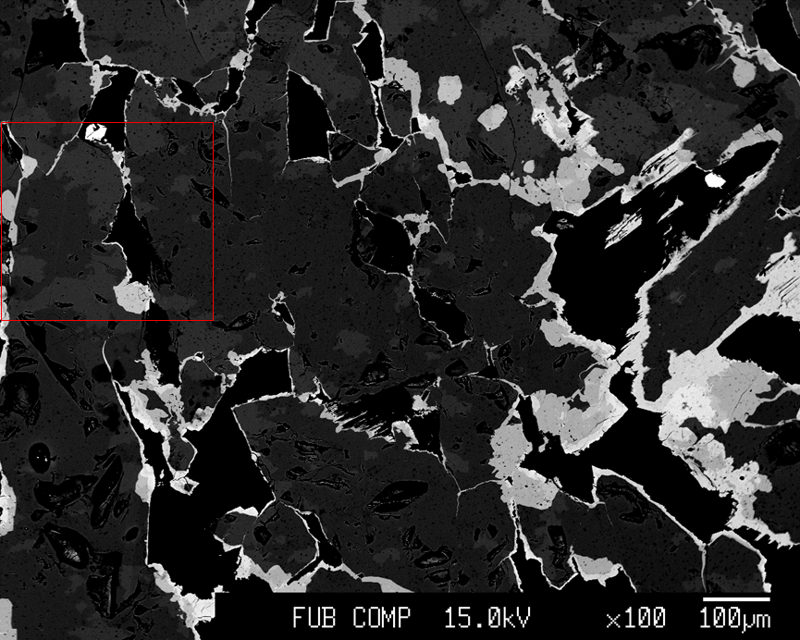
a

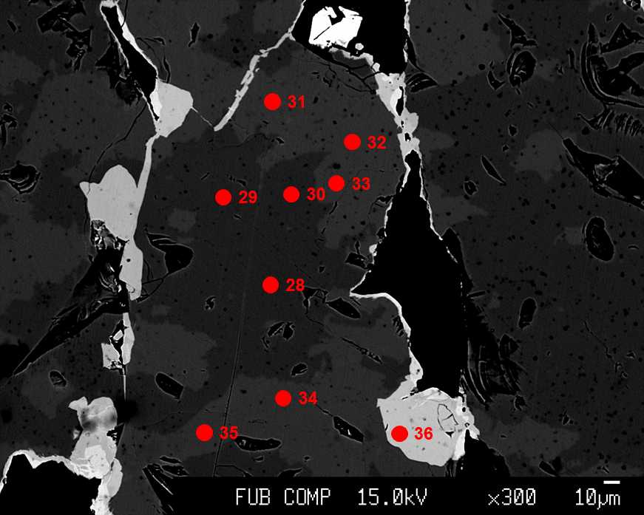
b

Figure S3. Back-scattered electron image from Zone 3 in the chimney, with (a) overview image with red box indicating the location of panel b; and (b) detailed spot locations for analyses (as listed in Table S1). Images show replacement textures of bornite (light-grey) and primary chalcopyrite (dark-grey). Grey-scale variations in the chalcopyrite are due to sample preparation and do not reflect compositional differences.

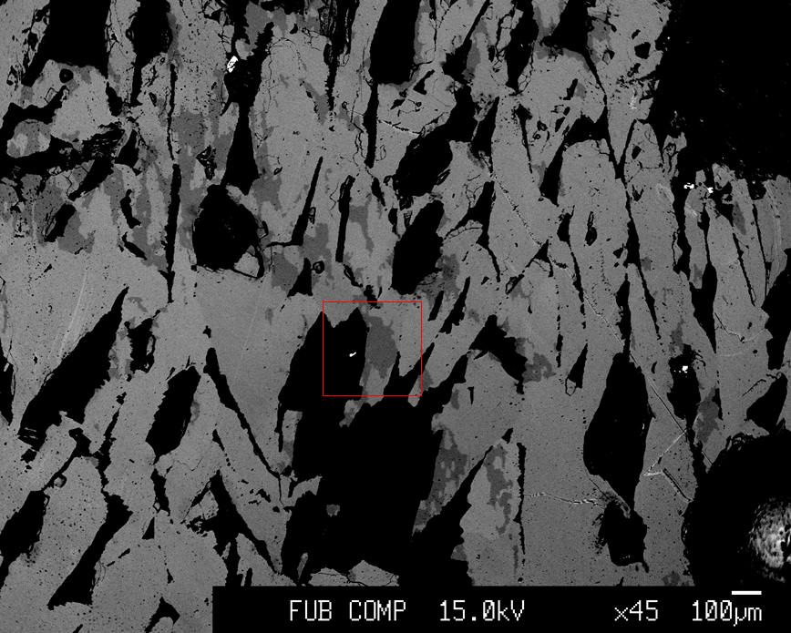
a

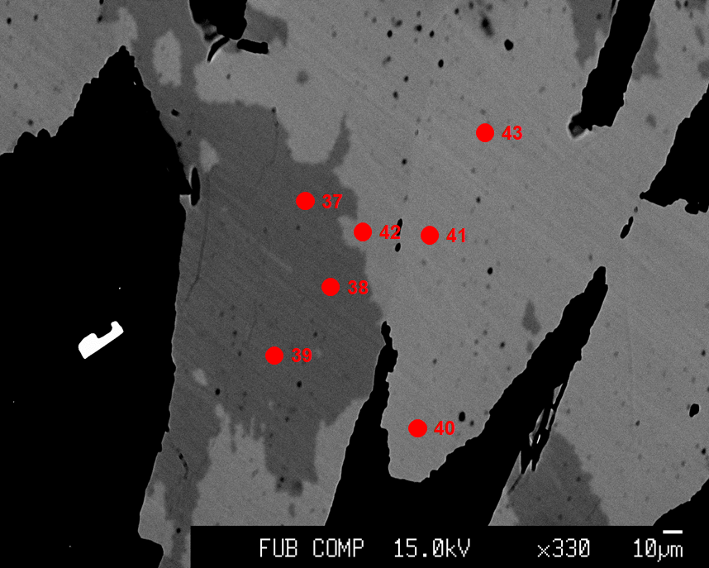
b

Figure S4. Back-scattered electron image from Zone 1 in the chimney, with (a) overview image with red box indicating the location of panel b; and (b) detailed spot locations for analyses (as listed in Table S1). Images show the dominance of chalcopyrite (medium-grey) in this inner part of the chimney. Grey-scale variations in the chalcopyrite are due to sample preparation and do not reflect compositional differences.

Spot | Fe (wt.%) | S  (wt.%) | Co  (wt.%) | Ni  (wt.%) | Cu  (wt.%) | Zn  (wt.%) | Total  (wt.%) | Fe (mol) | Cu (mol) | S (mol)
1 | 30.09 | 35.68 | 0.03 | 0.00 | 33.66 | 0.00 | 99.45 | 0.5 | 0.5 | 1.1
2 | 30.13 | 35.51 | 0.07 | 0.00 | 33.62 | 0.00 | 99.32 | 0.5 | 0.5 | 1.1
3 | 29.97 | 35.63 | 0.05 | 0.00 | 33.56 | 0.00 | 99.21 | 0.5 | 0.5 | 1.1
4 | 30.38 | 35.83 | 0.06 | 0.01 | 34.07 | 0.00 | 100.34 | 0.5 | 0.5 | 1.1
5 | 29.87 | 35.55 | 0.05 | 0.00 | 34.33 | 0.00 | 99.80 | 0.5 | 0.5 | 1.1
6 | 30.11 | 35.62 | 0.06 | 0.01 | 34.13 | 0.02 | 99.95 | 0.5 | 0.5 | 1.1
7 | 30.00 | 35.90 | 0.05 | 0.01 | 34.45 | 0.00 | 100.41 | 0.5 | 0.5 | 1.1
8 | 11.55 | 26.84 | 0.02 | 0.00 | 62.04 | 0.00 | 100.44 | 0.2 | 1.0 | 0.8
9 | 11.57 | 26.88 | 0.02 | 0.00 | 61.49 | 0.00 | 99.96 | 0.2 | 1.0 | 0.8
10 | 11.48 | 26.52 | 0.01 | 0.00 | 62.07 | 0.00 | 100.08 | 0.2 | 1.0 | 0.8
11 | 12.36 | 26.61 | 0.00 | 0.00 | 61.66 | 0.00 | 100.63 | 0.2 | 1.0 | 0.8
12 | 12.25 | 26.52 | 0.02 | 0.00 | 60.76 | 0.00 | 99.55 | 0.2 | 1.0 | 0.8
13 | 3.15 | 23.92 | 0.01 | 0.01 | 72.81 | 0.00 | 99.90 | 0.1 | 1.1 | 0.7
14 | 2.89 | 23.92 | 0.00 | 0.00 | 74.12 | 0.00 | 100.94 | 0.1 | 1.2 | 0.7
15 | 2.22 | 24.02 | 0.00 | 0.00 | 74.27 | 0.00 | 100.51 | 0.0 | 1.2 | 0.7
16 | 3.05 | 23.69 | 0.01 | 0.00 | 74.12 | 0.00 | 100.87 | 0.1 | 1.2 | 0.7
17 | 3.58 | 23.76 | 0.00 | 0.00 | 73.38 | 0.00 | 100.72 | 0.1 | 1.2 | 0.7
18 | 3.07 | 24.08 | 0.00 | 0.00 | 73.24 | 0.00 | 100.39 | 0.1 | 1.2 | 0.8
19 | 11.11 | 26.55 | 0.00 | 0.00 | 62.75 | 0.00 | 100.41 | 0.2 | 1.0 | 0.8
20 | 11.62 | 26.47 | 0.03 | 0.01 | 62.29 | 0.00 | 100.42 | 0.2 | 1.0 | 0.8
21 | 11.22 | 26.55 | 0.03 | 0.00 | 61.72 | 0.00 | 99.52 | 0.2 | 1.0 | 0.8
22 | 11.14 | 26.56 | 0.02 | 0.00 | 61.82 | 0.00 | 99.54 | 0.2 | 1.0 | 0.8
23 | 11.32 | 26.39 | 0.03 | 0.00 | 61.71 | 0.00 | 99.45 | 0.2 | 1.0 | 0.8
24 | 2.92 | 24.14 | 0.01 | 0.00 | 72.75 | 0.00 | 99.82 | 0.1 | 1.1 | 0.8
25 | 2.05 | 23.82 | 0.01 | 0.00 | 74.46 | 0.00 | 100.33 | 0.0 | 1.2 | 0.7
26 | 3.44 | 24.10 | 0.00 | 0.01 | 72.50 | 0.00 | 100.05 | 0.1 | 1.1 | 0.8
27 | 3.60 | 23.70 | 0.02 | 0.00 | 72.72 | 0.00 | 100.03 | 0.1 | 1.1 | 0.7
28 | 30.09 | 35.59 | 0.04 | 0.00 | 33.63 | 0.00 | 99.35 | 0.5 | 0.5 | 1.1
29 | 30.18 | 35.69 | 0.05 | 0.03 | 33.58 | 0.01 | 99.53 | 0.5 | 0.5 | 1.1
30 | 30.27 | 35.48 | 0.05 | 0.00 | 33.57 | 0.00 | 99.36 | 0.5 | 0.5 | 1.1
31 | 30.28 | 35.65 | 0.07 | 0.00 | 34.06 | 0.00 | 100.07 | 0.5 | 0.5 | 1.1
32 | 30.28 | 35.46 | 0.03 | 0.01 | 34.19 | 0.02 | 99.98 | 0.5 | 0.5 | 1.1
33 | 30.35 | 35.60 | 0.03 | 0.00 | 34.06 | 0.00 | 100.05 | 0.5 | 0.5 | 1.1
34 | 30.25 | 35.77 | 0.03 | 0.01 | 33.88 | 0.00 | 99.94 | 0.5 | 0.5 | 1.1
35 | 30.38 | 35.50 | 0.03 | 0.01 | 33.95 | 0.04 | 99.91 | 0.5 | 0.5 | 1.1
36 | 11.76 | 26.58 | 0.01 | 0.00 | 62.35 | 0.00 | 100.70 | 0.2 | 1.0 | 0.8
37 | 30.19 | 35.62 | 0.06 | 0.00 | 33.32 | 0.00 | 99.18 | 0.5 | 0.5 | 1.1
38 | 30.11 | 35.32 | 0.05 | 0.00 | 33.16 | 0.00 | 98.63 | 0.5 | 0.5 | 1.1
39 | 30.21 | 35.44 | 0.05 | 0.00 | 33.26 | 0.02 | 98.97 | 0.5 | 0.5 | 1.1
40 | 30.58 | 35.77 | 0.05 | 0.00 | 34.00 | 0.00 | 100.40 | 0.5 | 0.5 | 1.1
41 | 30.56 | 35.70 | 0.06 | 0.00 | 33.79 | 0.00 | 100.11 | 0.5 | 0.5 | 1.1
42 | 30.42 | 35.80 | 0.07 | 0.04 | 34.03 | 0.00 | 100.36 | 0.5 | 0.5 | 1.1
43 | 30.50 | 35.82 | 0.05 | 0.00 | 33.94 | 0.00 | 100.31 | 0.5 | 0.5 | 1.1
Std | 30.62 | 35.76 | 0.03 | 0.00 | 33.52 | 0.01 | 99.94 | 0.5 | 0.5 | 1.1

Table S1. Results from spot analyses by electron microprobe. Spot numbers correspond to the locations shown on Figures S1-S4. “Std” refers to a chalcopyrite standard.

