Heringer et al. - Economic costs of invasive non-native species in urban areas: An underexplored financial drain
Supplementary material 2
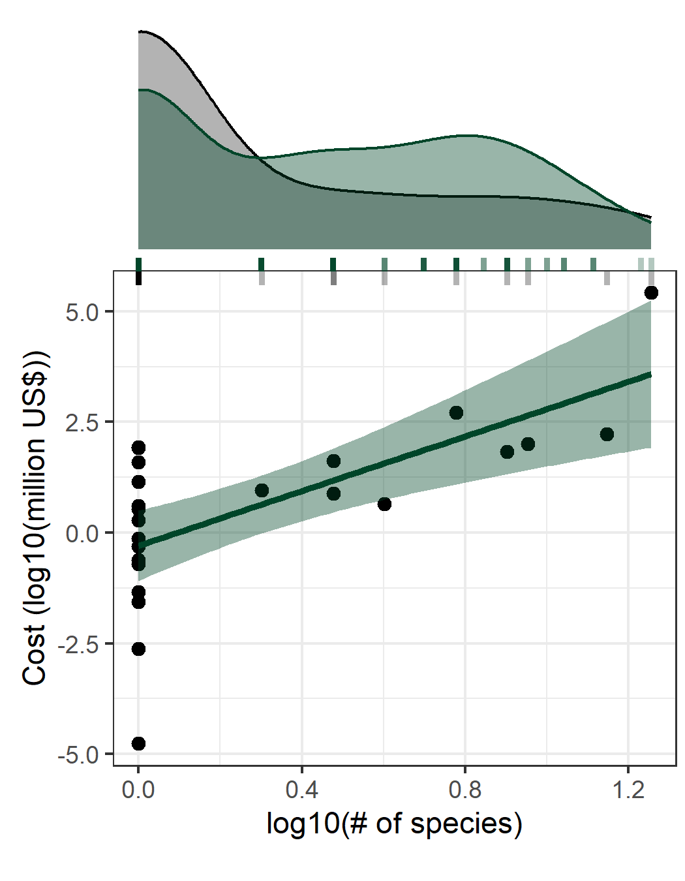
Fig. S1 – Relationship between number of invasive alien species that caused economic costs in urban areas (log10) and economic costs incurred in urban areas (log10). Density curves at the top show the observed number of invasive alien species that caused economic costs in urban areas (black) used in the analysis and the number of costly invasive alien species estimated from GBIF database (green). Observed values are plotted as gray sticks, whereas estimated values from GBIF database are plotted as green sticks

