**Dispersal limitation shapes distance-decay patterns of European spiders at the continental scale**

**- Supplementary Material -**

**Figure S1:** Relationship between the number of species and the area of the territory**.** a) log(richness)~log (area) curve for the studied European territories with the fitted model differentiating northern (blue dots) and southern (red dots) countries. b) Outliers based on Cook’s distance (cutoff = 0.15) are marked in red.

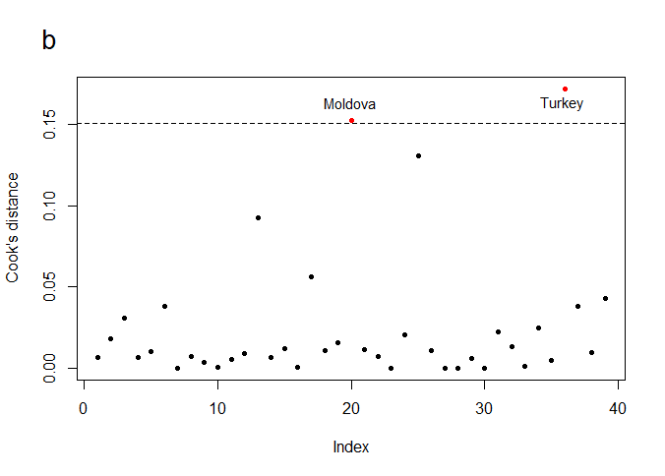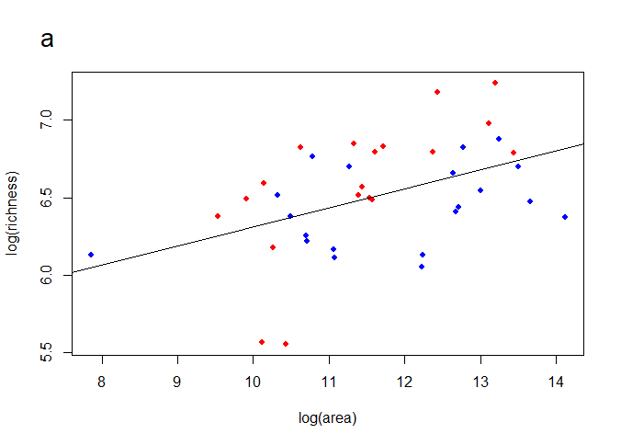

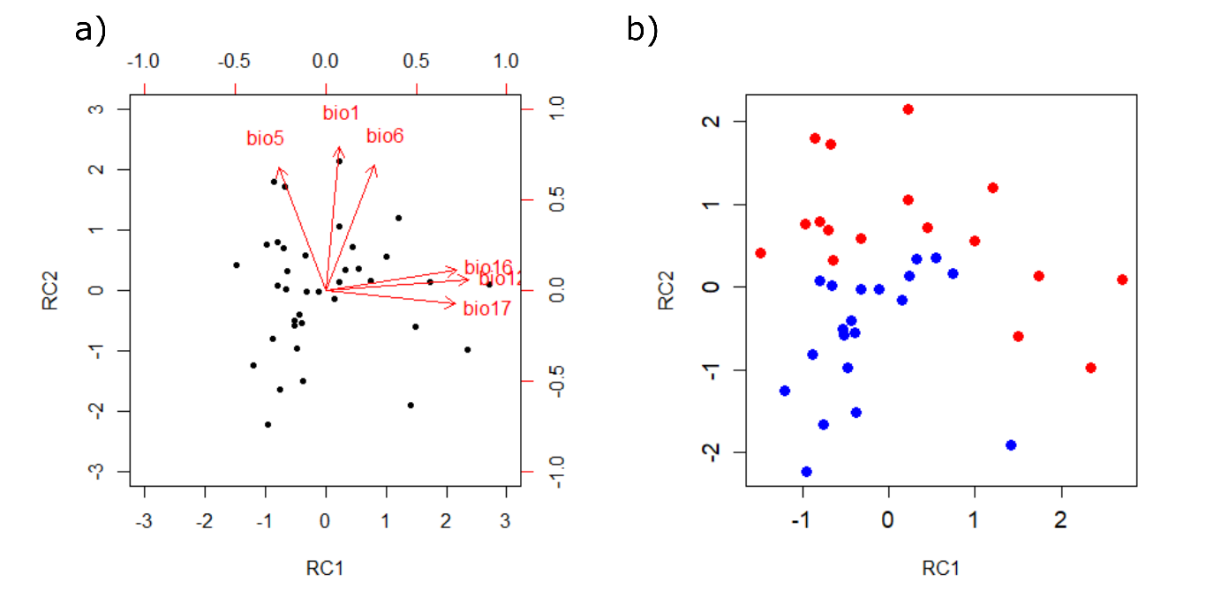**Figure S2:** Biplot (a) and ordination of territories based on PCA scores obtained from climate data (b).

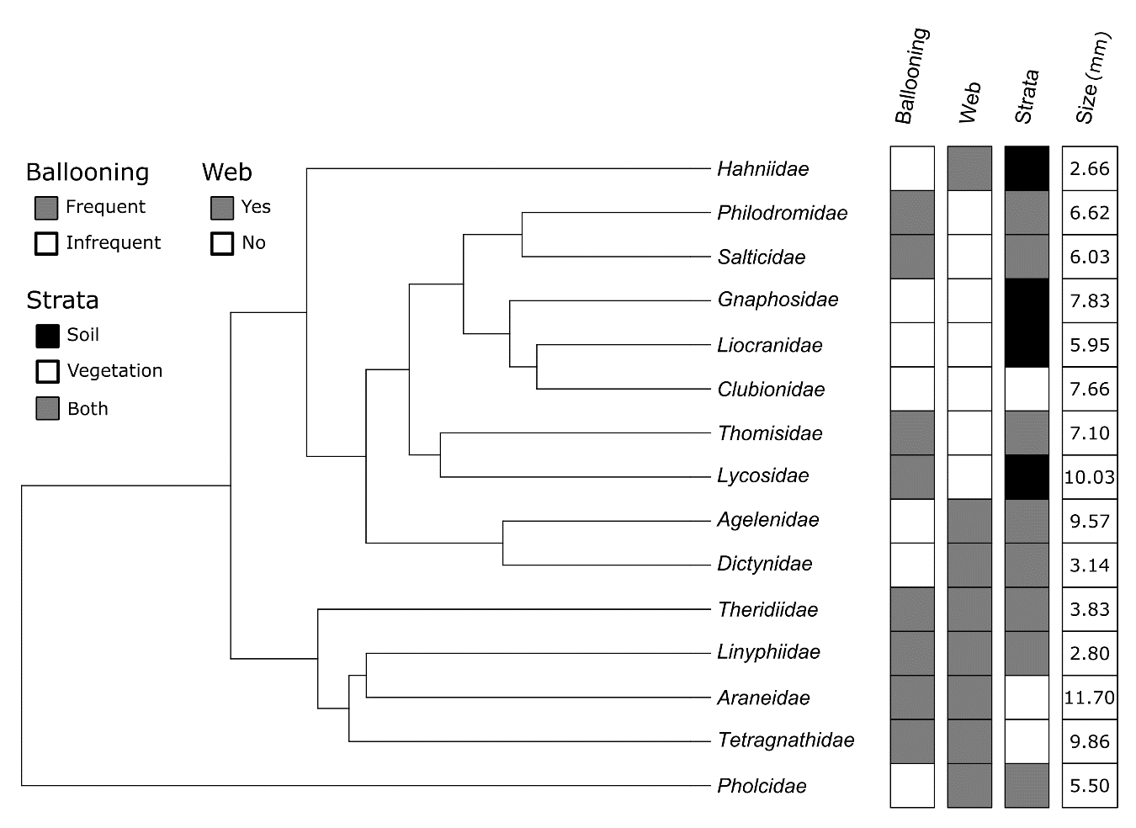

**Figure S3:** Pruned phylogenetic tree based on the phylogeny of Macías-Hernández et al. (2020a) with information on family-level dispersal traits of spiders.

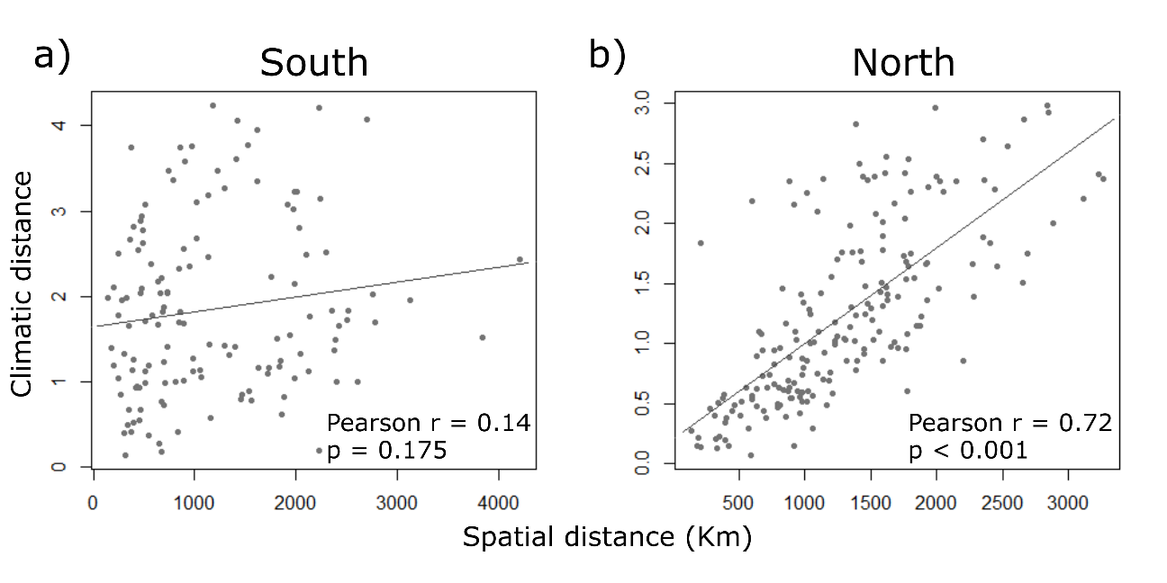

**Figure S4:** Scatterplots of the relationship between climatic and spatial distances in a) southern and b) northern Europe. Mantel correlations (Pearson r) are shown.

**Table S1:** AIC values of the power-law, negative exponential and Gompertz models for the spatial and climatic distance-decay models of each spider family in southern Europe. Lowest AIC value (and those with ΔAIC< 2) for each family are shown in bold.

|  |  |  |  |  |  |  |  |
| --- | --- | --- | --- | --- | --- | --- | --- |
|  | Spatial distance-decay | | |  | Climatic distance-decay | | |
| Family | Power-law | Negative exponential | Gompertz |  | Power-law | Negative exponential | Gompertz |
| Agelenidae | -138.1 | **-163.3** | **-161.5** |  | **-90.9** | -86.8 | -86.7 |
| Araneidae | -371.6 | **-411.9** | **-412.0** |  | **-340.5** | -337.3 | -337.2 |
| Clubionidae | -196.0 | -220.5 | **-224.4** |  | **-191.3** | **-190.9** | **-190.9** |
| Dictynidae | -143.5 | -167.9 | **-170.5** |  | **-134.4** | **-133.2** | **-133.2** |
| Gnaphosidae | -145.0 | -188.5 | **-192.4** |  | **-116.4** | **-115.0** | **-114.9** |
| Hahniidae | -69.7 | **-99.5** | -**101.3** |  | **-48.4** | **-48.0** | **-48.0** |
| Linyphiidae | -161.2 | **-190.8** | **-192.5** |  | **-135.5** | **-135.6** | **-135.6** |
| Liocranidae | -79.7 | **-100.2** | **-101.7** |  | **-70.1** | -67.8 | -67.6 |
| Lycosidae | -260.2 | **-320.1** | -317.6 |  | -191.2 | **-194.0** | **-194.1** |
| Philodromidae | -240.2 | **-247.8** | **-248.5** |  | **-239.9** | **-239.8** | **-239.8** |
| Pholcidae | -108.1 | **-134.8** | **-135.4** |  | **-76.1** | **-76.6** | **-76.5** |
| Salticidae | -252.9 | -302.0 | **-306.2** |  | **-213.6** | **-214.1** | **-214.0** |
| Tetragnathidae | **-273.8** | **-274.2** | **-274.2** |  | **-272.3** | **-272.2** | **-272.1** |
| Theridiidae | -216.9 | **-230.1** | **-231.0** |  | **-212.7** | **-213.7** | **-213.6** |
| Thomisidae | -237.5 | **-268.7** | **-270.5** |  | **-210.5** | **-209.6** | **-209.6** |

**Table S2:** AIC values of the power-law, negative exponential and Gompertz models for the spatial and climatic distance-decay models of each spider family in northern Europe.Lowest AIC value (and those with ΔAIC< 2) for each family are shown in bold.

|  |  |  |  |  |  |  |  |
| --- | --- | --- | --- | --- | --- | --- | --- |
|  | Spatial distance-decay | | |  | Climatic distance-decay | | |
| Family | Power-law | Negative exponential | Gompertz |  | Power-law | Negative exponential | Gompertz |
| Agelenidae | -139.6 | **-152.8** | **-151.8** |  | -127.0 | **-131.2** | **-130.8** |
| Araneidae | -548.8 | **-554.0** | **-554.2** |  | -545.9 | **-563.0** | **-564.4** |
| Clubionidae | -465.4 | -494.1 | **-499.4** |  | -452.1 | **-471.8** | **-473.1** |
| Dictynidae | -237.6 | **-273.8** | **-274.0** |  | -253.7 | -330.4 | **-337.7** |
| Gnaphosidae | -333.3 | **-356.5** | **-355.2** |  | -333.4 | **-352.6** | **-352.1** |
| Hahniidae | -382.6 | -394.3 | **-402.7** |  | **-377.7** | **-377.8** | **-377.8** |
| Linyphiidae | -387.9 | **-443.1** | **-443.7** |  | -372.9 | -417.3 | **-421.5** |
| Liocranidae | -235.3 | -**238.4** | **-238.6** |  | -227.4 | **-232.3** | **-232.9** |
| Lycosidae | -493.3 | **-531.8** | -527.1 |  | -481.5 | **-527.0** | **-527.7** |
| Philodromidae | -302.3 | **-324.7** | **-326.5** |  | -304.0 | **-321.4** | **-319.8** |
| Pholcidae | -43.1 | **-45.8** | **-44.1** |  | **-35.7** | -32.6 | -32.4 |
| Salticidae | -352.4 | **-377.1** | -376.9 |  | -344.9 | **-379.3** | **-378.0** |
| Tetragnathidae | -742.9 | -763.8 | **-771.4** |  | **-729.1** | **-729.1** | **-728.9** |
| Theridiidae | -401.1 | **-420.8** | **-422.3** |  | -388.7 | **-416.7** | **-417.3** |
| Thomisidae | -398.3 | **-415.0** | -409.1 |  | -392.7 | **-425.7** | -423.7 |

**Table S3:** Selected species for each family to build a family phylogenetic tree by pruning the phylogeny provided by Macías-Hernández et al., (2020a).

|  |  |
| --- | --- |
| **Family** | **Selected species** |
| Agelenidae | *Agelena labyrinthica* (Clerck, 1757) |
| Araneidae | *Araneus diadematus* Clerck, 1757 |
| Clubionidae | *Clubiona neglecta* Pickard-Cambridge, 1862 |
| Dictynidae | *Brigittea latens* (Fabricius, 1775) |
| Gnaphosidae | *Drassyllus praeficus* (Koch, 1866) |
| Hahniidae | *Hahnia nava* (Blackwall, 1841) |
| Linyphiidae | *Walckenaeria antica* (Wider, 1834) |
| Liocranidae | *Scotina celans* (Blackwall, 1841) |
| Lycosidae | *Piratula latitans* (Blackwall, 1841) |
| Philodromidae | *Philodromus aureoles* (Clerck, 1757) |
| Pholcidae | *Pholcus phalangioides* (Fuesslin, 1775) |
| Salticidae | *Evarcha arcuata* (Clerck, 1757) |
| Tetragnathidae | *Tetragnatha extensa* (Linnaeus, 1758) |
| Theridiidae | *Crustulina guttata* (Wider, 1834*)* |
| Thomisidae | *Xysticus cristatus* (Clerck, 1757) |

**Table S4:** Z-dep andp-values of parameter comparison (i.e. intercept and slope) of the spatial and climatic distance-decay curves of northern and southern Europe. In bold p-values < 0.05.

|  |  |  |  |  |  |
| --- | --- | --- | --- | --- | --- |
|  | **North** | |  | **South** | |
| **Family** | **p-value intercept** | **p-value slope** |  | **p-value intercept** | **p-value slope** |
| Agelenidae | Z-dep=1.86, p=0.06 | Z-dep=-1.54, p=0.13 |  | **Z-dep=2.59, p=0.01** | **Z-dep=-6.10, p<0.01** |
| Araneidae | Z-dep=-0.27, p=0.76 | Z-dep=-0.16, p=0.87 |  | **Z-dep=2.83, p<0.01** | **Z-dep=-5.31, p<0.01** |
| Clubionidae | Z-dep=1.35, p=0.19 | Z-dep=-1.48, p=0.14 |  | Z-dep=1.69, p=0.09 | **Z-dep=-3.14, p<0.01** |
| Dictyndae | Z-dep=0.76, p=0.40 | Z-dep=-0.22, p=0.81 |  | **Z-dep=2.05, p=0.04** | **Z-dep=-2.89, p<0.01** |
| Gnaphosidae | Z-dep=0.61, p=0.55 | Z-dep=-0.95, p=0.34 |  | **Z-dep=2.64, p<0.01** | **Z-dep=-4.90, p<0.01** |
| Hahniidae | Z-dep=1.82, p=0.06 | Z-dep=-1.60, p=0.10 |  | **Z-dep=2.90, p<0.01** | **Z-dep=-4.03, p<0.01** |
| Linyphiidae | Z-dep=1.28, p=0.20 | Z-dep=-1.35, p=0.17 |  | **Z-dep=2.33, p=0.02** | **Z-dep=-4.56, p<0.01** |
| Liocranidae | Z-dep=-0.09, p=0.93 | Z-dep=1.27, p=0.20 |  | Z-dep=1.34, p=0.18 | **Z-dep=-2.91, p<0.01** |
| Lycosidae | Z-dep=0.81, p=0.42 | Z-dep=-1.15, p=0.25 |  | **Z-dep=3.34, p<0.01** | **Z-dep=-6.77, p<0.01** |
| Philodromidae | Z-dep=0.74, p=0.46 | Z-dep=-0.69, p=0.49 |  | Z-dep=0.75, p=0.45 | Z-dep=-1.41, p=0.16 |
| Pholcidae | Z-dep=1.69, p=0.09 | Z-dep=-1.81, p=0.07 |  | **Z-dep=3.81, p<0.01** | **Z-dep=-5.93, p<0.01** |
| Salticidae | Z-dep=0.37, p=0.71 | Z-dep=-0.77, p=0.44 |  | **Z-dep=3.32, p<0.01** | **Z-dep=-5.82, p<0.01** |
| Tetragnathidae | **Z-dep=3.04, p<0.01** | **Z-dep=-2.78, p<0.01** |  | Z-dep=0.08, p=0.93 | Z-dep=-0.51, p=0.61 |
| Theridiidae | Z-dep=0.50, p=0.62 | Z-dep=-0.95, p=0.34 |  | Z-dep=0.54, p=0.59 | Z-dep=-1.64, p=0.10 |
| Thomisidae | Z-dep=0.18, p=0.86 | Z-dep=-0.40, p=0.69 |  | **Z-dep=3.06, p<0.01** | **Z-dep=-6.48, p<0.01** |

**Table S5:** Parameter values (i.e. intercept and slope) of the spatial and climatic distance-decay curves of northern and southern Europe for each spider family.

|  |  |  |  |  |  |  |  |  |  |
| --- | --- | --- | --- | --- | --- | --- | --- | --- | --- |
| **Family** | **North** | | | |  | **South** | | | |
| **Spatial** | | **Climatic** | |  | **Spatial** | | **Climatic** | |
| **Intercept** | **Slope** | **Intercept** | **Slope** |  | **Intercept** | **Slope** | **Intercept** | **Slope** |
| Agelenidae | 1.01 | -0.38 | 0.94 | -0.18 |  | 0.73 | -1.17 | 0.60 | -0.18 |
| Araneidae | 0.96 | -0.07 | 0.97 | -0.08 |  | 0.94 | -0.26 | 0.89 | -0.03 |
| Clubionidae | 0.99 | -0.20 | 0.97 | -0.13 |  | 0.94 | -0.31 | 0.89 | -0.06 |
| Dictynidae | 0.99 | -0.47 | 1.00 | -0.49 |  | 0.86 | -0.46 | 0.79 | -0.07 |
| Gnaphosidae | 0.91 | -0.32 | 0.90 | -0.26 |  | 0.85 | -0.75 | 0.74 | -0.09 |
| Hahniidae | 0.99 | -0.13 | 0.95 | -0.02 |  | 0.91 | -0.79 | 0.78 | -0.08 |
| Linyphiidae | 0.96 | -0.38 | 0.93 | -0.28 |  | 0.77 | -0.68 | 0.69 | -0.11 |
| Liocranidae | 0.93 | -0.19 | 0.91 | -0.11 |  | 0.81 | -0.68 | 0.74 | -0.17 |
| Lycosidae | 0.93 | -0.29 | 0.92 | -0.23 |  | 0.89 | -0.66 | 0.82 | -0.17 |
| Philodromidae | 0.99 | -0.29 | 0.98 | -0.24 |  | 0.84 | -0.15 | 0.81 | -0.03 |
| Pholcidae | 0.96 | -0.34 | 0.87 | -0.07 |  | 0.92 | -0.73 | 0.74 | 0.08 |
| Salticidae | 0.93 | -0.30 | 0.92 | -0.25 |  | 0.85 | -0.52 | 0.77 | -0.07 |
| Tetragnathidae | 1.01 | -0.07 | 0.98 | -0.01 |  | 0.90 | -0.08 | 0.90 | -0.04 |
| Theridiidae | 0.93 | -0.24 | 0.92 | -0.19 |  | 0.83 | -0.29 | 0.82 | -0.13 |
| Thomisidae | 0.97 | -0.25 | 0.97 | -0.23 |  | 0.88 | -0.42 | 0.79 | 0.00 |

|  |  |  |  |  |  |  |
| --- | --- | --- | --- | --- | --- | --- |
| Model predictors | Δ Spatial intercept | Δ Spatial slope | Δ Climatic intercept | Δ Climatic slope | βsim | βsne |
| Bal + Web + Siz + Str | **-33.19** | **5.52** | **-40.17** | -9.22 | -28.67 | **-18.27** |
| Bal + Web + Siz | -29.18 | 11.14 | -28.98 | -10.07 | -32.01 | -6.56 |
| Bal + Siz + Str | **-34.06** | **4.78\*** | **-40.54\*** | -10.47 | -30.21 | **-19.43\*** |
| Bal + Web + Str | -31.82 | 9.75 | -36.58 | -9.16 | -29.52 | -6.67 |
| Web + Siz + Str | **-33.71** | 7.10 | -37.24 | **-11.20** | -30.35 | -14.75 |
| Bal + Web | -31.18 | 10.59 | -30.85 | -8.32 | -30.66 | -7.15 |
| Bal + Siz | -29.99 | 9.26 | -30.13 | **-11.96** | **-33.52** | -8.32 |
| Bal + Str | **-33.21** | 8.24 | -37.83 | -10.70 | -31.21 | -8.58 |
| Web + Siz | -31.17 | 12.16 | -30.75 | **-11.08** | **-33.20** | -7.83 |
| Web + Str | **-33.41** | 8.78 | -36.61 | **-11.08** | -31.45 | -8.00 |
| Siz + Str | **-33.56** | 7.82 | -35.92 | -12.26 | -31.52 | -14.37 |
| Bal | -31.97 | 8.61 | -31.88 | -10.31 | **-32.54** | -9.07 |
| Web | **-33.17** | 11.02 | -32.58 | -9.83 | -32.27 | -8.66 |
| Siz | -31.94 | 10.79 | -31.58 | **-12.70\*** | **-34.31\*** | -9.29 |
| Str | **-34.22\*** | 8.06 | -36.62 | **-12.70\*** | **-32.95** | -9.59 |
| Null model | **-33.91** | 9.39 | -33.20 | **-11.79** | **-33.97** | -10.40 |

**Table S6:** AICs for the Phylogenetic Generalised Least Square (PGLS) models of the relationship between spider dispersal traits and the North-South difference of distance-decay parameters as well as the faunistic dissimilarity components: turnover (βsim) and nestedness-resultant dissimilarity (βsne). The lowest AIC value is shown in bold and with asterisk. Alternative models with (ΔAIC< 2) are shown in bold.

Bal = Ballooning tendency; Web = Web builders; Siz = Maximum size of the females; Str = Inhabiting strata.

|  |  |  |  |
| --- | --- | --- | --- |
| Variables | Estimate | Std. Error | p-value |
| Ballooning Infrequent | 0.309 | 0.155 | 0.074 |
| Maximum female size | 0.055 | 0.026 | 0.062 |
| Strata vegetation-Soil | 0.101 | 0.158 | 0.537 |
| Strata vegetation-Vegetation | -0.374 | 0.197 | 0.087 |

**Table S7:** Parameters for the best supported PGLS model for the North-South difference in the slope of spatial distance-decay models.

|  |  |  |  |
| --- | --- | --- | --- |
| Variables | Estimate | Std. Error | p-value |
| Strata vegetation-Soil | -0.53 | 0.039 | 0.198 |
| Strata vegetation-Vegetation | -0.082 | 0.044 | 0.083 |

**Table S8:** Parameters for the best supported PGLS model for the North-South difference in the intercept of spatial distance-decay models.

**Table S9:** Parameters for the best supported PGLS model for the North-South difference in the intercept of climatic distance-decay models.

|  |  |  |  |
| --- | --- | --- | --- |
| Variables | Estimate | Std. Error | p-value |
| Ballooning Infrequent | 0.079 | 0.055 | 0.040 |
| Maximum female size | 0.011 | 0.006 | 0.084 |
| Strata vegetation-Soil | -0.082 | 0.035 | 0.040 |
| Strata vegetation-Vegetation | -0.175 | 0.043 | 0.002 |

**Table S10:** Parameters for the best supported PGLS model for the North-South difference in the slope of climatic distance-decay models.

|  |  |  |  |
| --- | --- | --- | --- |
| Variables | Estimate | Std. Error | p-value |
| Strata vegetation-Soil | 0.162 | 0.080 | 0.064 |
| Strata vegetation-Vegetation | 0.131 | 0.089 | 0.167 |

**Table S11:** Parameters for the best supported PGLS model for North-South nestedeness-resultant dissimilarity (βsne).

|  |  |  |  |
| --- | --- | --- | --- |
| Variables | Estimate | Std. Error | p-value |
| Ballooning Infrequent | 0.169 | 0.112 | 0.034 |
| Maximum female size | 0.043 | 0.012 | 0.004 |
| Strata vegetation-Soil | -0.110 | 0.070 | 0.150 |
| Strata vegetation-Vegetation | -0.360 | 0.088 | 0.002 |

|  |  |  |  |
| --- | --- | --- | --- |
| Variables | Estimate | Std. Error | p-value |
| Maximum female size | -0.008 | 0.006 | 0.163 |

**Table S12:** Parameters for the best supported PGLS models for North-South turnover (βsim).