Cu transport and complexation by the marine diatom Phaeodactylum tricornutum: implications for trace metal complexation kinetics in the surface ocean

Melchor González-Dávila¹, Maria T. Maldonado², Aridane G. González¹, Jian Guo², David González-Santana¹, Antera Martel³, and J. Magdalena Santana-Casiano¹

¹Instituto de Oceanografía y Cambio Global, IOCAG, Universidad de Las Palmas de Gran Canaria, ULPGC, Spain.
²Department of Earth, Ocean, and Atmospheric Sciences, University of British Columbia, British Columbia, Canada
³Banco Español de Algas, Instituto de Oceanografía y Cambio Global, IOCAG, Universidad de Las Palmas de Gran Canaria, ULPGC, Spain

SUPPLEMENTARY MATERIAL
Figure S1. Example of a Cu titration curve in seawater containing Cu-binding ligands excreted by P. tricornutum grown in the control media and measured using CLE-CSV.
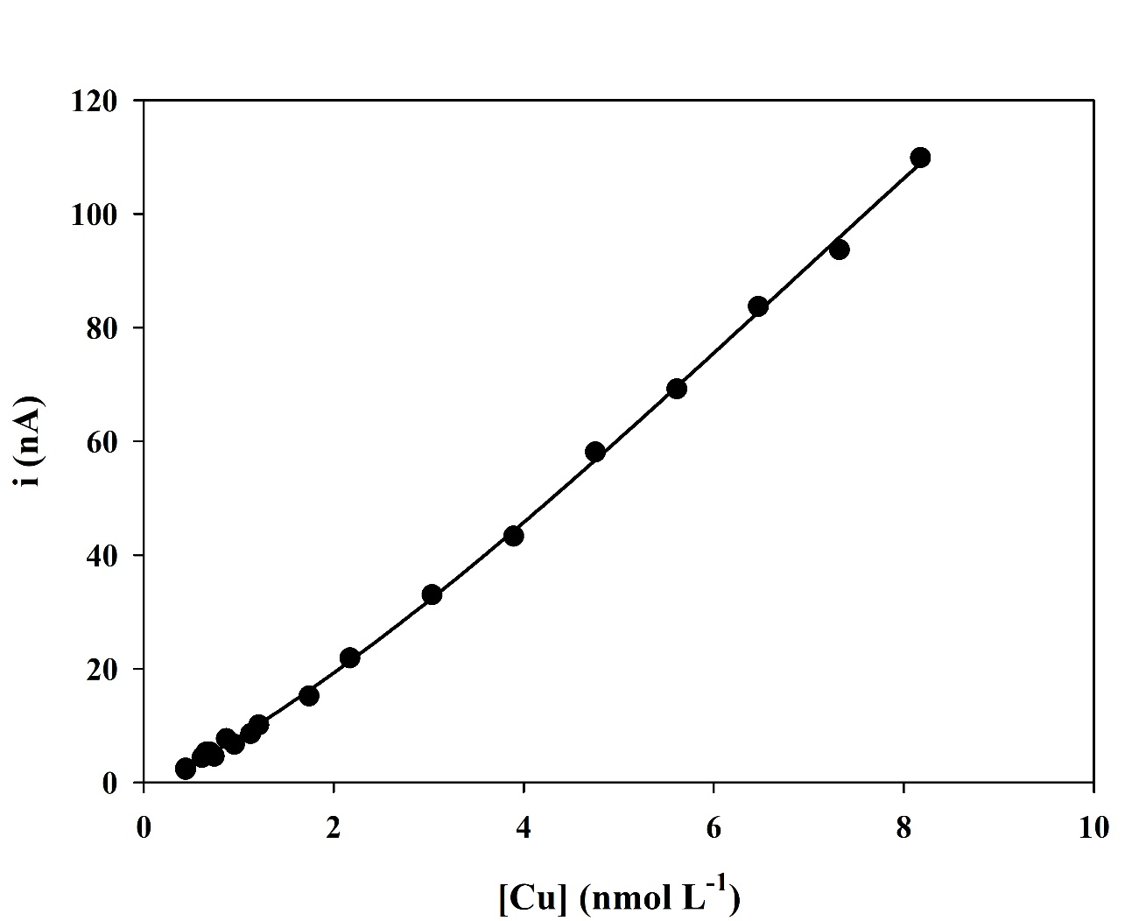

Figure S2. Percentage of total Cu in solution (added 4.43•10⁻⁹ mol L⁻¹ + initial [Cu] of 4.4•10⁻¹⁰ mol L⁻¹) that was adsorbed onto P. tricornutum as a function of time, at the natural ESTOC seawater pH_{F} of 8.01 ± 0.05, and a cell density of 48·10³ cells ml⁻¹.

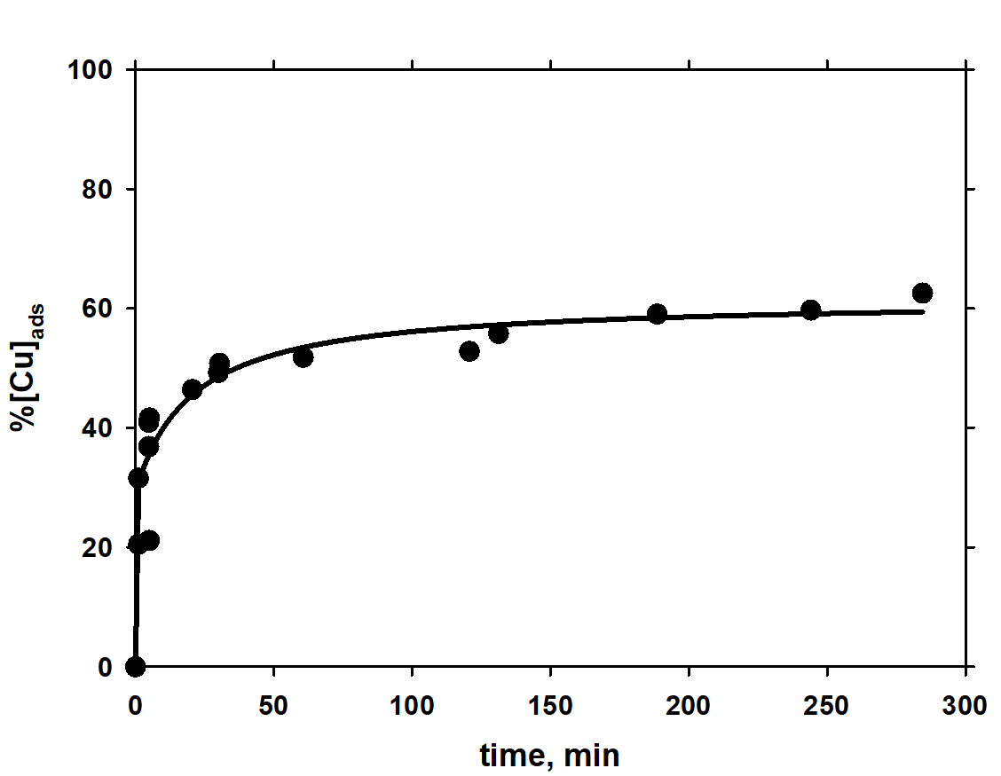

Table S1. Dissolved trace metal concentrations at the ESTOC site, measured and consensus values (nM) for the reference materials (SAFE S and D2). Measurements were carried out within 12 months after collection on a SF-HR-ICP-MS Element XR instrument (Thermo Fisher, Bremen, Germany) coupled with an online seaFAST system (Elemental ScientificTM), at Pôle Spectrométrie Océan (IFREMER, France).
 | ESTOC | SAFE S |  | SAFE D2
 |  | Measured | Consensus | Measured | Consensus
Mn | 0.860±0.019 | 0.760±0.070 | 0.790±0.060 | 0.340±0.070 | 0.350±0.050
Fe | 0.668±0.018 | 0.160±0.010 | 0.090±0.010 | 0.960±0.080 | 0.930±0.020
Co | 0.030±0.001 | 0.004±0.002 | 0.005±0.001 |  | 0.046±0.003
Cu | 0.420±0.008 | 0.430±0.020 | 0.520±0.050 | 2.116±0.040 | 2.280±0.150
Zn | 0.420±0.005 |  | 0.069±0.010 | 7.634±0.086 | 7.430±0.250
Ni | 1.423±0.025 | 2.269±0.039 | 2.28±0.090 | 8.769±0.025 | 8.630±0.250
Table S2. Exponential absolute growth rate (µ, d⁻¹), doublings per day (k, dd⁻¹) and the surface area (µm²) for the two experimental conditions CO_{MEDIUM} and Cy_{MEDIUM}. Growth rate data in the f/2 media used for culture maintenance in the Spanish Bank of Algae in Gran Canaria is also included. (NM, not measured). *values are statistically different (p < 0.05) from the Control. n = 11 and 10 for CO_{MEDIUM} and Cy_{MEDIUM}, respectively.

Rate | CO_{MEDIUM} | Cy_{MEDIUM} | f/2 media
µ (d⁻¹) | 0.94±0.44 | 0.97±0.30 | 1.72±0.028
k (dd⁻¹) | 1.35±0.64 | 1.40±0.44 | 2.48±0.04
µm² | 47.24±9.23 | 35.27±5.39* | NM

Table S3. Summary of kinetic parameters of the Cu-transport system in P. tricornutum (this study), T. oceanica (CCMP1003) and T. pseudonana (CCMP1335; Guo et al. 2010). V_{max} is the maximum Cu uptake rates, and K_{m} (nM [Cu]_{total} or pM [Cu']) is the half-saturation constants of the Cu uptake system. [Cu] _{total} is the total Cu concentration (nM) and [Cu´] is the dissolved inorganic Cu concentration (nM). In the case of P. tricornutum, the K_{m} for total Cu was converted to Cu’ considering the presence of L₁ and L₂ released by the algae (Table 3). For T. oceanica and T. pseudonana, the Cu’ values used were those in Table 5 in Guo et al. 2010.

 | Low affinity |  |  |  | High affinity
 | V_{max}  (10⁻²¹ mol Cu·µm⁻²·h⁻¹) | K_{m}  (nM [Cu]_{total}) | K_{m}  (pM [Cu']) |  | V_{max}  (10⁻²¹ mol Cu·µm⁻²·h⁻¹) | K_{m}  (nM [Cu]_{total}) | K_{m}  (pM [Cu'])
P. tricornutum | 19.3±10.6 | 2636±2156 | 1.37±1.12 |  | 1.48±0.60 | 154±130 | 0.08±0.07
T. oceanica | 238±63 | 6336±2253 | 3.33±1.18 |  | 1.3±1.1 | 7.3±32 | 0.08±0.35
T. pseudonana | 63±4.9 | 1117±525 | 0.59±0.28 |  | 4.8±7.8 | 52±129 | 0.64±1.6

Table S4. Rate constants, oceanic concentrations and physiological parameters for trace metals transport in T. weissflogii, as in Hudson and Morel 1993, with revised and updated data for Cd and Cu.

Metal | k_{f} (M⁻¹ s⁻¹) | [M]_{T} (nM) | [M'] (M) | pM | Q_{0.9} (mol cell⁻¹) | [L']_{min} (mol cell⁻¹) | k_{lim}^{in} (s⁻¹)
Mn | 3.00x10⁷ | 1 | 1.00 x10⁻⁹ | 9.2 | 8.00 x10⁻¹⁷ | 4.04 x10⁻²⁰ | 3.00 x10⁻²
Zn | 4.00x10⁷ | 0.2 | 4.00 x10⁻¹² | 11.7 | 2.00 x10⁻¹⁷ | 1.90 x10⁻¹⁸ | 1.60 x10⁻⁴
Ni | 1.00x10⁵ | 2 | 2.00 x10⁻⁹ | 9 | 2.00 x10⁻¹⁷ | 1.52 x10⁻¹⁸ | 2.00 x10⁻⁴
Fe | 2.00x10⁶ | 0.06 | 6.00 x10⁻¹¹ | 20.2 | 8.00 x10⁻¹⁷ | 1.01 x10⁻¹⁷ | 1.20 x10⁻⁴
Co | 4.00x10⁶ | 0.02 | 2.00 x10⁻¹¹ | 10.9
Cd | 4.00x10⁸ | 0.002 | 6.00 x10⁻¹³ | 13.7 | 6.40 x10^{-18 (c)} | 4.04 x10^{-19 (d)} | 2.40 x10^{-4 (d)}
Cu | 1.10x10^{7 (a)} | 0.6 | 2.00 x10⁻¹² | 12.7 | 2.00 x10^{-18 (b)} | 1.38 x10^{-18 (d)} | 2.20 x10^{-5 (d)}
 |  |  |  |  | 8.00 x10^{-18 (b)} | 7.95 x10^{-18 (d)} | 2.20 x10^{-5 (d)}
Note: This is a replica of Table 1 in Hudson and Morel (1993), with new values for Cd and Cu.
- k_{f} was calculated in this study.
- The added Q_{0.9} for Cu are for T.weissflogii from Annett et al. (2008)
- The added Q_{0.9} for Cd is from Ho et al. (2003), assuming a Cd quota of 8.9 µmol L_{cell volume}⁻¹ and that T.weissflogii cell volume is 731 fL cell⁻¹.
- [L']_{min} (mol cell⁻¹) and k_{lim}^{in} (s⁻¹) were calculated as indicated in Hudson and Morel (1993)

REFERENCES
Annett, A. L., Lapi, S., Ruth, T. J., and Maldonado, M. T. (2008). Annett, Amber L., Suzanne Lapi, Thomas J. Ruth, and Maria T. Maldonado. The effects of Cu and Fe availability on the growth and Cu:C ratios of marine diatoms. Limnol. Oceanogr., 53(6), 2008, 2451–2461.
Guo, J., Annett, A. L., Taylor, R. L., Lapi, S., Ruth, T. J., and Maldonado, M. T. (2010). Copper-uptake kinetics of coastal and oceanic diatoms. J Phycol 46, 1218–1228. doi: 10.1111/j.1529-8817.2010.00911.x.
Ho, T.-Y., Quigg, A., Finkel, Z. V., Milligan, A. J., Wyman, K., Falkowski, P. G., et al. (2003). The elemental composition of some marine phytoplankton. J Phycol 39, 1145–1159. doi: 10.1111/j.0022-3646.2003.03-090.x.
Hudson, R. J. M., and Morel, F. M. M. (1993). Trace metal transport by marine microorganisms: implications of metal coordination kinetics. Deep-Sea Research I 40, 129–150.

