Supplementary Material Title Page

Title: Comparisons of landings to scientific advice indicates overshooting within the common TAC for skates and rays in the Northeast Atlantic.
Authors: Jurgen Batsleer¹, Christopher A. Griffiths², Katinka Bleeker¹, Graham Johnston³, Massimiliano Cardinale², Pascal Lorance⁴

¹Wageningen Marine Research, Wageningen University and Research, P.O. Box 68, 1970 AB, IJmuiden, the Netherlands.
²Swedish University of Agricultural Sciences, Department of Aquatic Resources, Institute of Marine Research, Turistgatan 5, SE-453 30, Lysekil, Sweden.
³Marine Institute, Rinville, Oranmore, Galway, H91 R673, Ireland.
⁴DECOD (Ecosystem Dynamics and Sustainability), IFREMER, INRAE, Institut Agro— Agrocampus Ouest, Nantes, France

Corresponding author: Jurgen Batsleer, Wageningen Marine Research – E: Jurgen.Batsleer@gmail.com

Supporting Information
For Batsleer al. 2024. Comparisons of landings to scientific advice indicates overshooting within the common TAC for skates and rays in the Northeast Atlantic.

Table S1. Annual estimated ICES landings (tonnes) and ICES advice (tonnes) by stock and ecoregion. Ecoregions are listed as Bay of Biscay and Iberian coast (BI), Celtic Seas (CS) and Greater North Sea (GNS). ICES Advice (detailed in Table S2) has been split based on the annual proportion of landings per ecoregion for each stock (see MS text for more details). Landings and advice have been rounded to the nearest whole number.
Stock | Year | Ecoregion | ICES landings  (tonnes) | ICES advice  (tonnes)
rjc.27.3a47d | 2016 | GNS | 1807 | 2110
rjc.27.3a47d | 2017 | GNS | 1789 | 2110
rjc.27.3a47d | 2018 | GNS | 2218 | 2574
rjc.27.3a47d | 2019 | GNS | 2213 | 2574
rjc.27.3a47d | 2020 | GNS | 2241 | 2237
rjc.27.3a47d | 2021 | GNS | 2238 | 2237
rjc.27.3a47d | 2022 | GNS | 1964 | 2446
rjc.27.6 | 2016 | CS | 260 | 205
rjc.27.6 | 2017 | CS | 284 | 145
rjc.27.6 | 2018 | CS | 328 | 145
rjc.27.6 | 2019 | CS | 396 | 174
rjc.27.6 | 2020 | CS | 261 | 174
rjc.27.6 | 2021 | CS | 242 | 137
rjc.27.6 | 2022 | CS | 205 | 137
rjc.27.7afg | 2016 | CS | 861 | 1235
rjc.27.7afg | 2017 | CS | 878 | 1386
rjc.27.7afg | 2018 | CS | 840 | 1386
rjc.27.7afg | 2019 | CS | 960 | 1663
rjc.27.7afg | 2020 | CS | 909 | 1663
rjc.27.7afg | 2021 | CS | 972 | 1596
rjc.27.7afg | 2022 | CS | 1005 | 1596
rjc.27.7e | 2016 | CS | 423 | 260
rjc.27.7e | 2017 | CS | 372 | 212
rjc.27.7e | 2018 | CS | 438 | 212
rjc.27.7e | 2019 | CS | 490 | 212
rjc.27.7e | 2020 | CS | 464 | 212
rjc.27.7e | 2021 | CS | 541 | 170
rjc.27.7e | 2022 | CS | 566 | 170
rjc.27.8 | 2016 | BI | 373 | 238
rjc.27.8 | 2017 | BI | 369 | 434
rjc.27.8 | 2018 | BI | 529 | 434
rjc.27.8 | 2019 | BI | 513 | 276
rjc.27.8 | 2020 | BI | 523 | 276
rjc.27.8 | 2021 | BI | 538 | 389
rjc.27.8 | 2022 | BI | 794 | 389
rjc.27.9a | 2016 | BI | 682 | 911
rjc.27.9a | 2017 | BI | 744 | 1203
rjc.27.9a | 2018 | BI | 806 | 1203
rjc.27.9a | 2019 | BI | 802 | 1431
rjc.27.9a | 2020 | BI | 848 | 1431
rjc.27.9a | 2021 | BI | 942 | 1717
rjc.27.9a | 2022 | BI | 1090 | 1717
rje.27.7de | 2016 | GNS | 22 | 26
rje.27.7de | 2016 | CS | 14 | 17
rje.27.7de | 2017 | GNS | 22 | 22
rje.27.7de | 2017 | CS | 15 | 14
rje.27.7de | 2018 | GNS | 23 | 22
rje.27.7de | 2018 | CS | 15 | 14
rje.27.7de | 2019 | CS | 15 | 12
rje.27.7de | 2019 | GNS | 35 | 28
rje.27.7de | 2020 | GNS | 36 | 28
rje.27.7de | 2020 | CS | 16 | 12
rje.27.7de | 2021 | CS | 31 | 24
rje.27.7de | 2021 | GNS | 20 | 16
rje.27.7de | 2022 | GNS | 25 | 15
rje.27.7de | 2022 | CS | 41 | 25
rje.27.7fg | 2016 | CS | 198 | 188
rje.27.7fg | 2017 | CS | 201 | 154
rje.27.7fg | 2018 | CS | 245 | 154
rje.27.7fg | 2019 | CS | 313 | 192
rje.27.7fg | 2020 | CS | 230 | 192
rje.27.7fg | 2021 | CS | 110 | 123
rje.27.7fg | 2022 | CS | 151 | 123
rjf.27.67 | 2016 | CS | 185 | 186
rjf.27.67 | 2017 | CS | 200 | 210
rjf.27.67 | 2017 | GNS | 0 | 0
rjf.27.67 | 2018 | CS | 203 | 210
rjf.27.67 | 2018 | GNS | 0 | 0
rjf.27.67 | 2019 | CS | 194 | 168
rjf.27.67 | 2020 | CS | 181 | 168
rjf.27.67 | 2020 | GNS | 0 | 0
rjf.27.67 | 2021 | CS | 182 | 168
rjf.27.67 | 2022 | CS | 208 | 168
rjh.27.4a6 | 2016 | CS | 14 | 6
rjh.27.4a6 | 2016 | GNS | 0 | 0
rjh.27.4a6 | 2017 | CS | 6 | 6
rjh.27.4a6 | 2018 | GNS | 0 | 0
rjh.27.4a6 | 2018 | CS | 26 | 6
rjh.27.4a6 | 2019 | CS | 35 | 9
rjh.27.4a6 | 2019 | GNS | 1 | 0
rjh.27.4a6 | 2020 | CS | 21 | 9
rjh.27.4a6 | 2020 | GNS | 0 | 0
rjh.27.4a6 | 2021 | CS | 14 | 9
rjh.27.4a6 | 2021 | GNS | 0 | 0
rjh.27.4a6 | 2022 | CS | 5 | 6
rjh.27.4a6 | 2022 | GNS | 1 | 1
rjh.27.4bc7d | 2016 | GNS | 183 | 162
rjh.27.4bc7d | 2017 | GNS | 241 | 162
rjh.27.4bc7d | 2018 | GNS | 255 | 195
rjh.27.4bc7d | 2019 | GNS | 253 | 195
rjh.27.4bc7d | 2020 | GNS | 243 | 164
rjh.27.4bc7d | 2021 | GNS | 299 | 164
rjh.27.4bc7d | 2022 | GNS | 328 | 191
rjh.27.7afg | 2016 | CS | 1004 | 897
rjh.27.7afg | 2017 | CS | 1020 | 895
rjh.27.7afg | 2018 | CS | 1077 | 895
rjh.27.7afg | 2019 | CS | 1616 | 716
rjh.27.7afg | 2020 | CS | 1703 | 716
rjh.27.7afg | 2021 | CS | 1467 | 716
rjh.27.7afg | 2022 | CS | 1342 | 716
rjh.27.7e | 2016 | CS | 587 | 310
rjh.27.7e | 2017 | CS | 504 | 333
rjh.27.7e | 2018 | CS | 735 | 333
rjh.27.7e | 2019 | CS | 896 | 266
rjh.27.7e | 2020 | CS | 1014 | 266
rjh.27.7e | 2021 | CS | 992 | 266
rjh.27.7e | 2022 | CS | 1080 | 266
rjh.27.9a | 2016 | BI | 222 | 200
rjh.27.9a | 2017 | BI | 236 | 177
rjh.27.9a | 2018 | BI | 195 | 177
rjh.27.9a | 2019 | BI | 263 | 212
rjh.27.9a | 2020 | BI | 347 | 212
rjh.27.9a | 2021 | BI | 278 | 254
rjh.27.9a | 2022 | BI | 311 | 254
rji.27.67 | 2016 | CS | 75 | 39
rji.27.67 | 2017 | CS | 68 | 42
rji.27.67 | 2018 | CS | 77 | 42
rji.27.67 | 2019 | CS | 36 | 34
rji.27.67 | 2020 | CS | 30 | 34
rji.27.67 | 2021 | CS | 50 | 34
rji.27.67 | 2022 | CS | 57 | 34
rjm.27.3a47d | 2016 | GNS | 224 | 292
rjm.27.3a47d | 2017 | GNS | 260 | 292
rjm.27.3a47d | 2018 | GNS | 356 | 291
rjm.27.3a47d | 2019 | GNS | 339 | 291
rjm.27.3a47d | 2020 | GNS | 256 | 301
rjm.27.3a47d | 2021 | GNS | 275 | 301
rjm.27.3a47d | 2022 | GNS | 239 | 232
rjm.27.67bj | 2016 | CS | 116 | 53
rjm.27.67bj | 2017 | CS | 95 | 67
rjm.27.67bj | 2018 | CS | 104 | 67
rjm.27.67bj | 2019 | CS | 77 | 80
rjm.27.67bj | 2020 | CS | 5 | 80
rjm.27.67bj | 2021 | CS | 34 | 51
rjm.27.67bj | 2022 | CS | 19 | 51
rjm.27.7ae-h | 2016 | CS | 947 | 1118
rjm.27.7ae-h | 2017 | CS | 762 | 1197
rjm.27.7ae-h | 2018 | CS | 1001 | 1197
rjm.27.7ae-h | 2019 | CS | 1012 | 1296
rjm.27.7ae-h | 2020 | CS | 741 | 1296
rjm.27.7ae-h | 2021 | CS | 822 | 1041
rjm.27.7ae-h | 2022 | CS | 602 | 1041
rjm.27.8 | 2016 | BI | 159 | 94
rjm.27.8 | 2017 | BI | 180 | 115
rjm.27.8 | 2018 | BI | 215 | 115
rjm.27.8 | 2019 | BI | 267 | 108
rjm.27.8 | 2020 | BI | 231 | 108
rjm.27.8 | 2021 | BI | 220 | 129
rjm.27.8 | 2022 | BI | 135 | 129
rjm.27.9a | 2016 | BI | 73 | 106
rjm.27.9a | 2017 | BI | 99 | 112
rjm.27.9a | 2018 | BI | 62 | 112
rjm.27.9a | 2019 | BI | 90 | 108
rjm.27.9a | 2020 | BI | 69 | 108
rjm.27.9a | 2021 | BI | 113 | 108
rjm.27.9a | 2022 | BI | 87 | 108
rjn.27.3a4 | 2016 | GNS | 169 | 128
rjn.27.3a4 | 2017 | GNS | 155 | 128
rjn.27.3a4 | 2018 | GNS | 180 | 116
rjn.27.3a4 | 2019 | GNS | 203 | 116
rjn.27.3a4 | 2020 | GNS | 177 | 139
rjn.27.3a4 | 2021 | GNS | 169 | 139
rjn.27.3a4 | 2022 | GNS | 136 | 89
rjn.27.678abd | 2016 | BI | 996 | 674
rjn.27.678abd | 2016 | CS | 1955 | 1322
rjn.27.678abd | 2016 | GNS | 3 | 2
rjn.27.678abd | 2017 | GNS | 3 | 3
rjn.27.678abd | 2017 | BI | 915 | 893
rjn.27.678abd | 2017 | CS | 1886 | 1838
rjn.27.678abd | 2018 | GNS | 3 | 3
rjn.27.678abd | 2018 | BI | 1043 | 939
rjn.27.678abd | 2018 | CS | 1992 | 1793
rjn.27.678abd | 2019 | CS | 2183 | 2305
rjn.27.678abd | 2019 | BI | 923 | 975
rjn.27.678abd | 2019 | GNS | 1 | 1
rjn.27.678abd | 2020 | BI | 761 | 1019
rjn.27.678abd | 2020 | CS | 1690 | 2261
rjn.27.678abd | 2020 | GNS | 1 | 1
rjn.27.678abd | 2021 | CS | 1740 | 2179
rjn.27.678abd | 2021 | GNS | 2 | 2
rjn.27.678abd | 2021 | BI | 773 | 968
rjn.27.678abd | 2022 | BI | 658 | 908
rjn.27.678abd | 2022 | CS | 1624 | 2242
rjn.27.8c | 2016 | BI | 13 | 347
rjn.27.8c | 2017 | BI | 15 | 27
rjn.27.8c | 2018 | BI | 23 | 27
rjn.27.8c | 2019 | BI | 13 | 26
rjn.27.8c | 2020 | BI | 9 | 26
rjn.27.8c | 2021 | BI | 7 | 31
rjn.27.8c | 2022 | BI | 16 | 31
rjn.27.9a | 2016 | BI | 59 | 46
rjn.27.9a | 2017 | BI | 41 | 58
rjn.27.9a | 2018 | BI | 25 | 58
rjn.27.9a | 2019 | BI | 38 | 70
rjn.27.9a | 2020 | BI | 23 | 70
rjn.27.9a | 2021 | BI | 23 | 84
rjn.27.9a | 2022 | BI | 39 | 84
rju.27.7bj | 2016 | CS | 1 | 0
rju.27.7bj | 2017 | CS | 1 | 0
rju.27.7bj | 2018 | CS | 3 | 0
rju.27.7bj | 2019 | CS | 0 | 0
rju.27.7bj | 2020 | CS | 0 | 0
rju.27.7de | 2016 | GNS | 14 | 0
rju.27.7de | 2016 | CS | 70 | 0
rju.27.7de | 2017 | GNS | 22 | 10
rju.27.7de | 2017 | CS | 117 | 55
rju.27.7de | 2018 | GNS | 20 | 16
rju.27.7de | 2018 | CS | 123 | 99
rju.27.7de | 2019 | GNS | 58 | 27
rju.27.7de | 2019 | CS | 186 | 88
rju.27.7de | 2020 | GNS | 55 | 28
rju.27.7de | 2020 | CS | 170 | 87
rju.27.7de | 2021 | GNS | 33 | 30
rju.27.7de | 2021 | CS | 172 | 153
rju.27.7de | 2022 | CS | 196 | 154

Table S2. ICES divisions assigned to each of the three ecoregions. Ecoregions are listed as Bay of Biscay and Iberian coast (BI), Celtic Seas (CS) and Greater North Sea (GNS).

Ecoregion | ICES divisions
GNS | 27.2.b, 27.3.a.20, 27.3.a.21, 27.4.a, 27.4.b, 27.4.c, 27.2.a, 27.7.d, 27.4
CS | 27.6.a, 27.6.b, 27.7.a, 27.7.b, 27.7.c, 27.7.e, 27.7.f, 27.7.g, 27.7.h, 27.7.j, 27.7.k, 27.7, 27.6, 27.7.c.2, 27.7.j.2, 27.7.k.2, 27.6.b.1
BI | 27.8.a, 27.8.b, 27.8.c, 27.8.d, 27.9.a, 27.8.e, 27.9.b, 27.8.abd, 27.8.ce, 27.8.d.2

Table S3. Annual ICES advice (tonnes) by stock.

Stock | Year | ICES advice  (tonnes)
rjc.27.3a47d | 2016 | 2110
rjc.27.3a47d | 2017 | 2110
rjc.27.3a47d | 2018 | 2574
rjc.27.3a47d | 2019 | 2574
rjc.27.3a47d | 2020 | 2237
rjc.27.3a47d | 2021 | 2237
rjc.27.3a47d | 2022 | 2446
rjc.27.6 | 2016 | 205
rjc.27.6 | 2017 | 145
rjc.27.6 | 2018 | 145
rjc.27.6 | 2019 | 174
rjc.27.6 | 2020 | 174
rjc.27.6 | 2021 | 137
rjc.27.6 | 2022 | 137
rjc.27.7afg | 2016 | 1235
rjc.27.7afg | 2017 | 1386
rjc.27.7afg | 2018 | 1386
rjc.27.7afg | 2019 | 1663
rjc.27.7afg | 2020 | 1663
rjc.27.7afg | 2021 | 1596
rjc.27.7afg | 2022 | 1596
rjc.27.7e | 2016 | 260
rjc.27.7e | 2017 | 212
rjc.27.7e | 2018 | 212
rjc.27.7e | 2019 | 212
rjc.27.7e | 2020 | 212
rjc.27.7e | 2021 | 170
rjc.27.7e | 2022 | 170
rjc.27.8 | 2016 | 238
rjc.27.8 | 2017 | 434
rjc.27.8 | 2018 | 434
rjc.27.8 | 2019 | 276
rjc.27.8 | 2020 | 276
rjc.27.8 | 2021 | 389
rjc.27.8 | 2022 | 389
rjc.27.9a | 2016 | 911
rjc.27.9a | 2017 | 1203
rjc.27.9a | 2018 | 1203
rjc.27.9a | 2019 | 1431
rjc.27.9a | 2020 | 1431
rjc.27.9a | 2021 | 1717
rjc.27.9a | 2022 | 1717
rje.27.7de | 2016 | 43
rje.27.7de | 2017 | 36
rje.27.7de | 2018 | 36
rje.27.7de | 2019 | 40
rje.27.7de | 2020 | 40
rje.27.7de | 2021 | 40
rje.27.7de | 2022 | 40
rje.27.7fg | 2016 | 188
rje.27.7fg | 2017 | 154
rje.27.7fg | 2018 | 154
rje.27.7fg | 2019 | 192
rje.27.7fg | 2020 | 192
rje.27.7fg | 2021 | 123
rje.27.7fg | 2022 | 123
rjf.27.67 | 2016 | 186
rjf.27.67 | 2017 | 210
rjf.27.67 | 2018 | 210
rjf.27.67 | 2019 | 168
rjf.27.67 | 2020 | 168
rjf.27.67 | 2021 | 168
rjf.27.67 | 2022 | 168
rjh.27.4a6 | 2016 | 6
rjh.27.4a6 | 2017 | 6
rjh.27.4a6 | 2018 | 6
rjh.27.4a6 | 2019 | 9
rjh.27.4a6 | 2020 | 9
rjh.27.4a6 | 2021 | 9
rjh.27.4a6 | 2022 | 7
rjh.27.4bc7d | 2016 | 162
rjh.27.4bc7d | 2017 | 162
rjh.27.4bc7d | 2018 | 195
rjh.27.4bc7d | 2019 | 195
rjh.27.4bc7d | 2020 | 164
rjh.27.4bc7d | 2021 | 164
rjh.27.4bc7d | 2022 | 191
rjh.27.7afg | 2016 | 897
rjh.27.7afg | 2017 | 895
rjh.27.7afg | 2018 | 895
rjh.27.7afg | 2019 | 716
rjh.27.7afg | 2020 | 716
rjh.27.7afg | 2021 | 716
rjh.27.7afg | 2022 | 716
rjh.27.7e | 2016 | 310
rjh.27.7e | 2017 | 333
rjh.27.7e | 2018 | 333
rjh.27.7e | 2019 | 266
rjh.27.7e | 2020 | 266
rjh.27.7e | 2021 | 266
rjh.27.7e | 2022 | 266
rjh.27.9a | 2016 | 200
rjh.27.9a | 2017 | 177
rjh.27.9a | 2018 | 177
rjh.27.9a | 2019 | 212
rjh.27.9a | 2020 | 212
rjh.27.9a | 2021 | 254
rjh.27.9a | 2022 | 254
rji.27.67 | 2016 | 39
rji.27.67 | 2017 | 42
rji.27.67 | 2018 | 42
rji.27.67 | 2019 | 34
rji.27.67 | 2020 | 34
rji.27.67 | 2021 | 34
rji.27.67 | 2022 | 34
rjm.27.3a47d | 2016 | 292
rjm.27.3a47d | 2017 | 292
rjm.27.3a47d | 2018 | 291
rjm.27.3a47d | 2019 | 291
rjm.27.3a47d | 2020 | 301
rjm.27.3a47d | 2021 | 301
rjm.27.3a47d | 2022 | 232
rjm.27.67bj | 2016 | 53
rjm.27.67bj | 2017 | 67
rjm.27.67bj | 2018 | 67
rjm.27.67bj | 2019 | 80
rjm.27.67bj | 2020 | 80
rjm.27.67bj | 2021 | 51
rjm.27.67bj | 2022 | 51
rjm.27.7ae-h | 2016 | 1118
rjm.27.7ae-h | 2017 | 1197
rjm.27.7ae-h | 2018 | 1197
rjm.27.7ae-h | 2019 | 1296
rjm.27.7ae-h | 2020 | 1296
rjm.27.7ae-h | 2021 | 1041
rjm.27.7ae-h | 2022 | 1041
rjm.27.8 | 2016 | 94
rjm.27.8 | 2017 | 115
rjm.27.8 | 2018 | 115
rjm.27.8 | 2019 | 108
rjm.27.8 | 2020 | 108
rjm.27.8 | 2021 | 129
rjm.27.8 | 2022 | 129
rjm.27.9a | 2016 | 106
rjm.27.9a | 2017 | 112
rjm.27.9a | 2018 | 112
rjm.27.9a | 2019 | 108
rjm.27.9a | 2020 | 108
rjm.27.9a | 2021 | 108
rjm.27.9a | 2022 | 108
rjn.27.3a4 | 2016 | 128
rjn.27.3a4 | 2017 | 128
rjn.27.3a4 | 2018 | 116
rjn.27.3a4 | 2019 | 116
rjn.27.3a4 | 2020 | 139
rjn.27.3a4 | 2021 | 139
rjn.27.3a4 | 2022 | 89
rjn.27.678abd | 2016 | 1998
rjn.27.678abd | 2017 | 2734
rjn.27.678abd | 2018 | 2734
rjn.27.678abd | 2019 | 3281
rjn.27.678abd | 2020 | 3281
rjn.27.678abd | 2021 | 3150
rjn.27.678abd | 2022 | 3150
rjn.27.8c | 2016 | 347
rjn.27.8c | 2017 | 27
rjn.27.8c | 2018 | 27
rjn.27.8c | 2019 | 26
rjn.27.8c | 2020 | 26
rjn.27.8c | 2021 | 31
rjn.27.8c | 2022 | 31
rjn.27.9a | 2016 | 46
rjn.27.9a | 2017 | 58
rjn.27.9a | 2018 | 58
rjn.27.9a | 2019 | 70
rjn.27.9a | 2020 | 70
rjn.27.9a | 2021 | 84
rjn.27.9a | 2022 | 84
rju.27.7bj | 2016 | 0
rju.27.7bj | 2017 | 0
rju.27.7bj | 2018 | 0
rju.27.7bj | 2019 | 0
rju.27.7bj | 2020 | 0
rju.27.7bj | 2021 | 0
rju.27.7bj | 2022 | 0
rju.27.7de | 2016 | 0
rju.27.7de | 2017 | 65
rju.27.7de | 2018 | 115
rju.27.7de | 2019 | 115
rju.27.7de | 2020 | 115
rju.27.7de | 2021 | 183
rju.27.7de | 2022 | 183

Table S4. List of EU regulations used to derive the annual Total Allowable Catch (TAC) per ecoregion and year.
Year | Regulation
2016 | Council Regulation (EC) No 2016/72
2017 | Council Regulation (EC) No 2017/127
2018 | Council Regulation (EC) No 2018/120
2019 | Council Regulation (EC) No 2019/124
2020 | Council Regulation (EC) No 2020/123
2021 | Council Regulation (EC) No 2021/1239
2022 | Council Regulation (EC) No 2022/515

Table S5. Annual Total Allowable Catch (TAC; tonnes) by ecoregion. Ecoregions are listed as Bay of Biscay and Iberian coast (BI), Celtic Seas (CS) and Greater North Sea (GNS).

Ecoregion | Year | TAC  (tonnes)
BI | 2016 | 3420
BI | 2017 | 3762
BI | 2018 | 4326
BI | 2019 | 4759
BI | 2020 | 4759
BI | 2021 | 5129
BI | 2022 | 5140
CS | 2016 | 8032
CS | 2017 | 8434
CS | 2018 | 9699
CS | 2019 | 10184
CS | 2020 | 10184
CS | 2021 | 9675
CS | 2022 | 9482
GNS | 2016 | 2326
GNS | 2017 | 2488
GNS | 2018 | 2977
GNS | 2019 | 3105
GNS | 2020 | 3258
GNS | 2021 | 3095
GNS | 2022 | 3309

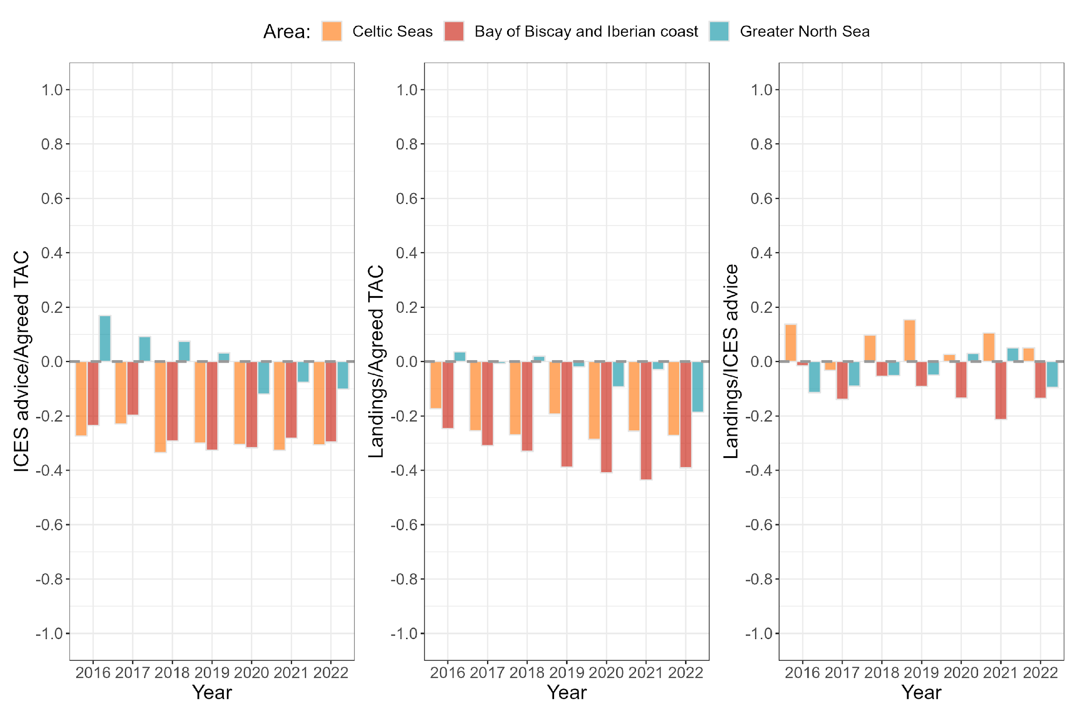

Figure S1. Comparison between ICES advice and TAC (left), landings and TAC (middle), and landings and ICES advice (right) by ecoregion and year. All values are in tonnes and are reported above in Tables S1 and S5. ICES advice are summed by ecoregion, as are landings. ICES advice has been split into ecoregions based on the annual proportion of landings per ecoregion for each stock (see Tables S1 and S3, and MS text for more details). The dashed grey line at zero signifies equivalence as we have used the relative scale and subtracted 1 in all instances. Trends show that ICES advice are comparable to the TAC in all three ecoregions, albeit slightly lower in the Celtic Seas and Bay of Biscay and Iberian coast. Landings are comparable to the TAC in the Greater North Sea and lower than the TAC in the other two ecoregions. Landings are comparable to ICES advice in all three ecoregions.
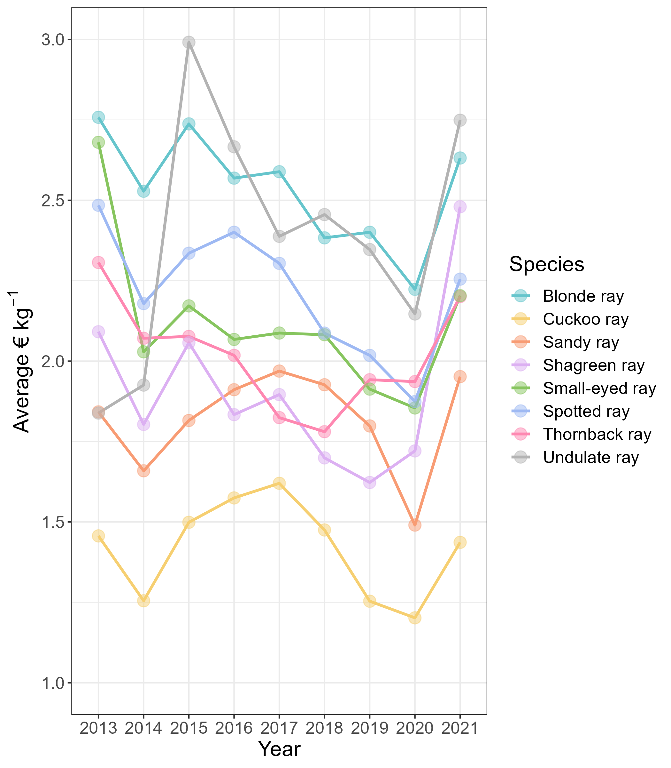

Figure S2. Estimated average landing price (euros per kilogram) per year and species for skates and rays in the Northeast Atlantic. Data on landing prices were sourced from the European Commission’s Fisheries Dependent Information database and are provided by country, year, quarter and métier. Only data from stocks listed in Table S1 and ICES divisions listed in Table S2 were considered.

