Geochemistry, Geophysics, Geosystems
Supporting Information for

Diffuse venting and near seafloor hydrothermal circulations at the Lucky Strike vent field, Mid-Atlantic Ridge.

Benjamin Wheeler¹, Mathilde Cannat¹, Valérie Chavagnac², Fabrice Fontaine^{1 and 3}
¹ Institut de Physique du Globe de Paris - Université Paris Cité (IPGP), UMR 7154 CNRS, 1 rue Jussieu, 75238 Paris cedex 05, France
² Géosciences Environnement Toulouse (GET) UMR 5563 CNRS, Observatoire Midi-Pyrénées
Université de Toulouse, 14 Avenue Édouard Belin, 31400 Toulouse
³ Observatoire Volcanologique du Piton de la Fournaise (OVPF), 14RN3 - km 27, 97418 La Plaine des Cafres, La Réunion

Contents of this file

Figures S1 to S10
Tables S1 to S4

Introduction
This supplementary material consists in 10 supplementary figures and their captions and 4 supplementary tables and their captions. All the references cited here are in the main text of the paper.

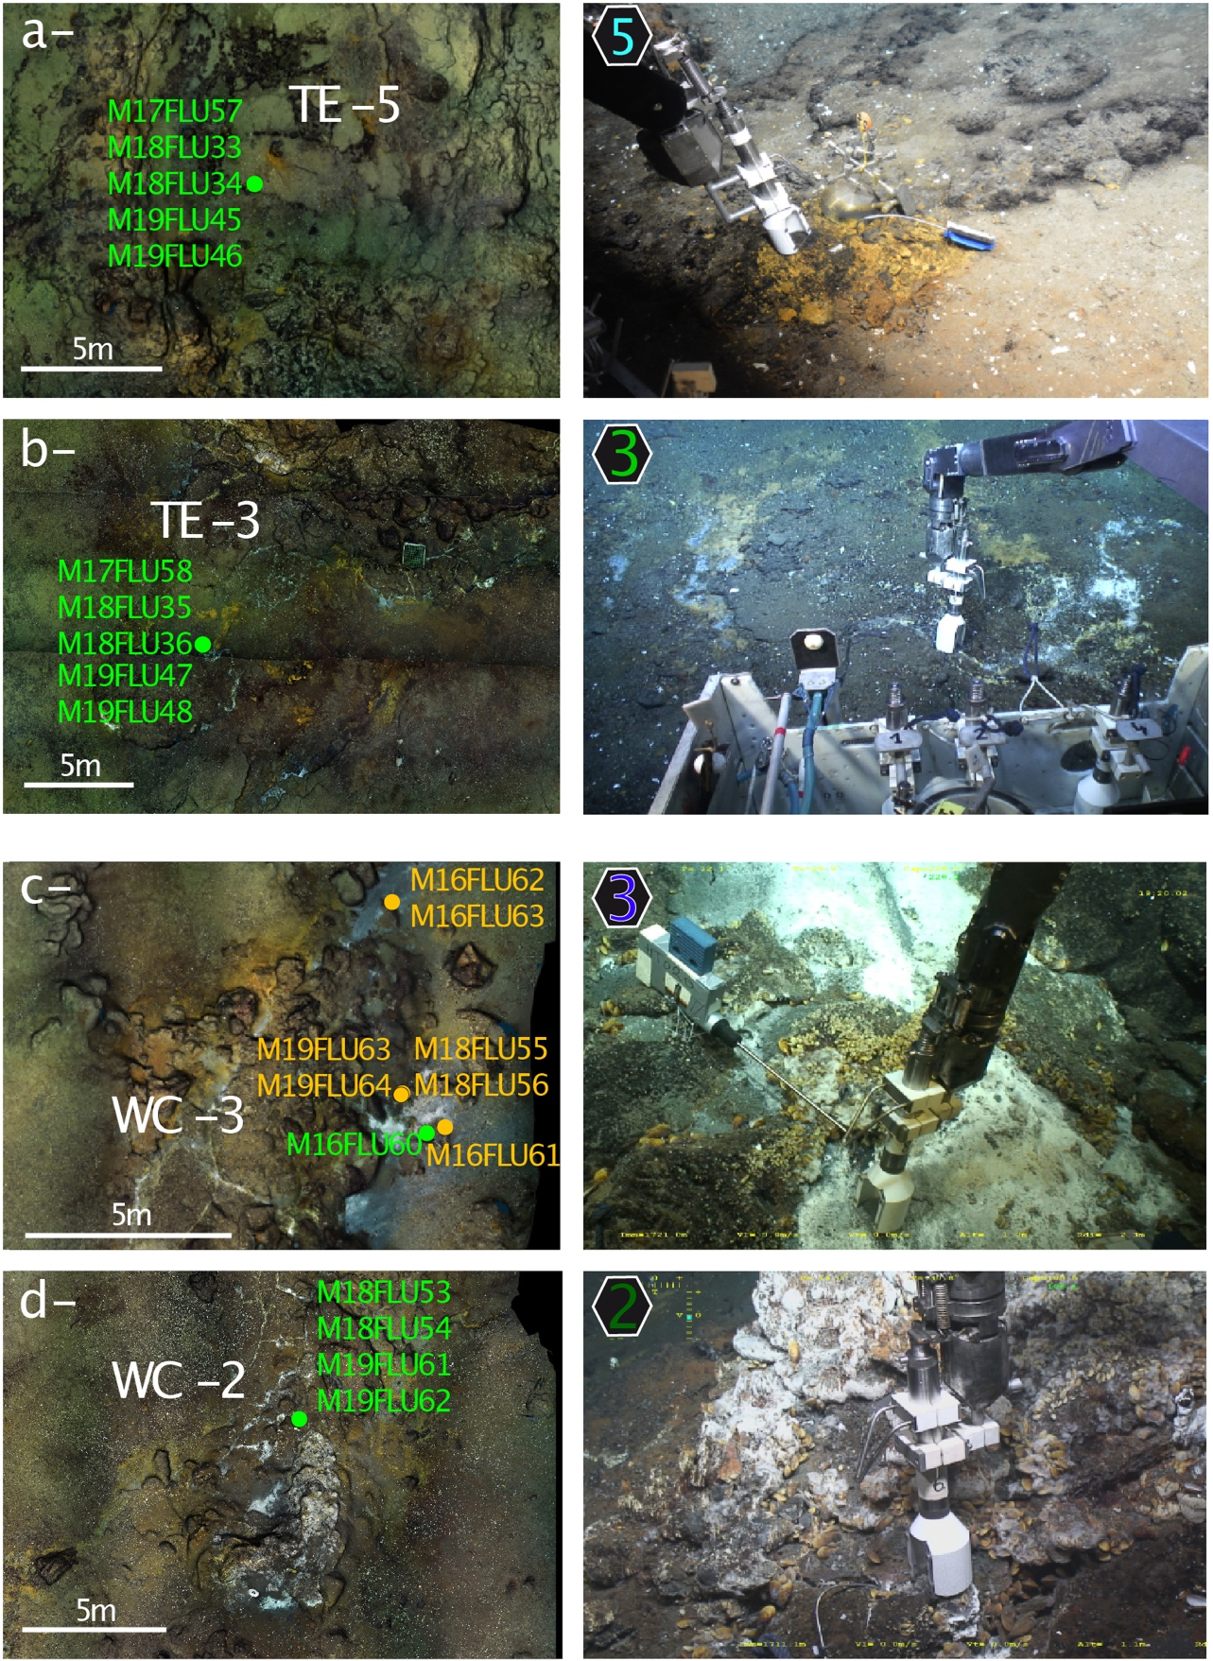
Figure S1. Sampling of diffuse fluids at the 4 temperature monitoring locations shown in the Tour Eiffel (TE) and White Castle (WC) maps of Figure 4. Details of mosaic of OTUS seafloor photographs (left panels) and ROV video snapshots (right panels). Sample numbers (Table 1) are shown in green when sampling was performed within 1 m of an autonomous temperature probe and in yellow if performed >1m away. (a) TE-5 monitoring location (north of Tour Eiffel), bell-shaped fluid sampler collects fluids at vent nested in yellow Fe-oxidizing bacterial mats. Fluid sampling is triggered when shimmering fluids have filled the bell and pushed ambient seawater out. (b) TE-3 monitoring location (south of Tour Eiffel), bell-shaped fluid sampler collects fluids at crack hosting mussels and white bacterial mats. (c) WC-3 monitoring location (north of White Castle), bell-shaped fluid sampler collects fluids over white diffuse venting patch, near the edge of mussel-hosting, slab formation. (d) WC-2 monitoring location (south of White Castle) bell-shaped fluid sampler collects fluids at crack near base of sulfide mound.

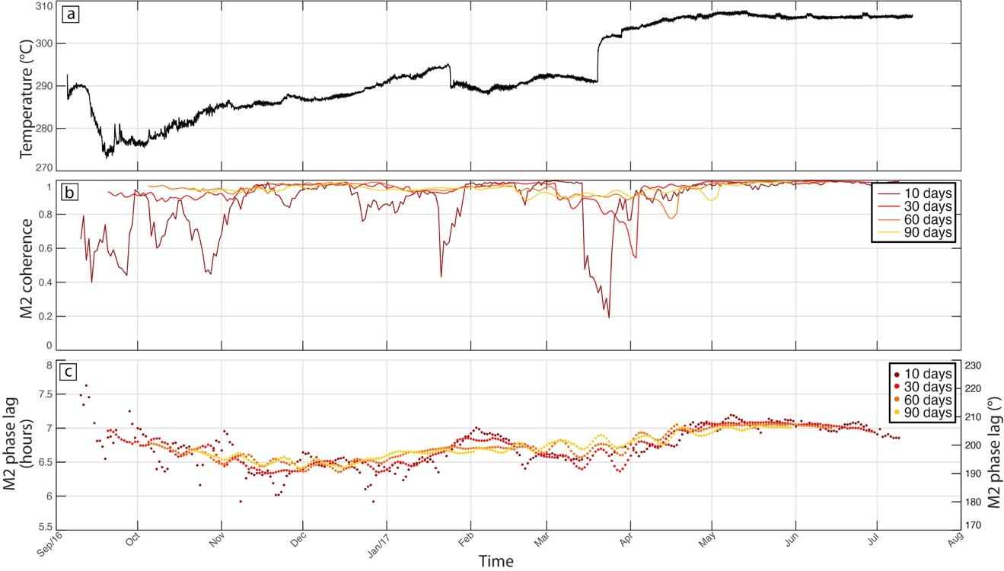
Figure S2. Testing 4 sizes (10, 30, 60 and 90 days; 1 day sliding time) for the sliding window used in calculations of the coherence and phase lag between time series of fluid temperature and seafloor pressure at the M2 tidal frequency. (a) Temperatures recorded over one year at monitoring location WC-2 (White Castle). (b) Time variation of the coherence at the M2 tidal frequency. (c) Time variation of the phase lag between temperature and seafloor pressure at the M2 tidal frequency. The 10 days sliding window appears too sensitive to episodic variations, while the 60 and 90 days sliding windows would prevent detection of fortnightly tidal variations.

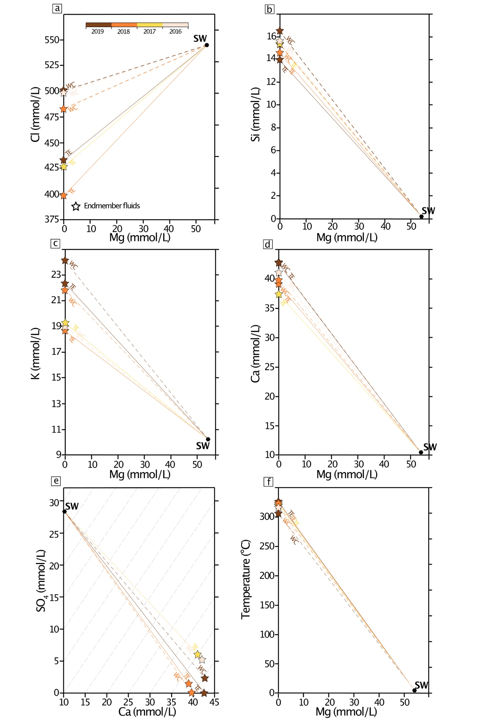

Figure S3. Magnesium, chloride, silicon, potassium, calcium, sulfate and temperature for focused end member fluids sampled at monitoring locations TE-1 and WC-1 in 2016-2019, with linear trends to seawater composition (SW; Millero et al. 2008). (a) Magnesium and chloride contents. (b) Magnesium and silica contents. (c) Magnesium and potassium contents. (d) Magnesium and calcium contents. (e) Calcium and sulfate ion contents. Dashed grey lines trace the concentrations expected for anhydrite dissolution or precipitation. (f) Magnesium and fluid temperature measured by the ROV or manned submersible.

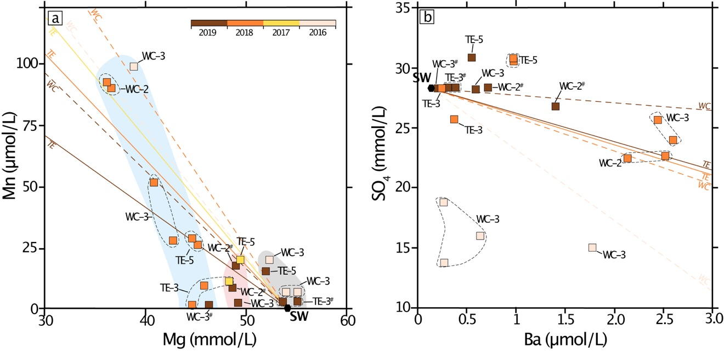

Figure S4. Chemical diversity of diffuse fluids sampled at Tour Eiffel (TE) and White Castle (WC) monitoring locations TE-3, TE-5, WC-2 and WC-3 in 2016, 2017, 2018 and 2019 (Table 1). (a) Magnesium and manganese contents. Except for fluids sampled near the WC-3 monitoring location in 2016, data plot near the end-member fluid to SW lines. 3 groups of samples are identifiable, based on their Mg content and position with respect to the end-member fluid to SW lines (see text; group 1 in grey, group 2 in pink, group 3 in blue). (b) Barium and sulfate ion contents. Fluids sampled at and near the WC-3 monitoring location in 2016 are again outliers. Other samples plot near, or above the end-member fluid to SW lines.

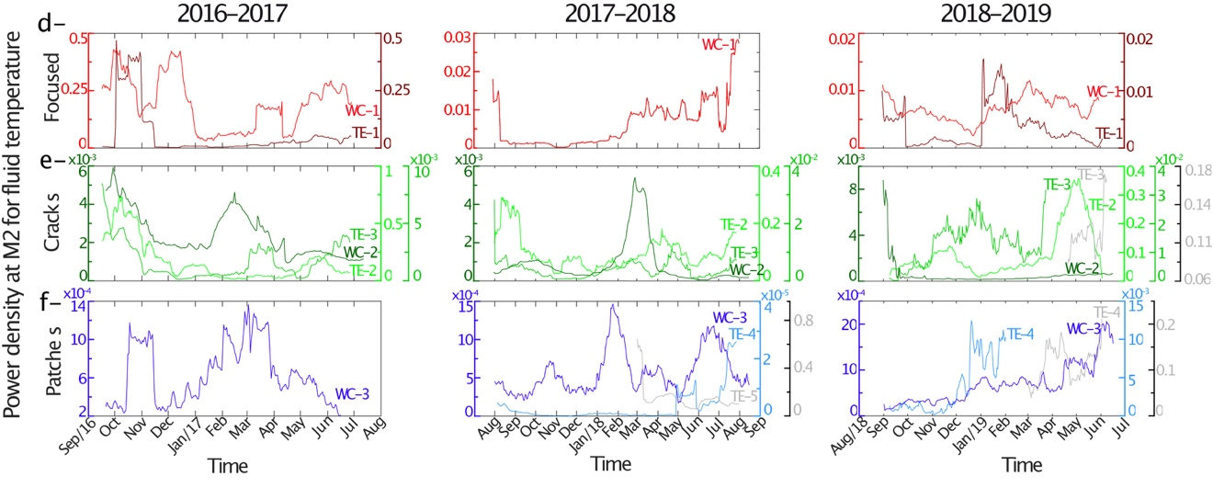
Figure S5. Time variation of the PSD of venting temperatures at the M2 frequency (30 days sliding window, 1 day sliding time) over the 3 years of the experiment at the TE and WC monitoring locations. (a) Focused vents; light red for WC-1. (b) Diffuse venting cracks; darker green for WC-2. (c) Diffuse venting sandy patches; darker blue for WC-3. PSD time variations for probes that had fallen off vent and recorded near seafloor seawater temperatures are shown in grey.

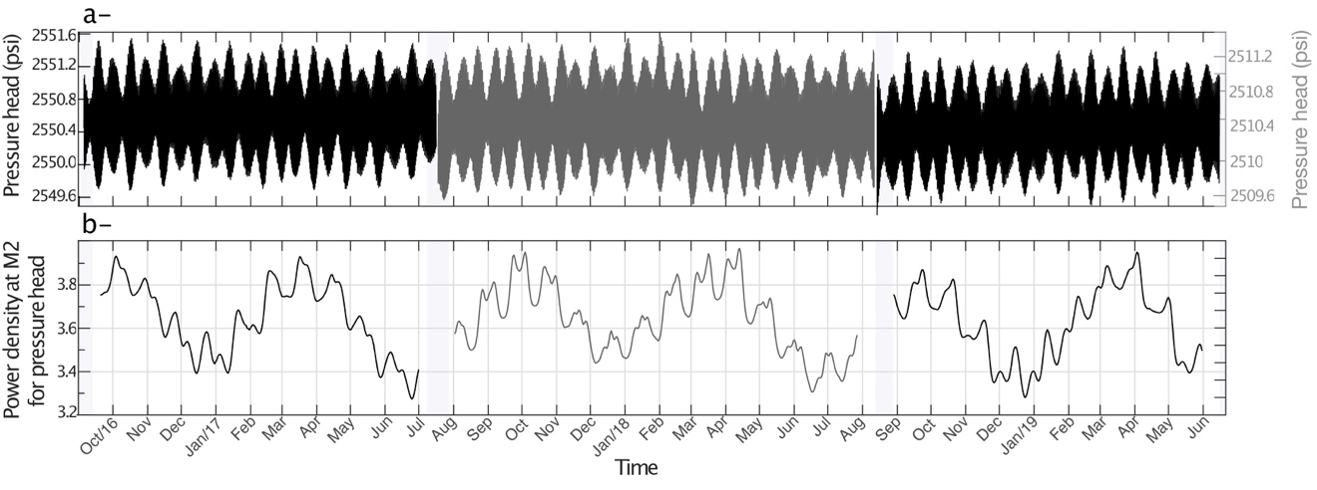Figure S6. Time variation of (a) seafloor pressure and of (b) the power spectrum density (PSD) of seafloor pressure at the M2 frequency over the 3 years of the experiment: probe located at JPPW (Figure 1) in 2016-2017 and 2018-2019 and at Seamon W in 2017-2018 (pressure head scale in grey). PSD values in (b) are calculated for a 30 days sliding window, 1 day sliding time.
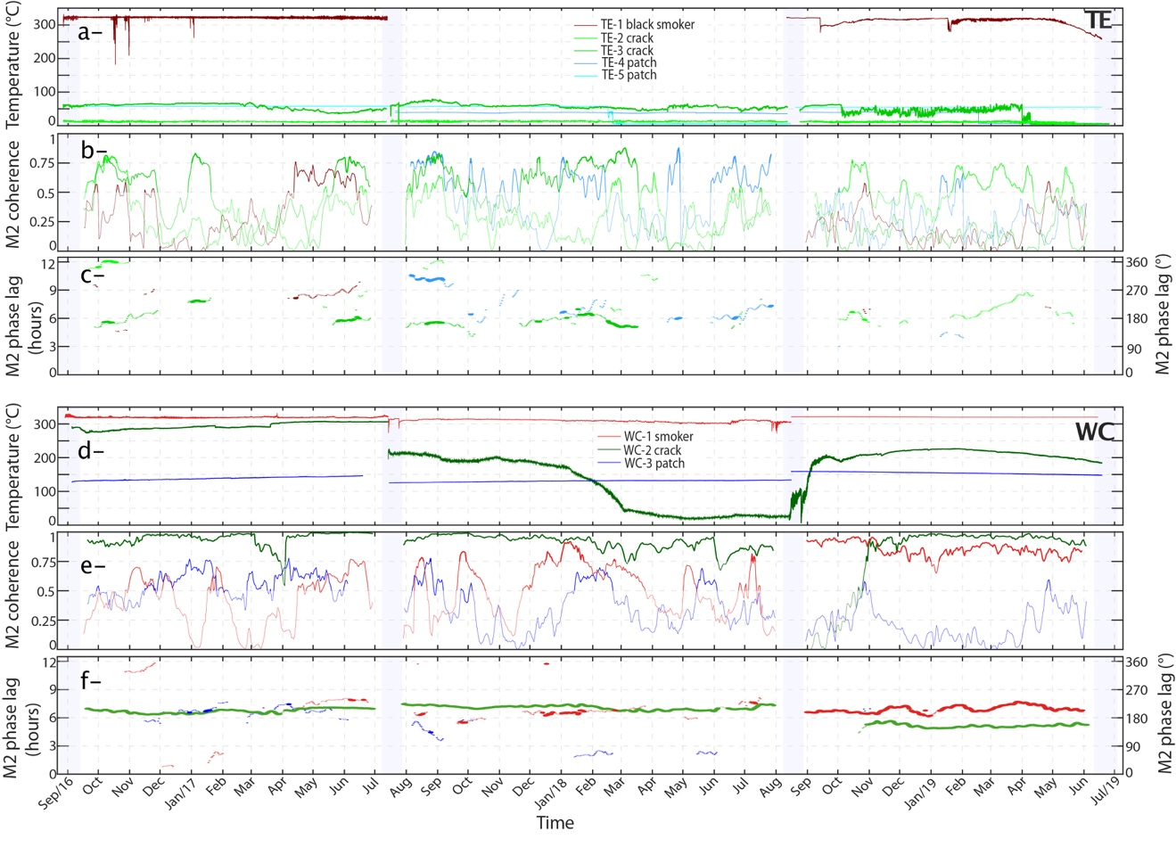

Figure S7. Temperatures recorded at focused and diffuse vents at the Tour Eiffel (TE) and White Castle (WC) sites and time variations of the coherence and phase lag with seafloor pressure at the M2 tidal frequency (30 days sliding window, 1 day sliding time). Light grey intervals correspond to maintenance cruises. This figure compiles data plotted in Figure 7 and uses the same color codes. Its purpose is to facilitate intercomparison of time variations recorded at several monitoring locations of the same hydrothermal site. (a) and (d) Temperature time-series for monitoring locations at TE and WC respectively. (b) and (e) Time variation of the coherence calculated between temperature and seafloor pressure at the M2 tidal frequency at TE and WC respectively. (c) and (f) Time variation of the phase lag calculated between temperature and seafloor pressure at the M2 tidal frequency for M2 coherence >0.75 (thicker lines), or >0.5 (thin lines) at TE and WC respectively.

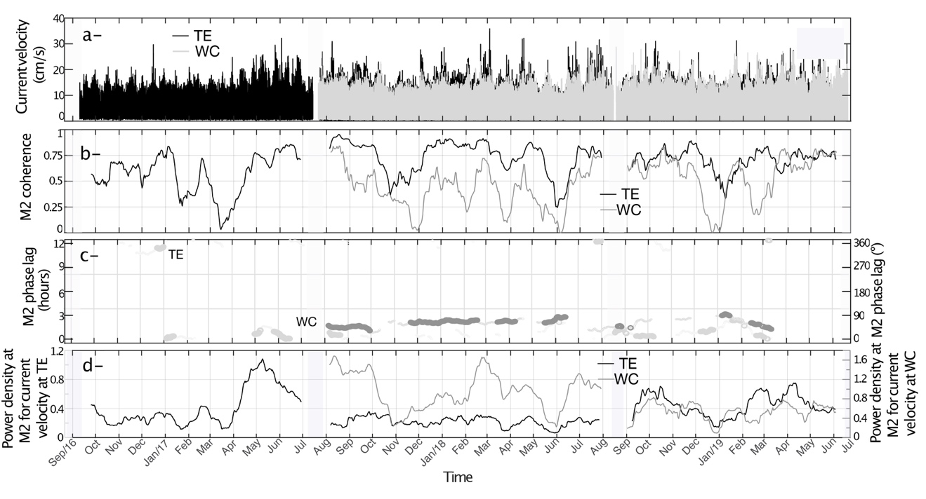Figure S8. Current velocity variations recorded over the 3 years of survey at near seafloor depths (1m) near the Tour Eiffel (TE) and White Castle (WC) sites (location in Figure 1) and time variations (30 days sliding window, 1 day sliding time) of the coherence and phase lag with seafloor pressure at the M2 tidal frequency. Light grey intervals correspond to maintenance cruises. (a) Current velocity time-series. (b) Time variation of the coherence calculated between current velocity and seafloor pressure at the M2 tidal frequency. (c) Time variation of the phase lag calculated between current velocity and seafloor pressure at the M2 tidal frequency for M2 coherence > 0.75 (thicker lines) or > 0.5 (thin lines). (d) Time variation of the PSD for current velocity at the M2 tidal frequency.

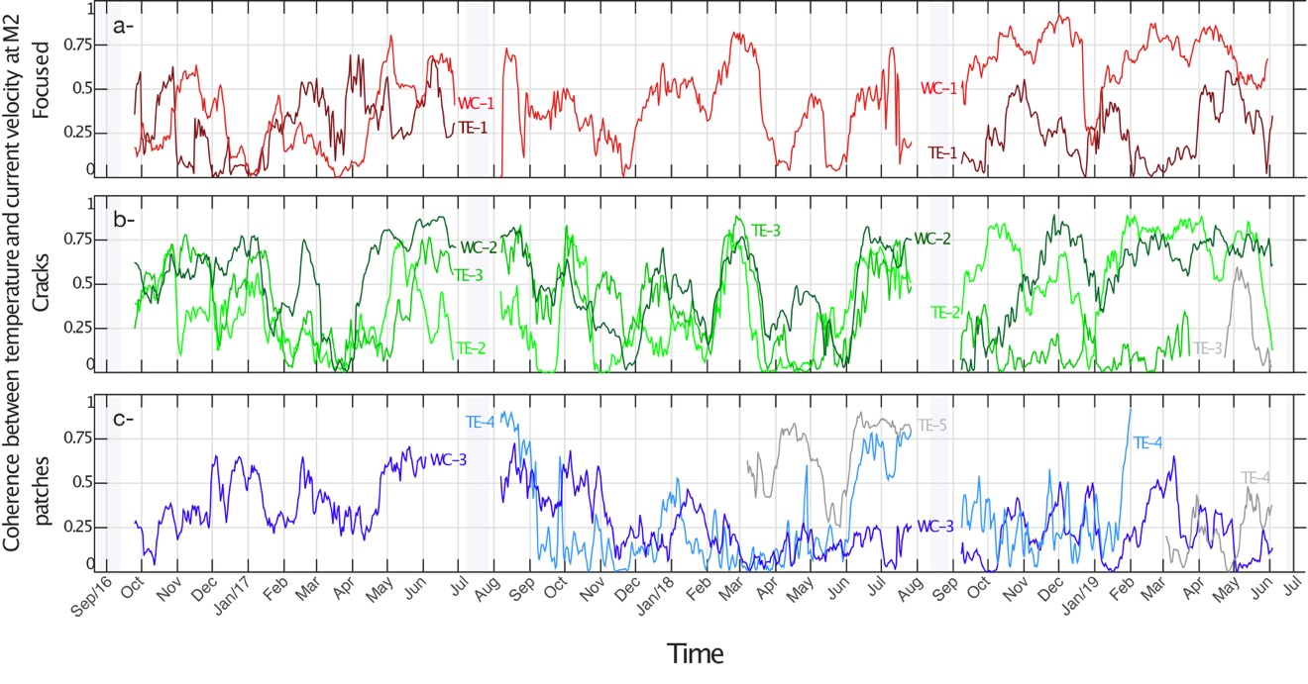Figure S9. Time variation of the coherence calculated between vent temperatures and current velocity at the M2 tidal frequency (30 days sliding window, 1 day sliding time) at Tour Eiffel (TE) and White Castle (WC) monitoring locations. Light grey intervals correspond to maintenance cruises. (a) focused vents TE-1 (dark red) and WC-1 (red). (b) venting cracks TE-2 (pale green), TE-3 (bright green) and WC-2 (dark green); (c) venting patches TE-4 (pale blue), TE-5 (electric blue) and WC-3 (dark blue).

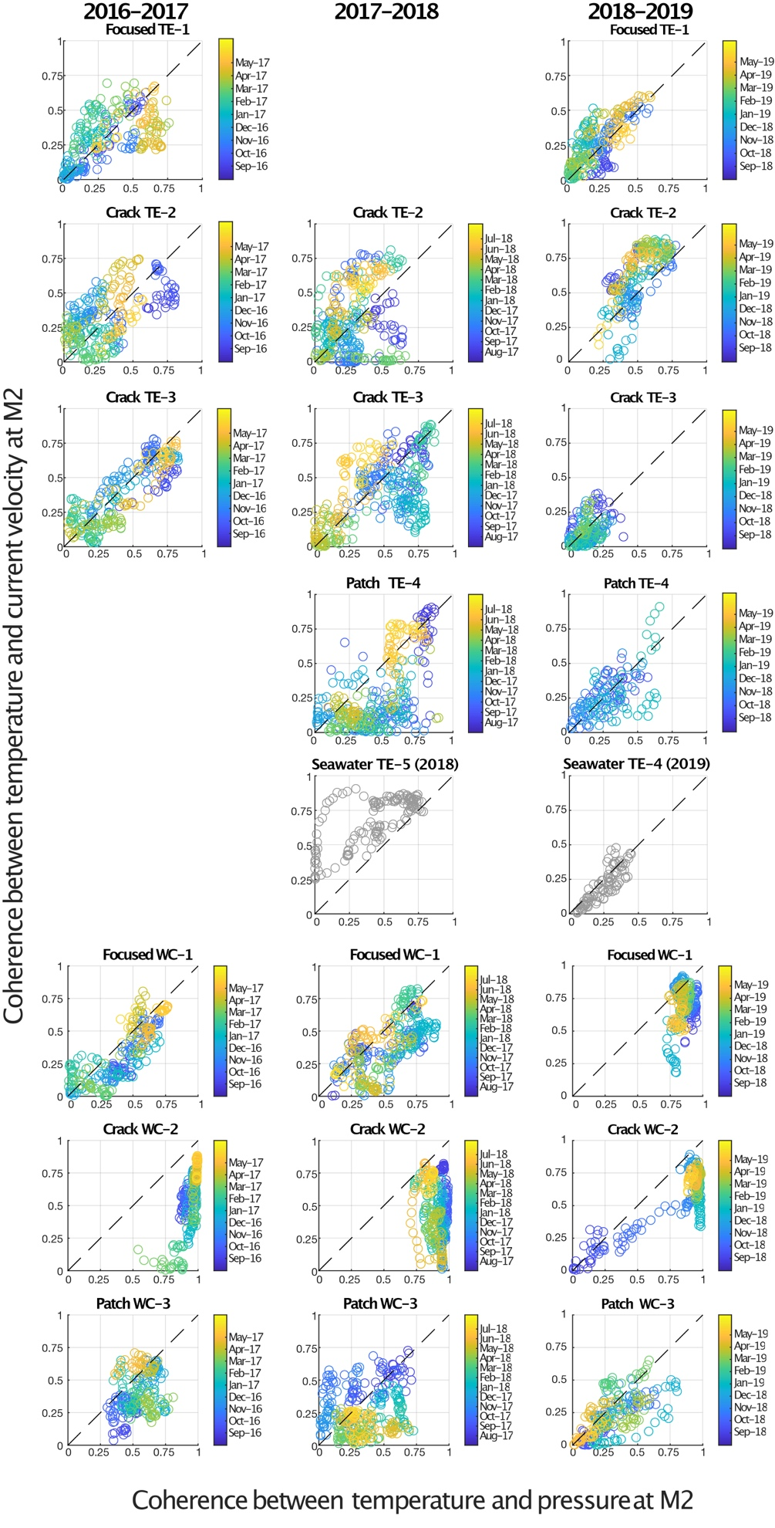

Figure S10. Plots showing coherence values at the M2 frequency between venting temperatures at the Tour Eiffel (TE) and White Castle (WC) monitoring locations and current velocity as a function of coherence values at the M2 frequency between the same venting temperatures and seafloor pressure. Each dot represents 1 day (dates indicated by color scale). Panels with grey dots correspond to seabed (seawater) temperature data recorded when probe had fallen off the monitored vent.

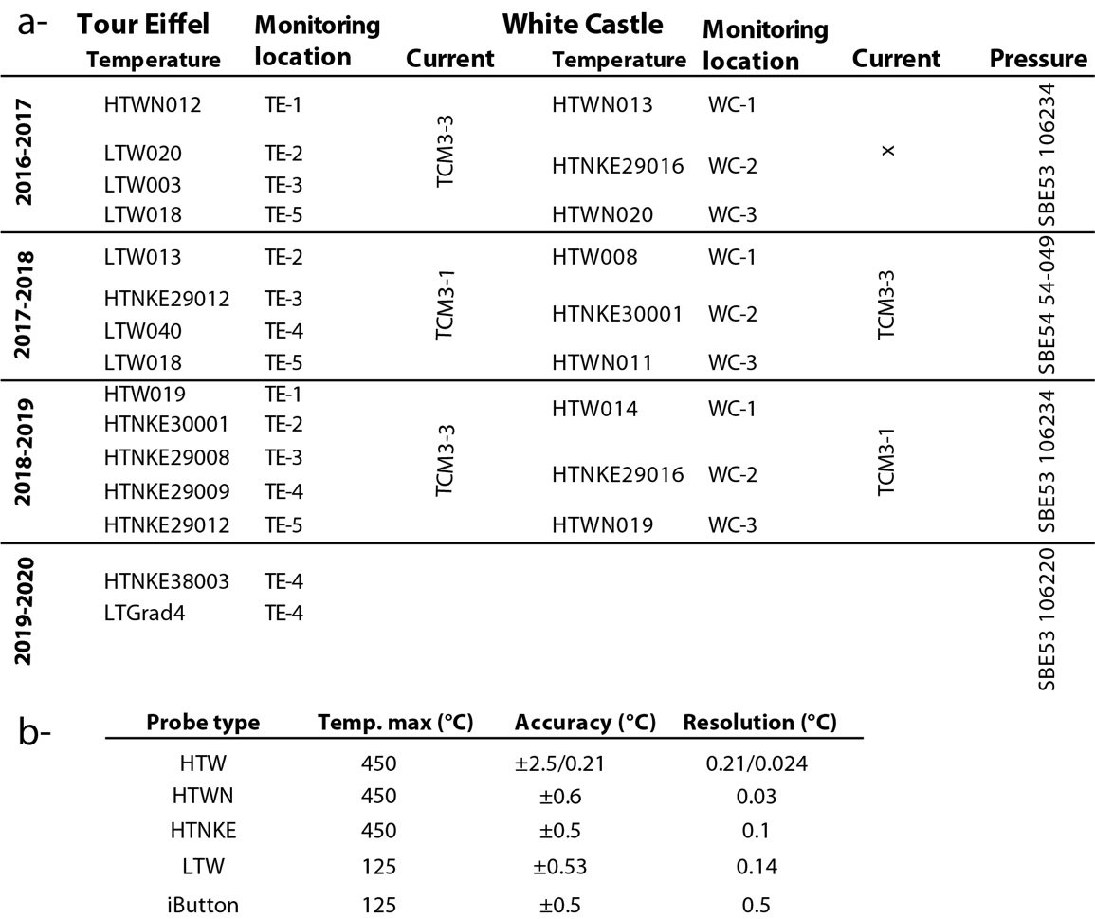

Table S1. a- Name of the instruments (temperature probes, current meters and pressure probes) for each deployment year and monitoring location. b- Instrumental characteristics of the 5 types of temperature probes used in this study. Full metadata (and data) accessible via the EMSO-Azores data portal (https://www.emso-fr.org/EMSO-Azores/Data-download) and referenced in text.

 | fluid T °C | fluid velocity mm/s | min max heat flux W/m²
mound+flanges+white patches ⁽¹⁾ | 8 to 20 | 1 to 5 | 0.017 | 0.329
cracks ⁽¹⁾ | 17.5 to 33 | 20 | 1.113 | 2.384
mound+flanges+white patches ⁽²⁾ | nd | nd | 0.078
grey patch WC-3 | 140 | 1 to 5 | 0.535 | 2.674
crack/patch TE-3 | 80 | 1 to 5 | 0.308 | 1.539
white patches ⁽³⁾ | 50 | 1 to 5 | 0.188 | 0.941
cracks beneath slab ⁽⁴⁾ | 140 | 5 to 10 | 2.674 | 5.348

Table S2. Ranges of fluid temperature, venting velocity and corresponding heat flux per M², used in the Qmin/Qmax diffuse heat flux estimate of Supplementary Table 3. (1) range of fluid temperature and venting velocity in Barreyre et al. (2012), from Cooper et al. (2006) and Mittelstaedt et al. (2012); (2) average heat flux per m² value proposed for white patches, flanges and mound in Mittelstaedt et al. (2012), based on fluid temperatures and venting velocities in Sarrazin et al. (2009). For WC-3 and TE-3, temperatures used are the maximum recorded values over the 3 years of monitoring; venting velocities are based on monitoring of TE patches by Sarrazin et al. (2009). For white patches (3), we use the average temperature measured at TE-3 and the same slow venting velocities. For the "cracks beneath the slab" category (4), the temperature and range of velocities proposed are for end-member rich fluids that could vent out of the basalt substratum beneath slab domains, based on monitoring values at the TEMPO location (Laes-Huon et al., 2019). All heat flux values are calculated for temperature dependant fluid density and thermal capacity, using Bischoff and Rosenbauer (1985) seawater equation of state at 200 bar.

Site | Slab and mound (m²) | mound (m²) | flanges (m²) | white patches (m²) | grey patches (m²) | cracks (m) | cracks (m²)
TE | 540 | 168 | 22 | 16 | 2 | 74 | 3
WC | 141 | 8 | 0 | 14 | 6 | 26 | 1

Table S3. Ranges of estimated diffuse hydrothermal heat flux for the Tour Eiffel and White Castle sites, based on values in Supplementary Tables 2 and 3. Qmin/Qmax (slab) is calculated for the mound and slab domain, based on a simplified setting in which cracks in the underlying basalts, vent 140°C end-member rich fluids at 5 to 10 mm/s (see Supplementary Table 2 for corresponding heat flux per m²) and represent 1/100 of the slab surface (Supplementary Table 3). Qmin/Qmax (off slab) is the range calculated for patches and cracks outside the slab domain, using 1.1 MW/m² (Mittelstaedt et al., 2012) for cracks (this corresponds to the minimum value used in Barreyre et al., 2012; Supplementary Table 2) and the following range of values for patches: 0.188 to 0.941 W/m² for white patches; and 0.308 to 1.539 W/m² for grey patches (Supplementary Table 2). (1) Mittelstaedt et al. (2012) total diffuse and focused heat flux estimates for Tour Eiffel.

Site | Diffuse  Qmin/Qmax (slab) (W) | Diffuse Qmin/Qmax (off slab) (W) | Diffuse Qmin/Qmax (total) (W) | Diffuse  Q (total) (W)  (1) | Focused  Q (total) (W)  (1)
TE | 14.44/28.88 | 6.92/25.19 | 21.36/54.07 | 18.75±2.2 | 1.07±0.66
WC | 3.77/7.54 | 4.48/22.41 | 8.25/29.95 | nd | nd

Table S4. Ranges of estimated diffuse hydrothermal heat flux for the Tour Eiffel and White Castle sites, based on values in Supplementary Tables 2 and 3. Qmin/Qmax (slab) is calculated for the mound and slab domain, based on a simplified setting in which cracks in the underlying basalts, vent 140°C end-member rich fluids at 5 to 10 mm/s (see Supplementary Table 2 for corresponding heat flux per m²) and represent 1/100 of the slab surface (Supplementary Table 3). Qmin/Qmax (off slab) is the range calculated for patches and cracks outside the slab domain, using 1.1 MW/m² (Mittelstaedt et al., 2012) for cracks (this corresponds to the minimum value used in Barreyre et al., 2012; Supplementary Table 2), and the following range of values for patches: 0.188 to 0.941 W/m² for white patches; and 0.308 to 1.539 W/m² for grey patches (Supplementary Table 2). (1) Mittelstaedt et al. (2012) total diffuse and focused heat flux estimates for Tour Eiffel.

