Warm-adapted sponges resist thermal stress by re-allocating carbon and nitrogen resources from cell turnover to somatic growth
Maggioni Federica^{1,2}, Raimbault Patrick³, Chateau Olivier⁴, Pujo-Pay Mireille⁵, Letourneur Yves¹, Rodolfo-Metalpa Riccardo^{1,2}

¹ ENTROPIE, IRD, Université de la Réunion, CNRS, IFREMER, Université de Nouvelle-Calédonie, Nouméa 98800, New Caledonia
² Labex ICONA International CO₂ Natural Analogues Network, JSPS, Japan
³ Aix-Marseille University, Mediterranean Institute of Oceanography (MIO), CNRS/INSU, IRD, Marseille, France
⁴ Laboratory of Marine Biology and Ecology, Aquarium des Lagons, Nouméa, New Caledonia
⁵ Sorbonne Université, CNRS, Laboratoire d’Océanographie Microbienne (LOMIC), UMR 7621, 66650 Banyuls sur Mer, France
Corresponding author: fedemaggio94@gmail.com

SUPPLEMENTARY METHOD
Bacteria and phytoplankton ingestion rates were also calculated according to the equations of Ribes et al. (1998) and Houlbrèque et al. (2004), which consider the growth of the prey during the incubations.
The growth rate of the prey (k, h^{–1}) was calculated as:
k = ln(C_{t}/C₀)/T_{t} – T₀
where C₀ and C_{t} are the prey concentrations in the chambers (cell mL^{–1}) at the initial time T₀ and at the final time T_{t}, respectively. g is the grazing coefficient (h^{–1}) calculated as:
g = k_{c} – k_{g}
where k_{c} is the prey growth rate in the control chamber (h^{–1}) and k_{g} is the growth in the sponge chambers (h^{–1}). The ingestion rate I (prey ingested ind.^{–1} h^{–1}) is:
I = FC
where F (cell h^{–1}) is the filtration rate calculated as follows:
F = V × g/N
where V is volume of seawater in the chamber (mL), g the grazing coefficient (h^{–1}) and N the total concentration of prey in the chamber (cells mL^{–1}). C is the average prey concentration (cells mL^{–1}) during the experiment calculated as follows:
C = C₀[e^{(k – g)(Tt – T0)} – 1]/(k – g) (T_{t} – T₀)

SUPPLEMENTARY TABLES

Table S1. Main carbon and nitrogen components measured during incubations, at 28°C and 32°C, and for both sponges from Bouraké (B) and Control (C). a) Consumption (negative) and/or production (positive) of dissolved organic carbon (DOC), particulate organic carbon (POC), particulate organic nitrogen (PON), bacteria, phytoplankton and detritus; b) Sponge cells ingestion rates of bacteria and main phytoplankton groups normalized by g of sponge; c) Carbon and nitrogen sources in the seawater medium at the beginning of incubations. The relative % of available carbon was calculated on DOC, POC, bacteria and phytoplankton; d) Bacteria and phytoplankton concentration at the beginning of incubations. Data are expressed as mean ± SD.
Temperature 28°C 32°C
Origin C B C B
a) Consumption and production during incubations (µmol C or N g⁻¹ h⁻¹)
DOC -1.13 ± 1.67 -1.00 ± 1.97 0.08 ± 2.14 -0.12 ± 1.32
POC 0.07 ± 1.20 0.72 ± 1.42 0.26 ± 1.67 -0.34 ± 0.57
Bacteria -0.10 ± 0.05 -0.09 ± 0.06 -0.12 ± 0.06 -0.09 ± 0.04
Phytoplankton -0.11 ± 0.06 -0.09 ± 0.07 -0.13 ± 0.06 -0.09 ± 0.04
PON 0.01 ± 0.28 0.15 ± 0.36 0.11 ± 0.34 -0.05 ± 0.14
Detritus 0.01 ± 0.51 0.66 ± 1.05 0.55 ± 1.72 -0.33 ± 0.69
b) Cell ingestion rate during incubations (x10^{x} cells g⁻¹ h⁻¹)
Total bacteria (x10⁶) 25.2 ± 10.8 23.8 ± 7.97 38.0 ± 18.1 27.9 ± 9.15
Syn (x10⁶) 1.30 ± 0.61 1.17 ± 0.70 1.57 ± 0.71 1.19 ± 0.57
Pro (x10⁴) 4.30 ± 1.99 1.47 ± 6.70 4.16 ± 1.68 3.30 ± 1.28
Peuk (x10⁴) 6.20 ± 3.31 4.03 ± 5.45 7.53 ± 2.88 5.94 ± 1.92
Nan (x10⁴) 1.61 ± 1.26 0.67 ± 2.17 1.39 ± 0.90 1.20 ± 1.00
Temperature 28°C 32°C
c) Carbon and nitrogen at the beginning of incubations (µmol C or N L⁻¹) (C %)
DOC 85.39 ± 7.73 (89.6%) 86.97 ± 6.34 (86.7%)
POC 8.69 ± 0.80 (9.2%) 11.21 ± 1.18 (11.9%)
Total bacteria 0.52 ± 0.14 (0.5%) 0.66 ± 0.11 (0.1%)
Phytoplankton 0.66 ± 0.27 (0.7%) 0.78 ± 0.29 (0.8%)
PON 1.65 ± 0.19 2.43 ± 0.47
d) Bacteria and phytoplankton concentrations at the beginning of incubations (x10^{x} cells L⁻¹)
Total bacteria (x10⁸) 3.12 ± 0.81 3.98 ± 0.69
Syn (x10⁷) 1.60 ± 0.67 1.81 ± 0.70
Proc (x10⁵) 5.82 ± 1.94 5.16 ± 1.58
Peuk (x10⁵) 8.17 ± 1.23 8.81 ± 1.58
Nano (x10⁵) 2.46 ± 1.08 3.18 ± 1.49
Table S2. Summary of two-way ANOVAs between temperature conditions (two levels, 28°C and 32°C), origin (two levels, control and Bouraké), and their interaction on ¹³C and ¹⁵N total flux in the tissues (µmol C or N d⁻¹) and detritus (µmol C or N h⁻¹). When the interaction was significant, a Tukey HSD test was applied. B. is Bouraké and C the control at 32°C and 28°C.
Temp Origin Temp x Origin
F-value (p) F-value (p) F-value (p) HSD Post hoc (p)
Day 4
¹³C_{tissue} 0.759 (0.396) 5.910 (<0.05) 11.277 (<0.01) C.28°C > B.28°C (<0.01); C.28°C > C.32°C (<0.001)
¹⁵N_{tissue} 0.325 (0.575) 4.067 (0.0581) 31.416 (<0.001) B.32°C > B.28°C (<0.001); B.32°C > C.32°C (<0.05);
C.32°C < C.28°C (<0.05)
¹³C_{detritus} 24.436 (<0.001) 7.662 (<0.05) 2.446 (0.1343)
¹⁵N_{detritus} 4.972 (<0.05) 0.133 (0.720) 2.477 (0.132)
Day 8
¹³C_{tissue} 8.809 (<0.05) 4.850 (<0.05) 20.186 (<0.001) B.32°C > B.28°C (<0.001); B.32°C > C.28°C (<0.05);
B.32°C > C.32°C (<0.05)
¹⁵N_{tissue} 14.36 (<0.01) 25.27 (<0.001) 24.37 (<0.001) B.32°C > B.28°C (<0.001); B.32°C > C.28°C (<0.05)
B.32°C > C.32°C (<0.001)
¹³C_{detritus} 13.915 (<0.01) 1.758 (0.202) 0.003 (0.956)
¹⁵N_{detritus} 8.071 (<0.05) 0.009 (0.924) 0.007 (0.934)

Table S3. Summary of main elemental fluxes concentrations measured in the blanks (chamber without sponges) at the beginning (T₀), at the end (T_{F}) of the incubations, and their differences (Δ=T_{F}-T₀). Only the main elemental fluxes of dissolved organic carbon (DOC), particulate organic carbon (POC), bacteria (BA), and phytoplankton (Phyto) for both temperature treatments (28°C and 32°C) were reported. Data of DOC and POC were expressed in µM while bacteria and phytoplankton in cell mL⁻¹.
Temp DOC_{T0} DOC_{TF} ΔDOC POC_{T0} POC_{TF} ΔPOC BA_{T0} BA_{TF} ΔBA Phyto_{T0} Phyto_{TF} ΔPhyto
28°C 77.2 69.0 -8.2 9.2 15.4 6.2 2.1 x 10⁵ 3.4 x 10⁵ 1.3 x 10⁵ 1.7 x 10⁴ 1.1 x 10⁴ -5.6 x 10³
28°C 95.5 77.7 -17.8 9.5 15.2 5.7 3.3 x 10⁵ 3.6 x 10⁵ 3.1 x 10⁴ 9.9 x 10³ 2.0 x 10⁴ 1.0 x 10⁴
28°C 86.4 70.3 -16.1 7.8 12.2 4.4 4.0 x 10⁵ 4.7 x 10⁵ 6.3 x 10⁴ 2.7 x 10⁴ 2.7 x 10⁴ -1.7 x 10²
28°C 82.5 78.2 -4.3 8.2 11.8 3.6 3.1 x 10⁵ 3.5 x 10⁵ 3.7 x 10⁴ 1.7 x 10⁴ 1.8 x 10⁴ 9.1 x 10²
32°C 86.1 68.0 -18.0 12.0 17.0 5.0 3.2 x 10⁵ 7.6 x 10⁵ 4.4 x 10⁵ 1.3 x 10⁴ 9.7 x 10³ -3.2 x 10³
32°C 95.9 76.3 -19.6 12.0 21.3 9.3 4.6 x 10⁵ 5.5 x 10⁵ 9.5 x 10⁴ 2.1 x 10⁴ 1.7 x 10⁴ -4.2 x 10³
32°C 85.0 69.9 -15.1 11.4 16.6 5.1 4.6 x 10⁵ 5.0 x 10⁵ 4.7 x 10⁴ 3.0 x 10⁴ 2.9 x 10⁴ -1.8 x 10²
32°C 81.0 81.2 0.2 11.9 18.7 6.8 3.6 x 10⁵ 4.4 x 10⁵ 8.6 x 10⁴ 1.6 x 10⁴ 1.9 x 10⁴ 3.6 x 10³

SUPPLEMENTARY FIGURES

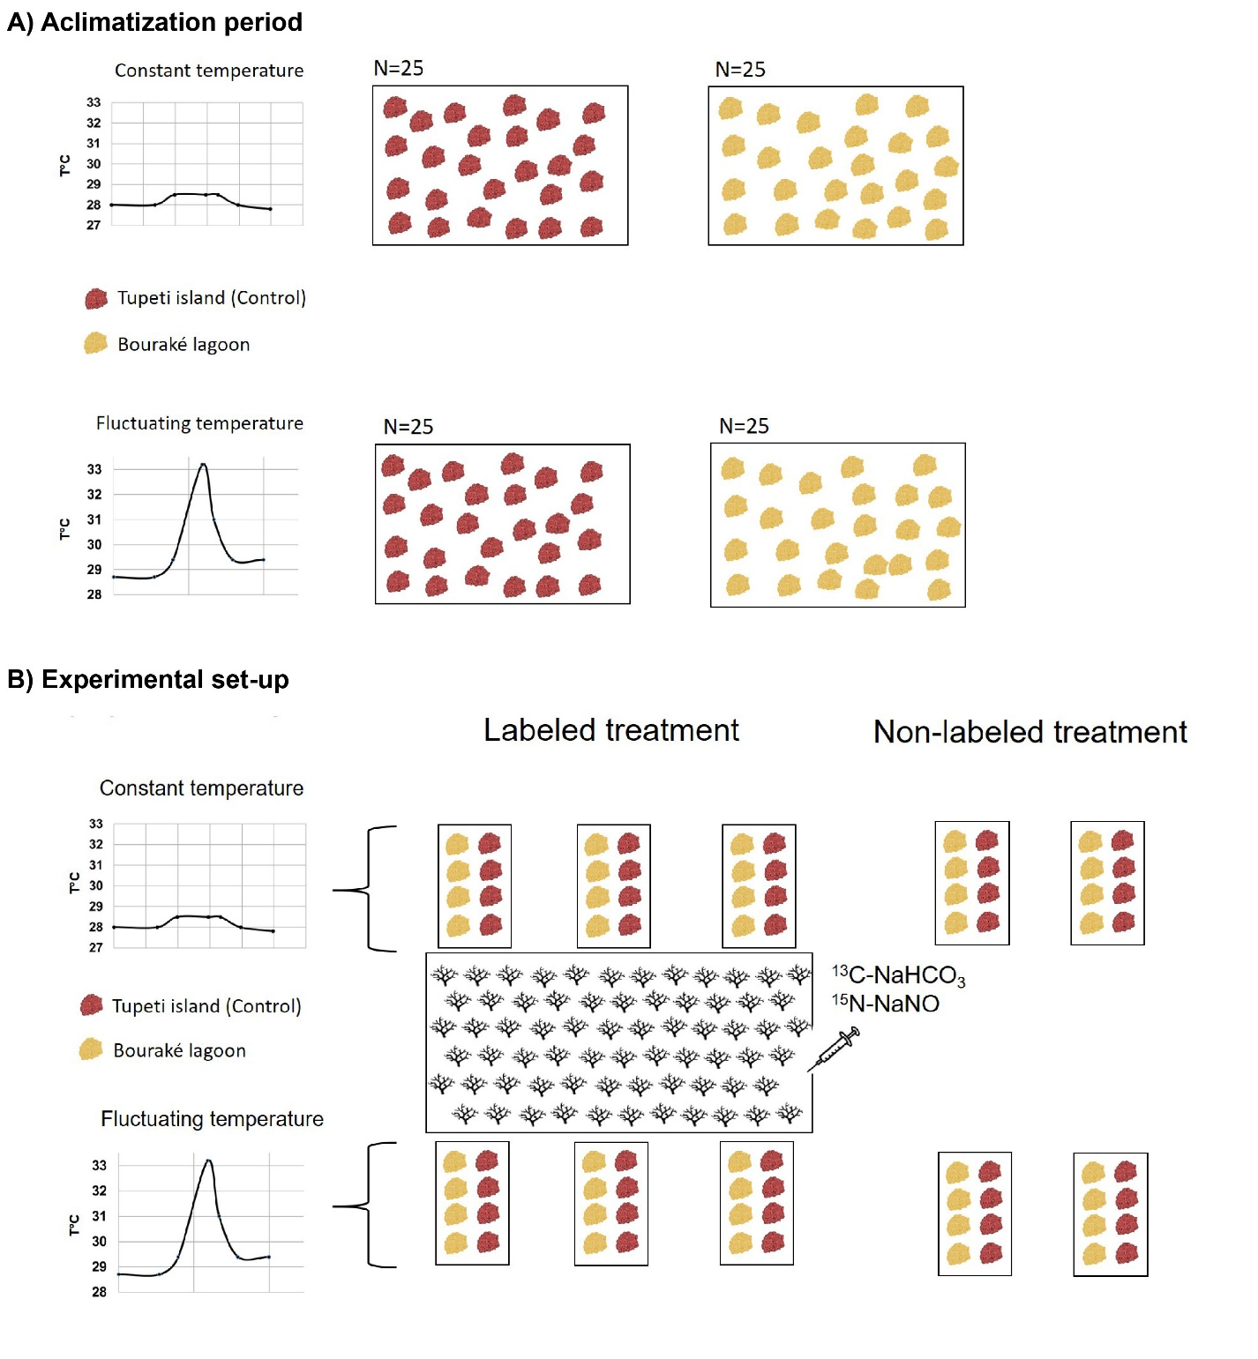
Figure S1. Schematic representation of the acclimatization period (A) and the experimental set-up (B). A) A total of 4 tanks (48 L) were used for sponge acclimatization period. Two tanks were maintained at constant temperature while the other two at fluctuating temperature. Each tanks contained 25 sponge samples divided by site origin. B) ¹³C and ¹⁵N were added during 5 days in the coral tank (120 L), and 6 flow through were open at the end of the labelling period. Flow through allowed the labeled DOM coral mucus to flow to the 6 experimental tanks (20 L) where 8 sponges (4 per site of origin) were maintained. Four more tanks contained an equal number of sponges but they were alimented by separates seawater flow throughs and non-labeled. For both labeled and non-labeled treatments half tanks were maintained at constant temperature, while the remaining at fluctuating temperature. Graphs reports the daily (24h) temperature variations set up and controlled by the Neptune Apex loggers for both the constant and fluctuating temperature treatments.

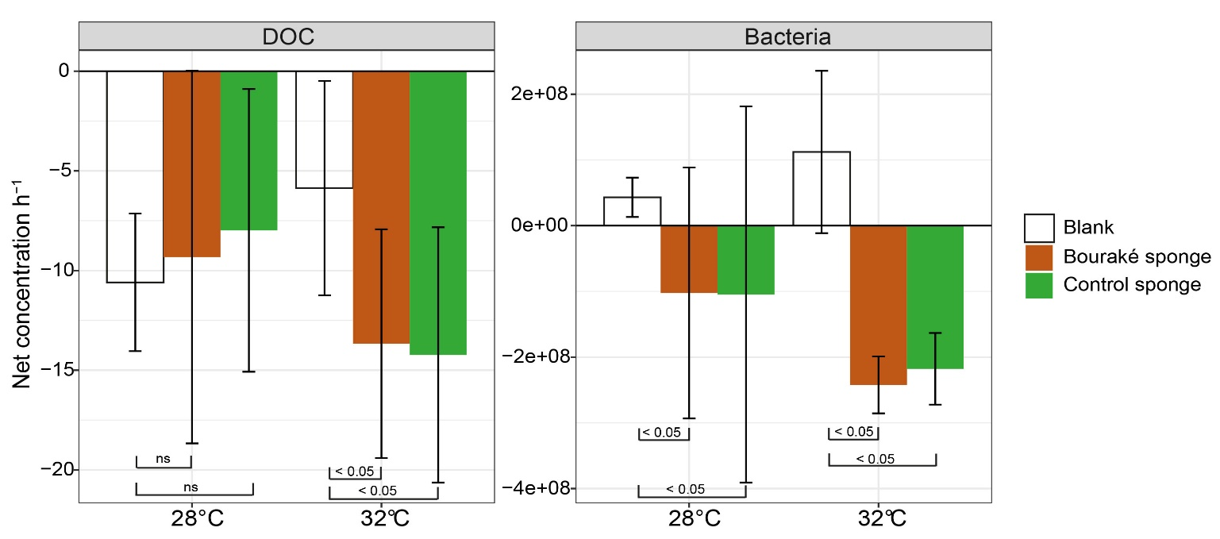
Figure S2. Net concentrations of dissolved organic carbon (DOC), and bacteria measured during incubation at 28°C and 32°C in the blank chambers (chambers without sponge) and in the Bouraké and control sponges (chambers with sponges). Bars are the average ± standard deviation of the net concentration resulted by the differences between the end and the beginning of incubation (Δ=T_{F}-T₀). Data from DOC were expressed as µmol h⁻¹, while for bacteria in cell h⁻¹. Significant levels from the Wilcoxon test and not significant differences (ns) were also shown.
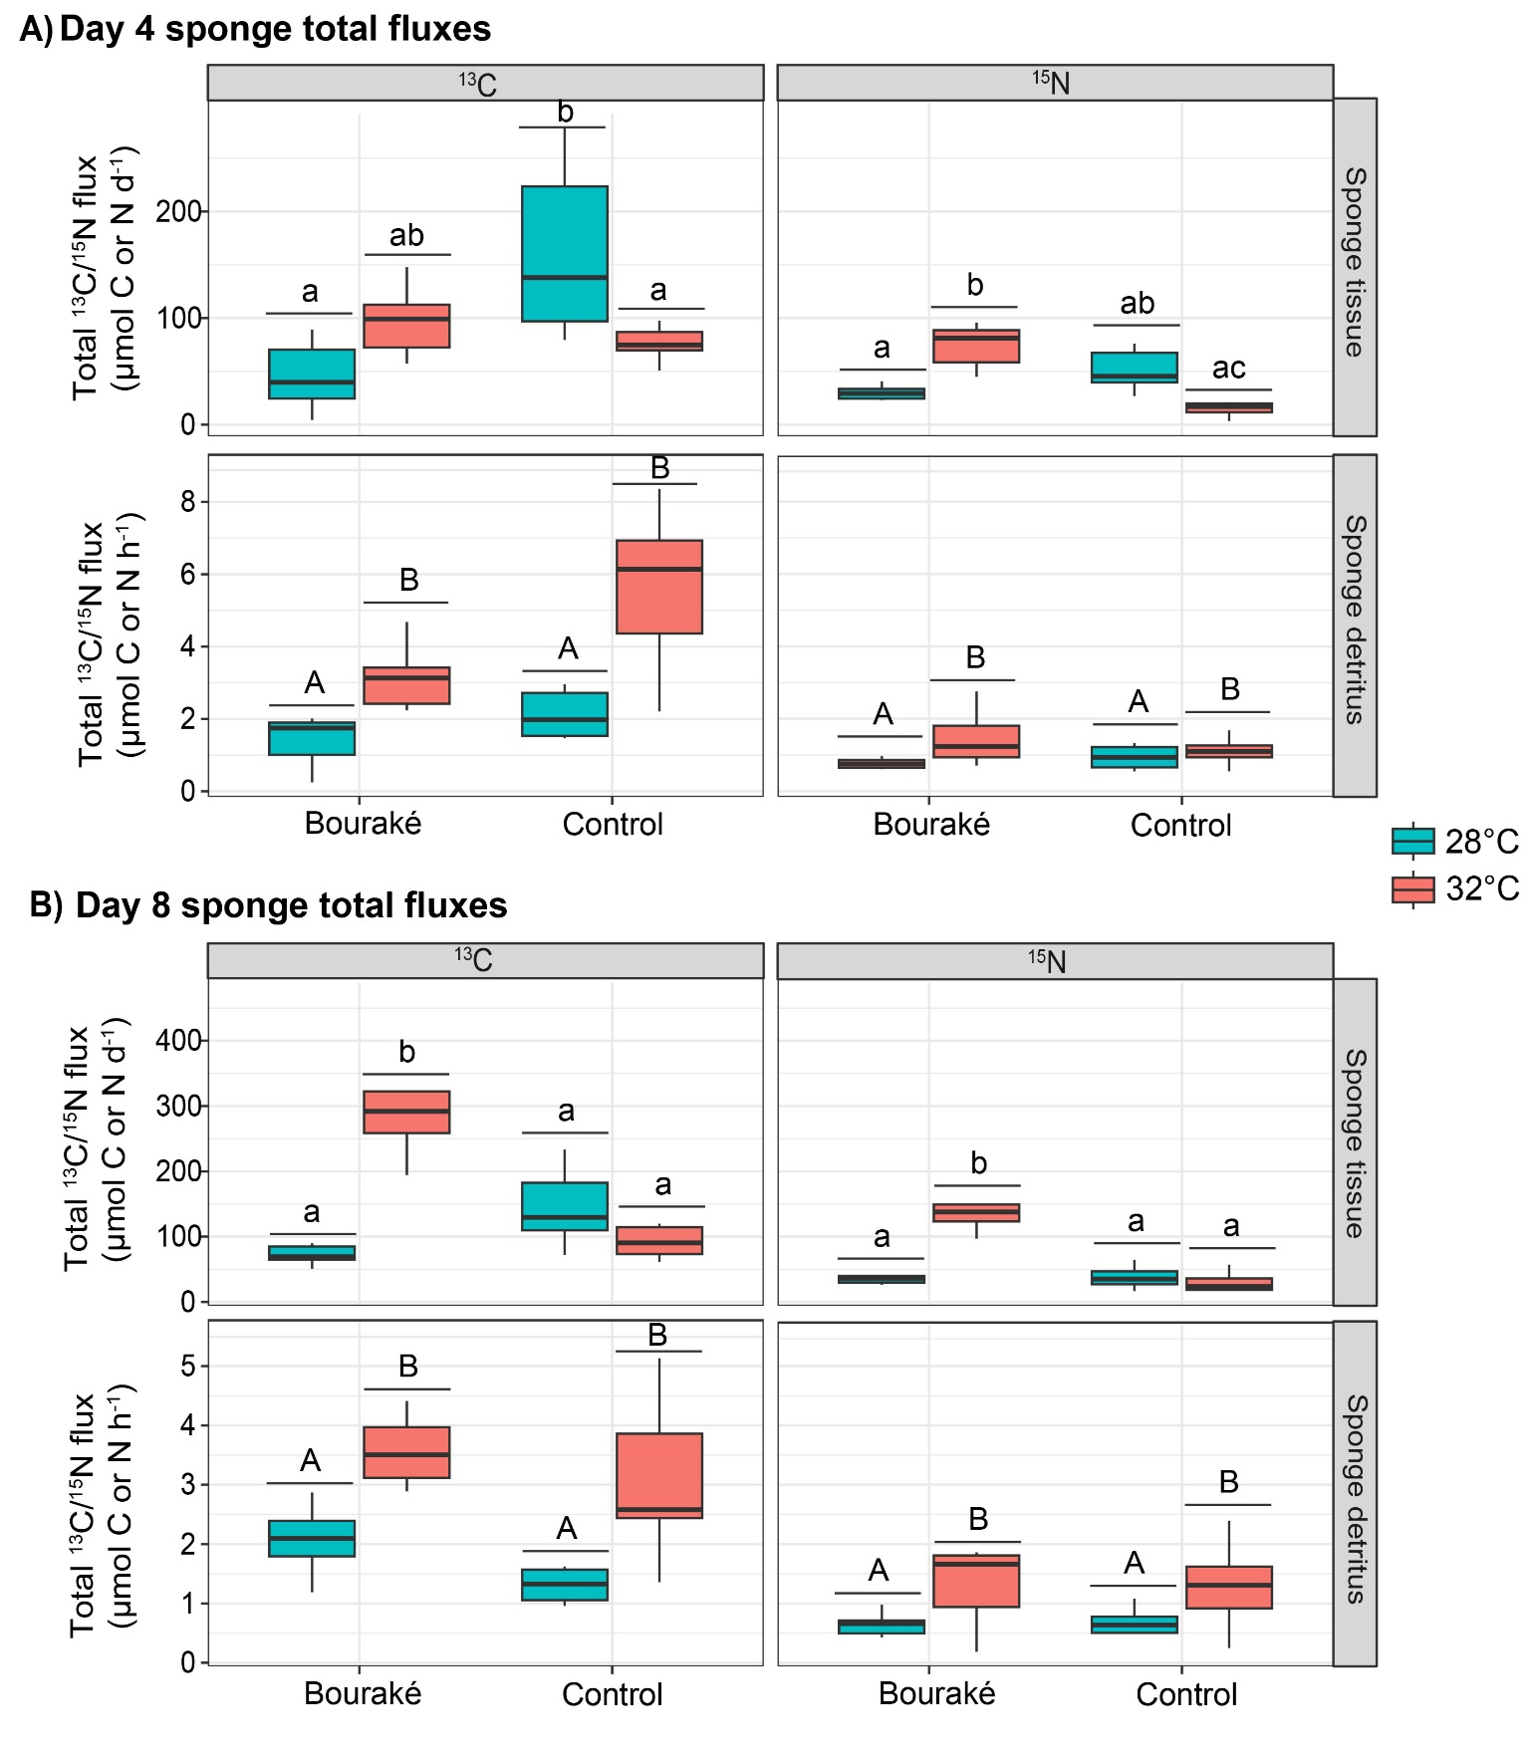
Figure S3. Total fluxes of ¹³C and ¹⁵N in sponge tissue and detritus. A) Total fluxes measured after 4 days, and B) total fluxes measured after 8 days of experiment at 28°C and 32°C, for both sponges from Bouraké and control (Tupeti). Noted that sponge tissue total fluxes are normalized by day (d⁻¹), while sponge detritus total fluxes by hour (h⁻¹). Boxes are the interquartile range of data (25th and 75th percentiles); the horizontal line is the median, and the whiskers represent the data range (i.e., minimum and maximum). Unlike letters referred to the significant differences. Capital letters referred to ANOVA two-way test, while small letters referred to Tukey post-hoc test. Unlike letters mean significant differences (p < 0.05).
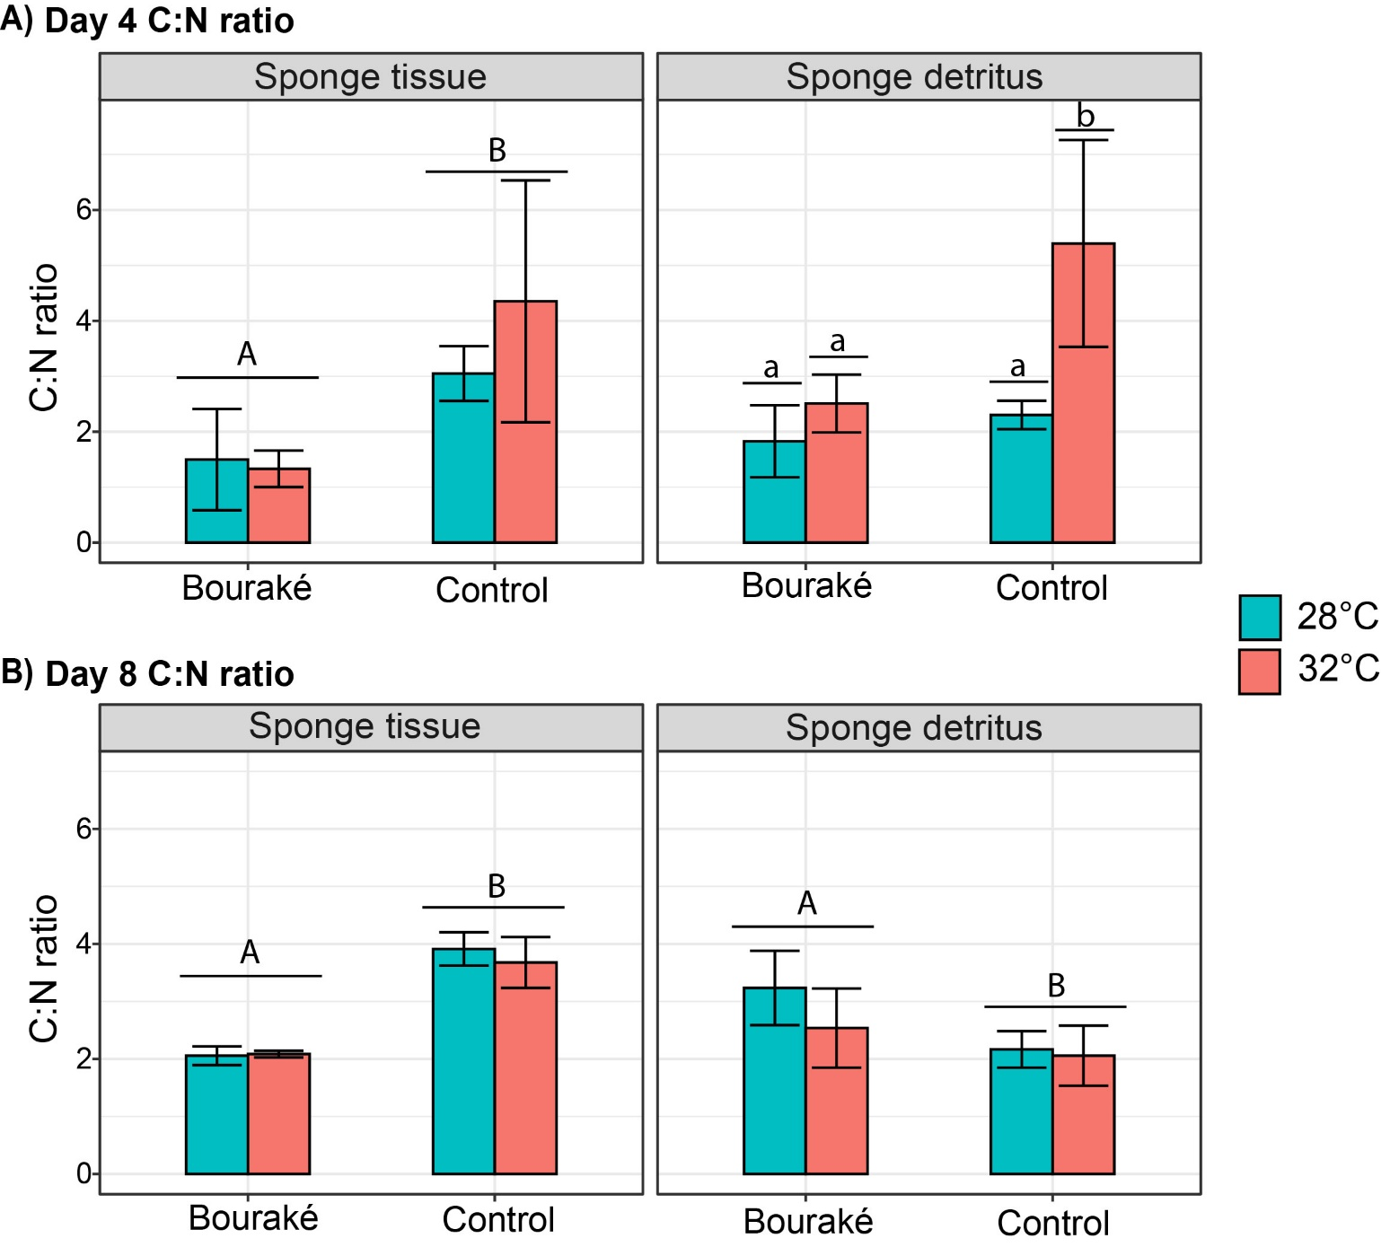
Figure S4. Carbon vs nitrogen ratios of coral mucus-derived organic matter in the sponge tissue and detritus after incubations at 28°C and 32°C, for both sponges from Bouraké and Control sites (Tupeti). Capital letters referred to ANOVA two-way test, while small letters referred to Tukey post-hoc test. Unlike letters mean significant differences (p < 0.05).

