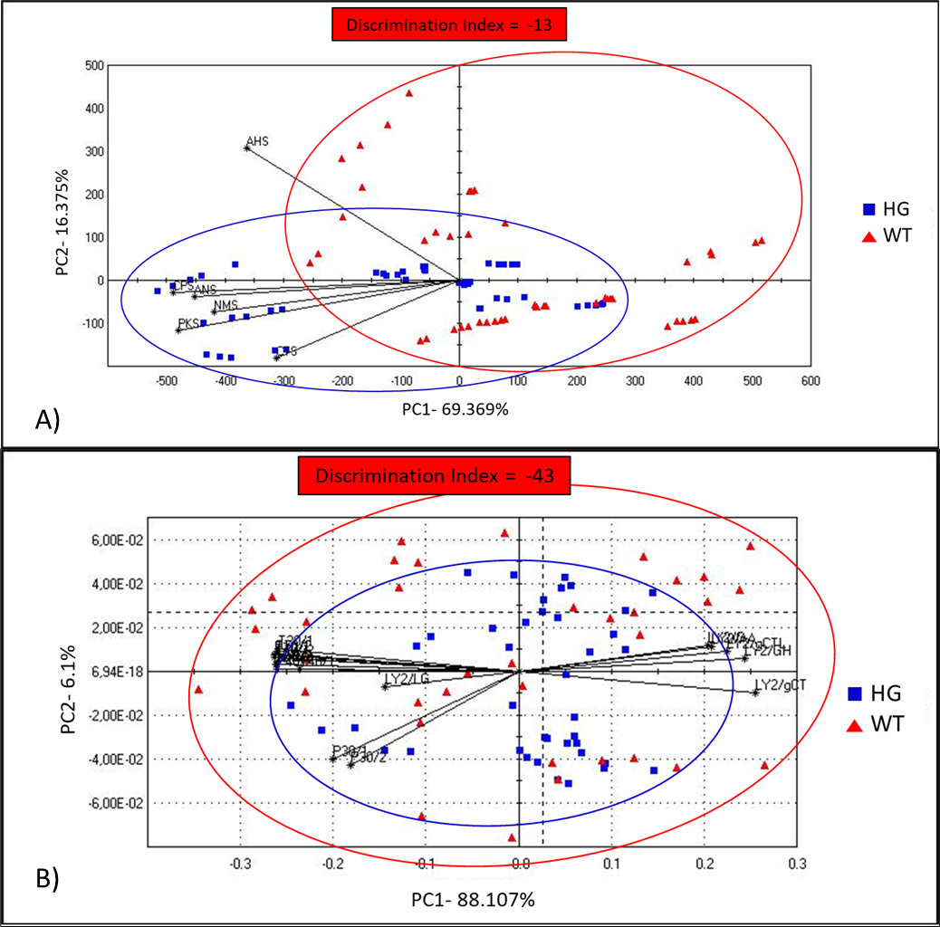
Supplementary Figure S1 A) PCA diagram of E-tongue (taste map) comparing groups HG and WT; B) PCA diagram of E-nose (smell map) comparing groups HG and WT without diet effect.

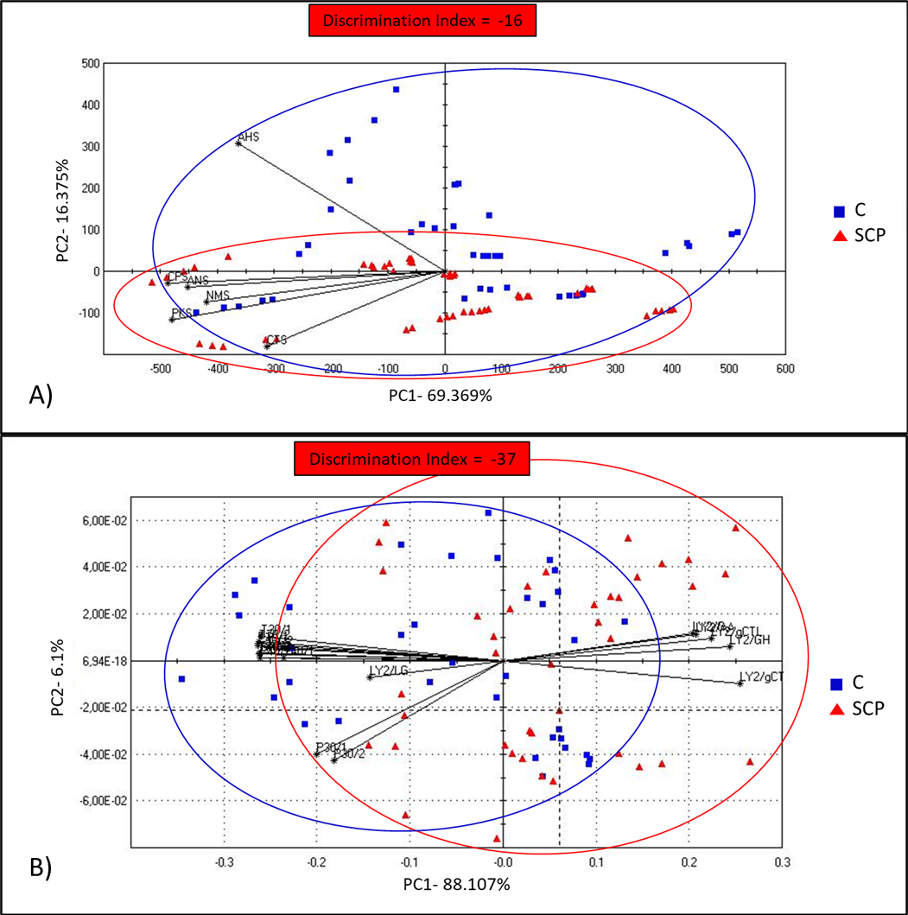
Supplementary Figure S2 A) PCA diagram of E-tongue (taste map) comparing groups C and SCP; B) PCA diagram of E-nose (smell map) comparing groups C and SCP without genotype effect.

