Supplementary Materials

A Salinity and dissolved oxygen valency groups
Table A.1: Benthodemersal fish taxa were assigned to ecological valency groups based on their tolerance to salinity and dissolved oxygen. Tolerance range values were retrieved from a meta-analysis of fish environmental niches conducted over estuarine and coastal nurseries of the Bay of Biscay. Ecological valency groups were attributed to all fish species using a classification procedure based on three tolerance range categories (wide: eury-, medium: meso-, narrow: steno-) of salinity (-haline) and DO (-oxybiontic).

Taxon | Salinity  tolerance | Salinity  valency | Oxygen  tolerance | Oxygen  valency
Abramis brama | 0.996 | euryhaline | 0.935 | euryoxybiontic
Ammodytes tobianus | 0.995 | euryhaline | 0.929 | euryoxybiontic
Anguilla anguilla | 0.998 | euryhaline | 0.990 | euryoxybiontic
Aphia minuta | 0.988 | euryhaline | 0.984 | euryoxybiontic
Arnoglossus laterna | 0.927 | euryhaline | 0.921 | euryoxybiontic
Buglossidium luteum | 0.972 | euryhaline | 0.979 | euryoxybiontic
Callionymus lyra | 0.994 | euryhaline | 0.987 | euryoxybiontic
Callionymus reticulatus | 0.176 | stenohaline | 0.161 | stenoxybiontic
Chelidonichthys lucerna | 0.984 | euryhaline | 0.978 | euryoxybiontic
Chelon labrosus | 0.776 | euryhaline | 0.233 | stenoxybiontic
Ciliata mustela | 0.991 | euryhaline | 0.976 | euryoxybiontic
Conger conger | 0.755 | euryhaline | 0.985 | euryoxybiontic
Ctenolabrus rupestris | 0.550 | mesohaline | 0.417 | mesoxybiontic
Dicentrarchus labrax | 0.995 | euryhaline | 0.993 | euryoxybiontic
Dicentrarchus punctatus | 0.596 | mesohaline | 0.906 | euryoxybiontic
Dicologlossa cuneata | 0.892 | euryhaline | 0.561 | mesoxybiontic
Echiichthys vipera | 0.974 | euryhaline | 0.983 | euryoxybiontic
Eutrigla gurnardus | 0.202 | stenohaline | 0.649 | mesoxybiontic
Gobius niger | 0.999 | euryhaline | 0.987 | euryoxybiontic
Hippocampus hippocampus | 0.936 | euryhaline | 0.988 | euryoxybiontic
Hyperoplus lanceolatus | 0.987 | euryhaline | 0.943 | euryoxybiontic
Lepadogaster candolii | 0.037 | stenohaline | 0.335 | stenoxybiontic
Limanda limanda | 0.858 | euryhaline | 0.637 | mesoxybiontic
Merlangius merlangus | 0.916 | euryhaline | 0.992 | euryoxybiontic
Merluccius merluccius | 0.273 | stenohaline | 0.517 | mesoxybiontic
Mullus surmuletus | 0.916 | euryhaline | 0.972 | euryoxybiontic
Osmerus eperlanus | 0.997 | euryhaline | 0.980 | euryoxybiontic
Pegusa lascaris | 0.830 | euryhaline | 0.429 | mesoxybiontic
Platichthys flesus | 0.998 | euryhaline | 0.994 | euryoxybiontic
Pleuronectes platessa | 0.997 | euryhaline | 0.994 | euryoxybiontic
Pollachius pollachius | 0.739 | euryhaline | 0.990 | euryoxybiontic
Pomatoschistus spp | 0.996 | euryhaline | 0.962 | euryoxybiontic
Raja undulata | 0.412 | mesohaline | 0.345 | stenoxybiontic
Sander lucioperca | 0.995 | euryhaline | 0.925 | euryoxybiontic
Scophthalmus maximus | 0.396 | mesohaline | 0.923 | euryoxybiontic
Scophthalmus rhombus | 0.870 | euryhaline | 0.990 | euryoxybiontic
Silurus glanis | 0.581 | mesohaline | 0.345 | stenoxybiontic
Solea senegalensis | 0.971 | euryhaline | 0.686 | mesoxybiontic
Solea solea | 0.999 | euryhaline | 0.993 | euryoxybiontic
Sparus aurata | 0.903 | euryhaline | 0.838 | euryoxybiontic
Spinachia spinachia | 0.820 | euryhaline | 0.978 | euryoxybiontic
Spondyliosoma cantharus | 0.485 | mesohaline | 0.983 | euryoxybiontic
Syngnathus acus | 0.988 | euryhaline | 0.986 | euryoxybiontic
Syngnathus rostellatus | 0.997 | euryhaline | 0.964 | euryoxybiontic
Syngnathus typhle | 0.956 | euryhaline | 0.496 | mesoxybiontic
Torpedo marmorata | 0.345 | mesohaline | 0.980 | euryoxybiontic
Trisopterus luscus | 0.846 | euryhaline | 0.989 | euryoxybiontic
Trisopterus minutus | 0.711 | mesohaline | 0.520 | mesoxybiontic
Zeugopterus norvegicus | 0.129 | stenohaline | 0.384 | mesoxybiontic

B Monthly variability in environmental conditions in the Loire estuary
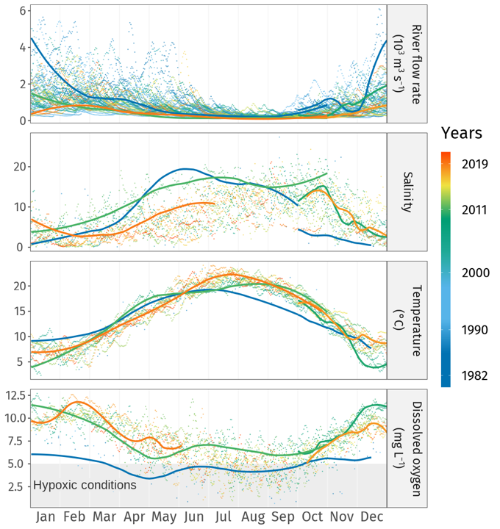
Figure B.1: Daily mean values of abiotic variables measured at Montjean-sur-Loire hydrologic station (flow rate) and Paimbœuf environmental monitoring station (salinity, temperature, and DO), presented with LoESS regression curves associated with the intra-annual surveys (1982, 2011, and 2019).

C Ecological trajectories and monthly composition of fish populations in the annual cycles
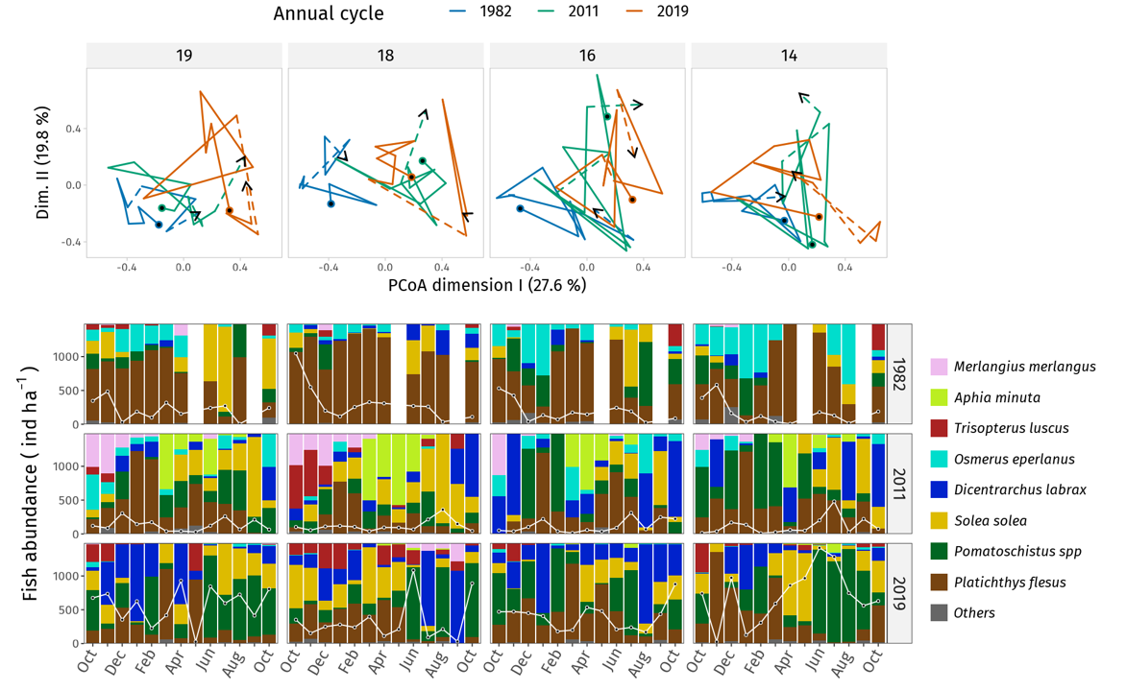
Figure C.1: Above: site-specific ecological trajectories across four sites (kilometer milestones) and over three annual cycles (1982, 2011, 2019). Below: monthly relative abundance data for fish taxa (each column totals 100%). Total fish abundance is superimposed as a white line with black dots associated with the ordinate axis values.

D Classification of inter-annual samples and species association with clusters
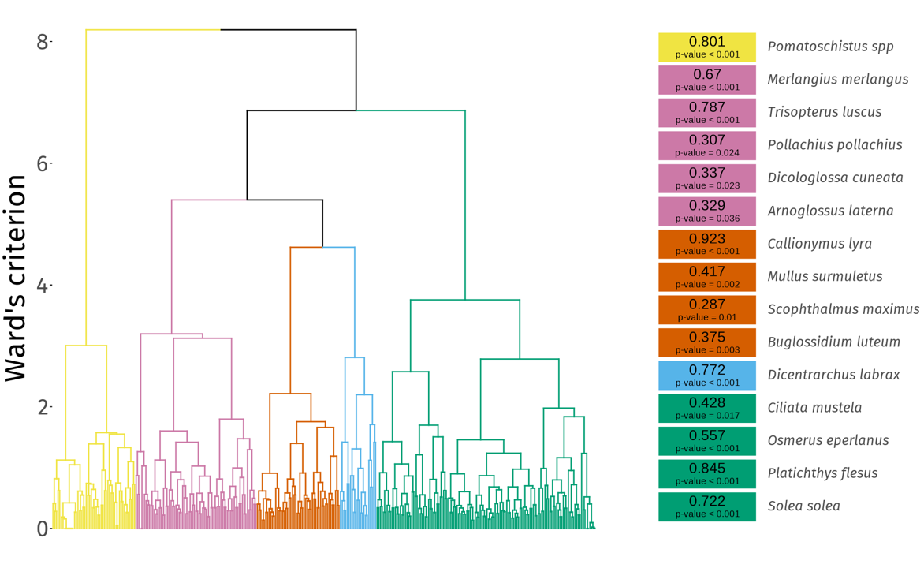
Figure D.1: Hierarchical clustering analysis (Ward’s method) of inter-annual samples identified five well-differentiated clusters of samples visible on the associated dendrogram. The Dufrêne-Legendre association index (IndVal) was computed for each taxon identified at the inter-annual scale and significant associations are presented in the rightmost part of the figure (Dufrêne & Legendre 1997).

E Partitioning of spatio-temporal variation
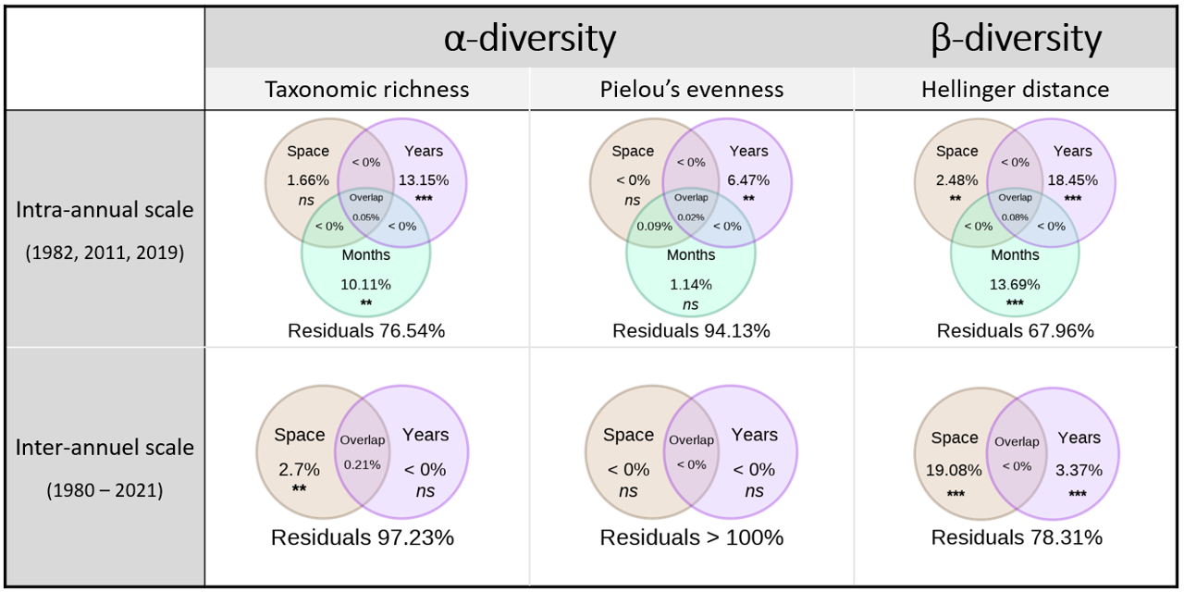
Figure E.1: Summary table of the partitioning of variability (Venn diagrams) in $α$-diversity, $β$-diversity, and dissimilarity among fish communities assessed at both intra-annual and inter-annual scales.

F Evolution of abundance of major fish taxa over fine and broad temporal scales
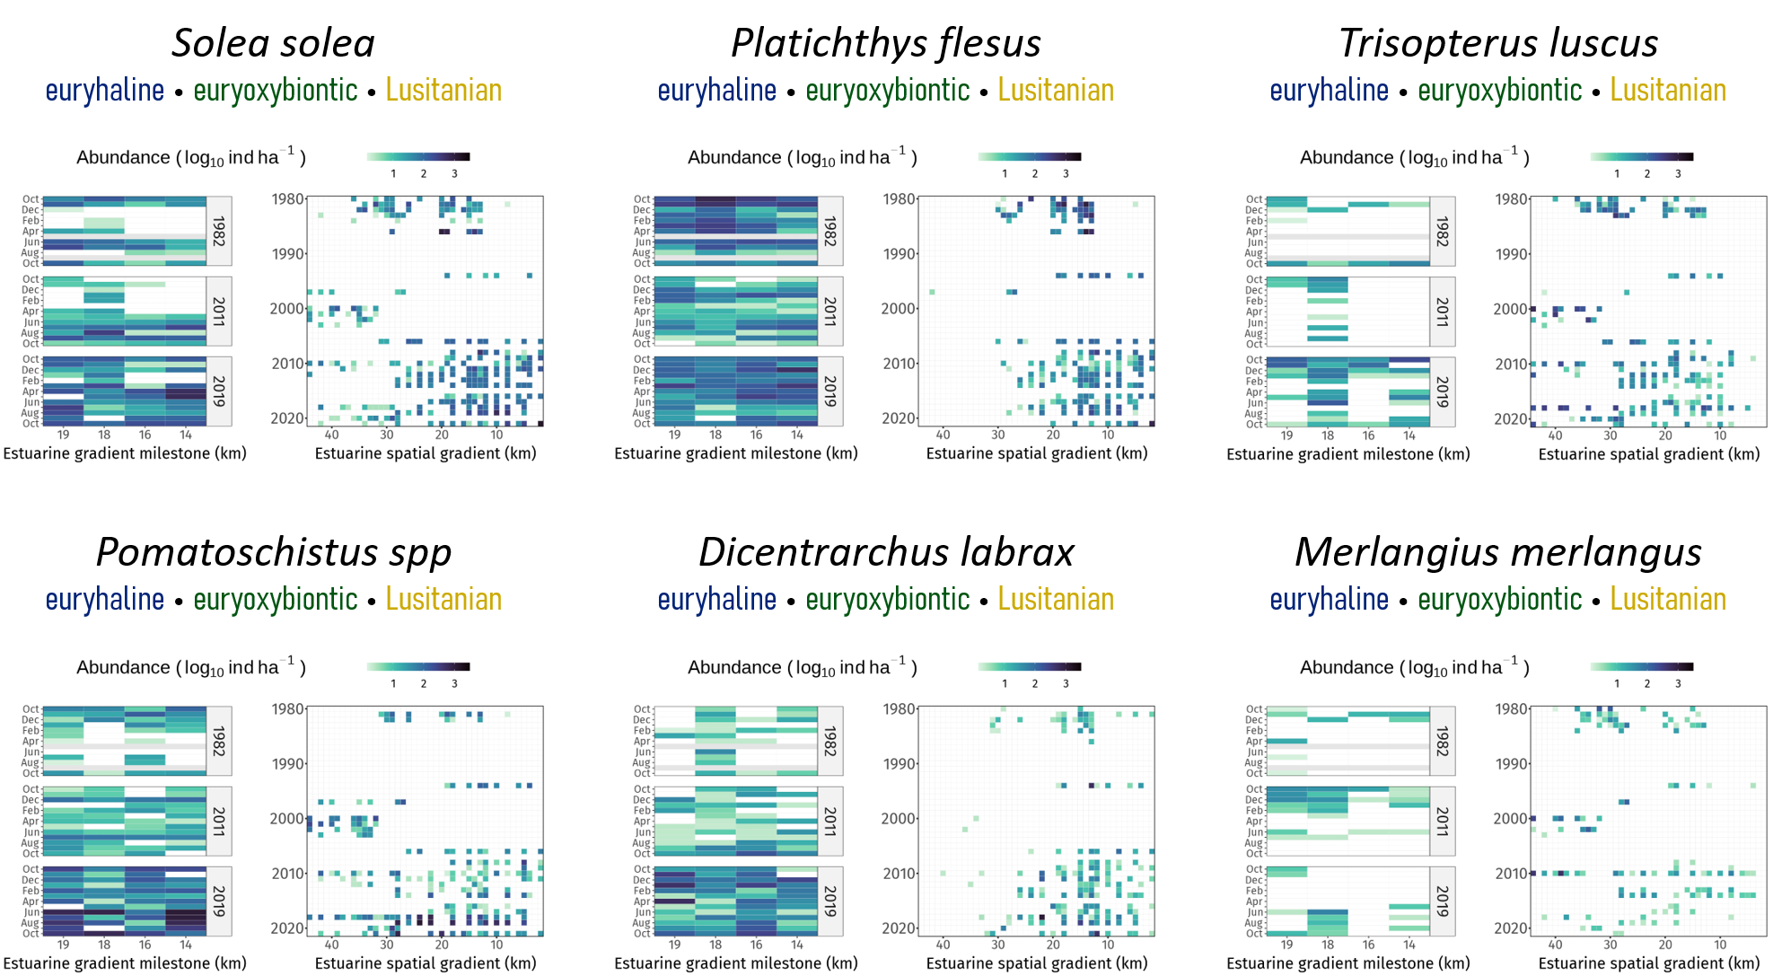
Figure F.1: Evolution of the abundance of major fish taxa over intra-annual (left grids) and inter-annual (right square-shaped grids) temporal scales.
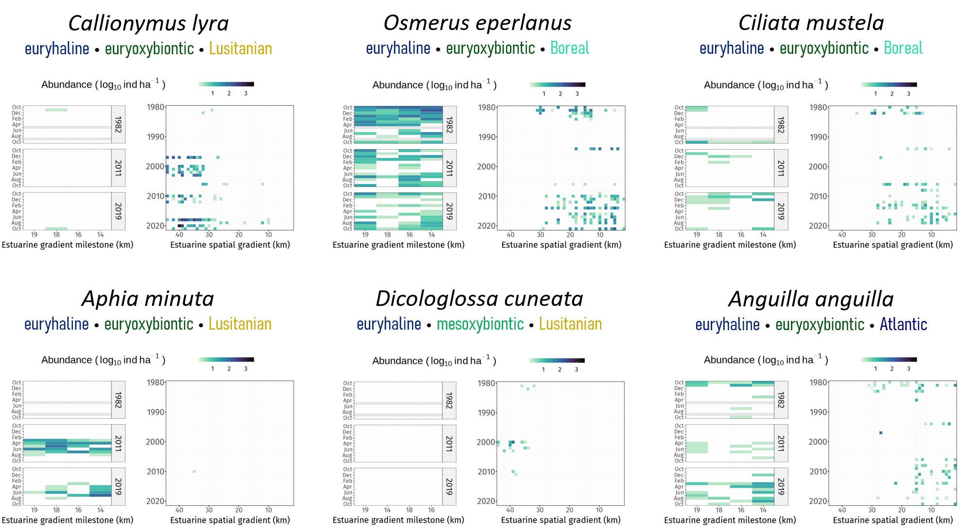
Figure F.1: Continued.

