Supplementary data

Otolith morphogenesis during the early life stages of fish is temperature-dependant: validation by experimental approach applied to European Seabass (Dicentrarchus labrax)
K. Mahé¹, F. Clota², M.O. Blanc³, G. Bled Defruit¹, B Chatain³, H. de Pontual⁴, R. Amara⁵, B. Ernande^{3,6}
¹IFREMER, Centre Manche Mer du Nord, Laboratoire ressources halieutiques, BP 699, 62321 Boulogne-sur-mer, France
² INRA, Unit 0558, Dept. PHASE, 37380 Nouzilly, France
³MARBEC, Univ. Montpellier, Ifremer, CNRS, IRD, Montpellier, France.
⁴IFREMER, Centre de Bretagne, Sciences et Technologies Halieutiques, Z.I. Pointe du Diable, CS 10070, 29280 Plouzané, France
⁵Université Littoral Côte d'Opale, UMR 8187, LOG, Laboratoire d'Océanologie et de Géosciences, F 62930 Wimereux, France
⁶Evolution and Ecology Program, International Institute for Applied Systems Analysis (IIASA), Luxemburg, Austria.

Corresponding author : K. Mahé, kelig.mahe@ifremer.fr

Supplementary Information Table 1: Fish number sampled by GDD values and days number at 16°C and 21°C. Total length characteristics (mean ± SD) are given for each sample.

N | TL (mm) | GDD (°C.day) | Nb Days at 16°C | Nb Days at 21°C
130 | 14.92±1.37 | 688 | 43 | -
156 | 18.66±2.34 | 1152 | 72 | -
160 | 22.47±3.45 | 1376 | 86 | -
72 | 22.35±5.39 | 1600 | 100 | -
96 | 81.31±6.39 | 3712 | 232 | 0
36 | 88.04±5.88 | 3817 | 211 | 21
170 | 97.47±7.81 | 3962 | 182 | 50
148 | 111.15±7.66 | 4107 | 153 | 79

Supplementary Information Table 2: Size dimension parameters and shape indices of otolith used to describe seabass otolith outline.
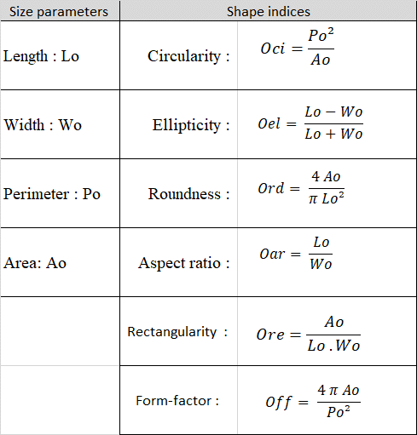

Supplementary Information Table 3: Average percentage of non-overlapping surface by degree.day between the two reconstructed otolith shapes at the different levels of GDD.
