Supplementary Information for

Probabilistic, scenario-based hazard assessment for pyroclastic density currents at Tungurahua volcano, Ecuador

A. Aravena^{1,2,3}, A. Tadini^{2,3}, A. Bevilacqua³, P. Samaniego^{2,4}, B. Bernard⁴, S. Hidalgo⁴, J.-L. Le Pennec⁵, P. Martínez-Yáñez¹, J. García⁴, O. Roche²

¹Facultad de Ciencias Básicas, Universidad Católica del Maule, Talca, Chile.
²Laboratoire Magmas et Volcans, Université Clermont Auvergne, CNRS, IRD, OPGC, Clermont-Ferrand, France.
³Istituto Nazionale di Geofisica e Vulcanologia, Sezione di Pisa, Pisa, Italy.
⁴Instituto Geofísico, Escuela Politécnica Nacional, Quito, Ecuador.
⁵Geo-Ocean, Université de Bretagne Occidentale, CNRS, Ifremer, UMR6538, IRD, IUEM, Plouzané, France.

Corresponding author: A. Bevilacqua (andrea.bevilacqua@ingv.it).

This document includes:
- Supplementary Tables S1-S3
- Supplementary Figures S1-S14
Supplementary Tables

Table S1. Inundation probability computed in a series of critical positions around Tungurahua volcano, considering different scenarios and calibration methods. Data are presented in percent.
Eruptive Scenario | Model ª | Calibration data | Comparison metric | Inundation probability
 |  |  |  | Palitahua | Juive G. | Chontapamba | Cusua | Bilbao
ES1 | 1 | July 2006 | JI | 11.2 | 8.0 | 6.2 | 7.0 | 6.8
ES1 | 1 | July 2006 | HD | 14.4 | 11.2 | 9.2 | 7.6 | 7.2
ES1 | 1 | July 2006 | RMSD | 19.2 | 16.8 | 15.4 | 14.4 | 13.4
ES1 | 1 | February 2008 | JI | 5.0 | 1.6 | 2.6 | 1.8 | 1.0
ES1 | 1 | February 2008 | HD | 11.8 | 8.4 | 7.4 | 6.0 | 5.6
ES1 | 1 | February 2008 | RMSD | 18.2 | 15.4 | 12.6 | 12.8 | 11.6
ES1 | 1 | May 2010 | JI | 5.4 | 3.6 | 2.4 | 1.8 | 1.8
ES1 | 1 | May 2010 | HD | 12.2 | 7.4 | 8.2 | 7.0 | 7.0
ES1 | 1 | May 2010 | RMSD | 15.8 | 11.6 | 10.8 | 10.4 | 9.6
ES1 | 1 | July 2013 | JI | 9.6 | 5.8 | 5.4 | 4.2 | 3.2
ES1 | 1 | July 2013 | HD | 7.2 | 5.8 | 4.2 | 4.2 | 3.4
ES1 | 1 | July 2013 | RMSD | 17.0 | 14.2 | 11.6 | 11.6 | 10.0
ES1 | 1 | February 2014 | JI | 8.0 | 4.4 | 4.0 | 3.6 | 3.8
ES1 | 1 | February 2014 | HD | 9.4 | 4.2 | 4.2 | 3.0 | 3.2
ES1 | 1 | February 2014 | RMSD | 19.0 | 14.6 | 12.2 | 12.6 | 10.2
ES1 | 1 | February 2016 | JI | 6.0 | 1.2 | 0.8 | 0.6 | 0.4
ES1 | 1 | February 2016 | HD | 11.8 | 9.6 | 7.6 | 7.0 | 6.6
ES1 | 1 | February 2016 | RMSD | 17.6 | 15.2 | 12.8 | 13.0 | 11.4
ES2 | 1 | August 2006 | JI | 31.4 | 23.0 | 21.4 | 21.8 | 19.2
ES2 | 1 | August 2006 | HD | 24.8 | 16.4 | 14.2 | 15.4 | 12.8
ES2 | 1 | August 2006 | RMSD | 30.0 | 23.8 | 21.4 | 22.4 | 19.6
ES2 | 2 | August 2006 | JI | 8.6 | 28.8 | 16.6 | 31.8 | 25.2
ES2 | 2 | August 2006 | HD | 8.6 | 23.8 | 14.0 | 24.2 | 20.8
ES2 | 2 | August 2006 | RMSD | 10.2 | 27.2 | 16.2 | 29.4 | 24.4
ES2 | 3 | August 2006 | JI | 9.6 | 22.2 | 13.4 | 24.4 | 18.0
ES2 | 3 | August 2006 | HD | 7.2 | 15.4 | 9.8 | 19.8 | 13.2
ES2 | 3 | August 2006 | RMSD | 10.2 | 17.8 | 12.8 | 19.2 | 17.0
ES2 | 4 | August 2006 | JI | 9.2 | 13.6 | 11.4 | 16.4 | 13.4
ES2 | 4 | August 2006 | HD | 6.0 | 7.6 | 6.6 | 10.2 | 7.8
ES2 | 4 | August 2006 | RMSD | 7.0 | 10.4 | 7.8 | 11.4 | 9.2
ES3 | 2 | Scattered outcrops ^{b} | CP | 60.0 | 99.6 | 99.0 | 99.6 | 99.4
ES3 | 3 | Scattered outcrops ^{b} | CP | 100.0 | 100.0 | 100.0 | 100.0 | 100.0
ES3 | 4 | Scattered outcrops ^{b} | CP | 99.8 | 100.0 | 100.0 | 100.0 | 100.0
Eruptive Scenario | Modelª | Statistical parameter |  | Inundation probability
 |  |  |  | Palitahua | Juive G. | Chontapamba | Cusua | Bilbao
ES1 | 1 | Average |  | 12.2 | 8.8 | 7.6 | 7.1 | 6.5
ES1 | 1 | Standard deviation |  | 4.8 | 5.0 | 4.2 | 4.4 | 3.9
ES1 | 1 | Maximum |  | 19.2 | 16.8 | 15.4 | 14.4 | 13.4
ES2 | 1 | Mean |  | 28.7 | 21.1 | 19.0 | 19.9 | 17.2
ES2 | 1 | Standard deviation |  | 3.5 | 4.1 | 4.2 | 3.9 | 3.8
ES2 | 1 | Maximum |  | 31.4 | 23.8 | 21.4 | 22.4 | 19.6
ES2 | 2-4 | Mean |  | 8.5 | 18.5 | 12.1 | 20.8 | 16.6
ES2 | 2-4 | Standard deviation |  | 1.5 | 7.4 | 3.5 | 7.4 | 6.2
ES2 | 2-4 | Maximum |  | 10.2 | 28.8 | 16.6 | 31.8 | 25.2
ES2 | 1-4 | Mean |  | 13.6 | 19.2 | 13.8 | 20.5 | 16.7
ES2 | 1-4 | Standard deviation |  | 9.4 | 6.7 | 4.7 | 6.6 | 5.5
ES2 | 1-4 | Maximum |  | 31.4 | 28.8 | 21.4 | 31.8 | 25.2
ES3 | 2-4 | Mean |  | 86.6 | 99.9 | 99.7 | 99.9 | 99.8
ES3 | 2-4 | Standard deviation |  | 23.0 | 0.2 | 0.6 | 0.2 | 0.3
ES3 | 2-4 | Maximum |  | 100.0 | 100.0 | 100.0 | 100.0 | 100.0
ª The following abbreviations were adopted: 1 (ECMapProb 2.0), 2 (BoxMapProb 2.0, considering $w_{s}=0.05m/s$), 3 (BoxMapProb 2.0, considering $w_{s}=0.3m/s$) and 4 (BoxMapProb 2.0, considering $w_{s}=1.2m/s$).
^{b} Two outcrops associated with large magnitude sub-Plinian to Plinian eruptions are considered (P₁ and P₂; see Fig. 3).

Table S2. Inundation probability computed in a series of critical positions around Tungurahua volcano, considering different scenarios and calibration methods. Data are presented in percent.
Eruptive Scenario | Model ª | Calibration data | Comparison metric | Inundation probability
 |  |  |  | Pondoa | Baños | Choglontus | Yuibug G. | Ulba
ES1 | 1 | July 2006 | JI | 4.8 | 5.0 | 3.2 | 3.6 | 3.2
ES1 | 1 | July 2006 | HD | 6.6 | 8.2 | 5.8 | 6.0 | 5.6
ES1 | 1 | July 2006 | RMSD | 12.6 | 11.6 | 10.4 | 9.8 | 7.4
ES1 | 1 | February 2008 | JI | 1.2 | 2.6 | 1.0 | 1.2 | 1.2
ES1 | 1 | February 2008 | HD | 5.0 | 5.4 | 4.2 | 4.0 | 3.4
ES1 | 1 | February 2008 | RMSD | 10.8 | 9.8 | 8.8 | 8.8 | 5.6
ES1 | 1 | May 2010 | JI | 1.4 | 2.0 | 0.6 | 0.6 | 1.2
ES1 | 1 | May 2010 | HD | 6.4 | 6.2 | 5.2 | 5.0 | 3.8
ES1 | 1 | May 2010 | RMSD | 8.8 | 8.8 | 7.8 | 7.8 | 7.0
ES1 | 1 | July 2013 | JI | 2.8 | 3.0 | 2.0 | 2.0 | 2.4
ES1 | 1 | July 2013 | HD | 2.8 | 4.4 | 2.0 | 1.8 | 1.4
ES1 | 1 | July 2013 | RMSD | 9.8 | 10.4 | 8.6 | 8.4 | 6.2
ES1 | 1 | February 2014 | JI | 4.2 | 2.8 | 2.6 | 2.8 | 3.0
ES1 | 1 | February 2014 | HD | 1.8 | 2.8 | 1.0 | 1.4 | 2.4
ES1 | 1 | February 2014 | RMSD | 9.0 | 9.6 | 8.0 | 8.4 | 6.2
ES1 | 1 | February 2016 | JI | 0.4 | 0.6 | 0.2 | 0.2 | 0.6
ES1 | 1 | February 2016 | HD | 6.6 | 5.8 | 5.2 | 5.8 | 6.4
ES1 | 1 | February 2016 | RMSD | 11.2 | 9.4 | 9.0 | 9.0 | 9.4
ES2 | 1 | August 2006 | JI | 19.8 | 15.0 | 16.0 | 14.2 | 8.2
ES2 | 1 | August 2006 | HD | 12.4 | 10.2 | 10.2 | 9.4 | 6.6
ES2 | 1 | August 2006 | RMSD | 20.0 | 15.6 | 16.8 | 16.2 | 9.4
ES2 | 2 | August 2006 | JI | 26.6 | 19.2 | 24.4 | 21.4 | 7.0
ES2 | 2 | August 2006 | HD | 22.2 | 15.8 | 22.8 | 17.4 | 7.8
ES2 | 2 | August 2006 | RMSD | 25.0 | 18.4 | 26.8 | 21.0 | 9.0
ES2 | 3 | August 2006 | JI | 22.6 | 14.4 | 21.4 | 14.6 | 7.0
ES2 | 3 | August 2006 | HD | 16.6 | 10.6 | 15.8 | 12.4 | 6.0
ES2 | 3 | August 2006 | RMSD | 17.8 | 14.2 | 18.2 | 14.2 | 8.0
ES2 | 4 | August 2006 | JI | 18.0 | 11.0 | 17.6 | 10.8 | 7.0
ES2 | 4 | August 2006 | HD | 11.4 | 4.8 | 10.2 | 7.6 | 2.8
ES2 | 4 | August 2006 | RMSD | 13.4 | 7.6 | 11.8 | 8.2 | 4.2
ES3 | 2 | Scattered outcrops ^{b} | CP | 99.4 | 99.2 | 99.4 | 99.4 | 96.6
ES3 | 3 | Scattered outcrops ^{b} | CP | 100.0 | 100.0 | 100.0 | 100.0 | 100.0
ES3 | 4 | Scattered outcrops ^{b} | CP | 100.0 | 99.8 | 100.0 | 100.0 | 100.0
Eruptive Scenario | Modelª | Statistical parameter |  | Inundation probability
 |  |  |  | Pondoa | Baños | Choglontus | Yuibug G. | Ulba
ES1 | 1 | Average |  | 5.9 | 6.0 | 4.8 | 4.8 | 4.2
ES1 | 1 | Standard deviation |  | 3.8 | 3.4 | 3.4 | 3.3 | 2.5
ES1 | 1 | Maximum |  | 12.6 | 11.6 | 10.4 | 9.8 | 9.4
ES2 | 1 | Mean |  | 17.4 | 13.6 | 14.3 | 13.3 | 8.1
ES2 | 1 | Standard deviation |  | 4.3 | 3.0 | 3.6 | 3.5 | 1.4
ES2 | 1 | Maximum |  | 20.0 | 15.6 | 16.8 | 16.2 | 9.4
ES2 | 2-4 | Mean |  | 19.3 | 12.9 | 18.8 | 14.2 | 6.5
ES2 | 2-4 | Standard deviation |  | 5.2 | 4.8 | 5.6 | 5.0 | 1.9
ES2 | 2-4 | Maximum |  | 26.6 | 19.2 | 26.8 | 21.4 | 9.0
ES2 | 1-4 | Mean |  | 18.8 | 13.1 | 17.7 | 14.0 | 6.9
ES2 | 1-4 | Standard deviation |  | 4.9 | 4.3 | 5.4 | 4.6 | 1.9
ES2 | 1-4 | Maximum |  | 26.6 | 19.2 | 26.8 | 21.4 | 9.4
ES3 | 2-4 | Mean |  | 99.8 | 99.7 | 99.8 | 99.8 | 98.9
ES3 | 2-4 | Standard deviation |  | 0.3 | 0.4 | 0.3 | 0.3 | 2.0
ES3 | 2-4 | Maximum |  | 100.0 | 100.0 | 100.0 | 100.0 | 100.0
ª The following abbreviations were adopted: 1 (ECMapProb 2.0), 2 (BoxMapProb 2.0, considering $w_{s}=0.05m/s$), 3 (BoxMapProb 2.0, considering $w_{s}=0.3m/s$) and 4 (BoxMapProb 2.0, considering $w_{s}=1.2m/s$).
^{b} Two outcrops associated with large magnitude sub-Plinian to Plinian eruptions are considered (P₁ and P₂; see Fig. 3).

Table S3. Inundation probability computed in a series of critical positions around Tungurahua volcano, considering different scenarios and calibration methods. Data are presented in percent.
Eruptive Scenario | Model ª | Calibration data | Comparison metric | Inundation probability
 |  |  |  | Puela | Cotaló | Pailitas | Huambaló
ES1 | 1 | July 2006 | JI | 1.4 | 1.0 | 0.6 | 0.0
ES1 | 1 | July 2006 | HD | 2.2 | 2.4 | 1.6 | 0.2
ES1 | 1 | July 2006 | RMSD | 4.4 | 3.0 | 1.0 | 0.0
ES1 | 1 | February 2008 | JI | 0.6 | 0.6 | 0.2 | 0.0
ES1 | 1 | February 2008 | HD | 2.2 | 2.0 | 0.8 | 0.0
ES1 | 1 | February 2008 | RMSD | 4.0 | 3.0 | 1.0 | 0.0
ES1 | 1 | May 2010 | JI | 0.4 | 0.2 | 0.0 | 0.0
ES1 | 1 | May 2010 | HD | 3.0 | 1.6 | 0.4 | 0.0
ES1 | 1 | May 2010 | RMSD | 4.4 | 3.4 | 0.6 | 0.0
ES1 | 1 | July 2013 | JI | 0.6 | 0.6 | 0.2 | 0.0
ES1 | 1 | July 2013 | HD | 0.8 | 0.8 | 0.6 | 0.0
ES1 | 1 | July 2013 | RMSD | 5.4 | 3.6 | 1.4 | 0.0
ES1 | 1 | February 2014 | JI | 1.4 | 1.2 | 0.8 | 0.0
ES1 | 1 | February 2014 | HD | 0.4 | 0.2 | 0.2 | 0.0
ES1 | 1 | February 2014 | RMSD | 3.4 | 2.8 | 1.0 | 0.0
ES1 | 1 | February 2016 | JI | 0.2 | 0.2 | 0.2 | 0.0
ES1 | 1 | February 2016 | HD | 2.8 | 2.4 | 1.4 | 0.0
ES1 | 1 | February 2016 | RMSD | 5.0 | 4.8 | 2.2 | 0.2
ES2 | 1 | August 2006 | JI | 7.2 | 5.2 | 2.0 | 0.6
ES2 | 1 | August 2006 | HD | 4.4 | 3.0 | 1.4 | 0.6
ES2 | 1 | August 2006 | RMSD | 9.0 | 6.4 | 2.8 | 1.0
ES2 | 2 | August 2006 | JI | 17.0 | 7.6 | 0.2 | 0.2
ES2 | 2 | August 2006 | HD | 15.0 | 8.8 | 1.4 | 0.6
ES2 | 2 | August 2006 | RMSD | 18.8 | 11.0 | 2.0 | 0.4
ES2 | 3 | August 2006 | JI | 15.2 | 8.6 | 0.6 | 0.4
ES2 | 3 | August 2006 | HD | 11.0 | 6.2 | 2.2 | 0.6
ES2 | 3 | August 2006 | RMSD | 12.8 | 8.4 | 2.4 | 0.6
ES2 | 4 | August 2006 | JI | 11.6 | 6.0 | 0.8 | 0.2
ES2 | 4 | August 2006 | HD | 6.2 | 2.6 | 0.6 | 0.0
ES2 | 4 | August 2006 | RMSD | 6.8 | 4.4 | 1.0 | 0.0
ES3 | 2 | Scattered outcrops ^{b} | CP | 99.2 | 98.6 | 10.4 | 3.6
ES3 | 3 | Scattered outcrops ^{b} | CP | 100.0 | 100.0 | 0.0 | 0.0
ES3 | 4 | Scattered outcrops ^{b} | CP | 100.0 | 99.8 | 22.2 | 1.6
Eruptive Scenario | Modelª | Statistical parameter |  | Inundation probability
 |  |  |  | Puela | Cotaló | Pailitas | Huambaló
ES1 | 1 | Average |  | 2.4 | 1.9 | 0.8 | 0.0
ES1 | 1 | Standard deviation |  | 1.7 | 1.4 | 0.6 | 0.1
ES1 | 1 | Maximum |  | 5.4 | 4.8 | 2.2 | 0.2
ES2 | 1 | Mean |  | 6.9 | 4.9 | 2.1 | 0.7
ES2 | 1 | Standard deviation |  | 2.3 | 1.7 | 0.7 | 0.2
ES2 | 1 | Maximum |  | 9.0 | 6.4 | 2.8 | 1.0
ES2 | 2-4 | Mean |  | 12.7 | 7.1 | 1.2 | 0.3
ES2 | 2-4 | Standard deviation |  | 4.3 | 2.5 | 0.8 | 0.2
ES2 | 2-4 | Maximum |  | 18.8 | 11.0 | 2.4 | 0.6
ES2 | 1-4 | Mean |  | 11.3 | 6.5 | 1.5 | 0.4
ES2 | 1-4 | Standard deviation |  | 4.6 | 2.5 | 0.8 | 0.3
ES2 | 1-4 | Maximum |  | 18.8 | 11.0 | 2.8 | 1.0
ES3 | 2-4 | Mean |  | 99.7 | 99.5 | 10.9 | 1.7
ES3 | 2-4 | Standard deviation |  | 0.5 | 0.8 | 11.1 | 1.8
ES3 | 2-4 | Maximum |  | 100.0 | 100.0 | 22.2 | 3.6
ª The following abbreviations were adopted: 1 (ECMapProb 2.0), 2 (BoxMapProb 2.0, considering $w_{s}=0.05m/s$), 3 (BoxMapProb 2.0, considering $w_{s}=0.3m/s$) and 4 (BoxMapProb 2.0, considering $w_{s}=1.2m/s$).
^{b} Two outcrops associated with large magnitude sub-Plinian to Plinian eruptions are considered (P₁ and P₂; see Fig. 3).

Supplementary Figures

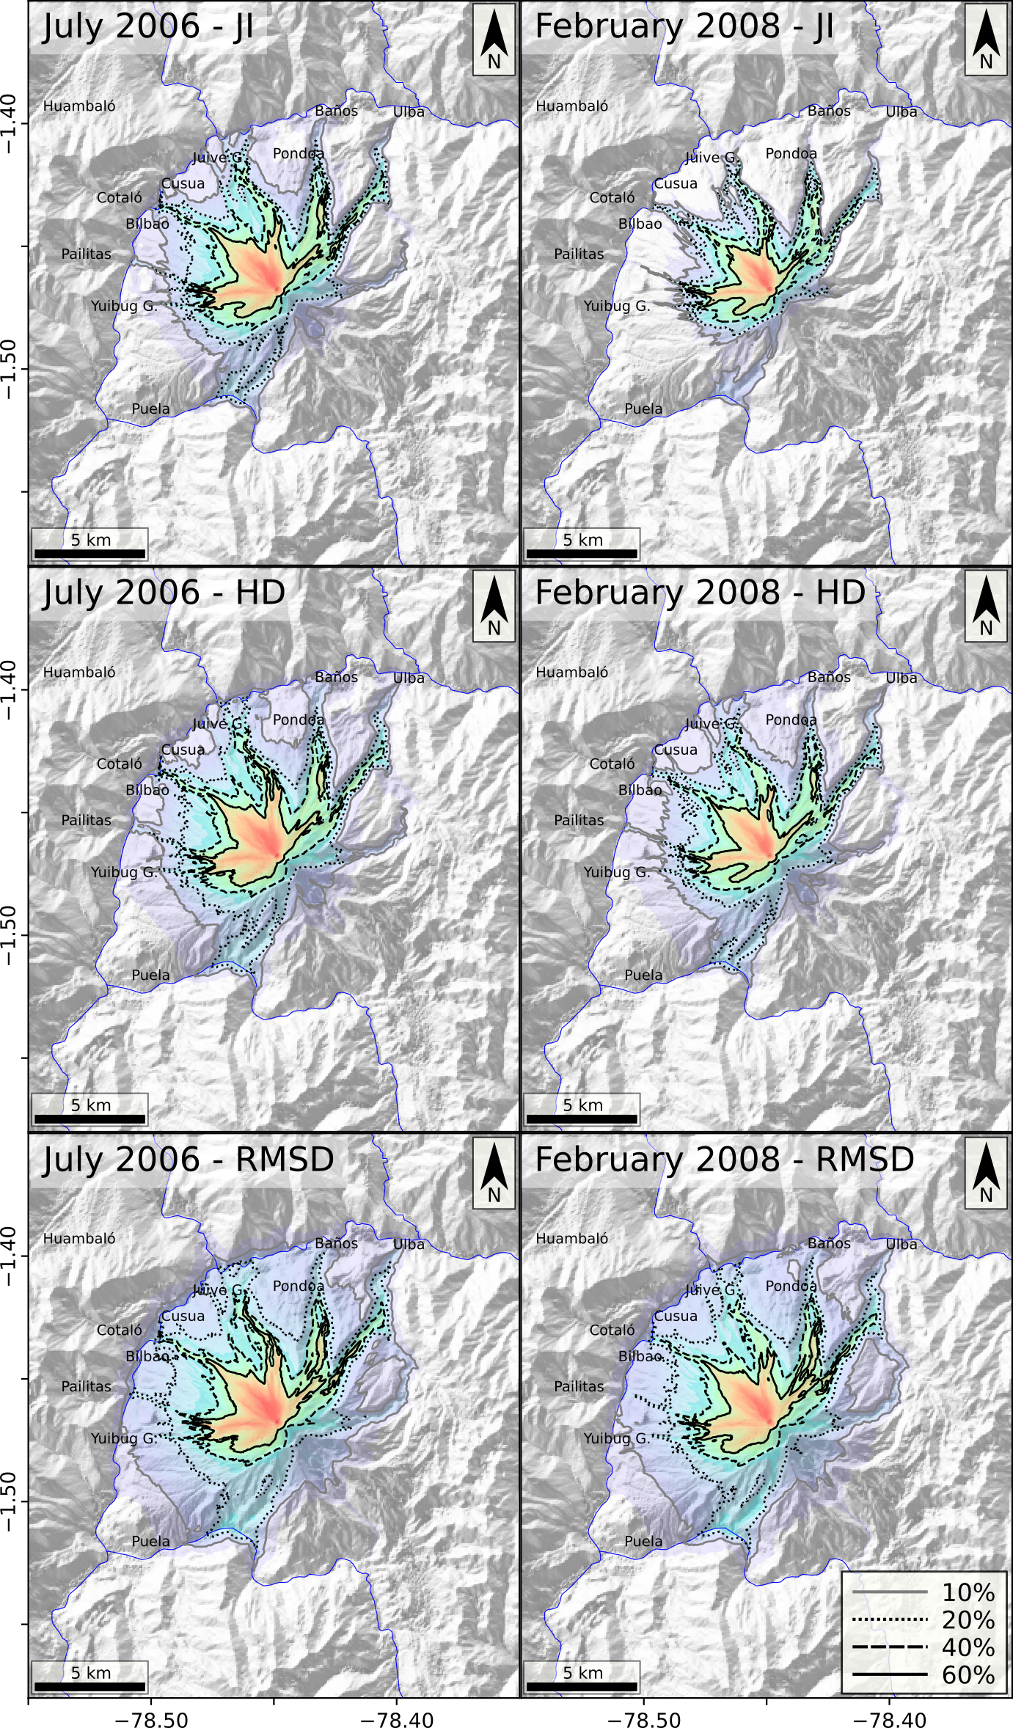

Figure S1. Probabilistic hazard maps for the eruptive scenario ES1 (violent Strombolian to Vulcanian eruption), considering two different reference PDCs to calibrate numerical simulations (July 2006 and February 2008; see titles) and three comparison metrics (JI, HD and RMSD; see titles). Inundation probabilities are indicated by a set of isoprobability curves (see legend) and a rainbow color scale. Labels indicate the main cities. Coordinates are expressed in DD notation.
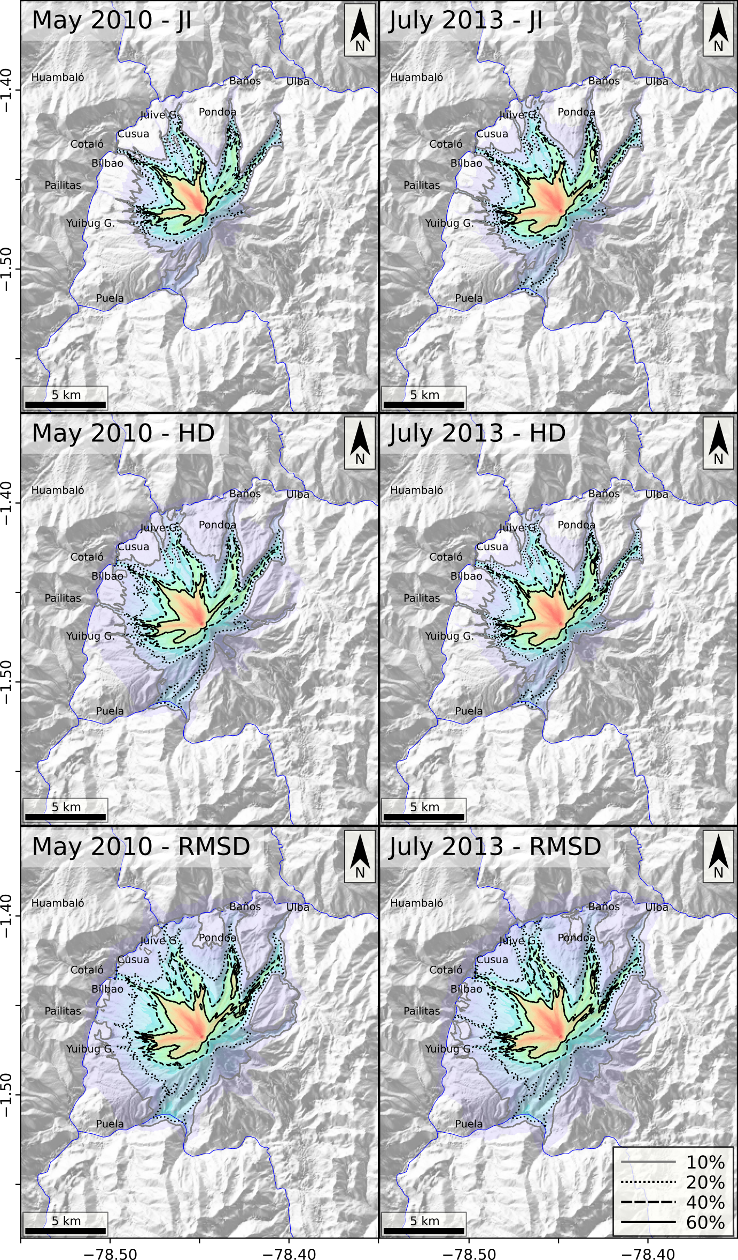

Figure S2. Probabilistic hazard maps for the eruptive scenario ES1 (violent Strombolian to Vulcanian eruption), considering two different reference PDCs to calibrate numerical simulations (May 2010 and July 2013; see titles) and three comparison metrics (JI, HD and RMSD; see titles). Inundation probabilities are indicated by a set of isoprobability curves (see legend) and a rainbow color scale. Labels indicate the main cities. Coordinates are expressed in DD notation.
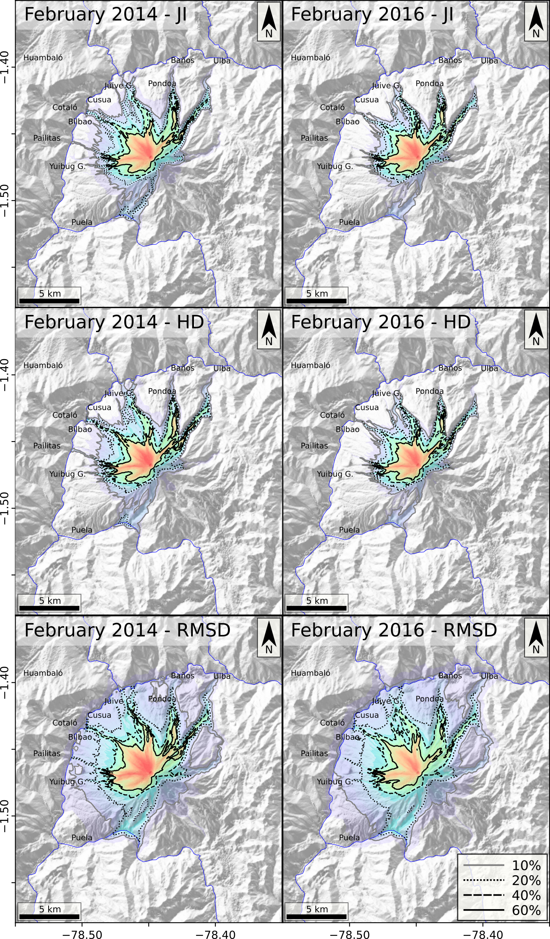
Figure S3. Probabilistic hazard maps for the eruptive scenario ES1 (violent Strombolian to Vulcanian eruption), considering two different reference PDCs to calibrate numerical simulations (February 2014 and February 2016; see titles) and three comparison metrics (JI, HD and RMSD; see titles). Inundation probabilities are indicated by a set of isoprobability curves (see legend) and a rainbow color scale. Labels indicate the main cities. Coordinates are expressed in DD notation.
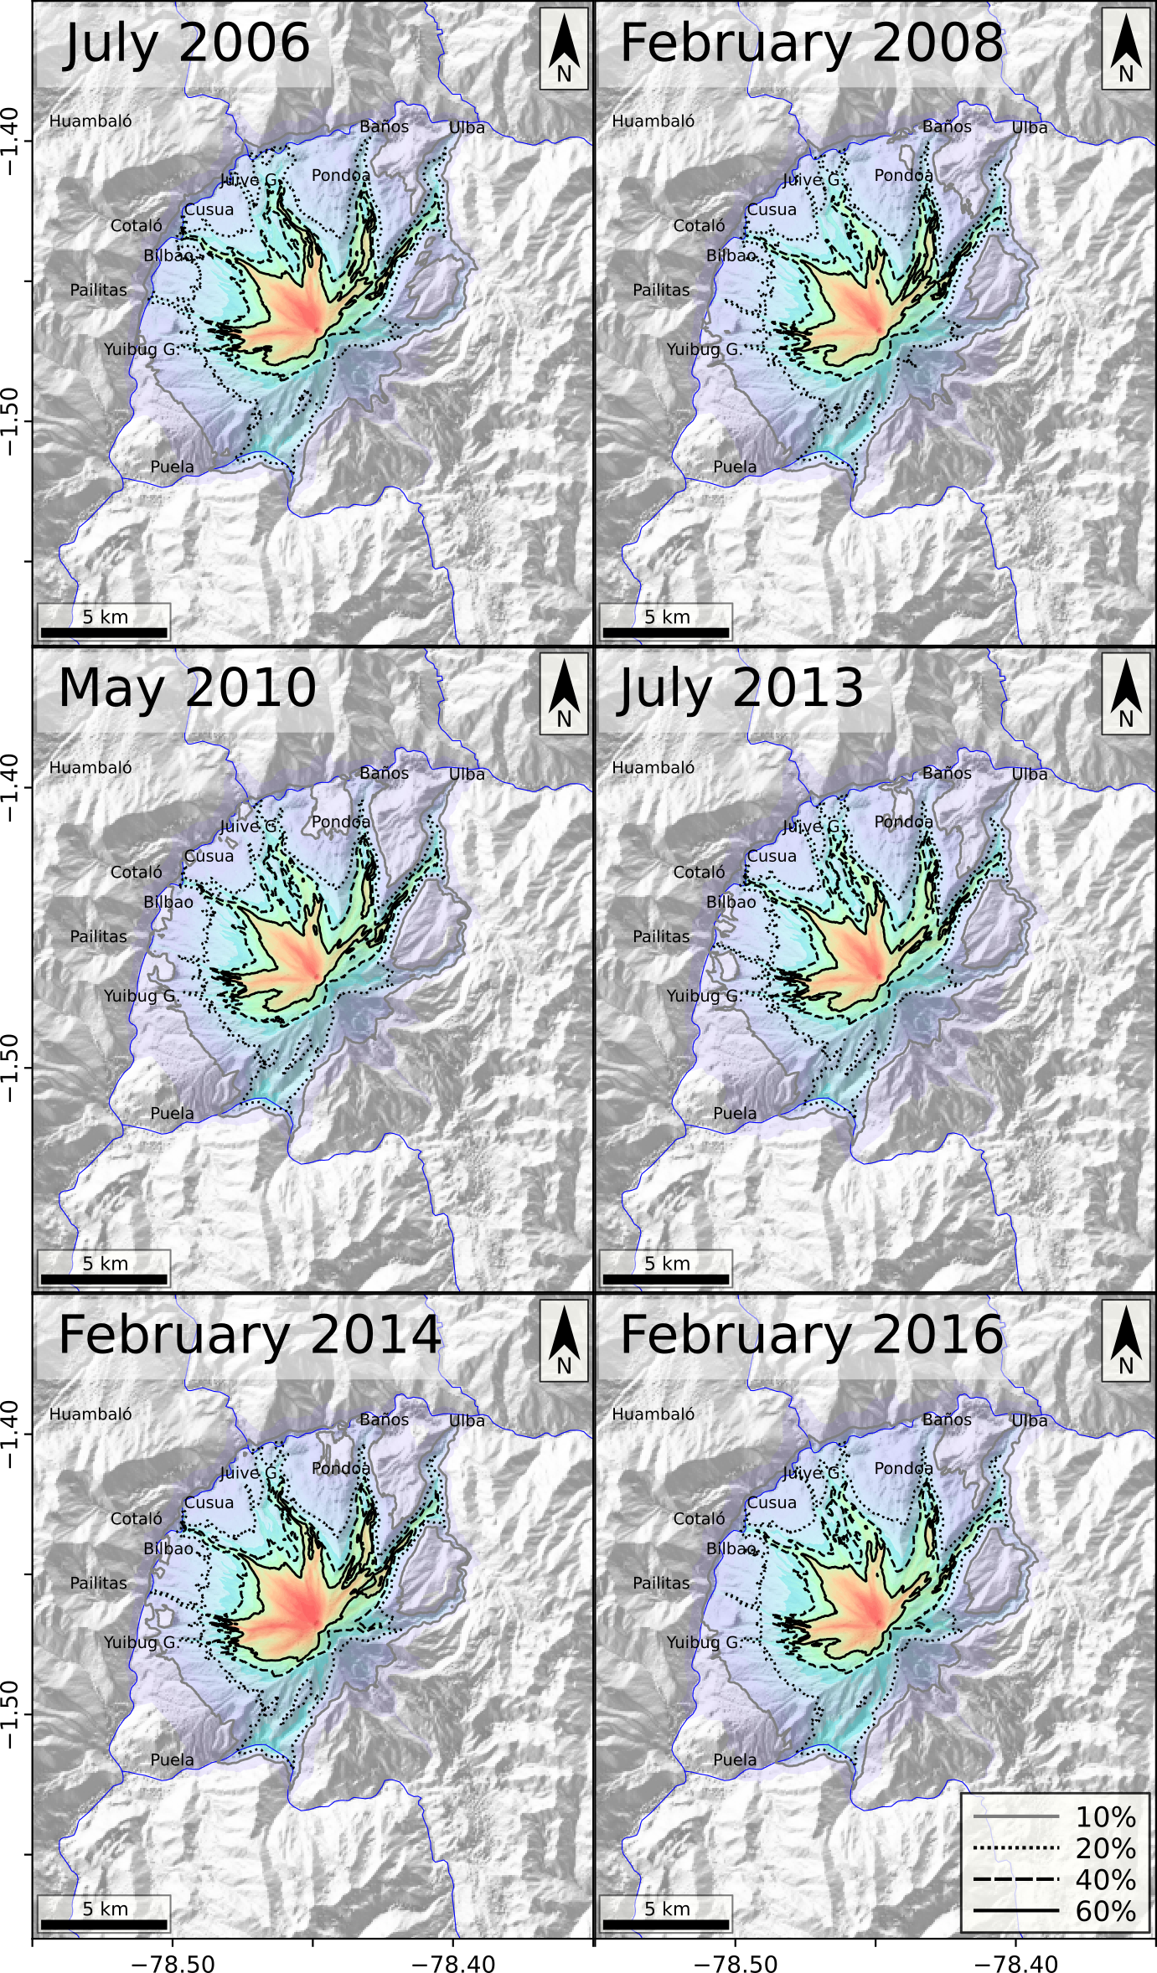
Figure S4. Probabilistic hazard maps for the eruptive scenario ES1 (violent Strombolian to Vulcanian eruption), considering separately six different reference PDCs to calibrate numerical simulations. In each panel, we present the maximum inundation probability computed using three different comparison metrics (see supplementary Figs. S1-S3). Inundation probabilities are indicated by a set of isoprobability curves (see legend) and a rainbow color scale. Labels indicate the main cities. Coordinates are expressed in DD notation.
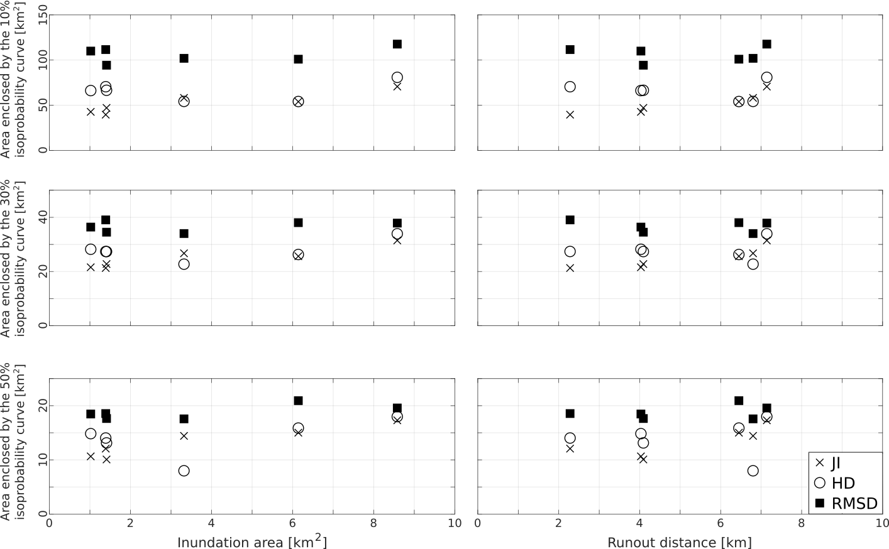

Figure S5. Relationship between geometrical properties of the inundation polygons used for the calibration of ES1 simulations (see Fig. 2) and the area enclosed by different iso-probability curves in the resulting hazard maps (see Supplementary Figs. S1- S3), considering different comparison metrics (see legend).

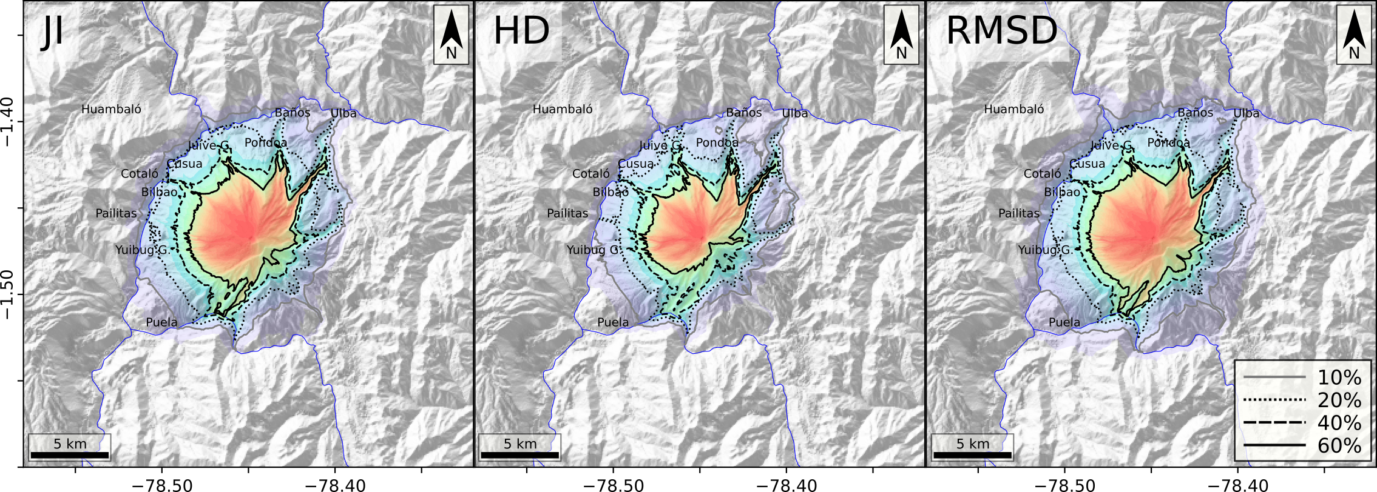

Figure S6. Probabilistic hazard maps for the eruptive scenario ES2 (intermediate magnitude sub-Plinian eruption), considering numerical results of the model ECMapProb 2.0 and three different comparison metrics to calibrate numerical simulations (JI, HD and RMSD; see titles). Inundation probabilities are indicated by a set of isoprobability curves (see legend) and a rainbow color scale. Labels indicate the main cities. Coordinates are expressed in DD notation.

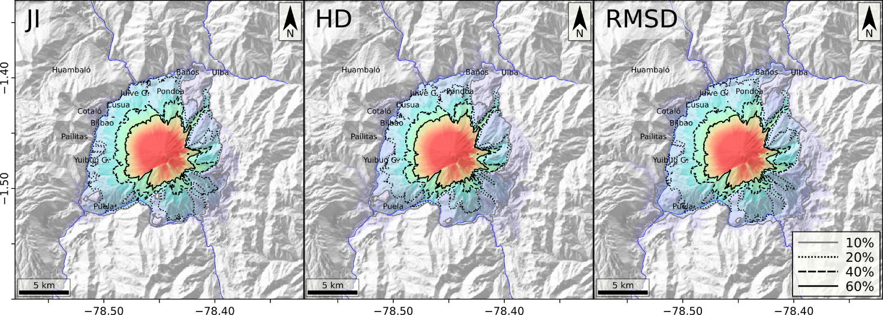
Figure S7. Probabilistic hazard maps for the eruptive scenario ES2 (intermediate magnitude sub-Plinian eruption), considering numerical results of the model BoxMapProb 2.0, $w_{s}=0.05m/s$ and three different comparison metrics to calibrate numerical simulations (JI, HD and RMSD; see titles). Inundation probabilities are indicated by a set of isoprobability curves (see legend) and a rainbow color scale. Labels indicate the main cities. Coordinates are expressed in DD notation.

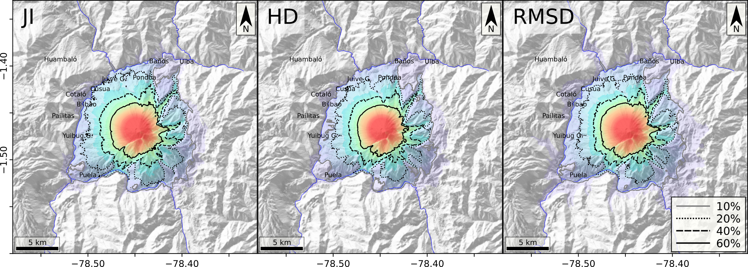

Figure S8. Probabilistic hazard maps for the eruptive scenario ES2 (intermediate magnitude sub-Plinian eruption), considering numerical results of the model BoxMapProb 2.0, $w_{s}=0.3m/s$, and three different comparison metrics to calibrate numerical simulations (JI, HD and RMSD; see titles). Inundation probabilities are indicated by a set of isoprobability curves (see legend) and a rainbow color scale. Labels indicate the main cities. Coordinates are expressed in DD notation.

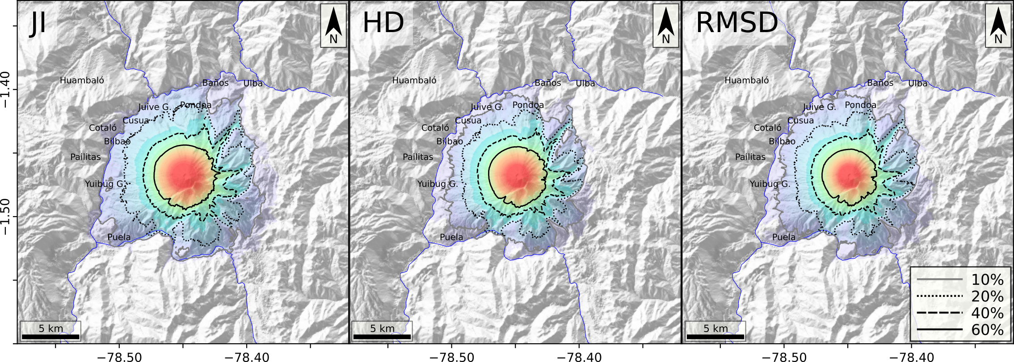
Figure S9. Probabilistic hazard maps for the eruptive scenario ES2 (intermediate magnitude sub-Plinian eruption), considering numerical results of the model BoxMapProb 2.0, $w_{s}=1.2m/s$, and three different comparison metrics to calibrate numerical simulations (JI, HD and RMSD; see titles). Inundation probabilities are indicated by a set of isoprobability curves (see legend) and a rainbow color scale. Labels indicate the main cities. Coordinates are expressed in DD notation.
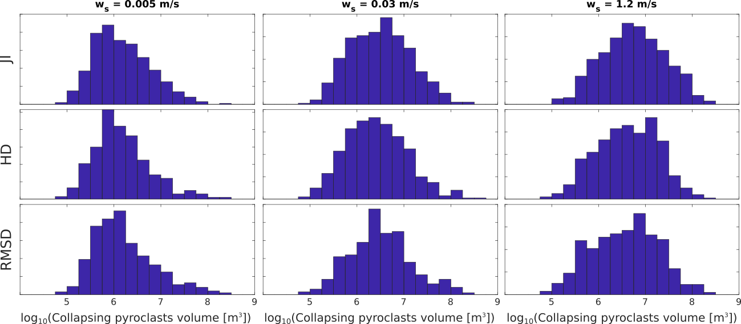
Figure S10. Histograms of the calibrated volumes of collapsing pyroclasts for the BoxMapProb 2.0 simulations associated with the eruptive scenario ES2, considering different values of sedimentation velocity ($w_{s}$; see titles) and comparison metrics (JI, HD and RMSD).

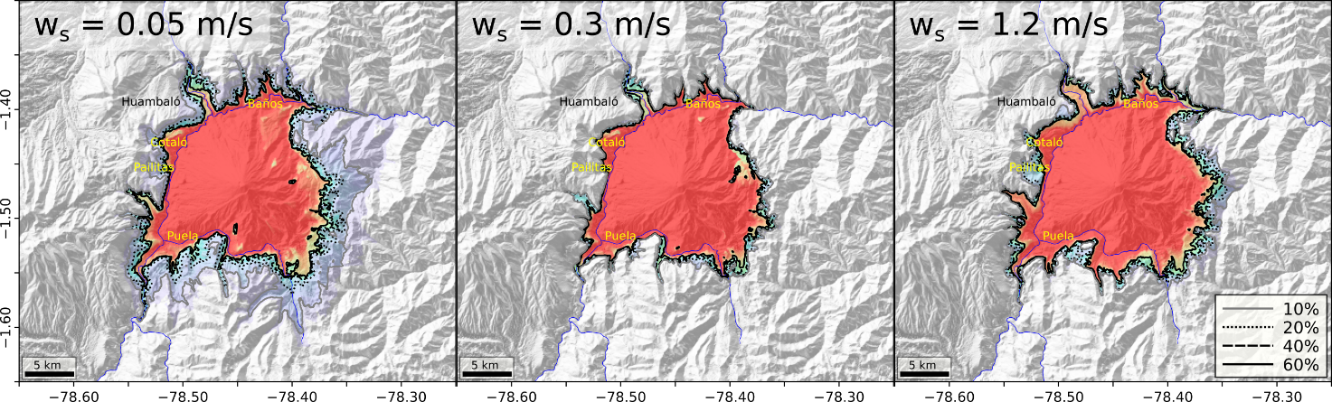

Figure S11. Probabilistic hazard maps for the eruptive scenario ES3 (large magnitude sub-Plinian to Plinian eruption), considering numerical results of the model BoxMapProb 2.0 and different values of $w_{s}$ (see titles). These hazard maps were constructed considering P₁ and P₂ (see Fig. 3) as control points for calibration effects. Inundation probabilities are indicated by a set of isoprobability curves (see legend) and a rainbow color scale. Labels indicate the main cities. Coordinates are expressed in DD notation.

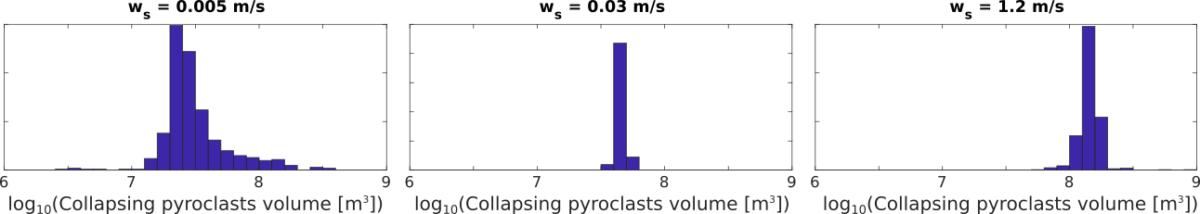

Figure S12. Histograms of the calibrated volumes of collapsing pyroclasts for the BoxMapProb 2.0 simulations associated with the eruptive scenario ES3, considering different values of sedimentation velocity ($w_{s}$; see titles).

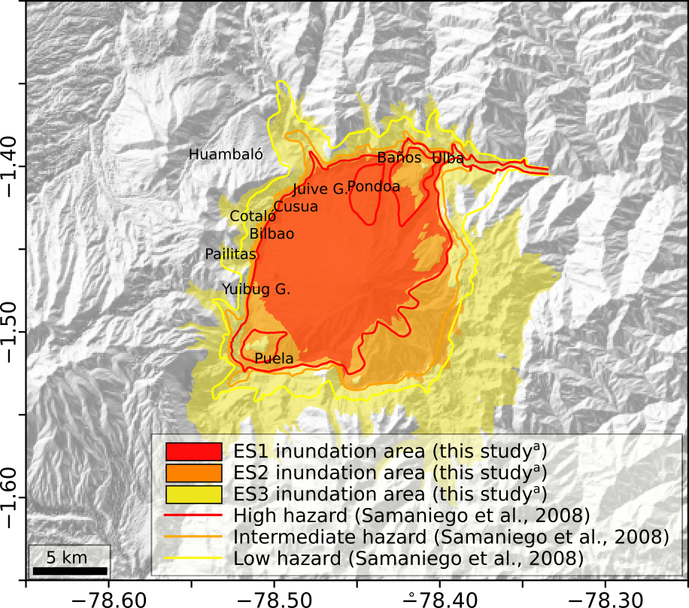
Figure S13. Illustrative example of a three-color hazard map of Tungurahua volcano, constructed by considering the 10% isoprobability curve of the maximum probabilistic hazard map of each scenario. Contours of the hazard levels defined by Samaniego et al. (2008) are also included. Labels indicate the main cities. Coordinates are expressed in DD notation.

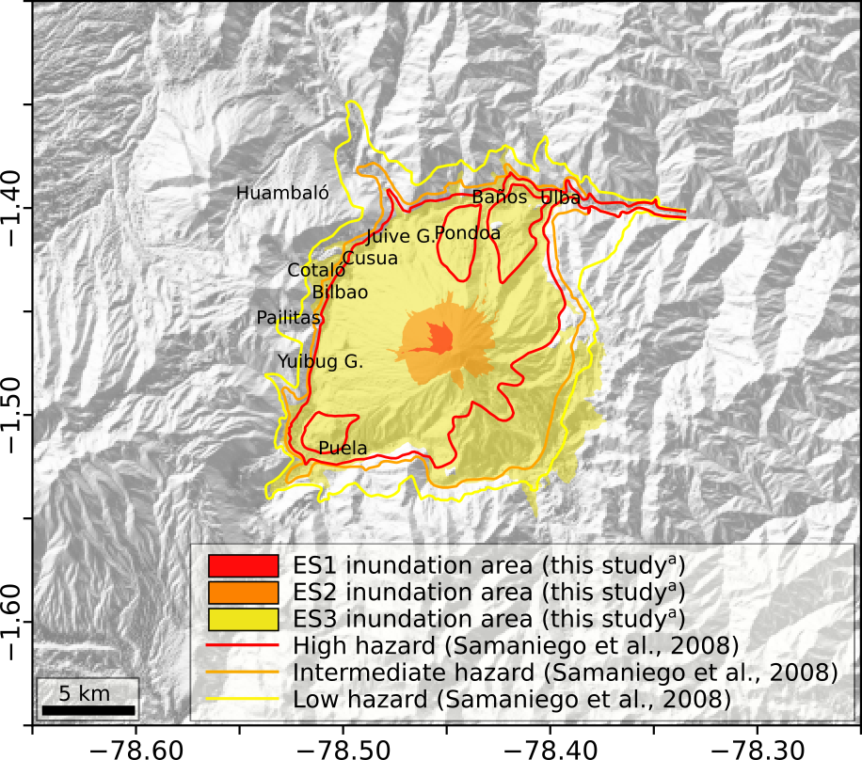
Figure S14. Illustrative example of a three-color hazard map of Tungurahua volcano, constructed by considering the 90% isoprobability curve of the maximum probabilistic hazard map of each scenario. Contours of the hazard levels defined by Samaniego et al. (2008) are also included. Labels indicate the main cities. Coordinates are expressed in DD notation.

