**SUPPLEMENTAL FIGURES**



**Figure S1**. Heatmap of phage f237 open reading frame (ORF).

**Figure S2.** **Minimum evolution tree (ME) constructed from protein sequences of TDH and TRH variants in *V. parahaemolyticus* strains used in this study.** Tree was constructed using MEGA X and annotated using iTOL v6. Bold: reference sequences

**Figure S3. Schematic representation of the VPaI-7 in the 19 *V. parahaemolyticus* strains used in this study.**

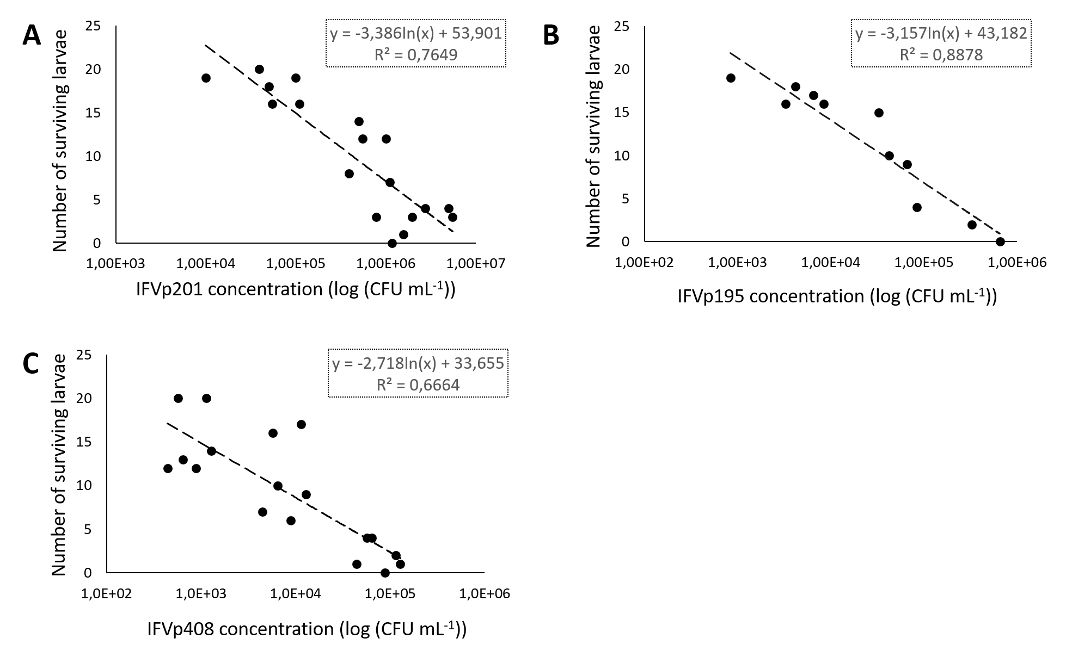

**Figure S4.** **Dose-dependent *G. mellonella* experiments with *V. parahaemolyticus* IFVp201 (A), IFVp195 (B) and IFVp408 (C) strains.** Groups of 20 larvae were experimentally injected with various doses of *V. parahaemolyticus* and survival measured at 24 h post infection. Linear regression was used to calculate LD50 values from the experimental data.

**SUPPLEMENTAL TABLES**

**Table S1. General features of *V. parahaemolyticus* genomes sequenced in this study**

|  |  |  |  |  |  |  |  |  |
| --- | --- | --- | --- | --- | --- | --- | --- | --- |
| **Strain** | **Replicon** | **Size (kbp)** | **%GC** | **Genes** | **CDS** | **rRNA** | **tRNA** | **Biosample accession No.** |
| IFVp18 | Ch. 1 | 3,300 | 45.19 | 3.281 | 3.145 | 5 | 93 | ERS12231012 |
| Ch. 2 | 1.805 | 45.43 | 1.685 | 1.657 | 2 | 10 |
| IFVp69 | Ch. 1 | 3.004 | 45.17 | 2.949 | 2.833 | 4 | 77 | ERS12231019 |
| Ch. 2 | 1.965 | 45.59 | 1.847 | 1.802 | 1 | 25 |
| IFVp182 | Ch. 1 | 3.329 | 45.21 | 3.308 | 3.172 | 3 | 88 | ERS12231013 |
| Ch. 2 | 2.076 | 45.2 | 2.112 | 2,060 | 1 | 29 |
| Plasmid | 40.18 | 41.45 | 46 | 45 | 0 | 0 |
| IFVp195 | Ch. 1 | 3,000 | 45.19 | 2.891 | 2.787 | 2 | 68 | ERS12231014 |
| Ch. 2 | 1.851 | 45.26 | 1.824 | 1.796 | 2 | 9 |
| IFVp408 | Ch. 1 | 3.203 | 45.26 | 3,110 | 2.999 | 2 | 71 | ERS12231018 |
| Ch. 2 | 1.853 | 45.27 | 1.826 | 1.794 | 2 | 13 |
| IFVp5 | Ch. 1 | 3.217 | 45.28 | 3.107 | 2.988 | 5 | 77 | ERS12231020 |
| Ch. 2 | 1.868 | 45.32 | 1.795 | 1.763 | 2 | 11 |
| IFVp201 | Ch. 1 | 3.266 | 45.32 | 3.214 | 3.085 | 4 | 84 | ERS12231015 |
| Ch. 2 | 1.864 | 45.39 | 1.853 | 1.818 | 3 | 15 |
| IFVp203 | Ch. 1 | 3.262 | 45.31 | 3.226 | 3.097 | 3 | 86 | ERS12231016 |
| Ch. 2 | 1.862 | 45.38 | 1.847 | 1.814 | 3 | 13 |
| IFVp136 | Ch. 1 | 3.306 | 45.12 | 3.238 | 3.107 | 3 | 90 | ERS12231010 |
| Ch. 2 | 1,850 | 45.3 | 1.772 | 1.736 | 3 | 15 |
| IFVp177 | Ch. 1 | 3.281 | 45.26 | 3.283 | 3.149 | 5 | 90 | ERS12231011 |
| Ch. 2 | 1.877 | 45.22 | 1.772 | 1.742 | 3 | 10 |
| IFVp22 | Ch. 1 | 3.284 | 45.26 | 3.267 | 3.138 | 4 | 86 | ERS12231017 |
| Ch. 2 | 1.898 | 45.2 | 1.868 | 1.831 | 3 | 15 |
| Ch.: Chromosome | | | |  |  |  |  |  |

**Table S2. Gene count for each genome of *V. parahaemolyticus****.*

|  |  |  |  |  |  |
| --- | --- | --- | --- | --- | --- |
| **Strains** | **No. of CDS** | | | **% of total CDS** | |
| **Total** | **Core** | **Accessory** | **Core** | **Accessory** |
| **IFVp18** | 4.802 | 3.616 | 1,228 | 75 | 26 |
| **IFVp69** | 4.635 | 3.616 | 1,132 | 78 | 24 |
| **IFVp182** | 5.275 | 3.616 | 1,698 | 69 | 32 |
| **IFVp195** | 4.579 | 3.616 | 915 | 79 | 20 |
| **IFVp408** | 4.79 | 3.616 | 1,149 | 75 | 24 |
| **IFVp5** | 4.748 | 3.616 | 1,118 | 76 | 24 |
| **IFVp201** | 4.903 | 3.616 | 1,245 | 74 | 25 |
| **IFVp203** | 4.911 | 3.616 | 1,263 | 74 | 26 |
| **IFVp136** | 4.843 | 3.616 | 1,310 | 75 | 27 |
| **IFVp177** | 4,890 | 3.616 | 1,386 | 74 | 28 |
| **IFVp22** | 4.966 | 3.616 | 1,481 | 73 | 30 |
|  |  |  |  |  |  |
| **CDC_K4557** | 4,844 | 3.616 | 1,278 | 75 | 35 |
| **FORC_014** | 5,064 | 3.616 | 1,704 | 71 | 47 |
| **FDA_R31** | 5,117 | 3.616 | 1,800 | 71 | 50 |
| **RIMD 2210633** | 5,131 | 3.616 | 1,687 | 70 | 47 |
| **BB22OP** | 4,818 | 3.616 | 1,397 | 75 | 39 |
| **MAVP-Q** | 5,178 | 3.616 | 1,739 | 70 | 48 |
| **VN-0028** | 4,891 | 3.616 | 1,447 | 74 | 40 |
| **ATCC 17802** | 5,112 | 3.616 | 1,586 | 71 | 44 |
|  |  |  |  |  |  |

**Table S3. Distribution of pathogenicity islands in *V. parahaemolyticus* strains used in this study.**

|  |  |  |  |  |  |  |
| --- | --- | --- | --- | --- | --- | --- |
| **Strains** | **VPaI-1#** | **VPaI-2** | **VPaI-3** | **VPaI-4** | **VPaI-5** | **VPaI-6** |
| **VP0380-VP0403** | **VP0635-VP0643** | **VP1071-VP1094** | **VP2131-VP2144** | **VP2900-VP2910** | **VPA1253-VPA1270** |
| **IFVp18** | VP0380 +  VP0382-VP0384 +  VP0386-VP0388 +  VP0394-VP0396 +  VP0398 + VP0400 +  VP0402-VP0403 | VP0635-VP0636 +  VP0643 | VP1088 + VP1091-VP1094 | VP3131-VP3139 + VP3142-VP3144 | VP2900-VP2903 + VP2905-VP2910 | - |
| **IFVp69** | - | VP0635-VP0636 + VP0638 | VP1088 + VP1091-VP1094 | - | - | - |
| **IFVp182** | - | VP0635-VP0636 +  VP0643 | VP1088 + VP1091-VP1094 | - | - | VPA1258 |
| **IFVp195** | - | VP0635-VP0636 +  VP0643 | VP1088 + VP1091-VP1094 | - | - | VPA1258 |
| **IFVp408** | - | VP0635-VP0636 +  VP0643 | VP1088 + VP1091-VP1094 | - | - | VPA1258 |
| **IFVp5** | VP0380 +  VP0382-VP0384 +  VP0386-VP0389 +  VP0391-VP0392 +  VP0394-VP0395 + VP0398 +  VP0400-VP0403 | VP0635-VP0639 +  VP0641-VP0643 | VP1071 +  VP1079-VP1088 + VP1091-VP1094 | - | - | VPA1254-VPA1263 + VPA1266-VPA1270 |
| **IFVp201** | - | VP0635-VP0636 +  VP0638-VP0639 +  VP0641-VP0643 | VP1088 + VP1091-VP1094 | - | - | - |
| **IFVp203** | - | VP0635-VP0636 +  VP0638-VP0639 +  VP0641-VP0643 | VP1088 + VP1091-VP1094 | - | - | - |
| **IFVp136** | - | VP0635-VP0636 +  VP0643 | VP1088 + VP1091-VP1094 | - | - | - |
| **IFVp177** | VP0394 | VP0635-VP0636 +  VP0638-VP0639 +  VP0641-VP0643 | VP1088 + VP1091-VP1094 | - | - | VPA1258 |
| **IFVp22** | - | VP0635-VP0636 + VP0638-VP0639 + VP0643 | VP1088 + VP1091-VP1094 | - | - | VPA1258-VPA1259 |
|  |  |  |  |  |  |  |
| **CDC_K4557** | VP0380 + VP0394 +  Vp0398-VP0400 +  VP0402-VP0403 | VP0635-VP0639 +  VP0641-VP0643 | VP1090 + VP1093-VP1094 | - | - | - |
| **FORC_014** | - | VP0635-VP0636 +  VP0643 | VP1088 + VP1091-VP1094 | - | - | - |
| **FDA_R31** | VP0394 | VP0635-VP0636 +  VP0643 | VP1088 + VP1091-VP1094 | - | - | VPA1258-VPA1259 + VPA1266-VPA1270 |
| **RIMD 2210633** | + | + | + | + | + | + |
| **BB22OP** | - | VP0635-VP0636 + VP0638-VP0639 + VP0643 | VP1088 + VP1091-VP1094 | - | VP2901-VP2903 | VPA1257-VPA1258 |
| **MAVP-Q** | - | VP0635-VP0643 | VP1088 + VP1091-VP1094 | - | - | VPA1258-VPA1259 |
| **VN-0028** | VP0386 + VP0395 VP0388-VP0389 + VP0391-VP0392 | VP0635-VP0636 +  VP0638-VP0639 +  VP0641-VP0643 | VP1088 + VP1091-VP1094 | - | - | - |
| **ATCC 17802** | - | VP0635-VP0636 +  VP0643 | VP1088-VP0089 + VP1091-VP1094 | - | - | VPA1253 |

#Results from BLASTp analysis.

**Table S4. Genes over-represented in *trh*+ and under-represented in *trh*- *V. parahaemolyticus* strains.**

|  |  |  |  |  |  |  |
| --- | --- | --- | --- | --- | --- | --- |
| ***Gene#*** | **Annotation** | **gene present in *trh+*** | **gene present in *trh-*** | **gene absent in *trh+*** | **gene absent in *trh-*** | **P value** |
| *appA* | Oligopeptide-binding protein AppA | 8 | 1 | 0 | 10 | 0.013 |
| *ddpC* | putative D D-dipeptide transport system permease protein DdpC | 8 | 1 | 0 | 10 | 0.013 |
| group_1068 | hypothetical protein | 8 | 1 | 0 | 10 | 0.013 |
| group_121 | hypothetical protein | 8 | 0 | 0 | 11 | 0.013 |
| group_1522 | hypothetical protein | 8 | 1 | 0 | 10 | 0.013 |
| group_1524 | hypothetical protein | 8 | 1 | 0 | 10 | 0.013 |
| group_1758 | hypothetical protein | 8 | 1 | 0 | 10 | 0.013 |
| group_1759 | hypothetical protein | 8 | 1 | 0 | 10 | 0.013 |
| group_1760 | hypothetical protein | 8 | 1 | 0 | 10 | 0.013 |
| group_1761 | hypothetical protein | 8 | 1 | 0 | 10 | 0.013 |
| group_196 | hypothetical protein | 8 | 1 | 0 | 10 | 0.013 |
| group_2486 | hypothetical protein | 8 | 1 | 0 | 10 | 0.013 |
| group_2488 | hypothetical protein | 8 | 1 | 0 | 10 | 0.013 |
| group_2492 | hypothetical protein | 7 | 0 | 1 | 11 | 0.013 |
| group_2494 | hypothetical protein | 8 | 1 | 0 | 10 | 0.013 |
| group_2497 | hypothetical protein | 8 | 1 | 0 | 10 | 0.013 |
| group_2502 | hypothetical protein | 8 | 1 | 0 | 10 | 0.013 |
| group_2504 | hypothetical protein | 8 | 1 | 0 | 10 | 0.013 |
| group_2647 | hypothetical protein | 8 | 1 | 0 | 10 | 0.013 |
| group_2648 | hypothetical protein | 8 | 0 | 0 | 11 | 0.013 |
| group_2650 | hypothetical protein | 8 | 1 | 0 | 10 | 0.013 |
| group_2651 | hypothetical protein | 8 | 1 | 0 | 10 | 0.013 |
| group_3647 | hypothetical protein | 8 | 1 | 0 | 10 | 0.013 |
| group_3649 | hypothetical protein | 8 | 1 | 0 | 10 | 0.013 |
| group_416 | hypothetical protein | 8 | 1 | 0 | 10 | 0.013 |
| group_472 | hypothetical protein | 8 | 0 | 0 | 11 | 0.013 |
| group_473 | hypothetical protein | 8 | 0 | 0 | 11 | 0.013 |
| group_476 | hypothetical protein | 8 | 1 | 0 | 10 | 0.013 |
| group_602 | hypothetical protein | 8 | 1 | 0 | 10 | 0.013 |
| group_666 | hypothetical protein | 8 | 1 | 0 | 10 | 0.013 |
| group_913 | hypothetical protein | 8 | 1 | 0 | 10 | 0.013 |
| group_915 | hypothetical protein | 8 | 1 | 0 | 10 | 0.013 |
| *hns_2* | DNA-binding protein H-NS | 8 | 1 | 0 | 10 | 0.013 |
| *hrcN* | Type III secretion ATP synthase HrcN | 8 | 1 | 0 | 10 | 0.013 |
| *nikE* | Nickel import system ATP-binding protein NikE | 8 | 1 | 0 | 10 | 0.013 |
| *ompA_8* | Outer membrane protein A | 8 | 1 | 0 | 10 | 0.013 |
| *oppB_4* | Oligopeptide transport system permease protein OppB | 8 | 1 | 0 | 10 | 0.013 |
| *oppD_6* | Oligopeptide transport ATP-binding protein OppD | 8 | 1 | 0 | 10 | 0.013 |
| *pdeG_2* | putative cyclic di-GMP phosphodiesterase PdeG | 8 | 1 | 0 | 10 | 0.013 |
| *sctC_4* | Type 3 secretion system secretin | 8 | 1 | 0 | 10 | 0.013 |
| *spaP_2* | Surface presentation of antigens protein SpaP | 8 | 1 | 0 | 10 | 0.013 |
| *ureA* | Urease subunit gamma | 8 | 1 | 0 | 10 | 0.013 |
| *ureB* | Urease subunit beta | 8 | 1 | 0 | 10 | 0.013 |
| *ureC* | Urease subunit alpha | 8 | 1 | 0 | 10 | 0.013 |
| *ureD* | Urease accessory protein UreD | 8 | 1 | 0 | 10 | 0.013 |
| *ureE* | Urease accessory protein UreE | 8 | 1 | 0 | 10 | 0.013 |
| *ureF* | Urease accessory protein UreF | 8 | 1 | 0 | 10 | 0.013 |
| *ureG* | Urease accessory protein UreG | 8 | 1 | 0 | 10 | 0.013 |
| *ureR* | Urease operon transcriptional activator | 8 | 1 | 0 | 10 | 0.013 |
| *yedA* | putative inner membrane transporter YedA | 8 | 1 | 0 | 10 | 0.013 |
| *yscU_2* | Yop proteins translocation protein U | 8 | 1 | 0 | 10 | 0.013 |

#results from Scoary analysis