**Supplementary figures Fig. S1 and Fig. S2 for Caruana et al., Comparison of methods for DMSP measurements in dinoflagellate cultures**

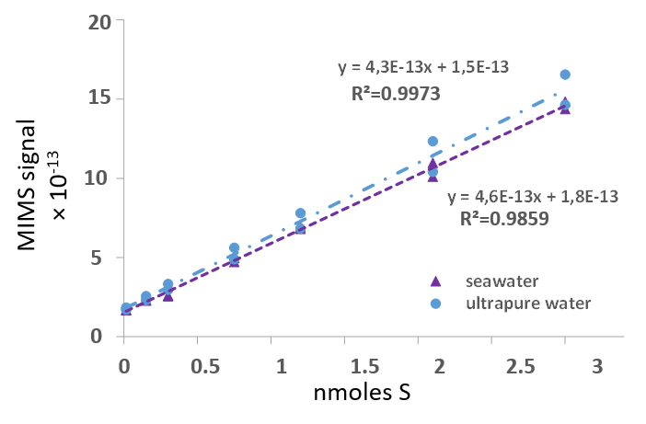

**Fig. S1 Linear ranges of the standard curves obtained for MIMS at low concentrations from 0,015 to 3 nmoles S. Similar results are observed for standards diluted in artificial seawater and freshwater.**

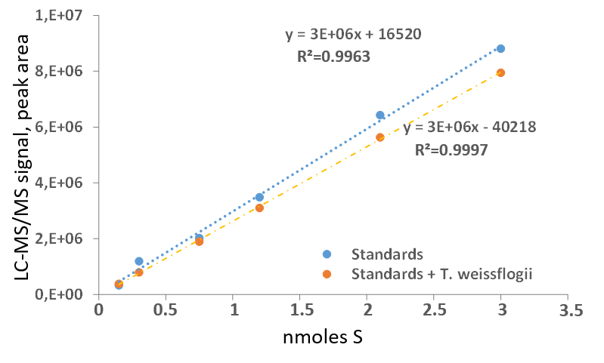

**Fig. S2 Standard curves obtained by LC-MS/MS for DMSP standards (n=2 for each standard concentration) in the presence and absence of *Thalassiosira weissflogii* cells.**