Supporting information for “The Tree of Life eDNA metabarcoding reveals a similar taxonomic richness but dissimilar evolutionary lineages between seaports and marine reserves”

Bastien Macé¹, David Mouillot^{2,3}, Alicia Dalongeville⁴, Morgane Bruno¹, Julie Deter^{2,5}, Alix Varenne^{6,7}, Anaïs Gudefin⁷, Pierre Boissery⁸, Stéphanie Manel^{1,3}

¹CEFE, Univ Montpellier, CNRS, EPHE-PSL University, IRD, Montpellier, France
²MARBEC, Univ Montpellier, CNRS, Ifremer, IRD, Montpellier, France
³Institut Universitaire de France, Paris, France
⁴SPYGEN, Le-Bourget-du-Lac, France
⁵Andromède Océanologie, Mauguio, France
⁶Université Côte d’Azur, CNRS, ECOSEAS, Nice, France
⁷Ecocean, Montpellier, France
⁸Agence de l’eau Rhône-Méditerranée-Corse, Délégation de Marseille, Marseille, France

Contact information: bastien.mace.49@gmail.com

OUTLINE

Supplementary Methods
Figure S1. MOTUs accumulation curves from eDNA samples.
Figure S2. Venn diagrams comparing the number of MOTUs shared between both sampling seasons or exclusive to one of them in every seaport after pooling replicates and combining all MOTUs.
Figure S3. Comparison of communities in seaports between seasons.

Figure S4. PCoA plots on total MOTU composition Jaccard distances between sites.
Figure S5. Comparison of communities in seaports between seasons across taxonomic levels.

Table S1. Scientific papers conducted in Mediterranean seaports for biodiversity surveys.

Table S2. Scientific papers using a multi-marker metabarcoding approach to target different taxonomic groups from seawater environmental DNA.

Table S3. Description of the sampling design in seaports.

Table S4. Description of the sampling design in reserves.

Table S5. IUCN statuses of the threatened species detected.

Table S6. Output of dbRDA conditioned by spatial coordinates testing the effect of habitat on Jaccard distances between samples.

Table S7. Output of dbRDA conditioned by spatial coordinates testing the seasonal effect on Jaccard distances between samples.

Table S8. Output of dbRDA conditioned by spatial coordinates testing the effect of the habitat on Jaccard/Bray-Curtis distances between samples after pooling replicates and combining all MOTUs.

Table S9. Output of dbRDA conditioned by spatial coordinates testing the seasonal effect on Jaccard/Bray-Curtis distances between samples after pooling replicates and combining all MOTUs.

Table S10. Results of the post-hoc Holm-Bonferroni-corrected Dunn’s test on pairwise dissimilarity indices' differences between each seaport and reserve at different taxonomic levels after pooling replicates and combining all MOTUs.

References

SUPPLEMENTARY METHODS

We scrutinized the scientific literature to report every publication surveying seaports biodiversity in the Mediterranean Sea. To achieve this, we selected the publications reviewed by Madon et al. (2023) and restricted the list they provide to the 49 studies conducted in the Mediterranean Sea. To get recent studies not reported in their review, we queried the Web of Science database on the 08/03/2024 with the same expressions used by Madon et al. (2023) (i.e. [(biodiversity AND port) OR (biodiversity AND harbour) OR (biodiversity AND harbor) OR (biodiversity AND marina) OR (biodiversity AND seaport) OR (biological diversity AND port) OR (biological diversity AND harbour) OR (biological diversity AND harbor) OR (biological diversity AND marina) OR (biological diversity AND seaport)]). This literature research added 20 new studies published between 2022 and 2024 and not reported in Madon et al., (2023). Finally, the 69 studies are reported in Table S1. Half of the publications concerned non-indigenous species monitoring. On the other half, all targeted a single or few taxonomic groups with some of them largely understudied, particularly mobile organisms. Only six studies used environmental DNA barcoding or metabarcoding for their survey. Among them, only two did not focus on non-indigenous species, one targeting bacteria, and the other one fish.

We conducted a second query in the Web of Science database to obtain every publication that used a multi-marker metabarcoding approach to target different taxonomic groups from seawater environmental DNA. The following expressions were queried on the 08/03/2024: [marine AND (environmental DNA OR metabarcoding) AND (multimarker OR multi-marker OR tree of life)]. The same query was additionally implemented in the search tool of the journal Environmental DNA since its publications are not yet indexed in Web of Science. All retrieved publications were screened manually to evaluate their relevance to our topic. Finally, we obtained a total of 21 studies reported in Table S2. Among them, only two provided holistic biodiversity assessments by using Tree of Life metabarcoding.

Figure S1. MOTUs accumulation curves from eDNA samples.
Sample-size-based interpolation (solid line segments) and extrapolation (dashed line segments) accumulation curves with 95% confidence interval (shaded areas) for fish (a), animals (b), eukaryotes (c), and prokaryotes (d). Interpolation and extrapolation curves smoothly join at the reference point denoting the observed MOTU richness across the 32 samples. The estimated asymptotes (i.e. overall MOTU richness) are represented by the black horizontal lines.

Figure S2. Venn diagrams comparing the number of MOTUs shared between both sampling seasons or exclusive to one of them in every seaport after pooling replicates and combining all MOTUs.
SMM = Saintes-Maries-de-la-Mer.

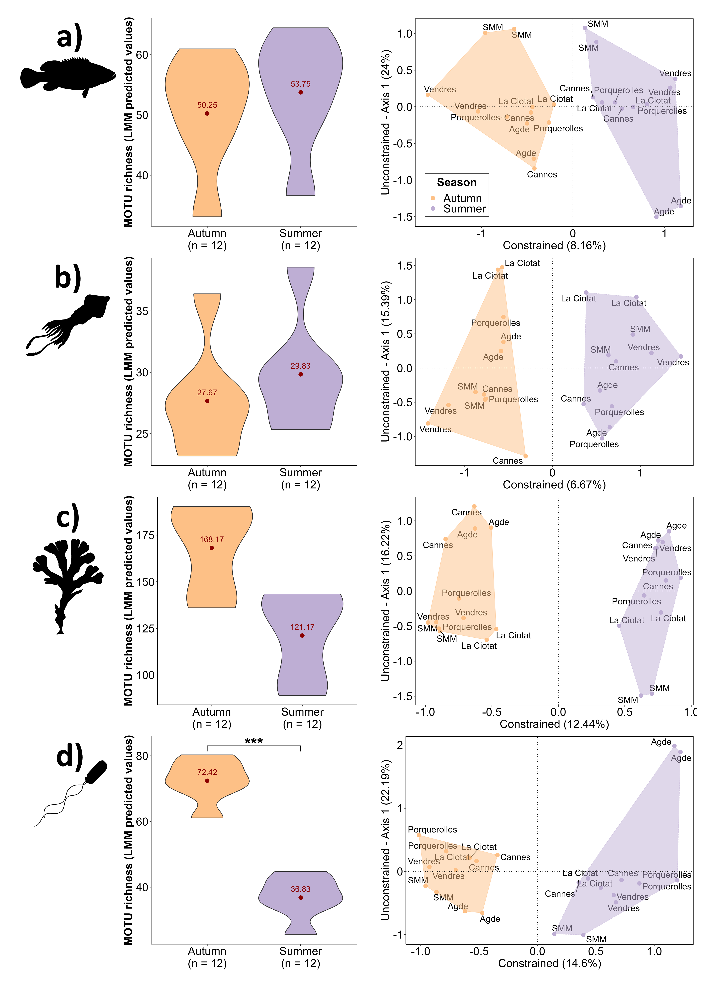
Figure S3. Comparison of communities in seaports between seasons.
Violin plots (left) represent linear mixed-effects model predicted value of MOTU richness for fish (a), animals (b), eukaryotes (c), and prokaryotes (d). Red dots indicate mean values. Asterisks (***) indicate a significance level at 0.001. Site scores plots (right) represent the two first dbRDA axes conditioned by spatial coordinates when testing the effect of season on Jaccard distances between samples (significant for all markers except metazoa; Table S7). SMM = Saintes-Maries-de-la-Mer.

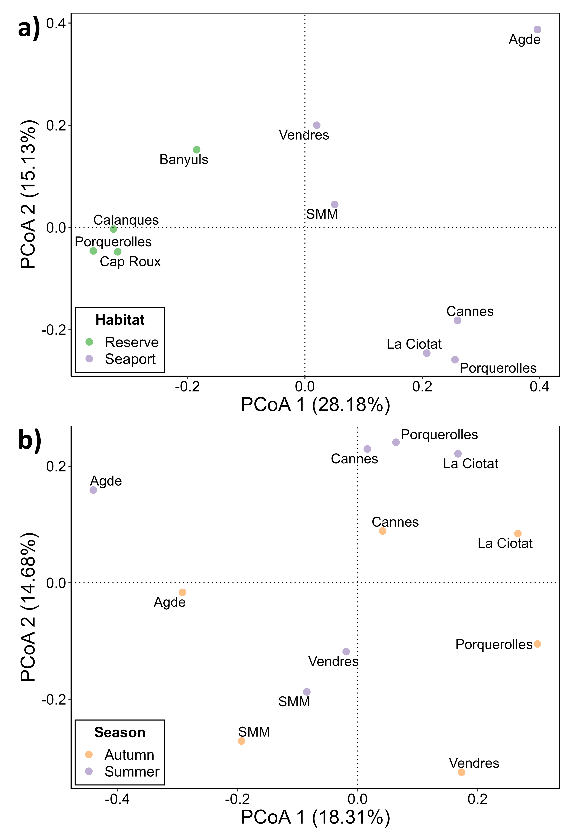
Figure S4. PCoA plots on total MOTU composition Jaccard distances between sites.
The first two dimensions are displayed, with sites colored according to habitat (a) or season (b). Replicates were pooled to have presence/absence data per site. SMM = Saintes-Maries-de-la-Mer.

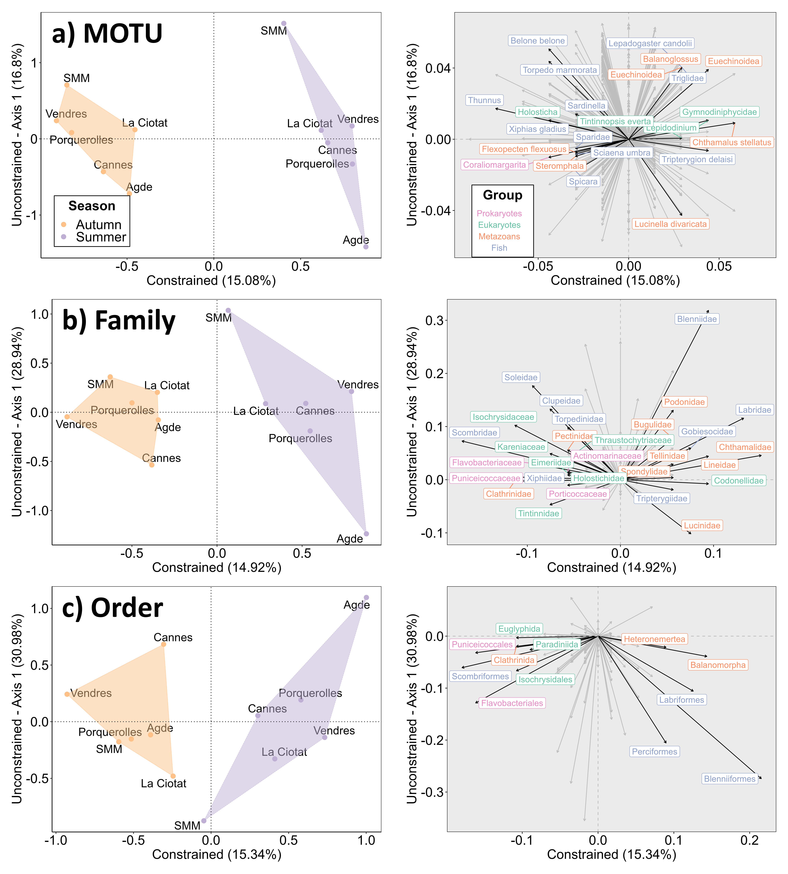
Figure S5. Comparison of communities in seaports between seasons across taxonomic levels.
Site scores (left) and species scores (right) plots represent the two first dbRDA axes conditioned by spatial coordinates testing the seasonal effect on Jaccard/Bray-Curtis distances between sites after pooling replicates and combining all MOTUs (not significant for every level tested; Table S9). Jaccard dissimilarity index is calculated at the MOTU level (a), whereas Bray-Curtis’ dissimilarities based on MOTU abundance are used for family (b) and order (c) levels. Top 10% taxa contributing to the constrained axis are displayed. Among them, only those with an assignment identity higher than 97% are kept at the MOTU level. SMM = Saintes-Maries-de-la-Mer.

Table S1. Scientific papers conducted in Mediterranean seaports for biodiversity surveys.
See "Supplementary Methods" for the methodology. For each study, we give the taxonomic groups targeted by the authors, the number of Mediterranean seaports they sampled, and whether they used seawater environmental DNA or not. Complete references are given at the end of the Supporting Information. NIS = Non-indigenous species.
Author | Date | DOI | Taxonomic group  targeted | Mediterranean  seaports sampled | Seawater  environmental DNA ? | Objective
Abdel-Halim & Khairy | 2007 | 10.12681/mms.153 | Phytoplankton | 1 | No | Anthropogenic impact
Abdel-Salam & Ramadan | 2008 | 10.12681/mms.142 | Bryozoa | 3 | No | Empirical knowledge
Accogli et al. | 2011 | 10.1111/j.1439-0469.2010.00598.x | Tardigrades | 1 | No | Empirical knowledge
Aglieri et al. | 2023 | 10.1016/j.marpolbul.2023.114792 | Fish | 30 | Yes | Non-indigenous species
Aloui-Bejaoui & Afli | 2012 | 10.12681/mms.25 | Zoobenthos | 1 | No | Anthropogenic impact
Ardura & Planes | 2017 | 10.1016/j.ecss.2017.02.004 | Metazoans | 1 | Yes | Non-indigenous species
Arias et al. | 2013 | 10.12681/mms.363 | Branchiomma bairdi | 1 | No | Non-indigenous species
Azzurro et al. | 2019 | 10.1016/j.marpolbul.2018.01.016 | Every NIS possible | 10 | No | Non-indigenous species
Bensari et al. | 2020 | 10.12681/mms.21927 | Fouling organisms | 1 | No | Non-indigenous species
Caliani et al. | 2023 | 10.1016/j.chemosphere.2022.137129 | Pachygrapsus marmoratus | 2 | No | Anthropogenic impact
Catania et al. | 2017 | 10.1139/cjm-2016-0406 | Bacteria | 1 | No | Anthropogenic impact
Chartosia et al. | 2018 | 10.12681/mms.18099 | Every NIS possible | 1 | No | Non-indigenous species
Chatzinikolaou et al. | 2021 | 10.3897/BDJ.9.e66420 | Zoobenthos | 3 | No | Empirical knowledge
Chatzinikolaou et al. | 2018 | 10.1016/j.scitotenv.2017.12.111 | Zoobenthos | 3 | No | Anthropogenic impact
Chebaane et al. | 2019 | 10.12681/mms.20229 | Every NIS possible | 6 | No | Non-indigenous species
Cibic et al. | 2017 | 10.3389/fmars.2017.00336 | Zoobenthos  Microphytobenthos | 1 | No | Anthropogenic impact  Empirical knowledge
Cillari et al. | 2022 | 10.3390/biology11020319 | Cassiopea andromeda | 1 | No | Non-indigenous species
Çinar et al. | 2008 | 10.1016/j.jmarsys.2007.05.004 | Mytilus galloprovincialis | 2 | No | Non-indigenous species
Çinar et al. | 2006 | 10.1111/j.1439-0485.2006.00102.x | Zoobenthos | 1 | No | Non-indigenous species
D'Alessandro et al. | 2020 | 10.1016/j.envpol.2020.113959 | Zoobenthos | 3 | No | Anthropogenic impact
Dauvin et al. | 2017 | 10.1016/j.marpolbul.2017.09.049 | Zoobenthos | 10 | No | Empirical knowledge
David et al. | 2007 | 10.1016/j.marpolbul.2006.08.041 | Plankton | 1 | No | Empirical knowledge
Dell'Anno et al. | 2012 | 10.1016/j.envpol.2012.03.043 | Bacteria | 1 | No | Anthropogenic impact
Elgharsalli et al. | 2015 | 10.4194/1303-2712-v15_3_20 | Molluscs | 1 | No | Empirical knowledge
Evcen & Çinar | 2020 | 10.12714/egejfas.37.2.05 | Sponges | 8 | No | Empirical knowledge
García-Gómez et al. | 2023 | 10.3389/fmars.2023.1166937 | Patella ferruginea | 2 | No | Empirical knowledge
Gauff et al. | 2023 | 10.1016/j.jembe.2023.151882 | Zoobenthos | 1 | No | Anthropogenic impact  Empirical knowledge
Gauff et al. | 2023 | 10.1016/j.marenvres.2022.105859 | Zoobenthos | 1 | No | Non-indigenous species
Gewing et al. | 2016 | 10.1007/s12526-015-0442-5 | Microcosmus exasperatus | 3 | No | Non-indigenous species
Ghannam et al. | 2020 | 10.1128/msphere.00481-19 | Bacteria | 3 | Yes | Empirical knowledge
Guerra-García et al. | 2021 | 10.1016/j.jenvman.2021.112237 | Zoobenthos | 4 | No | Anthropogenic impact
Ismail et al. | 2023 | 10.1007/s10661-023-11690-z | Phytoplankton | 2 | No | Anthropogenic impact  Empirical knowledge
Ismail & Ibrahim | 2017 | 10.1007/s12601-017-0042-3 | Phytoplankton  Bacteria | 1 | No | Anthropogenic impact
Jenhani et al. | 2018 | None | Plankton | 4 | No | Empirical knowledge
Kourkoutmani iet al. | 2023 | 10.12681/mms.32127 | Oithona davisae | 1 | No | Non-indigenous species
Lipej et al. | 2017 | 10.12681/mms.2068 | Every NIS possible | 2 | No | Non-indigenous species
López-Legentil et al. | 2015 | 10.1007/s10530-014-0821- z | Ascidians | 32 | No | Non-indigenous species
Maggio et al. | 2023 | 10.3390/d15111117 | Every NIS possible | 2 | Yes | Non-indigenous species
Maltagliati et al. | 2016 | 10.1111/maec.12261 | Styela plicata | 14 | No | Non-indigenous species
Manel et al. | 2024 | 10.1111/conl.13001 | Fish | 7 | Yes | Empirical knowledge
Megina et al. | 2016 | 10.1080/08927014.2016.1151500 | Eudendrium sp. | 2 | No | Non-indigenous species
Mercader et al. | 2017 | 10.1016/j.ecoleng.2017.03.022 | Fish | 1 | No | Empirical knowledge
Mioni & Furfaro | 2022 | 10.3390/d14080687 | Amathia verticillate  Favorinus ghanensis  Polycerella emertoni | 1 | No | Non-indigenous species
Montesanto et al. | 2022 | 10.12681/mms.28311 | Polyclinum constellatum | 2 | No | Non-indigenous species
Mosbahi et al. | 2021 | 10.1007/s11356-021-14729-1 | Zoobenthos | 12 | No | Non-indigenous species
Moscatello et al. | 2004 | 10.3989/scimar.2004.68s185 | Plankton | 1 | No | Empirical knowledge
Nasi et al. | 2018 | 10.1016/j.marenvres.2018.03.002 | Polychaetes | 1 | No | Anthropogenic impact
Orfanidis et al. | 2021 | 10.12681/mms.25294 | Every NIS possible | 1 | No | Non-indigenous species
Orlando-Bonaca et al. | 2021 | 10.1016/j.marpolbul.2020.111916 | Macrophytes | 20 | No | Non-indigenous species
Ostalé-Valriberas et al. | 2023 | 10.3389/fmars.2023.1127630 | Patella ferruginea | 1 | No | Anthropogenic impact
Ostalé-Valriberas et al. | 2022 | 10.1016/j.marpol.2021.104917 | Patella ferruginea | 1 | No | Anthropogenic impact
Petović & Mačić | 2017 | 10.32582/aa.58.2.14 | Pinctada radiata | 1 | No | Non-indigenous species
Pierri et al. | 2019 | 10.12681/mms.19732 | Sabella spallanzanii | 1 | No | Empirical knowledge
Pineda et al. | 2016 | 10.7717/peerj.2158 | Styela plicata | 9 | No | Non-indigenous species
Rebai et al. | 2022 | 10.3390/jmse10111625 | Zoobenthos | 3 | No | Anthropogenic impact
Selfati et al. | 2018 | 10.1016/j.biocon.2018.01.013 | Fish | 1 | No | Empirical knowledge
Simonini et al. | 2009 | None | Ophryotrocha sp. | 40 | No | Empirical knowledge
Spagnolo et al. | 2019 | 10.1016/j.marpolbul.2017.12.031 | Zoobenthos | 12 | No | Non-indigenous species
Tamburini et al. | 2022 | 10.1016/j.marpolbul.2022.113961 | Fouling organisms | 4 | No | Non-indigenous species
Tempesti et al. | 2020 | 10.1016/j.marpolbul.2019.110768 | Zoobenthos | 1 | No | Non-indigenous species
Tempesti et al. | 2022 | 10.1016/j.marpolbul.2022.114302 | Fouling organisms | 1 | No | Non-indigenous species
Tempesti et al. | 2023 | 10.1016/j.marenvres.2023.106041 | Fouling organisms | 1 | No | Non-indigenous species
Tempesti et al. | 2022 | 10.1016/j.marpolbul.2021.113191 | Fouling organisms | 9 | No | Non-indigenous species
Tempesti et al. | 2022 | 10.1016/j.ecss.2022.108156 | Fouling organisms  and associated macrofauna | 3 | No | Empirical knowledge  Non-indigenous species
Thessalou-Legaki et al. | 2012 | 10.12681/mms.313 | Every NIS possible | 1 | No | Non-indigenous species
Ulman et al. | 2019 | 10.1016/j.jenvman.2019.04.011 | Macro-invertebrates | 50 | No | Non-indigenous species
Varene et al. | 2023 | 10.3390/d15040505 | Macro-invertebrates | 3 | No | Empirical knowledge
Vidjak et al. | 2019 | 10.1016/j.marpolbul.2018.06.055 | Zooplankton | 10 | No | Non-indigenous species
Zarcero et al. | 2024 | 10.1016/j.isci.2023.108588 | Every NIS possible | 1 | Yes | Non-indigenous species

Table S2. Scientific papers using a multi-marker metabarcoding approach to target different taxonomic groups from seawater environmental DNA.
See "Supplementary Methods" for the methodology. For each study, we give the number of markers used by the authors as well as the number of taxonomic groups targeted, the number of samples collected, and whether the whole Tree of Life was targeted or not. Complete references are given at the end of the Supporting Information.
Author | Date | DOI | Markers | Taxonomic  groups | Samples | Tree of Life  metabarcoding ? | Objective
Açıkbaş et al. | 2024 | 10.1002/edn3.509 | 2 | 2 | 27 | No | Method comparison
Anderson & Thompson | 2022 | 10.1002/edn3.251 | 2 | 2 | 6 | No | Protocol optimization
Cicala et al. | 2024 | 10.3389/fmars.2023.1209093 | 2 | 2 | 27 | No | Empirical knowledge
Cordier et al. | 2019 | 10.1016/j.marenvres.2018.12.009 | 3 | 3 | 288 | No | Anthropogenic impact
DiBattista et al. | 2022 | 10.1002/edn3.252 | 4 | 4 | 120 | No | Empirical knowledge
Hoban et al. | 2023 | 10.1111/mec.17140 | 3 | 3 | 34 | No | Empirical knowledge
Holman et al. | 2021 | 10.1038/s41559-021-01439-7 | 3 | 3 | 54 | No | Empirical knowledge
Jensen et al. | 2022 | 10.1002/edn3.285 | 2 | 2 | 96 | No | Empirical knowledge  Protocol optimization
Jeunen et al. | 2020 | 10.1002/edn3.49 | 3 | 3 | 45 | No | Empirical knowledge  Protocol optimization
Jeunen et al. | 2019 | 10.1002/ece3.4843 | 4 | 4 | 10 | No | Protocol optimization
Jin et al. | 2023 | 10.1002/lom3.10538 | 3 | 3 | 1 | No | Method comparison
Kelly et al. | 2017 | 10.3389/fmars.2016.00283 | 3 | 2 | 12 | No | Method comparison
MacNeil et al. | 2022 | 10.1038/s41598-022-17313-w | 2 | 2 | 27 | No | Empirical knowledge  Method comparison
Maiello et al. | 2024 | 10.1002/edn3.389 | 2 | 2 | 72 | No | Protocol optimization
Ohnesorge et al. | 2023 | 10.1002/edn3.478 | 2 | 2 | 25 | No | Method comparison
Robinson et al. | 2023 | 10.1002/edn3.423 | 2 | 2 | 48 | No | Method comparison
Sildever et al. | 2023 | 10.1002/edn3.452 | 5 | 4 | 445 | No | Empirical knowledge
Stat et al. | 2017 | 10.1038/s41598-017-12501-5 | 10 | 9 | 9 | Yes | 1st Tree of Life metabarcoding
West et al. | 2020 | 10.1111/mec.15382 | 4 | 4 | 252 | No | Empirical knowledge
Yip et al. | 2023 | 10.1007/s12526-023-01385-6 | 2 | 2 | 12 | No | Protocol optimization
Zhang et al. | 2020 | 10.1016/j.envint.2019.105307 | 3 | 3 | 109 | Yes | Empirical knowledge

Table S3. Description of the sampling design in seaports.
Substrate typologies were retrieved from the DONIA expert map available on the Medtrix platform (www.medtrix.fr). Typologies found on the outside of seaports are also reported.
Site (West → East) | Season | Number  of samples | Substrates | Mean seafloor  depth (m)
Port-Vendres | Autumn  (October 2021) | 2 | Inside: Infralittoral soft bottom  Outside: Infralittoral soft bottom, Infralittoral algae, Posidonia oceanica meadow | 10.00
 | Summer  (June 2022) | 2
Agde  (Cap d'Agde) | Autumn  (October 2021) | 2 | Inside: Infralittoral soft bottom  Outside: Infralittoral soft bottom, Infralittoral algae, P. oceanica meadow | 3.50
 | Summer  (June 2022) | 2
Saintes-Maries  de-la-Mer | Autumn  (October 2021) | 2 | Inside: Infralittoral soft bottom  Outside: Infralittoral soft bottom | 2.50
 | Summer  (June 2022) | 2
La Ciotat  (Port de Plaisance) | Autumn  (October 2021) | 2 | Inside: Infralittoral soft bottom  Outside: P. oceanica meadow | 4.00
 | Summer  (June 2022) | 2
Porquerolles | Autumn  (October 2021) | 2 | Inside: Infralittoral soft bottom  Outside: P. oceanica meadow | 2.50
 | Summer  (June 2022) | 2
Cannes  (Pierre Canto) | Autumn  (October 2021) | 2 | Inside: Infralittoral soft bottom  Outside: Infralittoral soft bottom, P. oceanica meadow | 4.50
 | Summer  (June 2022) | 2

Table S4. Description of the sampling design in reserves.
Substrate typologies covered by the transects were retrieved from the DONIA expert map available on the Medtrix platform (www.metrix.fr).
Site (West → East) | Season | Number  of samples | Substrates | Mean seafloor  depth (m)
Banyuls  (Natural Marine Reserve of Cerbère-Banyuls) | Summer  (May 2020) | 2 | - Infralittoral soft bottoms  - Infralittoral algae  - P. oceanica meadow | 7.50
Calanques  (Calanques National Park) | Summer  (May 2020) | 2 | - Infralittoral soft bottoms  - Infralittoral algae  - P. oceanica meadow | 12.50
Porquerolles  (Port-Cros National Park) | Summer  (May 2020) | 2 | - Infralittoral soft bottoms  - Infralittoral algae  - P. oceanica meadow | 14.00
Cap Roux  (Cap Roux Protected Maritime Zone) | Summer  (May 2020) | 2 | - Infralittoral soft bottoms  - Infralittoral algae  - P. oceanica meadow | 13.00

Table S5. IUCN statuses of the threatened species detected.
IUCN Red List databases were queried in May 2023.
Species | Mediterranean  Red List status | Global  Red List status
Mola mola | Data Deficient (DD) | Vulnerable (VU)
Epinephelus marginatus | Not Evaluated (NE) | Vulnerable (VU)
Pomatoschistus microps | Critically Endangered (CR) | Least Concern (LC)
Merluccius merluccius | Vulnerable (VU) | Least Concern (LC)
Sciaena umbra | Vulnerable (VU) | Near Threatened (NT)

Table S6. Output of dbRDA conditioned by spatial coordinates testing the effect of habitat on Jaccard distances between samples.
Significant p-values are indicated in bold.
Marker | dbRDA inertia  decomposition | ANOVA-like  permutation test  (10,000 permutations) | Adjusted-R²
teleo | Conditional: 28.03%  Constrained: 16.28%  Unconstrained: 55.69% | F = 4.678  p-value = 1e-4 | 14.31%
metazoa | Conditional: 17.28%  Constrained: 11.68%  Unconstrained: 71.04% | F = 2.630  p-value = 1e-4 | 8.09%
euka2 | Conditional: 20.75%  Constrained: 17.51%  Unconstrained: 61.67% | F = 4.538  p-value = 1e-4 | 15.26%
bact2 | Conditional: 24.56%  Constrained: 23.41%  Unconstrained: 52.03% | F = 7.199  p-value = 1e-3 | 22.53%

Table S7. Output of dbRDA conditioned by spatial coordinates testing the seasonal effect on Jaccard distances between samples.
Significant p-values are indicated in bold.
Marker | dbRDA inertia  decomposition | ANOVA-like  permutation test  (10,000 permutations) | Adjusted-R²
teleo | Conditional: 27.44%  Constrained: 5.921%  Unconstrained: 66.64% | F = 1.777  p-value = 0.044 | 2.83%
metazoa | Conditional: 17.16%  Constrained: 5.524%  Unconstrained: 77.32% | F = 1.429  p-value = 0.065 | 1.82%
euka2 | Conditional: 21.46%  Constrained: 9.768%  Unconstrained: 68.77% | F = 2.841  p-value = 3e-4 | 6.93%
bact2 | Conditional: 21.93%  Constrained: 11.41%  Unconstrained: 66.71% | F = 3.420  p-value = 1e-4 | 8.84%

Table S8. Output of dbRDA conditioned by spatial coordinates testing the effect of the habitat on Jaccard/Bray-Curtis distances between samples after pooling replicates and combining all MOTUs.
Jaccard dissimilarity index is calculated at the MOTU level, whereas Bray-Curtis' dissimilarities based on MOTU abundance are used for higher taxonomic levels. Significant p-values are indicated in bold.
Taxonomic  level | dbRDA inertia  decomposition | ANOVA-like  permutation test  (10,000 permutations) | Adjusted-R²
MOTU | Conditional: 27.19%  Constrained: 22.53%  Unconstrained: 50.28% | F = 2.689  p-value = 0.015 | 18.20%
Family | Conditional: 33.33%  Constrained: 20.55%  Unconstrained: 46.12% | F = 2.673  p-value = 0.027 | 16.54%
Order | Conditional: 31.69%  Constrained: 22.09%  Unconstrained: 46.22% | F = 2.868  p-value = 0.033 | 18.50%
Class | Conditional: 32.04%  Constrained: 17.35%  Unconstrained: 50.61% | F = 2.056  p-value = 0.106 | 11.46%
Phylum | Conditional: 27.56%  Constrained: 22.05%  Unconstrained: 50.77% | F = 2.606  p-value = 0.060 | 17.55%

Table S9. Output of dbRDA conditioned by spatial coordinates testing the seasonal effect on Jaccard/Bray-Curtis distances between samples after pooling replicates and combining all MOTUs.
Jaccard dissimilarity index is calculated at the MOTU level, whereas Bray-Curtis' dissimilarities based on MOTU abundance are used for higher taxonomic levels. Significant p-values are indicated in bold.
Taxonomic  level | dbRDA inertia  decomposition | ANOVA-like  permutation test  (10,000 permutations) | Adjusted-R²
MOTU | Conditional: 26.01%  Constrained: 11.16%  Unconstrained: 62.83% | F = 1.420  p-value = 0.069 | 4.04%
Family | Conditional: 31.79%  Constrained: 10.18%  Unconstrained: 58.03% | F = 1.403  p-value = 0.171 | 3.58%
Order | Conditional: 26.93  Constrained: 11.21  Unconstrained: 61.86 | F = 1.450  p-value = 0.166 | 4.25%
Class | Conditional: 21.55  Constrained: 13.66  Unconstrained: 64.95 | F = 1.683  p-value = 0.139 | 6.80%
Phylum | Conditional: 16.85  Constrained: 12.06  Unconstrained: 71.95 | F = 1.341  p-value = 0.265 | 3.88%

Table S10. Results of the post-hoc Holm-Bonferroni-corrected Dunn’s test on pairwise dissimilarity indices' differences between each seaport and reserve at different taxonomic levels after pooling replicates and combining all MOTUs.
Previous Kruskal-Wallis' test was significant (H = 82.69, p-value = 2.2E-16), suggesting differences among taxonomic levels for β-diversity index. Significant p-values are indicated in bold.
Taxonomic  level 1 | Taxonomic  level 2 | Test  statistic | p-value | Adjusted  p-value
MOTU | Family | -3.77 | 1.63E-04 | 9.80E-04
MOTU | Order | -4.66 | 3.17E-06 | 2.53E-05
MOTU | Class | -7.49 | 7.12E-14 | 6.41E-13
MOTU | Phylum | -7.96 | 1.65E-15 | 1.65E-14
Family | Order | -0.89 | 3.73E-01 | 7.47E-01
Family | Class | -3.72 | 2.03E-04 | 1.01E-03
Family | Phylum | -4.20 | 2.73E-05 | 1.91E-04
Order | Class | -2.83 | 4.72E-03 | 1.42E-02
Order | Phylum | -3.31 | 9.50E-04 | 3.80E-03
Class | Phylum | -0.48 | 6.32E-01 | 7.47E-01

REFERENCES
Madon, B., David, R., Torralba, A., Jung, A., Marengo, M., & Thomas, H. (2023). A review of biodiversity research in ports: Let’s not overlook everyday nature! Ocean & Coastal Management, 242, 106623. https://doi.org/10.1016/j.ocecoaman.2023.106623

- Publications reported in Table S1
Abdel-Halim, A. M., & Khairy, H. M. (2007). Potential impact of some abiotic parameters on a phytoplankton community in a confined bay of the Eastern Mediterranean Sea: Eastern Harbour of Alexandria, Egypt. Mediterranean Marine Science, 8(2), Article 2. https://doi.org/10.12681/mms.153
Abdel-Salam, K. M., & Ramadan, S. E. (2008). Fouling Bryozoa from some Alexandria harbours, EGYPT. (I) Erect species. Mediterranean Marine Science, 9(1), Article 1. https://doi.org/10.12681/mms.142
Accogli, G., Gallo, M., D’Addabbo, R., & Hansen, J. G. (2011). Diversity and ecology of the marine tardigrades along the Apulian Coast. Journal of Zoological Systematics and Evolutionary Research, 49(s1), 53–57. https://doi.org/10.1111/j.1439-0469.2010.00598.x
Aglieri, G., Quattrocchi, F., Mariani, S., Baillie, C., Spatafora, D., Di Franco, A., Turco, G., Tolone, M., Di Gerlando, R., & Milazzo, M. (2023). Fish eDNA detections in ports mirror fishing fleet activities and highlight the spread of non-indigenous species in the Mediterranean Sea. Marine Pollution Bulletin, 189, 114792. https://doi.org/10.1016/j.marpolbul.2023.114792
Aloui-Bejaoui, N., & Afli, A. (2012). Functional diversity of the macro-invertebrate community in the port area of Kerkennah Islands (Tunisia). Mediterranean Marine Science, 13(1), Article 1. https://doi.org/10.12681/mms.25
Ardura, A., & Planes, S. (2017). Rapid assessment of non-indigenous species in the era of the eDNA barcoding: A Mediterranean case study. Estuarine, Coastal and Shelf Science, 188, 81–87. https://doi.org/10.1016/j.ecss.2017.02.004
Arias, A., Giangrande, A., Gambi, M. C., & Anadon, N. (2013). Biology and new records of the invasive species Branchiomma bairdi (Annelida: Sabellidae) in the Mediterranean Sea. Mediterranean Marine Science, 14(1), Article 1. https://doi.org/10.12681/mms.363
Azzurro, E., Bolognini, L., Dragičević, B., Drakulović, D., Dulčić, J., Fanelli, E., Grati, F., Kolitari, J., Lipej, L., Magaletti, E., Marković, O., Matić-Skoko, S., Mavrič, B., Milone, N., Joksimović, A., Tomanić, J., Scarpato, A., Tutman, P., Vrdoljak, D., & Zappacosta, F. (2019). Detecting the occurrence of indigenous and non-indigenous megafauna through fishermen knowledge: A complementary tool to coastal and port surveys. Marine Pollution Bulletin, 147, 229–236. https://doi.org/10.1016/j.marpolbul.2018.01.016
Bensari, B., Bahbah, L., Lounaouci, A., Fahci, S. E., Bouda, A., & Bachari, N. E. I. (2020). First records of non-indigenous species in port of Arzew (Algeria: Southwestern Mediterranean). Mediterranean Marine Science, 21(2), Article 2. https://doi.org/10.12681/mms.21927
Caliani, I., Cannicci, S., Pretti, C., Baratti, M., Contini, G., Vitale, M., Casini, S., Fossi, M. C., Iannucci, A., & Fratini, S. (2023). A multidisciplinary integrated approach using Pachygrapsus marmoratus to assess the impact of port activities on mediterranean marine protected areas. Chemosphere, 312, 137129. https://doi.org/10.1016/j.chemosphere.2022.137129
Catania, V., Sarà, G., Settanni, L., & Quatrini, P. (2017). Bacterial communities in sediment of a Mediterranean marine protected area. Canadian Journal of Microbiology, 63(4), 303–311. https://doi.org/10.1139/cjm-2016-0406
Chartosia, N., Anastasiadis, D., Bazairi, H., Crocetta, F., Deidun, A., Despalatović, M., Martino, V. D., Dimitriou, N., Dragičević, B., Dulčić, J., Durucan, F., Hasbek, D., Ketsilis-Rinis, V., Kleitou, P., Lipej, L., Macali, A., Marchini, A., Ousselam, M., Piraino, S., … Yapici, S. (2018). New Mediterranean Biodiversity Records (July 2018). Mediterranean Marine Science, 19(2), Article 2. https://doi.org/10.12681/mms.18099
Chatzinikolaou, E., Damianidis, P., Pavloudi, C., Vasileiadou, A., Faulwetter, S., Keklikoglou, K., Plaitis, W., Mavraki, D., Nikolopoulou, S., & Arvanitidis, C. (2021). Benthic communities in three Mediterranean touristic ports: MAPMED project. Biodiversity Data Journal, 9, e66420. https://doi.org/10.3897/BDJ.9.e66420
Chatzinikolaou, E., Mandalakis, M., Damianidis, P., Dailianis, T., Gambineri, S., Rossano, C., Scapini, F., Carucci, A., & Arvanitidis, C. (2018). Spatio-temporal benthic biodiversity patterns and pollution pressure in three Mediterranean touristic ports. Science of The Total Environment, 624, 648–660. https://doi.org/10.1016/j.scitotenv.2017.12.111
Chebaane, S., Sempere-Valverde, J., Dorai, S., Kacem, A., & Sghaier, Y. R. (2019). A Preliminary inventory of alien and cryptogenic species in Monastir Bay, Tunisia: Spatial distribution, introduction trends and pathways. Mediterranean Marine Science, 20(3), Article 3. https://doi.org/10.12681/mms.20229
Cibic, T., Franzo, A., Nasi, F., Auriemma, R., & Del Negro, P. (2017). The Port of Trieste (Northern Adriatic Sea)—A Case Study of the “Ecosystem Approach to Management.” Frontiers in Marine Science, 4. https://doi.org/10.3389/fmars.2017.00336
Cillari, T., Allegra, A., Berto, D., Bosch-Belmar, M., Falautano, M., Maggio, T., Milisenda, G., Perzia, P., Rampazzo, F., Sinopoli, M., & Castriota, L. (2022). Snapshot of the Distribution and Biology of Alien Jellyfish Cassiopea andromeda (Forsskål, 1775) in a Mediterranean Touristic Harbour. Biology, 11(2), Article 2. https://doi.org/10.3390/biology11020319
Çinar, M. E., Katağan, T., Koçak, F., Öztürk, B., Ergen, Z., Kocatas, A., Önen, M., Kirkim, F., Bakir, K., Kurt, G., Dağli, E., Açik, S., Doğan, A., & Özcan, T. (2008). Faunal assemblages of the mussel Mytilus galloprovincialis in and around Alsancak Harbour (Izmir Bay, eastern Mediterranean) with special emphasis on alien species. Journal of Marine Systems, 71(1), 1–17. https://doi.org/10.1016/j.jmarsys.2007.05.004
Çinar, M. E., Katagan, T., Öztürk, B., Egemen, Ö., Ergen, Z., Kocatas, A., Önen, M., Kirkim, F., Bakir, K., Kurt, G., Dagli, E., Kaymakçi, A., Açik, S., Dogan, A., & Özcan, T. (2006). Temporal changes of soft-bottom zoobenthic communities in and around Alsancak Harbor (Izmir Bay, Aegean Sea), with special attention to the autecology of exotic species. Marine Ecology, 27(3), 229–246. https://doi.org/10.1111/j.1439-0485.2006.00102.x
D’Alessandro, M., Porporato, E. M. D., Esposito, V., Giacobbe, S., Deidun, A., Nasi, F., Ferrante, L., Auriemma, R., Berto, D., Renzi, M., Scotti, G., Consoli, P., Del Negro, P., Andaloro, F., & Romeo, T. (2020). Common patterns of functional and biotic indices in response to multiple stressors in marine harbours ecosystems. Environmental Pollution, 259, 113959. https://doi.org/10.1016/j.envpol.2020.113959
Dauvin, J. C., Bakalem, A., Baffreau, A., & Grimes, S. (2017). Benthic ecological status of Algerian harbours. Marine Pollution Bulletin, 125(1), 378–388. https://doi.org/10.1016/j.marpolbul.2017.09.049
David, M., Gollasch, S., Cabrini, M., Perkovič, M., Bošnjak, D., & Virgilio, D. (2007). Results from the first ballast water sampling study in the Mediterranean Sea – the Port of Koper study. Marine Pollution Bulletin, 54(1), 53–65. https://doi.org/10.1016/j.marpolbul.2006.08.041
Dell’Anno, A., Beolchini, F., Rocchetti, L., Luna, G. M., & Danovaro, R. (2012). High bacterial biodiversity increases degradation performance of hydrocarbons during bioremediation of contaminated harbor marine sediments. Environmental Pollution, 167, 85–92. https://doi.org/10.1016/j.envpol.2012.03.043
Elgharsalli, R., Rabaoui, L., & Aloui-Bejaoui, N. (2015). Community Structure of a Molluscan Assemblage in an Anthropized Environment, Hammamet Marina, North-Eastern Tunisia. Turkish Journal of Fisheries and Aquatic Sciences, 15(3), 757–766.
Evcen, A., & Çinar, M. (2020). Sponge species from ports of the inner and middle parts of İzmir Bay (Aegean Sea, Eastern Mediterranean) İzmir iç ve orta körfezi limanlarından sünger türleri (Ege Denizi, Doğu Akdeniz). Ege Journal of Fisheries and Aquatic Sciences, 37, 149–155. https://doi.org/10.12714/egejfas.37.2.05
García-Gómez, J. C., Cid-Iturbe, A., Ostalé-Valriberas, E., Espada, R., Carballo, J. L., Fa, D. A., García-Olaya, C., & Blanca-Sújar, R. (2023). Advances in the management and translocation methodology of the endangered mollusk Patella ferruginea in artificial habitats of port infrastructures: Implications for its conservation. Frontiers in Marine Science, 10. https://doi.org/10.3389/fmars.2023.1166937
Gauff, R., Davoult, D., Bohner, O., Coudret, J., Jacquet, S., Loisel, S., Rondeau, S., Wafo, E., & Lejeusne, C. (2023). Unexpected biotic homogenization masks the effect of a pollution gradient on local variability of community structure in a marine urban environment. Journal of Experimental Marine Biology and Ecology, 562, 151882. https://doi.org/10.1016/j.jembe.2023.151882
Gauff, R. P. M., Joubert, E., Curd, A., Carlier, A., Chavanon, F., Ravel, C., & Bouchoucha, M. (2023). The elephant in the room: Introduced species also profit from refuge creation by artificial fish habitats. Marine Environmental Research, 185, 105859. https://doi.org/10.1016/j.marenvres.2022.105859
Gewing, M.-T., Bronstein, O., Nagar, L. R., Granot, I., Frid, O., & Shenkar, N. (2016). First record of the non-indigenous ascidian Microcosmus exasperatus, Heller 1878, in Cyprus. Marine Biodiversity, 46(4), 937–941. https://doi.org/10.1007/s12526-015-0442-5
Ghannam, R. B., Schaerer, L. G., Butler, T. M., & Techtmann, S. M. (2020). Biogeographic Patterns in Members of Globally Distributed and Dominant Taxa Found in Port Microbial Communities. mSphere, 5(1), 10.1128/msphere.00481-19. https://doi.org/10.1128/msphere.00481-19
Guerra-García, J. M., Navarro-Barranco, C., Ros, M., Sedano, F., Espinar, R., Fernández-Romero, A., Martínez-Laiz, G., Cuesta, J. A., Giráldez, I., Morales, E., Florido, M., & Moreira, J. (2021). Ecological quality assessement of marinas: An integrative approach combining biological and environmental data. Journal of Environmental Management, 286, 112237. https://doi.org/10.1016/j.jenvman.2021.112237
Ismail, M. M., Diab, M. H., & El-Sheekh, M. M. (2023). Trophic status determination of the Egyptian Eastern Mediterranean Sea based on phytoplankton diversity and their biochemical contents. Environmental Monitoring and Assessment, 195(9), 1040. https://doi.org/10.1007/s10661-023-11690-z
Ismail, M. M., & Ibrahim, H. A. A. (2017). Phytoplankton and bacterial community structures and their interaction during red-tide phenomena. Ocean Science Journal, 52(3), 411–425. https://doi.org/10.1007/s12601-017-0042-3
Jenhani, A., Fathalli, A., Aouani, J., & Romdhane, M. (2018). Plankton and sediment in ballast water discharge in the Gulf of Gabes (Tunisia). Vie et Milieu, 68(2-3), 65–74.
Kourkoutmani, P., Loufi, K., Kalantaridou, G., Karagianni, A., & Michaloudi, E. (2023). Spatio-temporal variation of the invasive copepod Oithona davisae in the zooplankton community of Kavala harbour. Mediterranean Marine Science, 24(1), Article 1. https://doi.org/10.12681/mms.32127
Lipej, L., Acevedo, I., Akel, E. H. K., Anastasopoulou, A., Angelidis, A., Azzurro, E., Castriota, L., Çelik, M., Cilenti, L., Crocetta, F., Deidun, A., Dogrammatzi, A., Falautano, M., Fernández-Álvarez, F. Á., Gennaio, R., Insacco, G., Katsanevakis, S., Langeneck, J., Lombardo, B. M., … Zava, B. (2017). “New Mediterranean Biodiversity Records” (March 2017). Mediterranean Marine Science, 18(1), Article 1. https://doi.org/10.12681/mms.2068
López-Legentil, S., Legentil, M. L., Erwin, P. M., & Turon, X. (2015). Harbor networks as introduction gateways: Contrasting distribution patterns of native and introduced ascidians. Biological Invasions, 17(6), 1623–1638. https://doi.org/10.1007/s10530-014-0821- z
Maggio, T., Cattapan, F., Falautano, M., Julian, D., Malinverni, R., Poloni, E., Sanseverino, W., Todesco, S., & Castriota, L. (2023). eDNA Metabarcoding Analysis as Tool to Assess the Presence of Non-Indigenous Species (NIS): A Case Study in the Bilge Water. Diversity, 15(11), Article 11. https://doi.org/10.3390/d15111117
Maltagliati, F., Lupi, L., Castelli, A., & Pannacciulli, F. G. (2016). The genetic structure of the exotic ascidian Styela plicata (Tunicata) from Italian ports, with a re-appraisal of its worldwide genetic pattern. Marine Ecology, 37(3), 492–502. https://doi.org/10.1111/maec.12261
Manel, S., Mathon, L., Mouillot, D., Bruno, M., Valentini, A., Lecaillon, G., Gudefin, A., Deter, J., Boissery, P., & Dalongeville, A. (n.d.). Benchmarking fish biodiversity of seaports with eDNA and nearby marine reserves. Conservation Letters, n/a(n/a), e13001. https://doi.org/10.1111/conl.13001
Megina, C., González-Duarte, M. M., & López-González, P. J. (2016). Benthic assemblages, biodiversity and invasiveness in marinas and commercial harbours: An investigation using a bioindicator group. Biofouling, 32(4), 465–475. https://doi.org/10.1080/08927014.2016.1151500
Mercader, M., Mercière, A., Saragoni, G., Cheminée, A., Crec’hriou, R., Pastor, J., Rider, M., Dubas, R., Lecaillon, G., Boissery, P., & Lenfant, P. (2017). Small artificial habitats to enhance the nursery function for juvenile fish in a large commercial port of the Mediterranean. Ecological Engineering, 105, 78–86. https://doi.org/10.1016/j.ecoleng.2017.03.022
Mioni, E., & Furfaro, G. (2022). Alien Travel Companies: The Case of Two Sea Slugs and One Bryozoan in the Mediterranean Sea. Diversity, 14(8), Article 8. https://doi.org/10.3390/d14080687
Montesanto, F., Chimienti, G., Gissi, C., & Mastrototaro, F. (2022). Polyclinum constellatum (Tunicata, Ascidiacea), an emerging non-indigenous species of the Mediterranean Sea: Integrated taxonomy and the importance of reliable DNA barcode data. Mediterranean Marine Science, 23(1), Article 1. https://doi.org/10.12681/mms.28311
Mosbahi, N., Pezy, J.-P., Neifar, L., & Dauvin, J.-C. (2021). Ecological status assessment and non-indigenous species in industrial and fishing harbours of the Gulf of Gabès (central Mediterranean Sea). Environmental Science and Pollution Research, 28(46), 65278–65299. https://doi.org/10.1007/s11356-021-14729-1
Moscatello, S., Rubino, F., Saracino, O. D., Fanelli, G., Belmonte, G., & Boero, F. (2004). Plankton biodiversity around the Salento Peninsula (South East Italy): An integrated water/sediment approach. Scientia Marina, 68(S1), Article S1. https://doi.org/10.3989/scimar.2004.68s185
Nasi, F., Nordström, M. C., Bonsdorff, E., Auriemma, R., Cibic, T., & Del Negro, P. (2018). Functional biodiversity of marine soft-sediment polychaetes from two Mediterranean coastal areas in relation to environmental stress. Marine Environmental Research, 137, 121–132. https://doi.org/10.1016/j.marenvres.2018.03.002
Orfanidis, S., Alvito, A., Azzurro, E., Badreddine, A., Souissi, J. B., Chamorro, M., Crocetta, F., Dalyan, C., Fortič, A., Galanti, L., Geyran, K., Ghanem, R., Goruppi, A., Grech, D., Katsanevakis, S., Madrenas, E., Mastrototaro, F., Montesanto, F., Pavičić, M., … Zenetos, A. (2021). “New Alien Mediterranean Biodiversity Records” (March 2021). Mediterranean Marine Science, 22(1), Article 1. https://doi.org/10.12681/mms.25294
Orlando-Bonaca, M., Lipej, L., & Bonanno, G. (2021). Non-indigenous macrophytes in Central Mediterranean ports, marinas and transitional waters: Origin, vectors and pathways of dispersal. Marine Pollution Bulletin, 162, 111916. https://doi.org/10.1016/j.marpolbul.2020.111916
Ostalé-Valriberas, E., Sabino-Lorenzo, Á., Ali-Ahmed, A., Pavón-Paneque, A., Sempere-Valverde, J., Espinosa, F., & García-Gómez, J. C. (2023). When the population of an endangered marine mollusc (Patella ferruginea) increases almost three-fold in ten years. Reality or fiction? Frontiers in Marine Science, 10. https://doi.org/10.3389/fmars.2023.1127630
Ostalé-Valriberas, E., Sempere-Valverde, J., Pavón-Paneque, A., Coppa, S., Espinosa, F., & García-Gómez, J. C. (2022). Artificial marine micro-reserves as a new ecosystem-based management tool for marine conservation: The case of Patella ferruginea (Gastropoda, Patellidae), one of the most endangered marine invertebrates of the Mediterranean. Marine Policy, 136, 104917. https://doi.org/10.1016/j.marpol.2021.104917
Petović, S., & Mačić, V. (2017). New data on Pinctada radiata (Leach, 1814) (Bivalvia: Pteriidae) in the Adriatic Sea. Acta Adriatica, 58(2), Article 2. https://doi.org/10.32582/aa.58.2.14
Pierri, C., Colangelo, P., Pasqua, M. D., Longo, C., & Giangrande, A. (2019). Consequences of the experimental removal of Sabella spallanzanii (Gmelin, 1791) from the fouling assemblage of a Mediterranean harbour. Mediterranean Marine Science, 20(3), Article 3. https://doi.org/10.12681/mms.19732
Pineda, M.-C., Lorente, B., López-Legentil, S., Palacín, C., & Turon, X. (2016). Stochasticity in space, persistence in time: Genetic heterogeneity in harbour populations of the introduced ascidian Styela plicata. PeerJ, 4, e2158. https://doi.org/10.7717/peerj.2158
Rebai, N., Mosbahi, N., Dauvin, J.-C., & Neifar, L. (2022). Ecological Risk Assessment of Heavy Metals and Environmental Quality of Tunisian Harbours. Journal of Marine Science and Engineering, 10(11), Article 11. https://doi.org/10.3390/jmse10111625
Selfati, M., El Ouamari, N., Lenfant, P., Fontcuberta, A., Lecaillon, G., Mesfioui, A., Boissery, P., & Bazairi, H. (2018). Promoting restoration of fish communities using artificial habitats in coastal marinas. Biological Conservation, 219, 89–95. https://doi.org/10.1016/j.biocon.2018.01.013
Simonini, R., V., G., Massamba N’Siala, G., Martino, M., Castelli, A., & D., P. (2009). Diversity, habitat affinities and diet of OPHRYOTROCHA species (Polychaeta, dorvilleidae) Living in mediterranean harbour habitats. Vie et Milieu, 60(1), 27–38.
Spagnolo, A., Auriemma, R., Bacci, T., Balković, I., Bertasi, F., Bolognini, L., Cabrini, M., Cilenti, L., Cuicchi, C., Cvitković, I., Despalatović, M., Grati, F., Grossi, L., Jaklin, A., Lipej, L., Marković, O., Mavrič, B., Mikac, B., Nasi, F., … Žuljević, A. (2019). Non-indigenous macrozoobenthic species on hard substrata of selected harbours in the Adriatic Sea. Marine Pollution Bulletin, 147, 150–158. https://doi.org/10.1016/j.marpolbul.2017.12.031
Tamburini, M., Occhipinti-Ambrogi, A., Lo Vullo, M., & Ferrario, J. (2022). Biotic resistance of native fouling communities to bioinvasions could not be demonstrated by transplant experiments in Northern Italy. Marine Pollution Bulletin, 182, 113961. https://doi.org/10.1016/j.marpolbul.2022.113961
Tempesti, J., Langeneck, J., Lardicci, C., Maltagliati, F., & Castelli, A. (2022). Short-term colonization of fouling communities within the port of Livorno (Northern Tyrrhenian Sea, Western Mediterranean): Influence of substrate three-dimensional complexity on non-indigenous species establishment. Marine Pollution Bulletin, 185, 114302. https://doi.org/10.1016/j.marpolbul.2022.114302
Tempesti, J., Langeneck, J., Lardicci, C., Maltagliati, F., & Castelli, A. (2023). Cut the rope: Short-term colonization of mooring lines by fouling community within the port of Livorno (Northern Tyrrhenian Sea, Western Mediterranean), focusing on alien species recruitment. Marine Environmental Research, 189, 106041. https://doi.org/10.1016/j.marenvres.2023.106041
Tempesti, J., Langeneck, J., Maltagliati, F., & Castelli, A. (2020). Macrobenthic fouling assemblages and NIS success in a Mediterranean port: The role of use destination. Marine Pollution Bulletin, 150, 110768. https://doi.org/10.1016/j.marpolbul.2019.110768
Tempesti, J., Langeneck, J., Romani, L., Garrido, M., Lardicci, C., Maltagliati, F., & Castelli, A. (2022a). Characterization of fouling structure components and their relationships with associated macrofauna in three Northern Tyrrhenian port systems (Mediterranean Sea). Estuarine, Coastal and Shelf Science, 279, 108156. https://doi.org/10.1016/j.ecss.2022.108156
Tempesti, J., Langeneck, J., Romani, L., Garrido, M., Lardicci, C., Maltagliati, F., & Castelli, A. (2022b). Harbour type and use destination shape fouling community and non-indigenous species assemblage: A study of three northern Tyrrhenian port systems (Mediterranean Sea). Marine Pollution Bulletin, 174, 113191. https://doi.org/10.1016/j.marpolbul.2021.113191
Thessalou-Legaki, M., Aydogan, O., Bekas, P., Bilge, G., Boyaci, Y. O., Brunelli, E., Circosta, V., Crocetta, F., Durucan, F., Erdem, M., Ergolavou, A., Filiz, H., Fois, F., Gouva, E., Kapiris, K., Katsanevakis, S., Kljajic, Z., Konstantinidis, E., Konstantinou, G., … Zenetos, A. (2012). New Mediterranean Biodiversity Records (December 2012). Mediterranean Marine Science, 13(2), Article 2. https://doi.org/10.12681/mms.313
Ulman, A., Ferrario, J., Forcada, A., Arvanitidis, C., Occhipinti-Ambrogi, A., & Marchini, A. (2019). A Hitchhiker’s guide to Mediterranean marina travel for alien species. Journal of Environmental Management, 241, 328–339. https://doi.org/10.1016/j.jenvman.2019.04.011
Varenne, A., Richardson, L. E., Radford, A. N., Rossi, F., Lecaillon, G., Gudefin, A., Bérenger, L., Abadie, E., Boissery, P., Lenfant, P., & Simpson, S. D. (2023). Immersion Time Determines Performance of Artificial Habitats in Commercial Harbours by Changing Biodiversity of Colonising Invertebrate Assemblages. Diversity, 15(4), Article 4. https://doi.org/10.3390/d15040505
Vidjak, O., Bojanić, N., de Olazabal, A., Benzi, M., Brautović, I., Camatti, E., Hure, M., Lipej, L., Lučić, D., Pansera, M., Pećarević, M., Pestorić, B., Pigozzi, S., & Tirelli, V. (2019). Zooplankton in Adriatic port environments: Indigenous communities and non-indigenous species. Marine Pollution Bulletin, 147, 133–149. https://doi.org/10.1016/j.marpolbul.2018.06.055
Zarcero, J., Antich, A., Rius, M., Wangensteen, O. S., & Turon, X. (2024). A new sampling device for metabarcoding surveillance of port communities and detection of non-indigenous species. iScience, 27(1). https://doi.org/10.1016/j.isci.2023.108588

- Publications reported in Table S2
Açıkbaş, A. H. O., Narisoko, H., Huerlimann, R., Nishitsuji, K., Satoh, N., Reimer, J. D., & Ravasi, T. (2024). Fish and coral assemblages of a highly isolated oceanic island: The first eDNA survey of the Ogasawara Islands. Environmental DNA, 6(1), e509. https://doi.org/10.1002/edn3.509
Anderson, S. R., & Thompson, L. R. (2022). Optimizing an enclosed bead beating extraction method for microbial and fish environmental DNA. Environmental DNA, 4(2), 291–303. https://doi.org/10.1002/edn3.251
Cicala, D., Maiello, G., Fiorentino, F., Garofalo, G., Massi, D., Sbrana, A., Mariani, S., D’Alessandro, S., Stefani, M., Perrodin, L., & Russo, T. (2024). Spatial analysis of demersal food webs through integration of eDNA metabarcoding with fishing activities. Frontiers in Marine Science, 10. https://doi.org/10.3389/fmars.2023.1209093
Cordier, T., Frontalini, F., Cermakova, K., Apothéloz-Perret-Gentil, L., Treglia, M., Scantamburlo, E., Bonamin, V., & Pawlowski, J. (2019). Multi-marker eDNA metabarcoding survey to assess the environmental impact of three offshore gas platforms in the North Adriatic Sea (Italy). Marine Environmental Research, 146, 24–34. https://doi.org/10.1016/j.marenvres.2018.12.009
DiBattista, J. D., Berumen, M. L., Priest, M. A., De Brauwer, M., Coker, D. J., Sinclair-Taylor, T. H., Hay, A., Bruss, G., Mansour, S., Bunce, M., Goatley, C. H. R., Power, M., & Marshell, A. (2022). Environmental DNA reveals a multi-taxa biogeographic break across the Arabian Sea and Sea of Oman. Environmental DNA, 4(1), 206–221. https://doi.org/10.1002/edn3.252
Hoban, M. L., Bunce, M., & Bowen, B. W. (2023). Plumbing the depths with environmental DNA (eDNA): Metabarcoding reveals biodiversity zonation at 45–60 m on mesophotic coral reefs. Molecular Ecology, 32(20), 5590–5608. https://doi.org/10.1111/mec.17140
Holman, L. E., de Bruyn, M., Creer, S., Carvalho, G., Robidart, J., & Rius, M. (2021). Animals, protists and bacteria share marine biogeographic patterns. Nature Ecology & Evolution, 5(6), 738–746. https://doi.org/10.1038/s41559-021-01439-7
Jensen, M. R., Sigsgaard, E. E., Ávila, M. de P., Agersnap, S., Brenner-Larsen, W., Sengupta, M. E., Xing, Y., Krag, M. A., Knudsen, S. W., Carl, H., Møller, P. R., & Thomsen, P. F. (2022). Short-term temporal variation of coastal marine eDNA. Environmental DNA, 4(4), 747–762. https://doi.org/10.1002/edn3.285
Jeunen, G.-J., Knapp, M., Spencer, H. G., Taylor, H. R., Lamare, M. D., Stat, M., Bunce, M., & Gemmell, N. J. (2019). Species-level biodiversity assessment using marine environmental DNA metabarcoding requires protocol optimization and standardization. Ecology and Evolution, 9(3), 1323–1335. https://doi.org/10.1002/ece3.4843
Jeunen, G.-J., Lamare, M. D., Knapp, M., Spencer, H. G., Taylor, H. R., Stat, M., Bunce, M., & Gemmell, N. J. (2020). Water stratification in the marine biome restricts vertical environmental DNA (eDNA) signal dispersal. Environmental DNA, 2(1), 99–111. https://doi.org/10.1002/edn3.49
Jin, S., Lee, H.-G., Park, C., & Kim, K. Y. (2023). Small-organelle-enriched metagenomics: An improved method for environmental DNA-based identification of marine plankton. Limnology and Oceanography: Methods, 21(4), 178–191. https://doi.org/10.1002/lom3.10538
Kelly, R. P., Closek, C. J., O’Donnell, J. L., Kralj, J. E., Shelton, A. O., & Samhouri, J. F. (2017). Genetic and Manual Survey Methods Yield Different and Complementary Views of an Ecosystem. Frontiers in Marine Science, 3. https://doi.org/10.3389/fmars.2016.00283
MacNeil, L., Desai, D. K., Costa, M., & LaRoche, J. (2022). Combining multi-marker metabarcoding and digital holography to describe eukaryotic plankton across the Newfoundland Shelf. Scientific Reports, 12(1), 13078. https://doi.org/10.1038/s41598-022-17313-w
Maiello, G., Talarico, L., Brodie, C., Carpentieri, P., Sbrana, A., Shum, P., Mariani, S., & Russo, T. (2024). Net gain: Low-cost, trawl-associated eDNA samplers upscale ecological assessment of marine demersal communities. Environmental DNA, 6(1), e389. https://doi.org/10.1002/edn3.389
Ohnesorge, A., John, U., Taudien, S., Neuhaus, S., Kuczynski, L., & Laakmann, S. (2023). Capturing drifting species and molecules—Lessons learned from integrated approaches to assess marine metazoan diversity in highly dynamic waters. Environmental DNA, 5(6), 1541–1556. https://doi.org/10.1002/edn3.478
Robinson, K. M., Prentice, C., Clemente-Carvalho, R., Hall, K., Monteith, Z. L., Morien, E., Olson, A. M., Pontier, O., Hessing-Lewis, M., Kellogg, C. T. E., & Lemay, M. A. (2023). Paired environmental DNA and dive surveys provide distinct but complementary snapshots of marine biodiversity in a temperate fjord. Environmental DNA, 5(3), 597–612. https://doi.org/10.1002/edn3.423
Sildever, S., Nishi, N., Tazawa, S., Kasai, H., Hirai, J., Shiomoto, A., Kikuchi, T., Katakura, S., & Nagai, S. (2023). Eight years of weekly eDNA monitoring in the North-Western Pacific. Environmental DNA, 5(6), 1202–1215. https://doi.org/10.1002/edn3.452
Stat, M., Huggett, M. J., Bernasconi, R., DiBattista, J. D., Berry, T. E., Newman, S. J., Harvey, E. S., & Bunce, M. (2017). Ecosystem biomonitoring with eDNA: Metabarcoding across the tree of life in a tropical marine environment. Scientific Reports, 7(1), 12240. https://doi.org/10.1038/s41598-017-12501-5
West, K. M., Stat, M., Harvey, E. S., Skepper, C. L., DiBattista, J. D., Richards, Z. T., Travers, M. J., Newman, S. J., & Bunce, M. (2020). eDNA metabarcoding survey reveals fine-scale coral reef community variation across a remote, tropical island ecosystem. Molecular Ecology, 29(6), 1069–1086. https://doi.org/10.1111/mec.15382
Yip, Z. T., Quek, Z. B. R., & Huang, D. (2023). Complementary broad-range mitochondrial markers improve eDNA characterization of marine metazoan diversity. Marine Biodiversity, 53(6), 76. https://doi.org/10.1007/s12526-023-01385-6
Zhang, Y., Pavlovska, M., Stoica, E., Prekrasna, I., Yang, J., Slobodnik, J., Zhang, X., & Dykyi, E. (2020). Holistic pelagic biodiversity monitoring of the Black Sea via eDNA metabarcoding approach: From bacteria to marine mammals. Environment International, 135, 105307. https://doi.org/10.1016/j.envint.2019.105307

