**Supplementary Materials**

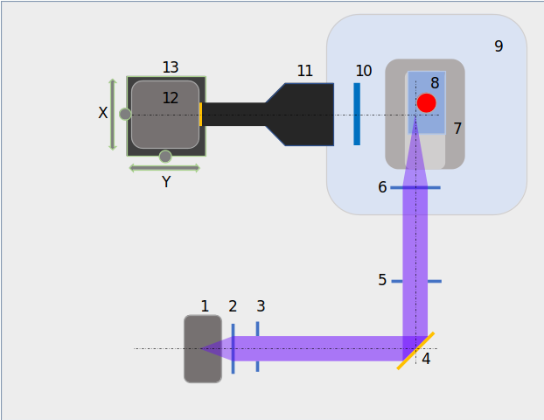

**Figure S1:** Schematic representation of the video-microscopic set-up. Cells from the culture flask (8) were excited in a continuous laser sheet at 402 nm (Laser Newport, (1) produced by lenses—(2) is a 40 mm-focal length spherical lens, and (6) is a 50 mm-focal length cylindrical lens)—(3) fixed iris, and (4) a mirror. A diaphragm shutter with a controller (5) was synchronized with the camera acquisition (12, EMCCD). A telecentric lens (4X, 11) was used behind a high-pass filter (615 nm, 10). The culture flask was placed on a mount (7). The flask and mount was fixed on a magnetic stirrer (9).

a

b



**Figure S2**: Clustering of the LISST size classes (*K*-means) to identify the minor and major axes (a) and their temporal evolution (b). The blue and red size classes are associated with the minor and major axes, respectively.

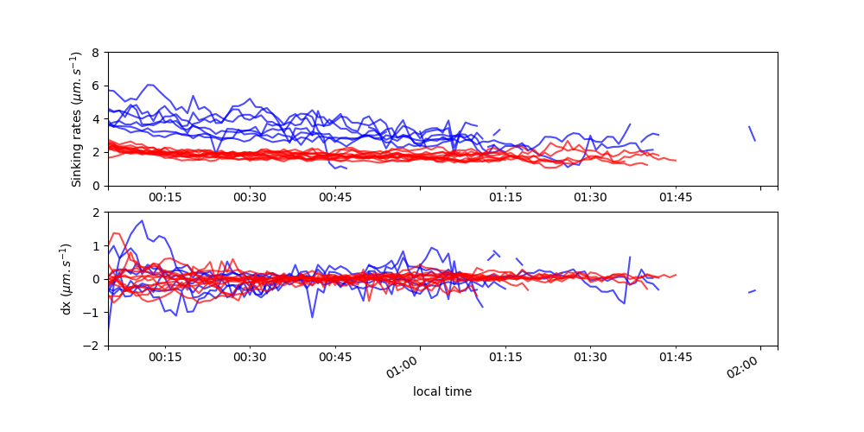

**Figure S3**: Sinking rates (a) and horizontal displacement (b) estimated from the trajectories extracted from the video-microscopy sequences. Results for the *Pseudo-nitzschia pungens* and *Pseudo-nitzschia fraudulenta* strains are shown in blue and red, respectively. Gaps are due to periods without particles detected in the field of view.

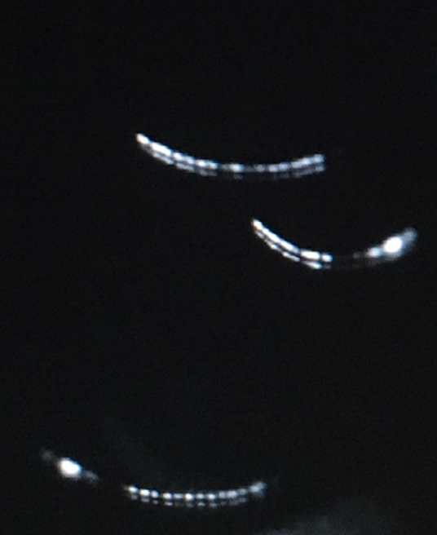

100 µm

**Figure 4**: Image of *Pseudo-nitzschia pungens* chains sinking with a typical “u” shape. The resolution is 1.825 µm ⋅ pixel−1, and the full field of view is 3.3 mm2. Two recorded sequences are available (Sourisseau 2023a, 2023b).

sourisseau, marc (2023a). Pseudo-nitzschia pungens PN19_3_1 / PN_P2. figshare.Media. https://doi.org/10.6084/m9.figshare.19597336.v1

sourisseau, marc (2023b). Pseudo-nitzschia fraudulenta PN20_2 / PN_F2. figshare. Media. <https://doi.org/10.6084/m9.figshare.19597420.v1>