Supplementary information for

**Modeling HepaRG metabolome responses to pyrrolizidine alkaloid exposure for insight into points of departure and modes of action**

Estelle Dubreil1, Keyvin Darney2, Marie-Laure Delignette-Muller3, Audrey Barranger1, Sylvie Huet1, Kevin Hoogeveen1, Thibaut Léger1, Valérie Fessard1, Ludovic Le Hégarat1

1ANSES, French Agency for Food, Environmental and Occupational Health & Safety, Fougères Laboratory, Toxicology of contaminants unit, 10 B rue Claude Bourgelat, Fougères, 35306, France

2 ANSES, French Agency for Food, Environmental and Occupational Health & Safety, Risk Assessment Department, 14 Rue Pierre et Marie Curie, 94701 Maisons-Alfort, France

3 University of Lyon 1, CNRS, VetAgro Sup, UMR 5558, Laboratoire de Biométrie et Biologie Evolutive, 69622 Villeurbanne, France

*Corresponding author:* [*estelle.dubreil@anses.fr*](mailto:estelle.dubreil@anses.fr)

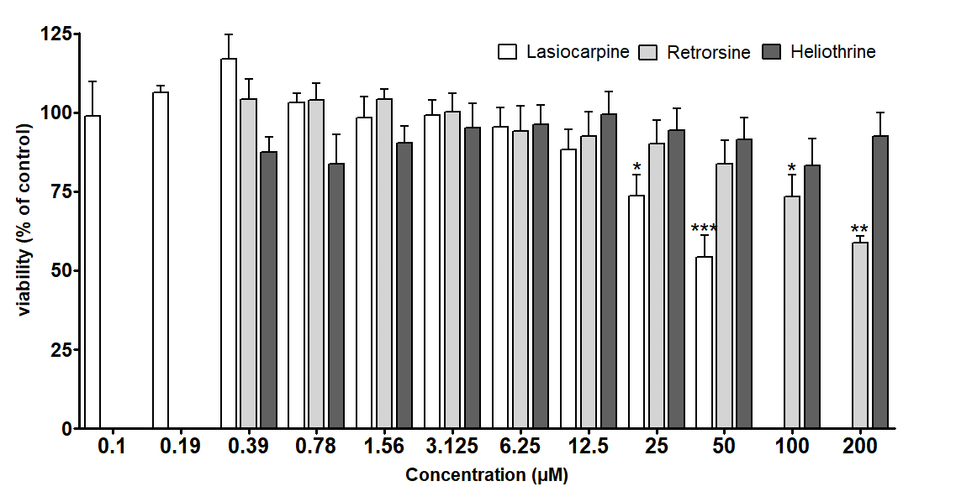

Supplementary Fig. 1 Cytotoxicity of the PAs HEL RET and LAS determined by the MTT assay. Percentage of cell viability (ratio compared to negative control). Results were calculated from at least 3 independent experiments. Data are presented as the mean ± SEM of the independent experiments.*p<0.05 (a one-way analysis of variance (ANOVA) and Dunnet's multiple comparison test were used)

Supplementary Table. 1 Annotated metabolites following lasiocarpine (LAS) treatment (m/z, ESI mode, adduct, delta mass, MW, proposed formula, database attribution, main fragments, m/z Cloud scoring) : Excel file

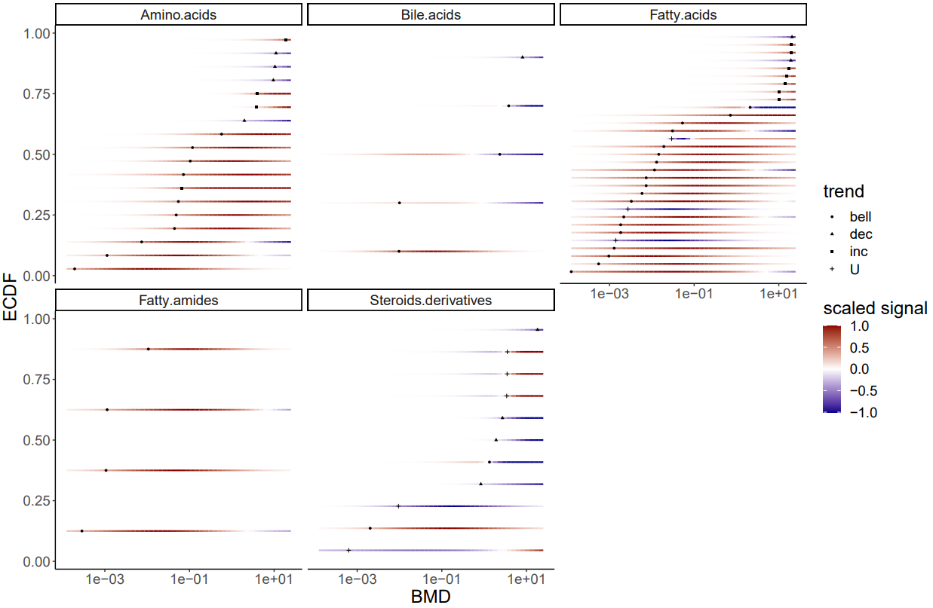

Supplementary Fig. 2 Cumulative distributions of the BMD values specific to each main pathway sub-class impaired after exposure of HepaRG cells to Lasiocarpine (LAS).

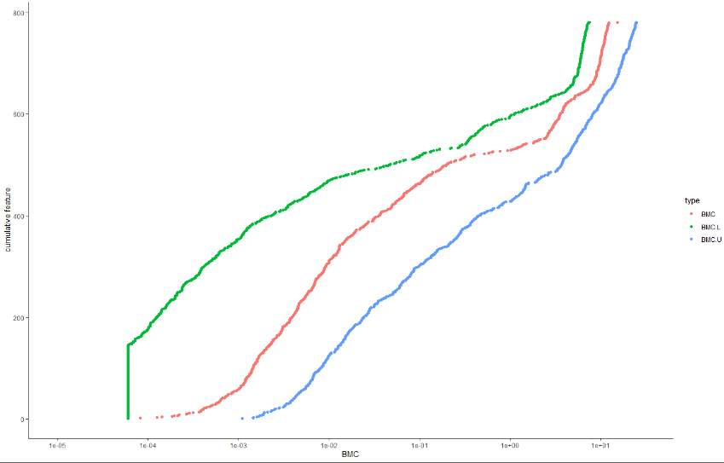

Supplementary Fig. 3 Cumulative distributions of the BMD values for unannotated (red) metabolites after exposure of HepaRG cells to Lasiocarpine (LAS), and its 95% confidence interval represented by BMDL (green) and BMDU (blue). The BMD-1SD is the concentration corresponding to a Benchmark Response (BMR-zSD) defined as follows: BMR-zSD=y0 +/− z*SD, where y0 is the mean control response, and SD is the residual standard deviation of the considered concentration-response model and z is the factor of SD (z fixed at 1 by default).

LASIO ENDO POS

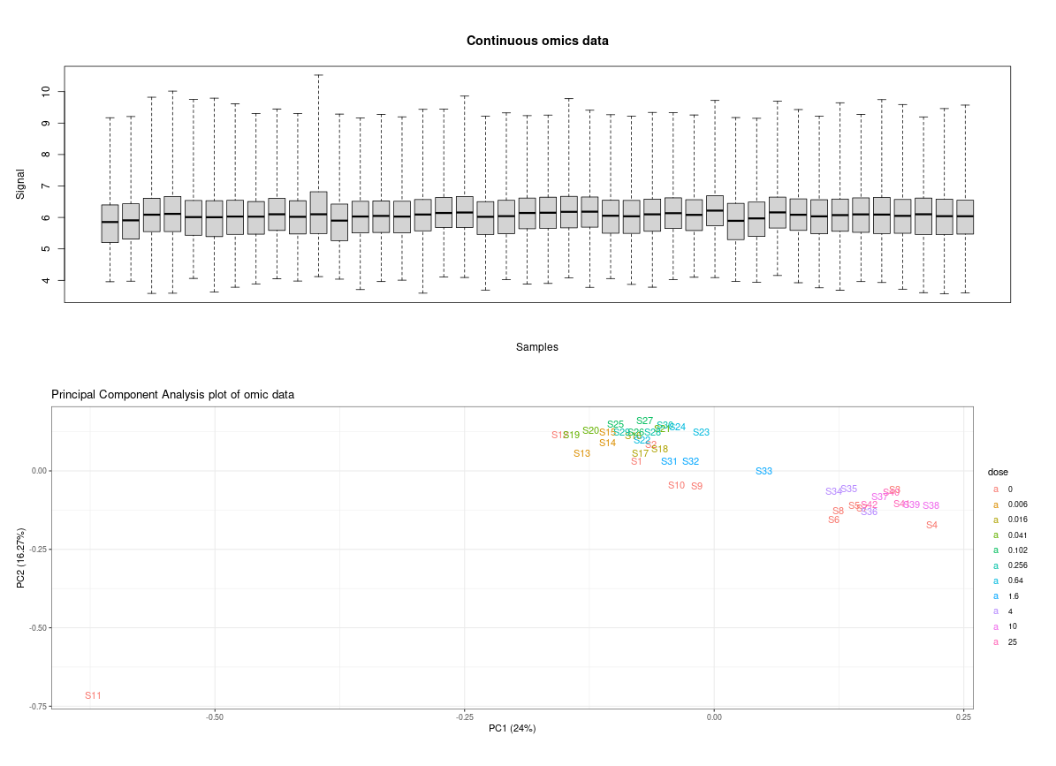

LASIO ENDO NEG

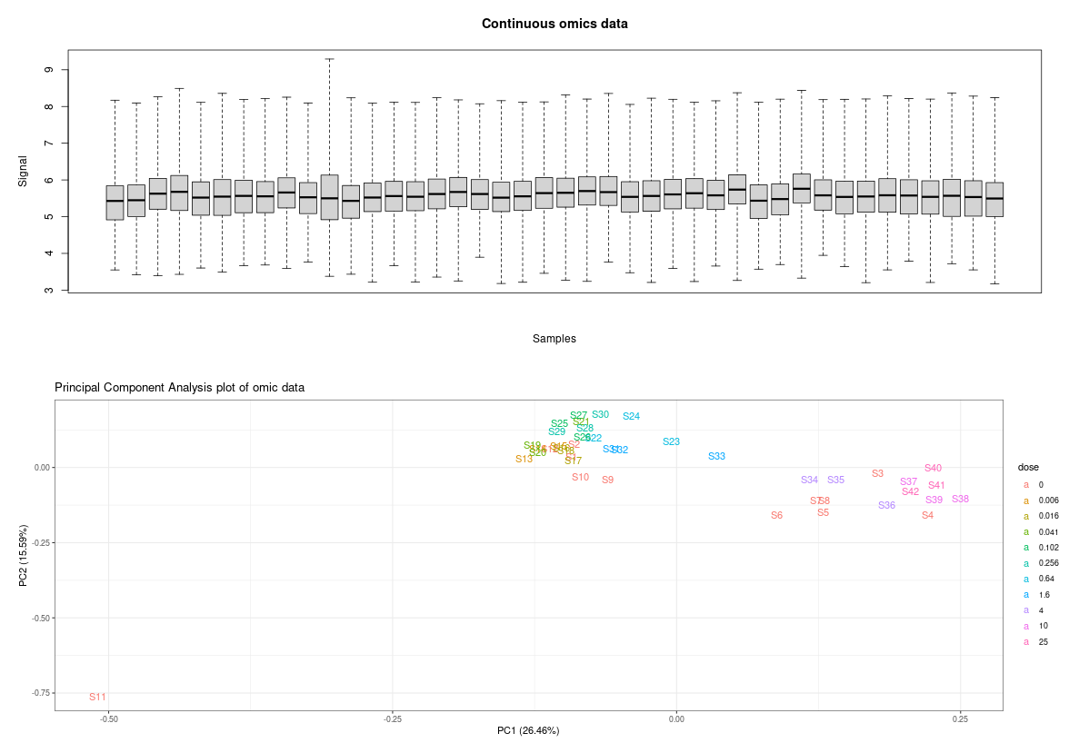

LASIO EXO POS

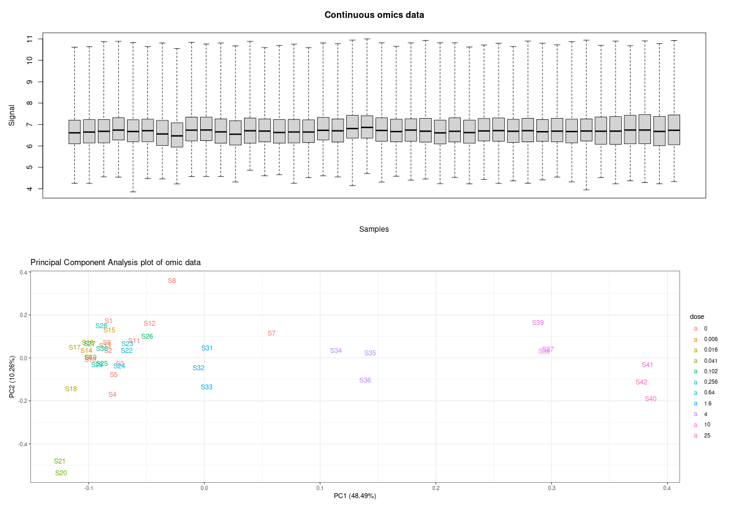

LASIO EXO NEG

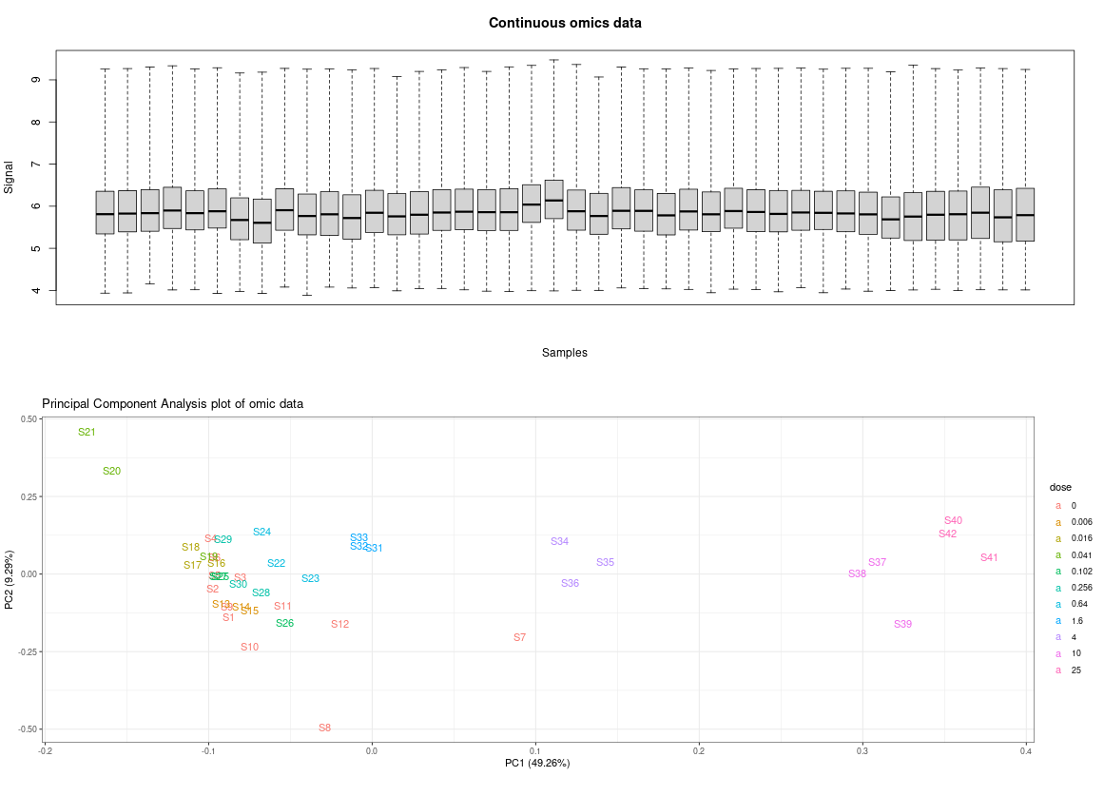

HELIO ENDO POS

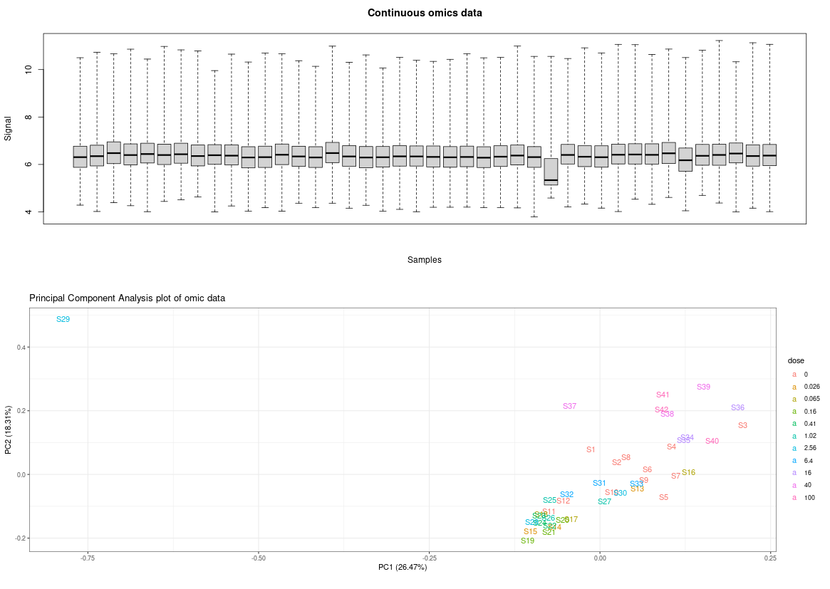

HELIO ENDO NEG

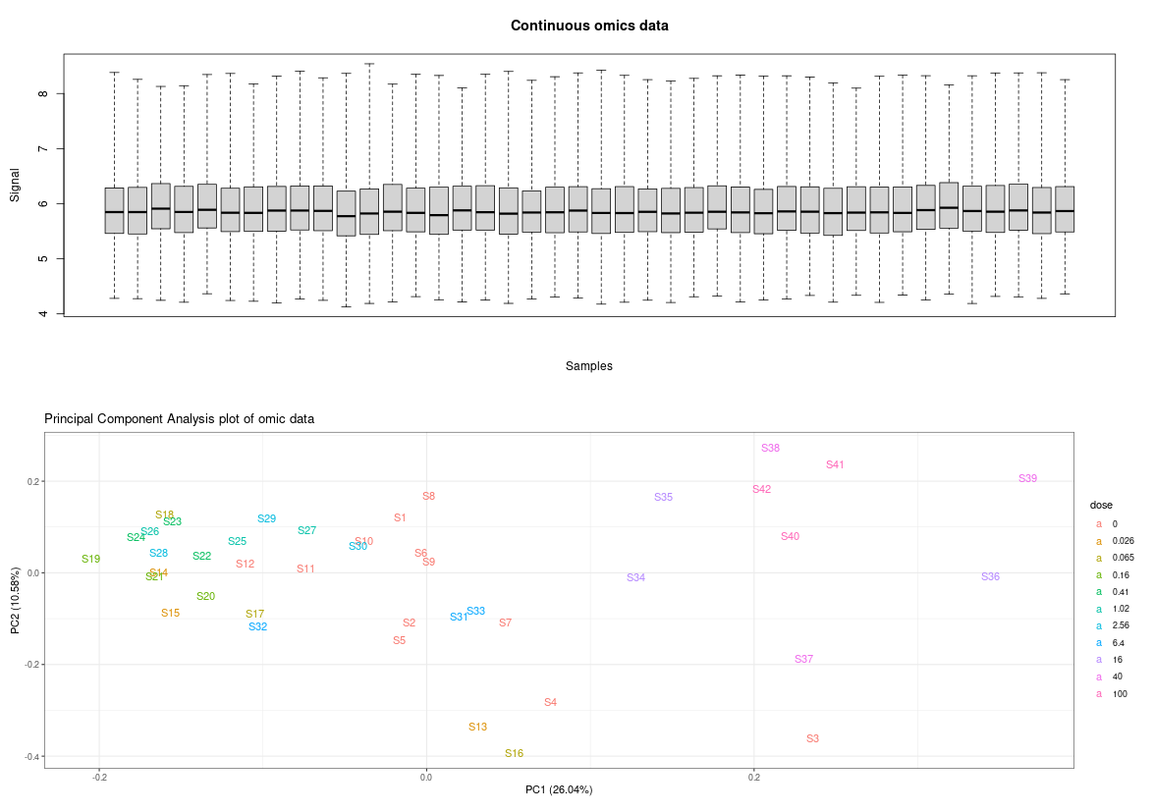

HELIO EXO POS

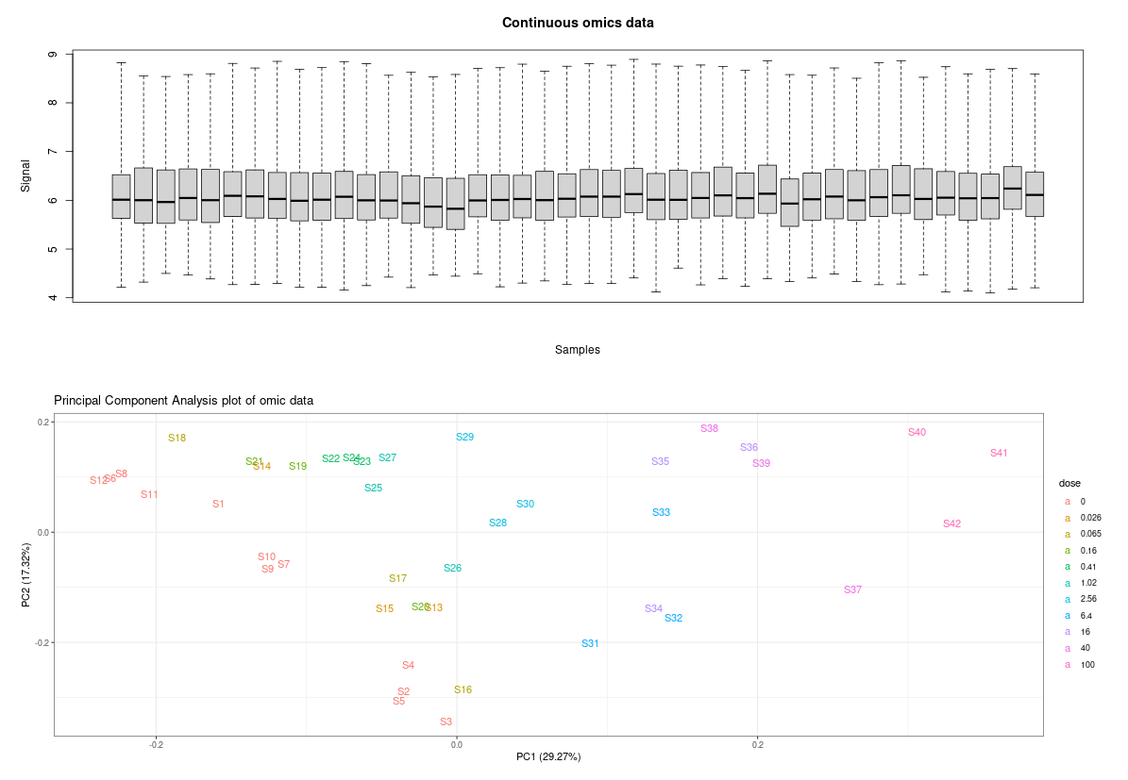

HELIO EXO NEG

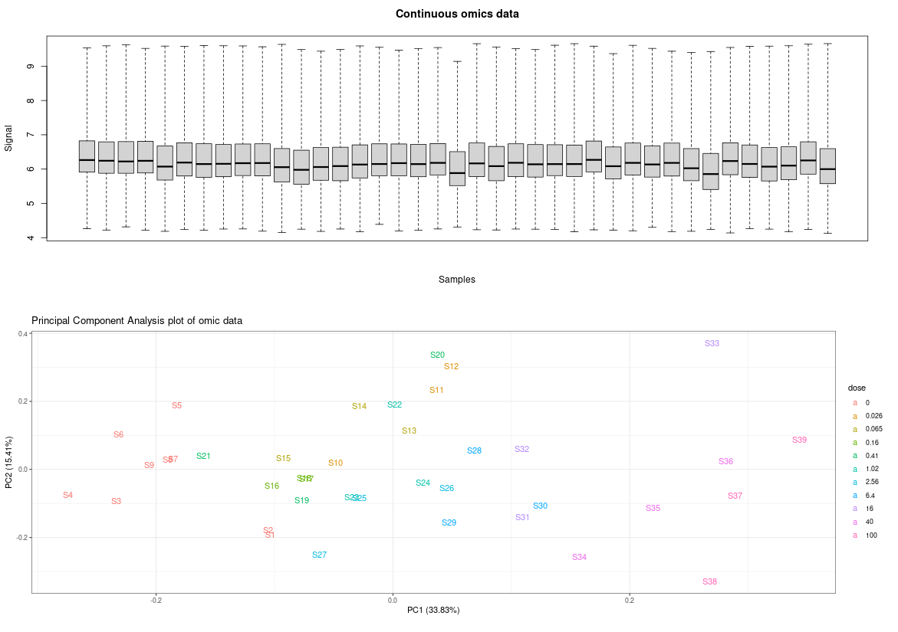

RETROR ENDO POS

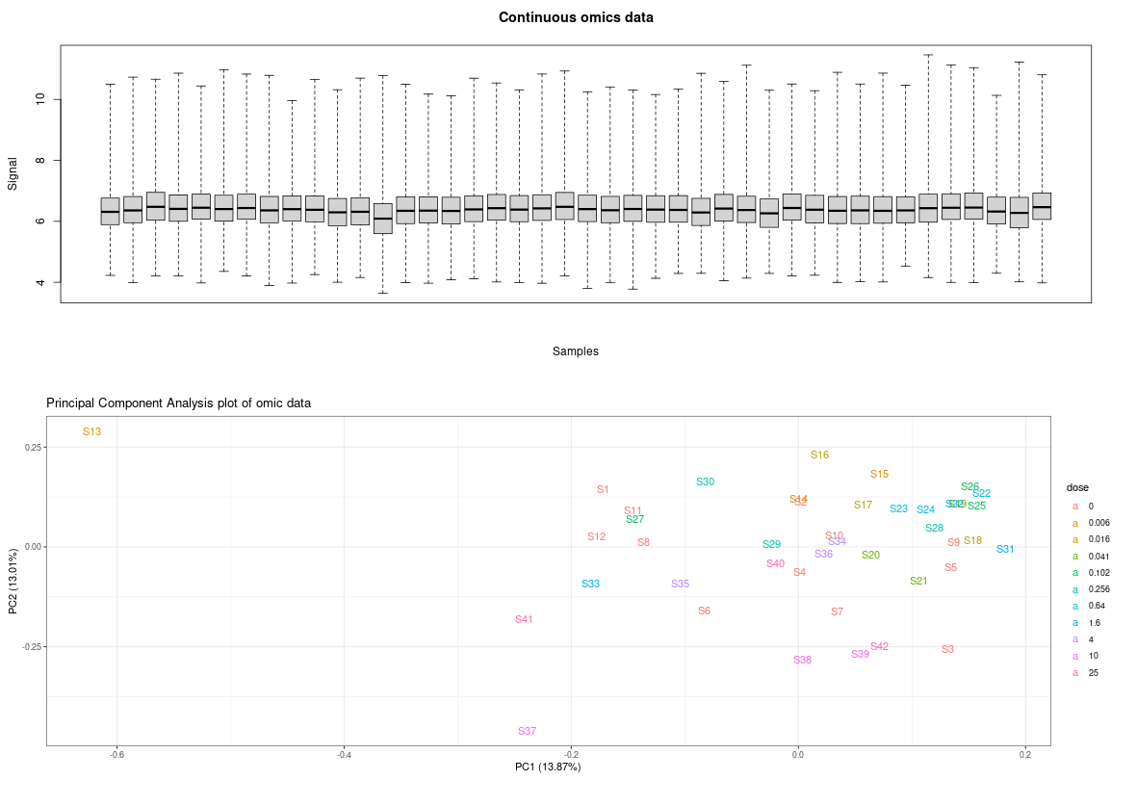

RETROR ENDO NEG

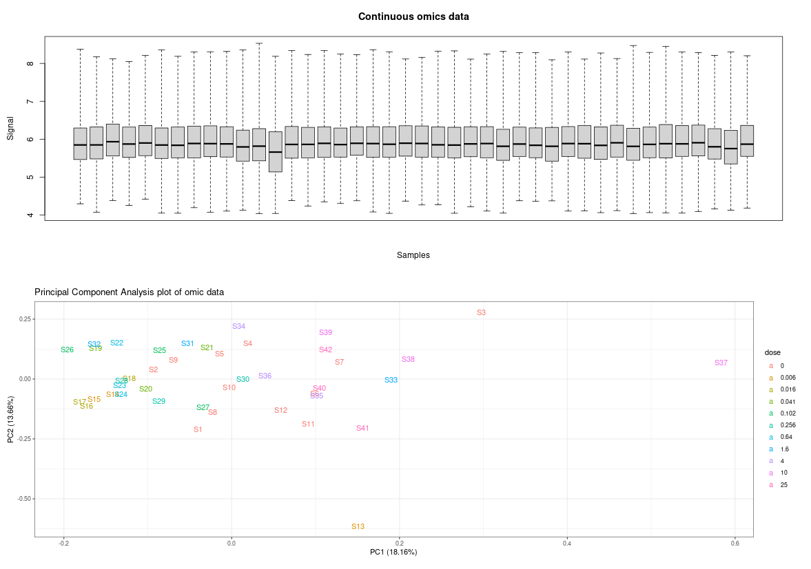

RETROR EXO POS

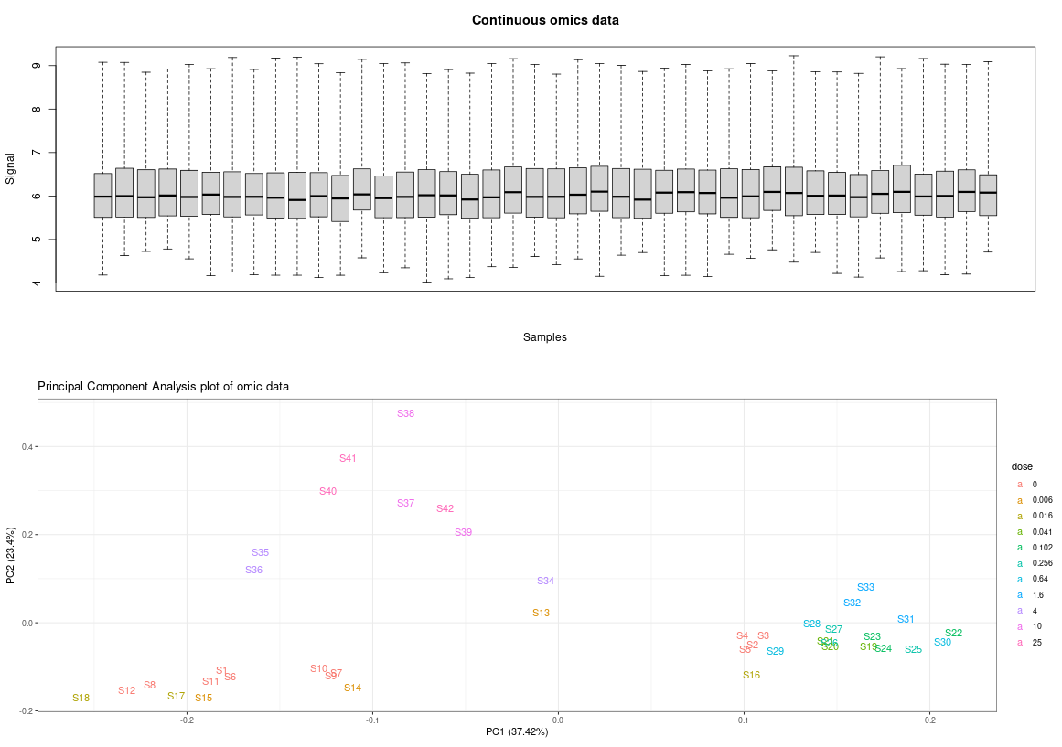

RETROR EXO NEG

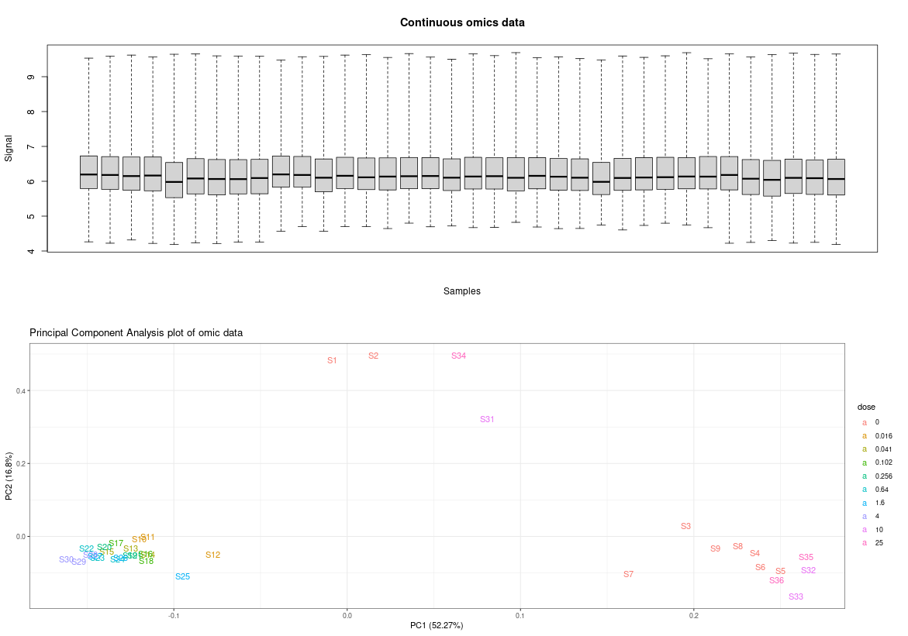

Supplementary Fig. 4 Boxplots and PCA plots of the 12 datasets

IS Flunixin-d3, treatment LASIO ENDO POS

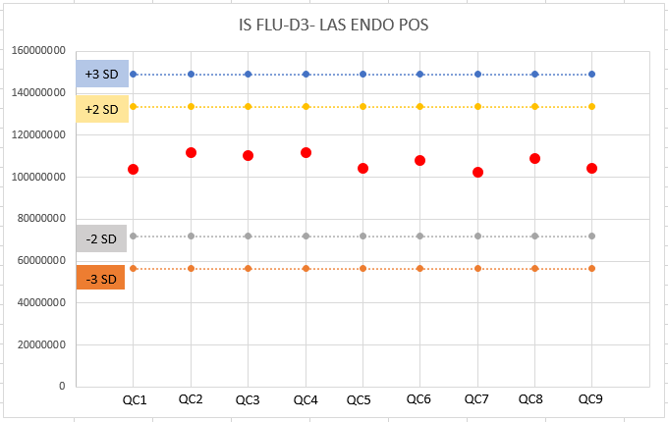

IS Flunixin-d3, treatment LASIO ENDO NEG

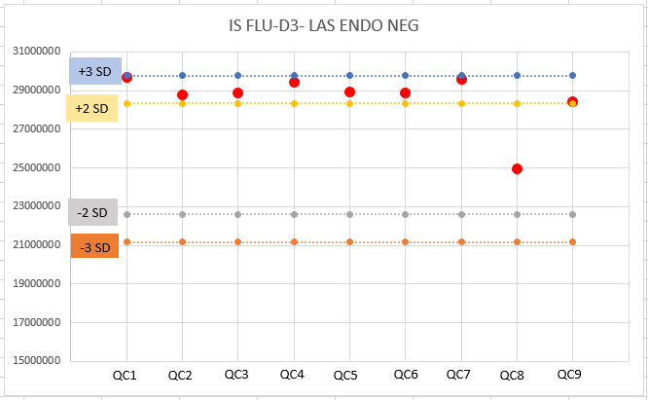

Supplementary Fig. 5 QC control chart of the IS FLU-d3, for the conditions LAS ENDO POS and LAS ENDO NEG

TIC, treatment LASIO ENDO POS



TIC, treatment LASIO ENDO NEG



TIC, treatment LASIO EXO POS



TIC, treatment LASIO EXO NEG



Supplementary Fig. 6 TIC of the QC injection after LAS treatment