**Harmful *Ostreopsis* cf. *ovata* blooms could extend in time span with climate change in the Western Mediterranean Sea.**

***Table A1:*** Sampling stations of monitoring programs where *Ostreopsis* cf. *ovata* was sampled. Depth of sampling is around 0.5 m

|  |  |  |  |  |
| --- | --- | --- | --- | --- |
| Site | Longitude (°E) | Latitude (°N) | Year of monitoring | Number of records |
| Monaco | 7.43 | 43.74 | 2007-2017 | 126 |
| Villefranche-sur-Mer | 7.30 | 43.69 | 2010, 2012, 2013, 2014, 2015, 2016, 2017 | 105 |
| Llavaneres | 2.48 | 41.6 | 2014-2017 | 54 |

**Table A2 :** Physical and biogeochemical data from Copernicus Marine Environment Monitoring Service (CMEMS) with range values on sampling points (Table A1). The spatial extent extracted is : longitude minimum =-5.5, latitude minimum =32.5, longitude maximum =19, latitude maximum =46

Physical data source:

<https://resources.marine.copernicus.eu/?option=com_csw&view=details&product_id=MEDSEA_REANALYSIS_PHYS_006_004> (accessed 2020/11/08)

Biogeochemical data source : G. Cossarini pers. comm.

|  |  |  |  |  |
| --- | --- | --- | --- | --- |
| Variable | Time period | Spatial resolution | Time resolution | Units |
| Temperature | 1999-2017 | 0.0625° x 0.0625° | Daily mean then weekly averaged | °C |
| Salinity | 1999-2017 | 0.0625° x 0.0625° | Daily mean then weekly averaged | Psu |
| Current u component | 1999-2017 | 0.0625° x 0.0625° | Daily mean then weekly averaged | m.s-1 |
| Current v component | 1999-2017 | 0.0625° x 0.0625° | Daily mean then weekly averaged | m·s-1 |
| Dissolved oxygen (O2) | 1999-2017 | 0.0625° x 0.0625° | Weekly mean | mmol·m-3 |
| Nitrate (NO3) | 1999-2017 | 0.0625° x 0.0625° | Weekly mean | mmol·m-3 |
| Phosphate (PO4) | 1999-2017 | 0.0625° x 0.0625° | Weekly mean | mmol·m-3 |
| Chlorophyll-a concentration (Chla) | 1999-2017 | 0.0625° x 0.0625° | Weekly mean | mg·m-3 |

**Table A3 : Physical data from the CNRM-RCSM4 simulation in the Western Mediterranean.** The spatial extent extracted is: longitude minimum =-5.5°W, latitude minimum =32.5°N, longitude maximum =19.0°E, latitude maximum =46.0°N

Source: <https://www.medcordex.eu/medcordex.php> (accessed 2020/11/08)

|  |  |  |  |  |  |
| --- | --- | --- | --- | --- | --- |
| Variables | Time period | Scenarios | Spatial resolution | Time resolution | Units |
| Temperature | 1999-2017 | Historical period (1999-2004, RCP8.5: 2005-2017)* | Interpolated to 0.0625° x 0.0625° | Daily mean then weekly averaged | °C |
| Temperature | 2041-2060 | RCP 8.5 | Interpolated to 0.0625° x 0.0625° | Daily mean then weekly averaged | °C |
| Temperature | 2081-2100 | RCP 8.5 | Interpolated to 0.0625° x 0.0625° | Daily mean then weekly averaged | °C |
| Salinity | 1999-2017 | Historical period (1999-2004, RCP 8.5: 2005-2017)* | Interpolated to 0.0625° x 0.0625° | Daily mean then weekly averaged | PSU |
| Salinity | 2041-2060 | RCP 8.5 | Interpolated to 0.0625° x 0.0625° | Daily mean then weekly averaged | PSU |
| Salinity | 2081-2100 | RCP 8.5 | Interpolated to 0.0625° x 0.0625° | Daily mean then weekly averaged | PSU |
| Current u component | 1999-2017 | Historical period (1999-2004, RCP 8.5: 2005-2017)* | Interpolated to 0.0625° x 0.0625° | Daily mean then weekly averaged | m.s-1 |
| Current u component | 2041-2060 | RCP 8.5 | Interpolated to 0.0625° x 0.0625° | Daily mean then weekly averaged | m.s-1 |
| Current u component | 2081-2100 | RCP 8.5 | Interpolated to 0.0625° x 0.0625° | Daily mean then weekly averaged | m.s-1 |
| Current v component | 1999-2017 | Historical period (1999-2004, RCP 8.5: 2005-2017)* | Interpolated to 0.0625° x 0.0625° | Daily mean then weekly averaged | m.s-1 |
| Current v component | 2041-2060 | RCP 8.5 | Interpolated to 0.0625° x 0.0625° | Daily mean then weekly averaged | m.s-1 |
| Current v component | 2081-2100 | RCP 8.5 | Interpolated to 0.0625° x 0.0625° | Daily mean then weekly averaged | m.s-1 |

*In the IPCC-AR5 scenario generation (the so-called RCP), the historical period stops in 2005. To complete obtain a reference period as close as possible from the reanalysis period, e therefore extracted the 2006-2017 period from the scenario simulation to complete the historical dataset.

**Table A4 : Biogeochemical data from Eco3M-S model.** The spatial extent extracted is: longitude minimum =-5.5°W, latitude minimum =32.5°E, longitude maximum =19.0°E, latitude maximum =46.0°N. The raw data from the Eco3M-S biogeochemical simulation can be accessed on request to [caroline.ulses@univ-tlse3.fr](mailto:caroline.ulses@univ-tlse.fr)

|  |  |  |  |  |  |
| --- | --- | --- | --- | --- | --- |
| Variables | Time period | scenarios | Spatial resolution | Time resolution | Units |
| Dissolved oxygen (O2) | 1999-2017 | Historical period (1999-2004, RCP 8.5: 2005-2017)* | Interpolated to 0.0625° x 0.0625° | Daily mean then weekly averaged | mmol O2 m-3 |
| Dissolved oxygen (O2) | 2041-2060 | RCP 8.5 | Interpolated to 0.0625° x 0.0625° | Daily mean then weekly averaged | mmol O2 m-3 |
| Dissolved oxygen (O2) | 2081-2100 | RCP 8.5 | Interpolated to 0.0625° x 0.0625° | Daily mean then weekly averaged | mmol O2 m-3 |
| Nitrate (NO3) | 1999-2017 | Historical period (1999-2004, RCP 8.5: 2005-2017)* | Interpolated to 0.0625° x 0.0625° | Daily mean then weekly averaged | mmol N m-3 |
| Nitrate (NO3) | 2041-2060 | RCP 8.5 | Interpolated to 0.0625° x 0.0625° | Daily mean then weekly averaged | mmol N m-3 |
| Nitrate (NO3) | 2081-2100 | RCP 8.5 | Interpolated to 0.0625° x 0.0625° | Daily mean then weekly averaged | mmol N m-3 |
| Phosphate (PO4) | 1999-2017 | Historical period (1999-2004, RCP 8.5: 2005-2017)* | Interpolated to 0.0625° x 0.0625° | Daily mean then weekly averaged | mmol N m-3 |
| Phosphate (PO4) | 2041-2060 | RCP 8.5 | Interpolated to 0.0625° x 0.0625° | Daily mean then weekly averaged | mmol N m-3 |
| Phosphate (PO4) | 2081-2100 | RCP 8.5 | Interpolated to 0.0625° x 0.0625° | Daily mean then weekly averaged | mmol N m-3 |
| Chlorophyll-a concentration (Chla) | 1999-2017 | Historical period (1999-2004, RCP 8.5: 2005-2017)* | Interpolated to 0.0625° x 0.0625° | Daily mean then weekly averaged | mg Chl m-3 |
| Chlorophyll-a concentration (Chla) | 2041-2060 | RCP 8.5 | Interpolated to 0.0625° x 0.0625° | Daily mean then weekly averaged | mg Chl m-3 |
| Chlorophyll-a concentration (Chla) | 2081-2100 | RCP 8.5 | Interpolated to 0.0625° x 0.0625° | Daily mean then weekly averaged | mg Chl m-3 |

*same as in Table A.3.

**Table A5** : Somlit data extracted from Point B (Villefranche-sur-Mer), Sola (Marseille), Frioul (Banyuls-sur-Mer).

Source : <https://www.somlit.fr/visualisation-des-donnees/> (accessed 2020/11/08)

|  |  |  |  |
| --- | --- | --- | --- |
| Variables | Time period | Time resolution | Units |
| Temperature | 1999-2017 | Weekly averaged | °C |
| Salinity | 1999-2017 | Weekly averaged | PSU |
| Dissolved oxygen (O2) | 1999-2017 | Weekly averaged | mL.L-1 converted to mmol.m-3 |
| Nitrate (NO3) | 1999-2017 | Weekly averaged | mmol.m-3 |
| Phosphate (PO4) | 1999-2017 | weekly averaged | mmol.m-3 |
| Chlorophyll-a | 1999-2017 | weekly averaged | mmol.m-3 |

Only measurements carried out under the best conditions both sampling and its analysis and not scientifically aberrant were retained https://www.somlit.fr/codes-qualite/). Because of high variability in the time series, we removed transient fluctuations and kept an overall trend by using a moving average, which estimates the trend-cycle at time *t* by averaging values within *k* periods of *t*. We chose *k*=2 and n=2 (number of times to smooth the data) as parameters for each station. These analyses were performed using the *castr* package (<https://github.com/jiho/castr>).

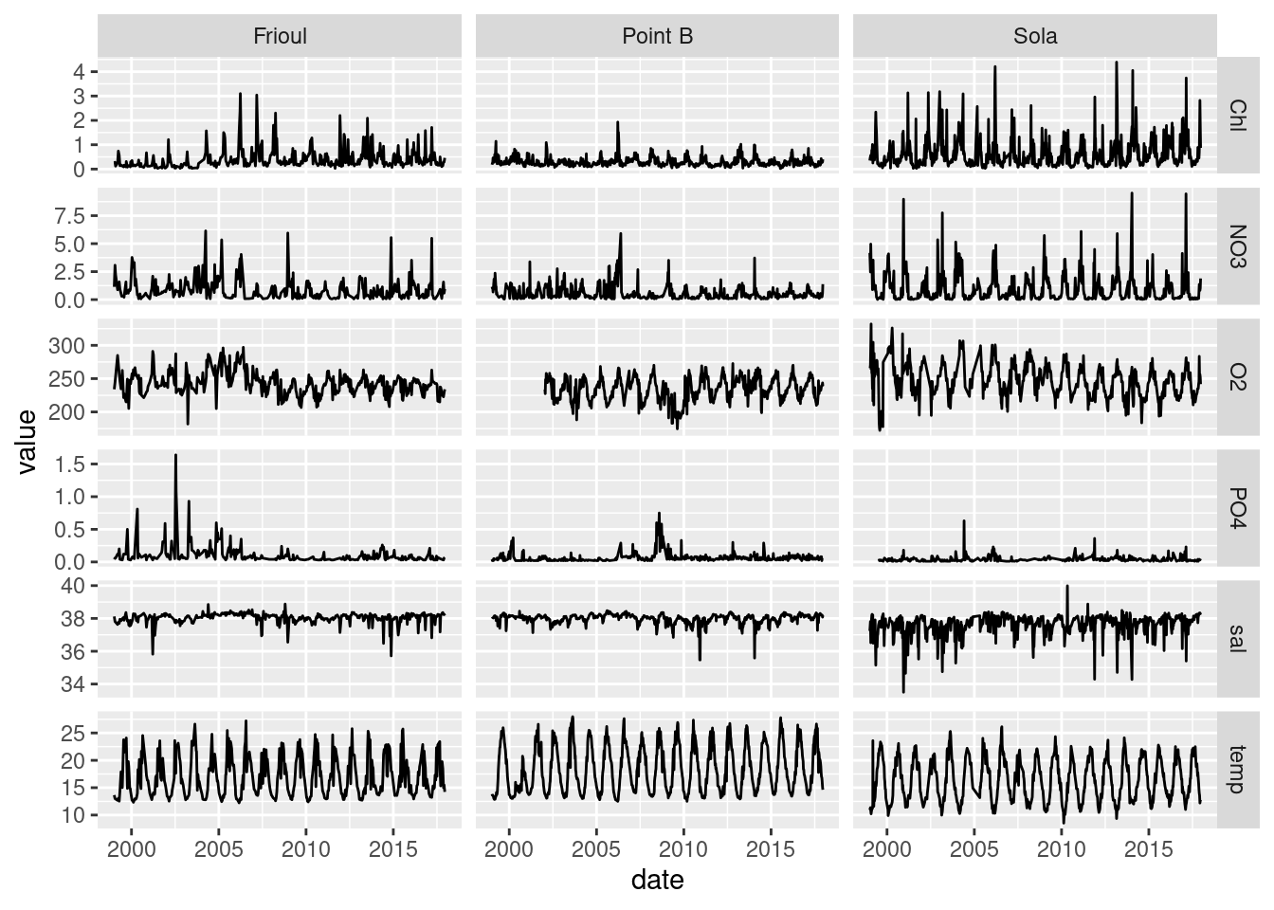

**Figure A1 : Somlit time series with temperature corrected**

***Table A6 : R-squared of regression between Somlit and Copernicus data***

|  |  |
| --- | --- |
| Variables | R2 |
| Temperature | 0.96 |
| Salinity | 0.43 |
| Oxygen | 0.63 |
| NO3 | 0.23 |
| PO4 | 0.01 |
| Chlorophyll-a | 0.27 |

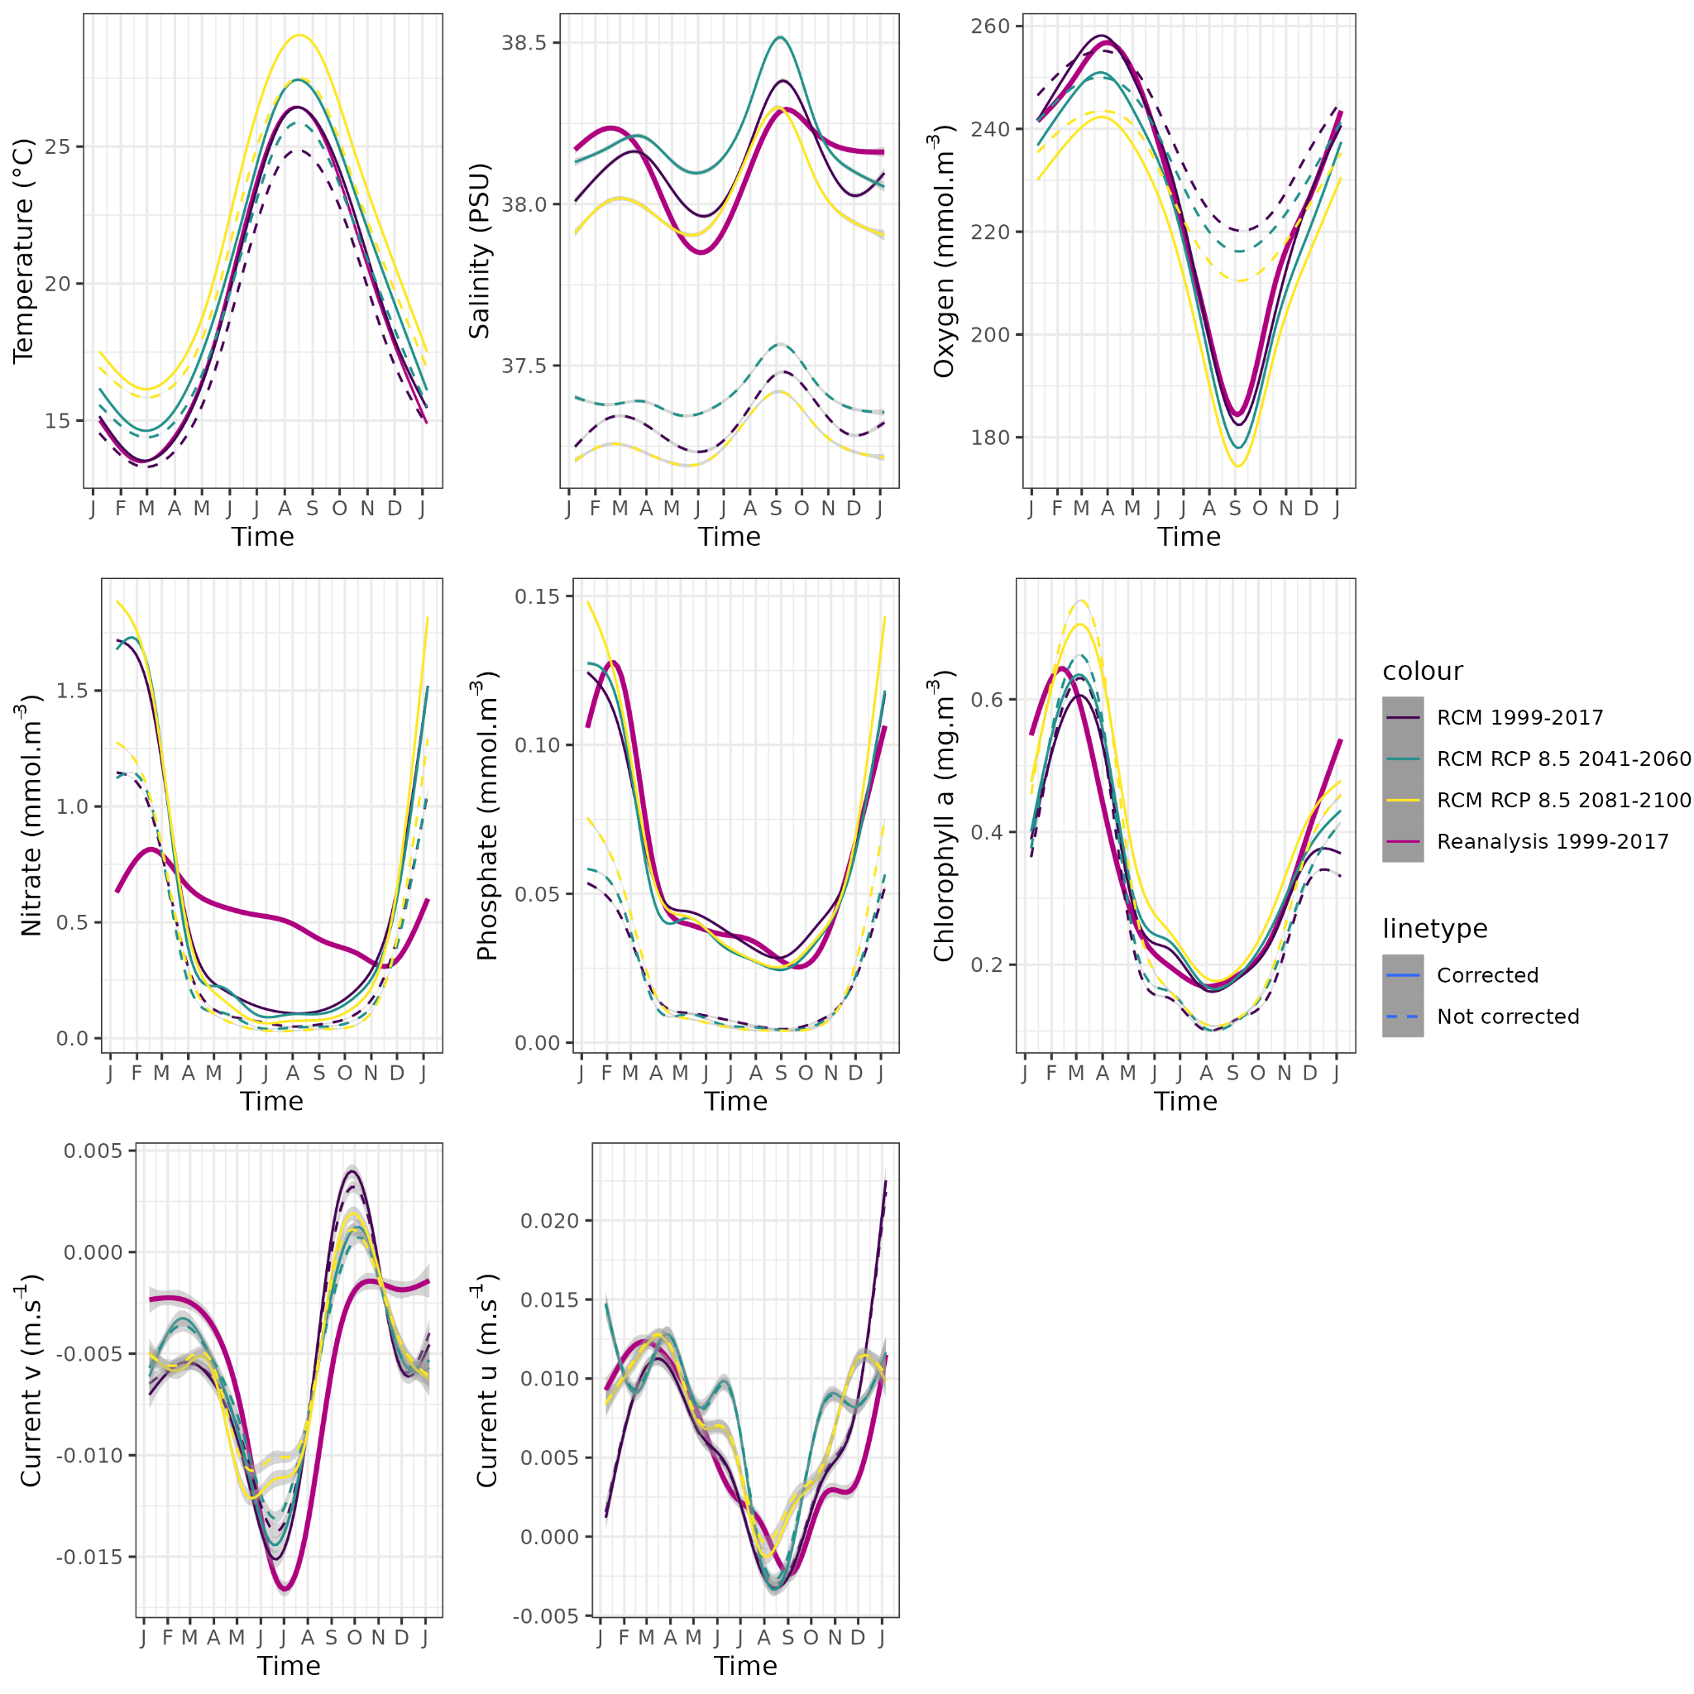

**Figure A2.** : Environmental predictors corrected with CDF-t method compared to non-corrected predictors for historical and mid/end-century for all the projection area of the model.

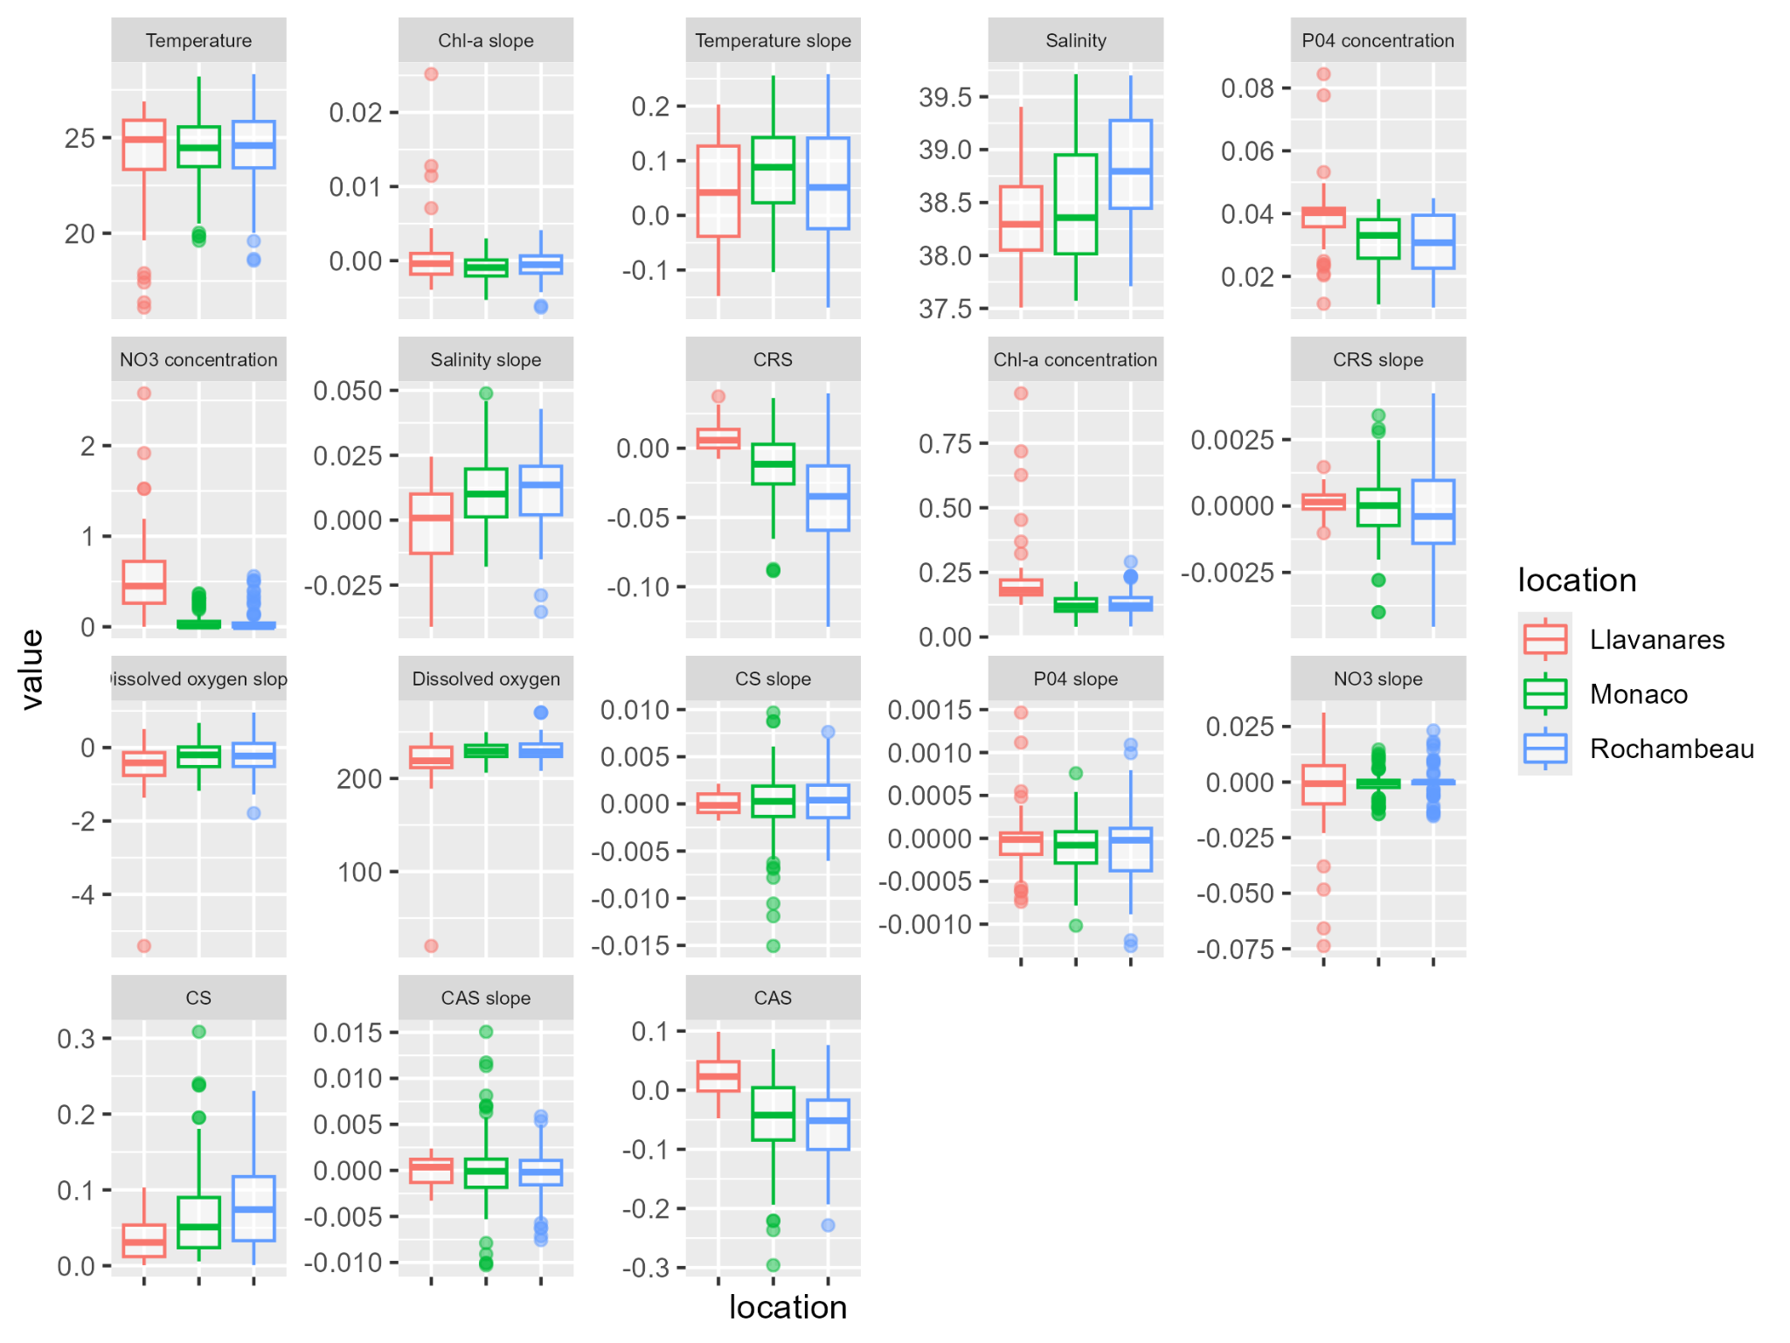

**Figure A3 :** Environmental characteristics of each sampling location based on the corrected reanalysis data. CRS = Current cross shore, CS= Current speed, CAS = Current along shore.

***Table A7 : Range values on sampling points for each predictor from Copernicus reanalysis corrected***

|  |  |  |  |
| --- | --- | --- | --- |
| Variables | Units | Minimal values | Maximal Values |
| Chlorophyll-a concentration | mg·m-3 | 0.0396 | 0.943 |
| Chlorophyll-a concentration slope | - | -0.00633 | 0.0252 |
| Nitrate concentration (NO3) | mmol.m-3 | 0 | 2.58 |
| Nitrate concentration slope | - | -0.0737 | 0.0313 |
| Phosphate (PO4) | mmol·.m-3 | 0.01 | 0.04 |
| Phosphate concentration slope | - | -0.00125 | 0.00147 |
| Salinity | PSU | 37.5 | 39.7 |
| Salinity slope | - | -0.0411 | 0.0489 |
| Temperature | mmol·m-3 | 16.1 | 28.3 |
| Temperature slope | - | -0.169 | 0.259 |
| Oxygen | mmol·m-3 | 20 | 271 |
| Oxygen slope | - | -5.41 | 0.956 |
| Current cross shore | m·s-1 | -0.129 | 0.00396 |
| Current cross shore slope | - | -0.00455 | 0.00424 |
| Current along shore | m·s-1 | -0.296 | 0.0987 |
| Current along shore slope | - | -0.0103 | 0.0151 |
| Current speed | m·s-1 | 0 | 0.309 |
| Current speed slope | - | -0.0151 | 0.00968 |

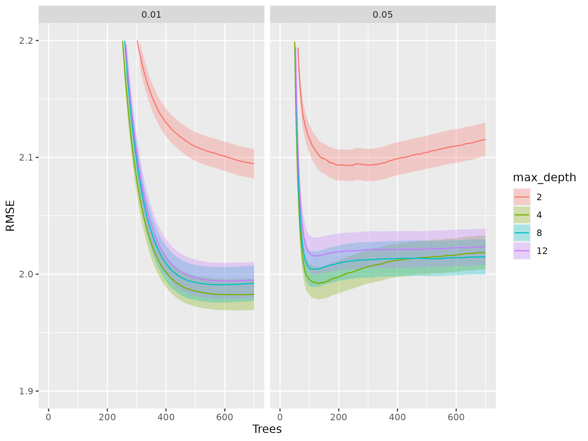

**Figure A4** : XGboost parametrized using 4-fold cross validation and tested for two eta values 0.01 and 0.05. max_depth controls the maximum depth of each tree, eta is the learning rate, trees is the number of trees to be produced.

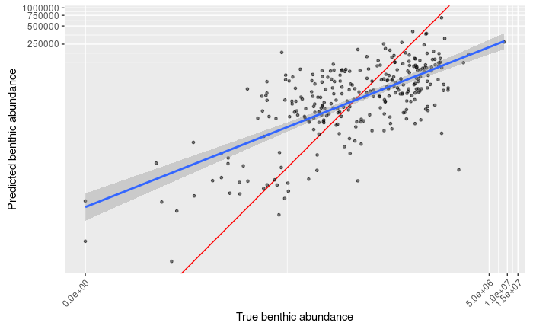

**Figure A5**: Abundances (in cells·g−1 FW) predicted according to measured abundances (in cells·g−1 FW) for training data (cross-validated model), red line is the identity line 1:1, the blue line is the regression slope between observed and predicted abundances, with a R2 of 0.33.

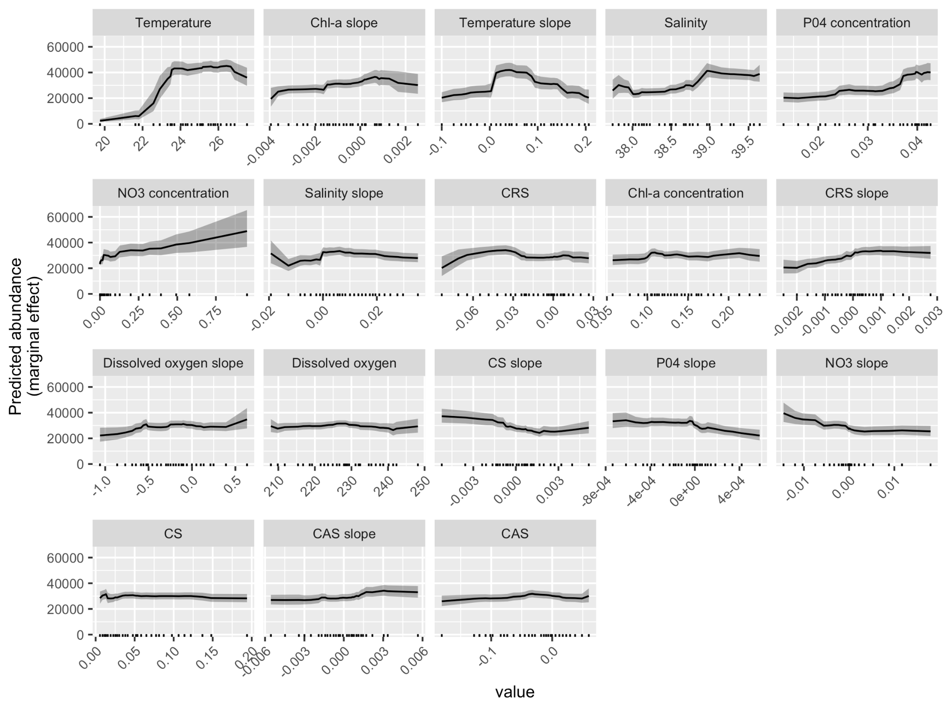

**Figure A6** : Partial dependence plots (pdps) showing the influence on mean *O.* cf. *ovata* cell abundance (in cells·g−1 FW) for all the environmental predictors in our XGBoost model, ordered by their relative influence. CRS = Current cross shore, CS= Current speed, CAS = Current along shore. Note that Y-axis is not logarithmic.