Supplementary 1: Underwater vision profiler (UVP) – Configuration and post-processing

Once recorded, UVP images were processed with the Zooprocess software (ImageJ adapted for UVP data) to split each image into single-particle images called “vignettes”. For each detected particle (≥ 1 pixel), area measurements were computed in pixels. For particles larger than 21 pixels (equivalent to a sphere of 310 µm diameter), vignettes were saved and transformed into gray level images. This threshold is commonly used with this UVP configuration to keep only identifiable particles, because fewer pixels is not sufficient to make a classification. Once the vignettes are processed, Zooprocess makes several biometric measurements on captured particles such as its area, perimeter, and the length of both minor and major axes of the ellipsoid fitted to the shape of the particle (see Appendices 4 and 5 from Gorsky et al. 2010). These data were imported to the Ecotaxa server (Picheral et al. 2017), where a random-forest model performed a classification of the particles to predict zooplankton taxonomy. Predictions were based on measurements of manually identified vignettes and were subsequently visually confirmed (all 358,510 predictions were verified manually).

Supplementary 2: Normalized Biovolume Size Spectrum (NBSS) calculations

To calculate size spectra, areas in pixels from Zooprocess were converted into equivalent spherical diameters (ESD) by considering the particle area as a disk (Eq. 1):

$$\left(1\right) ESD=2×√\frac{A×C^{2}}{π}$$

where A is the area of the particle and C is the conversion factor to transform pixels to millimetres (C = 0.06 for UVP acquisition and C = 0.0105833 for Zooscan acquisition). Once the ESD is calculated, it is transformed into biovolume (*bv*; Eq. 2) by considering the particle as a sphere:

$$\left(2\right) bv=\frac{4}{3}×π×{\left(\frac{ESD}{2}\right)}^{3}$$

Several mathematical methods can estimate the parameters of the power law distribution representing the NSS depending on both the units chosen and binning (Sprules & Munawar 1986; White et al. 2008; Guiet et al. 2016; Barth et al. 2019). We used the biovolume to calculate NSS (hereafter NBSS) rather than biomass because biovolume is more commonly used. This choice also allowed us to simplify calculations and avoid more derived estimations. Even though continuous data were available to build the size spectrum, size classes were chosen to facilitate interpretation. Size classes were log-spaced and the total biovolume in each size class was normalized. Normalization consisted of dividing the total biovolume contained in one size class by the extent of this size class (Eq. 3). This prevents bias and allows the use of a traditional continuous model such as linear regression (Sprules & Barth 2016). The NBSS in each size class *i* *(NBSSi*) was then estimated as:

$$\left(3\right) {NBSS}_{i}=\frac{{\sum_{i}{{bv}_{i}}}/{{Vol}_{e}}}{{∆bv}_{i}} with {∆bv}_{i}={max\left(V\right)}_{i}-{min(V)}_{i}$$

where ∑i *bv*i is the sum of particle biovolumes contained in size class i and Vole is the sample volume in litres. For the UVP data set, sample volume was the number of pictures considered multiplied by 0.18 since one UVP image samples 0.18L of water; ∆*bv*i is the extent of the corresponding size class, so the difference between the largest and the smallest volume of a particle within the size class.

Figure S1: Histograms of the size distribution of zooplankton individuals (Equivalent spherical diameter in mm) sampled in the study. Note that small-sized Chaoboridae were a consequence of cut images when the individual was taken in photo at the edge of the frame.

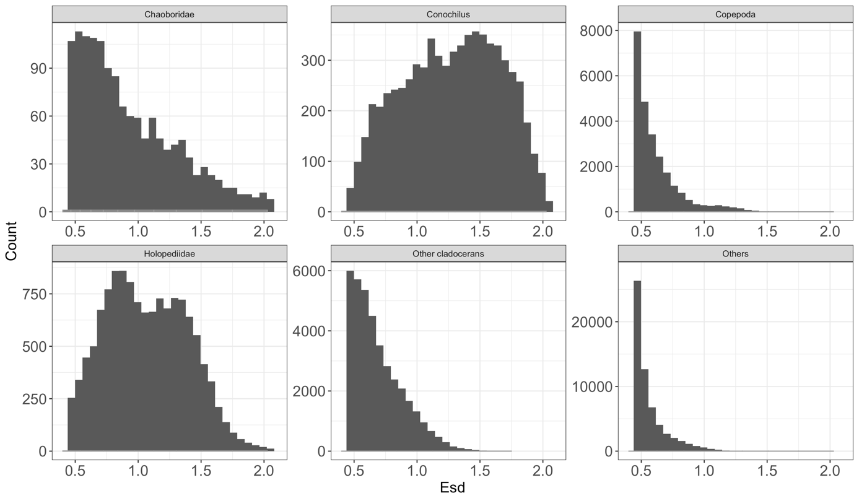

Figure S2: Histograms showing taxonomic comparisons from the Zooscan and the Underwater Vision Profiler (UVP) samples in the smaller half of the size classes, where a large amount of UVP vignettes were unidentified and classified into the “others” category.

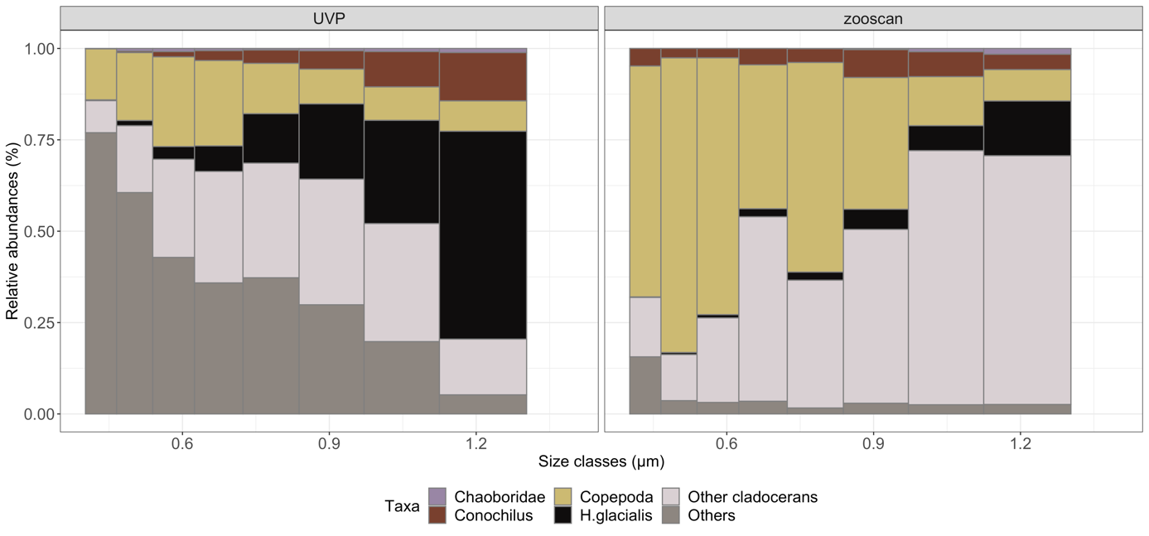

Size class (mm)

Figure S3: Comparison of polynomial (blue lines) and linear (dashed blue lines) fittings of normalized biovolume size spectra (NBSS) calculated from size classes 8 through 14 for each station. The black line represents the mean NBSS for the whole lake (all periods pooled). The table gives AICs and degrees of freedom (df) for each station and each type of fitting in order to assess whether the polynomial or linear model best fits the data from each station.

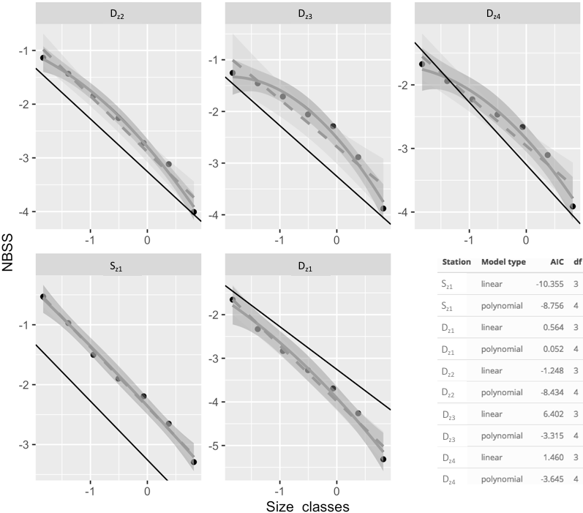

Log (Class volume center) (mm3)

Figure S4: Normalized biovolume size spectra (NBSS) calculated on identified zooplankton particles from all dates. To show the contribution of each taxon on the overall size spectrum (empty circles), the different taxa were removed one by one from the calculation of the NBSS (filled circles): A) Other cladocerans; B) copepods; C) *Holopedium glacialis,* and D) *Conochilus* sp. Gray symbols represent station Dz4 and blue symbols represent the shallow basin (Sz1 station).

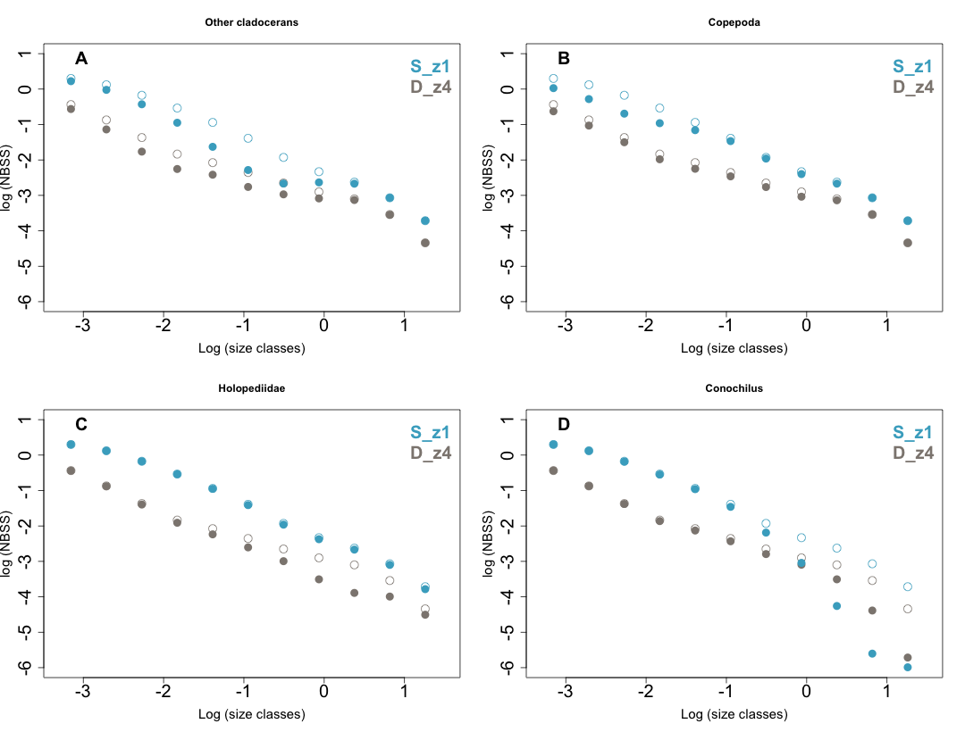

Log (Class volume center) (mm3)

Log (Class volume center) (mm3)



Figure S5: Profiles of fluorescence for each week sampled in the shallow and deep basin (respectively Sz1 and Dz4)



Figure S6: Normalized biovolume size spectra (NBSS) graph of all data measured on living particles captured by the underwater vision profiler (UVP – circles) and from Patalas samples measured with Zooscan (squares). Contribution of different size classes in the NBSS were compared between Zooscan and UVP NBSS by translating the Zooscan NBSS to the same height of the UVP NBSS (crosses). Size classes are numbered for clarity. Zooscan regression slope and adjusted R2 are written in black. UVP regression slope and adjusted R2 are in yellow and take only into account the size classes falling between the two vertical dotted lines (yellow circles). Gray circles show size classes removed from the analysis due to methodological issues (see text) (see text).



Figure S7: Boxplots showing the effect of date (A), station (B) and period of the day (C) on the size diversity index. Letters below the boxplots represent groupings of the Tukey post-hoc tests.

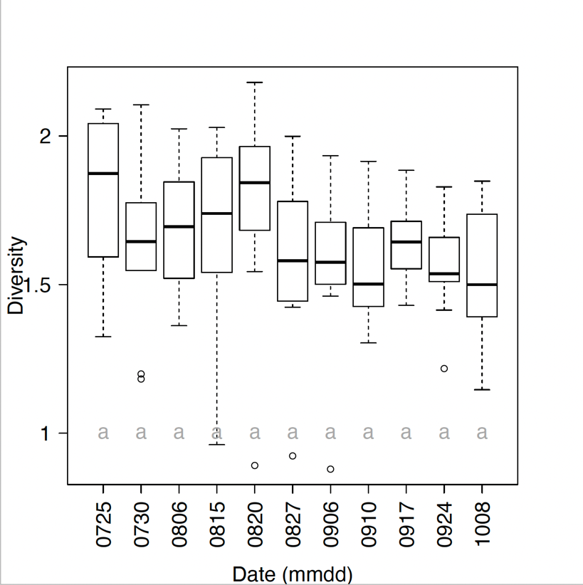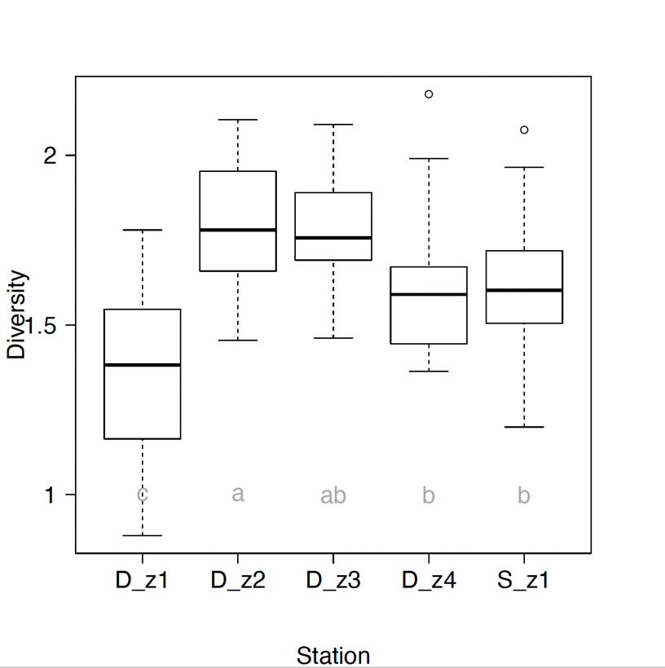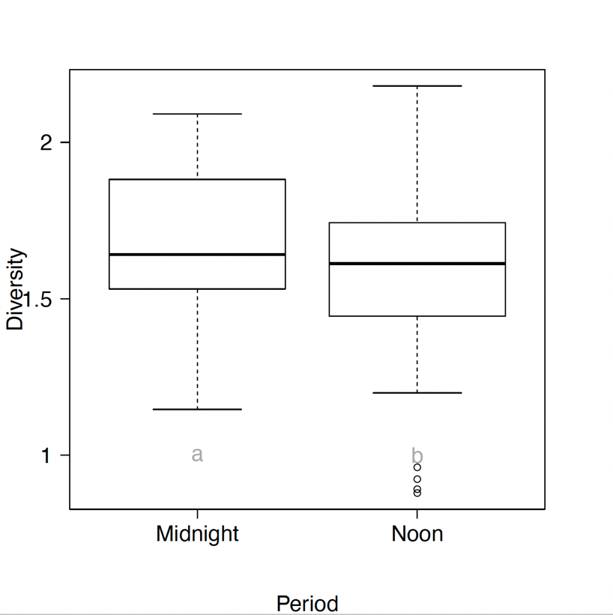

A

B

C

Figure S8: Left: NMDS plot on abundance data, displaying shallow (lightblue) and deeper (darkblue) stations with ellipsoids (based on standard deviation). Right: NMDS plot on abundance data, displaying seasons (Summer in yellow and Autumn in red) with ellipsoids (based on standard deviation). Summer gathers samplings from 25th July to 04th September and Autumn, from 10th September to 08th October, when surface temperature was under 20°C. Difference of colors in each plot represents statistical differences found with the permanova analysis and distance-based pairwise comparison (p values adjusted with Bonferonni correction <0.05).



Figure S9: Boxplot of fish swimming speed during the sampling period. Data were extracted from a fish acoustic telemetry survey that took place continuously and simultaneously with zooplankton sampling (P. Magnan, unpublish. data). Only positions recorded in the two hours prior to sunset were considered in order to simplify the analysis and because brook charr is expected to be more active at this time of the day (Bourke et al. 1996). All available positions and fish within these two hours were retained. The swimming speed calculation was the distance between each position detected by telemetry divided by the time between these two detections. If time between two detections exceeded one minute, data were discarded. Letters above boxplots are derived from a mixed model [speed ~ Weeks + (1|fish_individual)] and a subsequent group analysis (emmeans package).

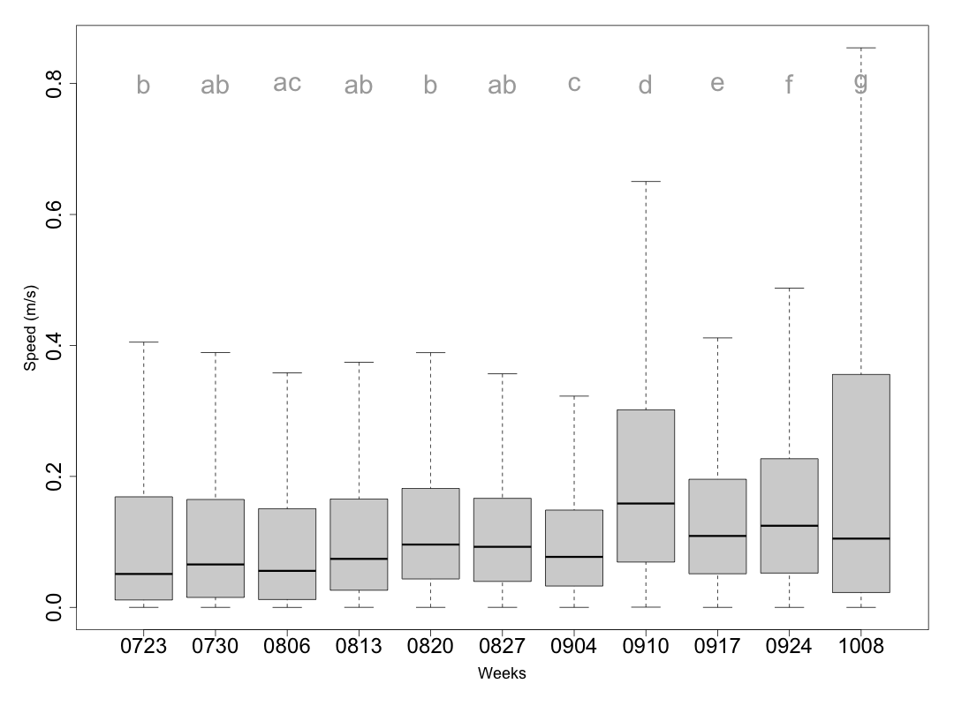

Week

References

Barth, L. E., Shuter, B. J., Sprules, W. G., Minns, C. K., & Rusak, J. A. (2019). Calibration of the zooplankton community size spectrum as an indicator of change in Canadian Shield lakes. *Canadian Journal of Fisheries and Aquatic Sciences*, *76*(12), 2268-2287.

Bourke, P., Magnan, P., & Rodriguez, M. A. (1996). Diel locomotor activity of brook charr, as determined by radiotelemetry. *Journal of Fish Biology*, 49(6), 1174-1185.

Gorsky, G. and others (2010). Digital zooplankton image analysis using the ZooScan integrated system. *Journal of Plankton Research*, 32(3), 285-303.

Guiet, J., Poggiale, J. C., & Maury, O. (2016). Modelling the community size-spectrum: recent developments and new directions. *Ecological Modelling*, 337, 4-14.

Picheral, M., Colin, S., & Irisson, J.-O. (2017). EcoTaxa, a tool for the taxonomic classification of images. <http://ecotaxa.obs-vlfr.fr>

Sprules, W. G., & Munawar, M. (1986). Plankton size spectra in relation to ecosystem productivity, size, and perturbation. *Canadian Journal of Fisheries and Aquatic Sciences*, 43(9), 1789-1794.

Sprules, W. G., & Barth, L. E. (2016). Surfing the biomass size spectrum: some remarks on history, theory, and application. *Canadian Journal of Fisheries and Aquatic Sciences*, 73(4), 477-495.

White, E. P., Enquist, B. J., & Green, J. L. (2008). On estimating the exponent of power‐law frequency distributions. *Ecology*, 89(4), 905-912.