Long-term decoupling in taxonomic and functional composition of European marine fish assemblages.

Supplementary
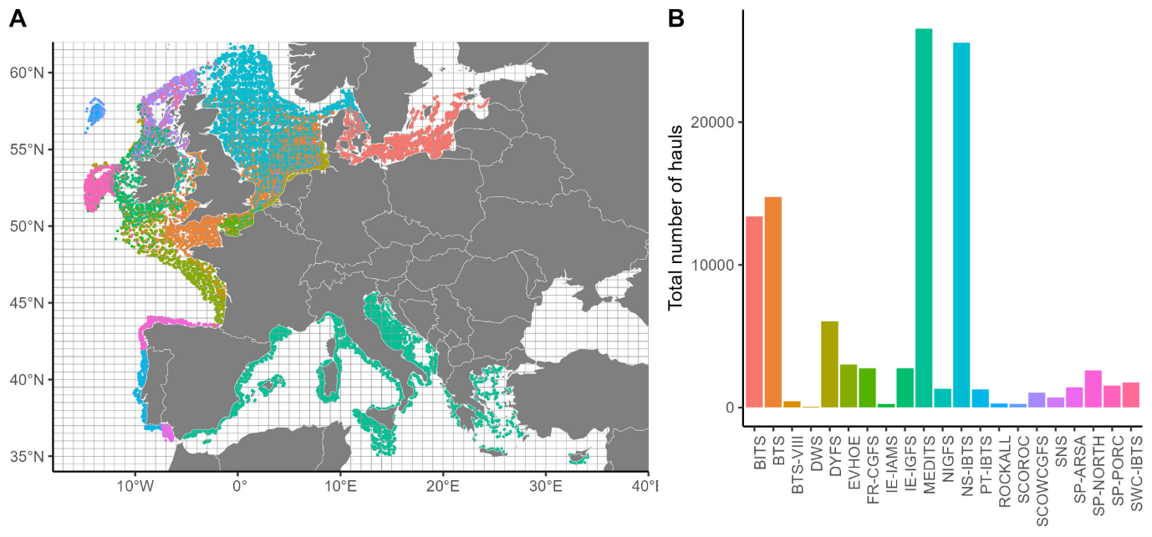
Figure S1. (A) Map of initial available data before the sampling selection, with each point representing one haul from one survey (color); and (B) the total number of hauls per survey.

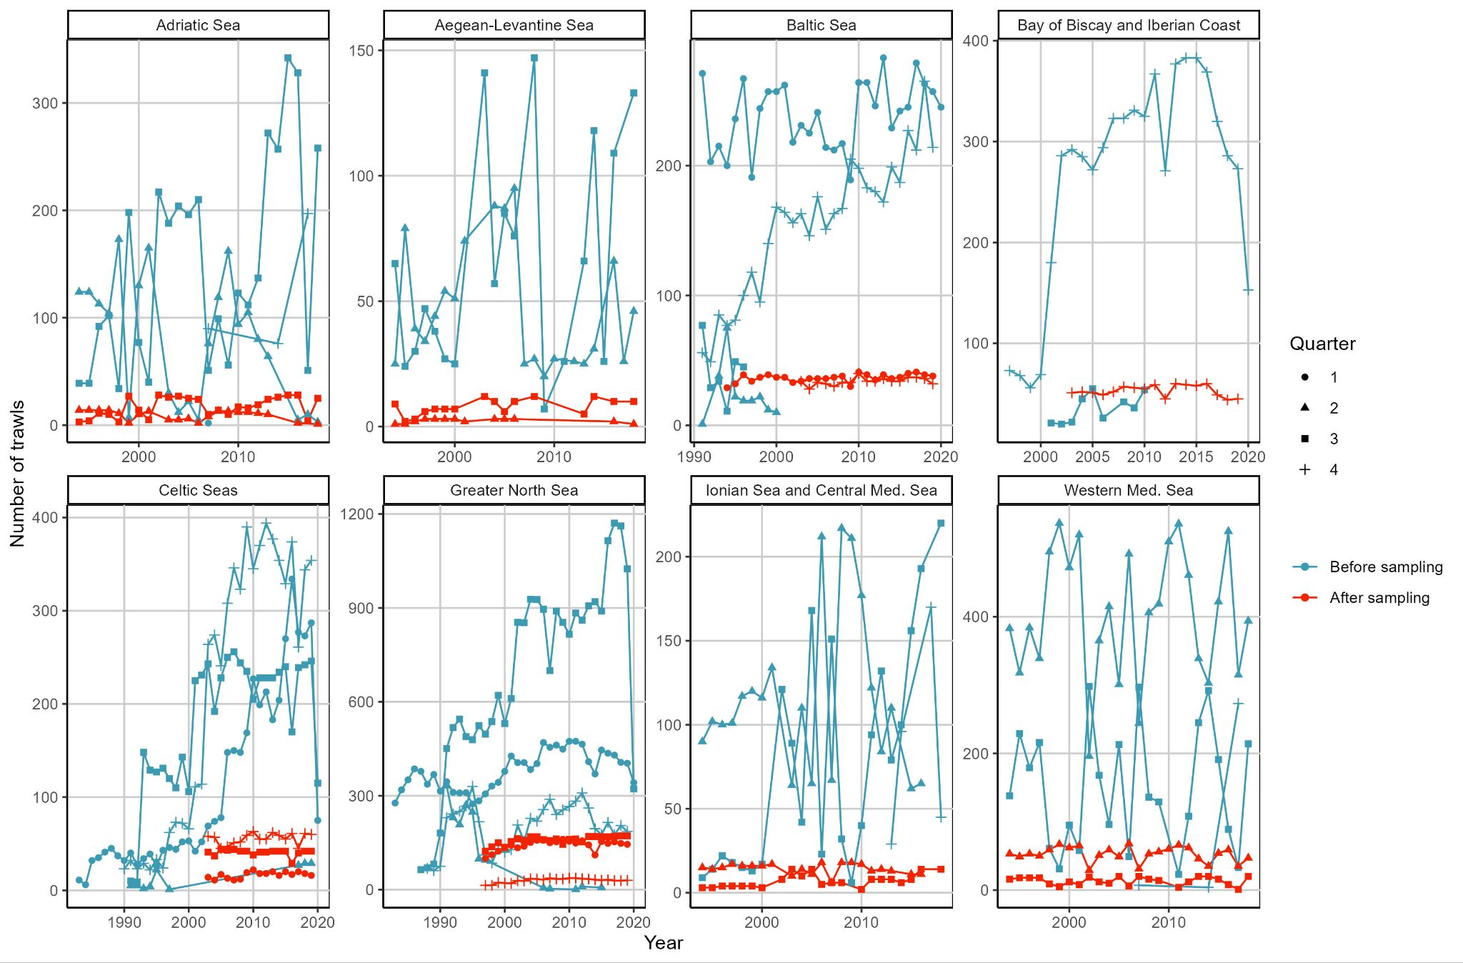
Figure S2. Total number of trawls before and after (colors) the subsampling process, by year (x-axis), quarter (shape) and ecoregions (panels).

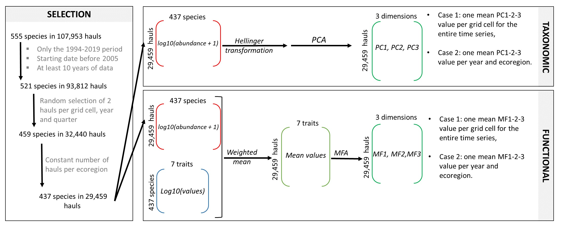
Figure S3. Workflow applied to the original survey data set that includes the hauls selection procedure (left), the taxonomic analysis (top right) and the functional analysis (bottom right).

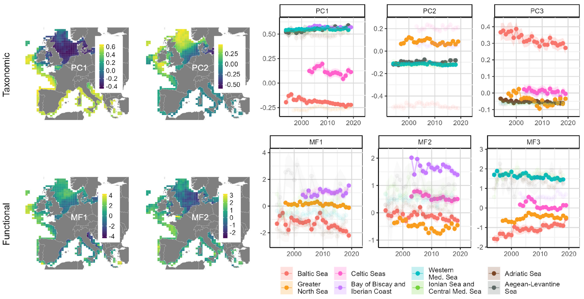
Figure S4. Examples of spatial and temporal results by changing the random selection of two hauls (first example)

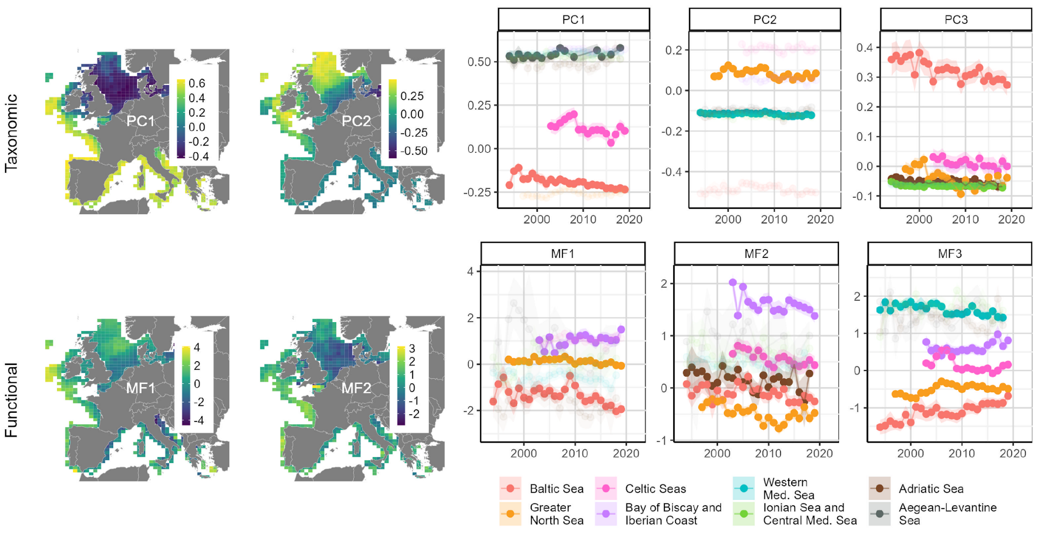
Figure S4. Examples of spatial and temporal results by changing the random selection of two hauls (second example).

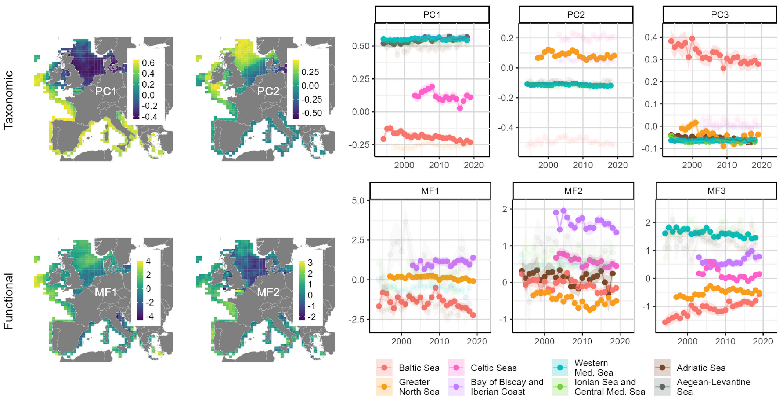
Figure S4. Examples of spatial and temporal results by changing the random selection of two hauls (third example).

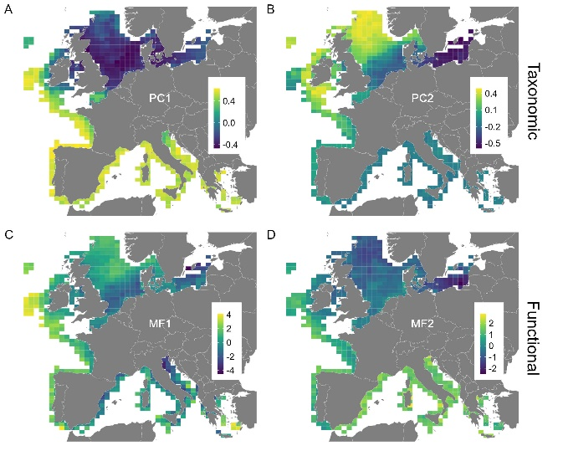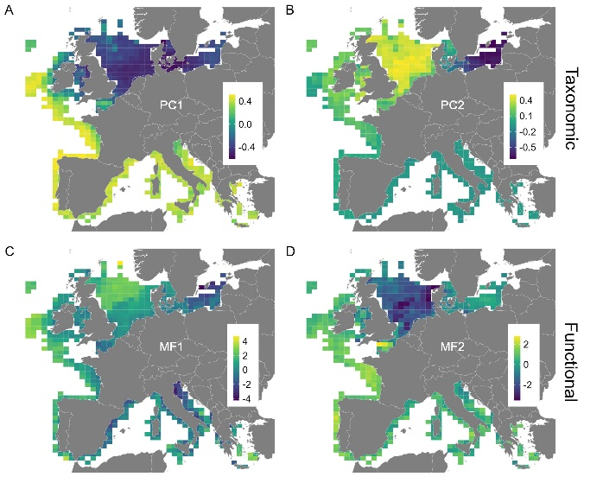
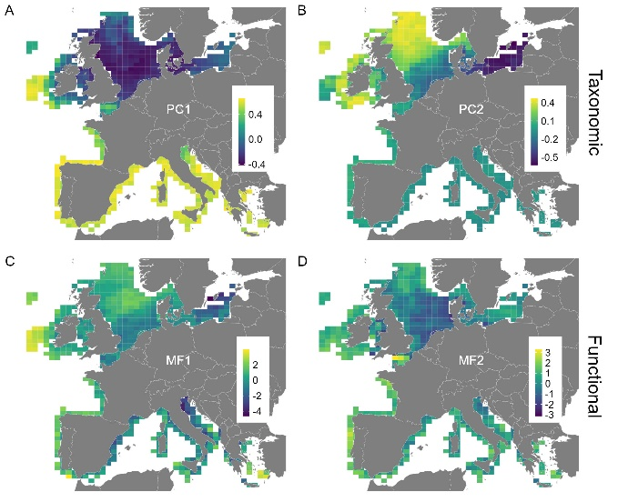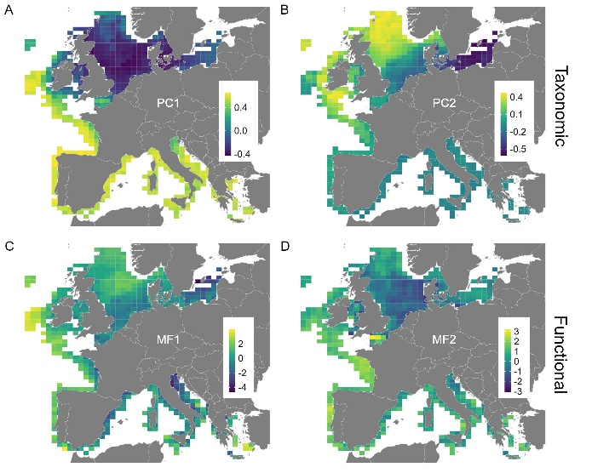
Figure S5. Mean PC1/PC2/MF1/MF2 spatial patterns with for each map one survey removed:
top left: result without BTS; top right: result without NS-IBTS
bottom left: result without EVHOE; bottom right: result without BTS-VIII

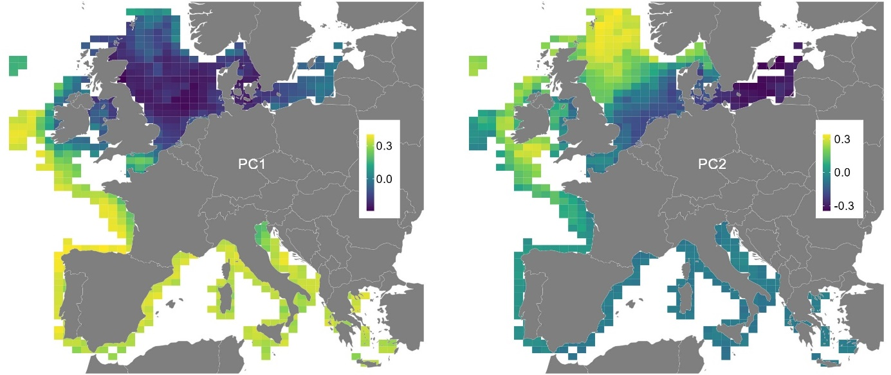
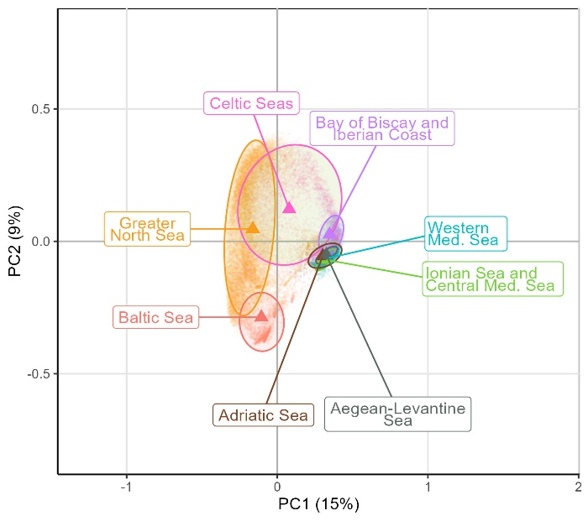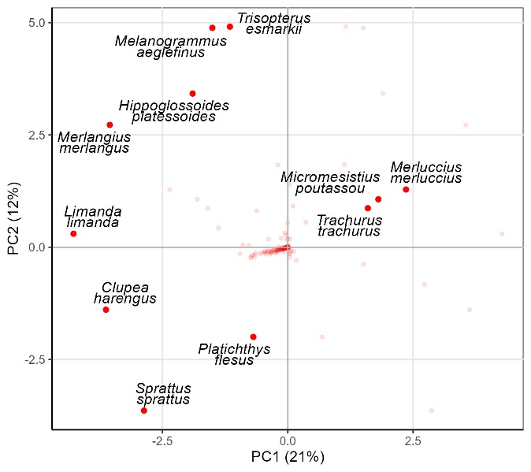
Figure S6. results with the Bray-curtis/PCoA framework. (top) Spatial patterns of the PCo1 and PCo2 ; (bottom left) taxonomic space from the PCoA with only species with coordinates higher than the 95% percentile of each dimension; (bottom right) position of the fish assemblages on the 1st principal component (PC1; x-axis) and 2nd principal component (PC2; y-axis) in the taxonomic spaces.

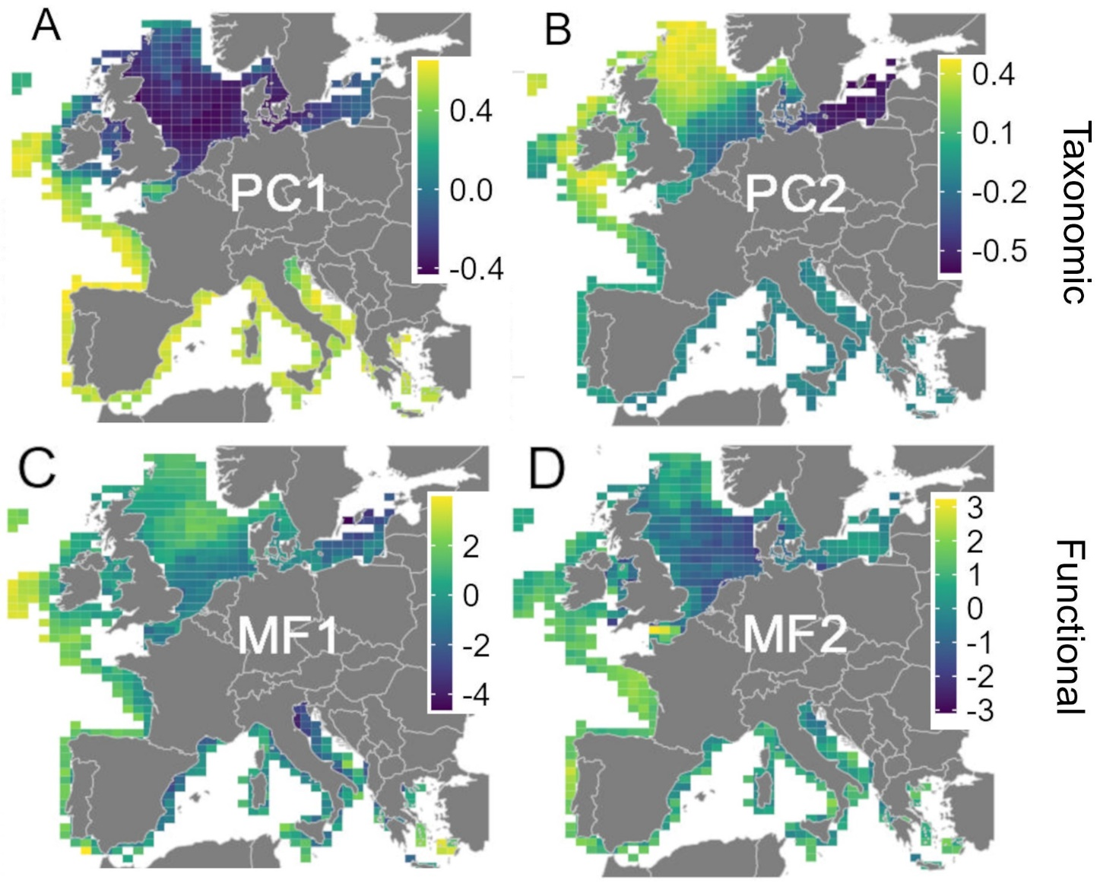
Figure S7. Spatial distribution of the taxonomic structure (PC1, A; PC2, B) and functional structure (MF1, C; MF2, D).

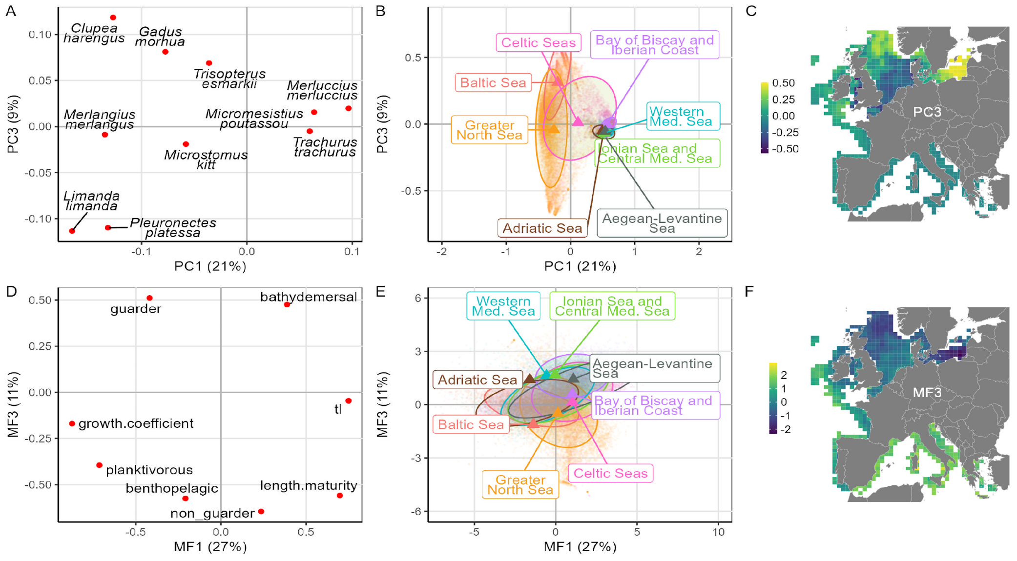
Figure S8. (A) Taxonomic and (E) functional spaces from the PCA and MFA, respectively with only species/traits with coordinates higher than the 95% percentile of each dimension; position of the fish assemblages on the 1st principal component (PC1/MF1; x-axis) and 3rd principal component (PC3/MF3; y-axis) in the taxonomic (B) and (E) functional spaces; spatial distribution of the taxonomic structure (PC3, C) and functional structure (MF3, F). The colors on (B) and (E) show the ecoregions (see Figure 1). The variance explained by each dimension is given on the corresponding axis (A, B, D and E).

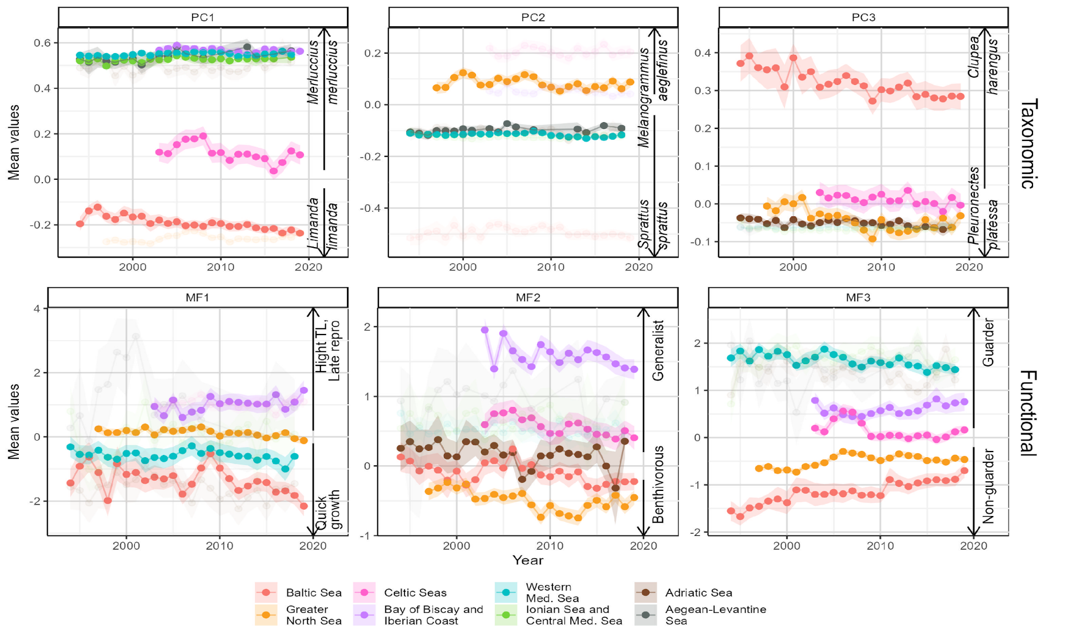
Figure S8. Mean values of taxonomic PC1 (1st Principal Component), PC2 and PC3 (panels, first row), and functional MF1 (1st Multiple Factor component), MF2, and MF3 (panels, second row) by year (x-axis) by ecoregion (colors). The arrows and texts on the different panels show the most driving species and traits for each dimension. Ribbons show the confidence interval around each mean value.
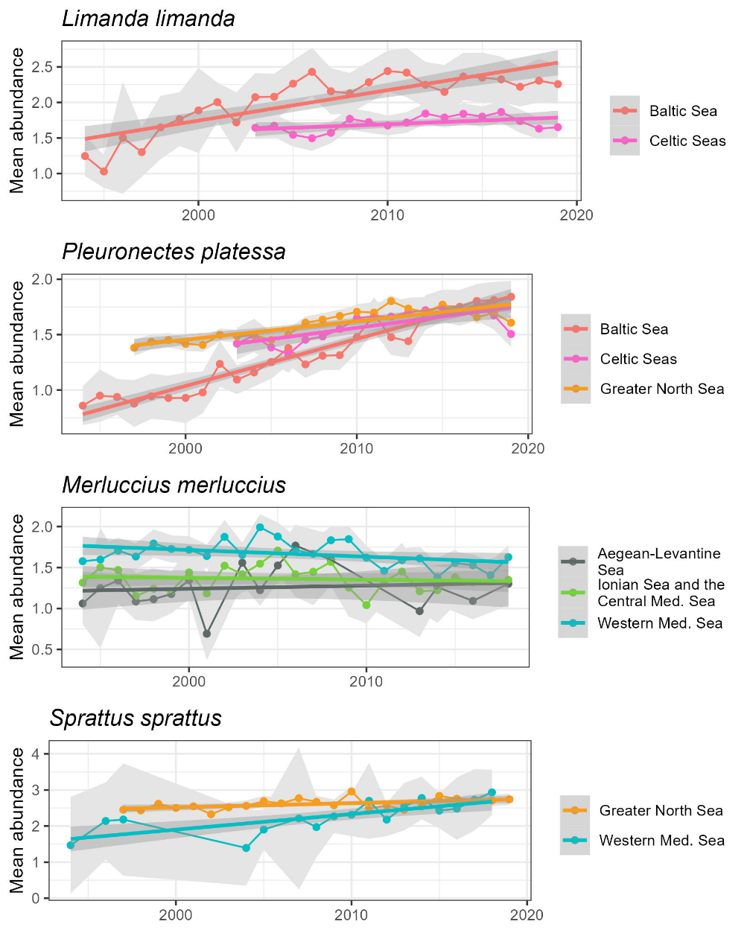
Figure S9. Time series showing the mean abundance for three different species (titles) by year (x-axis) in different ecoregion (colors).
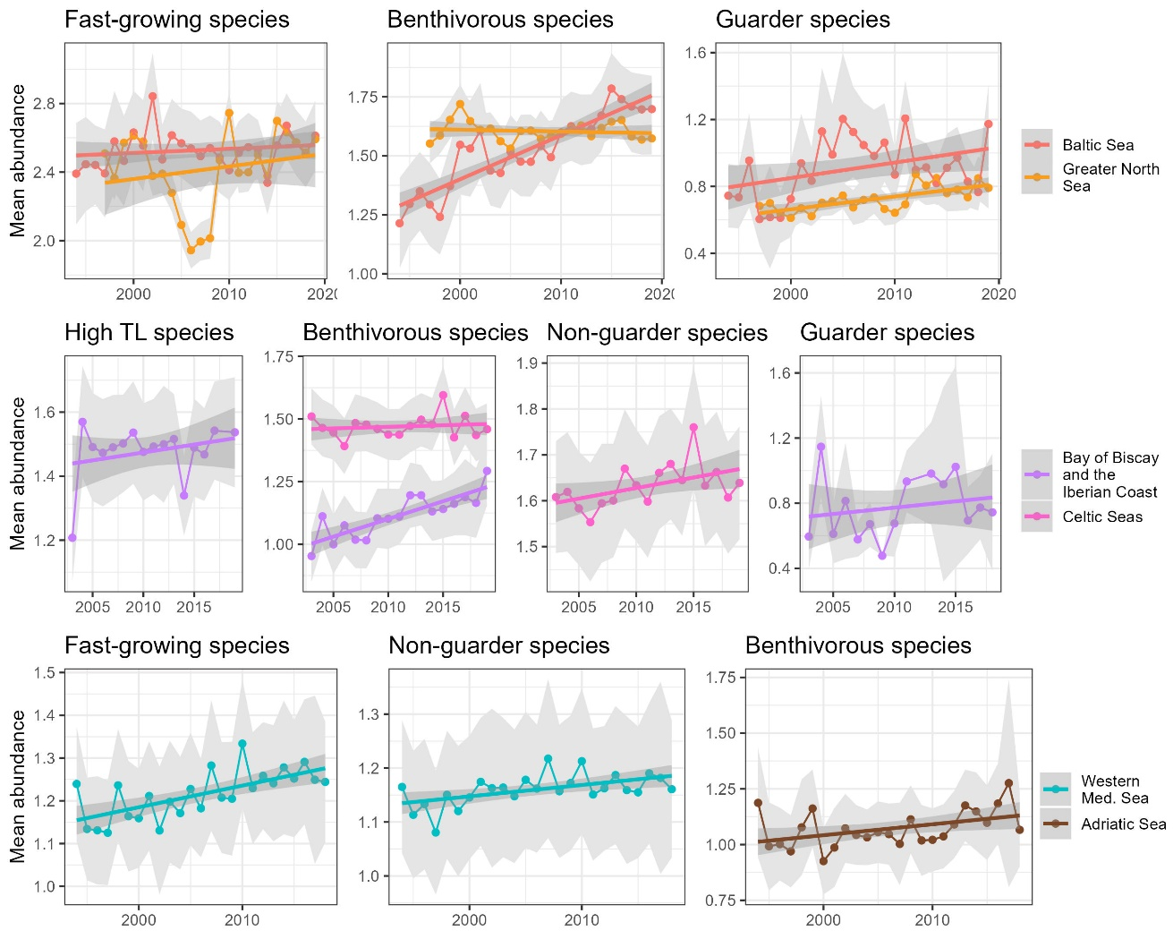
Figure S10. Time series showing the mean abundance for several groups (titles) of species over the year (x-axis) across different ecoregions (colors). Considering the fast-growing species and those at a high trophic level (TL) species, we selected species in the top 90% quantile of the growth coefficient and TL distributions, respectively. Then, we calculated the mean abundance of these selected species by year and bioregion. For category groups (e.g., demersal species), the abundance was averaged for the species with the specific category.

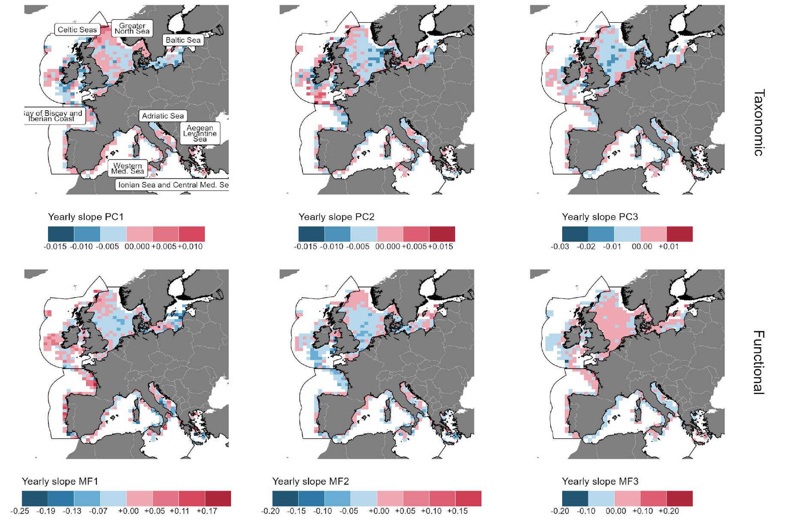
Figure S11. Maps showing the yearly slope of taxonomic PC1, PC2 and PC3 (first row) and functional MF1 (A), MF2 (B) and MF3 (C) mean values in each ICES cell.

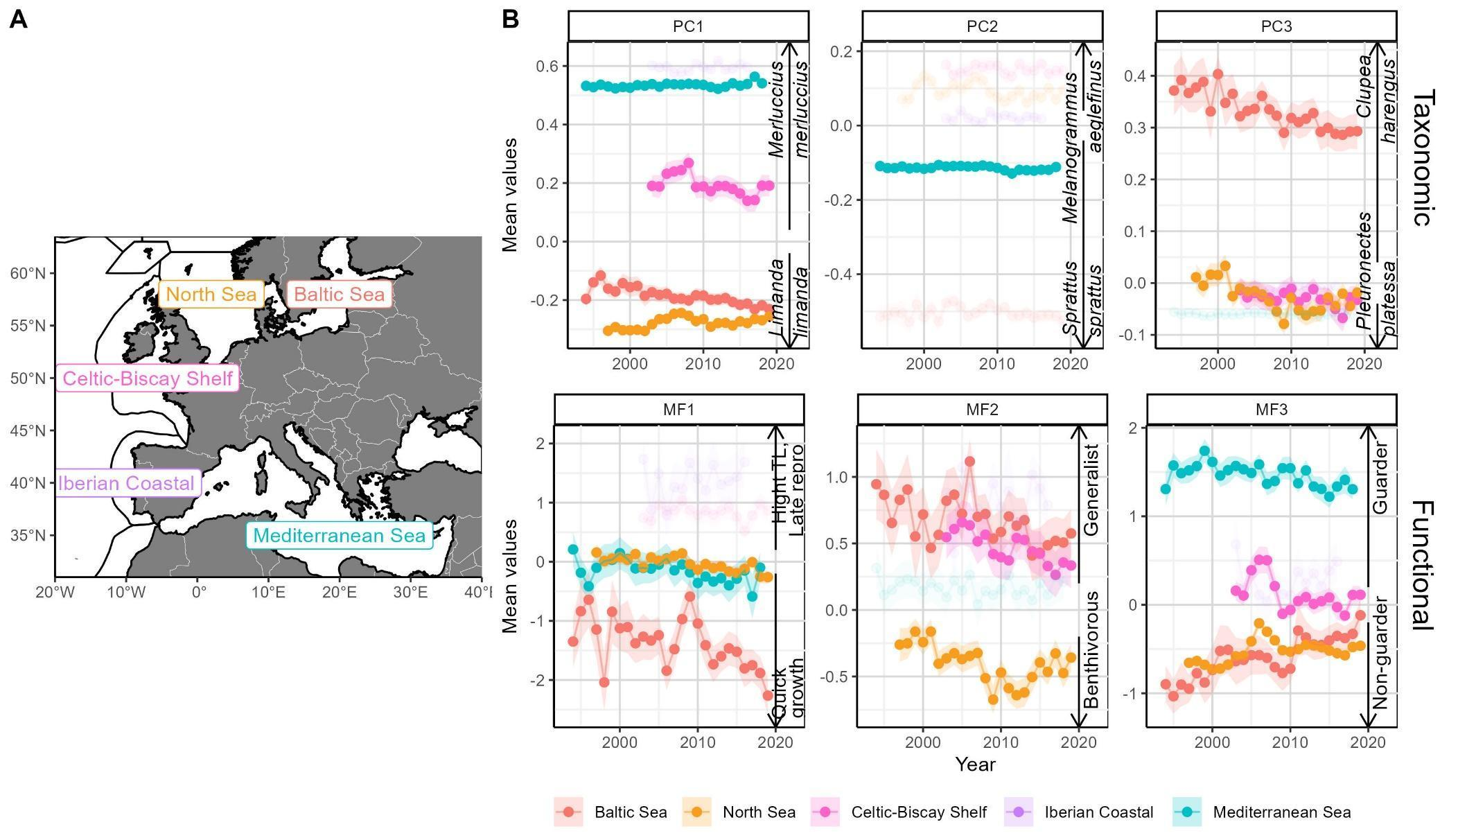
Figure S12. (A) Map of the Large Marine Ecosystems (LME) and (B) taxonomic (PC1, PC2 and PC3) and functional (MF1, MF2 and MF3) time series by LME (colors).

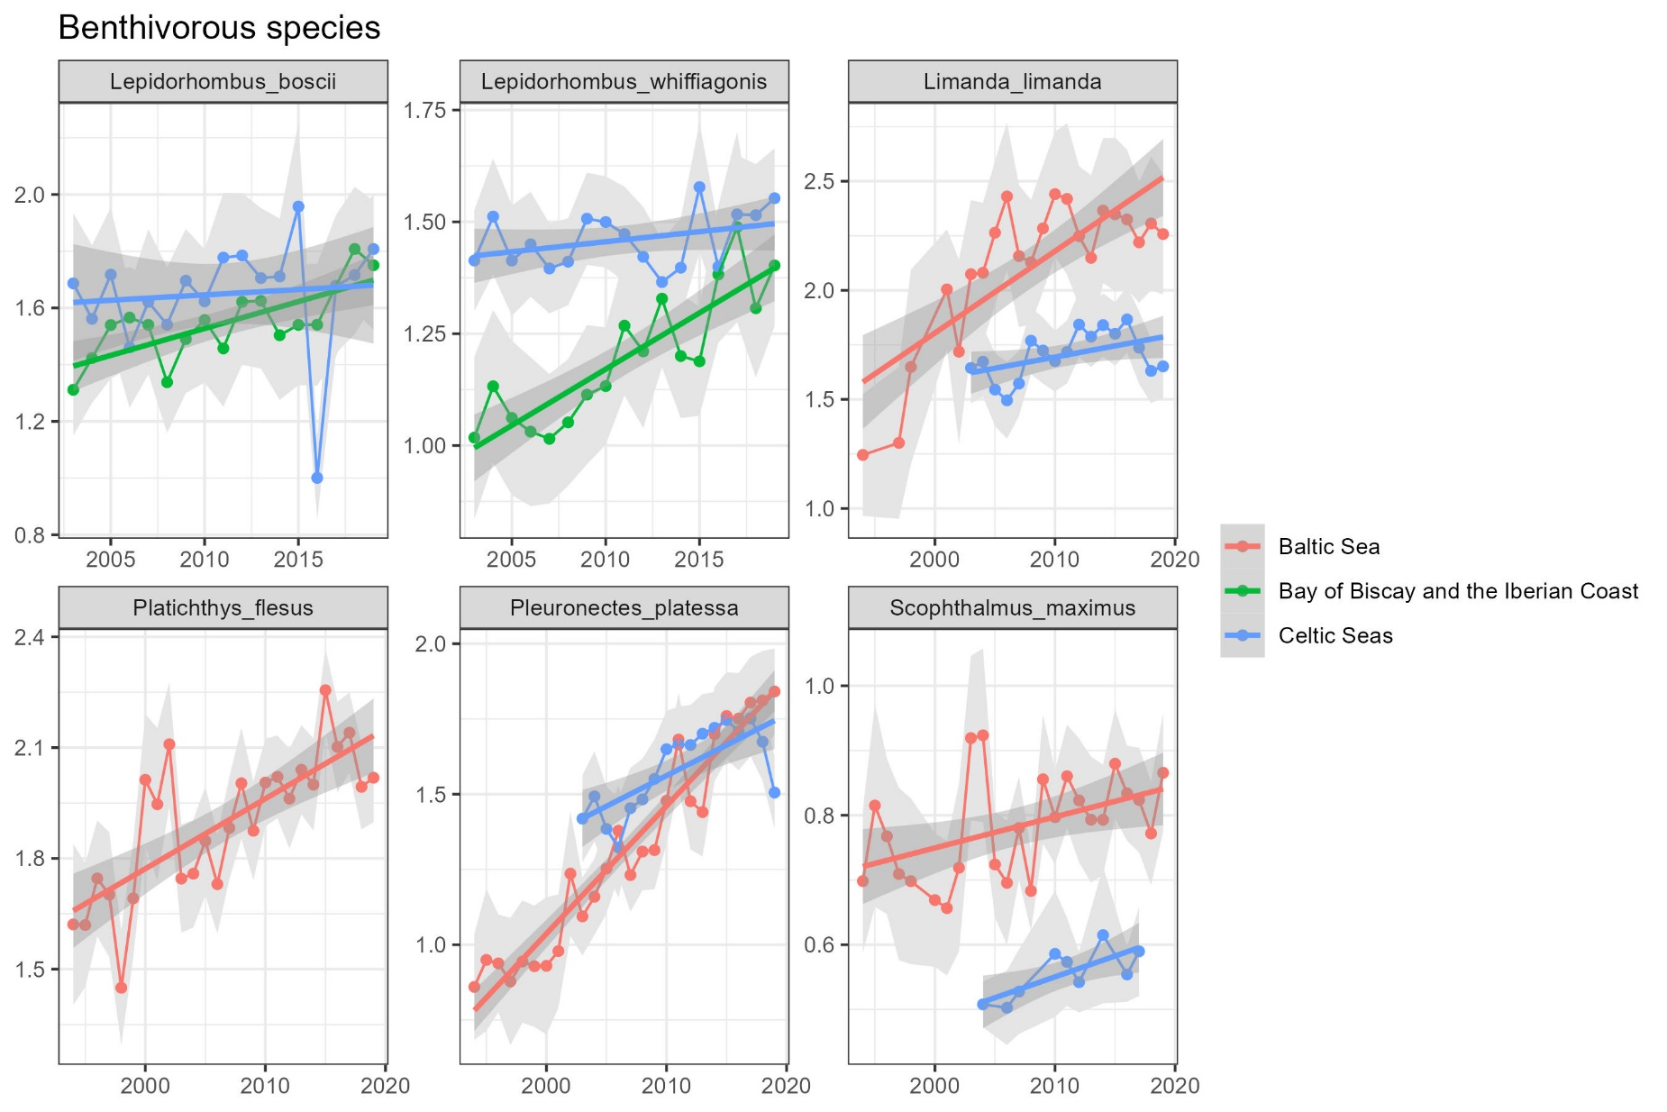
Figure S13. Time series showing the mean abundance (y-axis) for 6 benthivorous species (panels) by year (x-axis) in different ecoregions (colors).
Table S1. Survey details. The period and quarter given correspond to the final dataset used in the analsysis (i.e., after the resampling proccess).
Survey code | Survey name | Area | Period | Quarter | Gear name | Gear type | Vessel | Ref
BITS | Baltic International Trawl Survey | Baltic Sea | 1994-2019 | Q1, Q4 | CAM; CHP; DT; EGY; ESB; EXP; FOT; GOV; GRT; H20; HAK; LBT; LPT; P20; PEL; SON; TVL; TVS | Bottom trawl | 26HF; 67BC; 77SE; ARG; ATL; ATLD; BAL; BALL; BPE; CEV; CLP; CLV; COML; DAN2; DANS; DAR; HAF; KOH; KOOT; MIM; MON; MONL; SOL; SOL2; VSH; ZBA | 4
BTS | Beam Trawl Survey | Celtic Sea; English Channel; North Sea | 1997-2019 | Q3 | BT4A; BT4AI; BT4P; BT4S; BT7; BT8 | Beam trawl | 11BE; CAR; COR; END; ISI; SOL; SOL2; TRI2 | 7
BTS-VIII | Beam Trawl Survey – Bay of Biscay | Bay of Biscay | 2011-2019 | Q4 | BT4A | Beam trawl | 35A8; 35C4; GWD | 7
DWS | Deepwater Survey | Irish Sea | 2006-2007 | Q3 | JDT | Bottom trawl | CEXP | 8
DYFS | Inshore Beam Trawl Survey | Southern North Sea | 2002-2019 | Q3, Q4 | BT3; BT6 | Beam trawl | 06NQ; 11BR; 11SS; 64LC; COMG; ISI; SCV; STE | 7
EVHOE | French Southern Atlantic Bottom trawl Survey | Bay of Biscay and Celtic Sea | 2003-2019 | Q4 | GOV 36/47 | Bottom trawl | THA2 | 1
FR-CGFS | French Channel ground Survey | English Channel | 1997-2019 | Q4 | GOV 36/47 | Bottom trawl | GWD ; THA2 | 2
IE-IAMS | Irish Anglerfish and megrim Survey | Scottish rockall and Irish Sea | 2016-2019 | Q4 | JDT | Bottom trawl | CEXP | 2
IE-IGFS | Irish Groundfish Survey | Ireland Shelf Sea | 2003-2019 | Q2, Q3 | GOV 36/47 | Bottom trawl | CEXP | 2
MEDITS | International bottom trawl survey in the Mediterranean | Mediterranean Sea | 1994-2018 | Q2, Q3 | GOC73 | Bottom trawl | AND; BIM; BIO; CIR; COR; DAP; DEG; DEM; EGU; EVA; FRP; FUL; GAB; GIS; IGO; IRO; LEU; LIB; MEG; MIZ; MOL; NAU; NUS; PEC; PRI; SAN; TAM | 9
NIGFS | Northern Ireland Groundfish Survey | Irish Sea | 2009-2019 | Q1, Q4 | RockHopper ROT | Bottom trawl | COR | 2
NS-IBTS | North Sea International Bottom Trawl Survey | North Sea | 1997-2019 | Q1, Q3 | GOV 36/47 | Bottom trawl | 06NI; 26D4; 58G2; 58UO; 748S; 74E9; 77SE; AND2; ARG; CIR; DAN2; DANG; DANS; ELD; END; ENDN; ENDW; EXP; GOS; HAV; ISI; JHJ; MIC; MIM; SCO2; SCO3; SOL; THA; THA2; TRI; TRI2; TRIF; WAH2; WAH3 | 3
PT-IBTS | Portuguese International Bottom Trawl Survey | Portugal Shelf Sea | 2003-2017 | Q4 | CAR & NCT | Bottom trawl | CAP; NOR | 2
ROCKALL | Scottish Rockall Survey (until 2010) | Rockall plateau | 2003-2009 | Q3 | GOV 36/47 | Bottom trawl | SCO3 | 2
SCOROC | Scottish Rockall Survey (from 2011) | Scottish plateau | 2011-2019 | Q3 | GOV | Bottom trawl | SCO3 | 2
SCOWCGFS | Scottish West Coast Groundfish Survey | Scottish west coast | 2011-2019 | Q1, Q4 | GOV | Bottom trawl | SCO3 | 2
SNS | Sole Net Survey | Southern North Sea | 2002-2019 | Q3, Q4 | BT6 | Beam trawl | ISI ; TRI2 | 7
SP-ARSA | Spanish Gulf of Cadiz Bottom Trawl Survey | Spain | 2003-2019 | Q4 | BAKa trawl 44/60 | Bottom trawl | 29CS; 29MO | 6
SP-NORTH | Spanish North Bottom Trawl Survey | North of Spain | 2003-2019 | Q4 | BAKa trawl 44/60 | Bottom trawl | 29CS; 29MO | 2
SP-PORC | Spanish Porcupine Bottom Trawl Survey | Irish Sea | 2003-2019 | Q3 | PORB | Bottom trawl | 29VE | 5
SWC-IBTS | Scottish West Coast International Bottom Trawl Survey | Scotland Shelf Sea | 1999-2010 | Q1, Q4 | GOV 36/47 | Bottom trawl | SCO2; SCO3 | 2
BAK: Baka trawl; BT4A: Four m Beam trawl; BT4AI: Four m Beam trawl; BT4P: Four m Beam Trawl; BT4S: Four m Beam Trawl; BT6: Beam trawl 6 meters; BT7: Seven m Beam trawl; BT8: Eight m Beam trawl; CAM: Unspecified Gear; CAR: Bottom trawl FGAV019; CHP: Cod Hopper; DT: Russian bottom trawl; EGY: Unspecified Gear; ESB: Estonian small bottom trawl; EXP: EXPO trawl - winged midwater trawl; FOT: Fotomidwater trawl, GOV: Grande Ouverture Verticale Trawl; GOC73: Grande ouverture et côtés; GRT: Granton trawl; H20: Herring ground trawl (HG20/25); HAK: Hake- 4M; JDT: Jackson Trawl; LBT: Latvian Bottom Trawl; LPT: Latvian Pelagic Trawl; PEL: Pelagic midwater trawl; PORB: Porcupine Baka; SON: Sonderborg trawl; TVL: Large TV trawl; TVS: Small TV trawl.
1. ICES. The EVHOE survey (France). ICES Documents. (1997). Available at: https://archimer.ifremer.fr/doc/00036/14707/12013.pdf
2. ICES. Manual of the IBTS North Eastern Atlantic Surveys. Series of ICES Survey Protocols SISP 15 (2017). doi:10.17895/ices.pub.3519
3. ICES. Manual for the International Bottom Trawl Surveys Revision VIII. Series of ICES Survey Protocols SISP 10 - IBTS IX. (2015).
4. https://ices-library.figshare.com/articles/report/SISP_7_-_Manual_for_the_Baltic_International_Trawl_Surveys_BITS_/19050986
5. https://gis.ices.dk/geonetwork/srv/api/records/ce94a257-c8b3-44f7-9fd0-6bd7449ce073
6. http://ices.dk/sites/pub/CM%20Doccuments/2002/D/D0302A.pdf
7. https://ices-library.figshare.com/articles/report/SISP_14_-_Manual_for_the_Offshore_Beam_Trawl_Surveys_WGBEAM_/19051328
8. https://gis.ices.dk/geonetwork/srv/api/records/936b4fb7-9baa-4dbc-abd0-b1b7bda16406
9. https://archimer.ifremer.fr/doc/00117/22783/20585.pdf
Table S2. Spearman correlations (r) for the spatial patterns of the two first PC and MF scores, when one Survey was removed after the other.
Score | without NS-IBTS  compared to  without BTS | without NS-IBTS  compared to  all surveys used | without BTS  compared to  all surveys used | without EVHOE  compared to  without BTS-VIII | without EVHOE  compared to  all surveys used | without BTS-VIII  compared to  all surveys used
PC1 | 0,98 | 0,99 | 0,99 | 0,99 | 0,99 | 0,99
PC2 | 0,68 | 0,7 | 0,99 | 0,99 | 0,99 | 0,99
MF1 | 0,84 | 0,92 | 0,98 | 0,98 | 0,99 | 0,99
MF2 | 0,49 | 0,94 | 0,51 | 0,98 | 0,99 | 0,99

Table S3. Description of each species trait.
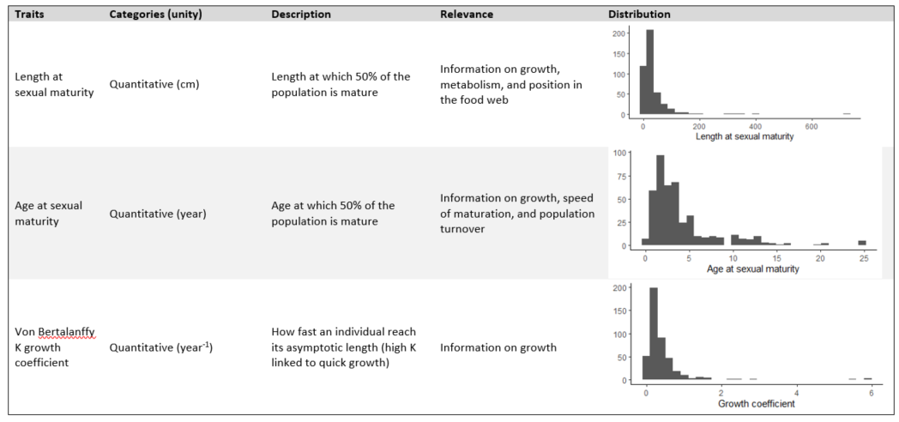
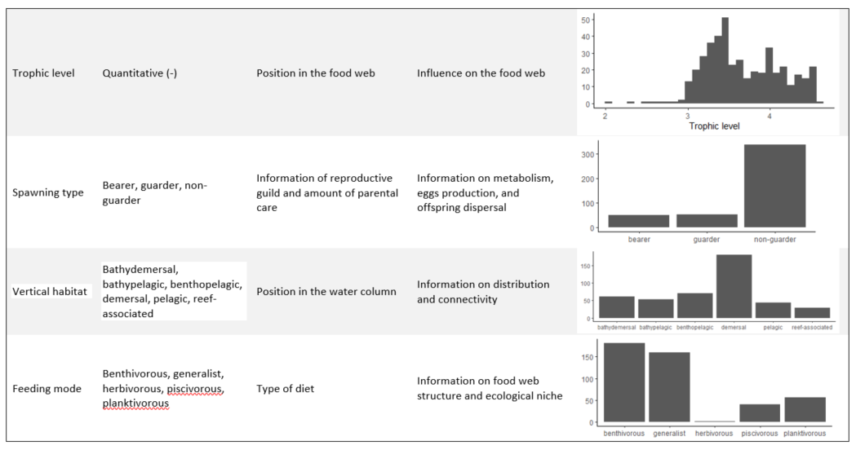

Table S4. AIC values for the GLS top 3 models for the spatial dimension for the taxonomic and the functional aspects.
Dim | Intercept | Chloro | STD chloro | Depth | Depth span | Fishing hours | Mixed layer depth | Bottom oxygen | STD bottom oxygen | Surface salinity | STD surface salinity | Surface temperature | STD surface temperature | Bottom temperature | STD bottom temperature | Bottom current | STD bottom current | DF | logLik | AICc | R²
MF1 | 0,43 | -0,33 | NA | NA | NA | NA | 0,23 | NA | -0,27 | 0,71 | NA | NA | NA | -0,37 | NA | NA | NA | 8 | -281,4 | 579,4 | 79
MF1 | 0,45 | NA | -0,22 | NA | NA | NA | 0,24 | NA | -0,29 | 0,78 | NA | NA | NA | -0,36 | NA | NA | NA | 8 | -281,7 | 579,9
MF1 | 0,44 | -0,32 | NA | NA | NA | -0,11 | 0,23 | NA | -0,29 | 0,71 | NA | NA | NA | -0,36 | NA | NA | NA | 9 | -281,2 | 581,1
MF2 | 0,32 | NA | 0,19 | NA | NA | NA | 0,47 | -0,24 | NA | -0,25 | NA | NA | NA | NA | -0,37 | NA | NA | 9 | -205,8 | 430,2 | 73
MF2 | 0,32 | -0,27 | 0,3 | NA | NA | NA | 0,45 | -0,23 | NA | -0,28 | NA | NA | NA | NA | -0,31 | NA | NA | 10 | -205,2 | 431,2
MF2 | 0,32 | NA | NA | NA | NA | NA | 0,45 | -0,21 | NA | -0,22 | NA | 0,58 | NA | NA | -0,33 | NA | NA | 8 | -207,8 | 432,1
PC1 | 0,09 | NA | NA | NA | NA | NA | 0,11 | -0,05 | NA | -0,09 | NA | 0,51 | NA | NA | -0,12 | NA | NA | 8 | 194,1 | -371,6 | 53
PC1 | 0,09 | NA | NA | NA | 0,04 | NA | 0,11 | -0,04 | NA | -0,09 | NA | 0,46 | NA | 0,05 | -0,12 | 0,03 | NA | 11 | 195,5 | -370,1
PC1 | 0,09 | NA | 0,04 | NA | NA | NA | 0,12 | -0,06 | NA | -0,09 | NA | NA | NA | NA | -0,12 | NA | NA | 9 | 194,3 | -369,9
PC2 | 0,04 | -0,14 | NA | -0,02 | NA | NA | NA | NA | NA | 0,26 | NA | NA | NA | NA | NA | NA | NA | 7 | 272,8 | -531,2 | 64
PC2 | 0,04 | -0,13 | NA | -0,02 | -0,03 | NA | NA | NA | NA | 0,27 | NA | 0,29 | NA | -0,04 | NA | NA | -0,02 | 10 | 274,0 | -529,3
PC2 | 0,04 | -0,12 | NA | -0,02 | NA | NA | NA | NA | NA | 0,27 | NA | 0,25 |  | NA | -0,03 | NA | NA | 8 | 272,2 | -527,9

Table S5. AIC values for the GLS top 3 temporal models for the taxonomic and the functional aspect.
Dimension | Ecoregion | Intercept | Chloro | STD chloro | Mixed layer depth | STD mixed layer depth | Bottom oxygen | STD bottom oxygen | Bottom temperature | STD bottom temperature | Surface temp | STD surface temp | Bottom current | STD bottom current | Surface salinity | STD surface salinity | Degree of freedom | logLik | AICc | R²
MF1 | Adriatic Sea | -2,5 | NA | NA | 2,6 | -2,1 | NA | NA | 2,5 | NA | NA | NA | NA | NA | NA | NA | 6 | 0,9 | 14,8 | 51,0
MF1 | Adriatic Sea | -2,3 | NA | NA | 2,6 | -2,2 | 0,7 | NA | 2,6 | NA | NA | NA | NA | NA | NA | NA | 7 | 1,8 | 16,9
MF1 | Adriatic Sea | -3,4 | NA | NA | NA | NA | NA | NA | 2,2 | NA | NA | NA | NA | NA | NA | NA | 4 | -3,7 | 17,4
MF2 | Adriatic Sea | -0,1 | -1,0 | 0,5 | NA | NA | NA | 0,3 | NA | NA | NA | NA | NA | NA | NA | NA | 6 | 13,3 | -10,0 | 50,0
MF2 | Adriatic Sea | -0,1 | -1,0 | 0,5 | NA | NA | NA | NA | NA | NA | NA | NA | NA | NA | NA | NA | 5 | 11,5 | -9,9
MF2 | Adriatic Sea | 0,2 | NA | NA | NA | NA | NA | NA | NA | NA | NA | NA | NA | NA | NA | NA | 3 | 7,9 | -8,7
MF1 | Aegean-Levantine Sea | -4,5 | NA | NA | NA | NA | NA | NA | 7,5 | 2,8 | NA | NA | NA | NA | NA | NA | 5 | -9,9 | 35,9 | 63,0
MF1 | Aegean-Levantine Sea | -6,6 | NA | NA | NA | NA | NA | NA | 7,5 | NA | NA | NA | NA | NA | NA | NA | 4 | -12,6 | 36,9
MF1 | Aegean-Levantine Sea | -4,6 | -0,8 | NA | NA | NA | NA | NA | 7,2 | 3,0 | NA | NA | NA | NA | NA | NA | 6 | -8,0 | 37,4
MF2 | Aegean-Levantine Sea | 1,8 | NA | NA | NA | NA | NA | NA | NA | 1,2 | NA | NA | NA | NA | NA | NA | 4 | -4,3 | 20,3 | 43,0
MF2 | Aegean-Levantine Sea | 0,9 | NA | NA | NA | NA | NA | NA | NA | NA | NA | NA | NA | NA | NA | NA | 3 | -6,4 | 20,8
MF2 | Aegean-Levantine Sea | 1,4 | 0,6 | NA | NA | NA | NA | NA | NA | NA | NA | NA | NA | NA | -0,5 | NA | 5 | -5,2 | 22,0
MF1 | Baltic Sea | -2,7 | NA | NA | NA | NA | NA | NA | -0,8 | NA | NA | NA | NA | NA | NA | NA | 4 | -8,5 | 27,0 | 29,0
MF1 | Baltic Sea | -3,5 | NA | NA | 0,5 | NA | NA | NA | -1,2 | NA | NA | NA | NA | NA | NA | NA | 5 | -7,5 | 28,0
MF1 | Baltic Sea | -2,6 | NA | NA | NA | 0,2 | NA | NA | -0,8 | NA | NA | NA | NA | NA | NA | NA | 5 | -7,8 | 28,6
MF2 | Baltic Sea | 0,2 | NA | NA | NA | NA | -0,2 | NA | NA | NA | NA | NA | NA | NA | NA | NA | 4 | 16,5 | -23,2 | 35,0
MF2 | Baltic Sea | -0,1 | NA | NA | NA | NA | NA | NA | NA | NA | NA | NA | NA | NA | NA | NA | 3 | 14,8 | -22,4
MF2 | Baltic Sea | 0,4 | NA | NA | NA | 0,4 | -0,2 | NA | NA | NA | NA | NA | NA | NA | NA | NA | 5 | 17,4 | -21,8
MF1 | Bay of Biscay and the Iberian Coast | 1,8 | NA | NA | NA | NA | NA | NA | 0,8 | NA | NA | NA | NA | NA | NA | NA | 4 | 2,5 | 6,3 | 30,0
MF1 | Bay of Biscay and the Iberian Coast | 1,5 | NA | NA | NA | NA | NA | NA | NA | 1,0 | NA | NA | NA | NA | NA | NA | 4 | 2,0 | 7,3
MF1 | Bay of Biscay and the Iberian Coast | 1,0 | NA | NA | NA | NA | NA | NA | NA | NA | NA | NA | NA | NA | NA | NA | 3 | 0,0 | 7,9
MF2 | Bay of Biscay and the Iberian Coast | 2,0 | NA | NA | NA | NA | 0,9 | NA | NA | NA | NA | NA | NA | NA | NA | NA | 4 | 7,2 | -3,0 | 29,0
MF2 | Bay of Biscay and the Iberian Coast | 1,0 | NA | NA | NA | NA | NA | NA | -0,6 | NA | NA | NA | NA | NA | NA | NA | 4 | 7,1 | -2,8
MF2 | Bay of Biscay and the Iberian Coast | 1,6 | NA | NA | NA | NA | NA | NA | NA | NA | NA | NA | NA | NA | NA | NA | 3 | 4,6 | -1,4
MF1 | Celtic Seas | 1,2 | NA | NA | NA | NA | NA | NA | NA | -0,7 | NA | NA | NA | NA | NA | NA | 4 | 13,3 | -15,3 | 54,0
MF1 | Celtic Seas | 1,1 | NA | NA | NA | NA | -0,6 | NA | NA | -0,7 | NA | NA | NA | NA | -0,2 | NA | 6 | 14,8 | -14,1
MF1 | Celtic Seas | 1,1 | NA | NA | NA | NA | NA | NA | NA | -0,7 | -0,2 | NA | NA | NA | NA | NA | 5 | 13,6 | -11,7
MF2 | Celtic Seas | 0,8 | NA | NA | NA | NA | NA | NA | -0,8 | NA | 0,9 | NA | NA | NA | NA | NA | 5 | 17,6 | -19,7 | 53,0
MF2 | Celtic Seas | 0,4 | NA | NA | NA | NA | NA | NA | -0,6 | NA | NA | NA | NA | NA | NA | NA | 4 | 15,3 | -19,3
MF2 | Celtic Seas | 0,6 | NA | NA | NA | NA | NA | NA | NA | NA | NA | NA | NA | NA | NA | NA | 3 | 13,3 | -18,7
MF1 | Greater North Sea | 0,1 | NA | NA | NA | NA | NA | NA | NA | NA | NA | NA | NA | NA | NA | NA | 3 | 17,5 | -27,7 | NA
MF1 | Greater North Sea | 0,3 | NA | NA | NA | NA | NA | NA | NA | NA | 0,2 | NA | NA | NA | NA | NA | 4 | 17,3 | -24,4
MF1 | Greater North Sea | 0,3 | NA | NA | NA | NA | NA | NA | NA | -0,1 | NA | NA | NA | NA | NA | NA | 4 | 17,2 | -24,2
MF2 | Greater North Sea | -0,5 | NA | NA | NA | NA | NA | NA | NA | NA | NA | NA | NA | NA | NA | NA | 3 | 14,1 | -21,0 | NA
MF2 | Greater North Sea | 0,0 | NA | NA | NA | NA | -0,5 | NA | NA | NA | NA | NA | NA | NA | NA | NA | 4 | 15,1 | -19,9
MF2 | Greater North Sea | -0,4 | NA | NA | NA | 0,3 | NA | NA | NA | NA | NA | NA | NA | NA | NA | NA | 4 | 14,8 | -19,4
MF1 | Ionian Sea and the Central Mediterranean Sea | 25,6 | 5,1 | -2,2 | NA | NA | NA | NA | -25,4 | NA | 2,6 | NA | NA | NA | NA | NA | 7 | -2,8 | 27,2 | 3,6
MF1 | Ionian Sea and the Central Mediterranean Sea | 14,6 | -4,2 | NA | NA | NA | NA | NA | -21,2 | NA | 1,7 | NA | NA | NA | NA | NA | 6 | -5,5 | 28,2
MF1 | Ionian Sea and the Central Mediterranean Sea | 19,0 | NA | -1,0 | NA | NA | NA | NA | -22,5 | NA | 2,1 | NA | NA | NA | NA | NA | 6 | -5,8 | 28,9
MF2 | Ionian Sea and the Central Mediterranean Sea | -5,5 | -1,1 | NA | 0,6 | NA | NA | NA | 5,8 | NA | NA | NA | NA | NA | NA | NA | 6 | 16,4 | -15,5 | 44,0
MF2 | Ionian Sea and the Central Mediterranean Sea | -4,9 | NA | NA | 0,5 | NA | NA | NA | 6,2 | NA | NA | NA | NA | NA | NA | NA | 5 | 14,1 | -14,7
MF2 | Ionian Sea and the Central Mediterranean Sea | 2,0 | NA | NA | NA | NA | NA | NA | 0,1 | 1,5 | NA | NA | NA | NA | NA | NA | 5 | 14,1 | -14,7
MF1 | Western Mediterranean Sea | -3,2 | NA | NA | NA | NA | NA | NA | 3,4 | NA | NA | NA | NA | NA | NA | NA | 4 | 14,5 | -19,0 | 45,6
MF1 | Western Mediterranean Sea | -2,7 | NA | NA | NA | NA | 0,8 | NA | 3,3 | NA | 0,6 | NA | NA | NA | NA | NA | 6 | 17,8 | -18,9
MF1 | Western Mediterranean Sea | -4,2 | NA | NA | NA | NA | NA | NA | 4,5 | NA | 0,5 | NA | NA | NA | NA | NA | 5 | 15,9 | -18,6
MF2 | Western Mediterranean Sea | 1,3 | NA | NA | NA | NA | NA | NA | -1,0 | NA | NA | NA | NA | NA | NA | NA | 4 | 25,2 | -40,4 | 23,6
MF2 | Western Mediterranean Sea | 0,5 | NA | NA | NA | NA | NA | NA | NA | NA | NA | NA | NA | NA | NA | NA | 3 | 23,6 | -40,1
MF2 | Western Mediterranean Sea | 2,2 | NA | NA | NA | NA | NA | NA | -1,1 | 0,9 | NA | NA | NA | NA | NA | NA | 5 | 26,5 | -39,8
PC1 | Adriatic Sea | 0,5 | NA | NA | NA | NA | NA | -0,1 | NA | NA | NA | NA | NA | NA | NA | NA | 4 | 56,5 | -102,9 | 26
PC1 | Adriatic Sea | 0,5 | NA | NA | NA | 0,0 | NA | -0,1 | NA | NA | NA | NA | NA | NA | NA | NA | 5 | 56,3 | -99,4
PC1 | Adriatic Sea | 0,4 | NA | NA | 0,0 | NA | NA | -0,1 | NA | NA | NA | NA | NA | NA | NA | NA | 5 | 55,5 | -97,9
PC2 | Adriatic Sea | -0,1 | NA | NA | NA | NA | NA | NA | NA | NA | NA | NA | NA | NA | NA | NA | 3 | 73,9 | -140,7 | NA
PC2 | Adriatic Sea | -0,1 | NA | NA | NA | NA | NA | NA | 0,0 | NA | NA | NA | NA | NA | NA | NA | 4 | 71,8 | -133,5
PC2 | Adriatic Sea | -0,1 | 0,0 | NA | NA | NA | NA | NA | NA | NA | NA | NA | NA | NA | NA | NA | 4 | 71,5 | -133,1
PC1 | Aegean-Levantine Sea | 0,7 | 0,2 | NA | NA | NA | NA | NA | NA | NA | NA | NA | NA | NA | NA | NA | 4 | 43,2 | -74,8 | 77
PC1 | Aegean-Levantine Sea | 0,7 | 0,2 | NA | NA | NA | NA | NA | NA | NA | 0,0 | NA | NA | NA | NA | NA | 5 | 42,3 | -68,6
PC1 | Aegean-Levantine Sea | 0,8 | 0,2 | NA | NA | NA | NA | NA | NA | 0,1 | NA | NA | NA | NA | NA | NA | 5 | 42,3 | -68,5
PC2 | Aegean-Levantine Sea | -0,1 | NA | NA | NA | NA | NA | NA | NA | NA | NA | NA | NA | NA | NA | NA | 4 | 45,1 | -82,3 | NA
PC2 | Aegean-Levantine Sea | 0,0 | NA | NA | NA | NA | NA | NA | NA | 0,1 | NA | NA | NA | NA | NA | 0,1 | 4 | 43,9 | -76,2
PC2 | Aegean-Levantine Sea | -0,1 | 0,1 | NA | NA | NA | NA | NA | NA | NA | NA | NA | NA | NA | NA | NA | 4 | 43,8 | -76,0
PC1 | Baltic Sea | -0,4 | NA | NA | NA | NA | NA | NA | NA | NA | -0,1 | NA | NA | NA | NA | NA | 4 | 63,1 | -116,3 | 68
PC1 | Baltic Sea | -0,1 | NA | NA | NA | NA | 0,0 | NA | NA | NA | NA | NA | NA | NA | 1,0 | NA | 5 | 62,1 | -114,4
PC1 | Baltic Sea | -0,2 | NA | NA | NA | NA | 0,0 | NA | NA | NA | -0,1 | NA | NA | NA | NA | NA | 5 | 63,2 | -113,4
PC2 | Baltic Sea | -0,5 | NA | NA | NA | NA | NA | NA | NA | NA | NA | NA | NA | NA | NA | NA | 3 | 65,5 | -123,9 | NA
PC2 | Baltic Sea | -0,5 | NA | NA | NA | 0,0 | NA | NA | NA | NA | NA | NA | NA | NA | NA | NA | 4 | 63,4 | -116,8
PC2 | Baltic Sea | -0,5 | NA | NA | 0,0 | NA | NA | NA | NA | NA | NA | NA | NA | NA | NA | NA | 4 | 63,2 | -116,5
PC1 | Bay of Biscay and the Iberian Coast | 0,6 | NA | NA | NA | NA | NA | NA | NA | NA | NA | NA | NA | NA | NA | NA | 3 | 53,4 | -98,9 | NA
PC1 | Bay of Biscay and the Iberian Coast | 0,6 | NA | NA | NA | NA | 0,0 | NA | NA | NA | NA | NA | NA | NA | NA | NA | 4 | 51,2 | -91,0
PC1 | Bay of Biscay and the Iberian Coast | 0,6 | NA | NA | NA | NA | NA | NA | NA | NA | 0,0 | NA | NA | NA | NA | NA | 4 | 51,1 | -90,9
PC2 | Bay of Biscay and the Iberian Coast | 0,1 | NA | NA | NA | NA | NA | NA | NA | NA | NA | NA | NA | NA | NA | NA | 3 | 47,3 | -86,8 | NA
PC2 | Bay of Biscay and the Iberian Coast | 0,0 | NA | NA | NA | NA | NA | NA | 0,0 | NA | NA | NA | NA | NA | NA | NA | 4 | 45,7 | -80,1
PC2 | Bay of Biscay and the Iberian Coast | 0,1 | NA | NA | NA | NA | 0,0 | NA | NA | NA | NA | NA | NA | NA | NA | NA | 4 | 45,6 | -79,9
PC1 | Celtic Seas | 0,0 | NA | NA | NA | NA | NA | NA | -0,3 | NA | NA | NA | NA | NA | NA | NA | 4 | 34,2 | -57,0 | 24
PC1 | Celtic Seas | 0,2 | NA | NA | NA | NA | NA | NA | NA | -0,2 | NA | NA | NA | NA | NA | NA | 4 | 33,6 | -55,9
PC1 | Celtic Seas | 0,1 | NA | NA | NA | NA | NA | NA | NA | NA | NA | NA | NA | NA | NA | NA | 3 | 31,5 | -55,1
PC2 | Celtic Seas | 0,2 | NA | NA | NA | NA | NA | NA | NA | NA | NA | NA | NA | NA | NA | NA | 3 | 43,0 | -78,2 | NA
PC2 | Celtic Seas | 0,3 | NA | NA | NA | NA | NA | NA | NA | NA | NA | 0,1 | NA | NA | NA | NA | 4 | 42,9 | -74,4
PC2 | Celtic Seas | 0,2 | NA | NA | NA | NA | NA | NA | 0,1 | NA | NA | NA | NA | NA | NA | NA | 4 | 41,7 | -72,0
PC1 | Greater North Sea | -0,3 | NA | NA | NA | NA | NA | NA | NA | NA | NA | NA | NA | NA | NA | NA | 3 | 63,4 | -119,6 | NA
PC1 | Greater North Sea | -0,3 | NA | NA | NA | 0,0 | NA | NA | NA | NA | NA | NA | NA | NA | NA | NA | 4 | 62,2 | -114,2
PC1 | Greater North Sea | -0,2 | NA | NA | NA | NA | 0,0 | NA | NA | NA | NA | NA | NA | NA | NA | NA | 4 | 61,3 | -112,3
PC2 | Greater North Sea | 0,1 | NA | NA | NA | NA | NA | NA | NA | NA | NA | NA | NA | NA | NA | NA | 3 | 55,8 | -104,4 | NA
PC2 | Greater North Sea | 0,1 | NA | NA | NA | NA | NA | NA | NA | NA | 0,0 | NA | NA | NA | NA | NA | 4 | 54,1 | -97,9
PC2 | Greater North Sea | 0,1 | NA | NA | NA | NA | 0,0 | NA | NA | NA | NA | NA | NA | NA | NA | NA | 4 | 53,8 | -97,3
PC1 | Ionian Sea and the Central Mediterranean Sea | 0,5 | NA | NA | NA | 0,0 | NA | NA | NA | NA | NA | NA | NA | NA | NA | NA | 4 | 73,7 | -137,3 | 40
PC1 | Ionian Sea and the Central Mediterranean Sea | 0,5 | NA | NA | 0,0 | NA | NA | NA | NA | NA | NA | NA | NA | NA | NA | NA | 4 | 73,6 | -137,0
PC1 | Ionian Sea and the Central Mediterranean Sea | 0,5 | NA | NA | NA | NA | NA | NA | NA | NA | NA | NA | NA | NA | NA | NA | 3 | 71,9 | -136,5
PC2 | Ionian Sea and the Central Mediterranean Sea | -0,3 | 0,0 | NA | NA | NA | NA | NA | 0,2 | NA | NA | NA | NA | NA | NA | NA | 5 | 85,0 | -156,5 | 4,7
PC2 | Ionian Sea and the Central Mediterranean Sea | -0,1 | NA | NA | NA | NA | NA | NA | NA | NA | NA | NA | NA | NA | NA | -0,9 | 4 | 81,3 | -155,3
PC2 | Ionian Sea and the Central Mediterranean Sea | -0,3 | NA | 0,0 | NA | NA | NA | NA | 0,2 | NA | NA | NA | NA | NA | NA | NA | 5 | 84,3 | -155,1
PC1 | Western Mediterranean Sea | 0,5 | NA | NA | NA | NA | NA | NA | NA | NA | NA | NA | NA | NA | NA | NA | 3 | 86,3 | -165,5 | NA
PC1 | Western Mediterranean Sea | 0,7 | NA | NA | NA | NA | NA | NA | -0,2 | NA | NA | NA | NA | NA | NA | NA | 4 | 86,2 | -162,4
PC1 | Western Mediterranean Sea | 0,5 | NA | NA | NA | NA | NA | NA | NA | -0,1 | NA | NA | NA | NA | NA | NA | 4 | 85,0 | -160,0
PC2 | Western Mediterranean Sea | -0,1 | NA | NA | NA | NA | NA | NA | NA | NA | NA | NA | NA | NA | NA | NA | 3 | 92,0 | -176,9 | NA
PC2 | Western Mediterranean Sea | -0,1 | NA | NA | NA | NA | NA | NA | 0,0 | NA | NA | NA | NA | NA | NA | NA | 4 | 90,4 | -170,8
PC2 | Western Mediterranean Sea | -0,1 | NA | NA | NA | NA | 0,0 | NA | NA | NA | NA | NA | NA | NA | NA | NA | 4 | 89,9 | -169,8

