Supplementary material:

TABLE S1

Primer pairs utilized for amplification of the Atacama Trench sediment samples in this study.

|  |  |  |  |
| --- | --- | --- | --- |
| **Primer set** | **Primer sequence (5'-3')** | **Fragment length (bp)** | **Reference** |
| 18S Euka02 (v7) | F-TTTGTCTGSTTAATTSCG | 133 | Guardiola et al. (2015). |
|  | R-CACAGACCTGTTATTGC |  |  |
|  |  |  |  |
| 18sMini (V9) | F-CCAGCASCYGCGGTAATTCC | 130 | Amaral-Zettler et al. (2009). |
|  | R-CCTTCYGCAGGTTCACCTA |  |  |

TABLE S2

Significance values based on the Wald Chi-squared test applied on the generalized lineal models to determine if explanatory predictors affect the community composition among individuals of the Actinopteri class and the Cnidarian phylum. Here taken as the presence/absence of every unique ASV in each unique sample.   
*=Statistically significant predictor.

|  |  |  |  |  |
| --- | --- | --- | --- | --- |
|  | **Fish** |  | **Cnidarians** |  |
| Predictor | Wald | Pr(>wald) | Wald | Pr(>wald) |
|  | Value |  | Value |  |
| Time Period | 0.044 | 0.202 | 0.086 | 0.855 |
| Sea Surface Temperature | 2.509 | 0.337 | 5.868 | 0.271 |
| Interdecadal Pacific Oscillation | 1.468 | 0.898 | 5.207 | 0.414 |
| Index |  |  |  |  |
| Niño 1+2 Index | 0.638 | 0.896 | 3.437 | 0.835 |
| Oceanic Niño Index | 1.453 | 0.604 | 4.272 | 0.799 |
| Niño 1+2 + Tons of fish by fishing | 0.857 | 0.756 | 2.964 | 0.976 |
| Chlorophyll-a concentration | 0.779 | 0.889 | 5.416 | 0.063 |
| Tons of fish by fishing | 1.857 | 0.145 | 6.485 | 0.023* |
| Tons of fish by aquaculture | 1.179 | 0.627 | 5.038 | 0.139 |
|  |  |  |  |  |

Fig. S1.- 210Pbex concentration and total organic carbon (TOC) profiles measured in sediment cores recovered in the Atacama Trench region. Sediment layers deposited during mass-wasting events, as inferred from relatively stable 210Pbex concentrations over distinct depth intervals and typically associated with abnormal TOC distributions are shown in gray hatches Dashed horizontal lines at A9, A10, A3, and A5 indicate the depth for surface mixed layers. Solid and dashed lines in the 210Pbex graphs were obtained by exponential curve fitting to the respective 210Pbex concentration profiles in the indicated depth interval. From Oguri et al. (2022).

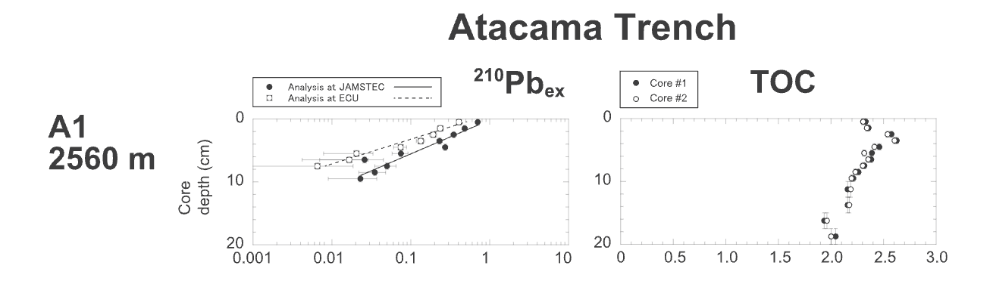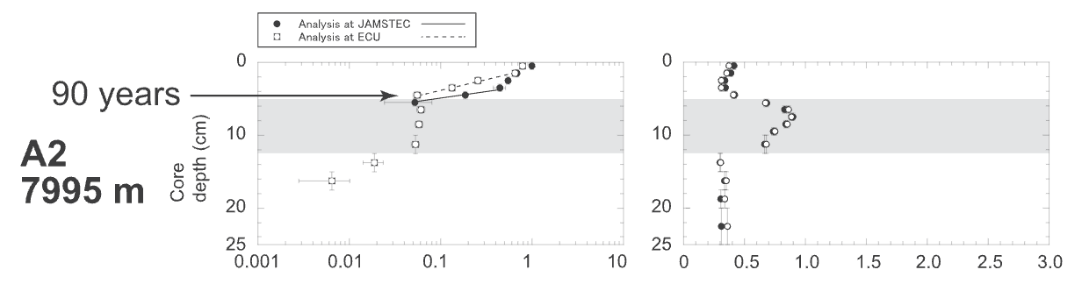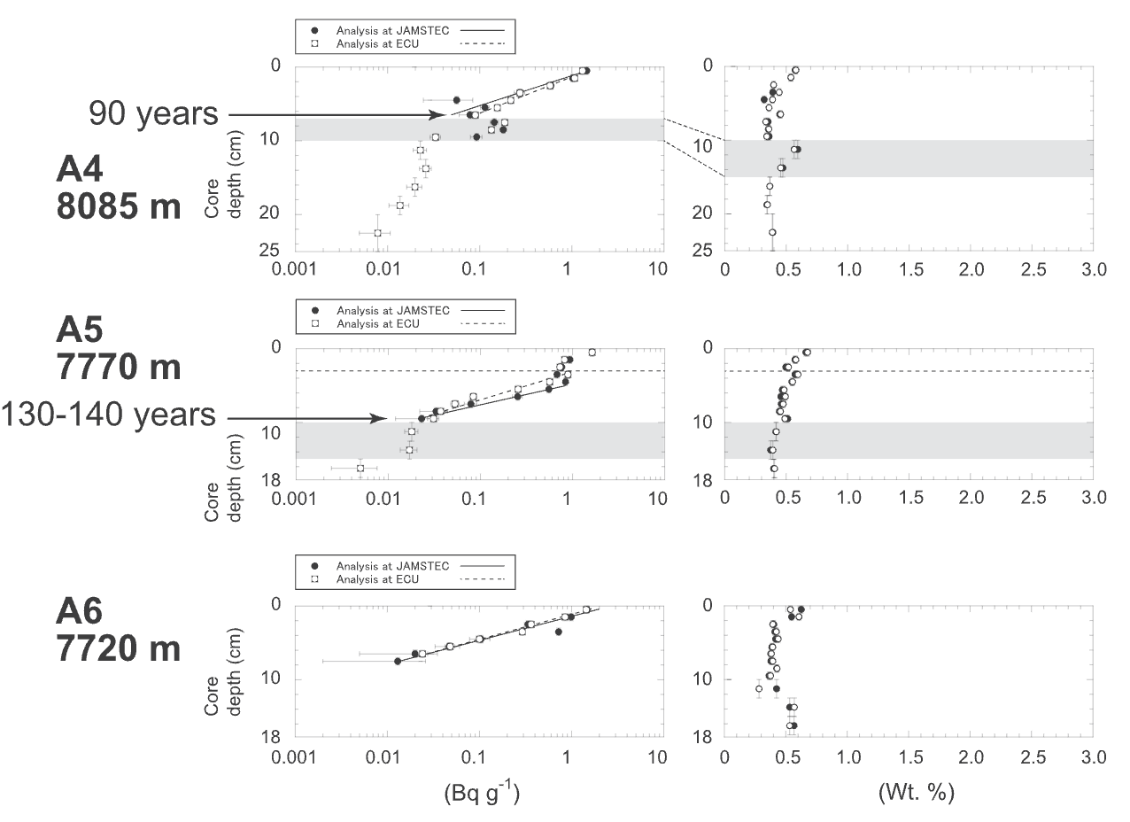

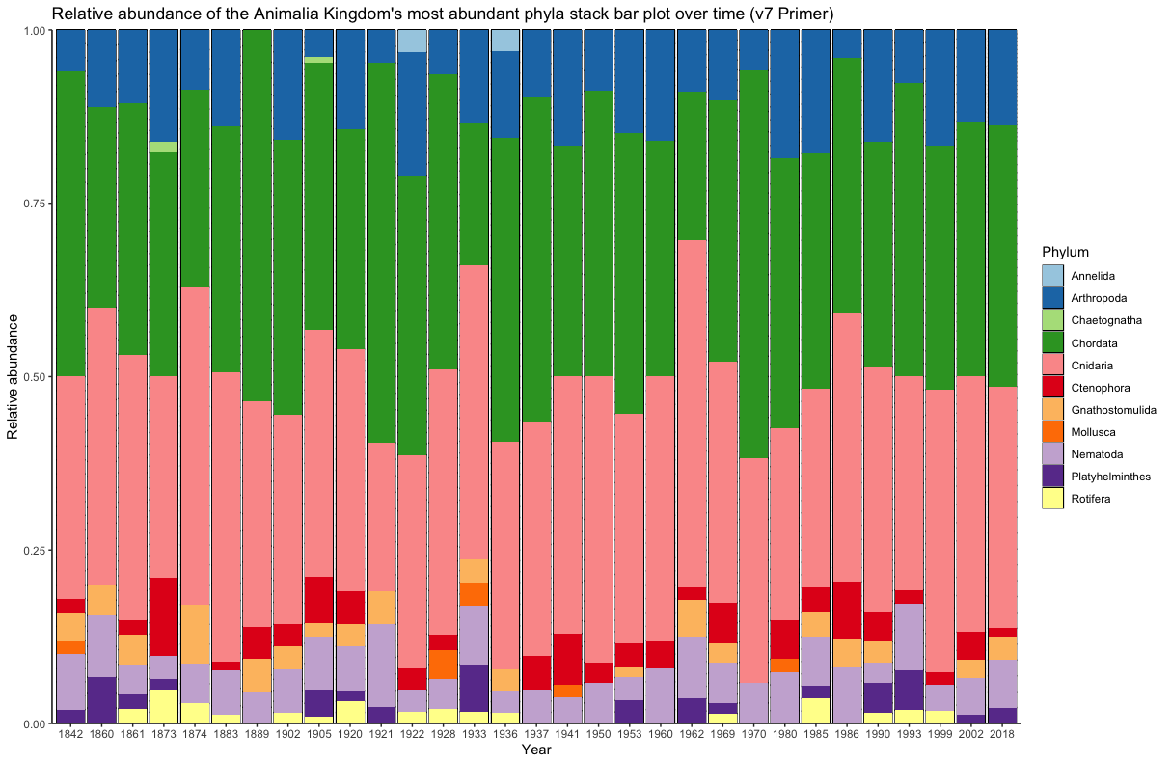

FIGURE S2: Bar plot of the Animalia Kingdom’s community composition for the v7 primer. Each bar represents a total community at a given year calculated by the sediment chronology, and each color represents the percentage of reads by a specific phylum in the total abundance of reads of that community.

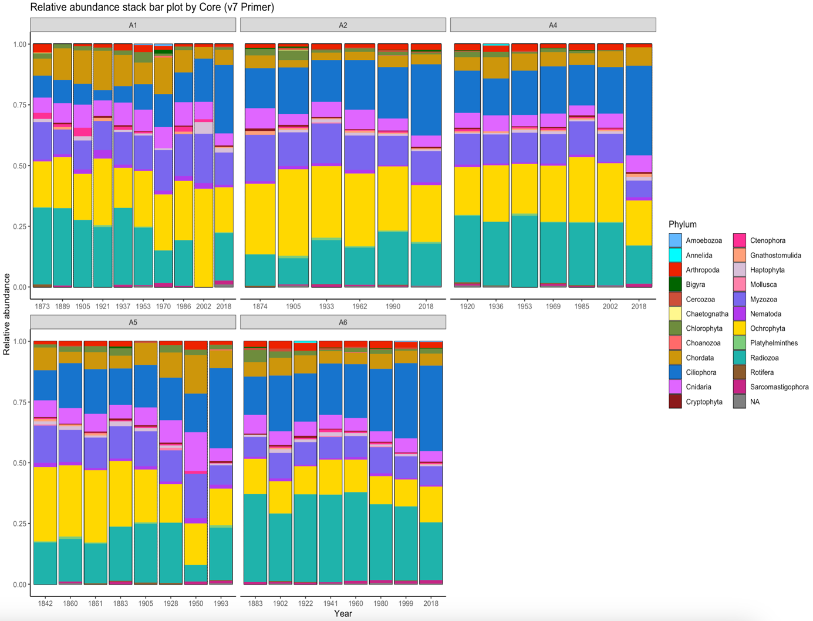FIGURE S3: Bar plot of the relative abundance for the community composition of pelagic phyla found in each core for the v7 primer. Each bar represents a total community at a given year calculated by the sediment chronology, and each color represents the percentage of reads by a specific phylum in the total abundance of reads of that community.

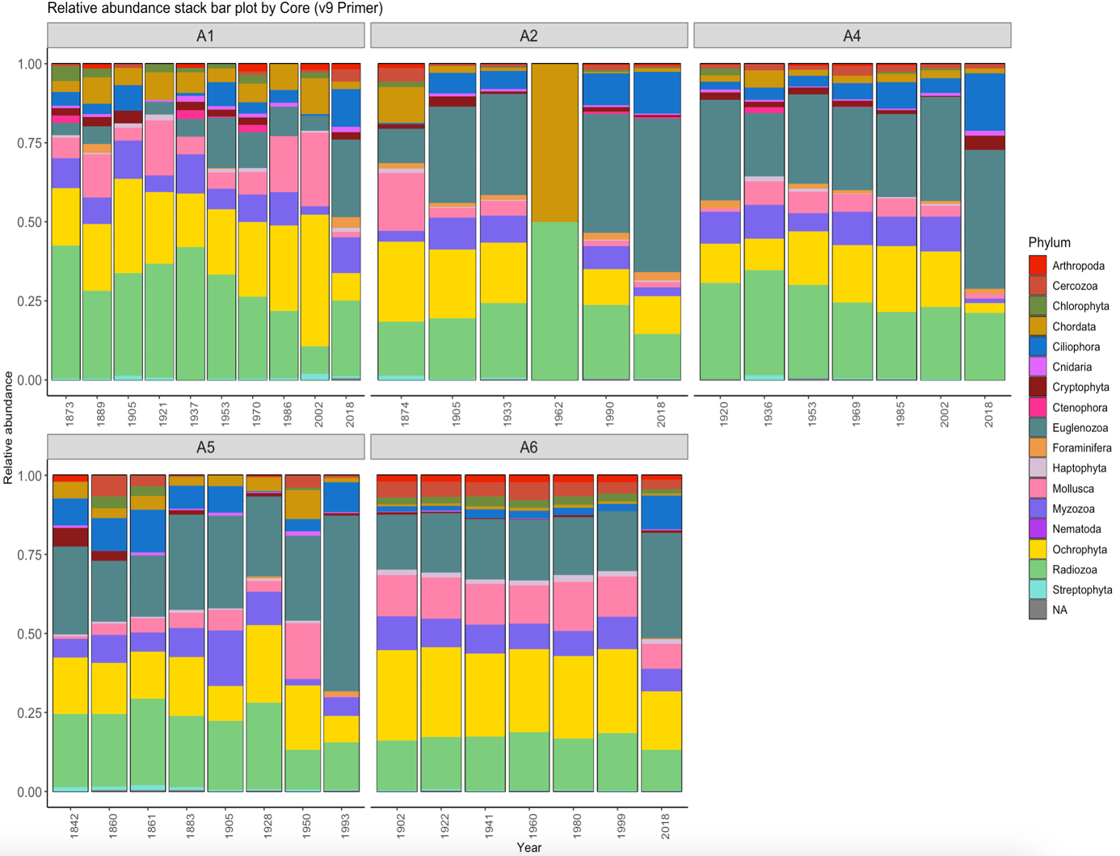FIGURE S4: Bar plot of the relative abundance for the community composition of pelagic phyla found in each core for the v9 primer. Each bar represents a total community at a given year calculated by the sediment chronology, and each color represents the percentage of reads by a specific phylum in the total abundance of reads of that community.