Supplementary Figures

***Supplementary Figure 1.*** *Maps showing location of four areas outside the axis of the upper canyon that are inferred to have undergone no significant (< 0.5m) seabed elevation change between surveys 2019 and 2020. Data from these areas was used to assess uncertainties in bathymetric change between 2019 and 2020, and to generate histograms of seabed elevation in Figure 4 A-D. From Talling et al. (2022; their supplementary material).*

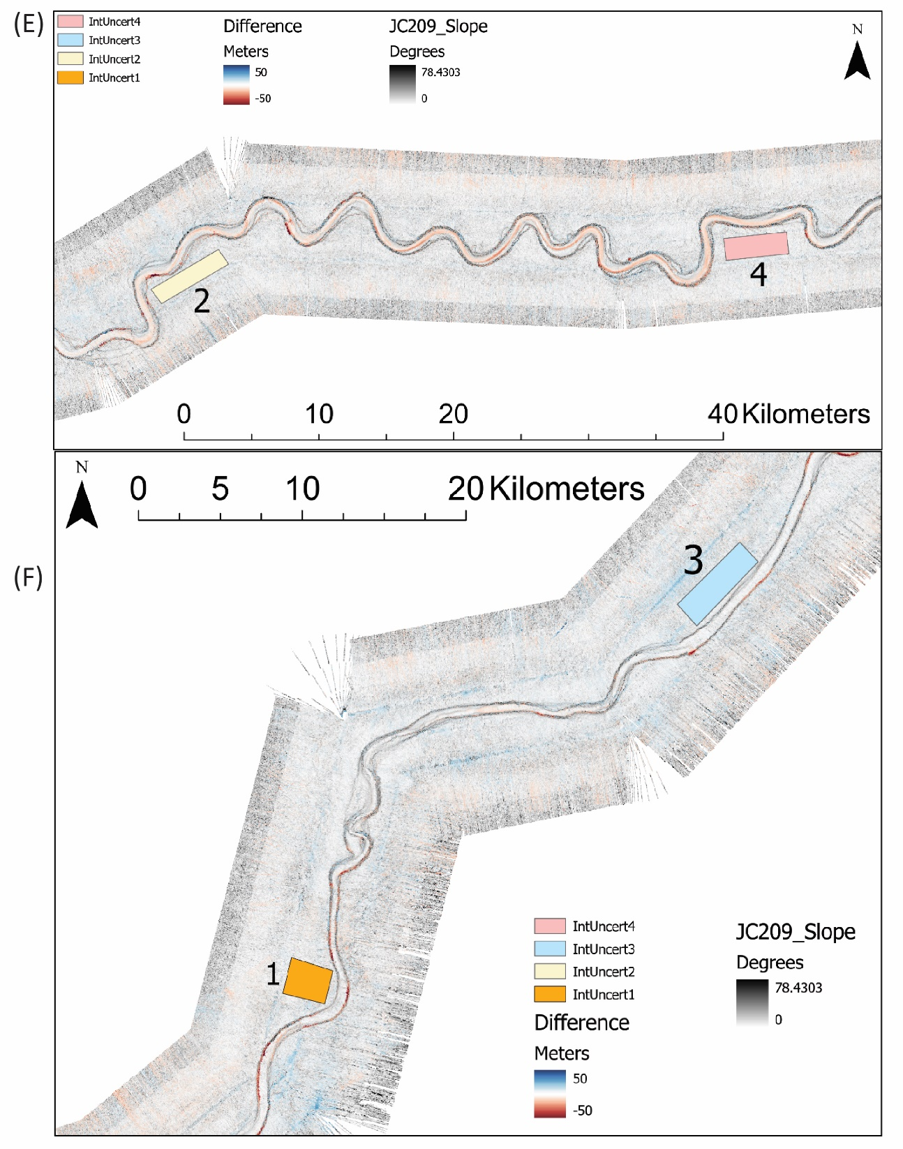

***Supplementary Figure 2.*** *Maps showing location of four areas outside the deep-sea submarine channel that are inferred to have undergone no significant (< 0.5m) seabed elevation change between surveys 2019 and 2020. Data from these areas was used to assess uncertainties in bathymetric change between 2019 and 2020, and to generate histograms of seabed elevation in Figure 4 E-H. From Talling et al. (2022; their supplementary material).*