**Rare Earth elements in the North Atlantic, part II: partition coefficients**

Lagarde Mariona,b, Pham Viet Quocb,c, Lemaitre, Nolwennb,1, Belhadj Moustafab,2 and Jeandel Catherineb,3

a LOCEAN-IPSL, Sorbonne Université/IRD/CNRS/MNHN, Paris, France, [marion.lagarde@locean.ipsl.fr](mailto:marion.lagarde@locean.ipsl.fr) (corresponding author)

b LEGOS, CNRS, UT3, CNES, IRD, University of Toulouse, 14 avenue Edouard Belin, Toulouse, 31400, France.

1 nolwenn.lemaitre@univ-tlse3.fr

2 [moustafa.belhadj@univ-tlse](mailto:moustafa.belhadj@legos.obs-mip.fr)3.fr

3 catherine.jeandel@univ-tlse3.fr

c Institute of Environmental Technology, 18 Hoàng Quốc Việt street, Cầu Giấy, Hanoi, Vietnam. viet.pham@univ-tlse3.fr

keywords: Rare earth elements; dissolved particulate exchanges; partition coefficients; suspended particle mass; manganese oxides; iron hydroxides; GEOTRACES; GEOVIDE

# APPENDIX A: Supplementary material

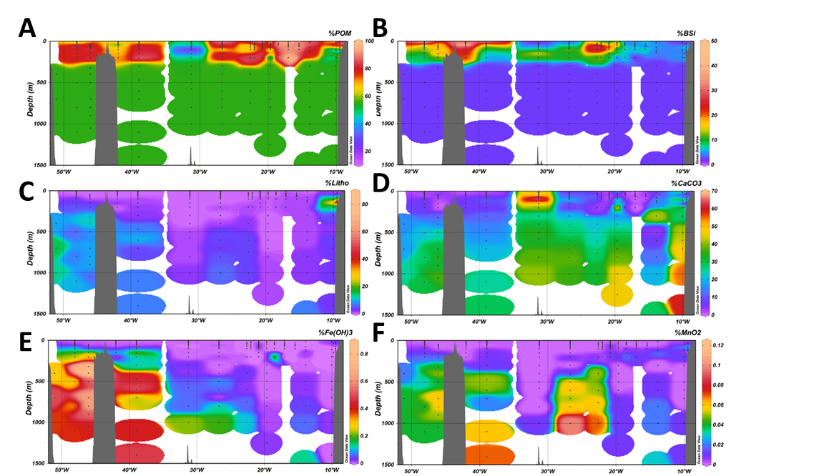

Figure S1: Relative contributions of the main particulate phases to the SPM: **A.** Particulate organic matter (POM) **B.** Biogenic silica **C.** Lithogenic component **D.** Calcium carbonate **E.** Fe hydroxides and **F.** Mn oxides

Table S1: Suspended particle mass (SPM) values along the GEOVIDE transect (µg.L-1)

Table S1: end



Table S2: Partition coefficient Kd of REE along the GEOVIDE transect

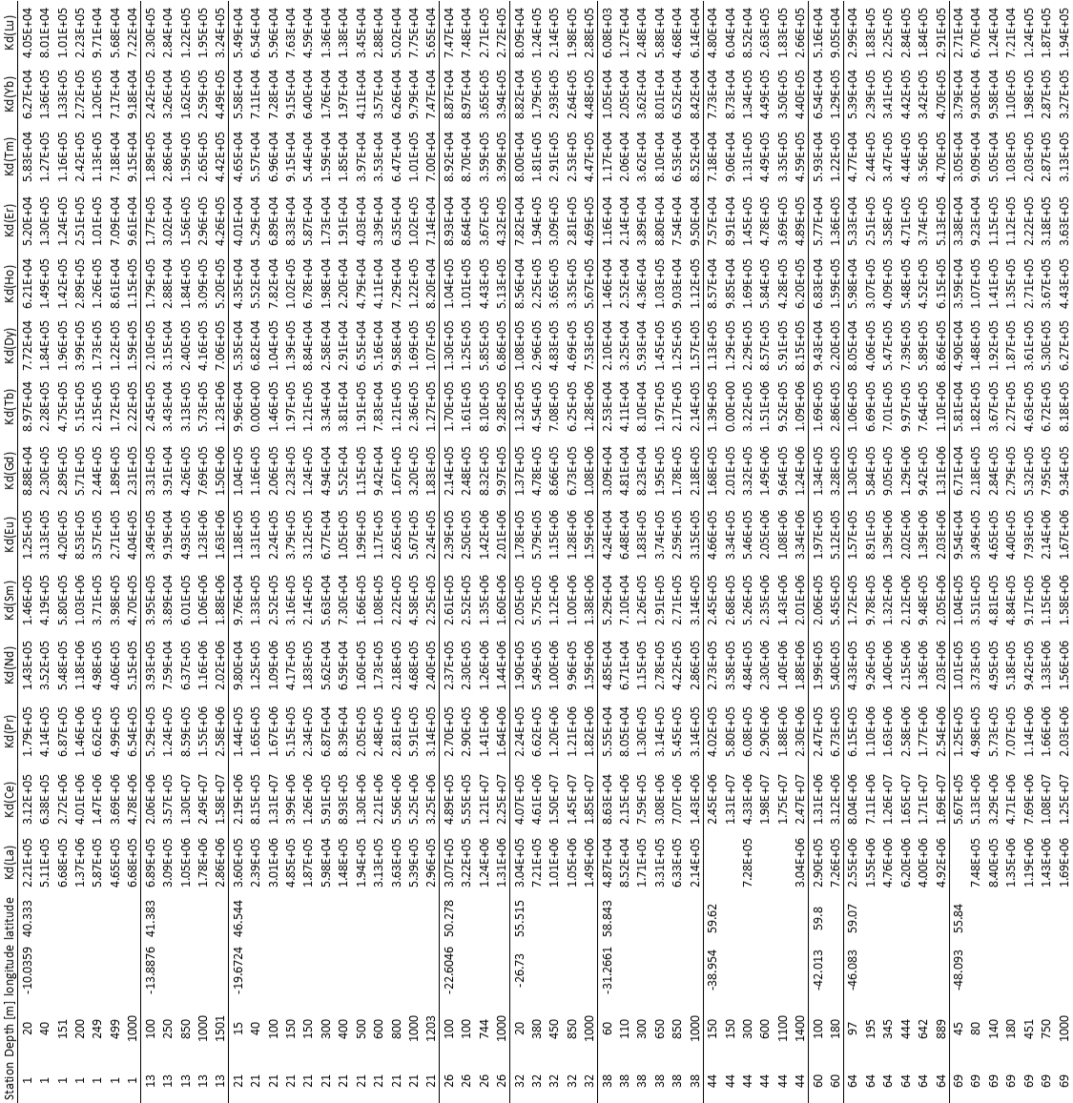

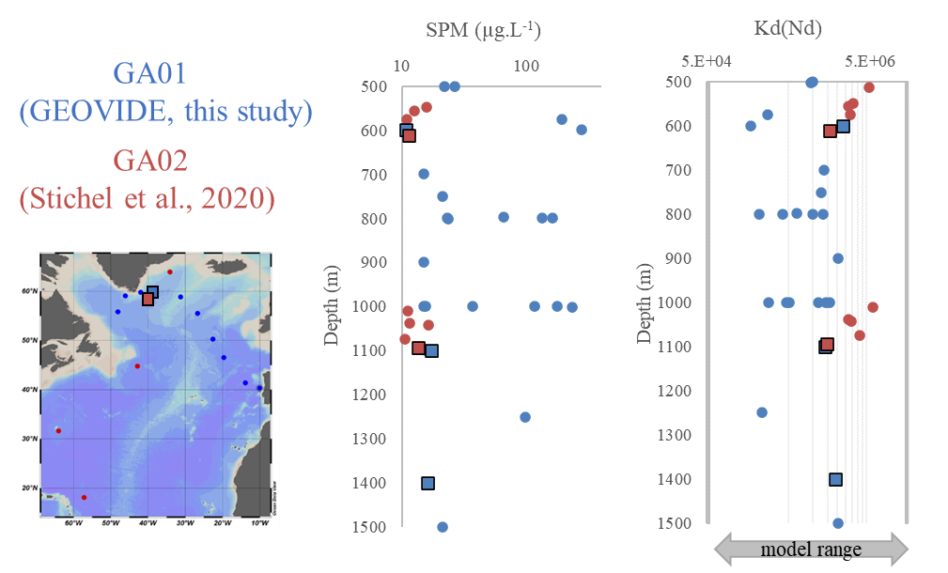

Figure S2: Comparison of the SPM and Kd presented in this study (in blue) with those published by Stichel et al. (2020, in red). The squares represent the two closest stations from each cruise, in the Irminger Sea. The arrow on Kd(Nd) profiles represents the range of Kd used to model dNd distribution in Siddall et al. (2008); Rempfer et al. (2011); Gu et al. (2017) for the different particulate phases.

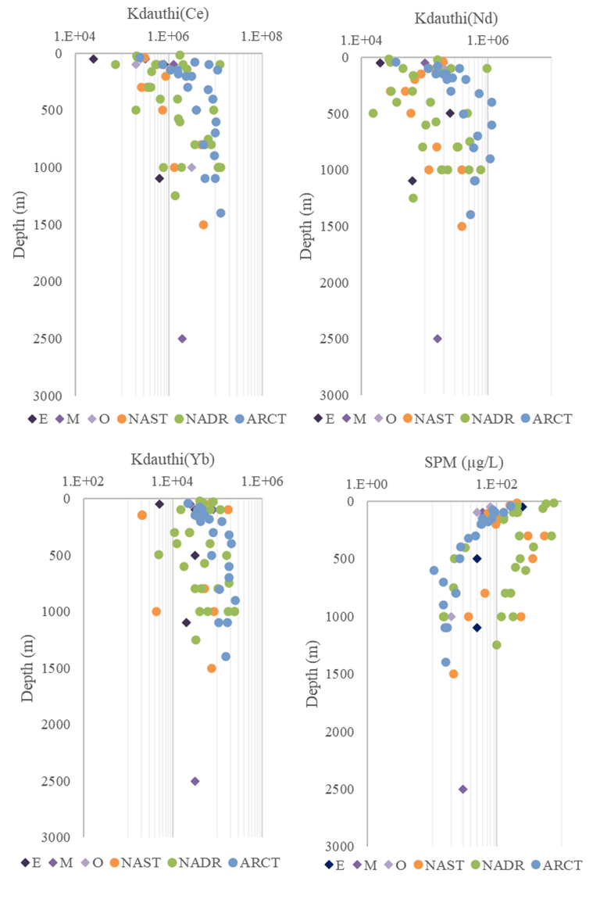

Figure S3: Comparison of the Kdauthi and SPM presented in this study (red, green and blue dots) with those published by Tachikawa et al. (1999, purple diamonds, tropical northeast Atlantic) for cerium (Ce), neodymium (Nd) and ytterbium (Yb). E: eutrophic; M: mesotrophic and O: oligotrophic sites of Tachikawa et al. study. NAST: subtropical north Atlantic; NADR: north Atlantic drift; ARCT: arctic, biogeochemical provinces presented in this study.

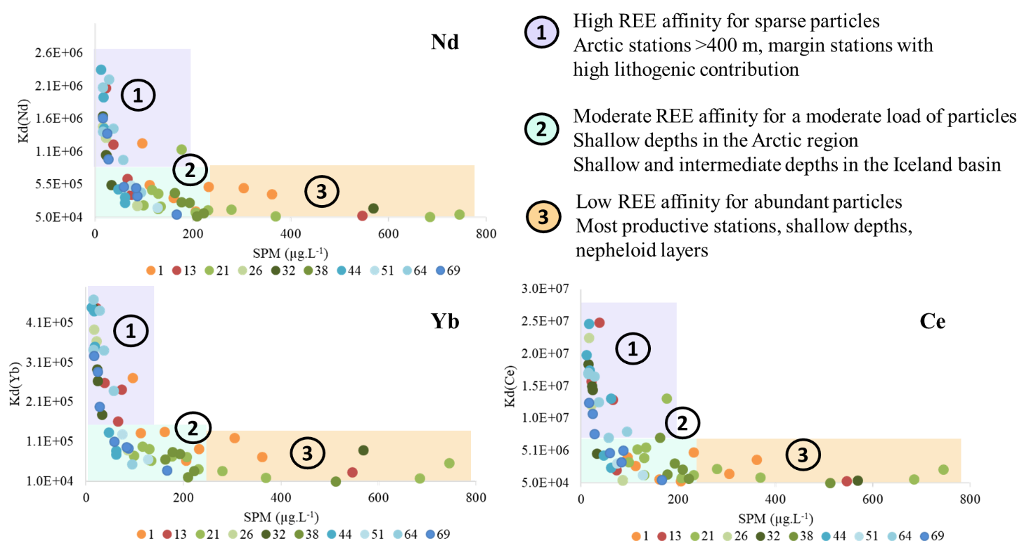

Figure S4: Partition coefficients Kd of Nd, Ce and Yb in function of the suspended particle mass (SPM) for the GEOVIDE stations (dots coloured per station). Three types of REE behavior are highlighted : 1) in purple areas with a high REE affinity for particles 2) in blue areas with moderate REE affiinty for particles 3) in orange areas with low REE affinity for particles.

Table S3: Matrix of correlation between Kd(Nd) and the proportions of the different particulate phases, with the associated confidence intervals (95%).



Table S4: Matrix of correlation between Kd(Ce) and the proportions of the different particulate phases, with the associated confidence intervals (95%).



Table S5: Matrix of correlation between Kd(Yb) and the proportions of the different particulate phases, with the associated confidence intervals (95%).

