Supplementary Materials for:
Accounting for spatio-temporal distribution changes in size-structured abundance estimates for a data-limited stock of Raja clavata
Timo Michael Staeudle, Bram Parmentier, Jan Jaap Poos
Table of Contents
Figure S1. Haul locations of International Bottom Trawl Survey (NS-IBTS; quarter 1 and 3), Beam Trawl Survey (NS-BTS; quarter 3), and Channel Groundfish Survey (FR-CGFS; quarter 4) for 1988-1999. 2
Figure S2. Haul locations of International Bottom Trawl Survey (NS-IBTS; quarter 1 and 3), Beam Trawl Survey (NS-BTS; quarter 3), and Channel Groundfish Survey (FR-CGFS; quarter 4) for 2000-2011. 3
Figure S3. Haul locations of International Bottom Trawl Survey (NS-IBTS; quarter 1 and 3), Beam Trawl Survey (NS-BTS; quarter 3), and Channel Groundfish Survey (FR-CGFS; quarter 4) for 2012-2023. 4
Figure S4. European Nature Information systems (EUNIS) substrate and habitat type in study area of the Greater North Sea, obtained from the European Environment Agency. 5
Table S1. Total Area of substrate within the study area of the Greater North Sea and number of Hauls per substrate across Surveys. 6
Table S2. Total Area of habitat within the study area of the Greater North Sea and number of Hauls across surveys per habitat class (EUNIS2019C). 6
Figure S5. Mesh designed for the Greater North Sea study area using Delaunay triangulation, with inner and outer boundary. 8
Figure S6. Beam gear efficiency for size classes of Raja clavata, adapted from Walker et al. (2017). 9
Table S3. Size class specific parameters for lengths, gear efficiencies, and-weights. 9
Figure S7. Posterior mean of the spatial field by 25km2 grid cells from 1988 to 2023 for 9 equally spaced temporal knots. 11
Figure S8. Posterior standard deviation (SD) of the spatial field by 25km2 grid cells from 1988 to 2023 for 9 equally spaced temporal knots. The white boundary indicates the interior mesh area used for predictions. 12
Figure S9. Median predicted biomass of size classes of Raja clavata for the Greater North Sea study area with 95% credible intervals: (a) on a linear scale; (b) on a logarithmic scale. 13
References 13

Figure S1. Haul locations of International Bottom Trawl Survey (NS-IBTS; quarter 1 and 3), Beam Trawl Survey (NS-BTS; quarter 3), and Channel Groundfish Survey (FR-CGFS; quarter 4) for 1988-1999.

Figure S2. Haul locations of International Bottom Trawl Survey (NS-IBTS; quarter 1 and 3), Beam Trawl Survey (NS-BTS; quarter 3), and Channel Groundfish Survey (FR-CGFS; quarter 4) for 2000-2011.

Figure S3. Haul locations of International Bottom Trawl Survey (NS-IBTS; quarter 1 and 3), Beam Trawl Survey (NS-BTS; quarter 3), and Channel Groundfish Survey (FR-CGFS; quarter 4) for 2012-2023.

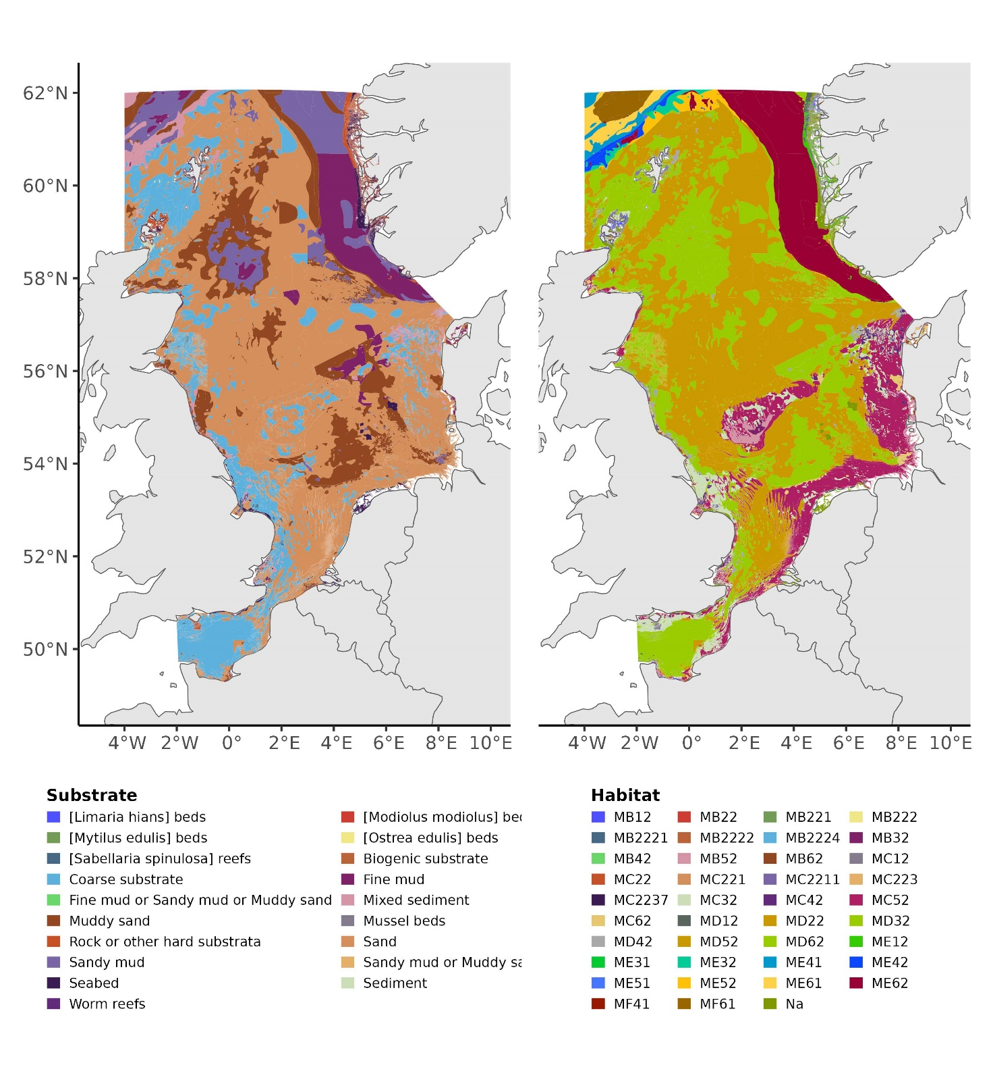

Figure S4. European Nature Information systems (EUNIS) substrate and habitat type in study area of the Greater North Sea, obtained from the European Environment Agency.

Table S1. Total Area of substrate within the study area of the Greater North Sea and number of Hauls per substrate across Surveys.
Substrate | Total Area (km²) | Number of Hauls
Coarse substrate | 103,329 | 7,104
Rock or other hard substrata | 9,024 | 48
Mixed sediment | 14,134 | 321
Sand | 332,074 | 21,298
Muddy sand | 82,788 | 4,793
Sandy mud or muddy sand | 43 | 20
Sandy mud | 42,589 | 462
Fine mud | 36,559 | 495
Worm reefs | 306 | 5
Sabellaria spinulosa reefs | 730 | 24

Table S2. Total Area of habitat within the study area of the Greater North Sea and number of Hauls across surveys per habitat class (EUNIS2019C).
Habitat | Total Area (km2) | Number of Hauls
MB32 | 1,535 | 77
MB52 | 8,005 | 270
MB62 | 806 | 16
MC12 | 2,915 | 25
MC221 | 210 | 53
MC2211 | 450 | 12
MC32 | 23,405 | 2,236
MC42 | 3,071 | 146
MC52 | 64,778 | 6,080
MC62 | 3,914 | 320
MD12 | 3,223 | 23
MD22 | 325 | 14
MD32 | 75,361 | 4,791
MD42 | 3,607 | 175
MD52 | 254,322 | 14,948
MD62 | 93,746 | 5,434

Figure S5. Mesh designed for the Greater North Sea study area using Delaunay triangulation, with inner and outer boundary. The inner mesh was created with a 2% radius of the approximate diameter of the observation set of haul locations across surveys: International Bottom Trawl Survey quarter 1 and 3 (NS-IBTS), Beam Trawl Survey quarter 3 (NS-BTS), and Channel Groundfish Survey quarter 4 (FR-CGFS) for 1988-2023 and contained within the Greater North Sea ecoregion to prevent overlap with landmass. The outer boundary extends the inner boundary as a buffer area to reduce boundary effects.

Figure S6. Beam gear efficiency for size classes of Raja clavata, adapted from Walker et al. (2017). Dashed vertical lines indicating average length of size class 1 (31cm), 2 (59cm), and 3 (80cm).
Table S3. Size class specific parameters for lengths, gear efficiencies, and-weights. Mean weights are based on lengths using a length-weight relationship with $a$= 0.0054 and $b$ = 3.0465.
Size class | Average length (cm) | Gear | Efficiency | Weight (kg)
1 | 31 | GOV | 0.3556 | 0.262
2 | 59 | GOV | 0.4887 | 1.402
3 | 80 | GOV | 0.7527 | 3.436
1 | 31 | BEAM | 0.7925 | 0.262
2 | 59 | BEAM | 0.7931 | 1.402
3 | 80 | BEAM | 0.5574 | 3.436

Figure S7. Posterior mean of the spatial field by 25km2 grid cells from 1988 to 2023 for 9 equally spaced temporal knots. The white boundary indicates the interior mesh area used for predictions.
Figure S8. Posterior standard deviation (SD) of the spatial field by 25km2 grid cells from 1988 to 2023 for 9 equally spaced temporal knots. The white boundary indicates the interior mesh area used for predictions.

Figure S9. Median predicted biomass of size classes of Raja clavata for the Greater North Sea study area with 95% credible intervals: (a) on a linear scale; (b) on a logarithmic scale. Pre-2000 peak biomass prediction baselines for each size classes are indicated as dashed horizontal lines.

References
Walker, N. D., Maxwell, D. L., Le Quesne, W. J. F., and Jennings, S. 2017. Estimating efficiency of survey and commercial trawl gears from comparisons of catch-ratios. ICES Journal of Marine Science, 74: 1448-1457.

