Supplementary
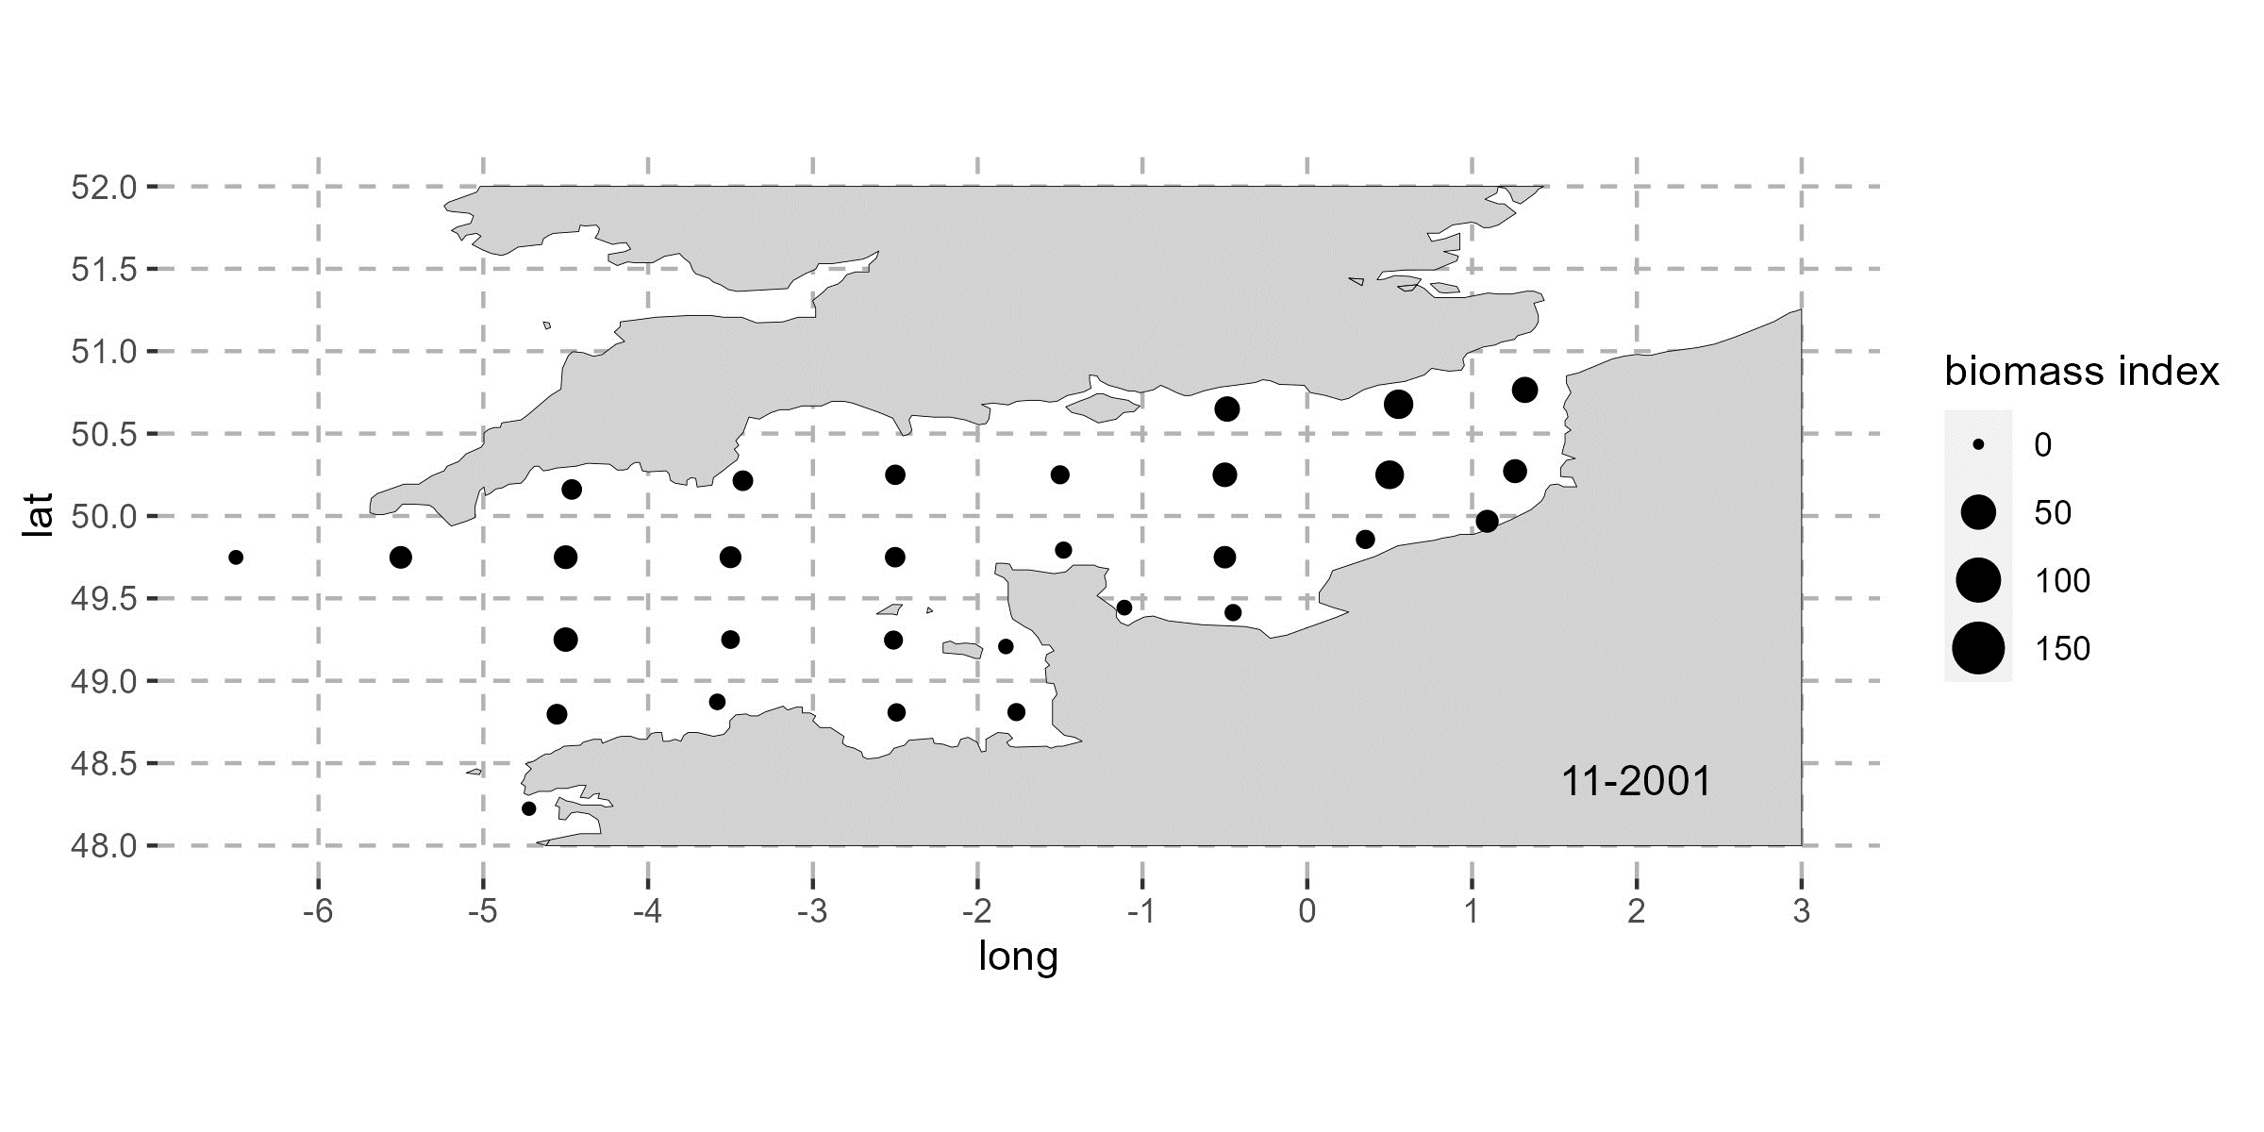
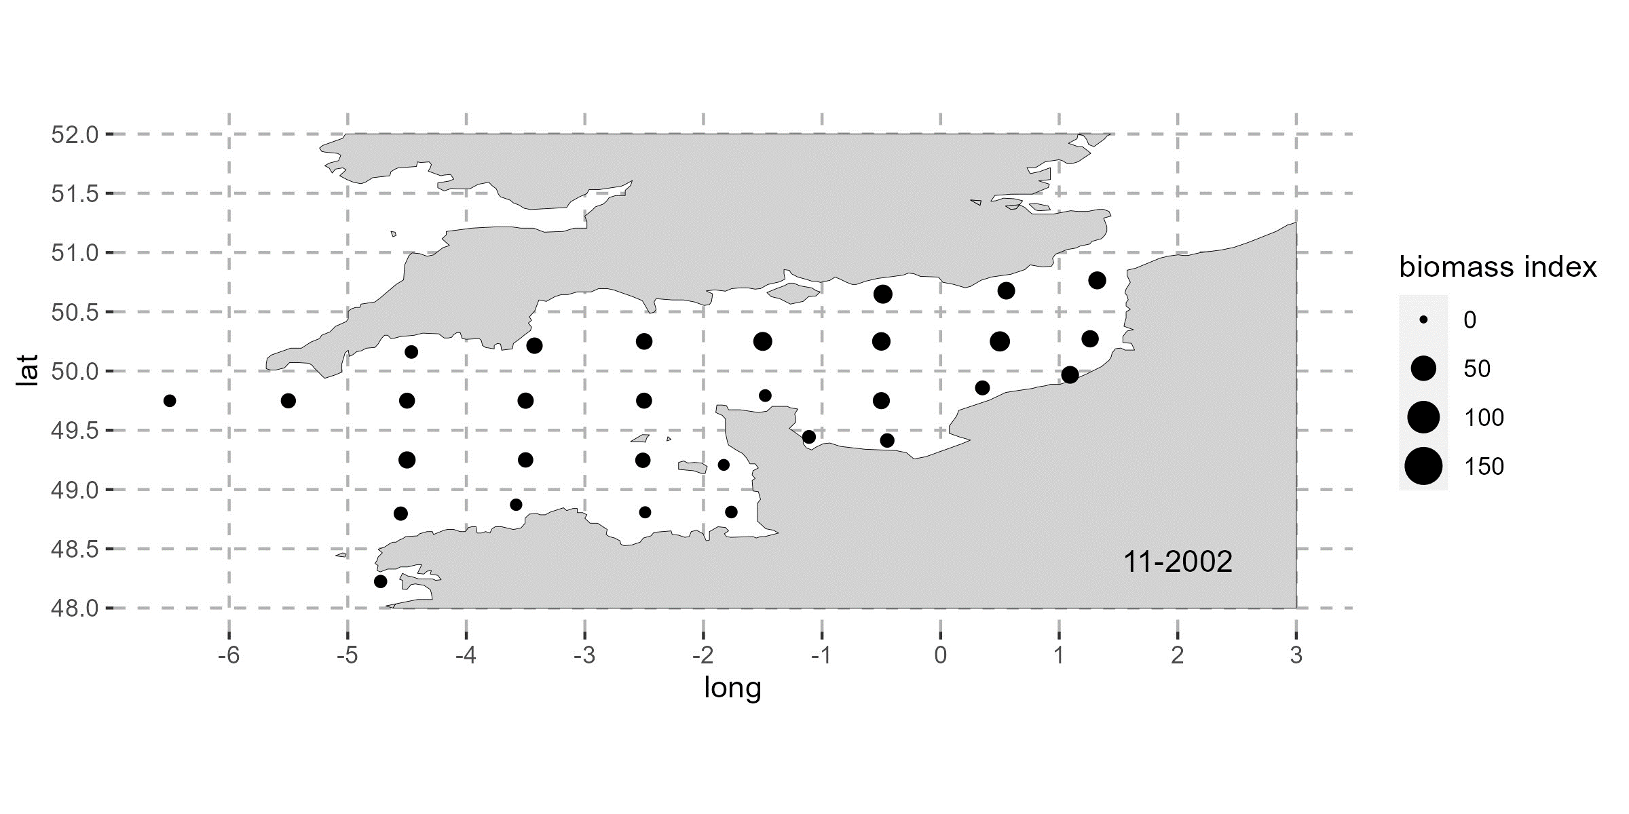
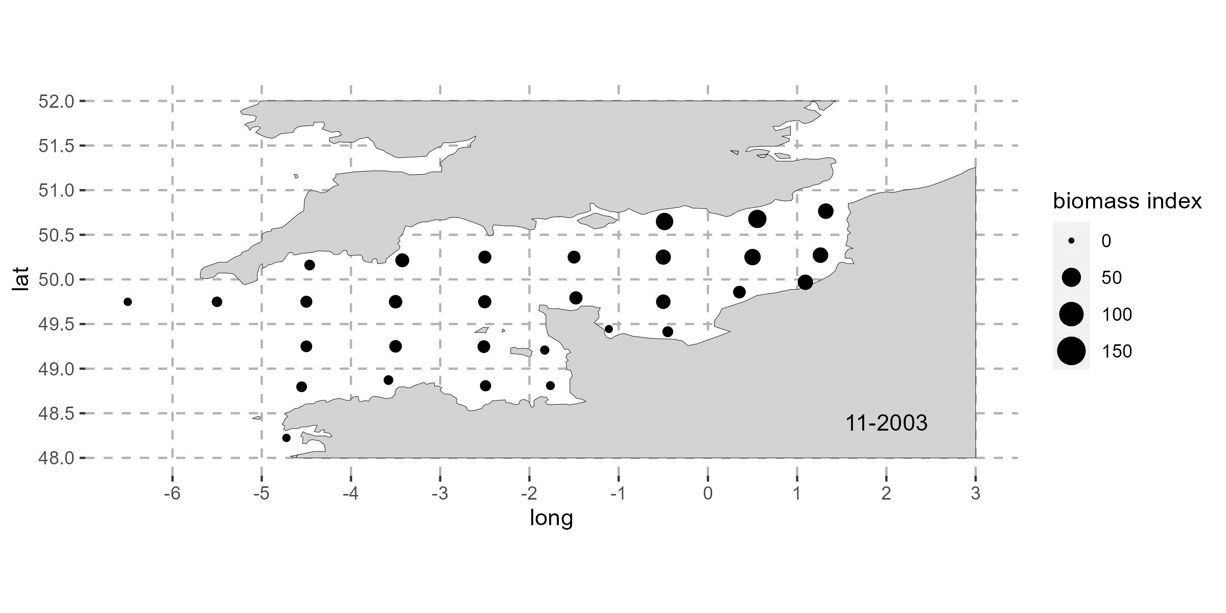
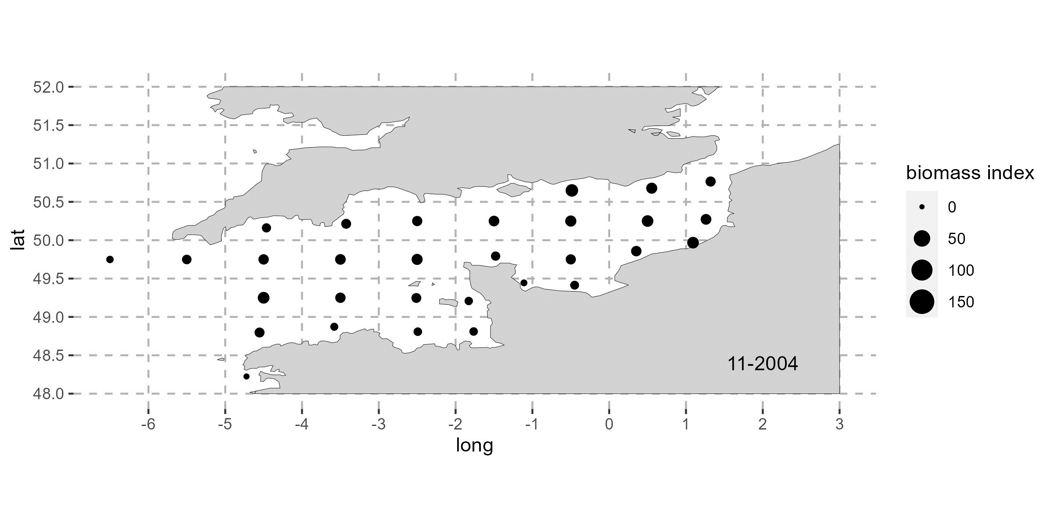
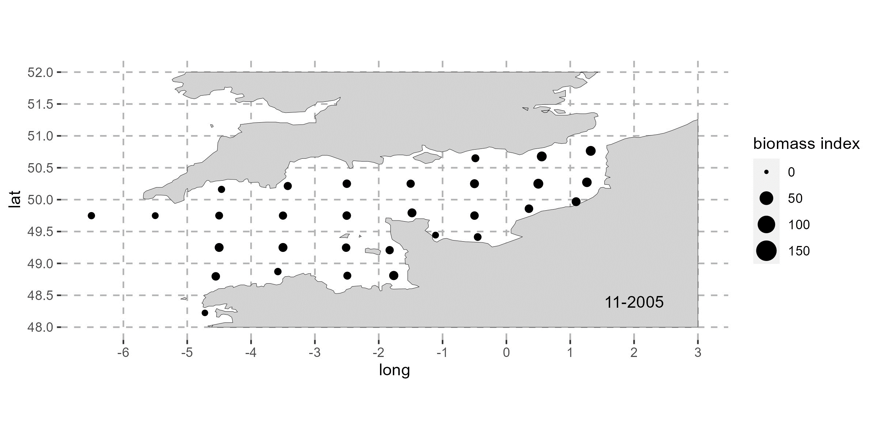
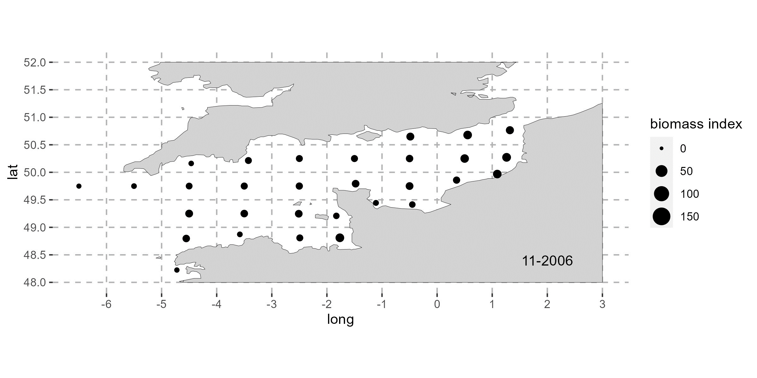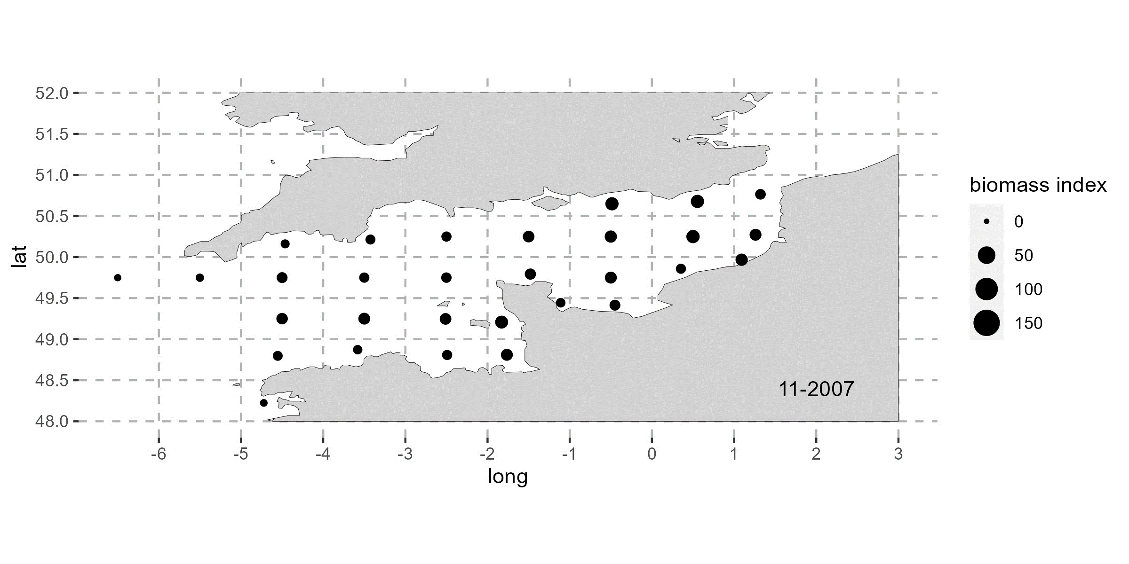
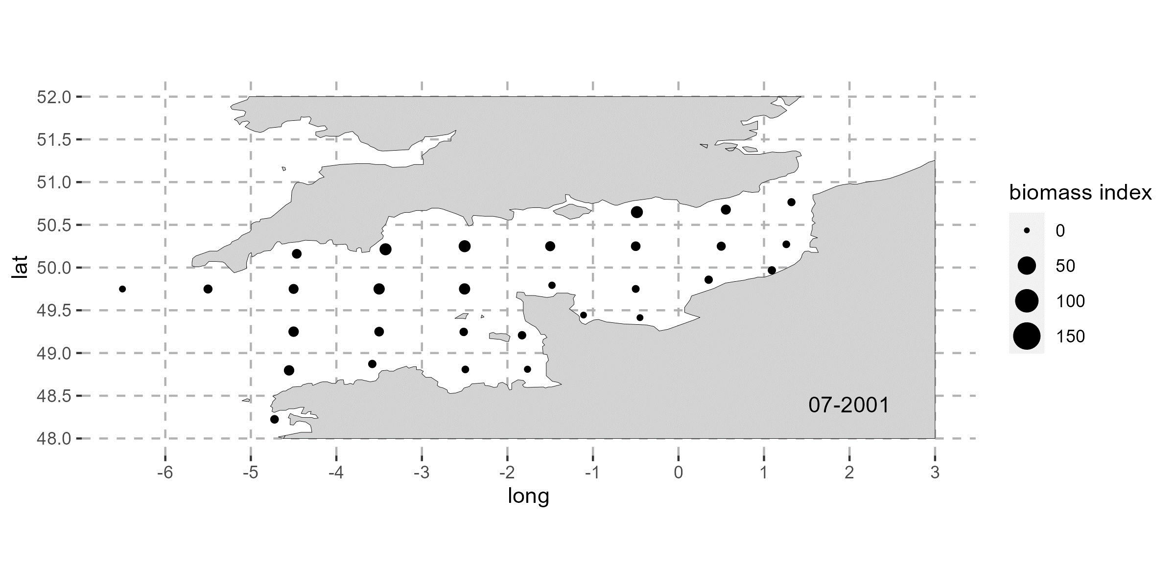
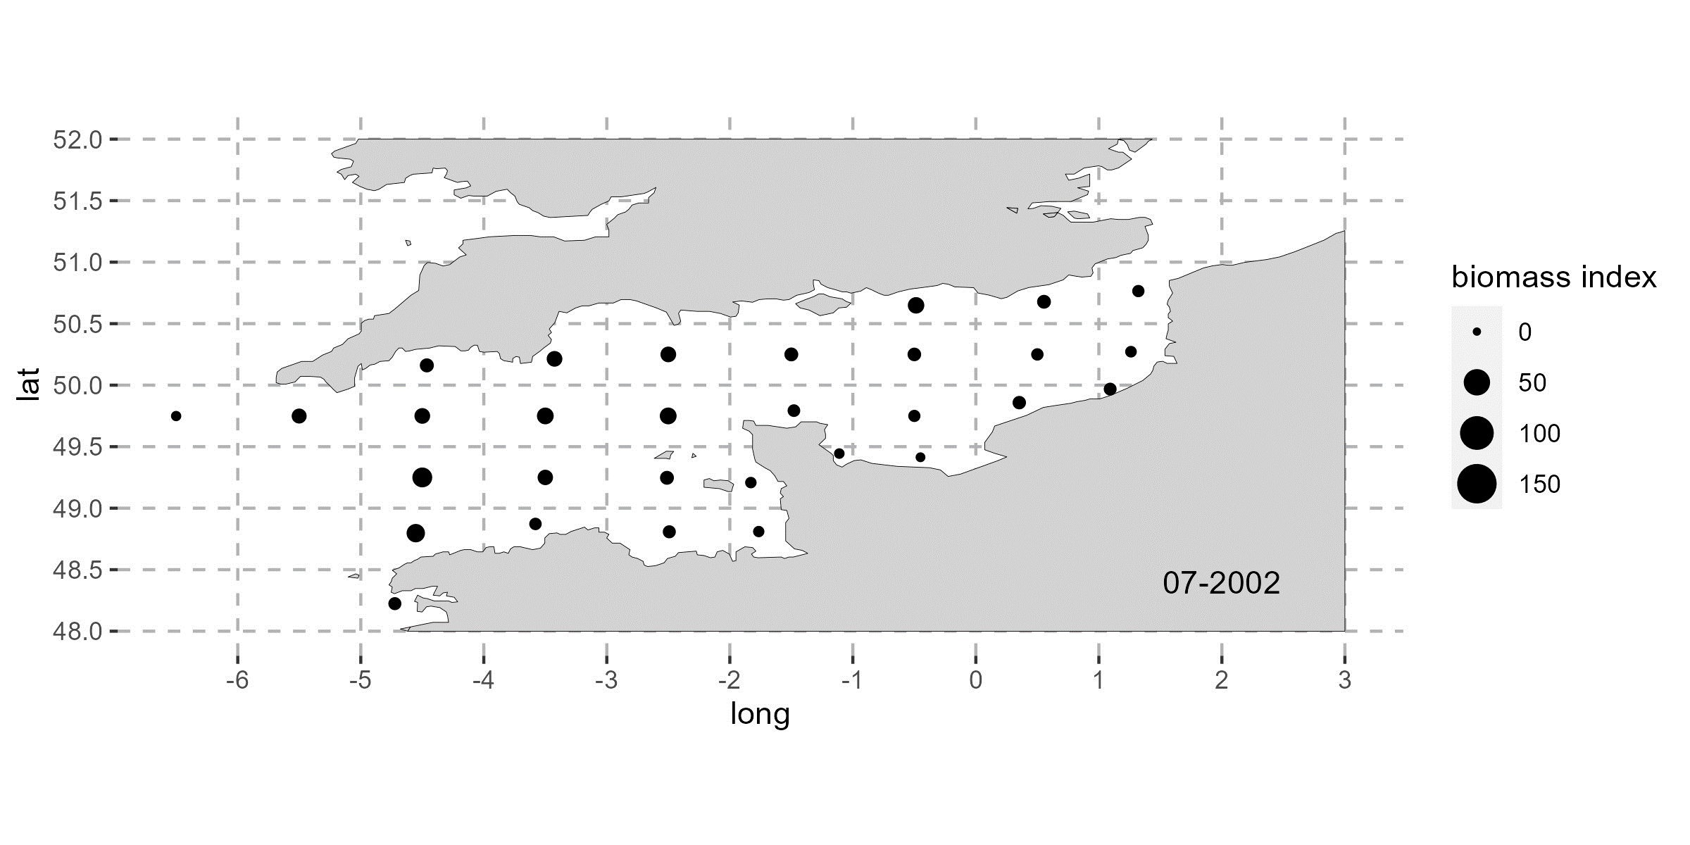
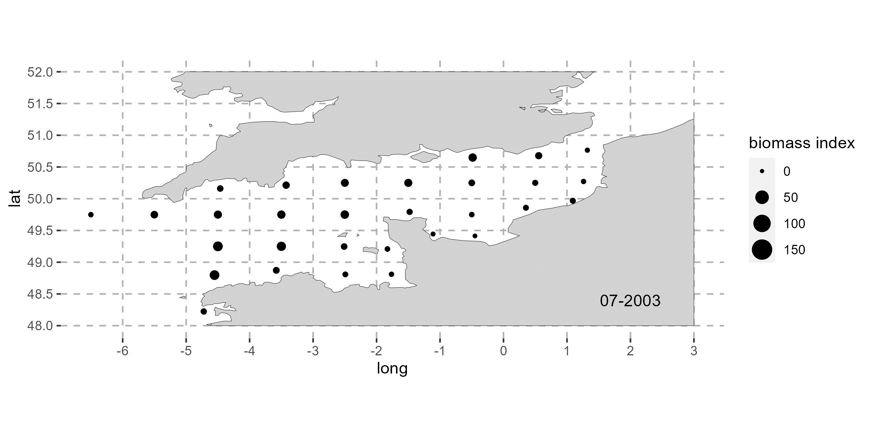
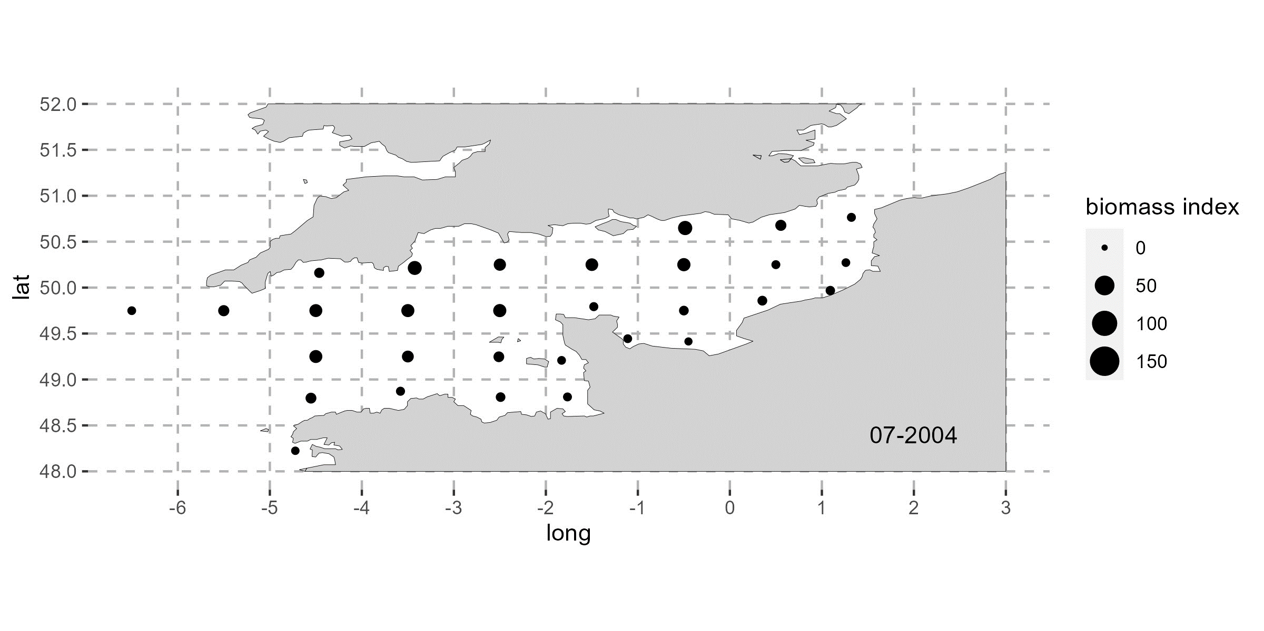
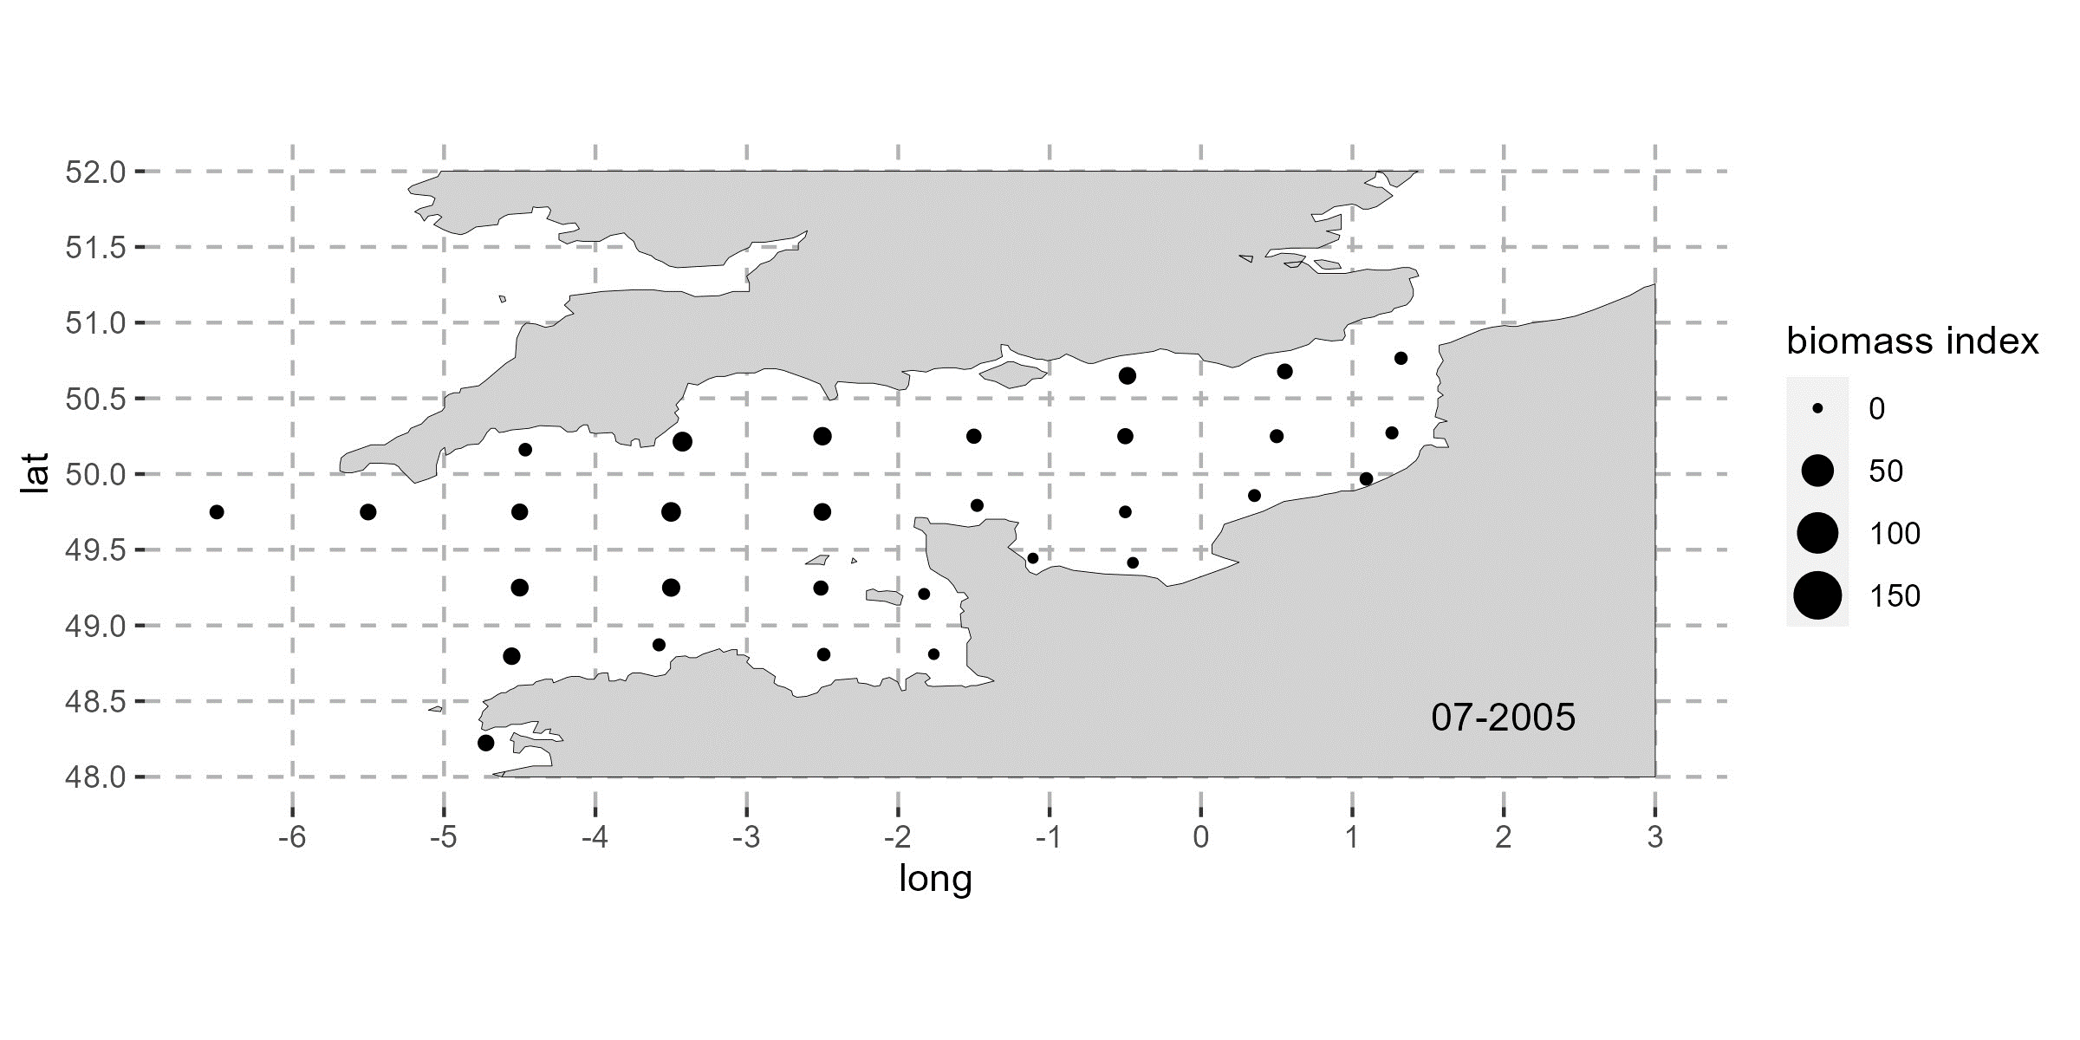
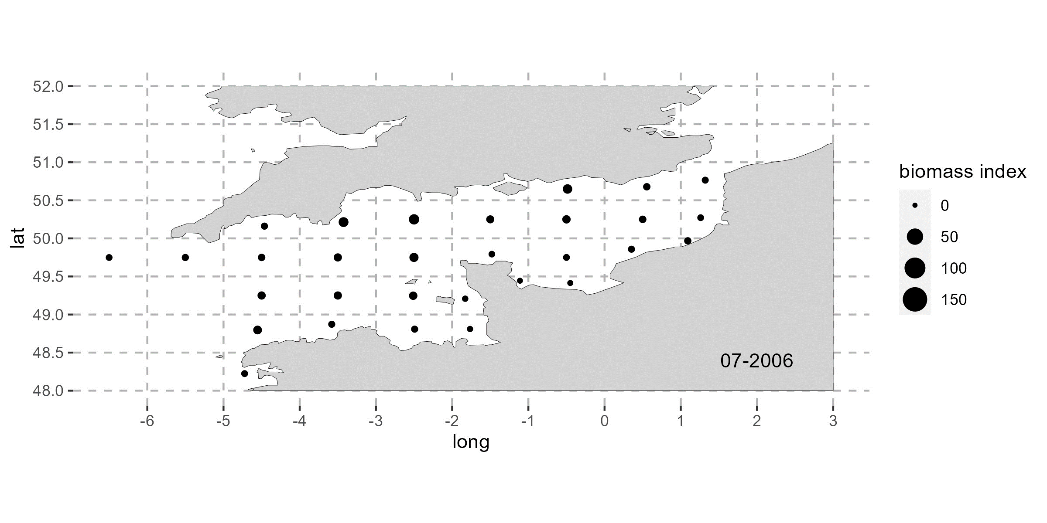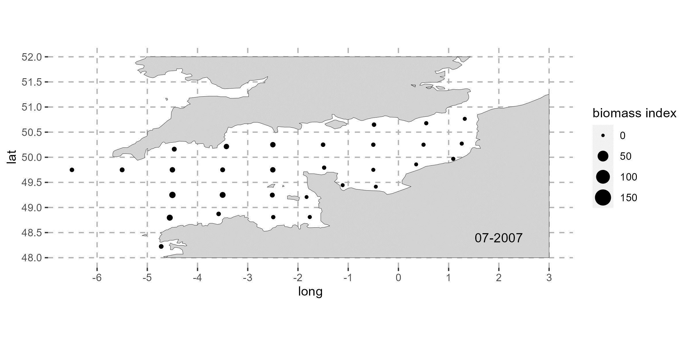

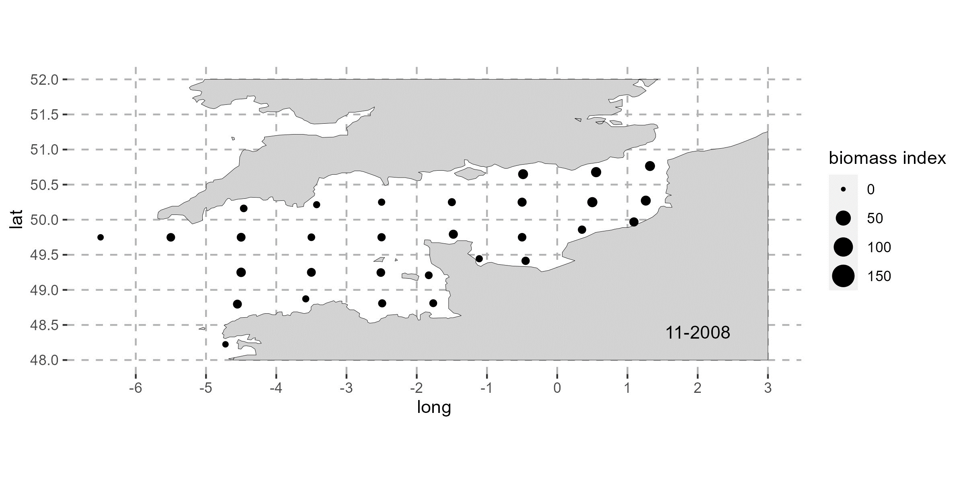
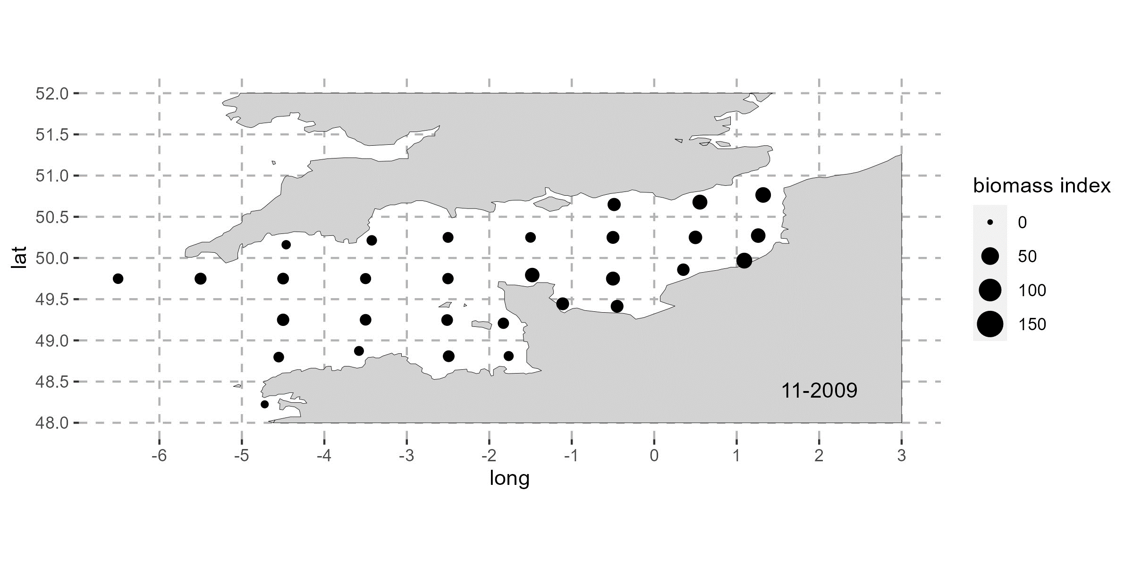
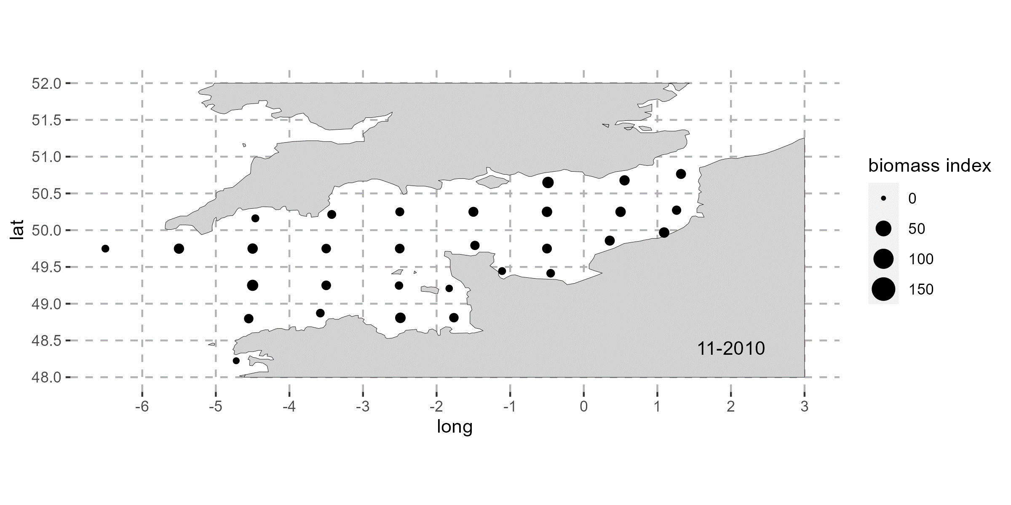
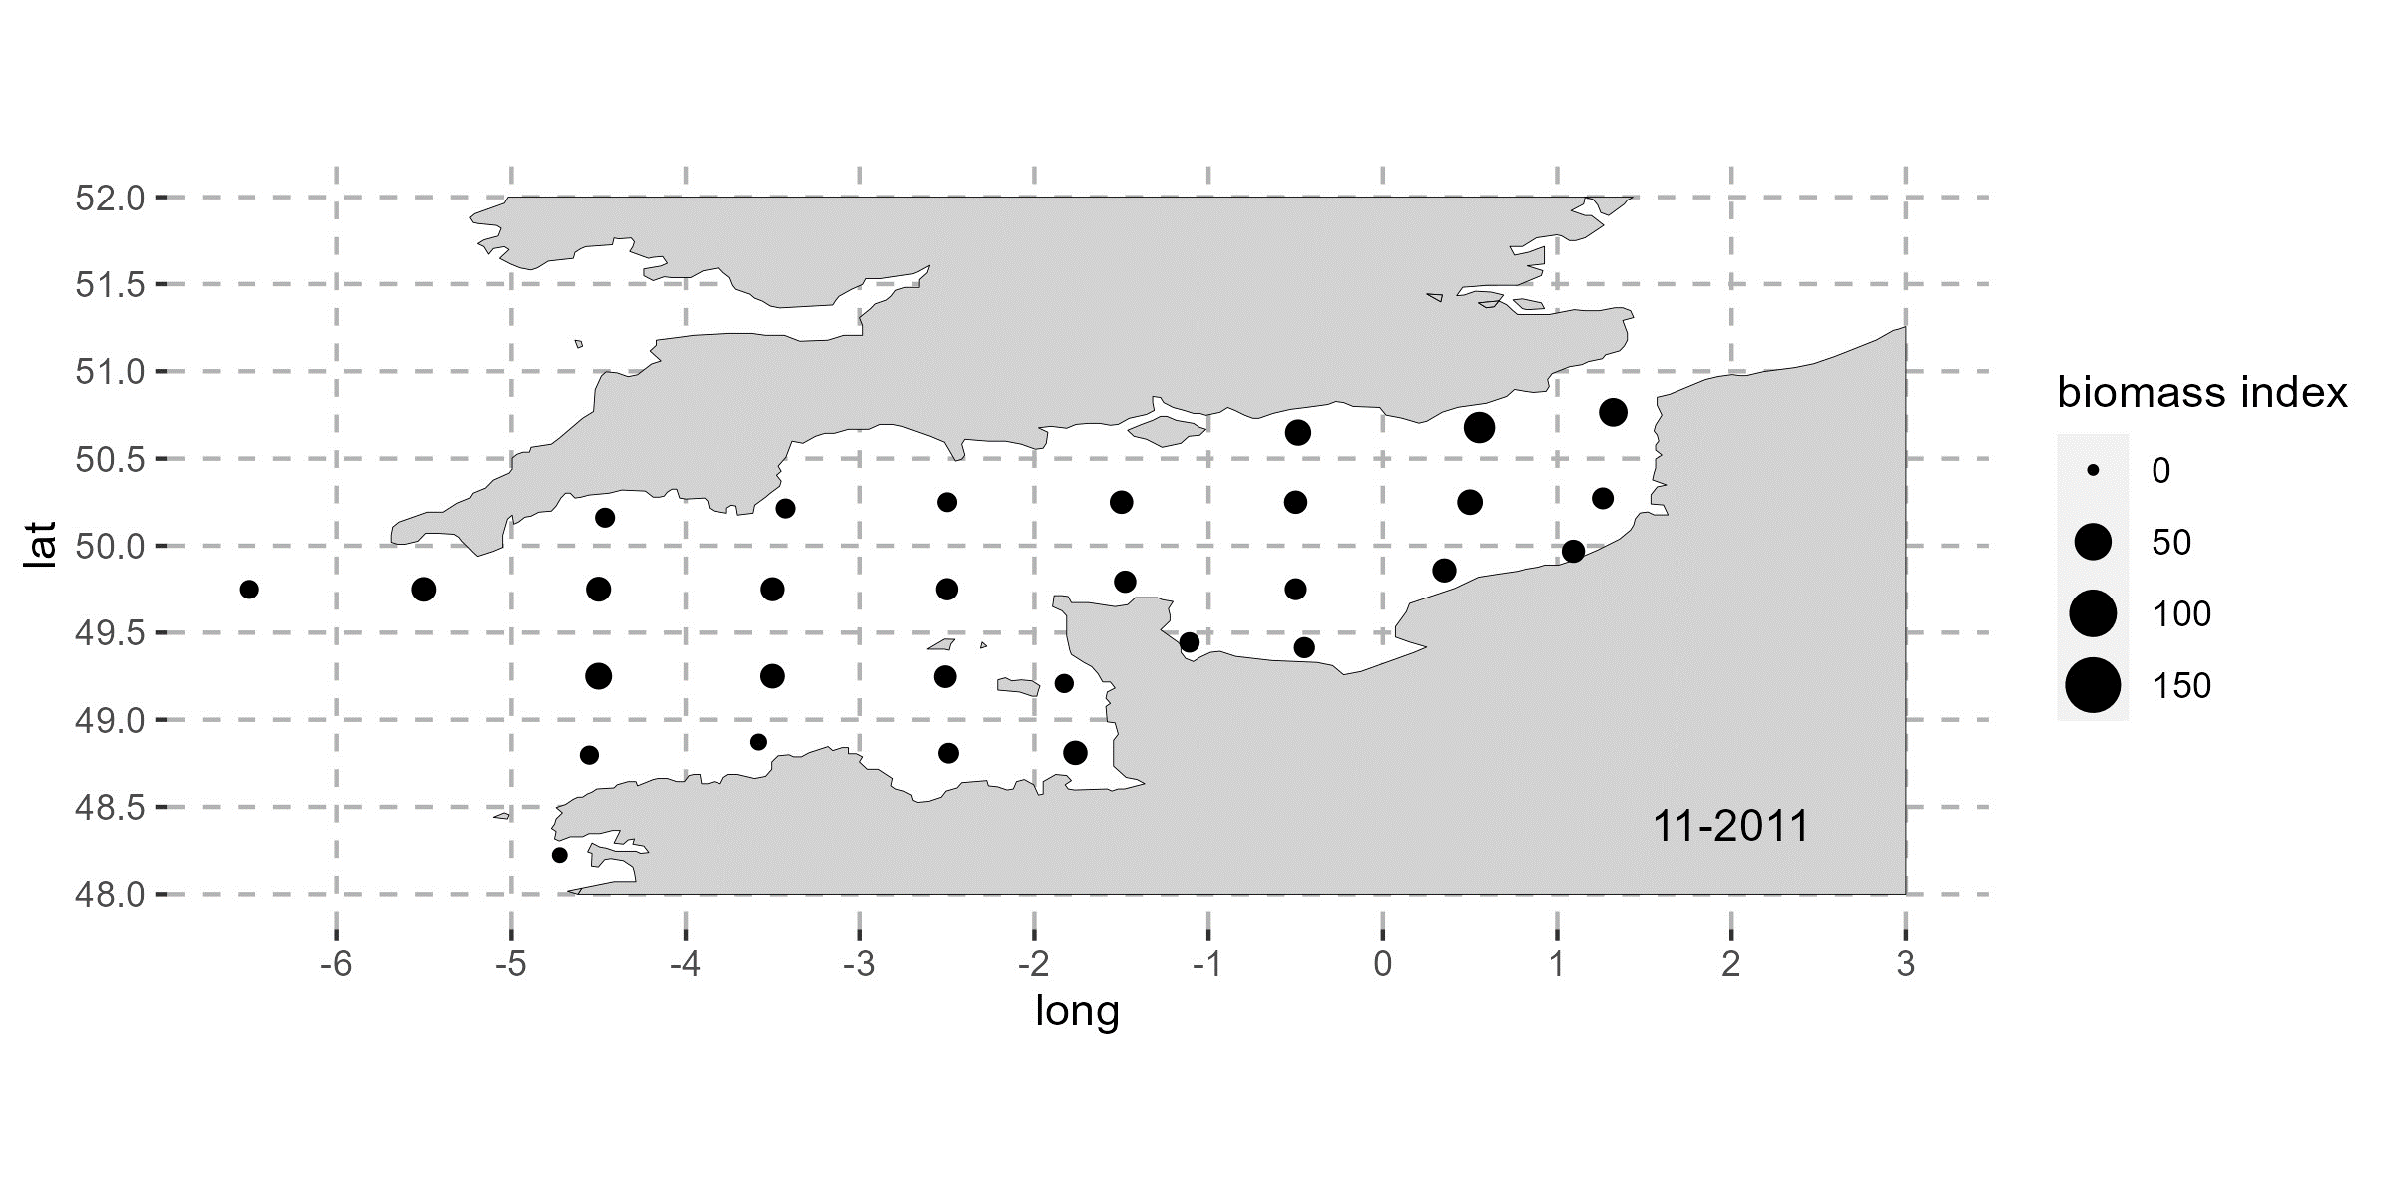
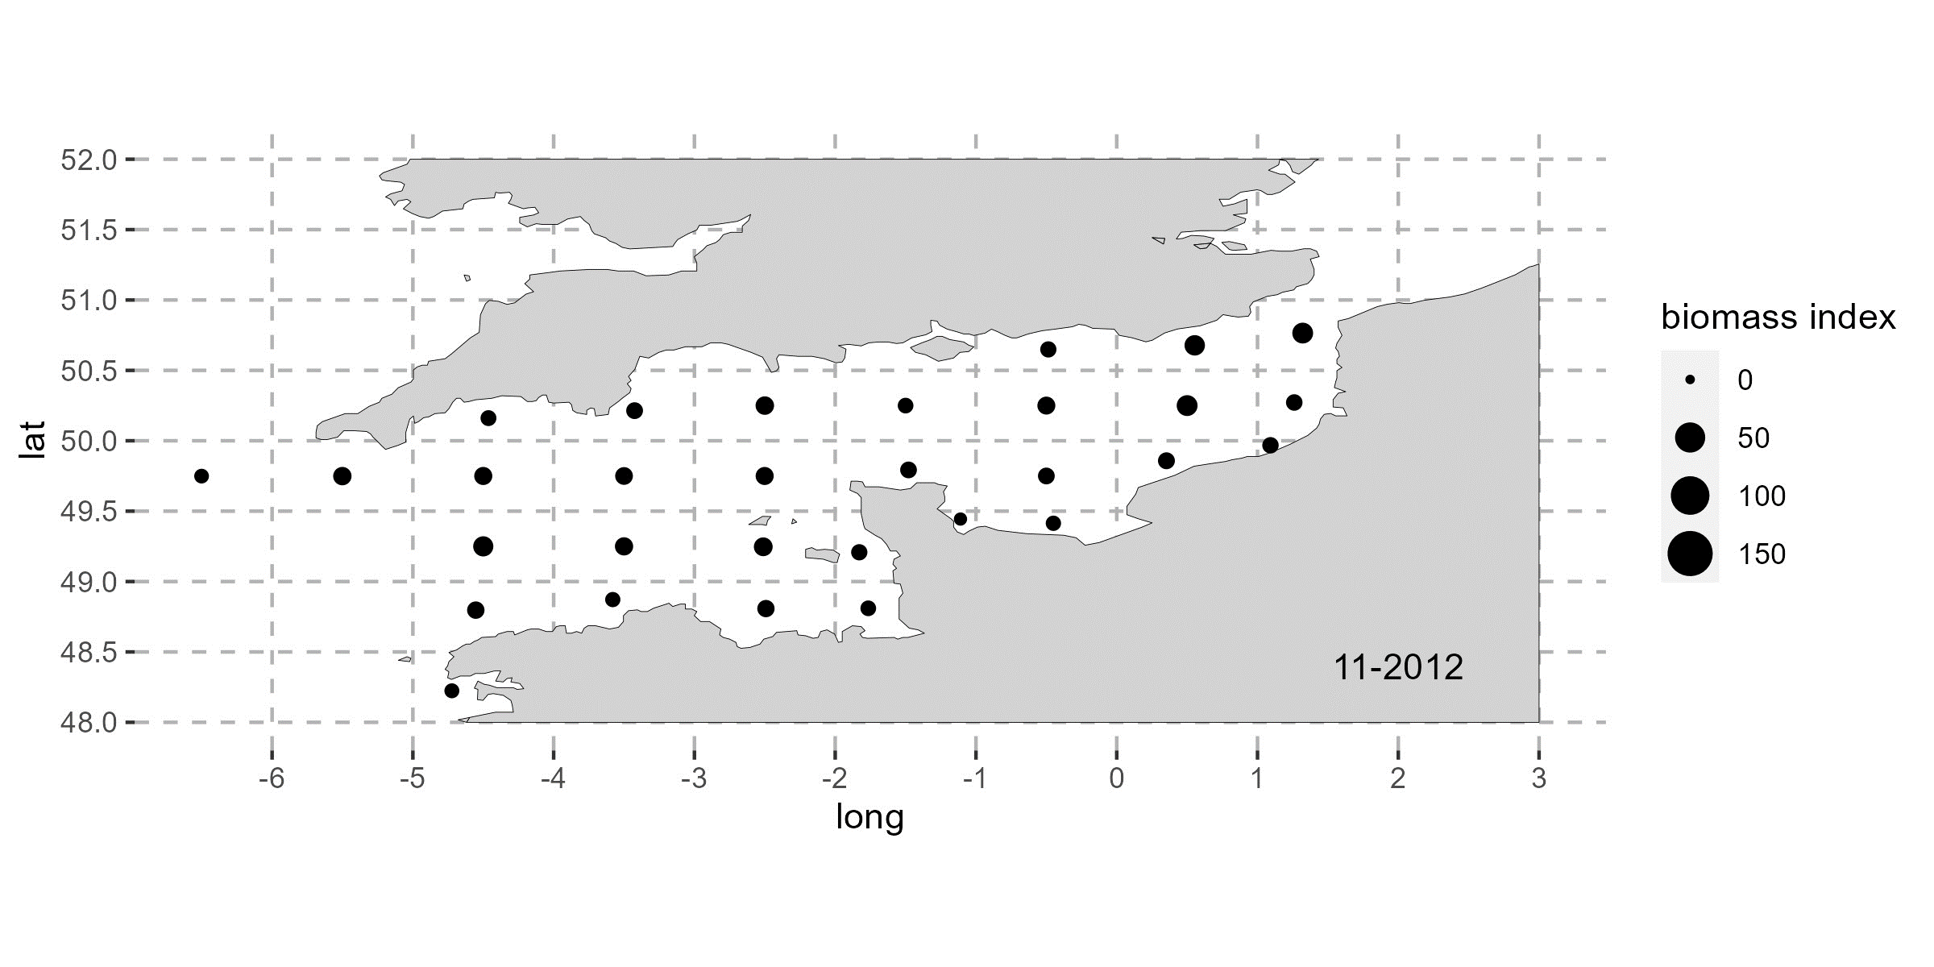
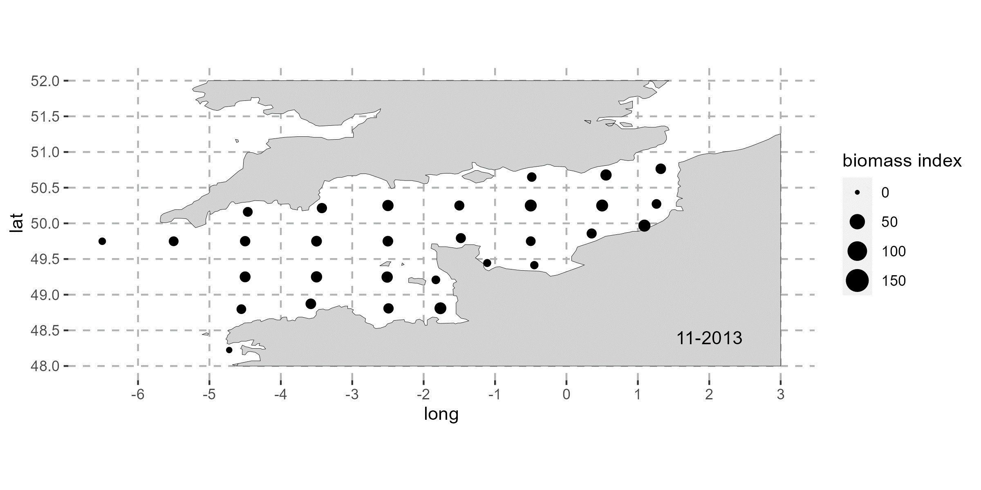
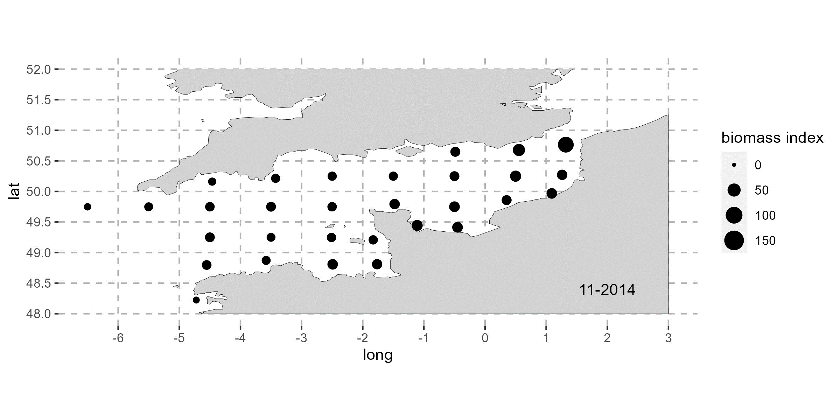
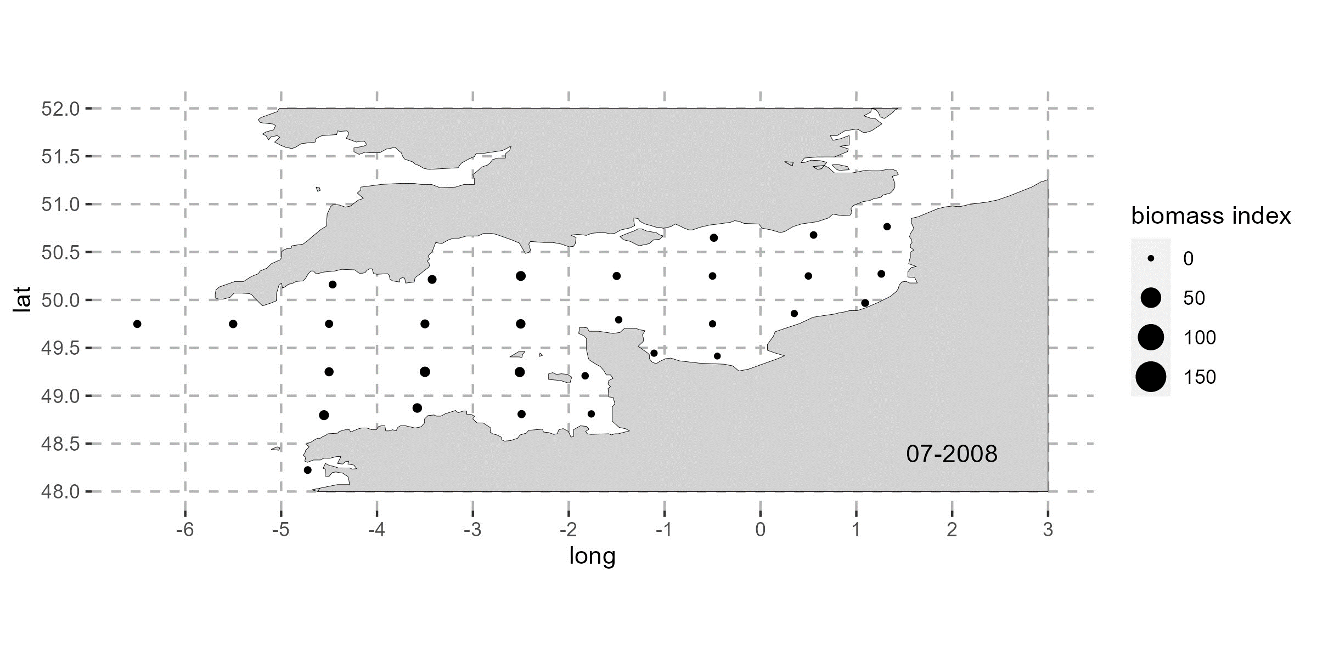
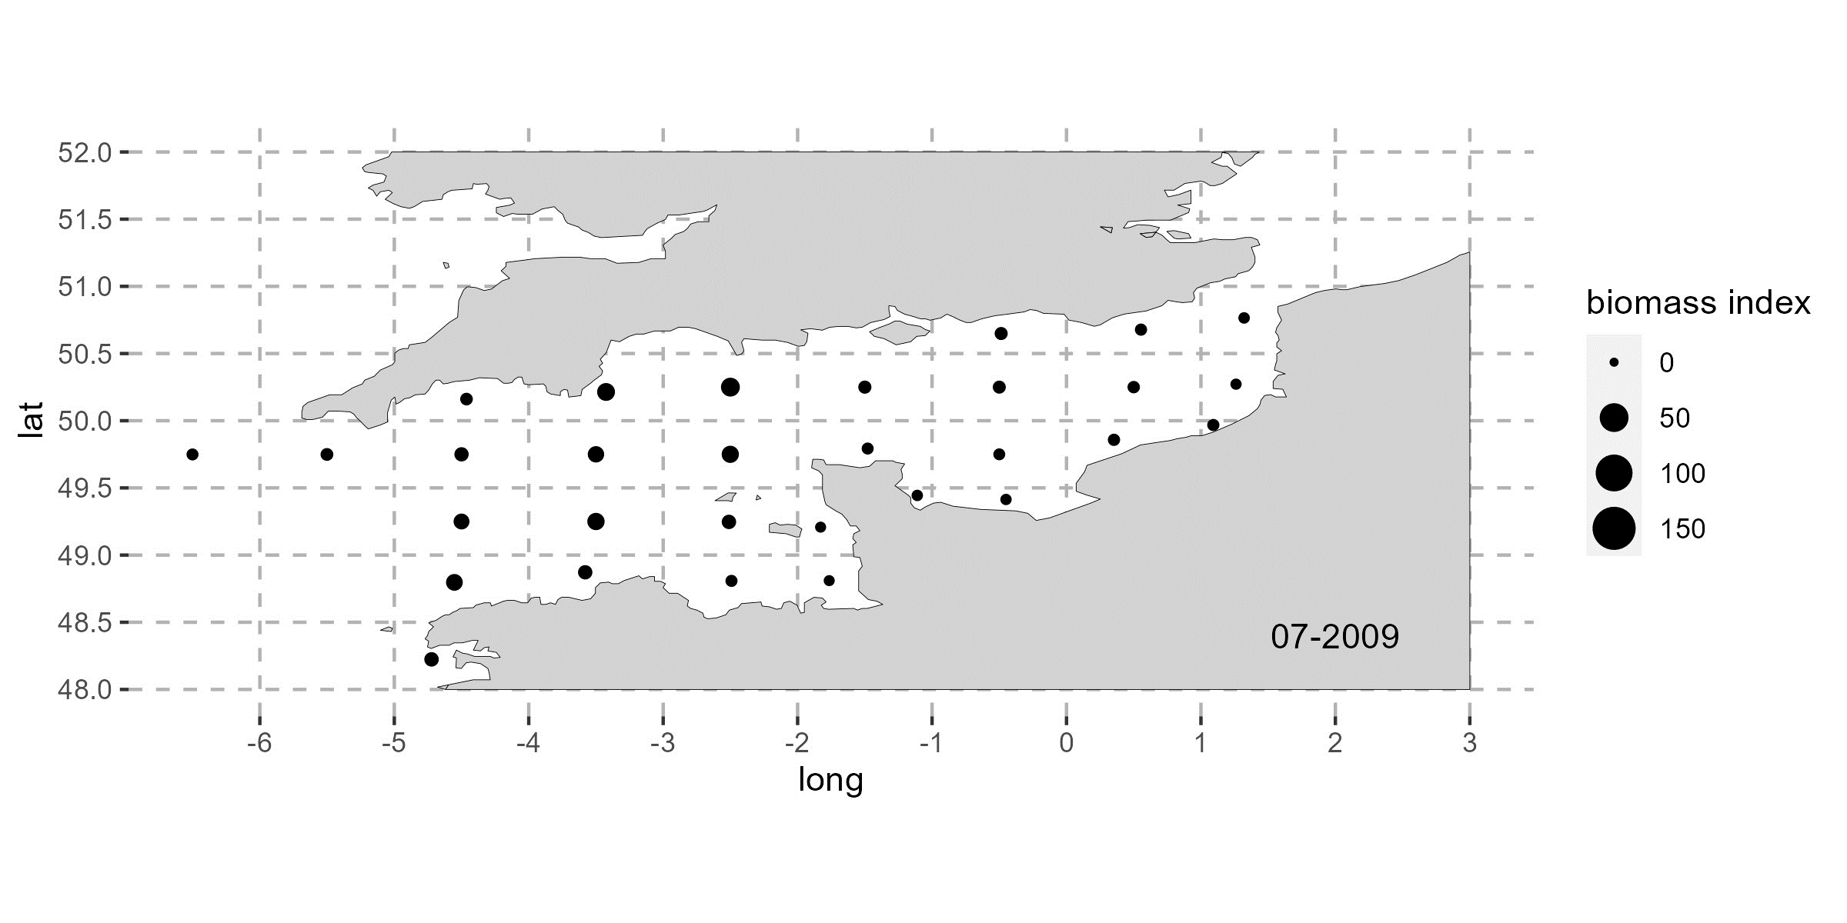
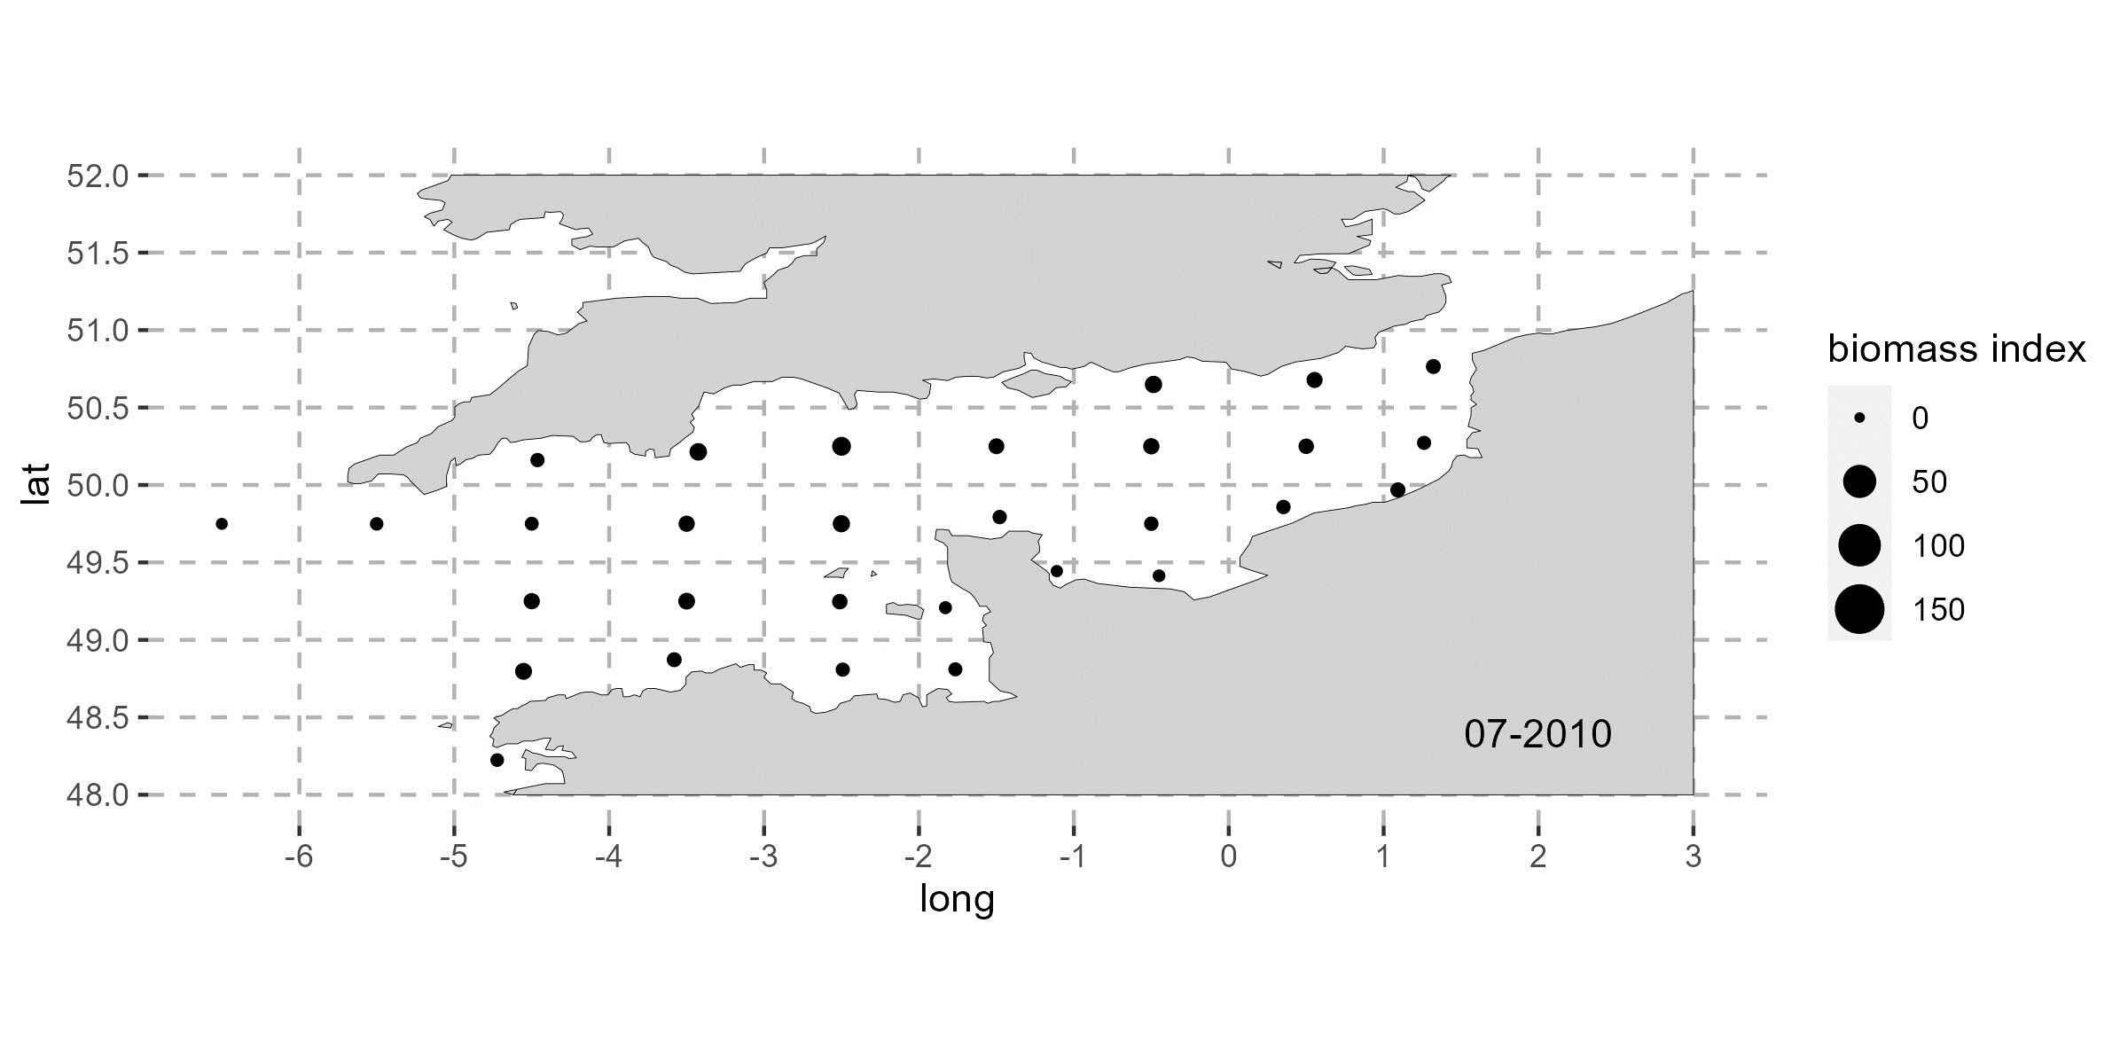
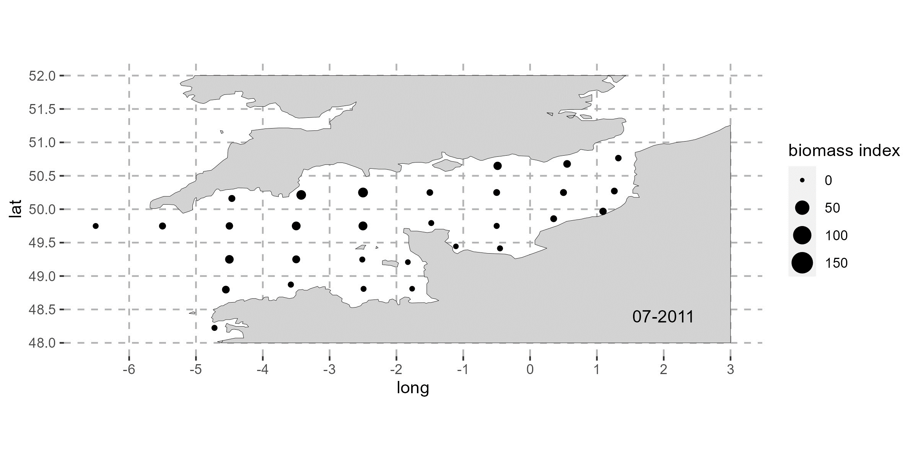
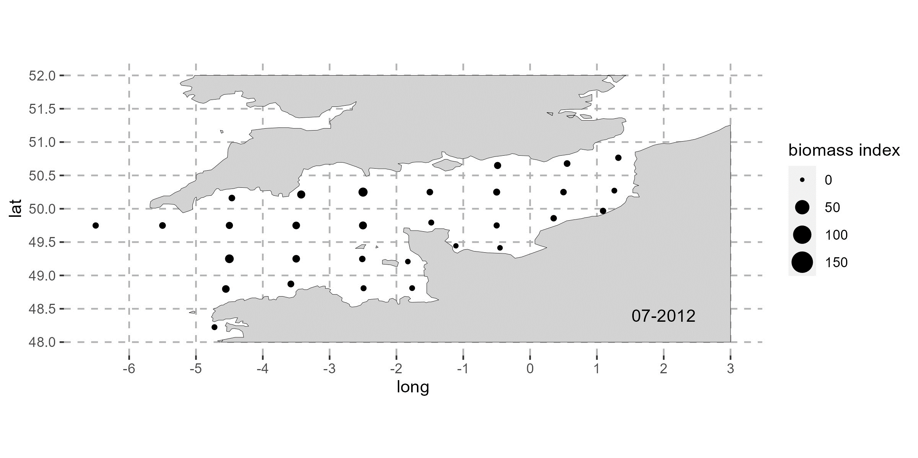
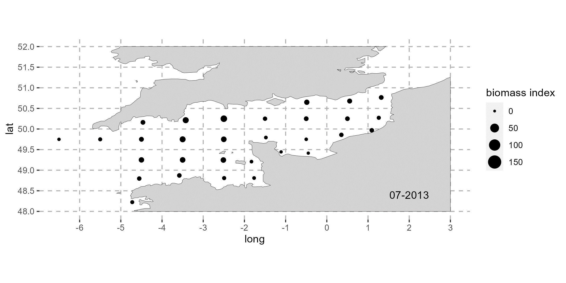
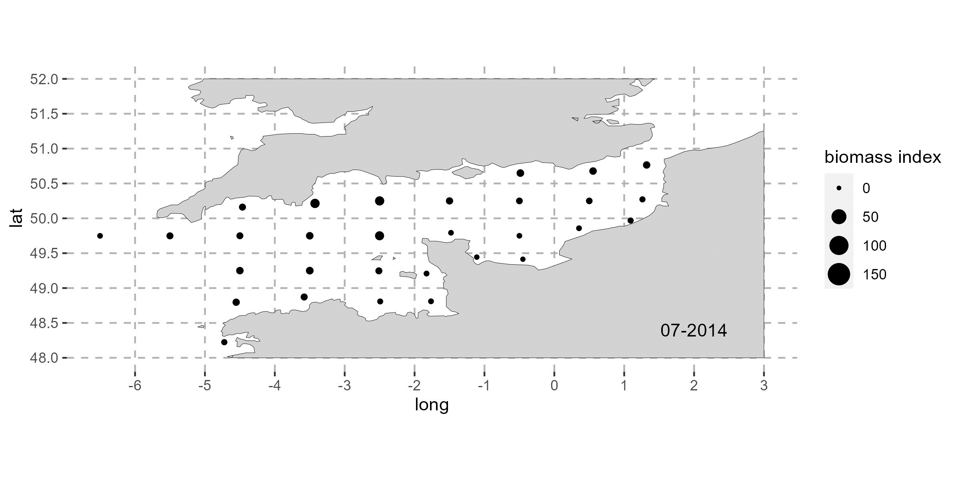

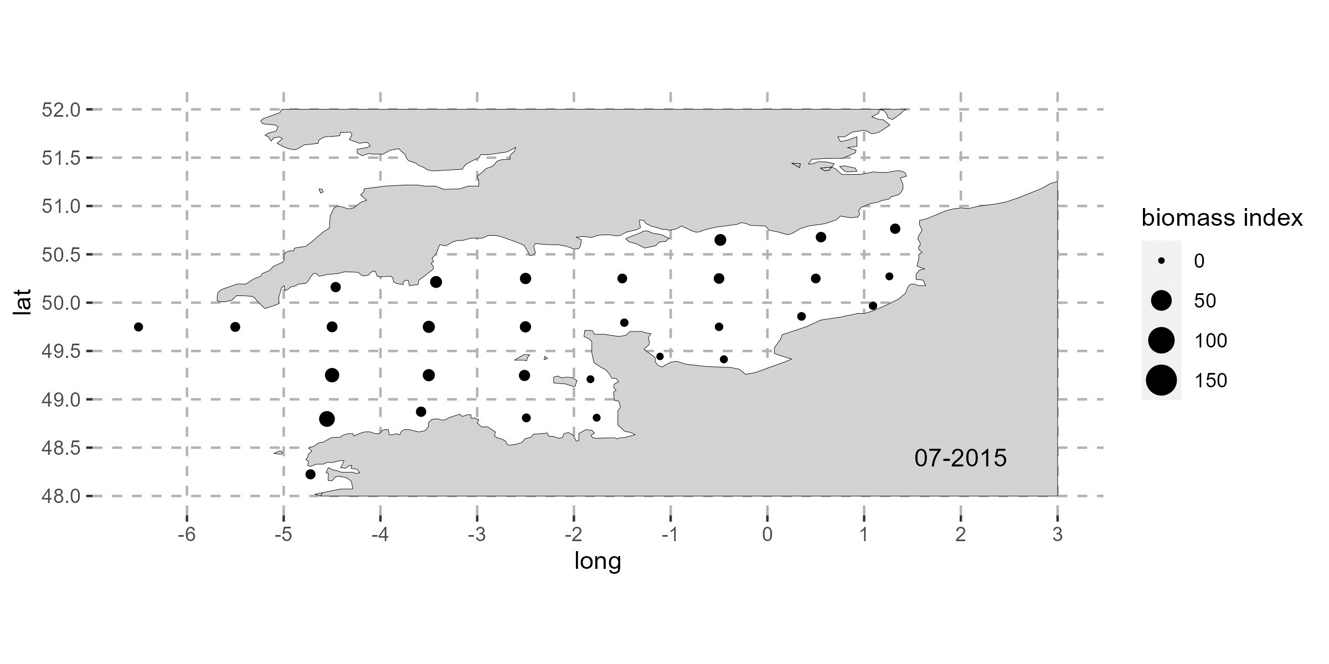
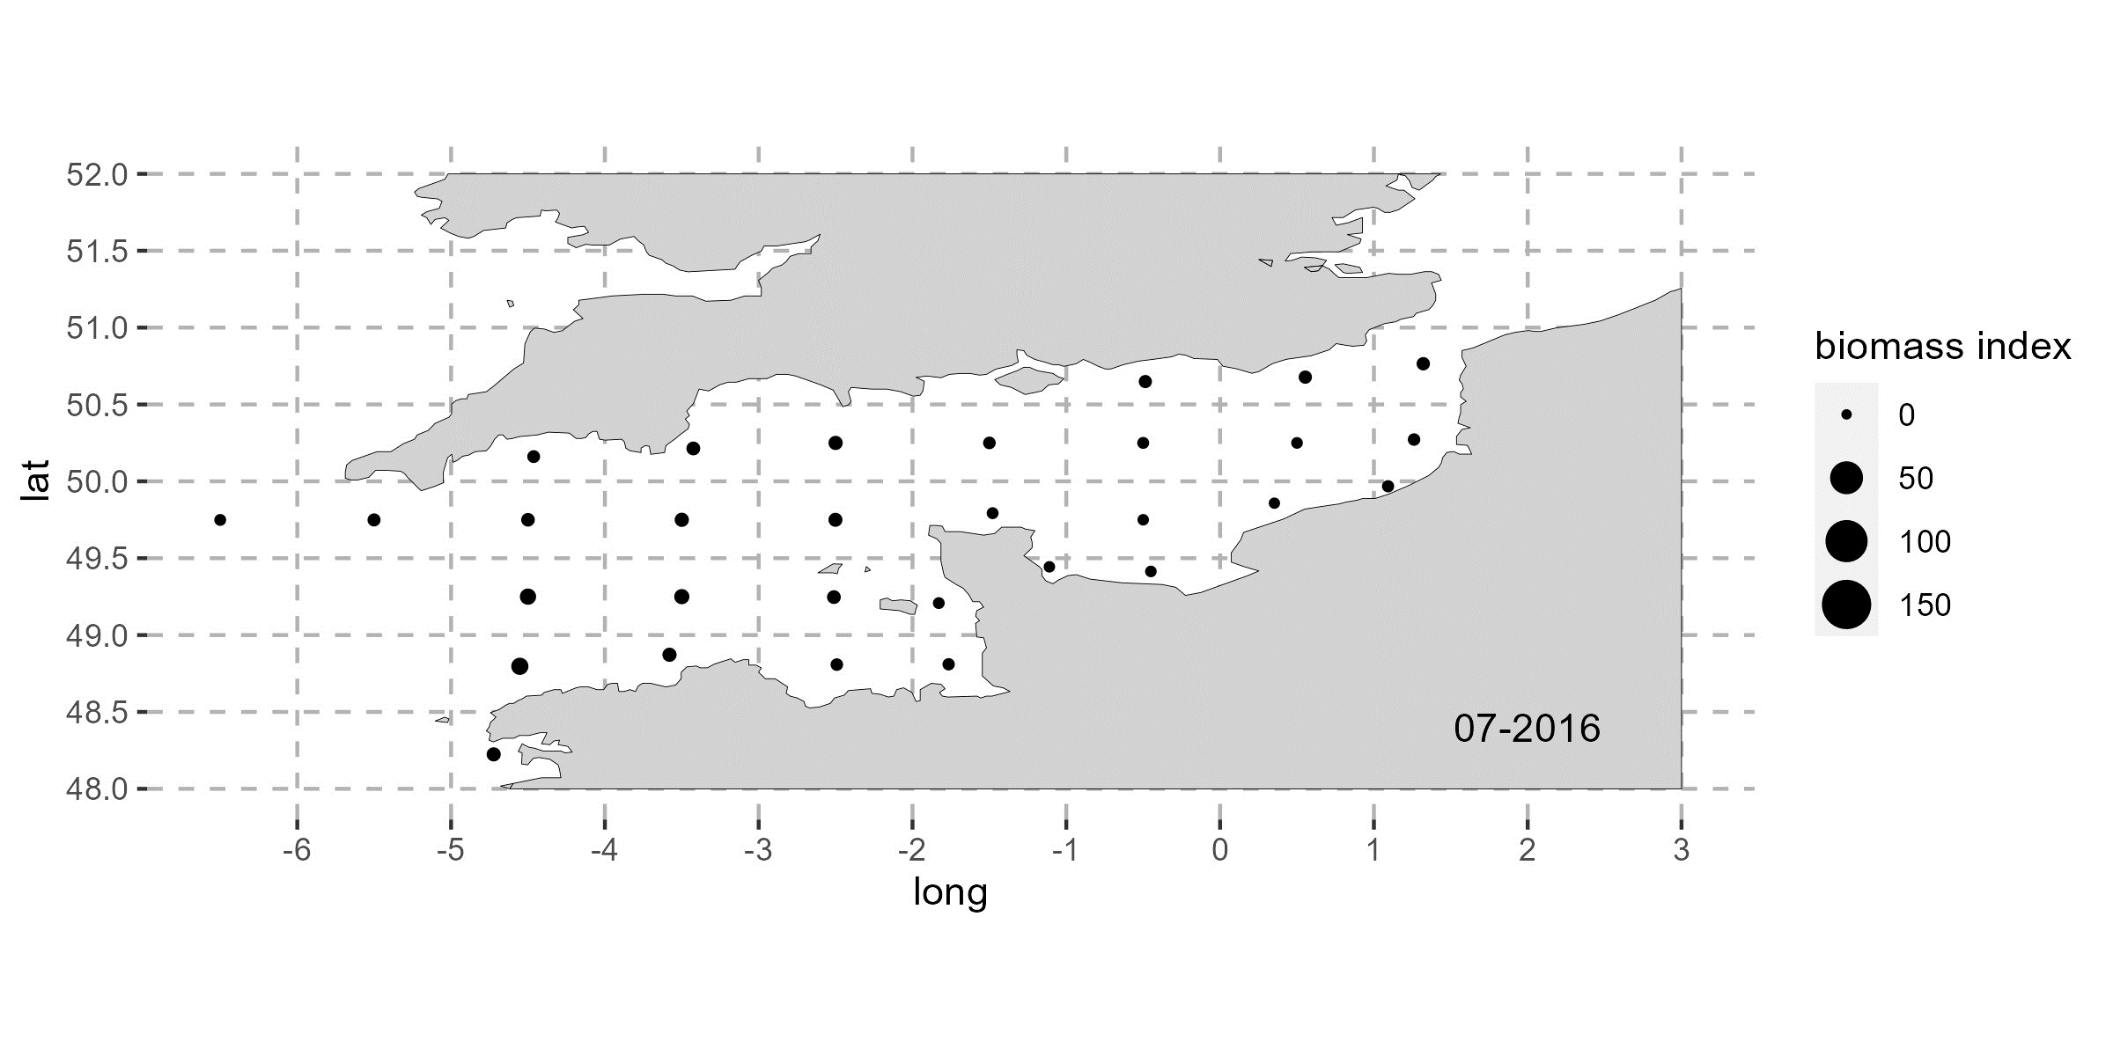
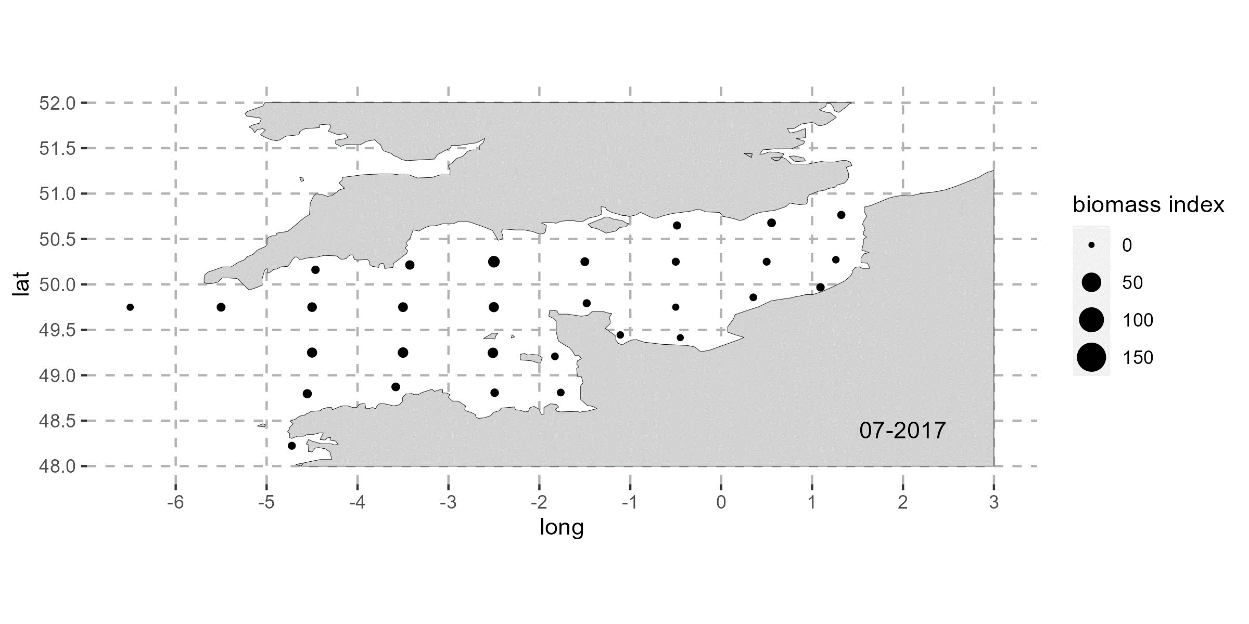
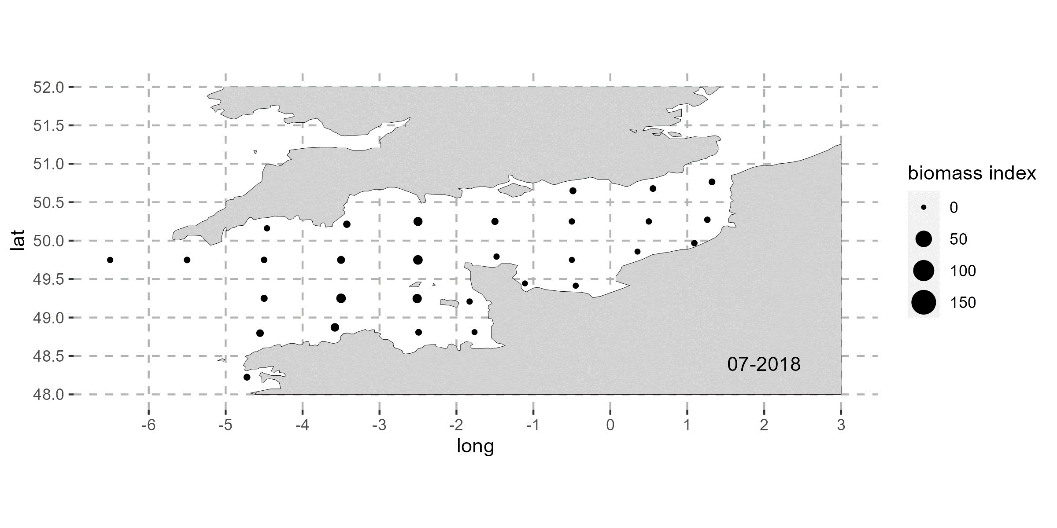
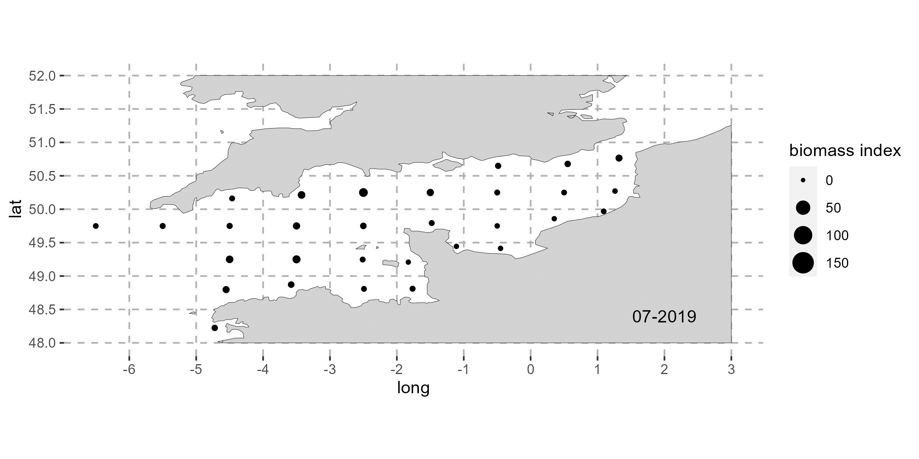
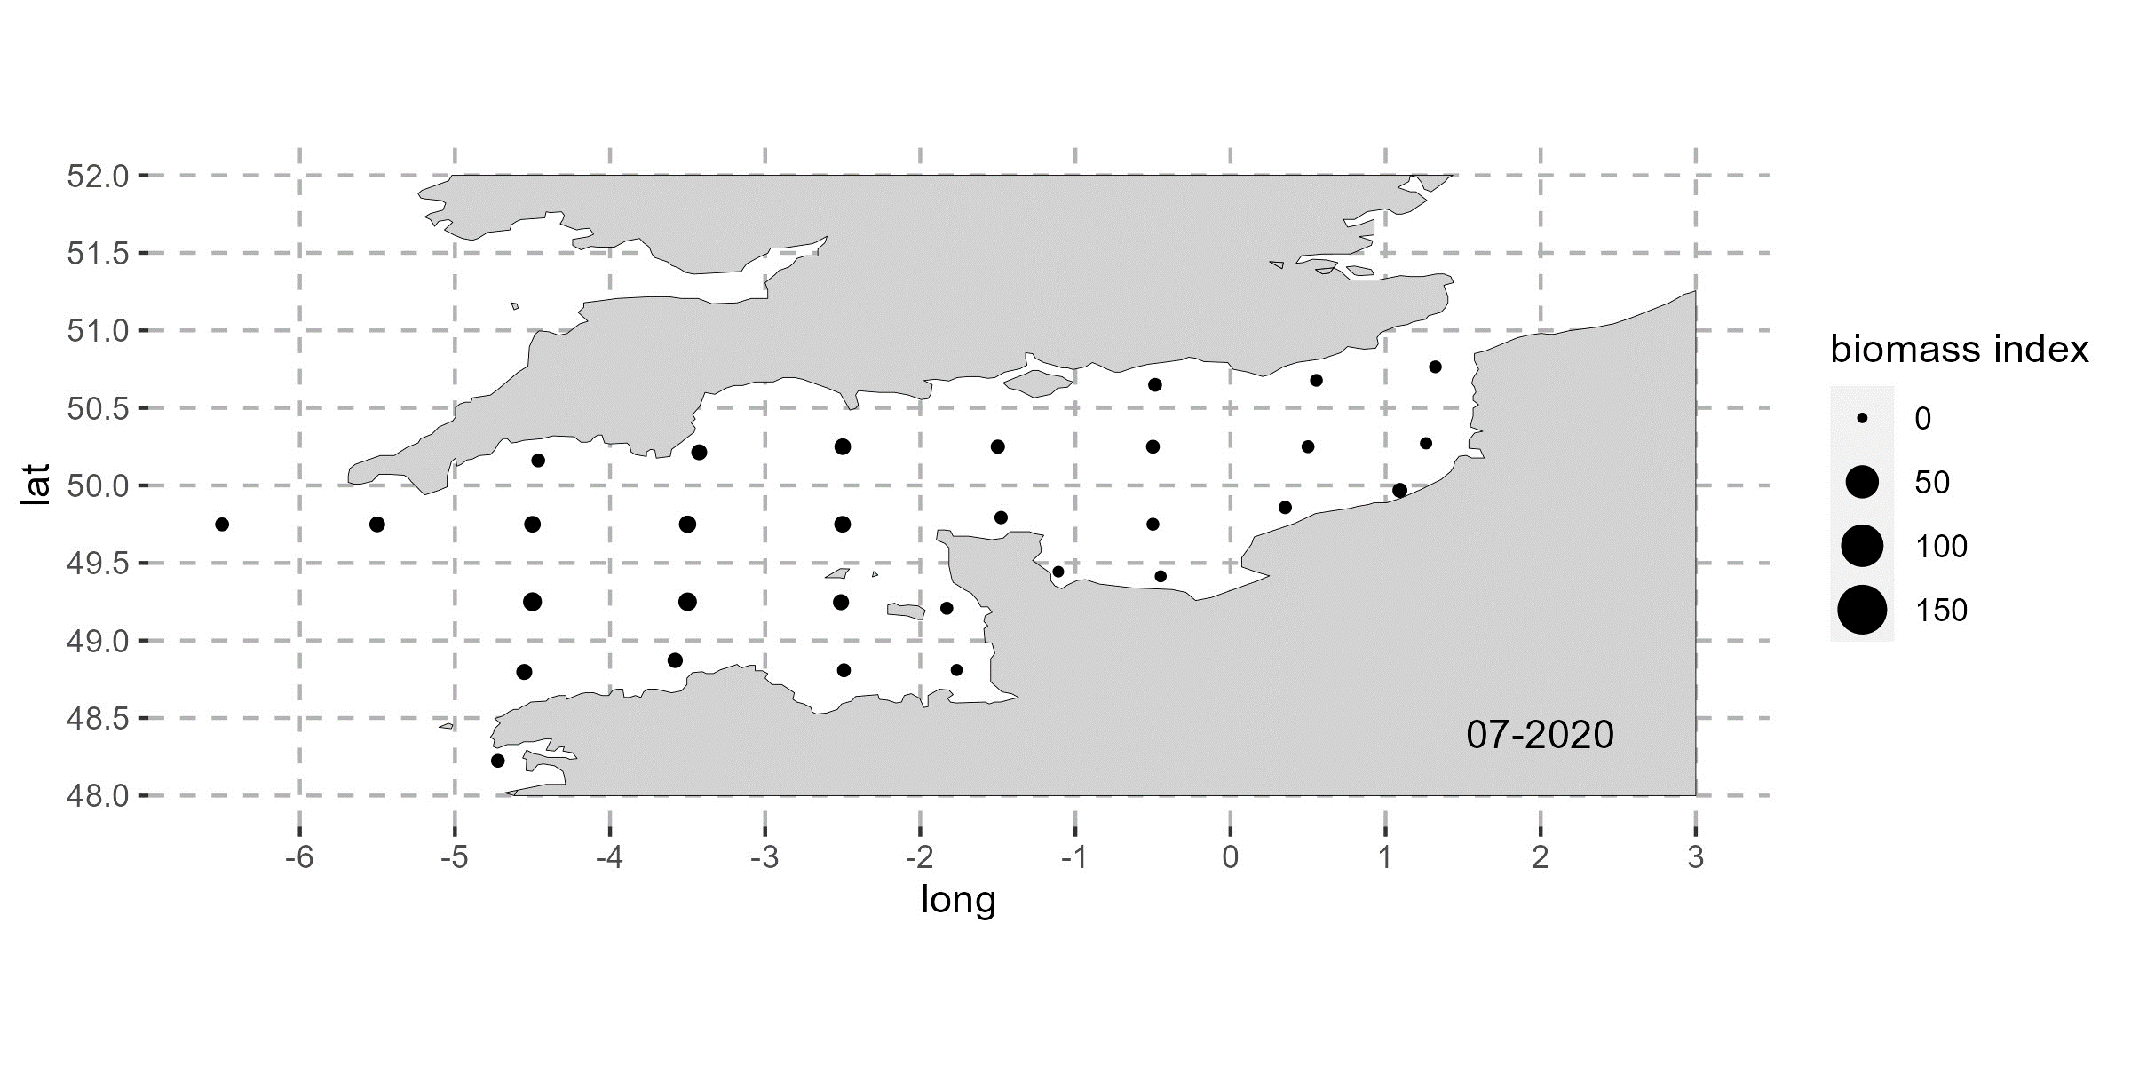
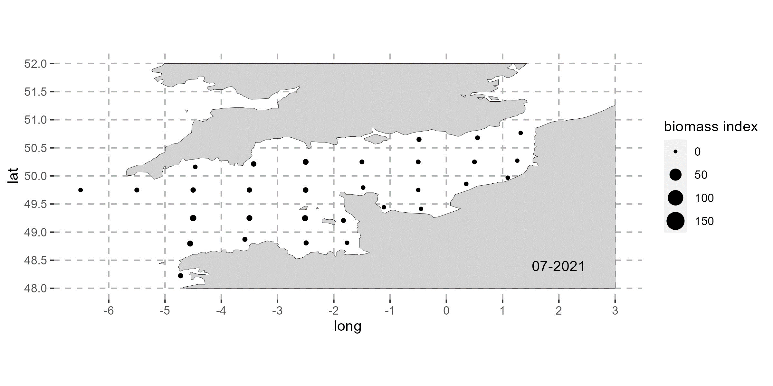
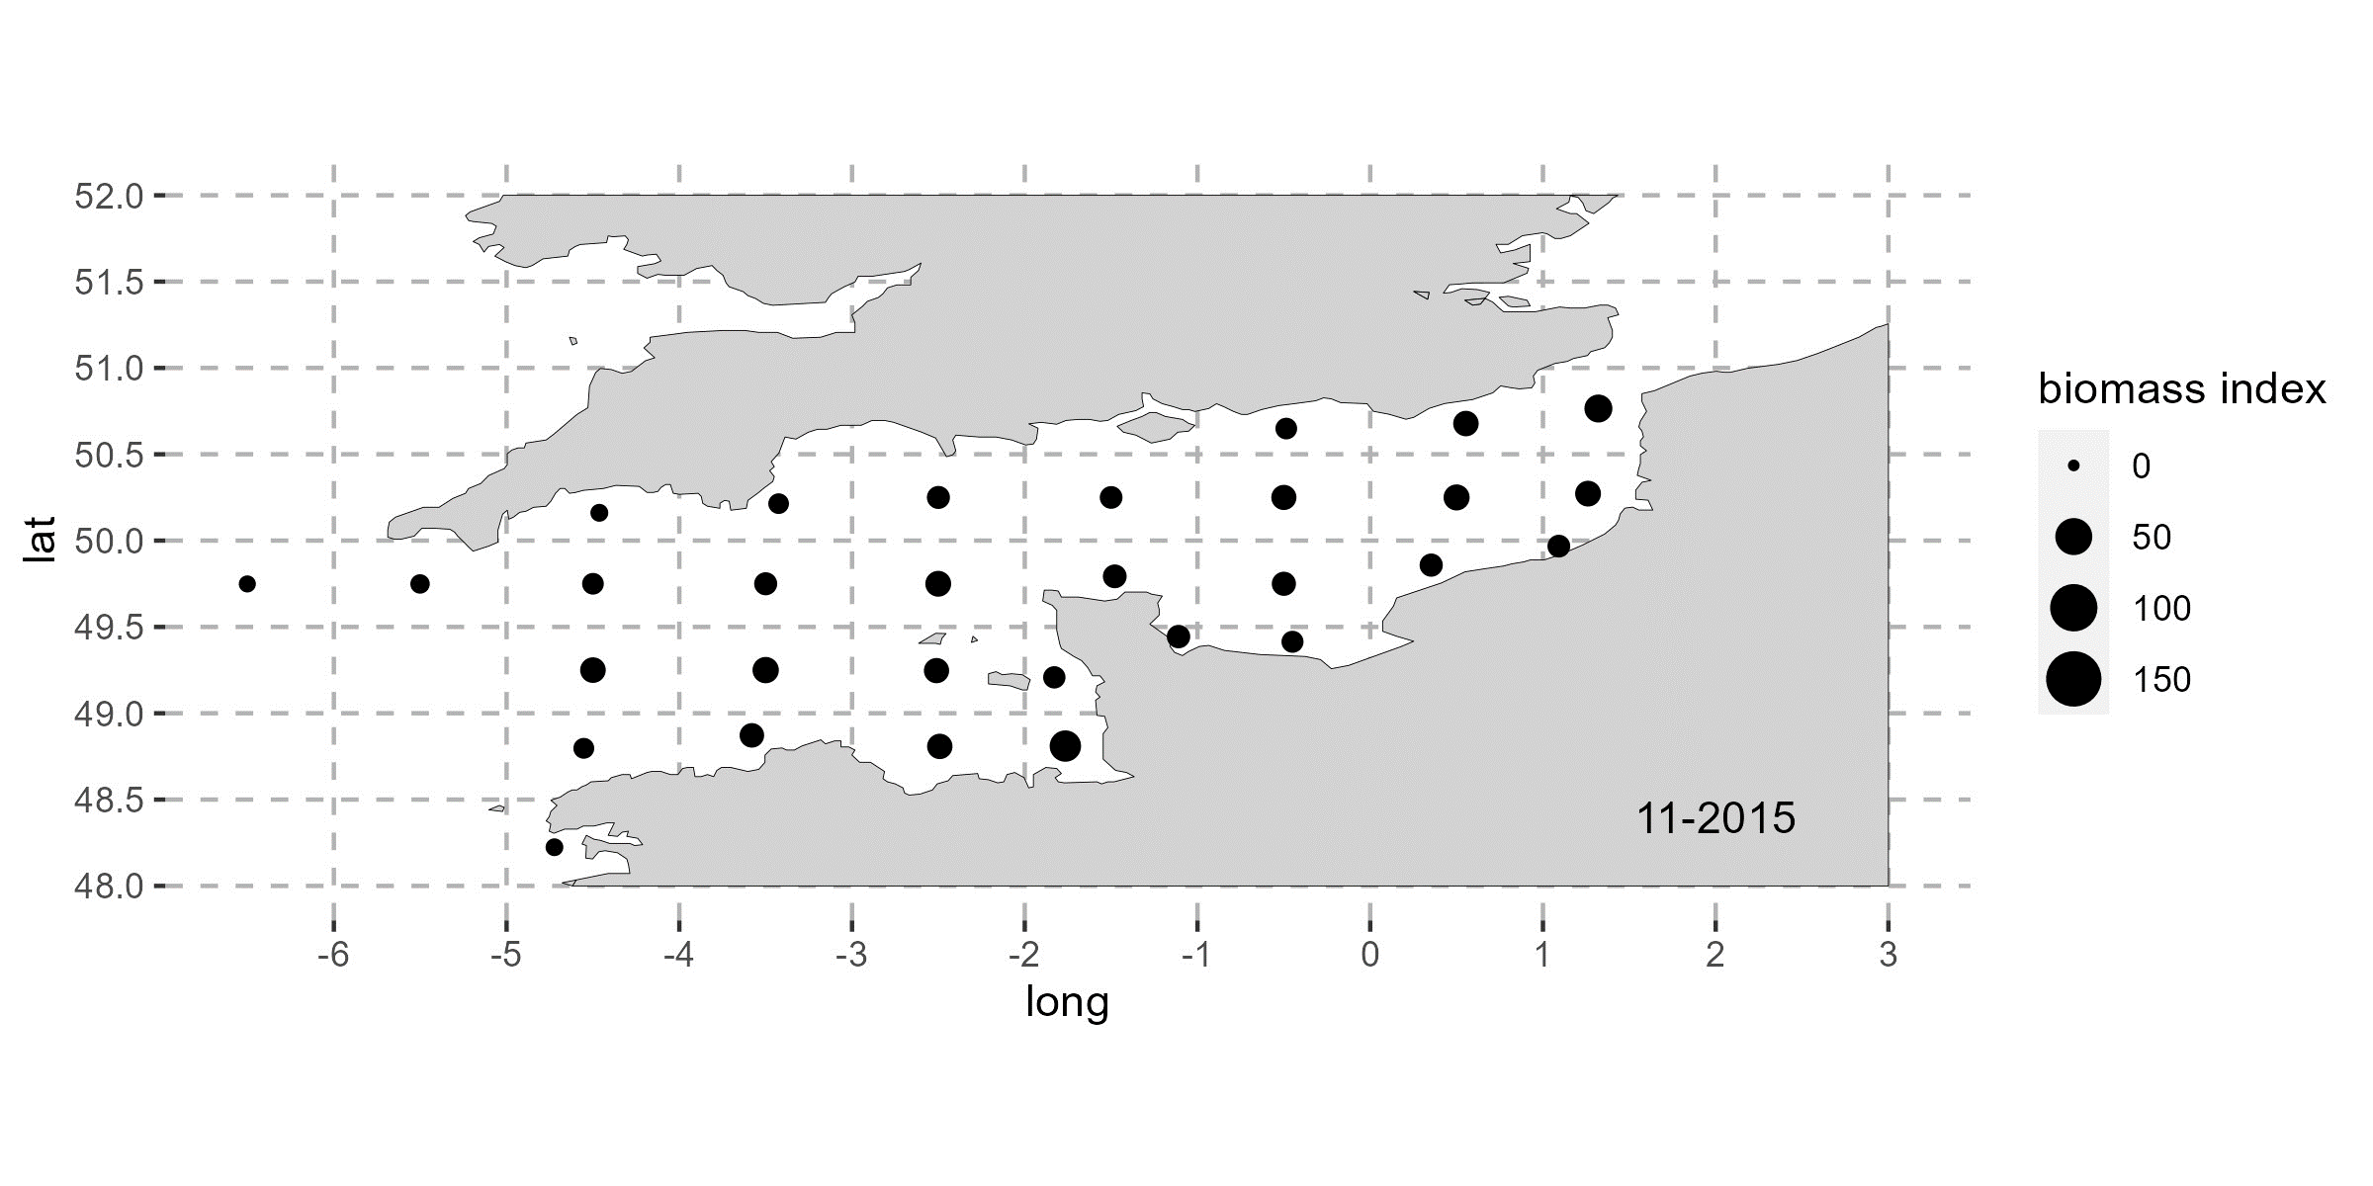
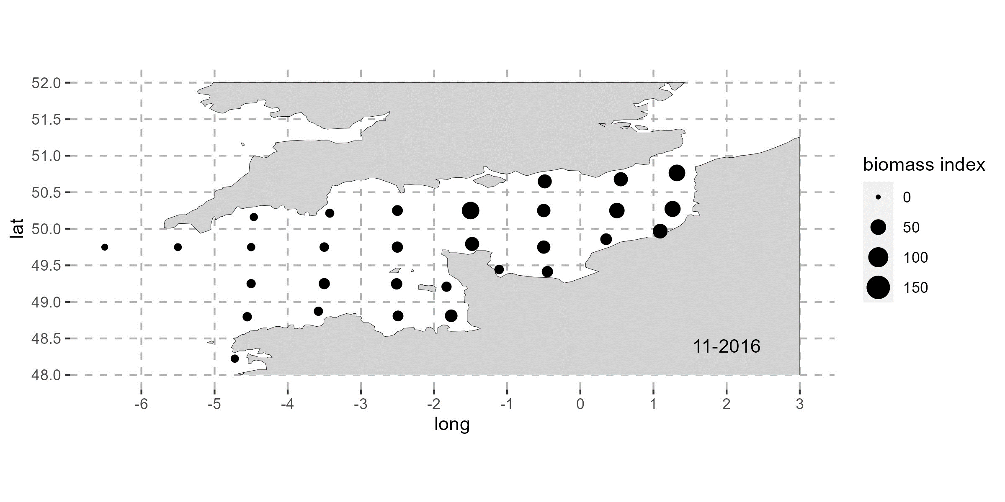
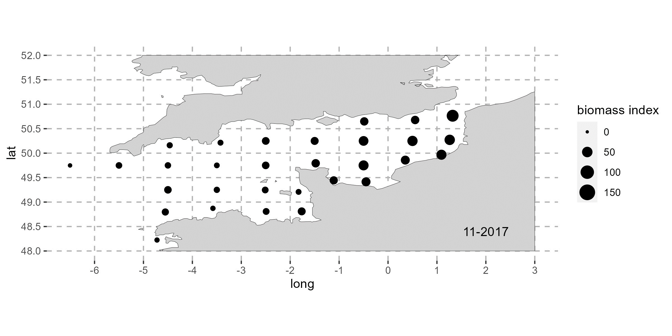
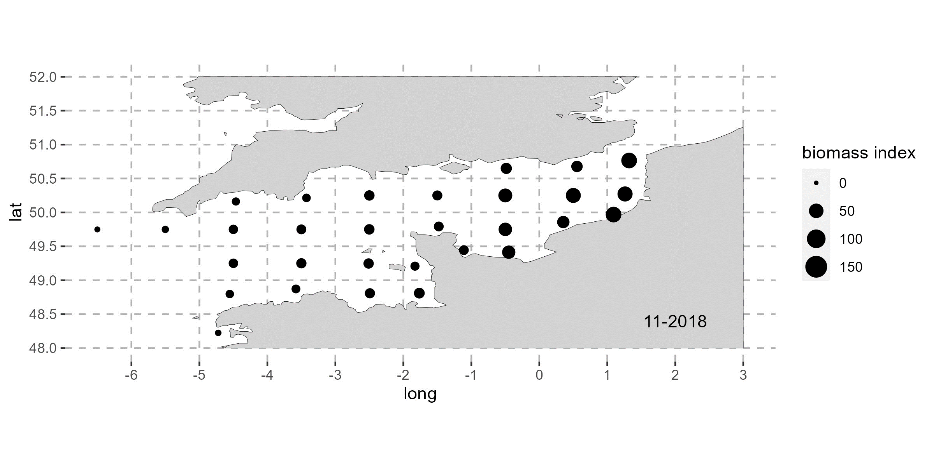
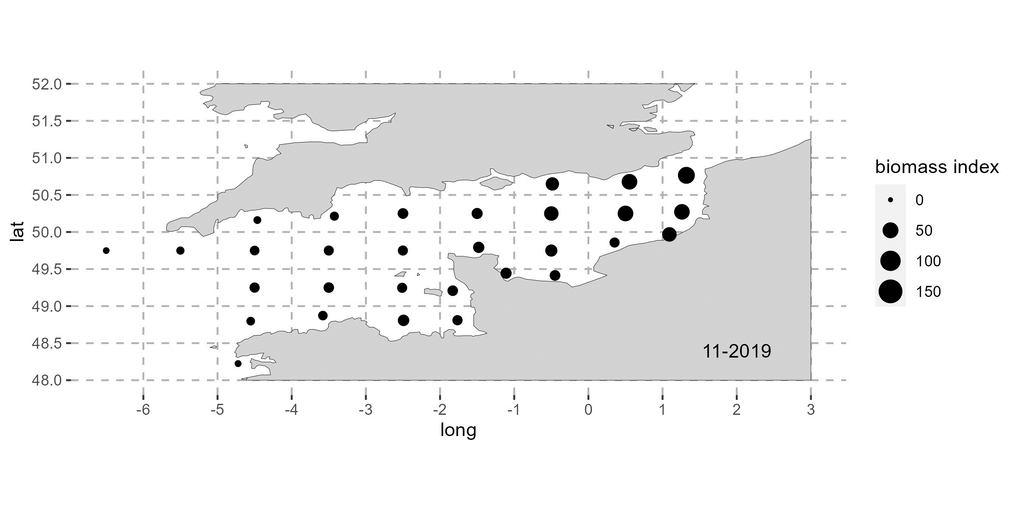
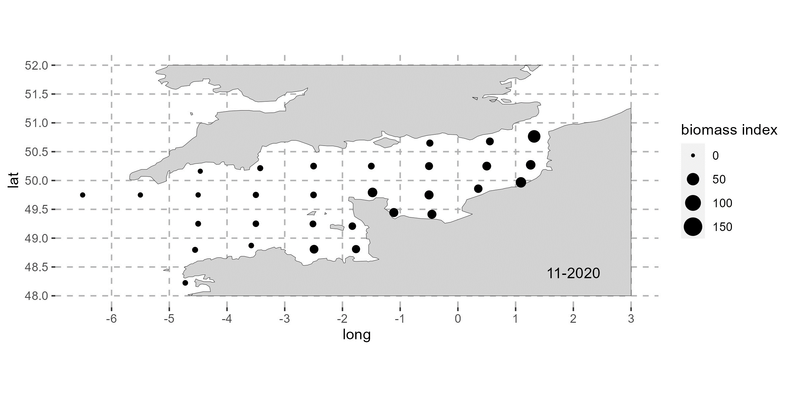
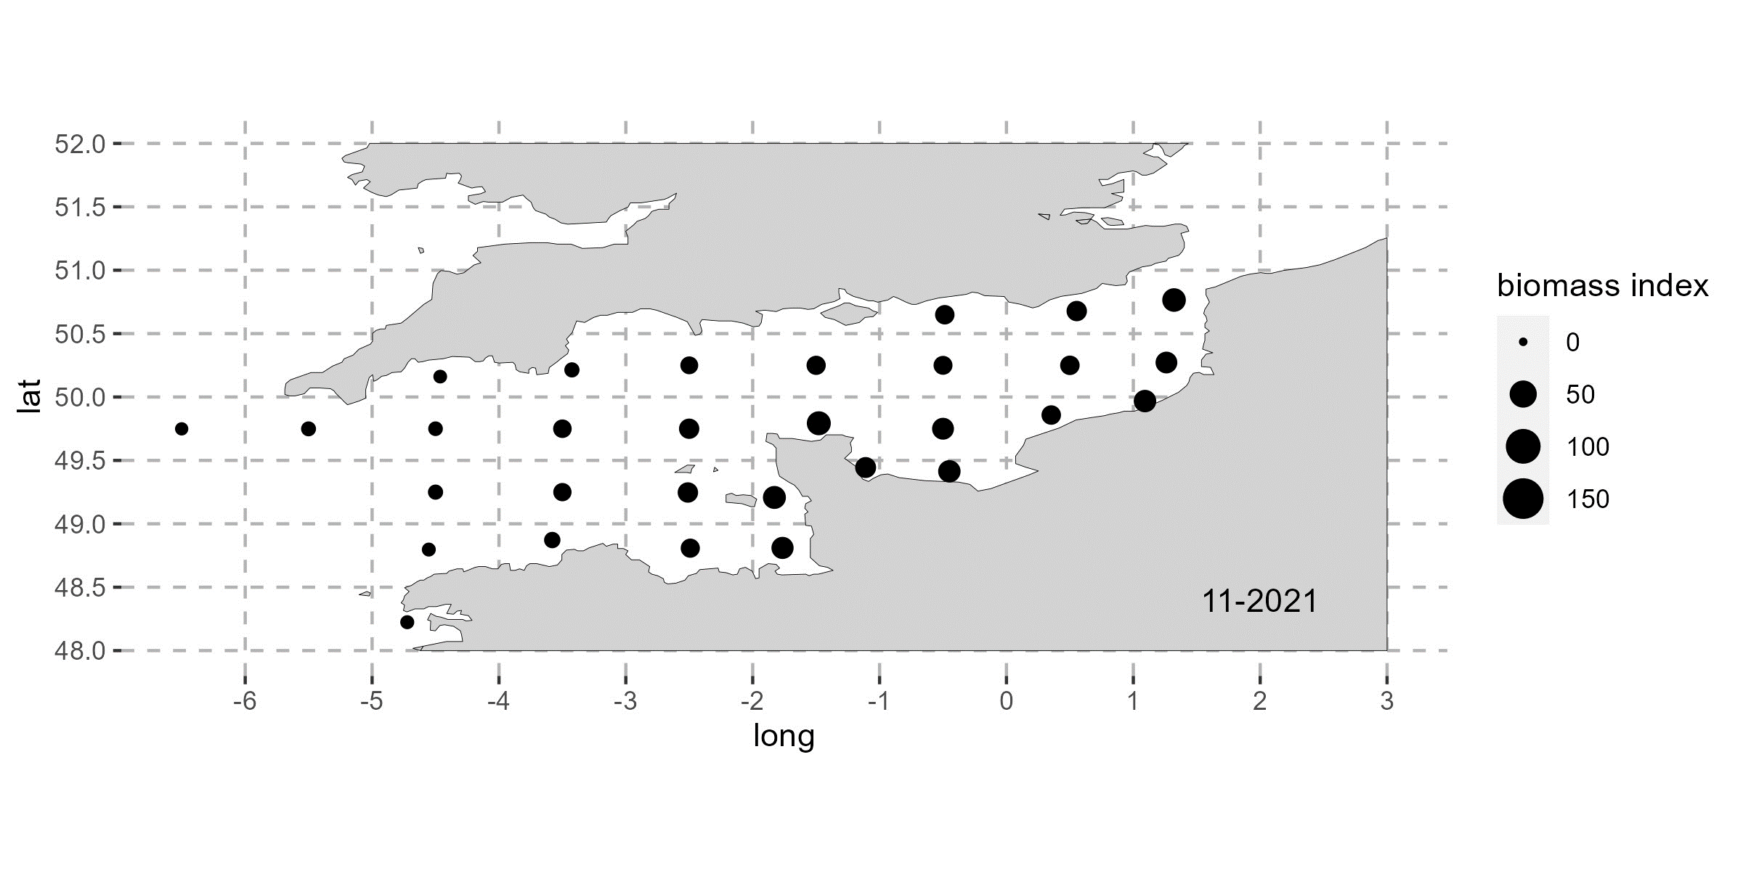

Appendix 1. Squid biomass indices in the English Channel from 2000 to 2021 for L. forbesii recruitment in July (a) and for L. vulgaris recruitment in November (b) for each ICES statistical rectangle of the English Channel.
 |  | bottomT | so | uo | vo | nppv | po4 | lat | lon | no3 | chl
December |  | 2.65 | 35.11 | 1.51 | 1.38 | 34.03 | 5.18 | 2.46 | 3.19 | 45.39 | 41.41
(year-1) | -chl | 2.40 | 32.26 | 1.39 | 1.38 | 2.07 | 4.77 | 1.84 | 3.04 | 43.08 | -
 | -no3 | 2.21 | 2.37 | 1.38 | 1.37 | 1.87 | 1.59 | 1.81 | 3.04 | - | -
January |  | 3.53 | 32.34 | 1.62 | 1.58 | 36.37 | 4.44 | 2.81 | 3.95 | 41.68 | 42.12
 | -chl | 3.08 | 31.95 | 1.57 | 1.58 | 1.54 | 4.34 | 1.85 | 3.92 | 41.43 | -
 | -no3 | 2.95 | 2.79 | 1.56 | 1.57 | 1.51 | 1.94 | 1.83 | 3.88 | - | -
February |  | 4.19 | 25.46 | 1.85 | 1.92 | 23.96 | 4.03 | 2.70 | 4.65 | 32.73 | 27.27
 | -chl | 3.41 | 25.34 | 1.80 | 1.84 | 2.37 | 4.00 | 2.09 | 4.65 | 32.65 | -
 | -no3 | 3.41 | 2.76 | 1.74 | 1.84 | 2.33 | 1.99 | 2.02 | 4.52 | - | -
March |  | 2.46 | 25.56 | 1.18 | 1.31 | 18.02 | 3.04 | 2.54 | 4.81 | 26.16 | 16.12
 | -chl | 1.99 | 25.44 | 1.16 | 1.30 | 2.69 | 3.04 | 2.33 | 4.77 | 26.16 | -
 | -no3 | 1.95 | 2.71 | 1.16 | 1.26 | 2.69 | 1.91 | 2.27 | 4.77 | - | -
Appendix 2. Variance inflation factor (VIF) analysis for environmental variables during the pre-recruitment period of L. forbesii (7, 6, 5 or 4 months before L. forbesii recruitment in July)
 |  | bottomT | so | uo | vo | nppv | po4 | lat | lon | no3 | chl
April |  | 1.52 | 20.44 | 1.22 | 1.29 | 6.68 | 3.11 | 2.47 | 4.46 | 18.04 | 6.96
 | -chl | 1.48 | 20.44 | 1.22 | 1.29 | 2.02 | 3.10 | 2.47 | 3.94 | 18.00 | -
 | -no3 | 1.48 | 2.25 | 1.21 | 1.28 | 2.00 | 2.54 | 2.47 | 3.94 | - | -
May |  | 1.92 | 20.53 | 1.11 | 1.25 | 14.36 | 1.85 | 2.63 | 4.31 | 20.02 | 14.01
 | -chl | 1.89 | 20.38 | 1.09 | 1.25 | 2.14 | 1.71 | 2.63 | 3.06 | 19.26 | -
 | -no3 | 1.89 | 2.55 | 1.08 | 1.25 | 2.03 | 1.38 | 2.63 | 3.01 | - | -
June |  | 3.59 | 20.45 | 1.07 | 1.29 | 26.64 | 2.12 | 2.85 | 5.68 | 26.21 | 18.76
 | -chl | 3.42 | 20.17 | 1.06 | 1.29 | 6.23 | 1.74 | 2.82 | 4.94 | 26.11 | -
 | -no3 | 3.42 | 4.14 | 1.06 | 1.28 | 4.76 | 1.71 | 2.82 | 4.91 | - | -
July |  | 5.25 | 19.80 | 1.15 | 1.56 | 16.61 | 2.34 | 3.18 | 8.04 | 25.21 | 12.04
 | -chl | 5.10 | 19.79 | 1.12 | 1.55 | 6.62 | 2.30 | 3.18 | 9.02 | 25.13 | -
 | -no3 | 5.07 | 4.40 | 1.12 | 1.55 | 5.83 | 2.07 | 3.18 | 7.93 | - | -
Appendix 3. Variance inflation factor (VIF) analysis for environmental variables during the pre-recruitment period of L. vulgaris (7, 6, 5 or 4 months before L. vulgaris recruitment in November)
Models | lag  in month | Environmental predictors in | Optimal model | Degrees of freedom | p | AIC | Deviance explained
A | 7 | December | bottomT | 2.712 | 0.028*
 |  | (year-1) | so | 1.750 | 0.225
 |  |  | uo | 1.551 | 0.025*
 |  |  | vo | 2.642 | 0.004** | 1141.570 | 60.5%
 |  |  | nppv | 1.001 | <0.001***
 |  |  | po4 | 2.109 | 0.024*
 |  |  | lat,lon | 10.448 | <0.001***
B | 6 | January | bottomT | 2.647 | <0.001***
 |  |  | so | 3.147 | 0.144
 |  |  | uo | 3.925 | <0.001***
 |  |  | vo | 2.697 | 0.001** | 1108.540 | 65.8%
 |  |  | nppv | 2.382 | <0.001***
 |  |  | po4 | 3.895 | 0.041*
 |  |  | lat,lon | 10.617 | <0.001***
C | 5 | February | bottomT | 3.508 | <0.001***
 |  |  | so | 3.993 | <0.001***
 |  |  | uo | 2.405 | 0.019*
 |  |  | vo | 2.708 | 0.049* | 1178.069 | 61.0%
 |  |  | nppv | 3.057 | <0.001***
 |  |  | po4 | 4.002 | 0.015*
 |  |  | lat,lon | 10.553 | <0.001***
D | 4 | March | bottomT | 2.756 | 0.024*
 |  |  | so | 3.611 | 0.004**
 |  |  | uo | 1.000 | <0.001***
 |  |  | vo | 1.000 | 0.041* | 1198.381 | 58.4%
 |  |  | nppv | 3.578 | 0.025*
 |  |  | po4 | 2.717 | 0.031*
 |  |  | lat,lon | 10.446 | <0.001***
Appendix 4. Deviance analysis for generalized additive models (GAM) fitted to the recruitment biomass indices in July
Models | Lag in month | Environmental predictors in | Optimal model | Degrees of freedom | p | AIC | Deviance explained
E | 7 | April | bottomT | - | -
 |  |  | so | 3.242 | 0.001**
 |  |  | uo | 1.689 | 0.026*
 |  |  | vo | 3.513 | 0.042* | 1198.381 | 58.4%
 |  |  | nppv | - | -
 |  |  | po4 | 3.560 | <0.001***
 |  |  | lat,lon | 9.916 | <0.001***
F | 6 | May | bottomT | 1.000 | 0.166
 |  |  | so | 3.154 | 0.089
 |  |  | uo | 2.199 | 0.171
 |  |  | vo | - | - | 882.817 | 52.7%
 |  |  | nppv | 1.000 | 0.021*
 |  |  | po4 | 3.609 | <0.001***
 |  |  | lat,lon | 9.619 | <0.001***
G | 5 | June | bottomT | 2.737 | <0.001***
 |  |  | so | 3.238 | 0.007**
 |  |  | uo | 3.911 | <0.001***
 |  |  | vo |  | - | 851.022 | 55.9%
 |  |  | nppv | 2.150 | 0.028*
 |  |  | po4 |  | -
 |  |  | lat,lon | 10.533 | <0.001***
H | 4 | July | bottomT | 3.415 | <0.001***
 |  |  | so | 2.971 | 0.058
 |  |  | uo | 1.318 | 0.058
 |  |  | vo | 2.313 | 0.048* | 838.428 | 56.7%
 |  |  | nppv | 1.000 | <0.001***
 |  |  | po4
 |  |  | lat,lon | 10.534 | <0.001***
Appendix 5. Deviance analysis for generalized additive models (GAM) fitted to the recruitment biomass indices in November (optimal model)
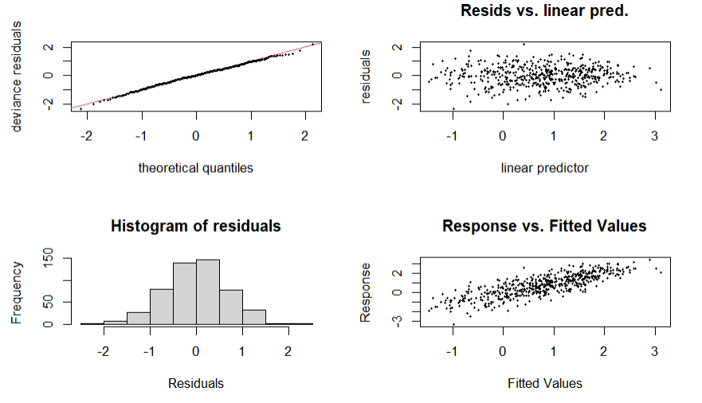
(a)
(d)
(c)
(b)
Appendix 6. Model B diagnostics: (a) Normal theorical quantiles (Q-Q plot) with 1:1 line plotted in red; (b) dispersion plot of model residuals; (c) histogram of class-wise residuals frequency and (d) plot of predicted (y-axis) and observed values (x-axis).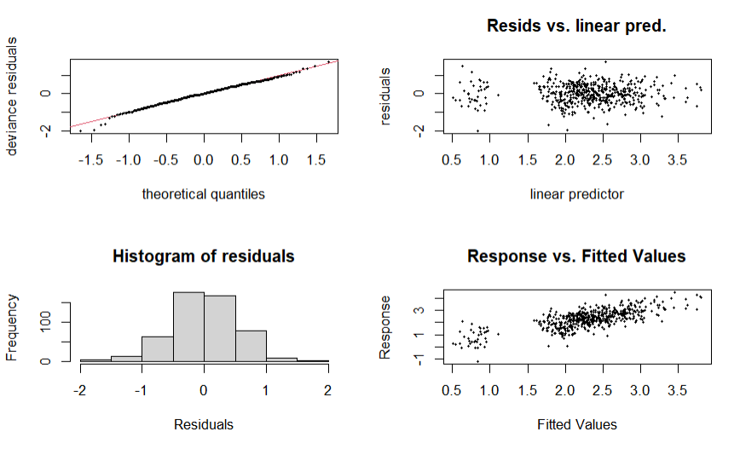
(a)
(c)
(b)
(d)
Appendix 7. Model H diagnostics: (a) Normal theorical quantiles (Q-Q plot) with 1:1 line plotted in red; (b) dispersion plot of model residuals; (c) histogram of class-wise residuals frequency and (d) plot of predicted (y-axis) and observed values (x-axis).

