**Table S1.** List of observed and predicted life-history traits for the tropical (left) and temperate (right) fish species.

|  |  |  |  |  |  |  |  |  |  |  |  |  |
| --- | --- | --- | --- | --- | --- | --- | --- | --- | --- | --- | --- | --- |
| **Variate** | **DEB symbol** | **Unit** | **Temperature (in K)** | **Observe** | **Predicted** | **Relative error** | **Reference** | **Temperature (in K)** | **Observe** | **Predicted** | **Relative error** | **Reference** |
| **Tropical species (*Abudefduf vaigiensis*)** | | | | | | | | **Temperate species (*Atypicthys strigatus*)** | | | | |
| Age at first feeding | tb | day | 299.05 | 9.5 | 6.179 | 0.350 | Alshuth et al. 1998 | 292.31 | 1.3 | 3.389 | 1.607 | Arima 1999 |
| Age at settlement | tj | day | 301.65 | 23.35 | 29.61 | 0.268 | Thresher et al. 1989, Alshuth et al. 1998, Soeparno et al. 2012 | 292.31 | 23 | 33.8 | 0.327 | Seike et al. 2009 |
| Age at puberty | tp | day | 303.75 | 730 | 693.8 | 0.050 | Fraser and McCormick 2014 | 292.31 | 605 | 500.3 | 0.173 | Fishbase |
| Life span | am | day | 298.65 | 5475 | 5451 | 0.004 | Brough et al. 2020 | 292.31 | 3010 | 3012 | 0.001 | Fishbase |
| Wet weight at first feeding | Wwb | g | NA | 0.0024 | 0.0022 | 0.095 | Alshuth et al. 1998 | NA | 0.0015 | 0.001608 | 0.072 | Neira et al. 1998 |
| Wet weight at settlement | Wwj | g | NA | 0.094 | 0.08857 | 0.058 | Alshuth et al. 1998, current study, Fishbase | NA | 0.0486 | 0.04969 | 0.022 | Current study |
| Wet weight at puberty | Wwp | g | NA | 28.89 | 26.89 | 0.069 | Fraser and McCormick 2014, Fishbase | NA | 86.07 | 90.22 | 0.048 | Fishbase |
| Ultimate wet weight | Wwi | g | NA | 176 | 194.2 | 0.104 | Fishbase | NA | 342.7 | 334.2 | 0.025 | Hutchins and Swainston 1986 |
| Standard length at first feeding | Lb | cm | NA | 0.33 | 0.3539 | 0.072 | Alshuth et al. 1998 | NA | 0.29 | 0.3237 | 0.116 | Neira et al. 1998 |
| Standard length at settlement | Lj | cm | NA | 1.23 | 1.221 | 0.007 | Alshuth et al. 1998 | NA | 1.21 | 1.016 | 0.161 | Neira et al. 1998, current study |
| Standard length at puberty | Lp | cm | NA | 8.83 | 8.162 | 0.076 | Fraser and McCormick 2014, Fishbase | NA | 13.2 | 12.39 | 0.061 | Fishbase |
| Ultimate standard length | Li | cm | NA | 15.09 | 15.78 | 0.046 | Fishbase | NA | 20.5263 | 19.17 | 0.066 | Hutchins and Swainston 1986 |
| Maximum reproduction rate | Ri | # of eggs/d | 297.15 | 54.8 | 57.55 | 0.050 | Brough et al. 2020 | NA | NA | NA | NA |  |
| Mean Relative Error | 0.096 | | | | | | | 0.097 | | | | |
| Symmetric Mean Squared Error | 0.103 | | | | | | | 0.088 | | | | |

**Table S2**. DEB parameters estimated in the current study using the covariation method.

|  |  |  |  |  |
| --- | --- | --- | --- | --- |
|  |  |  | **Tropical species** | **Temperate species** |
| **Primary Parameters** | **Symbol** | **Units** | **Value** | **Value** |
| Zoom factor | *z* | - | 1.555 | 2.393 |
| Allocation fraction to soma | κ | - | 0.8 | 0.8 |
| Digestion efficiency of food to reserve | κX | - | 0.050 | 0.1861 |
| Energy conductance | v̇ | cm/d | 0.040 | 0.263 |
| Reproduction efficiency | κR | - | 0.459 | 0.950 |
| Volume specific somatic maintenance rate | [*ṗM*] | J/d.cm^3 | 24.40 | 36.43 |
| Volume specific cost of structure | [EG] | J/cm^3 | 5230 | 5246 |
| Maturity threshold for feeding | |  | | --- | |  | | J | 2.58 | 1.90 |
| Maturity threshold for metamorphosis | $$E_{H}^{b}$$ | J | 97.00 | 60.94 |
| Maturity threshold for reproduction | $$E_{H}^{j}$$ | J | 38000 | 184850 |
| Weibull aging acceleration | *ḣa $$E_{H}^{p}$$* | 1/d^2 | 7.67E-11 | 3.44E-09 |
| Gompertz stress coefficient | *sG* | - | 2.96E-03 | 3.57E-05 |
| Arrhenius temperature | *TA* | K | 3175.00 | 4204.00 |
| Upper limit of tolerance range | *TH* | K | 303.50 | 299.10 |
| Lower limit of tolerance range | *TL* | K | 292.90 | 293.10 |
| Arrhenius temperature at upper limit | *TAH* | K | 8.48E+0.4 | 4.64E+04 |
| Arrhenius temperature at lower limit | *TAL* | K | 3.14E+0.5 | 1.27E+05 |
| Shape coefficient | *δM* | - | 0.318 | 0.3243 |
| Scaled functional response (literature) | *f* | - | 1.000 | 1.000 |
| Scaled functional response (no interaction) | *f_single* | - | 1.316 | 0.891 |
| Scaled functional response (with interaction) | *f_paired* | - | 1.644 | 0.810 |

**Table S3.** The presence (Y) and absence (N) ofJanuaryrecruitment for our study species at a given latitude for different years.

|  |  |  |  |  |
| --- | --- | --- | --- | --- |
| Latitude | Longitude | Year | *A. vaigiensis* | *A. strigatus* |
| -30.30 | 153.1 | 2010 | N |  |
| -32.72 | 152.1 | 2010 | Y |  |
|  |  | 2011 | N | Y |
| -33.23 | 151.2 | 2010 |  | Y |
|  |  | 2011 |  | Y |
| -33.87 | 151.2 | 2010 | Y | N |
|  |  | 2011 | Y | Y |
|  |  | 2012 | Y |  |
|  |  | 2013 | Y |  |
|  |  | 2014 | Y |  |
| -36.89 | 149.9 | 2005 | N |  |
|  |  | 2011 | N |  |
|  |  | 2013 | Y |  |
|  |  | 2014 | N |  |

a) DEB model under benign conditions

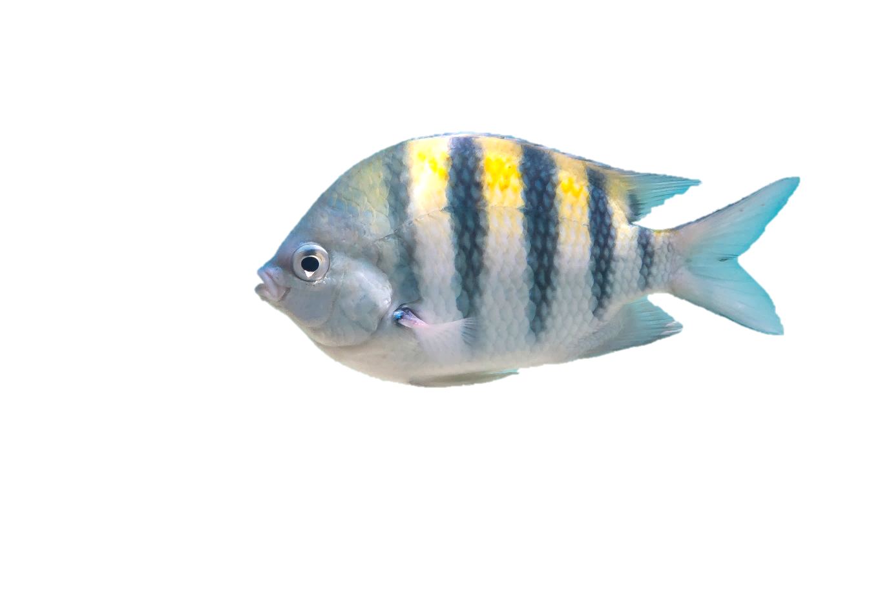

*Somatic maintenance*

*Growth overhead*



***ṗM***

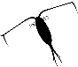

***ṗG***

***κṗC***

**Structure**



***f***

$x$

***ṗC***

***ṗA***

**Reproductive buffer**

*Offspring*

**Reserve**



***ṗR***

***ṗR***

**(1-*κ*)*****ṗC***



**Maturation**



***ṗJ***

*Reproduction overhead*

*Maturity maintenance*

b) DEB model under stressful conditions



**Temperature (e.g., warming)**

*Somatic maintenance*

*Growth overhead*



***ṗM***

**Food availability (e.g., competition)**

***ṗG***

***κṗC***

**Structure**



***ṗR***

***ṗA***

**Reproductive buffer**

*Offspring*

***f***

**Reserve**



***ṗR***

**(1-*κ*)*****ṗC***



**Maturation**

***ṗJ***

*Reproduction overhead*

*Maturity maintenance*

**Figure S1.** Schematic representation of the energy flow in the DEB model (a) under non-stressful conditions, and (b) under stressful conditions due to changes in forcing variables (e.g., when warming and/or novel species interactions transform current benign conditions to suboptimal conditions). State variables (i.e., reserve, structure, maturation, and reproductive buffer) are indicated in brown pictograms, and energy fluxes (i.e., letter beginning with *ṗ*) are indicated by the arrows. Food density is indicated as *x* whereas functional response is indicated as *f*. Type of arrow characterises the status of energy flow: continuous arrows = energy allocated to maintenance and state variables; dashed arrows = energy dissipates as overhead cost. The colour of the arrows indicates the level of energy availability: black arrows = sufficient energy for maintenance and state variables; red arrows = insufficient energy for maintenance and state variables; blue arrow = reduced energy for maintenance and state variables. Red cross indicates when the energy levels become insufficient for energy processing. (a) Under the benign conditions, sufficient energy from the environment can be obtained and allocated to maintenance, growth, and maturity development, but (b) when the external factor constrained the rate of energy flow, the available energy for somatic maintenance and growth are reduced or become insufficient (as indicated by red arrows). For the latter case, energy from maturation is diverted to support the cost of somatic maintenance.

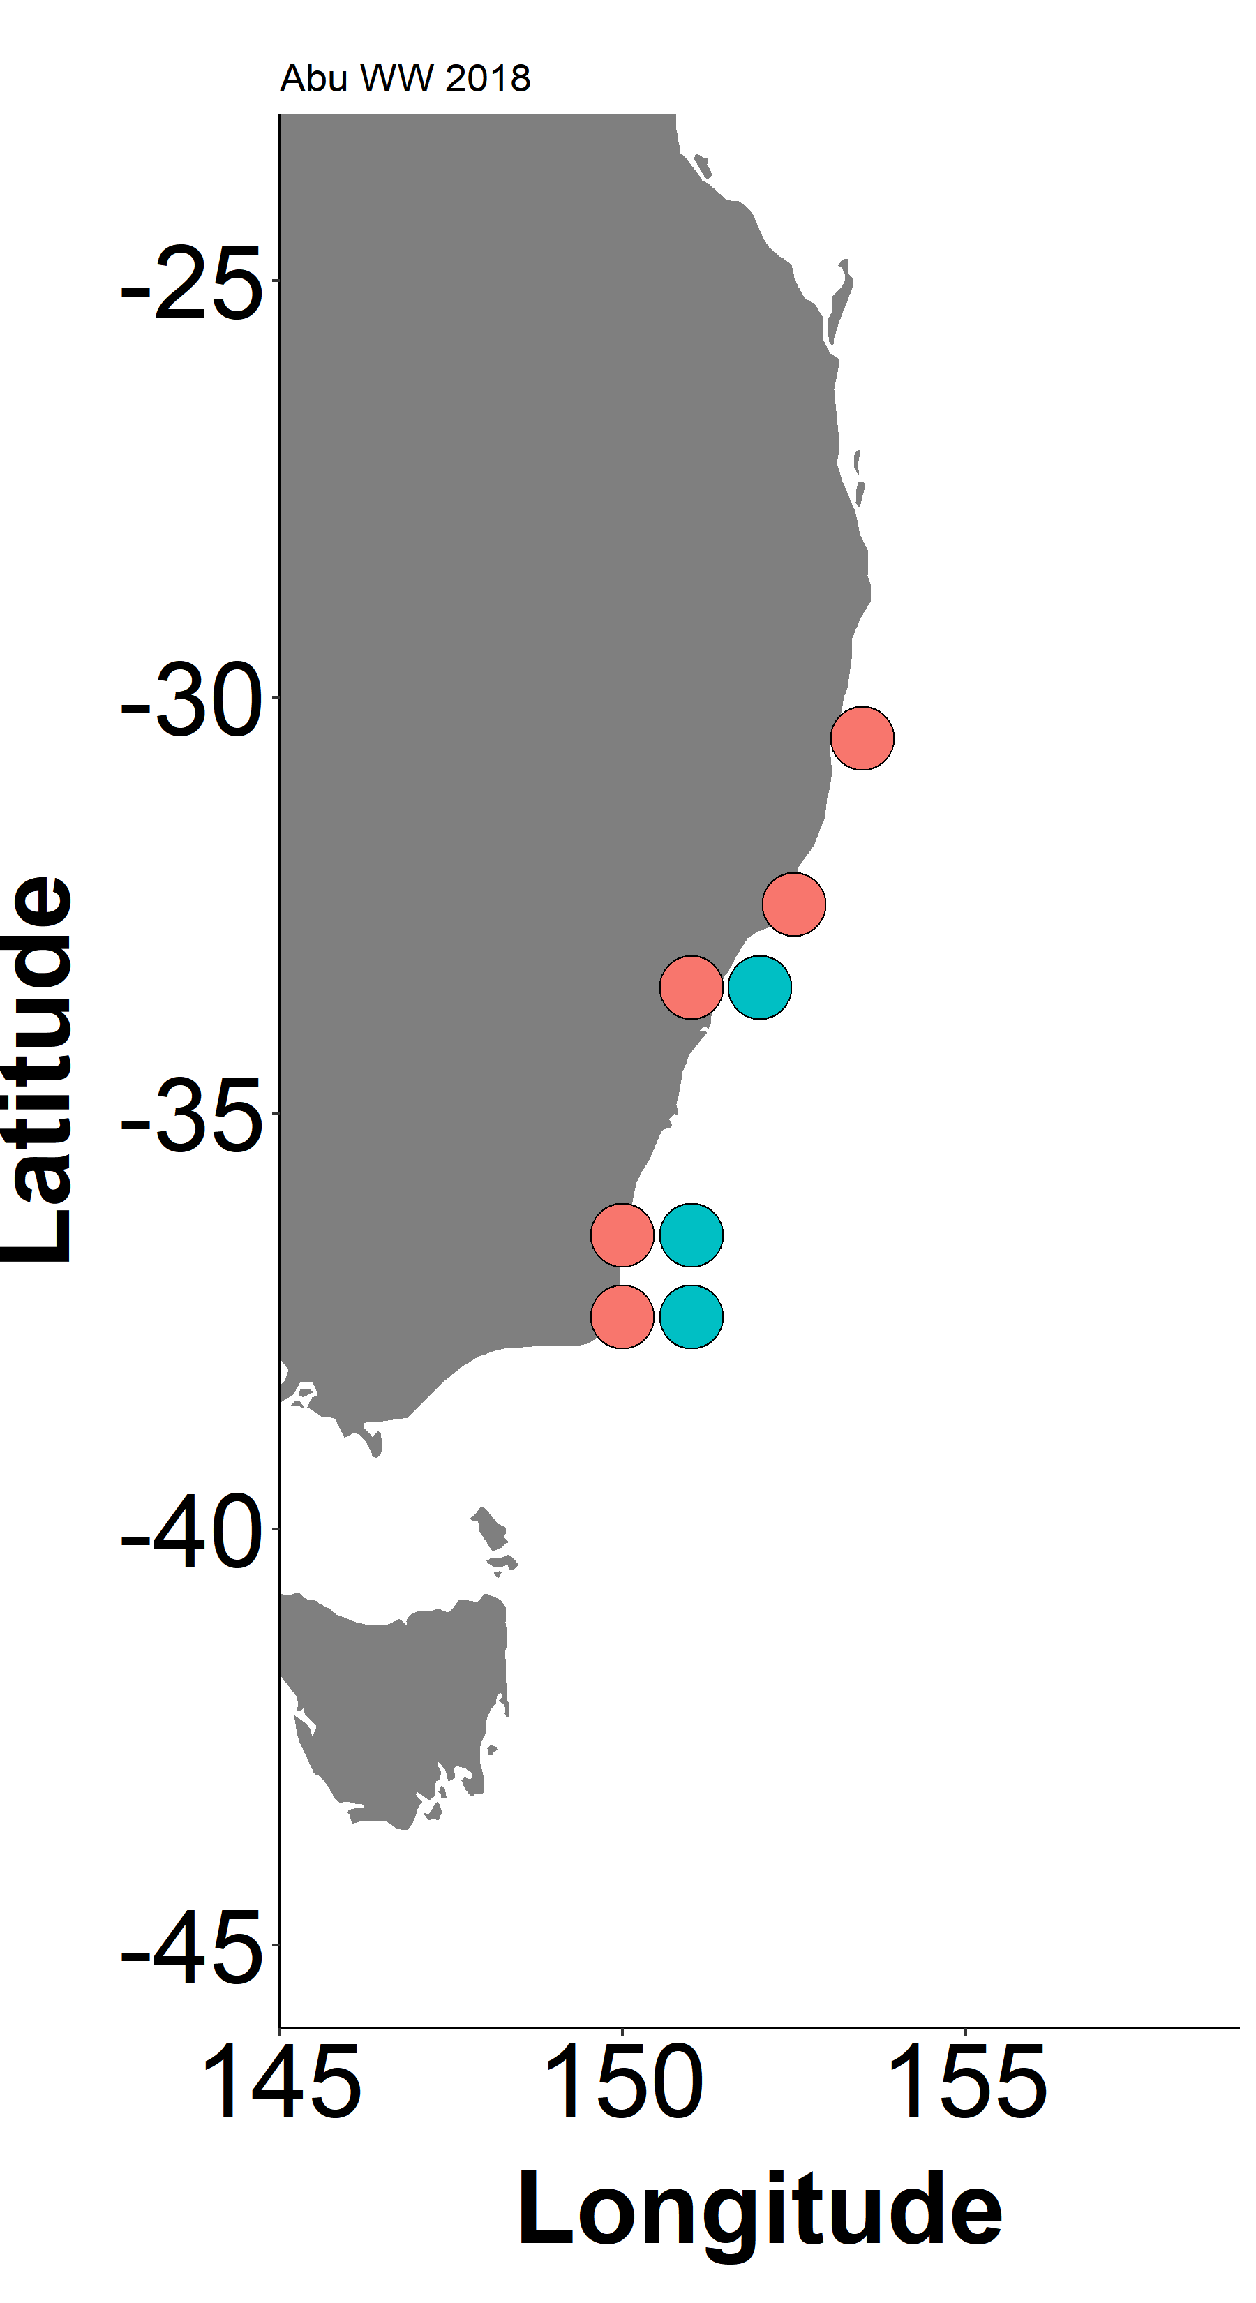

8-12/Mar

5/Mar

15-16 /Mar

22/Jun

20-26 /Mar

18-25 /Mar

**Figure S2**. Map showing sites and dates when the tropical species (pink) and the temperate species (blue) were collected. Date boxes with both pink and blue colours indicate the dates when both species were sampled at the same site during the same period. Date boxes with only pink indicate the date when only the tropical species was sampled. Sampling was conducted in 2018.

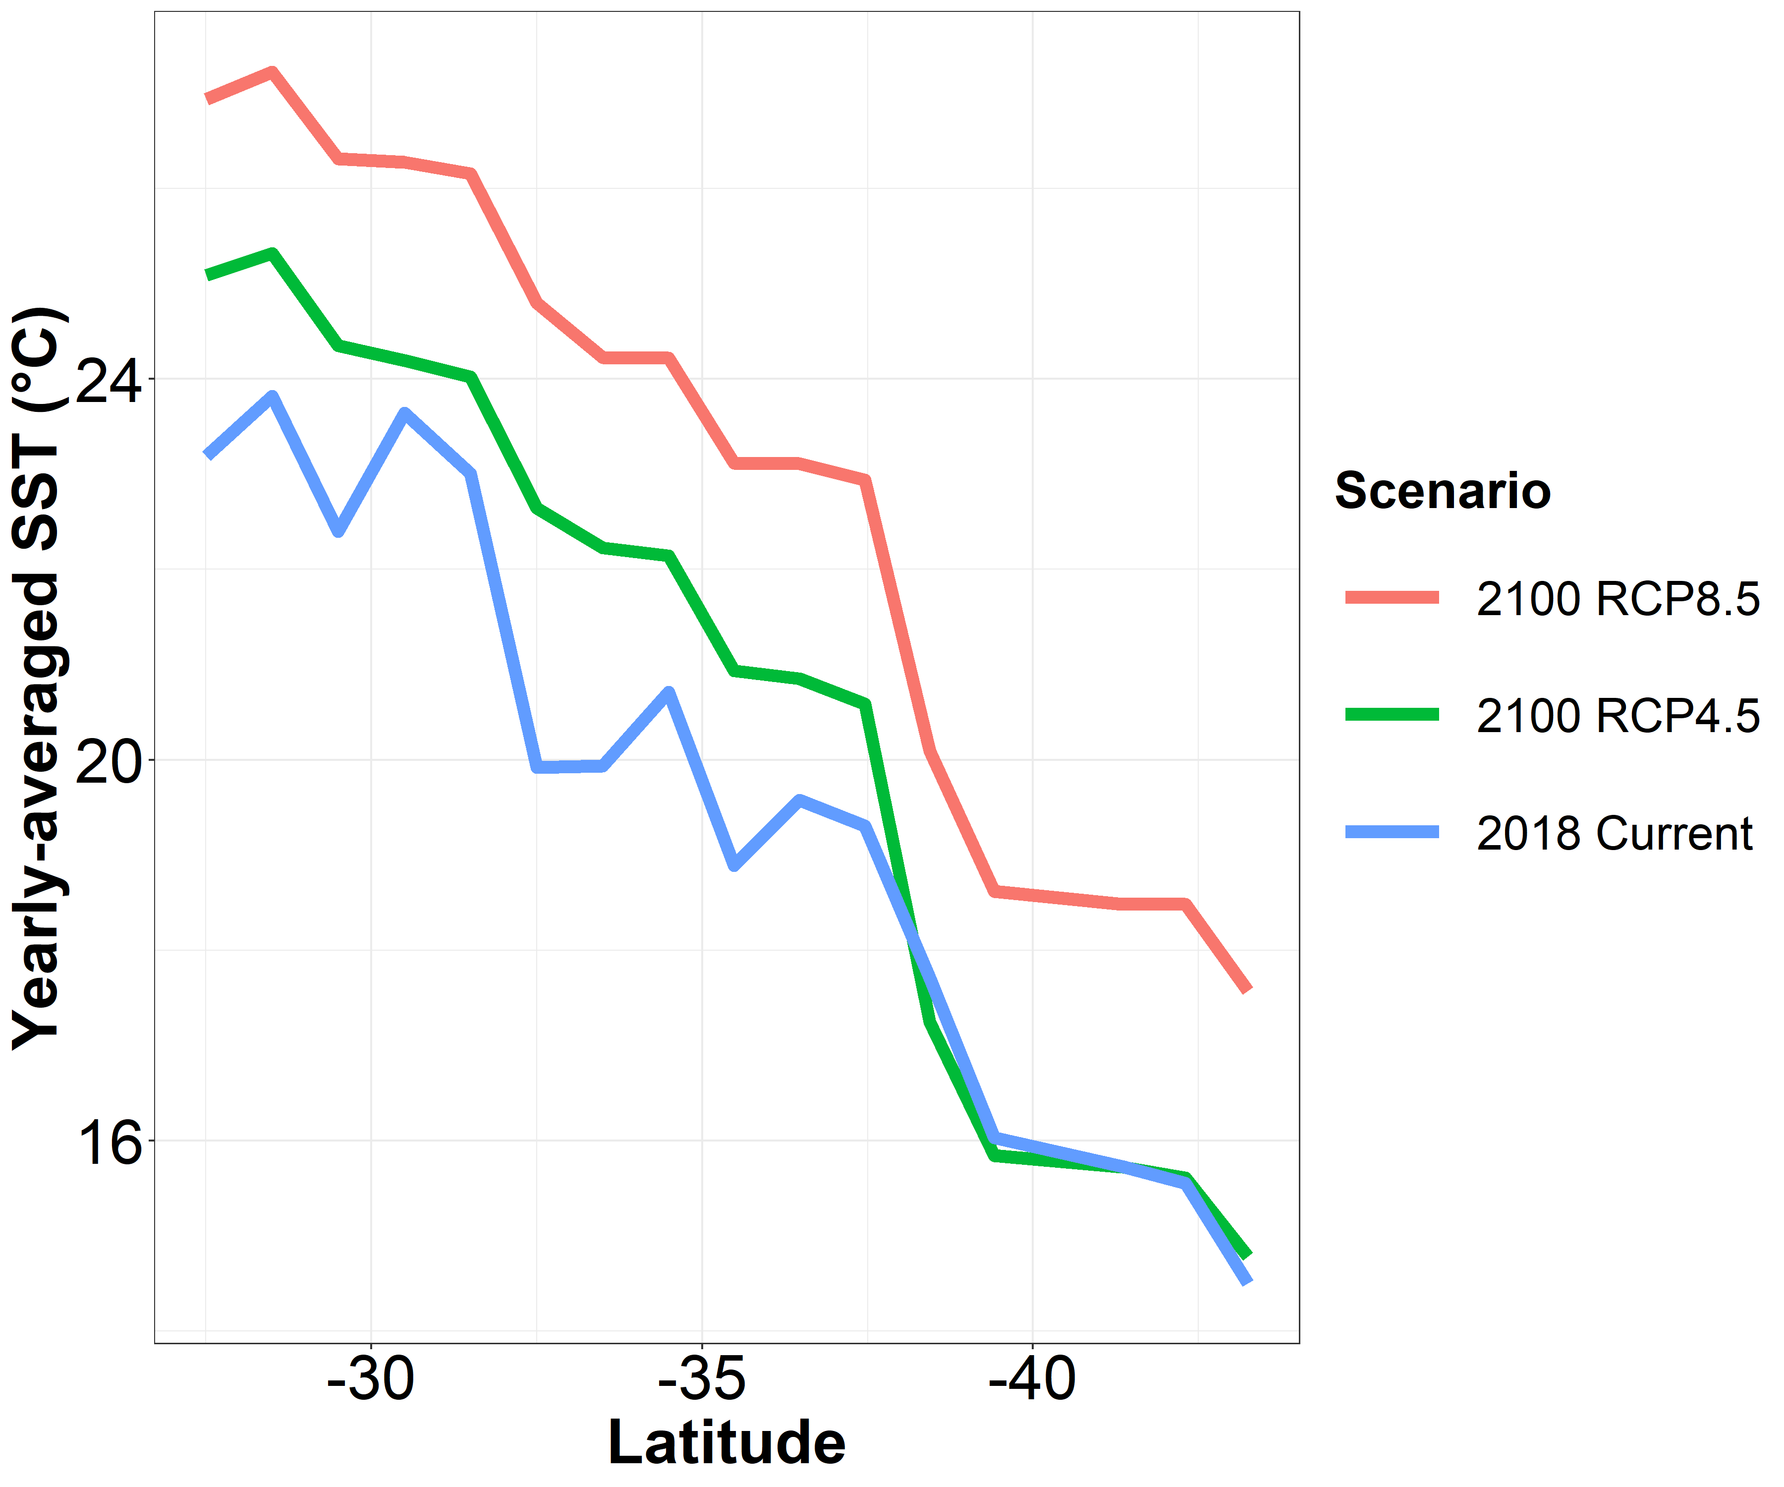

**Figure S3**. Yearly averaged SST under the current (blue, IMOS 2019), RCP 4.5 (green, WDC CLIMATE2019) and RCP 8.5 (pink, WDC CLIMATE2019) condition along the sites simulated in the current study. Current SST shows the pattern in year 2018 while projected SST in both scenarios shows the pattern in year 2100.

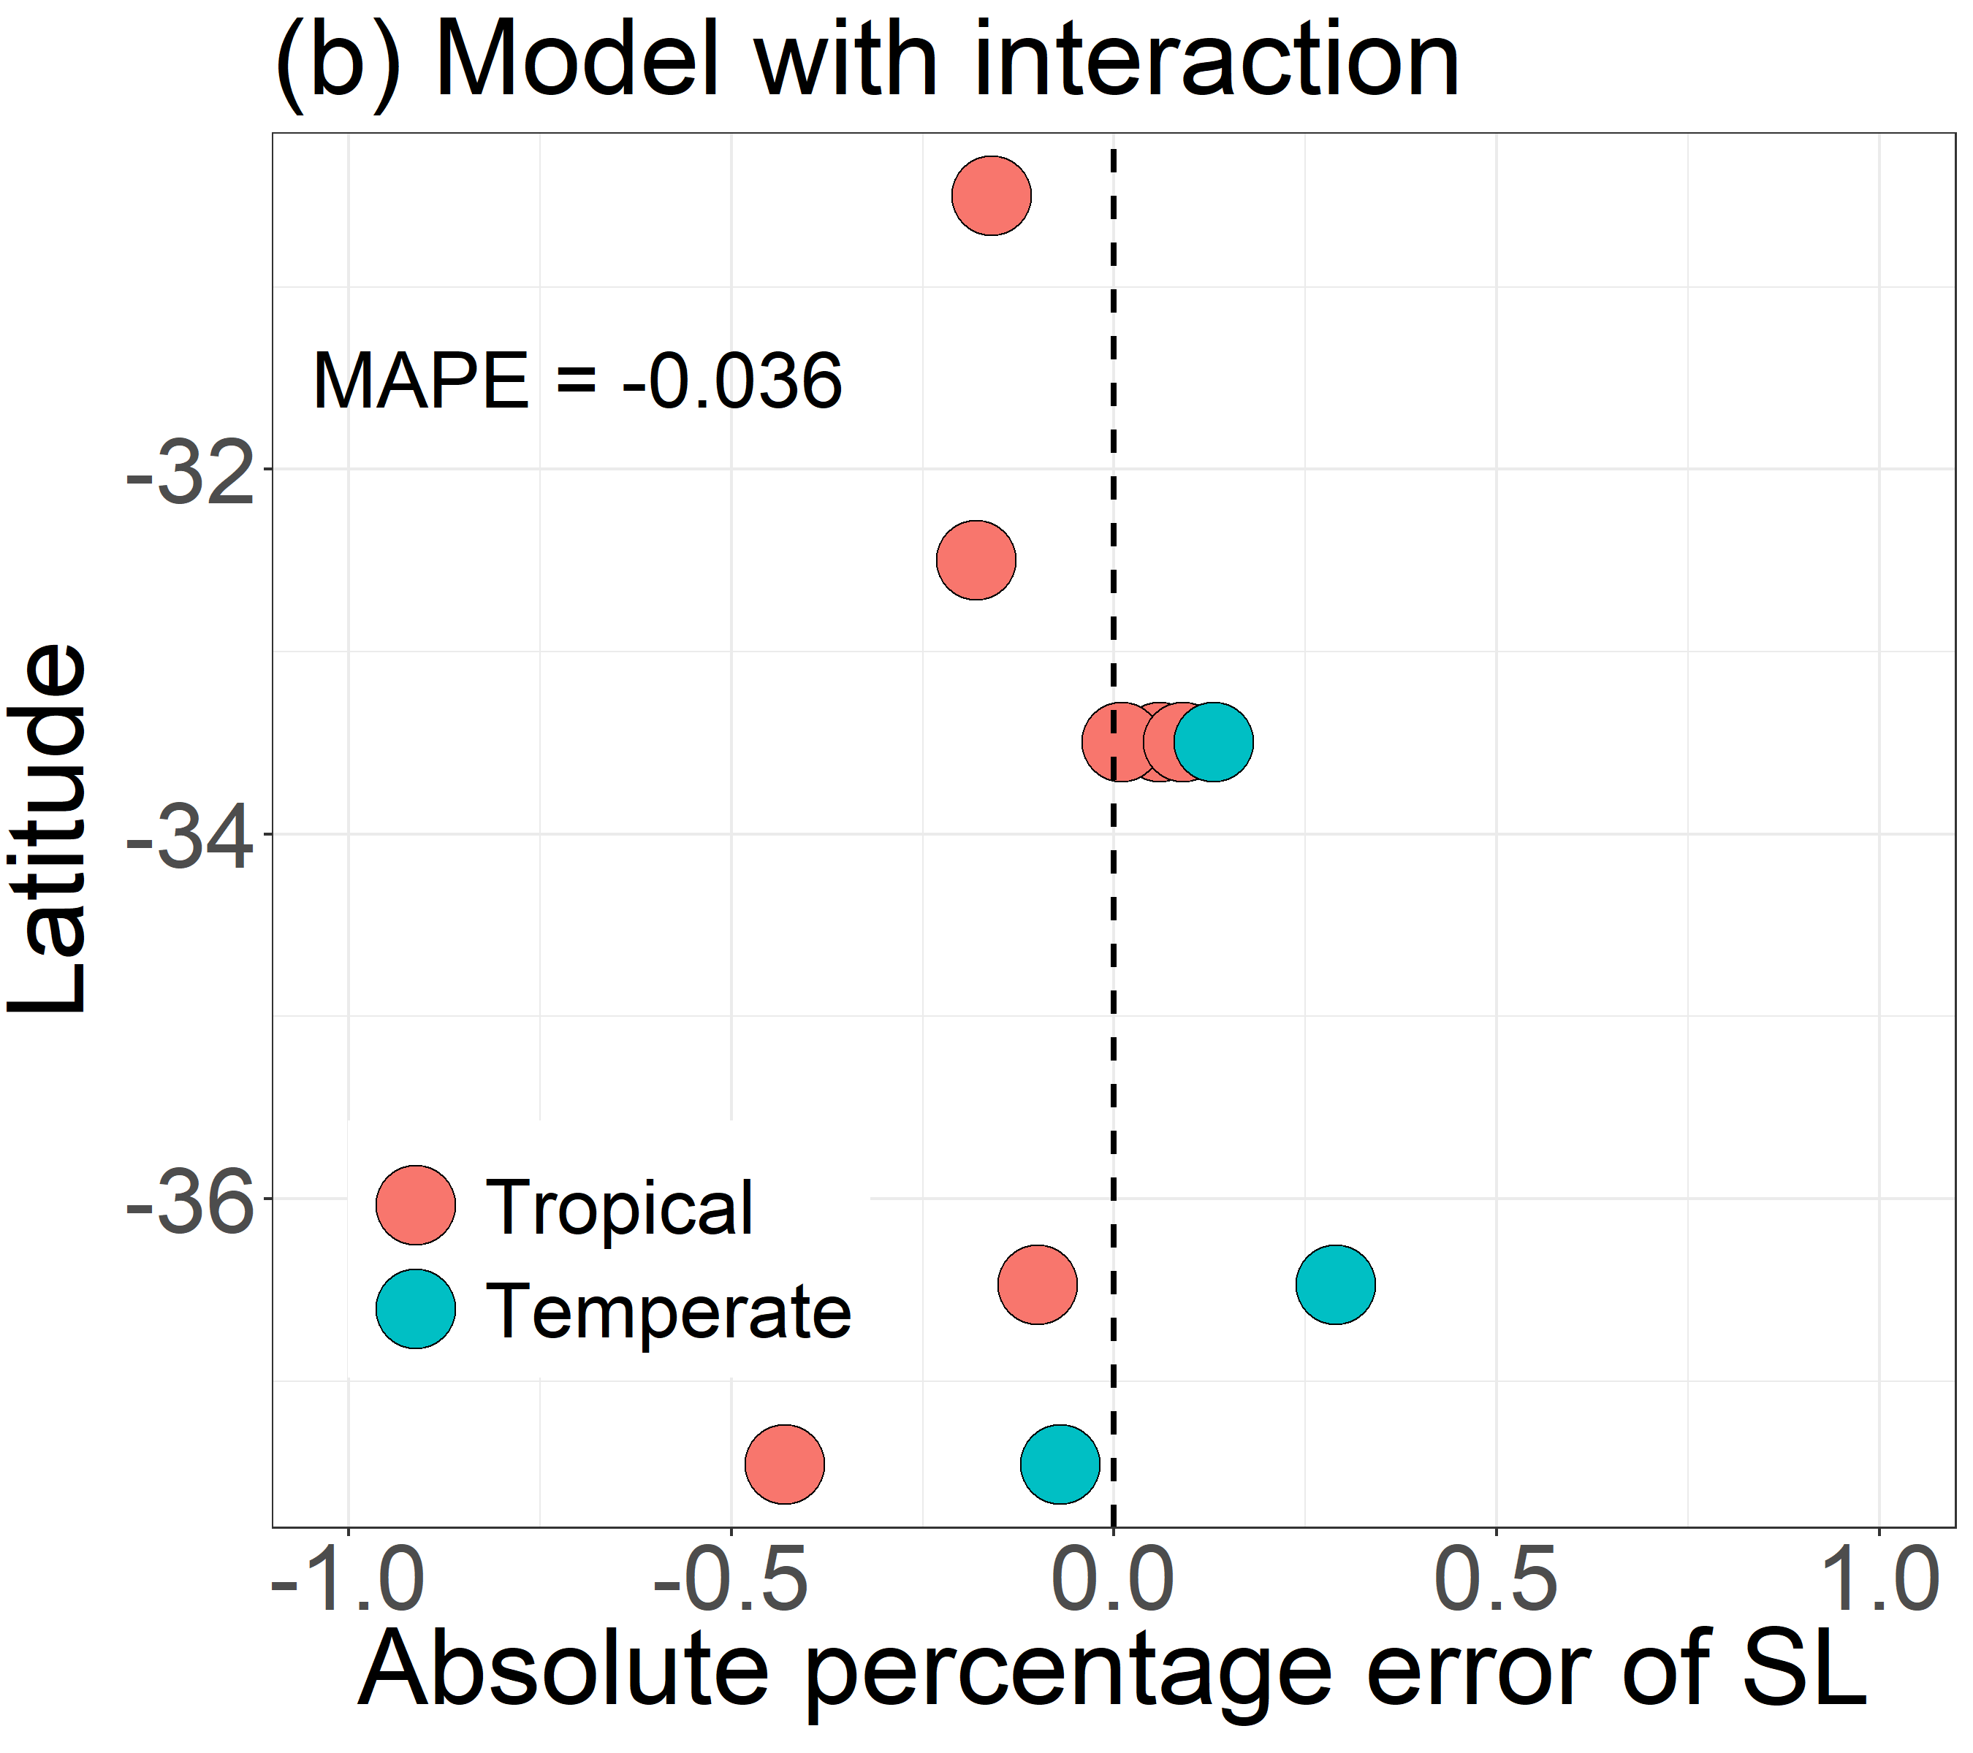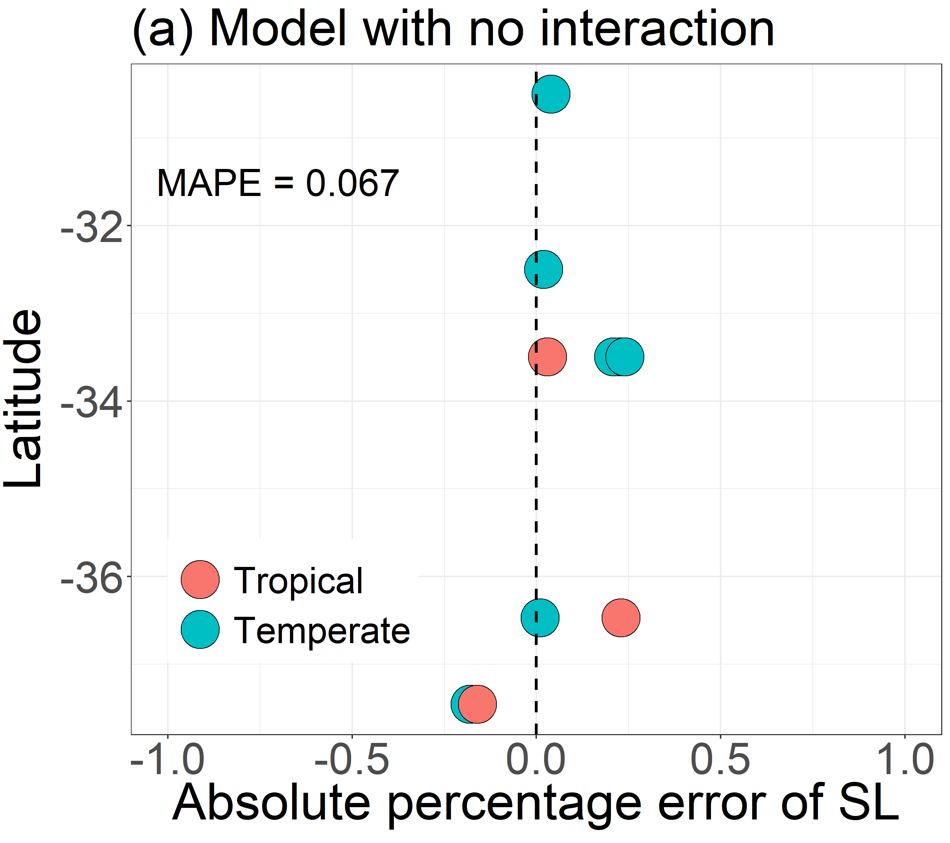

(b)

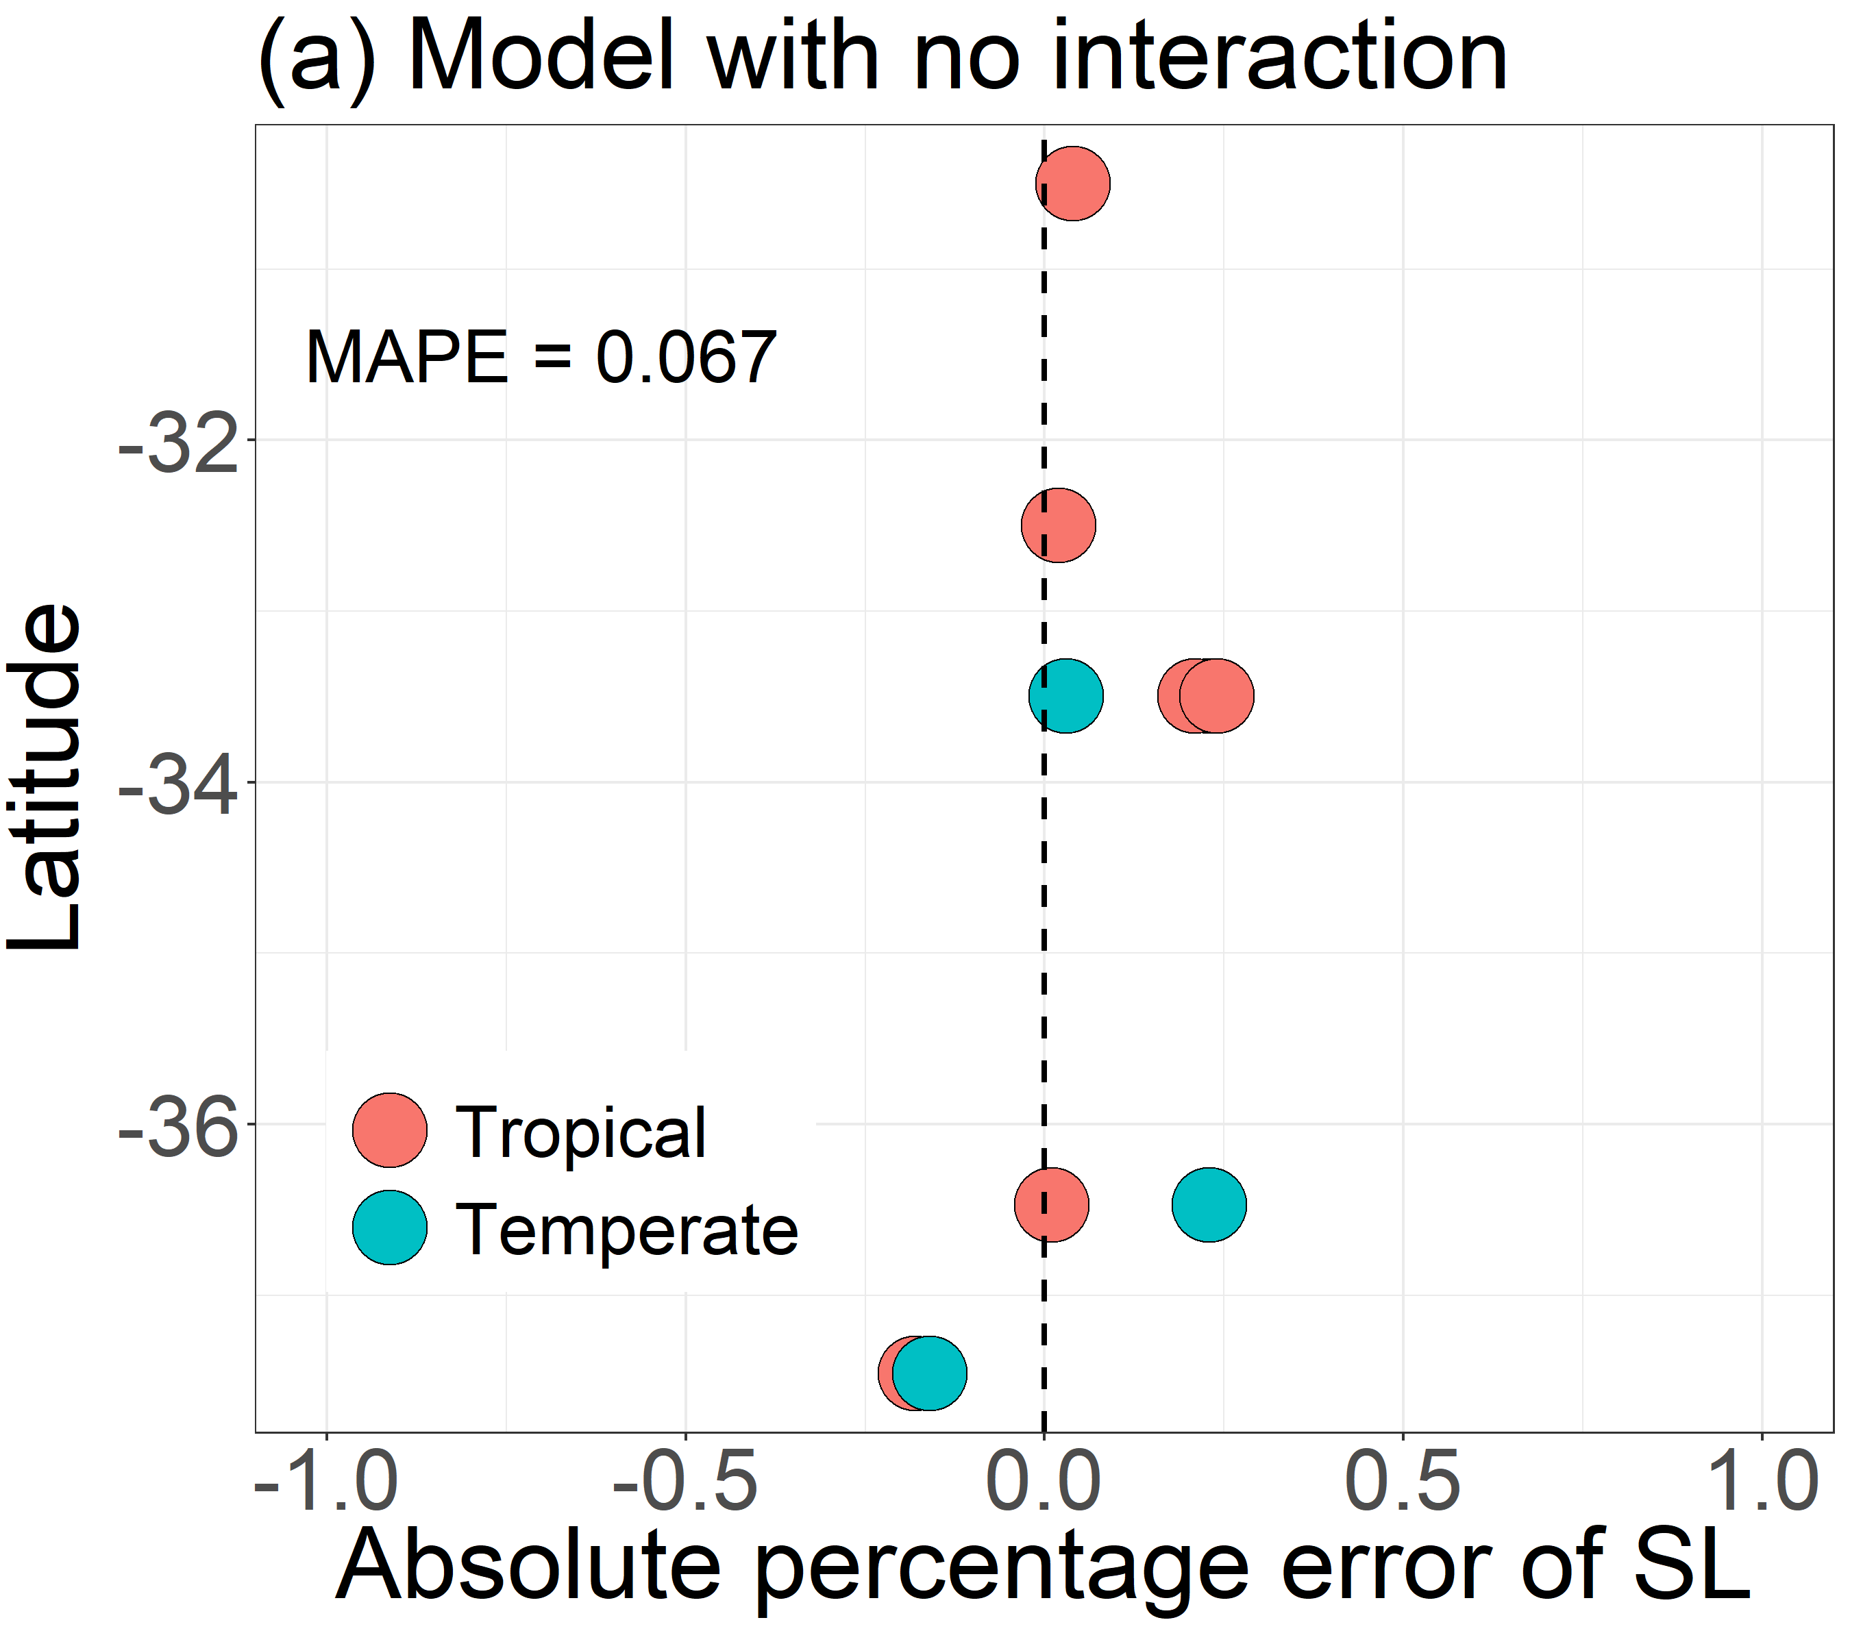 

(a)

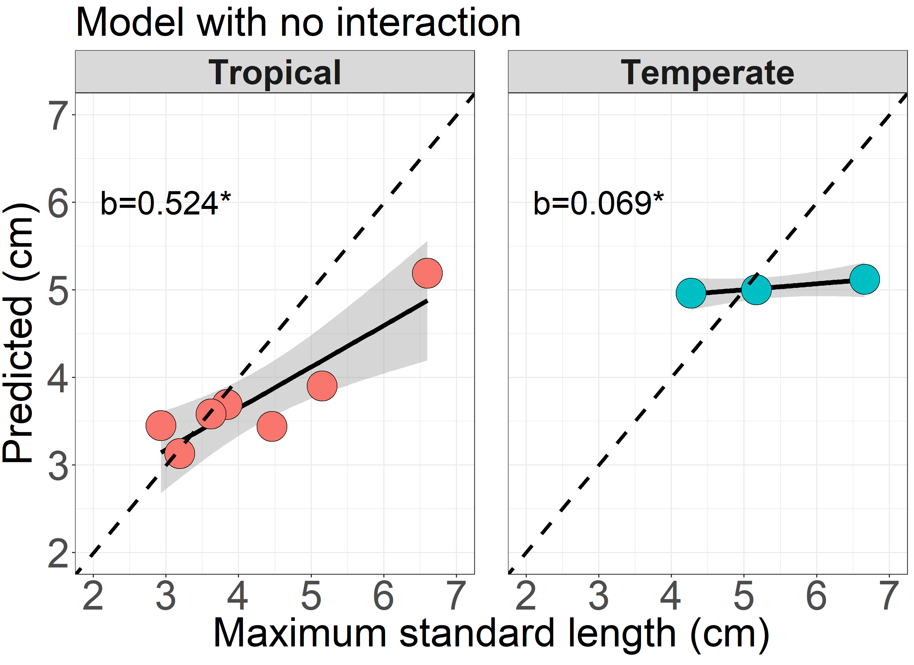 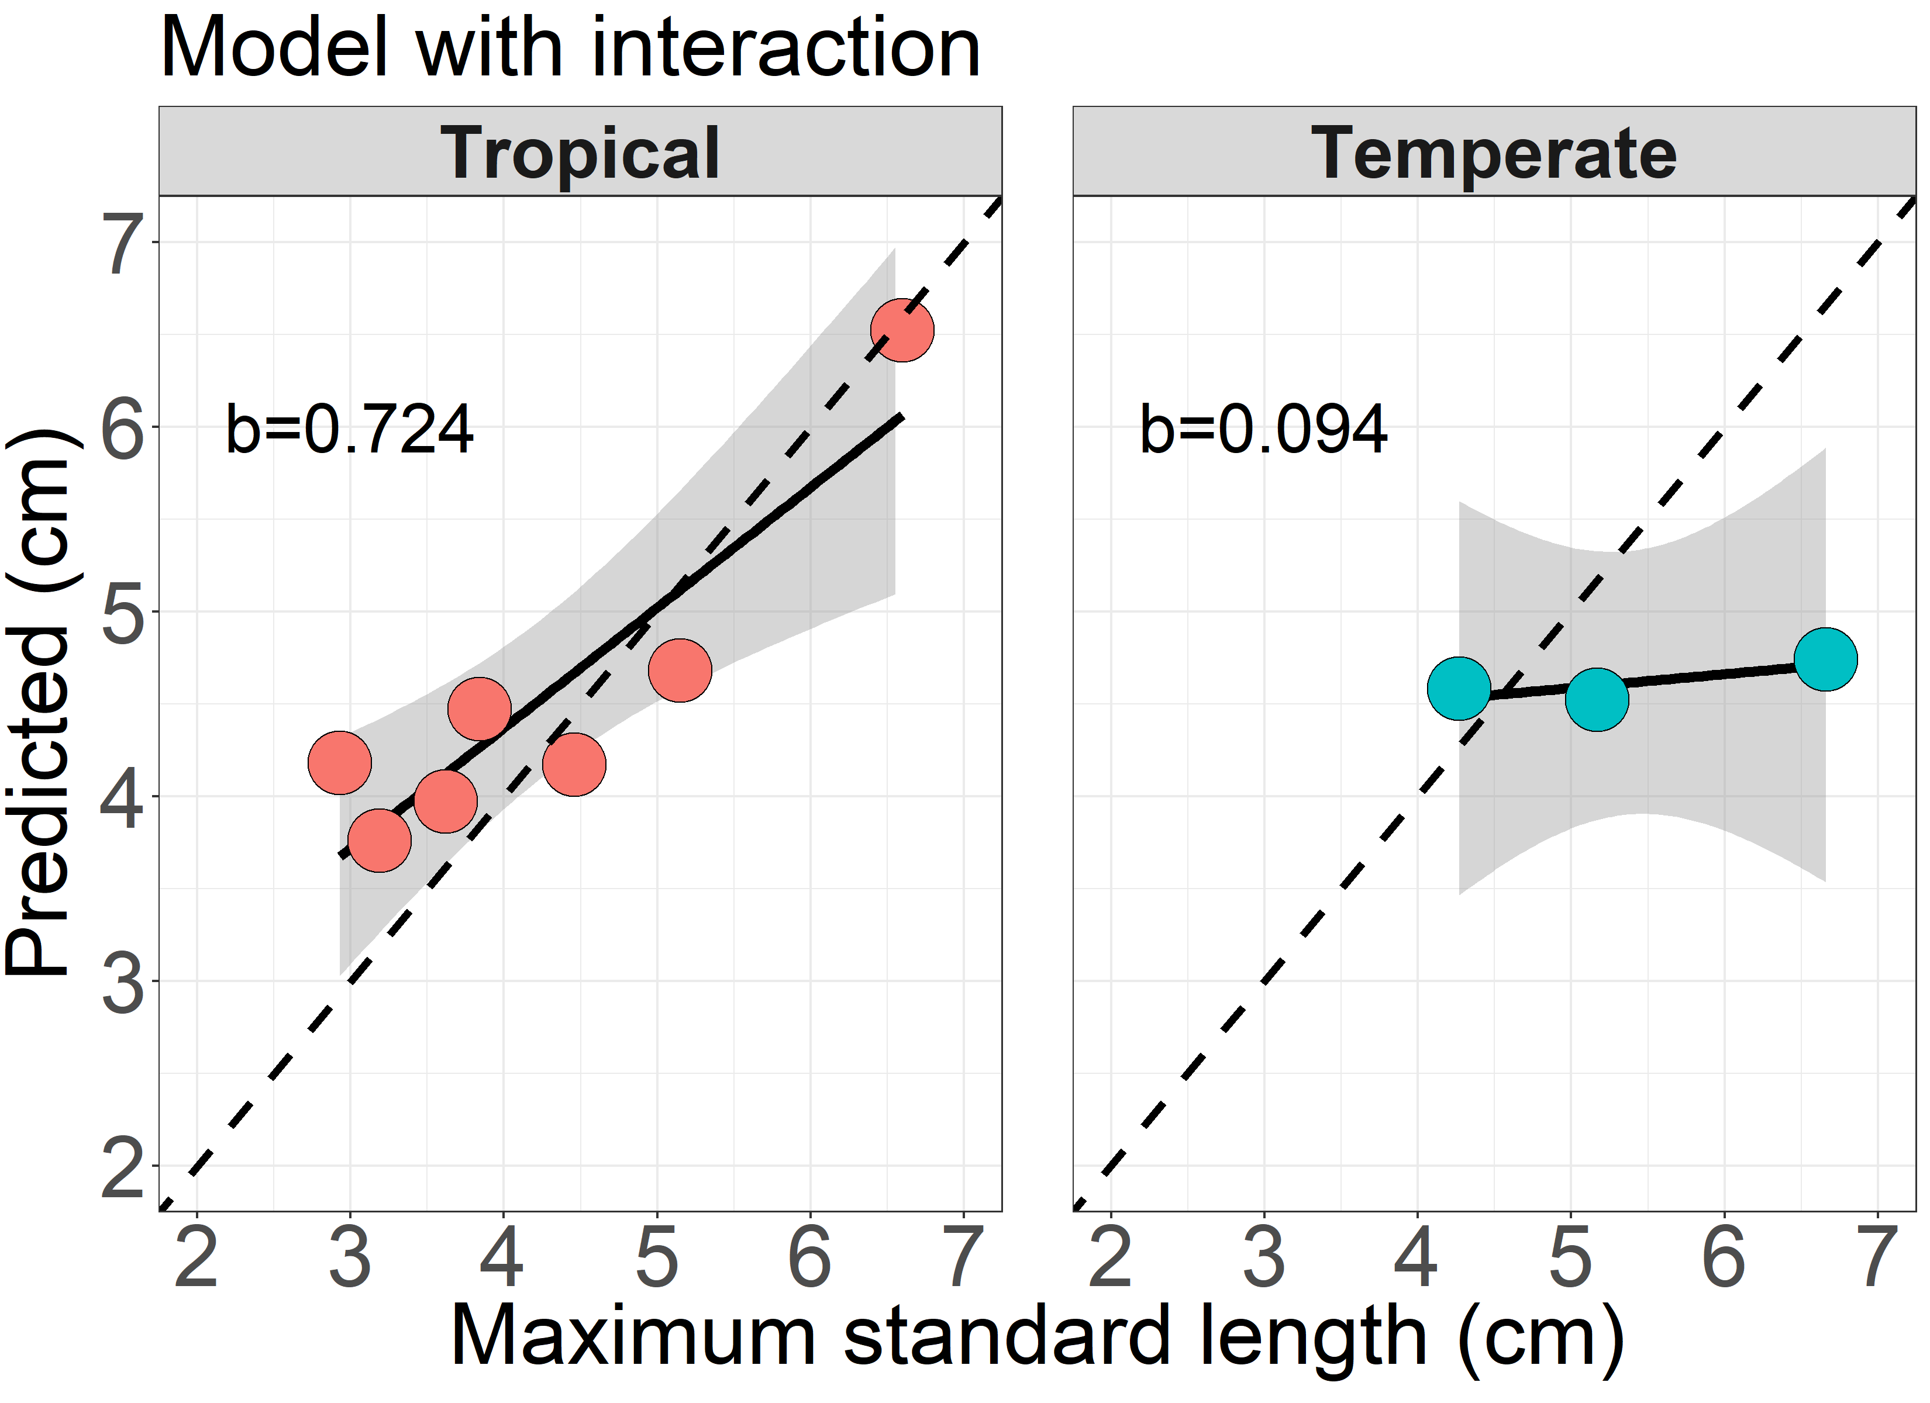

(f)

(e)

(d)

(c)

**Figure S4**. (**Top panel**) Model performance based on absolute percentage error between observed maximum length and predicted length for model without interactions (a) and with interactions (b). Mean absolute percentage error (MAPE) was calculated and shown at top left corner of each plot. (**Bottom panel**) Correlations between simulated standard length and observed maximum length using a model without interaction (c, d) and with interaction (e, f). Slope values (*b*) and their significance (*) from a 1:1 relationship (hatched lines) are provided. Shaded areas show 95% confident intervals.

**Figure S5**. Persistence duration in *A. vaigiensis* (a) and *A. strigatus* (b) under the current (“Current”) and two future (“RCP4.5” and “RCP8.5”) scenarios based on the model with species interaction. Latitudinal position on y-axis and duration for persistence in days is on x-asix.