**Supplementary Information**

**for**

**Three-dimensional conservation planning of fish biodiversity metrics to achieve deep-sea 30x30 conservation target**

**Appendix S1:** **Supplementary Methods**

**Data collection**

New Caledonia is a South Pacific archipelago, east of Australia, in the Coral Sea. The 400 km-long main island of “Grande Terre” is surrounded by the second longest barrier reef in the world cumulating 1,600 km. Beyond the barrier reef is the island's deep slope habitat, also surrounding the remote atolls (Chesterfield, Bellona, Entrecasteaux…), the three Loyalty Islands and the other smaller islands and remote reefs of the archipelago (Fig. 1). Two third of the archipelago’s population lives in Grand Terre’s southwest, in and around Nouméa (∼180,000 people) (ISEE, 2019), creating a gradient of human pressure from densely populated areas to wilderness areas located at > 10-20 h travel time from the capital (Januchowski-hartley et al., 2020).

We sampled 11 seamounts across the archipelago, and four deep island slopes along the west coast of Grande Terre (Figure 1, Figures S1-15). Samples were collected on the summit of the seamounts or the seafloor along the deep slopes (benthic samples), as well as in the pelagic waters, 2-7 miles away from the seamounts or island slopes (pelagic samples).

Benthic environmental DNA samples were collected with 4 x 8 L Niskin bottles at each station, 5 m above the seafloor, with 10 stations on each seamount summit or deep island slope (total of 150 stations). The shallowest benthic eDNA sample was collected at 45 m deep and the deepest at 570 m deep (Table S1). Pelagic eDNA samples were collected at one vertical profile per site, with samples of 32 L collected at 6 depths: 20, 80, 150, 250, 500 and 1000 m. The Niskin bottles were lifted on the ship and the water from the four bottles per station was filtered on a single filtration capsule. The eDNA filtration was done with an Alexis® peristaltic pump (Proactive Environmental Products LLC, Bradenton, Florida, USA; nominal flow of 1.0 L.min-1), a VigiDNA® 0.2 µM cross flow filtration capsule with a polyethersulfone membrane (SPYGEN, le Bourget du Lac, France) and disposable sterile tubing for each filtration capsule. At the end of each filtration, the water inside the capsules were emptied, and the capsules were filled with 80 mL of CL1 Conservation buffer (SPYGEN, le Bourget du Lac, France) and stored at room temperature. For each sampling campaign, a strict contamination control protocol was followed in both field and laboratory stages (Goldberg et al., 2016; Valentini et al., 2016), and each water sample processing included the use of disposable gloves and single-use filtration equipment. The shallowest benthic eDNA sample was collected at 45 m deep and the deepest at 570 m deep (Table S1).

On the same sites (summits and deep slopes), baited remote underwater videos stations (BRUVS) were deployed on the seafloor, at 5 to 10 stations per site (total of 120 stations, Table S1). Stations were separated by at least 1 km to avoid individuals from appearing on multiple videos and assume independence of samples (Langlois et al., 2020). The BRUVS were composed of two cameras aligned horizontally on a metallic structure, a bait of 1kg of crushed sardines at the end of a 1.5 m bar facing the cameras, a spotlight, and 20 kg of weight to hold the system still on the floor. The stereo pair of cameras were separated by 800 mm, with a convergent angle of 8 °. GoPro Hero 4 cameras were used and set to a medium field of view (FOV) in 1920 x 1080 pixel format running at 60 frames per second. Soaking times were calculated from the time the BRUVS reached the seabed (t0) to t0 + 120 mns. The shallowest BRUVS was deployed at 47 m deep and the deepest at 552 m deep (Table S1).

Acoustic data were recorded in-situ continuously during the cruises, using an EK60 echosounder (SIMRAD Kongsberg Maritime AS, Horten, Norway) connected to four split-beam transducers at 38, 70, 120 and 200 kHz. EK60 calibration was performed according to Foote (1987) for each cruise. In the present study, we used 38 kHz only as only that frequency allowed to cover all depth ranges considered. The hull-mounted transducer was 4 m below the surface and detections shallower than 6 m below the transducer face were deleted from the records to avoid surface noise. Thus, acoustic data collection started at 10 m below the surface. The water column was sampled down to 800 m depth for all the surveys.

**eDNA extraction, amplification and sequencing**

DNA extraction was performed in a dedicated DNA laboratory (SPYGEN, [www.spygen.com](http://www.spygen.com/)) equipped with positive air pressure, UV treatment and frequent air renewal. Decontamination procedures were conducted before and after all manipulations. Each filtration capsule was agitated for 15 min on a S50 Shaker (Cat Ingenieurbüro™) at 800 rpm and then the buffer was emptied into two 50-mL tubes before being centrifuged for 15 min at 15,000×g. The supernatant was removed with a sterile pipette, leaving 15 mL of liquid at the bottom of each tube. Subsequently, 33 mL of ethanol and 1.5 mL of 3M sodium acetate were added to each 50-mL tube and stored for at least one night at -20 °C. The DNA extraction was performed using NucleoSpin® Soil (MACHEREY-NAGEL GmbH & Co., Düren Germany) starting from step 6 and following the manufacturer’s instructions. The elution was performed by adding 100 μL of SE buffer twice. The two 50 mL tubes per filtration capsule were extracted separately then the two DNA samples were pooled before the amplification step. A teleost-specific 12S mitochondrial rRNA primer pair (teleo, forward primer - ACACCGCCCGTCACTCT, reverse primer – CTTCCGGTACACTTACCATG, Valentini et al 2016) was used for the amplification of metabarcode sequences. As we analyzed our data using MOTUs as a proxy for species to overcome genetic database limitations, we chose to amplify only one marker. Twelve DNA amplifications PCR per sample were performed in a final volume of 25 μL, using 3 μL of DNA extract as the template. The amplification mixture contained 1 U of AmpliTaq Gold DNA Polymerase (Applied Biosystems, Foster City, CA), 10 mM Tris-HCl, 50 mM KCl, 2.5 mM MgCl2, 0.2 mM each dNTP, 0.2 μM of each primer, 4 µM human blocking primer for the “teleo” primers and 0.2 µg/µL bovine serum albumin (BSA, Roche Diagnostic, Basel, Switzerland). The PCR mixture was denatured at 95 °C for 10 min, followed by 50 cycles of 30 s at 95 °C, 30 s at 55 °C, 1 min at 72 °C and a final elongation step at 72 °C for 7 min. The teleo primers were 5’-labeled with an eight-nucleotide tag unique to each PCR replicate with at least three differences between any pair of tags, allowing the assignment of each sequence to the corresponding sample during sequence analysis. The tags for the forward and reverse primers were identical for each PCR replicate. Negative extraction controls and negative PCR controls (ultrapure water) were amplified (with 12 replicates as well) and sequenced in parallel to the samples to monitor possible contaminations. After amplification, samples were titrated using capillary electrophoresis (QIAxcel; Qiagen GmbH, Hilden, Germany) and purified using a MinElute PCR purification kit (Qiagen GmbH, Hilden, Germany). The purified PCR products were pooled in equal volumes, to achieve a theoretical sequencing depth of 1,000,000 reads per sample. Library preparation and sequencing were performed at Fasteris (Geneva, Switzerland). A total of 24 libraries were prepared using MetaFast protocol. A paired-end sequencing (2x125 bp) was carried out using an Illumina MiSeq (2x125 bp, Illumina, San Diego, CA, USA) using the MiSeq Flow Cell Kit v3 (Illumina, San Diego, CA, USA) or a NextSeq sequencer (2x125 bp, Illumina, San Diego, CA, USA) with the NextSeq Mid kit following the manufacturer’s instructions. This generated an average of 527,540 (± 721,560) sequence reads (paired-end Illumina) per sample.

**eDNA bioinformatic analyses**

Following sequencing, reads were processed using clustering and post-clustering cleaning to remove errors and estimate the number of species using Molecular Operational Taxonomic Units (MOTUs) (Marques et al., 2020). First, reads were assembled using vsearch (Rognes et al., 2016), then demultiplexed and trimmed using cutadapt (Martin., 1994) and clustering was performed using Swarm v.2 (Mahé et al., 2015) with d = 1, which corresponds to a maximum of one mismatch between neighboring pairs of sequences within each cluster. The iterative process of SWARM leads to clusters composed of many sequences with more than d mismatches. Further, we used the -f (fastidious) option, which creates virtual sequences within clusters to link more dissimilar sequences together, hence limiting alpha-diversity inflation by joining low abundant MOTUs within larger ones. The minimum distance between clusters is 2 mismatches (d+1).Taxonomic assignment of MOTUs was carried out using the Lower Common Ancestor (LCA) algorithm ecotag implemented in the Obitools toolkit (Boyer et al., 2016) and the European Nucleotide Archive (ENA, Leinonen et al., 2011) as a reference database (release 143, March 2020). It assigns a taxonomy to sequences even when the sequence match is not perfect, based on NCBI taxonomic tree of species to consider the current knowledge on molecular diversity per branch and assign a taxonomy at the lowest possible rank. If the sequence matches several identifications with equal percentages of similarity, ecotag assigns to the upper taxonomic level common between all possible matches. We then applied quality filters to be conservative in our estimates. We discarded all observations with less than 10 reads, and present in only one PCR per site to avoid spurious MOTUs originating from a PCR error. Then, errors generated by index-hopping (MacConaill et al., 2018) were filtered using a threshold empirically determined per sequencing batch using experimental blanks (combinations of tags not present in the libraries) (Taberlet et al., 2018), and tag-jump (Schnell et al., 2015) was corrected using a threshold of 0.001 of occurrence for a given MOTU within a library. Taxonomic assignments at the species level were accepted if the percentage of similarity with the reference sequence was 100%, at the genus level if the similarity was between 90 and 99%, and at the family level if the similarity was > 85%. If these criteria were not met, the MOTU was left unassigned. The post-LCA algorithm correction threshold of 85% similarity for family assignment was chosen to include a maximum of correct family assignment while minimizing the risk of adding wrong family assignments in the family detections.

**Video analysis**

Stereo measurement was made available with the recording of three claps before deployment to synchronize frames. Calibration was done using the software CAL and fish were counted using the EventMeasure software ([www.seagis.com.au](http://www.seagis.com.au/)). We used the MaxN metric (corresponding to the maximum number of a particular species seen in any one video frame across the duration of the video record), which is until now the standard and most used method (Cappo et al., 2007; Langlois et al., 2020; Whitmarsh et al., 2017). Fork length of individual fish was measured, when possible, up to a limit of 10 individuals per BRUVS per species to optimize video processing time. Biomass was calculated for each species of each BRUVS using the length-weight relationship: $Weight\left(g\right)=a*{Length\left(cm\right)}^{b}$ (Taylor & Willis, 1998) with *a* and *b* being the allometric coefficient of the length-weight relationship retrieved from FishBase (www.fishbase.se). As we did not seek highly accurate length structure among replicates but rather the general patterns of biomass, the length used for each estimation was the average length of all measured individuals per species (up to ten) in a single BRUVS. When particular species could not be measured on a single BRUVS, the missing species length was estimated by data imputation using the MissForest algorithm with 999 trees. Missing length were imputed using measured length records of other samples, but also family, genus, maximum species size, and size type from Fishbase. Latitude and longitude of available species lengths were also used to account for geographic proximity of measured lengths. The MissForest accuracy was tested with a k-fold cross validation procedure by predicting 5% of the lengths each time by training the missForest on the 95% left of the data and looking at the linear fit between the original and predicted. We also ensured that imputed length did not exceed Fishbase’s max reported length.

**Acoustic data cleaning**

All raw acoustic data were processed with the open-source Matecho software (Perrot et al., 2018). A first manual cleaning step removed ghost bottom echoes. Then, four semi-automatic cleaning filters were applied to: (i) remove acoustic device interference (‘un-parasite’ Matecho filter), (ii) remove attenuated signals (‘white pings’ filter), (iii) remove elevated signals (‘deep spike’ filter) and (iv) reduce background noise (De Robertis & Higginbottom, 2007). Details of filter parameters can be found in Béhagle *et al.,* (2016) and Perrot *et al.,* (2018). After data cleaning, the echo-integration was done on cells of 1m deep and 0.1nm long, providing volume backscattering strength $S_{v}$ ($S_{v}$, in $dB.re.1.m^{-1})$, and the nautical area scattering coefficient $s_{A}$ $(NASC or s_{A}, in m^{2}.{nm}^{-2})$, a proxy for the fish biomass for each cell (Irigoien et al., 2014; Maclennan et al., 2002). Vertical profiles were smoothed using a locally polynomial quantile regression (Koenker, 2004) to remove high-frequency peaks (e.g. interferences or very small schools that create peaks in an acoustic profile) that were considered non-interpretable in the present study. The final dataset was composed of 5,064 vertical profiles ranging from 10 to 800 m depth with $s_{A}$ integrated in 10 m vertical bins and 500 m horizontal resolution.

**Modeling abundance, richness and acoustic biomass**

Seventeen variables were collected as potential explanatory variables for fish biodiversity patterns. At each station, we recorded the sampling depth, the bottom depth, the habitat (seamount or deep island slope) and the depth of the summit. Using a bathymetry at 100m resolution (Roger, 2020), we calculated the summit area (km²) and the summit rugosity as the standard deviation of depth in the cells of the summit area. For deep slope stations, the summit depth was set at 0, as the land is considered to be the summit, and the summit area was calculated as the area of cells with depth < 60 m. For each station, we extracted maximum and mean sea surface temperature (SST), mean surface salinity, eastward and northward current velocity, surface suspended particulate matter, seafloor potential temperature and chlorophyll a over the last 10 years from available rasters. We also calculated the travel time from Noumea to our stations as a proxy for human pressure and habitat remoteness (Januchowski-hartley et al., 2020) and the minimum distances from our stations to reefs and land, using the New-Caledonia Millennium Geomorphology (Andréfouët et al., 2006).

The MOTU and species richness were modeled with a Poisson distribution, while biomass, abundance and acoustic biomass were modeled with a Gaussian distribution.

The BRT combination with the lowest deviance and standard error was then selected to identify best parameters. Models were computed again with the best parameters and fixed number of trees with the function *gbm.fixed*. The predictors contributing the most to the models were selected, removing variables contributing less than 5%, and a *gbm.step* was computed with this reduced predictors selection to fit the final models.

The contributions reflect the relative influence of each predictor and are computed based on the number of times a variable is selected for splitting, weighted by the squared improvement to the model as a result of each split, and averaged over all trees (Friedman & Meulman, 2003). The relative influence (or contribution) of each variable is scaled so that the sum adds to 100, with higher numbers indicating stronger influence on the response.

The explanatory variables to include in each GJAM model were selected with a step-by-step process, analyzing the sensitivity of the response variables to each variable and their quadratic and cubic terms. Only variables with a VIF < 10 were kept in the final model. The response variable type was set to ‘discrete abundance’ for species abundance and ‘count composition’ for read number, and the models were run with parameters *ng* = 2500 and *burnin* = 500. Pearson’s correlation coefficient R was computed between observed and predicted values, to estimate the model’s goodness-of-fit.

**Predictions and conservation planning**

Using the best models, we predicted the 7 biodiversity metrics and the individual species and MOTUs abundances at the scale of the New-Caledonian EEZ, at a resolution of 1x1km, according to the explanatory variables. To remain in the validity range of our data, we selected seamounts in the EEZ with a summit shallower than 600m deep (n=22, Allain et al., 2008), and all the deep slopes surrounding islands, atolls, banks or drowned atolls, where the bottom depth did not exceed the maximum bottom depth on which we sampled (2175m). For the benthic data, we predicted diversity from below the surface to 600m on seamounts, and from 60 to 600m on deep slopes. For pelagic data, we made predictions by layers of 20m down to 600m deep, on top and around seamounts and deep slopes. So for deep slopes, predictions were extrapolated down to 600m. Predictions from the 7 BRTs were carried out with the function predict from R package dismo, and predictions from the 3 GJAMs were made with the function gjamPredict from the R package gjam.

A principal component analysis on acoustic vertical profiles and a classification by k-means of these profiles allowed us to identify three depth layers with differentiated acoustic signals: 0-200 m, 200-400 m and 400-600 m, approximately corresponding to euphotic, intermediate and aphotic zones, respectively. We thus decided to use these three depth layers for our planning in three dimensions. We divided our benthic predictions between these three depth layers, and aggregated our pelagic predictions within these three depth layers (sum of acoustic biomass, and mean of MOTU richness).

**References**

Béhagle, N., Cotté, C., Ryan, T. E., Gauthier, O., Roudaut, G., Brehmer, P., Josse, E., & Cherel, Y. (2016). Acoustic micronektonic distribution is structured by macroscale oceanographic processes across 20-50°S latitudes in the South-Western Indian Ocean. *Deep-Sea Research Part I: Oceanographic Research Papers*, *110*, 20–32. https://doi.org/10.1016/j.dsr.2015.12.007

Boyer, F., Mercier, C., Bonin, A., Le Bras, Y., Taberlet, P., & Coissac, E. (2016). obitools: A unix-inspired software package for DNA metabarcoding. *Molecular Ecology Resources*, *16*(1), 176–182. https://doi.org/10.1111/1755-0998.12428

Cappo, M., Harvey, E., & Shortis, M. (2007). Counting and measuring fish with baited video techniques -- an overview. *Australian Society for Fish Biology Workshop Proceedings, Hobart, Tasmania, August 2006*, *August*, 101–114.

De Robertis, A., & Higginbottom, I. (2007). A post-processing technique to estimate the signal-to-noise ratio and remove echosounder background noise. *ICES Journal of Marine Science*, *64*(6), 1282–1291. https://doi.org/10.1093/icesjms/fsm112

Foote, K. G. (1987). Fish target strengths for use in echo integrator surveys. *Journal of the Acoustical Society of America*, *82*(3), 981–987. https://doi.org/10.1121/1.395298

Friedman, J. H., & Meulman, J. J. (2003). Multiple additive regression trees with application in epidemiology. *Statistics in Medicine*, *22*(9), 1365–1381. https://doi.org/10.1002/sim.1501

Goldberg, C. S., Turner, C. R., Deiner, K., Klymus, K. E., Thomsen, P. F., Murphy, M. A., Spear, S. F., McKee, A., Oyler-McCance, S. J., Cornman, R. S., Laramie, M. B., Mahon, A. R., Lance, R. F., Pilliod, D. S., Strickler, K. M., Waits, L. P., Fremier, A. K., Takahara, T., Herder, J. E., & Taberlet, P. (2016). Critical considerations for the application of environmental DNA methods to detect aquatic species. *Methods in Ecology and Evolution*, *7*(11), 1299–1307. https://doi.org/10.1111/2041-210X.12595

Irigoien, X., Klevjer, T. A., Røstad, A., Martinez, U., Boyra, G., Acuña, J. L., Bode, A., Echevarria, F., Gonzalez-Gordillo, J. I., Hernandez-Leon, S., Agusti, S., Aksnes, D. L., Duarte, C. M., & Kaartvedt, S. (2014). Large mesopelagic fishes biomass and trophic efficiency in the open ocean. *Nature Communications*, *5*(May 2013), 3271. https://doi.org/10.1038/ncomms4271

Koenker, R. (2004). Quantile regression for longitudinal data. *Journal of Multivariate Analysis*, *91*(1), 74–89. https://doi.org/10.1016/j.jmva.2004.05.006

Langlois, T. J., Goetze, J., Bond, T., Monk, J., Abesamis, R. A., Asher, J., Barrett, N., Bernard, A. T. F., Bouchet, P. J., Birt, M. J., Cappo, M., Currey-Randall, L. M., Driessen, D., Fairclough, D. V., Fullwood, L. A. F., Gibbons, B., Harasti, D., Heupel, M. R., Hicks, J., … Harvey, E. S. (2020). A field and video annotation guide for baited remote underwater stereo-video surveys of demersal fish assemblages. *Methods in Ecology and Evolution*, *11*, 1401–1409.

Leinonen, R., Akhtar, R., Birney, E., Bower, L., Cerdeno-Tárraga, A., Cheng, Y., Cleland, I., Faruque, N., Goodgame, N., Gibson, R., Hoad, G., Jang, M., Pakseresht, N., Plaister, S., Radhakrishnan, R., Reddy, K., Sobhany, S., Hoopen, P. Ten, Vaughan, R., … Cochrane, G. (2011). The European nucleotide archive. *Nucleic Acids Research*, *39*(SUPPL. 1), 44–47. https://doi.org/10.1093/nar/gkq967

MacConaill, L. E., Burns, R. T., Nag, A., Coleman, H. A., Slevin, M. K., Giorda, K., Light, M., Lai, K., Jarosz, M., McNeill, M. S., Ducar, M. D., Meyerson, M., & Thorner, A. R. (2018). Unique, dual-indexed sequencing adapters with UMIs effectively eliminate index cross-talk and significantly improve sensitivity of massively parallel sequencing. *BMC Genomics*, *19*(1), 1–10. https://doi.org/10.1186/s12864-017-4428-5

Maclennan, D. N., Fernandes, P. G., & Dalen, J. (2002). A consistent approach to definitions and symbols in fisheries acoustics. *ICES Journal of Marine Science*, *59*(2), 365–369. https://doi.org/10.1006/jmsc.2001.1158

Mahé, F., Rognes, T., Quince, C., de Vargas, C., & Dunthorn, M. (2015). Swarm v2: highly-scalable and high-resolution amplicon clustering. *PeerJ*, *3*, 1–12.

Marques, V., Guérin, P. É., Rocle, M., Valentini, A., Manel, S., Mouillot, D., & Dejean, T. (2020). Blind assessment of vertebrate taxonomic diversity across spatial scales by clustering environmental DNA metabarcoding sequences. *Ecography*, *43*, 1–12.

Martin., M. (1994). Cutadapt removes adapter sequences from high-throughput sequencing reads. *EMBnet.Journal*, *17*(1), 10–12.

Perrot, Y., Brehmer, P., Habasque, J., Roudaut, G., Behagle, N., Sarré, A., & Lebourges-Dhaussy, A. (2018). Matecho: An Open-Source Tool for Processing Fisheries Acoustics Data. *Acoustics Australia*, *46*(2), 241–248. https://doi.org/10.1007/s40857-018-0135-x

Rognes, T., Flouri, T., Nichols, B., Quince, C., & Mahé, F. (2016). VSEARCH: a versatile open source tool for metagenomics. *PeerJ*, *4*, 1–22. https://doi.org/10.7717/peerj.2584

Schnell, I. B., Bohmann, K., & Gilbert, M. T. P. (2015). Tag jumps illuminated - reducing sequence-to-sample misidentifications in metabarcoding studies. *Molecular Ecology Resources*, *15*(6), 1289–1303. https://doi.org/10.1111/1755-0998.12402

Taberlet, P., Bonin, A., Coissac, E., & Zinger, L. (2018). *Environmental DNA: For biodiversity research and monitoring*. Oxford University Press.

Taylor, R. B., & Willis, T. J. (1998). Relationships amongst length, weight and growth of north-eastern New Zealand reef fishes. *Marine Freshwater Resource*, *49*, 255–260.

Valentini, A., Taberlet, P., Miaud, C., Civade, R., Herder, J., Thomsen, P. F., Bellemain, E., Besnard, A., Coissac, E., Boyer, F., Gaboriaud, C., Jean, P., Poulet, N., Roset, N., Copp, G. H., Geniez, P., Pont, D., Argillier, C., Baudoin, J. M., … Dejean, T. (2016). Next-generation monitoring of aquatic biodiversity using environmental DNA metabarcoding. *Molecular Ecology*, *25*(4), 929–942. https://doi.org/10.1111/mec.13428

Whitmarsh, S. K., Fairweather, P. G., & Huveneers, C. (2017). What is Big BRUVver up to? Methods and uses of baited underwater video. *Reviews in Fish Biology and Fisheries*, *27*(1), 53–73. https://doi.org/10.1007/s11160-016-9450-1

***Appendix S2.*** *Information on benthic eDNA and BRUVS sampling on deep slopes and seamounts. Pelagic eDNA and acoustic sampling can be seen in Figures S1-S15.*

|  |  |  |  |  |  |  |  |  |  |
| --- | --- | --- | --- | --- | --- | --- | --- | --- | --- |
| Environment | Site name | Latitude | Longitude | Summit depth (m) | Summit height (m) | eDNA | | BRUVS | |
|  |  |  |  |  |  | Number of samples | Sample depth range (m) | Number of stations | Sample depth range (m) |
| Seamount_50 | Torche | -22.87503 | 167.6631 | 45 | 1318 | 10 | 45 - 58 | 5 | 47 - 62 |
|  | Antigonia | -23.42824 | 168.0752 | 54 | 1330 | 10 | 54 - 70 | 8 | 56 - 66 |
|  | Capel | -25.03758 | 159.5323 | 60 | 3054 | 10 | 60 - 70 | 10 | 65 - 69 |
|  | Fairway | -21.04964 | 162.255 | 62 | 2964 | 10 | 62 - 67 | 10 | 63 - 67 |
| Deep slope_150 | St Vincent | -22.12531 | 166.0376 | - | - | 10 | 80 - 219 | 7 | 120 - 180 |
|  | Nepoui | -21.42488 | 164.9774 | - | - | 10 | 88 - 218 | 10 | 105 - 150 |
|  | Poum | -20.15007 | 163.7853 | - | - | 10 | 100 - 185 | 8 | 100 - 220 |
|  | Grand Lagon Nord | -19.45239 | 163.2159 | - | - | 10 | 85 - 235 | 10 | 118 - 150 |
| Seamount_250 | Crypthelia | -23.3078 | 168.2498 | 195 | 1627 | 10 | 201 - 236 | 9 | 200 - 244 |
|  | Kaimon Maru | -24.74137 | 168.1411 | 236 | 1799 | 10 | 238 - 325 | 8 | 238 - 340 |
|  | Jumeau Ouest | -23.68215 | 168.0081 | 239 | 1119 | 10 | 242 - 313 | 8 | 245 - 339 |
|  | Argo | -23.09286 | 159.463 | 299 | 2251 | 10 | 299 - 313 | 8 | 301 - 312 |
| Seamount_500 | Stylaster | -23.6461 | 167.7134 | 434 | 801 | 10 | 439 - 488 | 8 | 444 - 491 |
|  | Ile Des Pins | -22.38325 | 167.407 | 470 | 818 | 10 | 469 - 488 | 5 | 480 - 506 |
|  | Eponge | -24.91183 | 168.363 | 511 | 1932 | 10 | 518 - 570 | 7 | 520 - 552 |

***Appendix S3.*** *Information and sources of environmental variables*

|  |  |  |  |  |  |  |
| --- | --- | --- | --- | --- | --- | --- |
| **Variable** | **Source** | **Unit** | **Original spatial resolution** | **Temporal resolution** | **Temporal duration** | **Web link** |
| Sea Surface Temperature | GLOBAL observed high resolution Sea Surface Temperatures. | Celcius degrees | 1 km |  | 2011-2021 | https://thredds.jpl.nasa.gov/thredds/ncss/grid/OceanTemperature/MUR-JPL-L4-GLOB-v4.1.nc/dataset.html |
| Sea surface Salinity | Global observed sea surface salinity | PSU | 8 km | Monthly | 2009-2019 | [https://resources.marine.copernicus.eu/product-detail/MULTIOBS_GLO_PHY_S_SURFACE_MYNRT_015_013](https://resources.marine.copernicus.eu/product-detail/MULTIOBS_GLO_PHY_S_SURFACE_MYNRT_015_013/INFORMATION) |
| Surface Chlorophyll-A | CMEMS GlobColour  : observed satellite chlorophyll | Mg m-3 | 4 km | Monthly | 2010-2020 | https://resources.marine.copernicus.eu/product-detail/OCEANCOLOUR_GLO_CHL_L4_REP_OBSERVATIONS_009_082 |
| Eastward Velocity | CMEMS Mercator model reanalyses at the surface | m. s-1 | 8 km | Monthly | 2009-2019 | https://resources.marine.copernicus.eu/product-detail/GLOBAL_REANALYSIS_PHY_001_031 |
| Northward Velocity | CMEMS Mercator model reanalyses at the surface | m. s-1 | 8 km | Monthly | 2009-2019 | https://resources.marine.copernicus.eu/product-detail/GLOBAL_REANALYSIS_PHY_001_031 |
| Suspended particulate matter | CMEMS GlobColour : observed satellite data | g. m-3 | 4 km | Monthly | 2010-2020 | https://resources.marine.copernicus.eu/product-detail/OCEANCOLOUR_GLO_OPTICS_L4_NRT_OBSERVATIONS_009_083 |
| Potential seafloor temperature | CMEMS Mercator model reanalyses at the surface | Celcius degrees | 8 km | Monthly | 2009-2019 | https://resources.marine.copernicus.eu/product-detail/GLOBAL_REANALYSIS_PHY_001_031 |

***Appendix S4.*** *Sampling design in site 1 (Nouméa). Grey shading indicates the depth category. BRUVS sampling stations (triangles), eDNA sampling stations (circles), and acoustic recordings (black dots).*

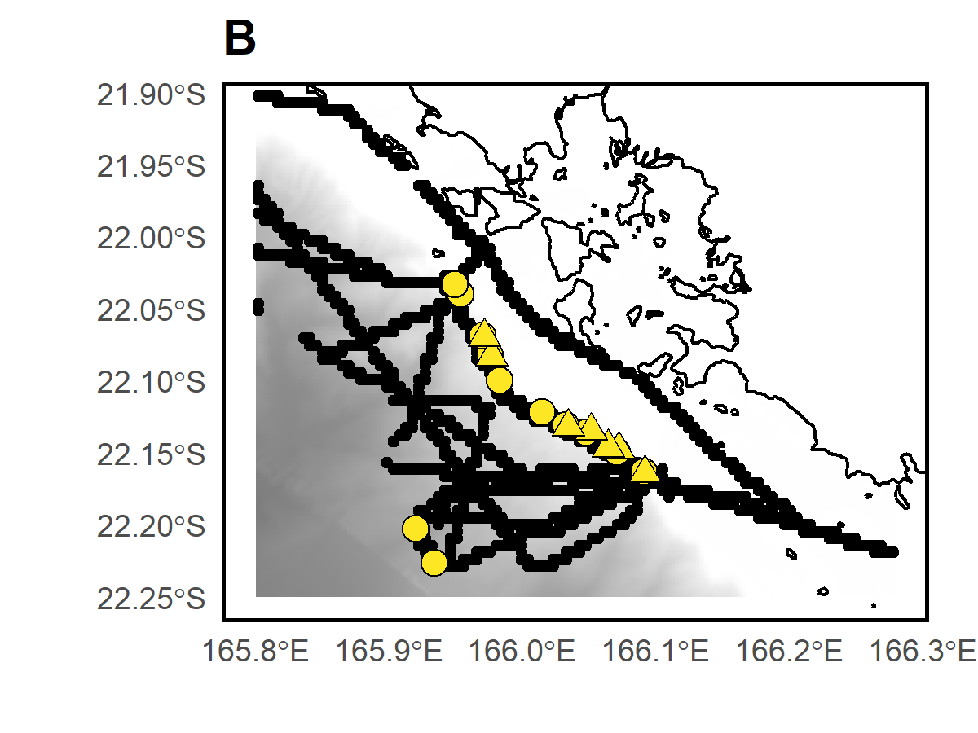

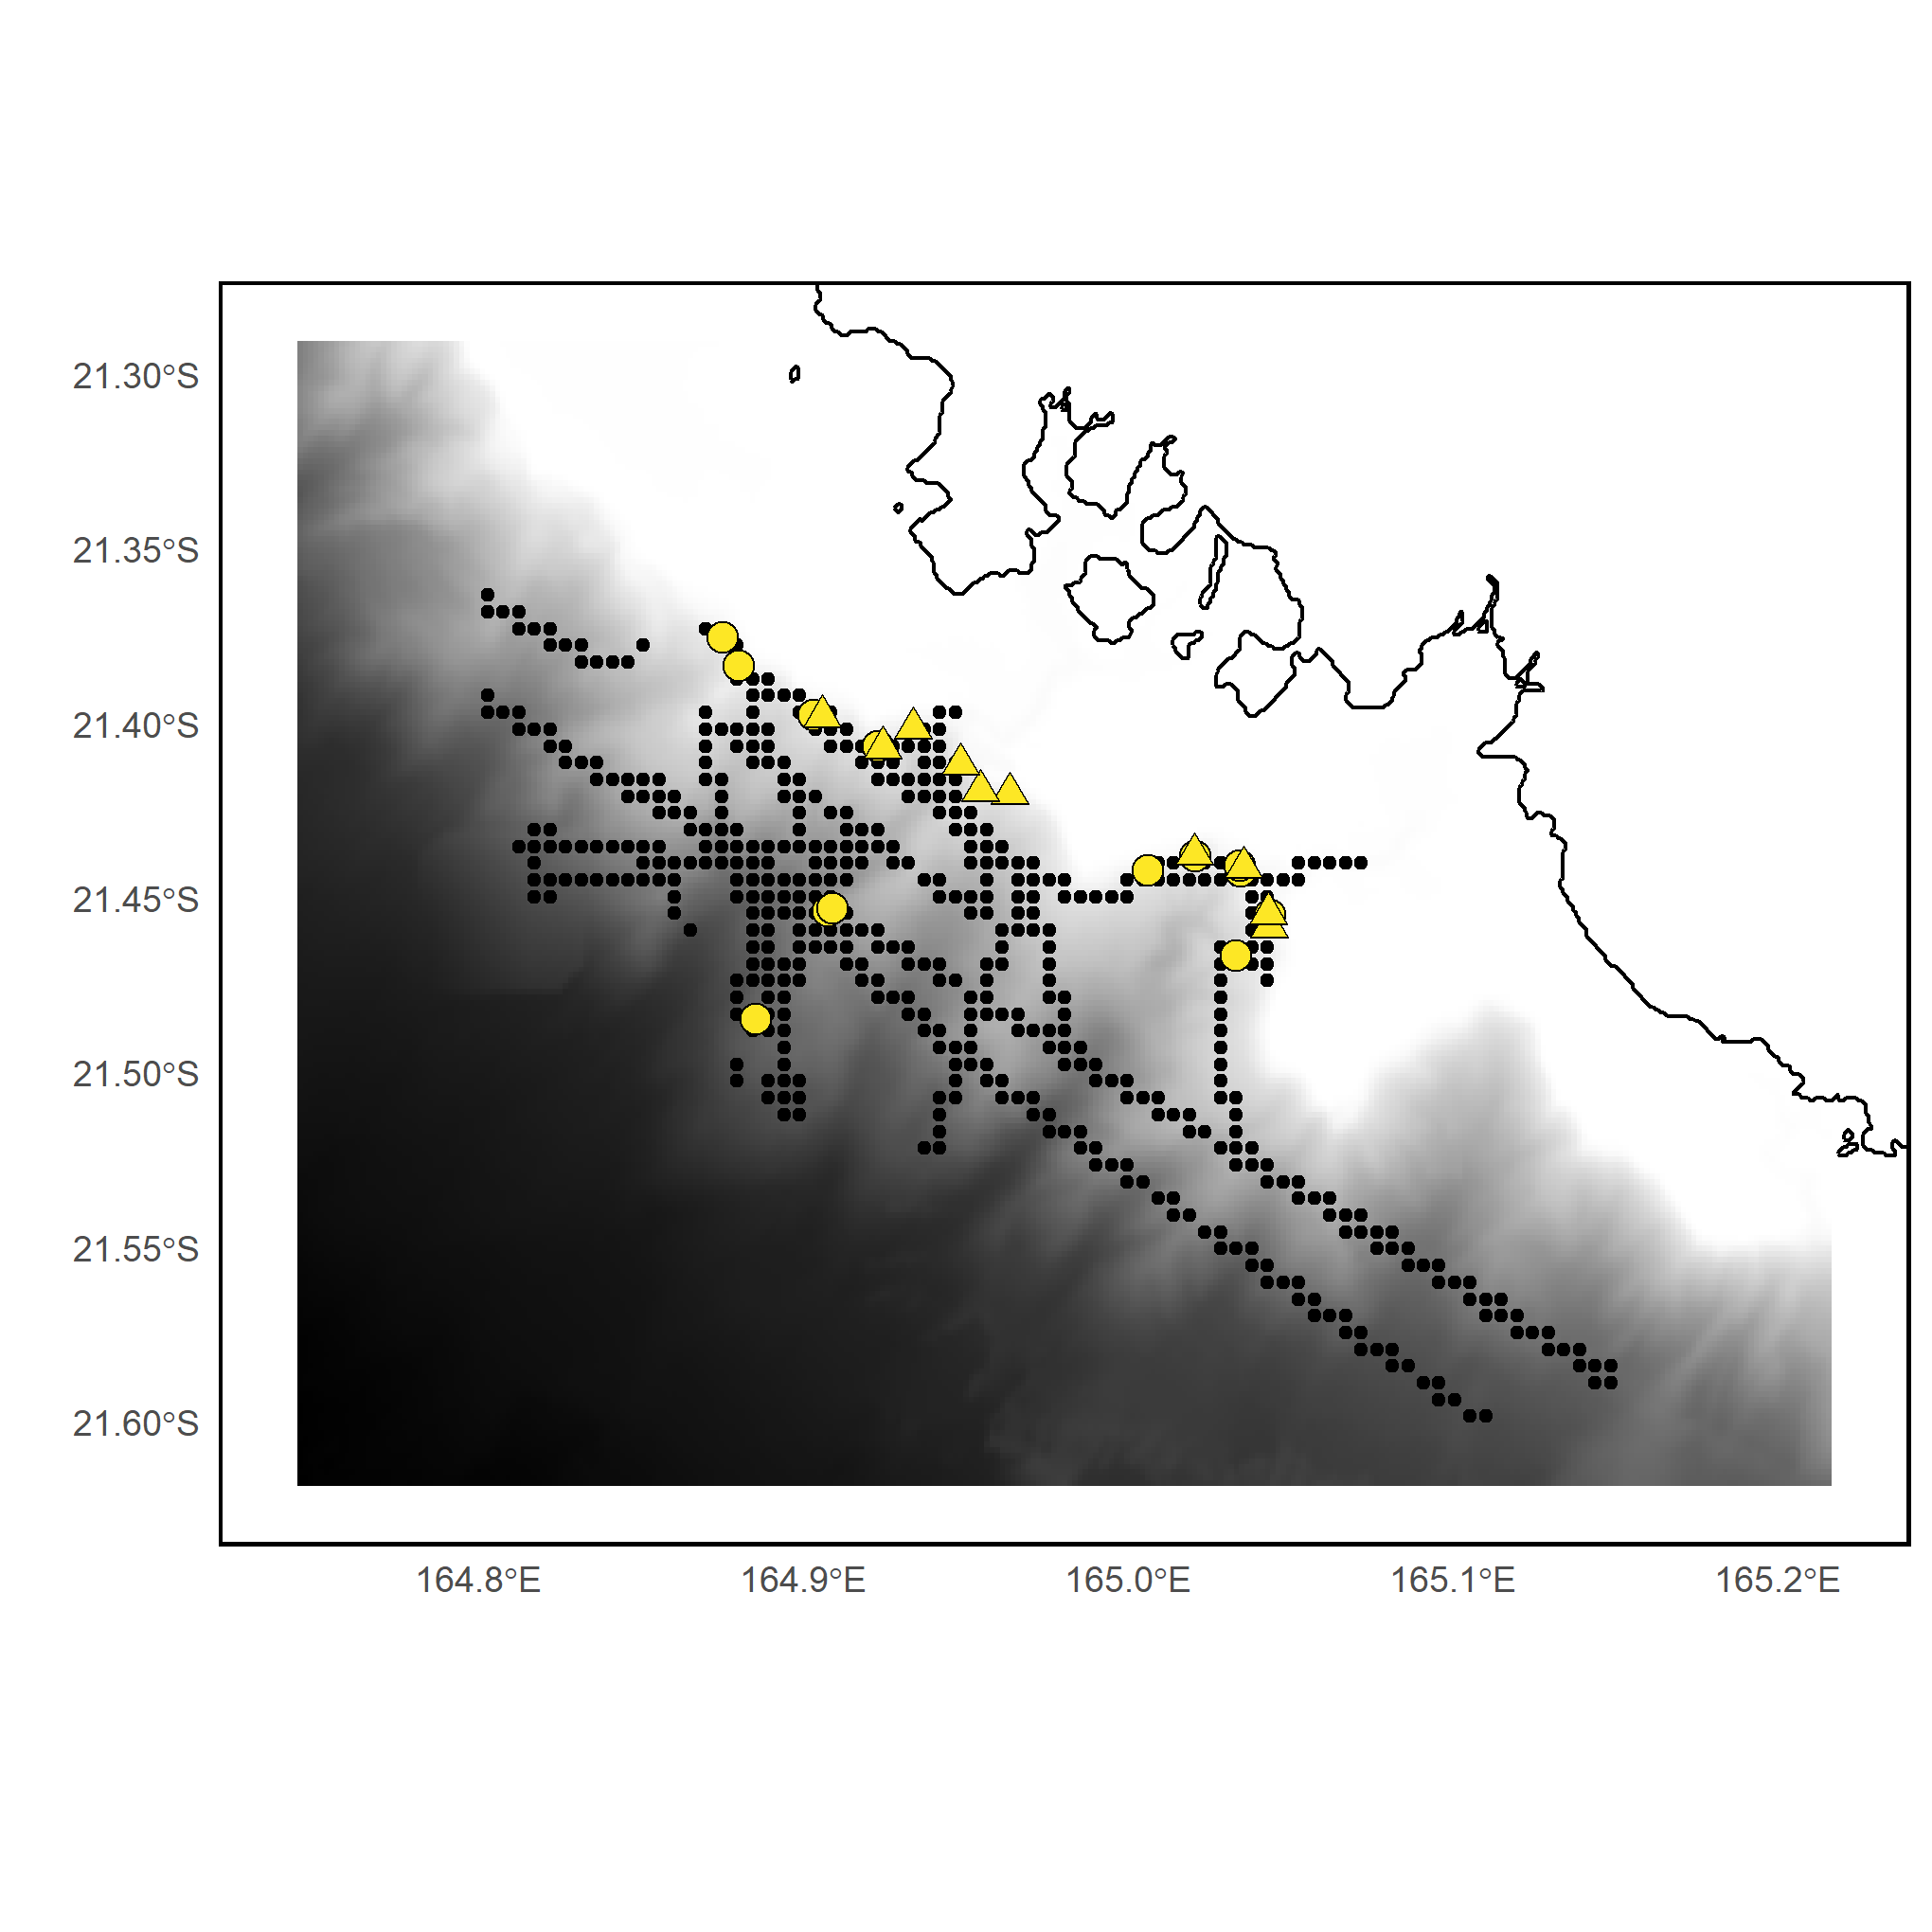

***Appendix S5.*** *Sampling design in site 2 (Poya-Nepoui). Grey shading indicates the depth category. BRUVS sampling stations (triangles), eDNA sampling stations (circles), and acoustic recordings (black dots).*

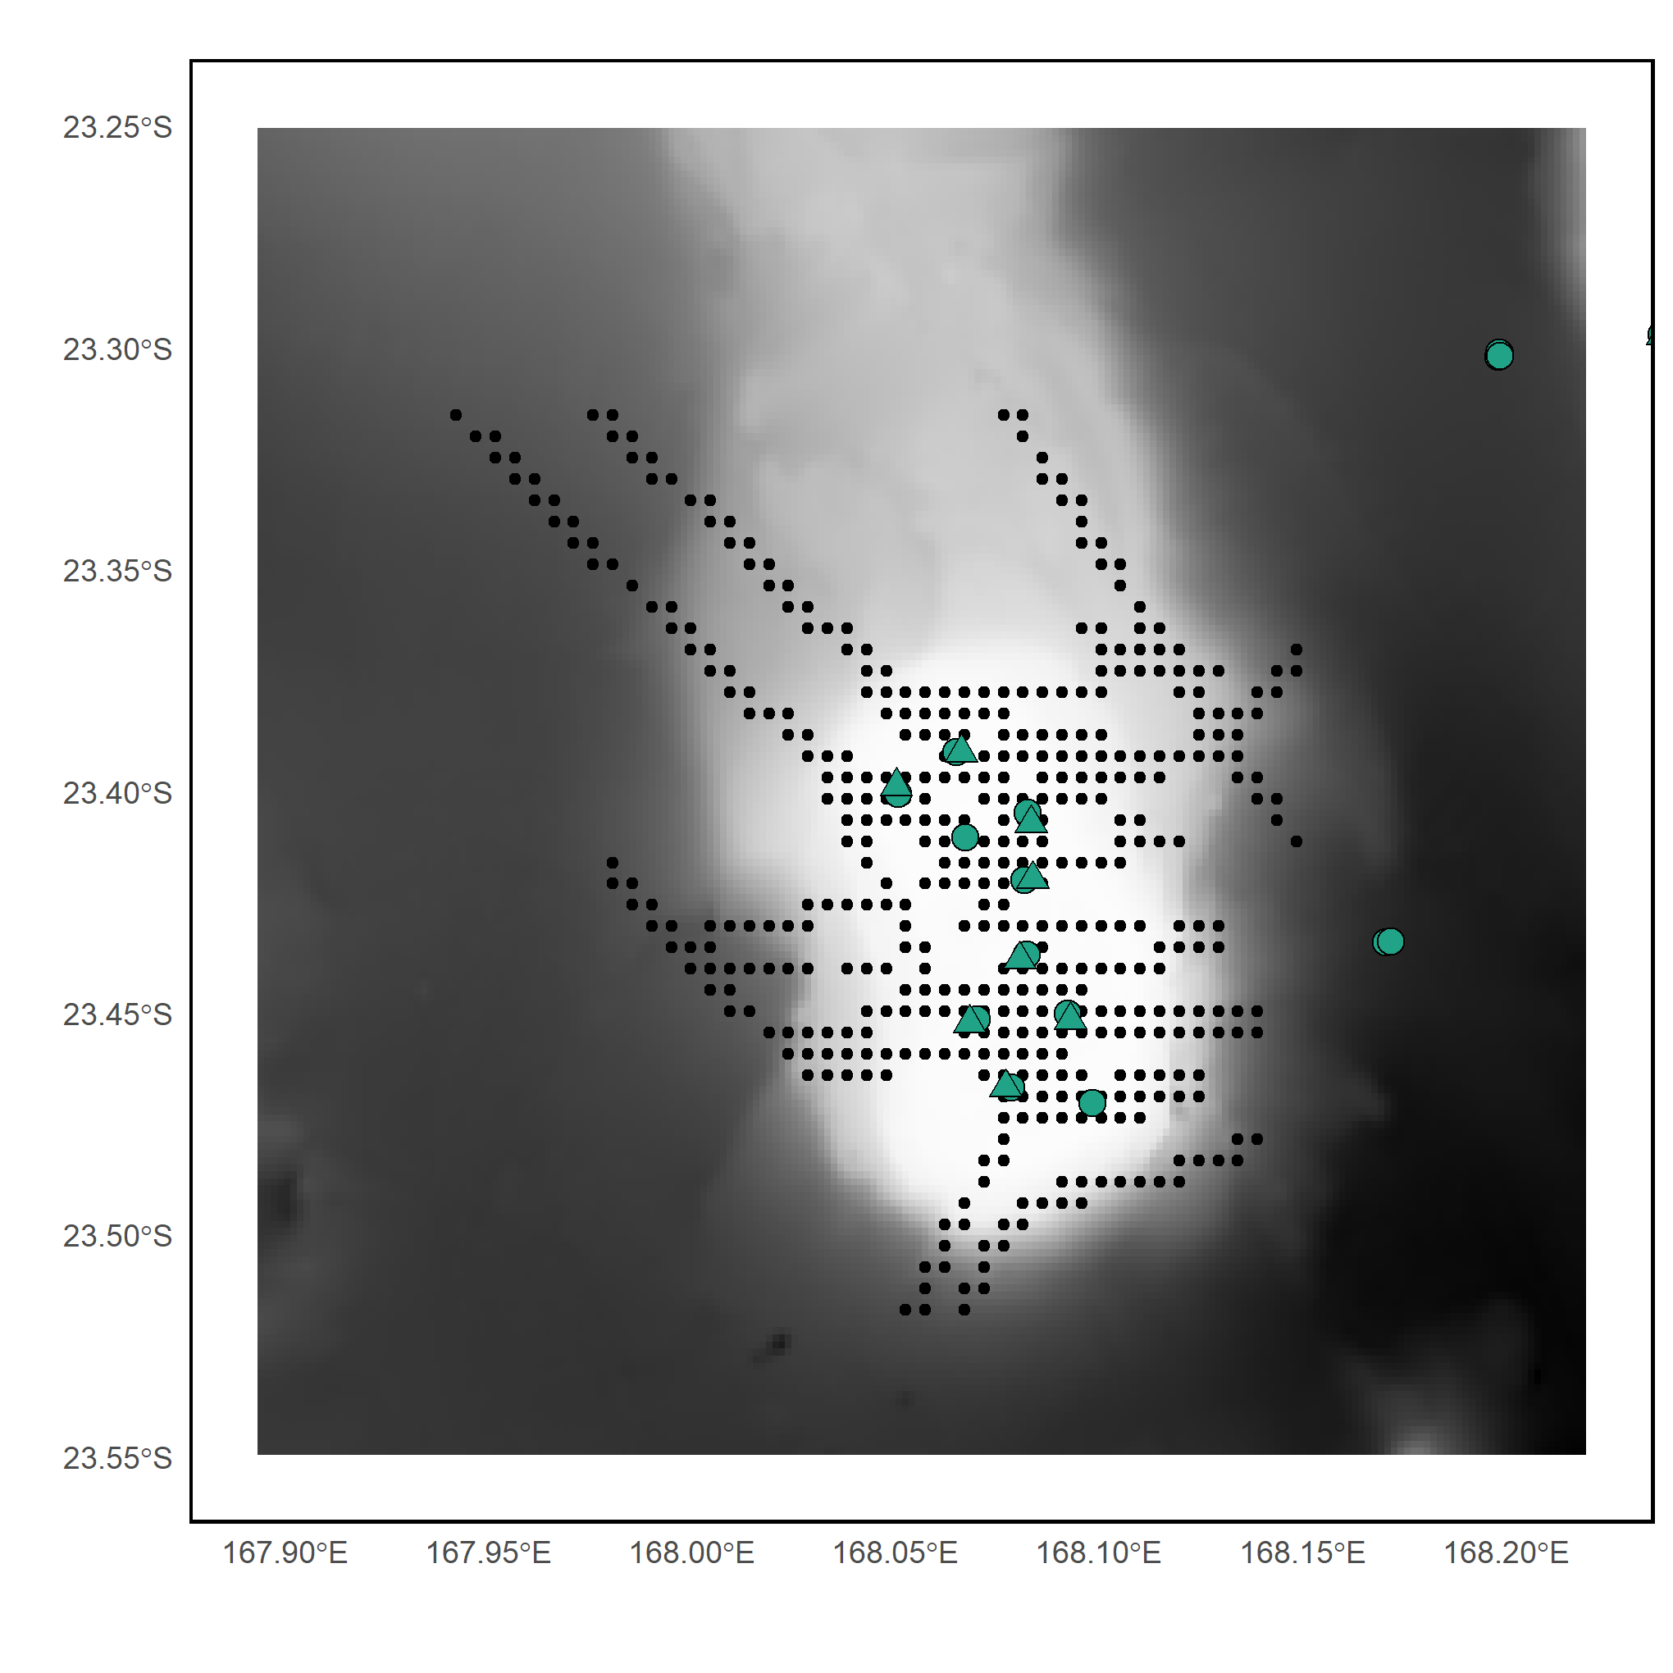

***Appendix S6.*** *Sampling design in site 3 (Antigonia). Grey shading indicates the depth category. BRUVS sampling stations (triangles), eDNA sampling stations (circles), and acoustic recordings (black dots).*

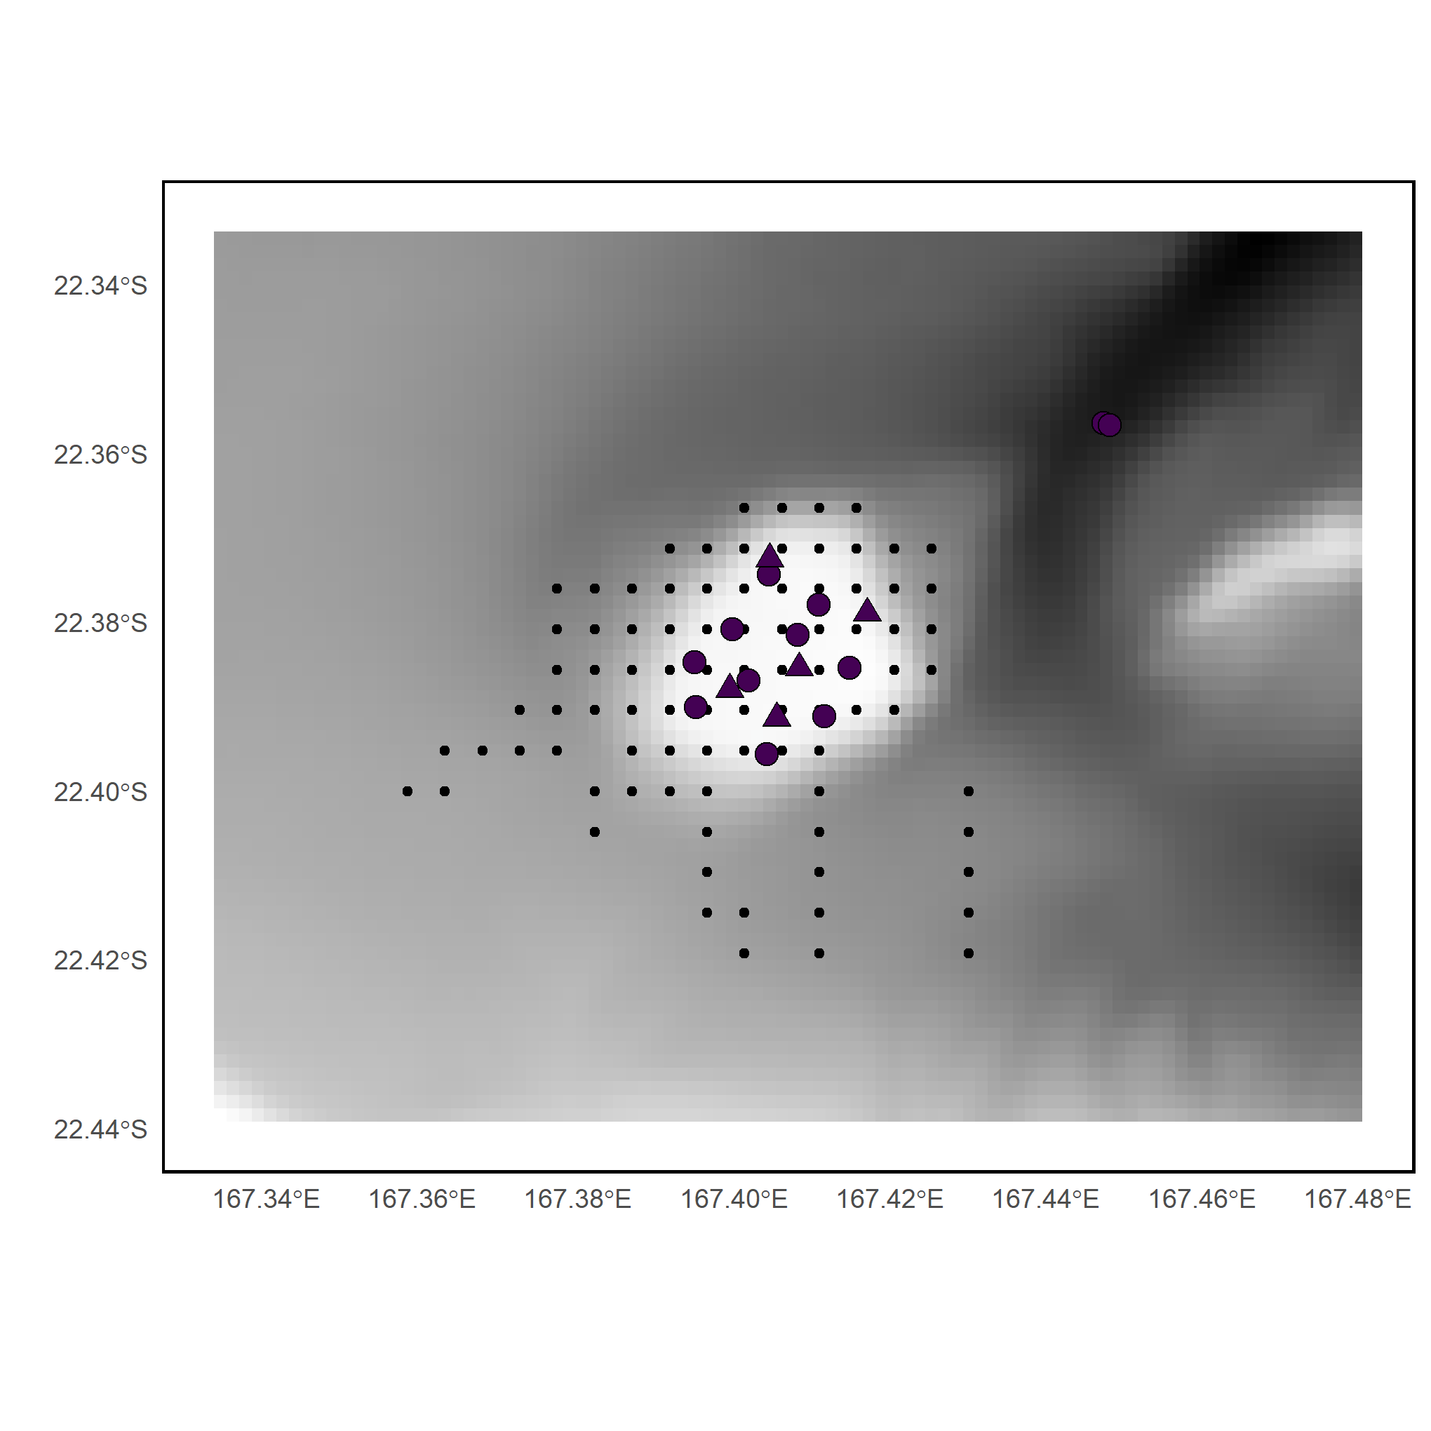

***Appendix S7.*** *Sampling design in site 4 (Ile des Pins). Grey shading indicates the depth category. BRUVS sampling stations (triangles), eDNA sampling stations (circles), and acoustic recordings (black dots).*

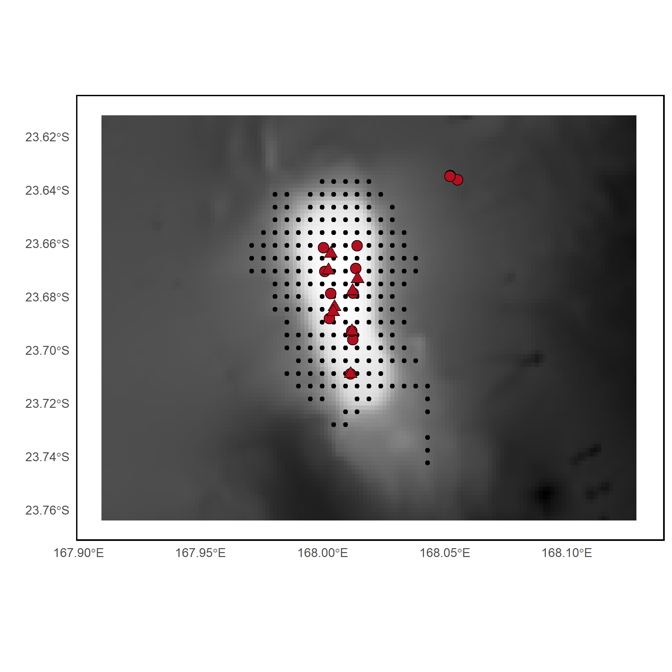

***Appendix S8.*** *Sampling design in site 5 (Jumeau West). Grey shading indicates the depth category. BRUVS sampling stations (triangles), eDNA sampling stations (circles), and acoustic recordings (black dots).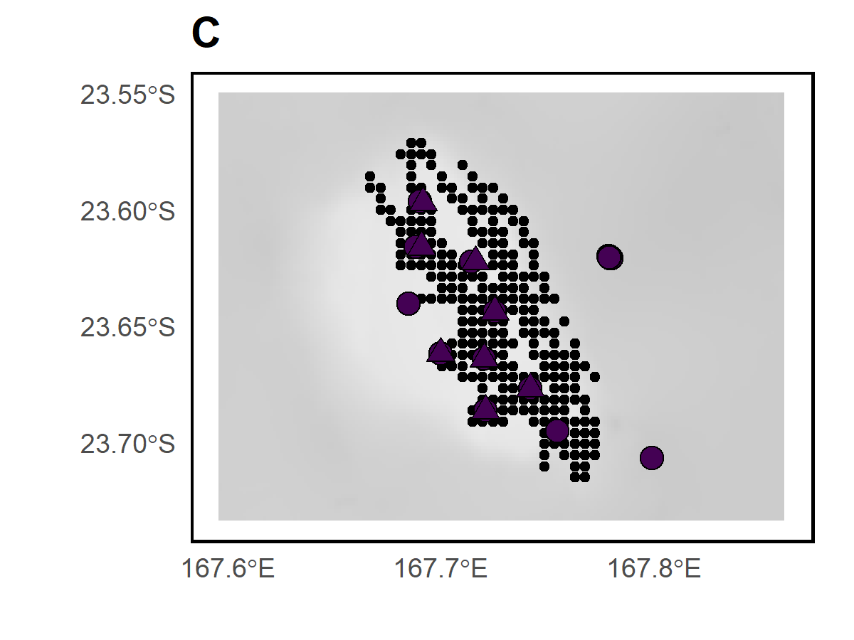*

***Appendix S9.*** *Sampling design in site 6 (Stylaster). Grey shading indicates the depth category. BRUVS sampling stations (triangles), eDNA sampling stations (circles), and acoustic recordings (black dots).*

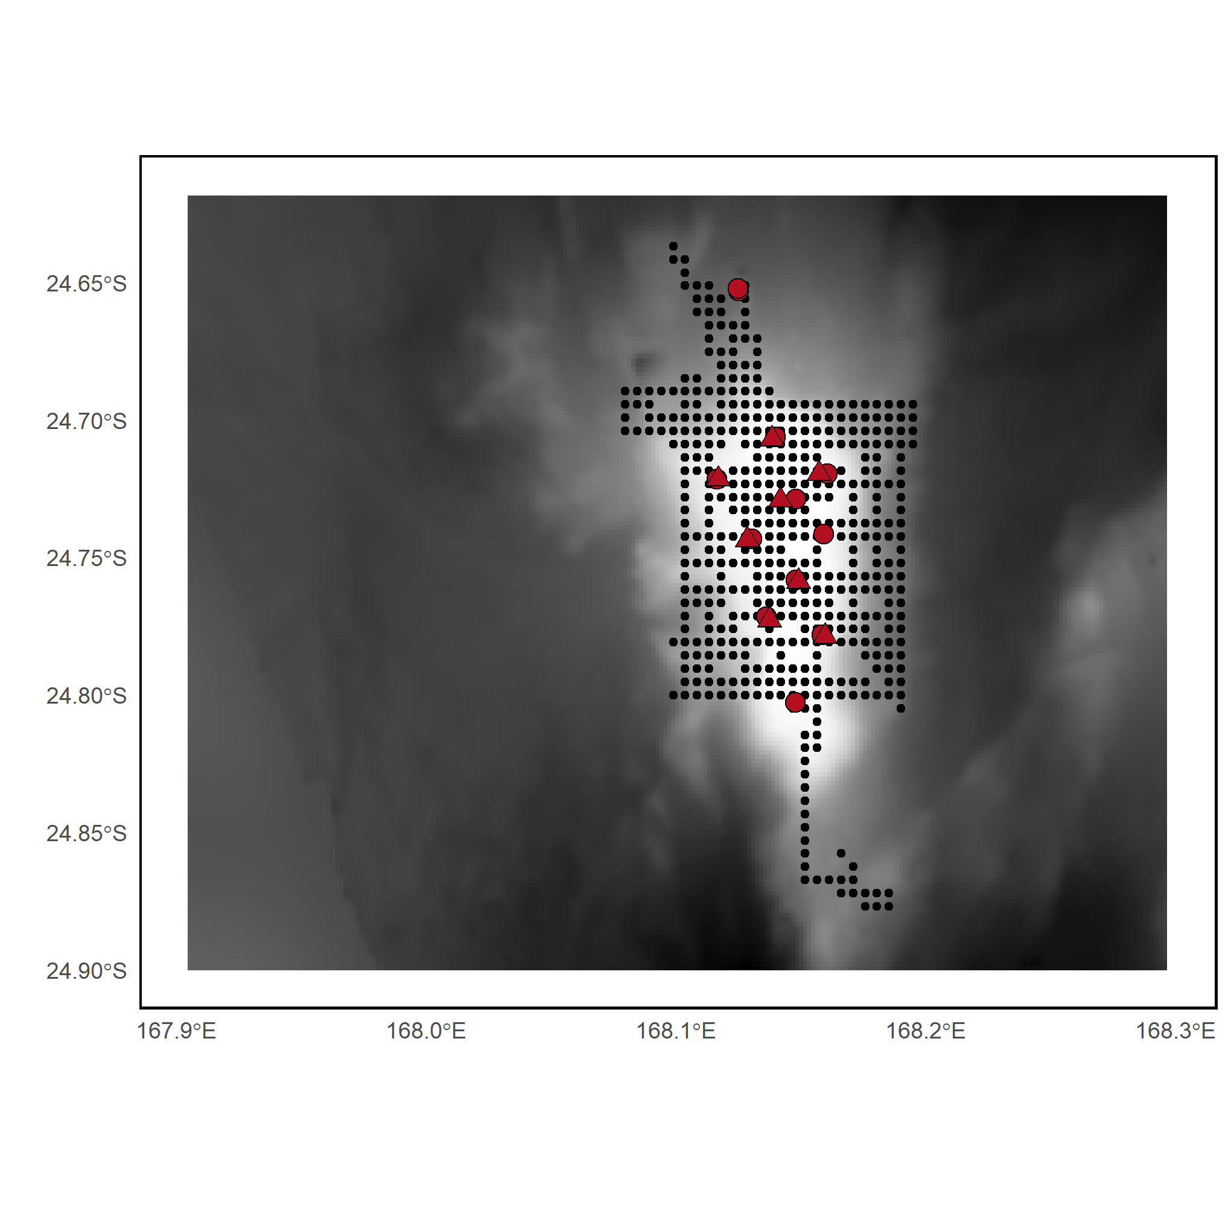

***Appendix S10.*** *Sampling design in site 7 (Kaimon Maru). Grey shading indicates the depth category. BRUVS sampling stations (triangles), eDNA sampling stations (circles), and acoustic recordings (black dots).*

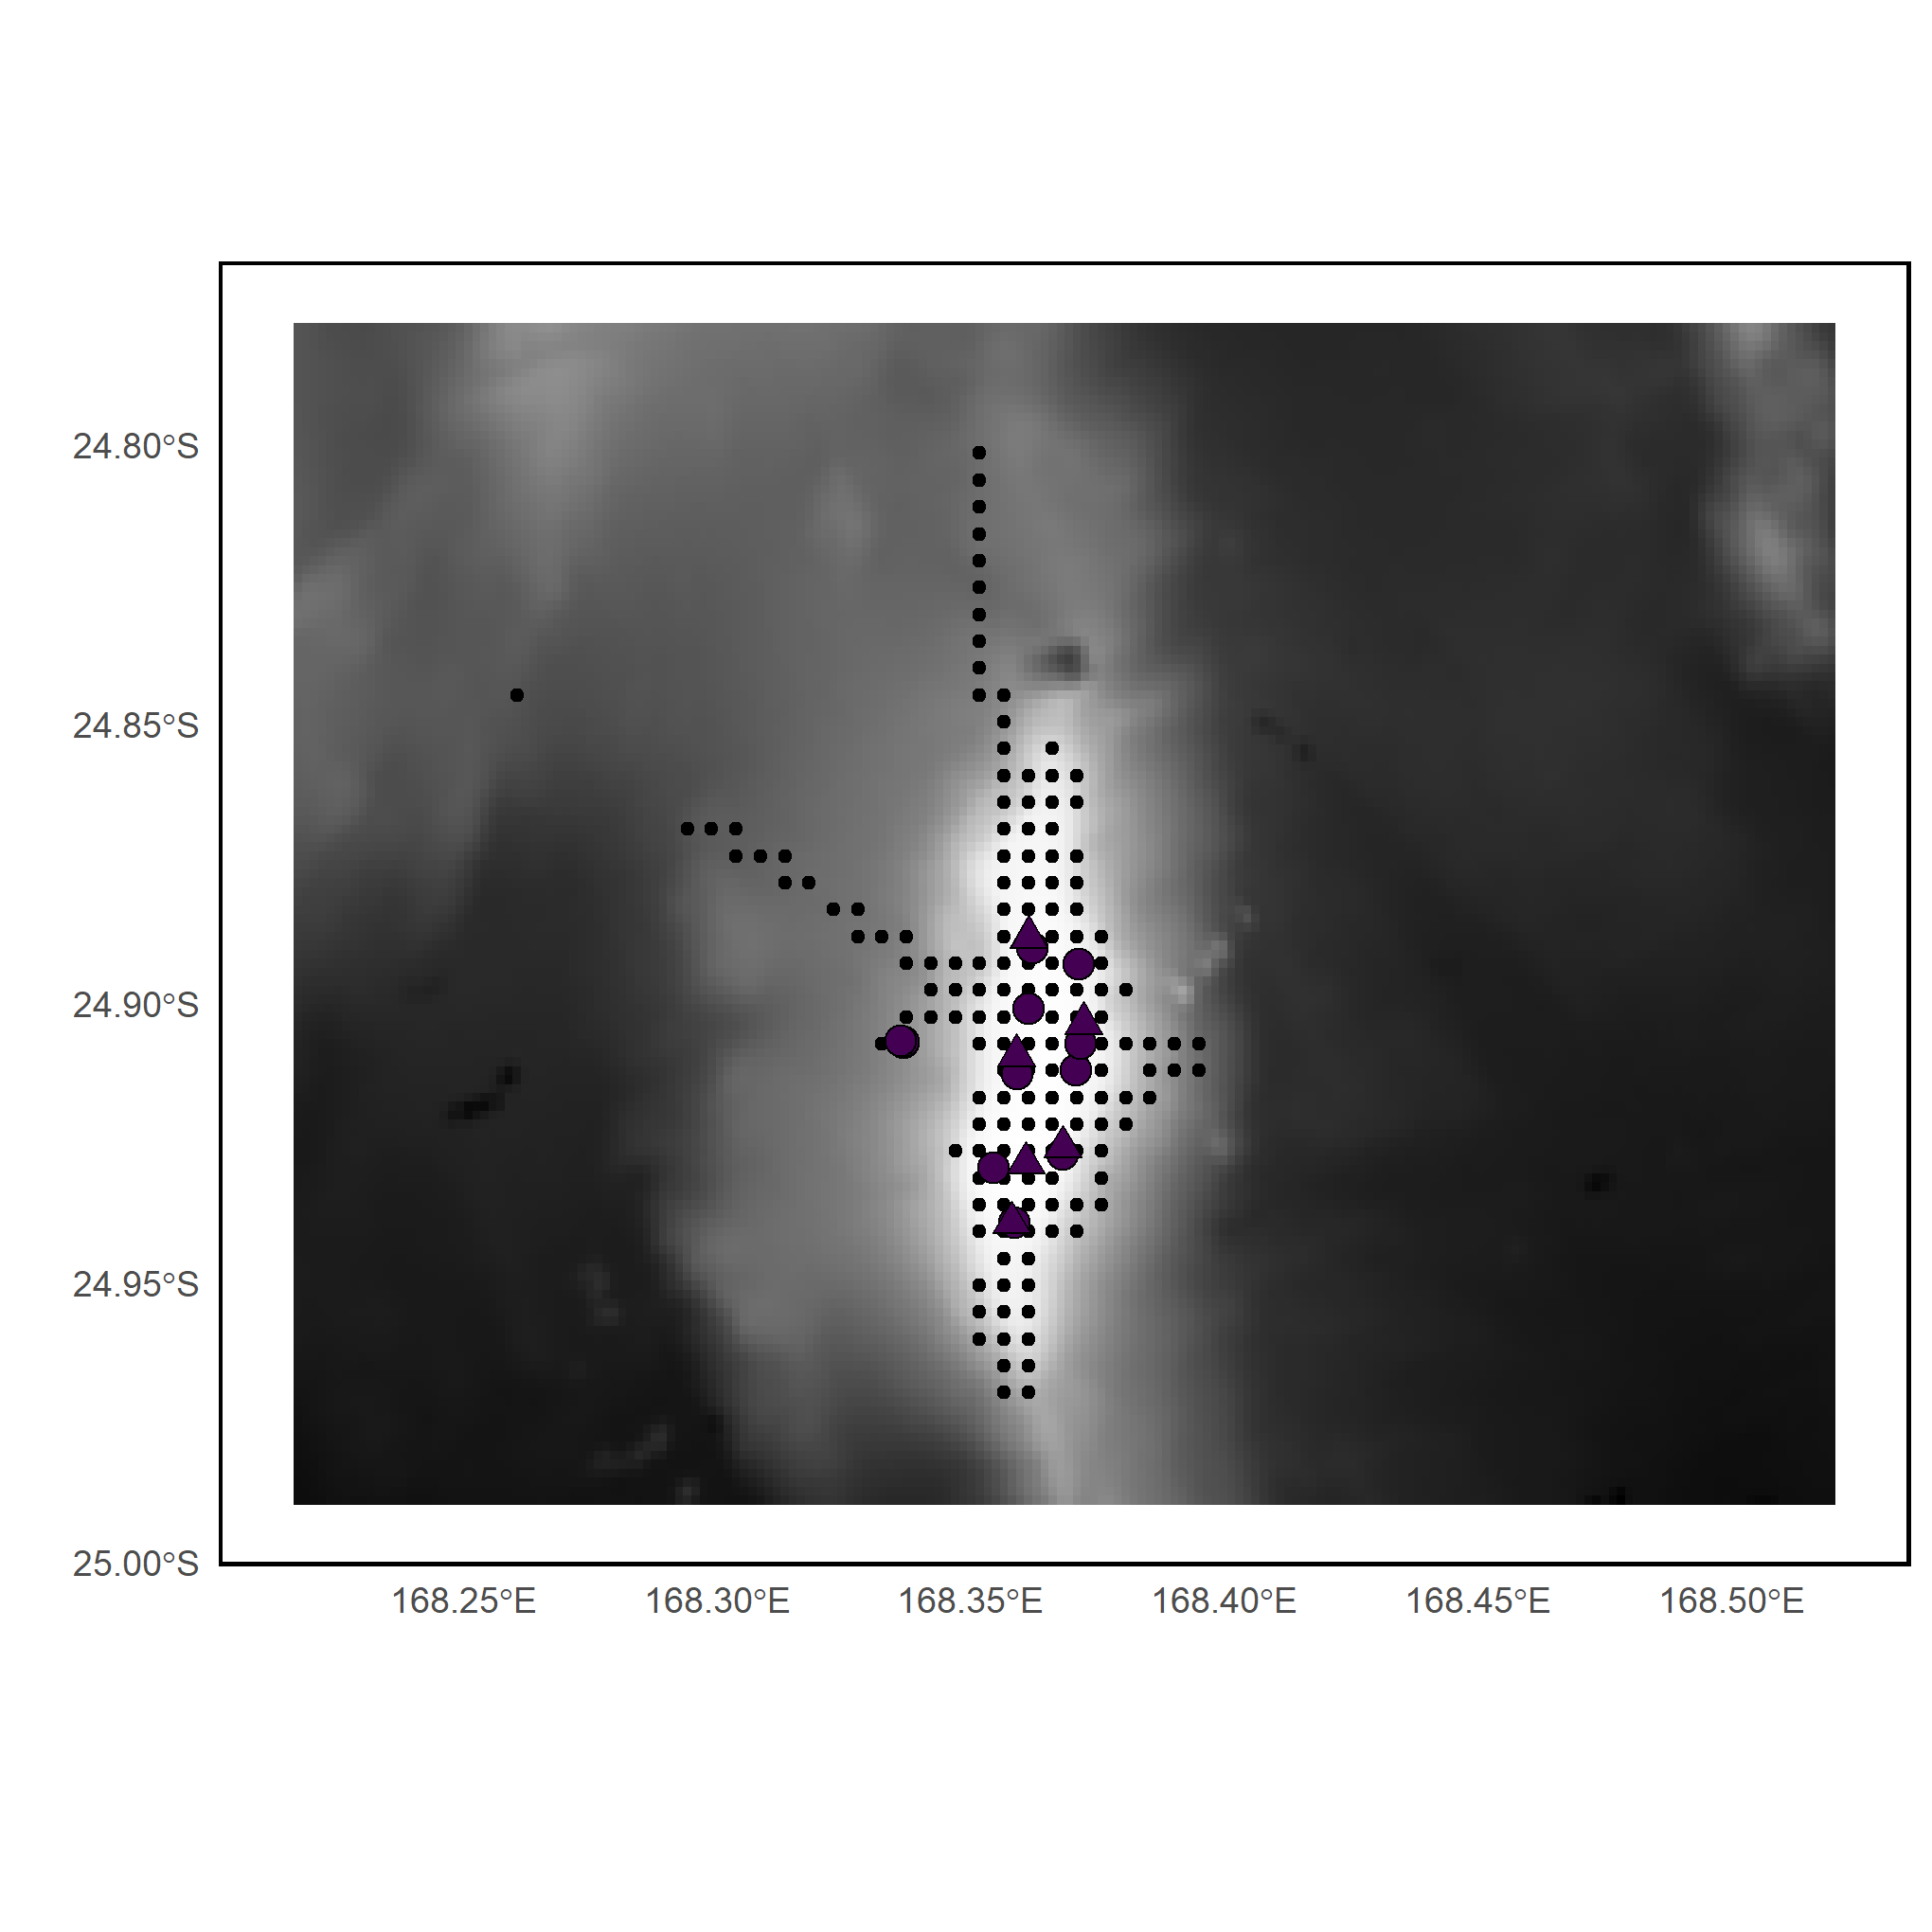

***Appendix S11.*** *Sampling design in site 8 (Eponge). Grey shading indicates the depth category. BRUVS sampling stations (triangles), eDNA sampling stations (circles), and acoustic recordings (black dots).*

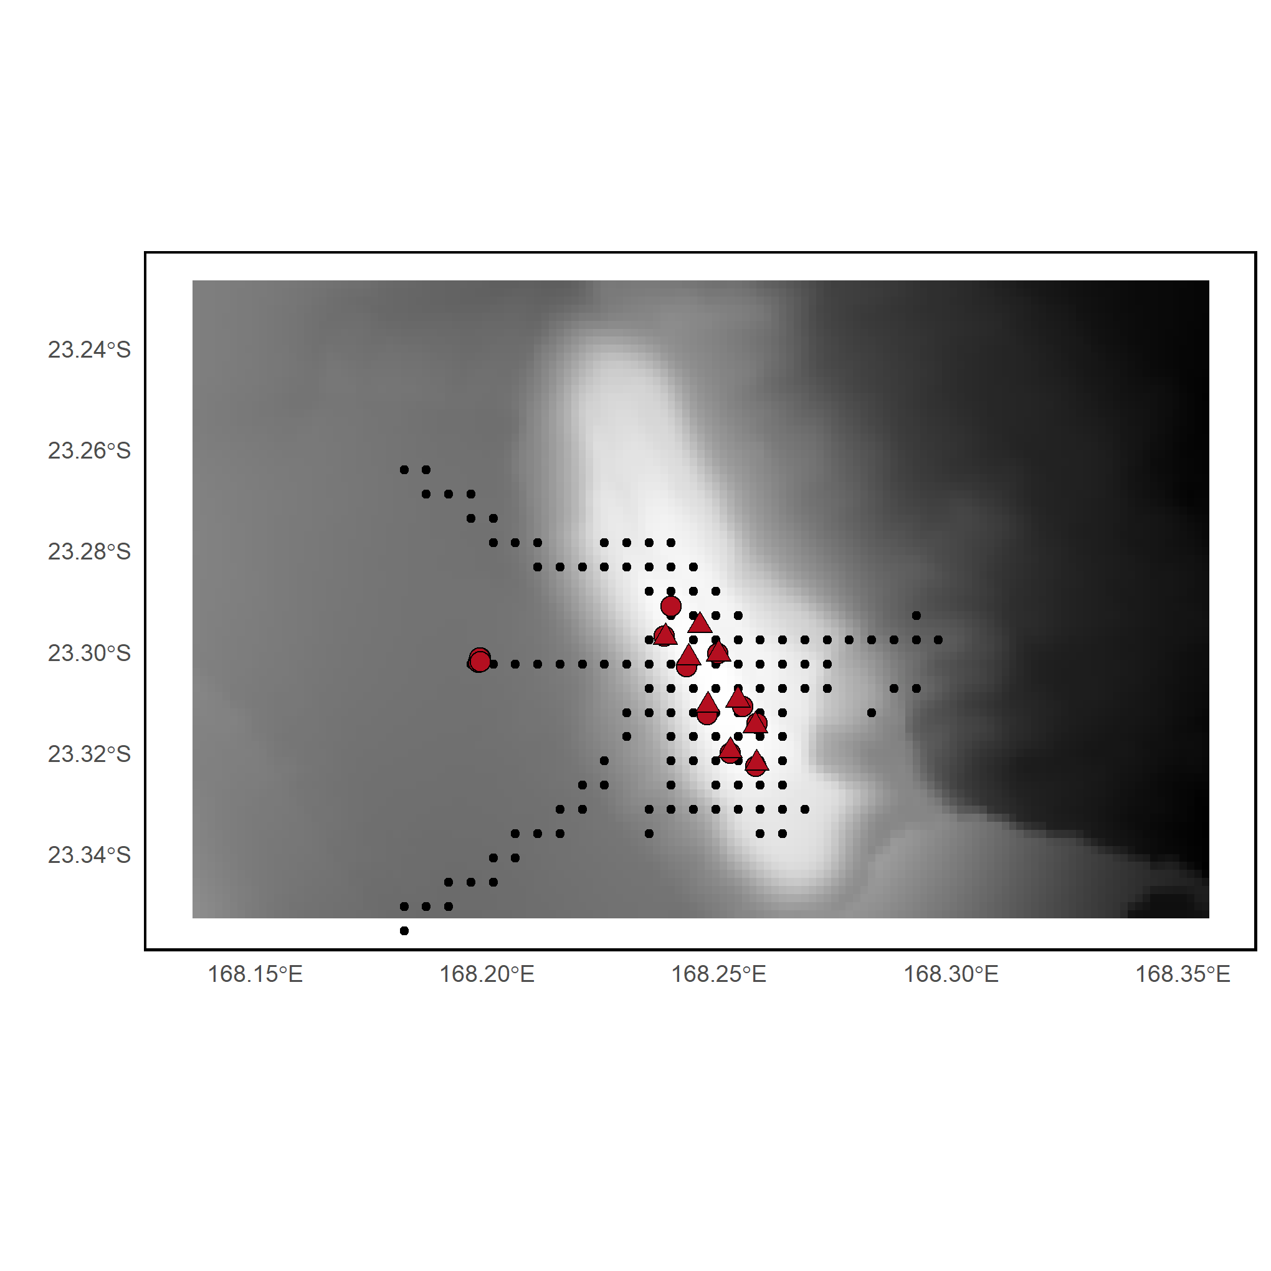

***Appendix S12.*** *Sampling design in site 9 (Crypthelia). Grey shading indicates the depth category. BRUVS sampling stations (triangles), eDNA sampling stations (circles), and acoustic recordings (black dots).*

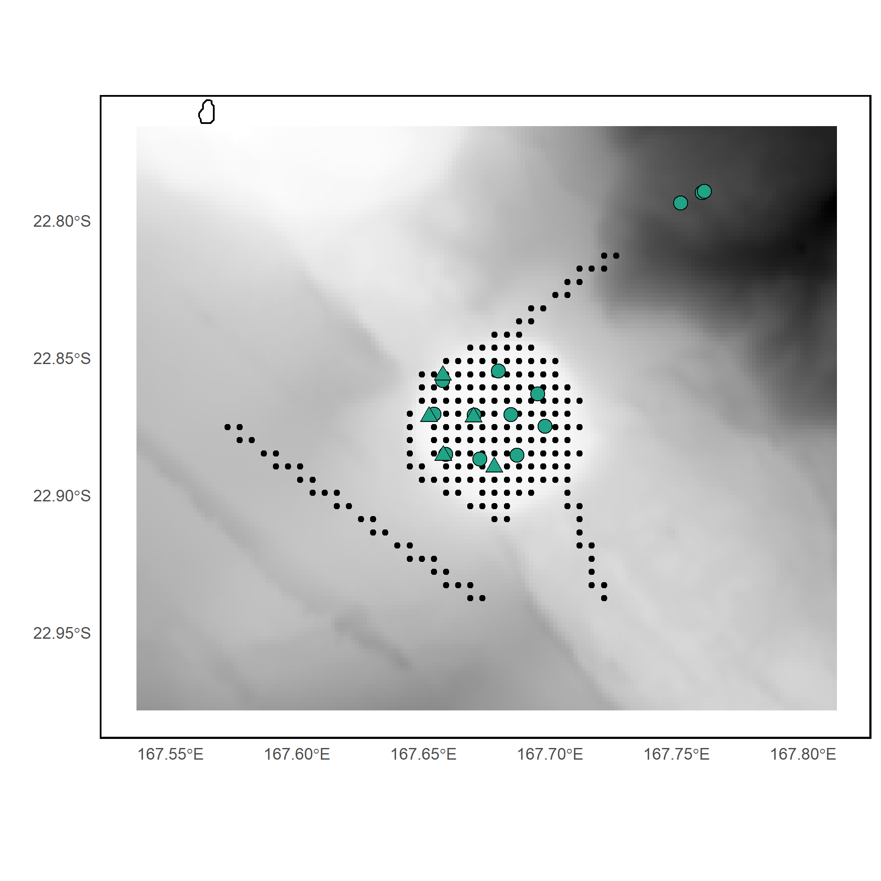

***Appendix S13.*** *Sampling design in site 10 (Torche). Grey shading indicates the depth category. BRUVS sampling stations (triangles), eDNA sampling stations (circles), and acoustic recordings (black dots).*

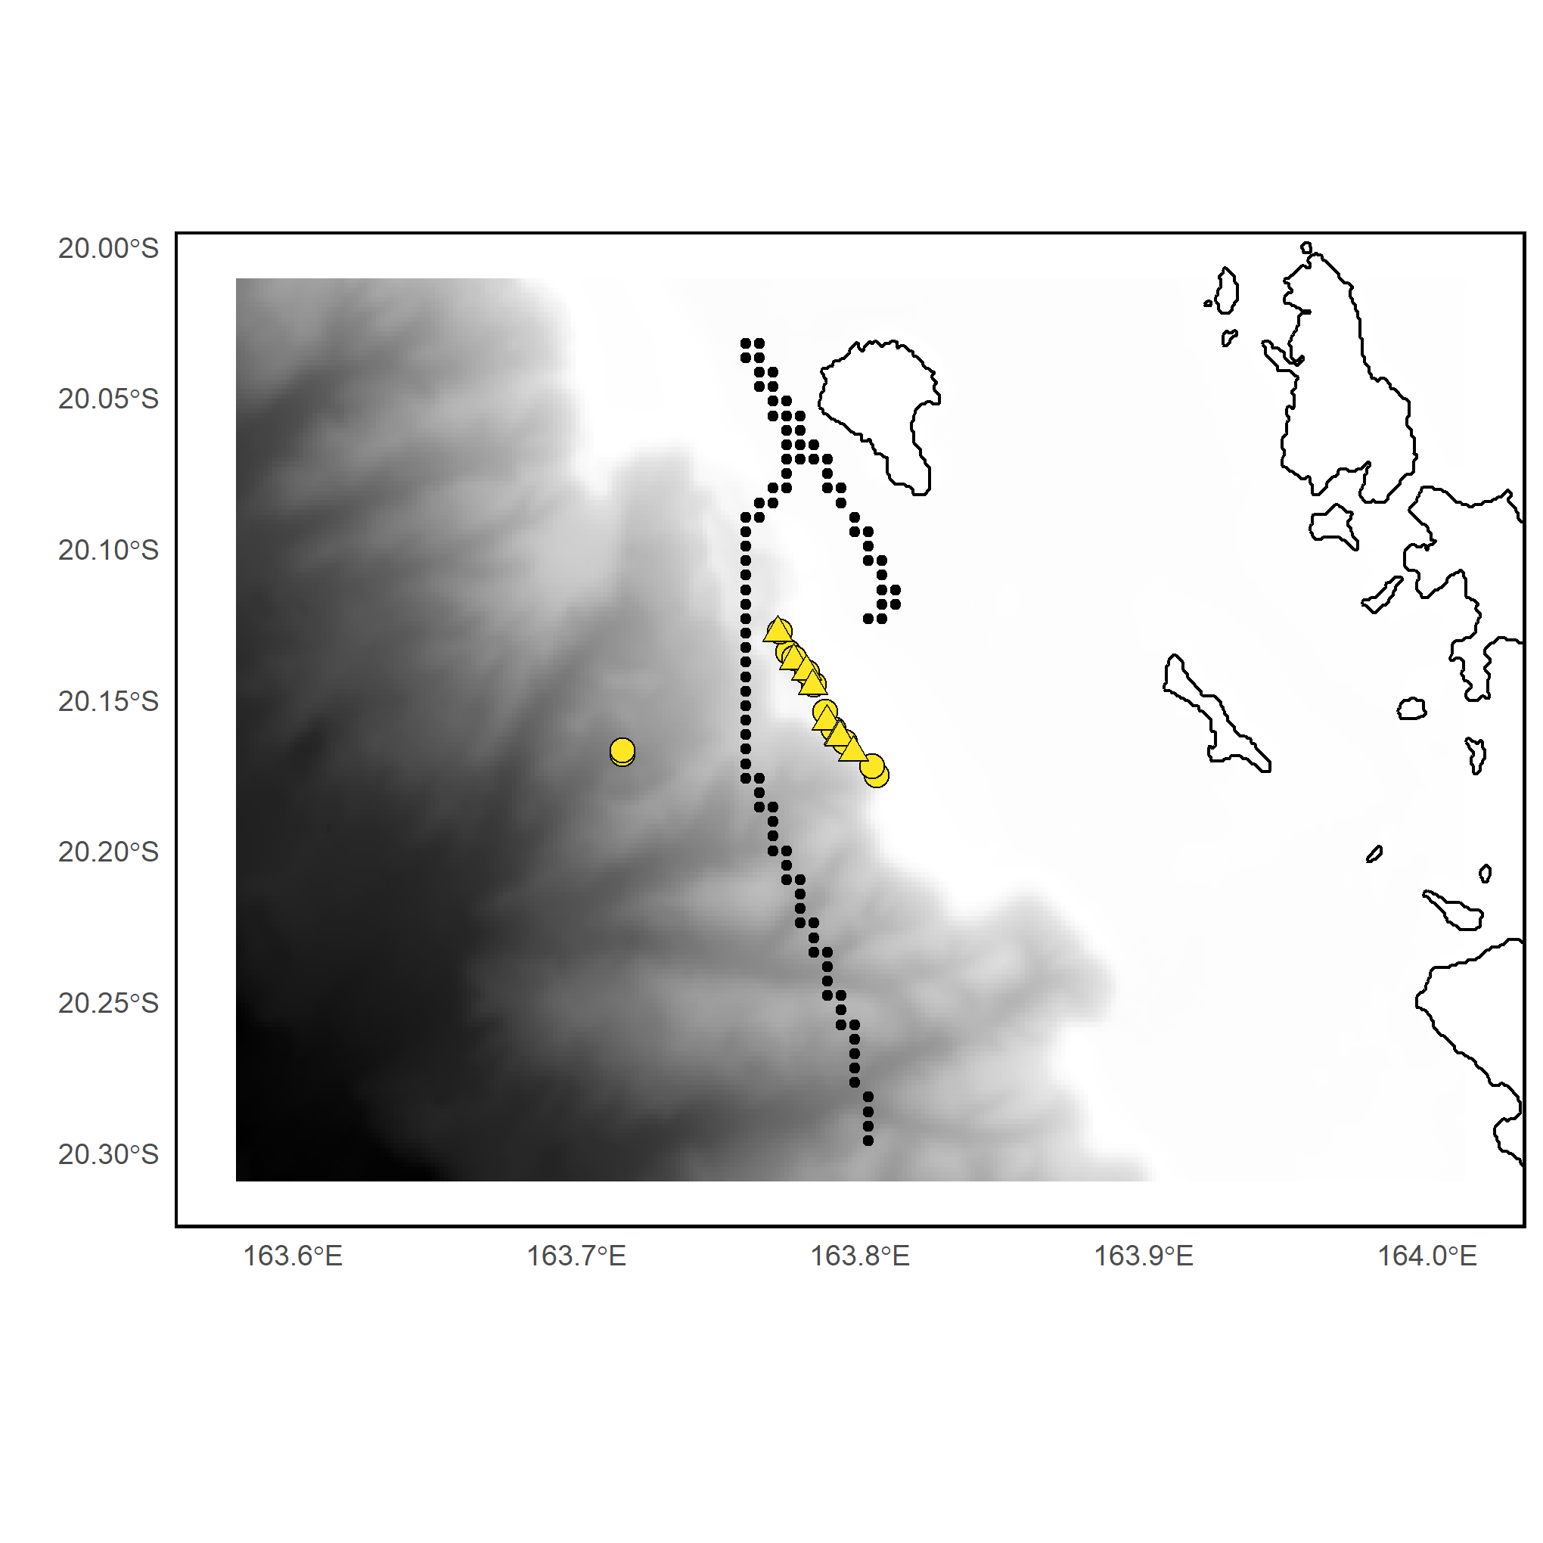

***Appendix S14.*** *Sampling design in site 11 (Poum). Grey shading indicates the depth category. BRUVS sampling stations (triangles), eDNA sampling stations (circles), and acoustic recordings (black dots).*

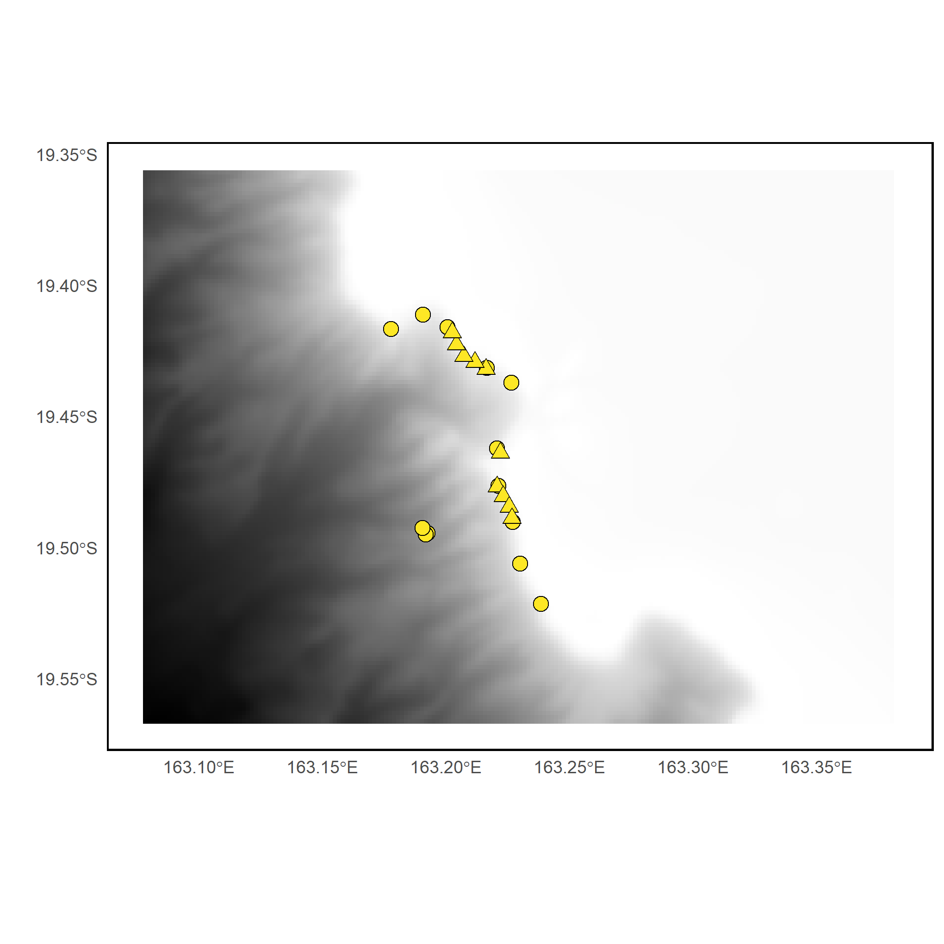

***Appendix S15.*** *Sampling design in site 12 (Great Northern Lagoon). Grey shading indicates the depth category. BRUVS sampling stations (triangles), eDNA sampling stations (circles), and acoustic recordings (black dots).*

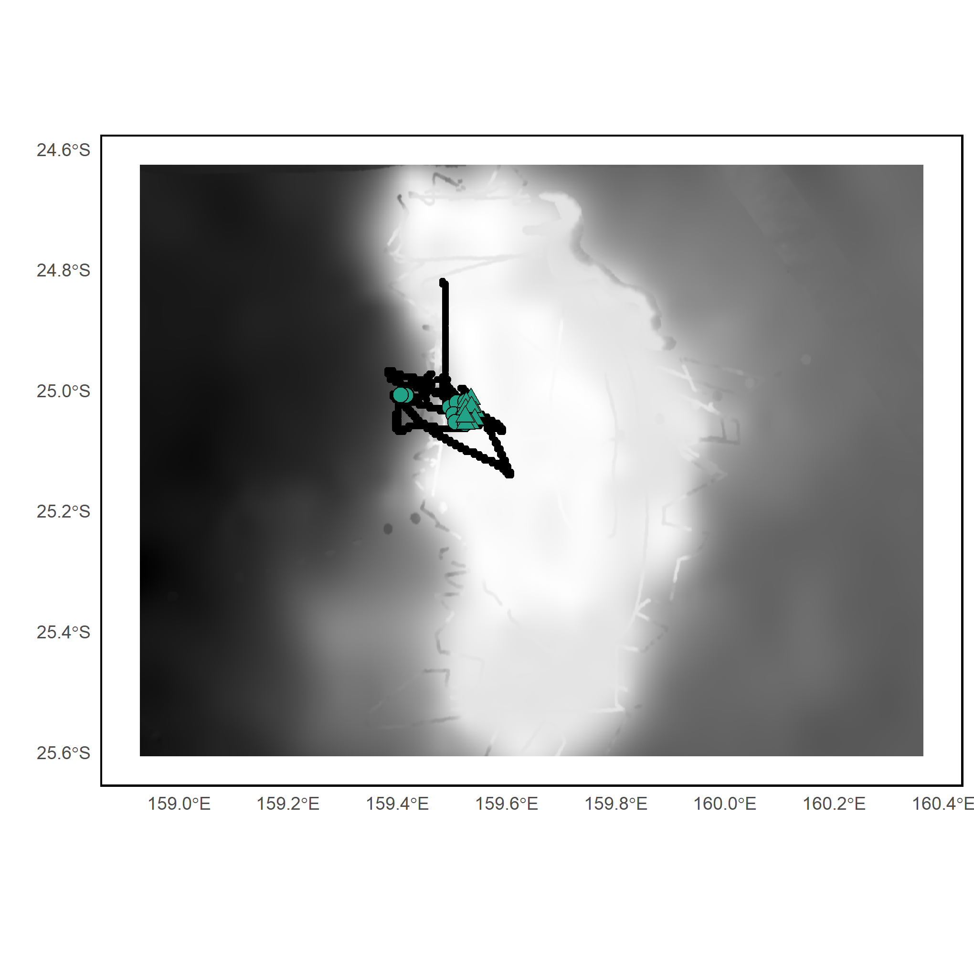

***Appendix S16.*** *Sampling design in site 13 (Capel). Grey shading indicates the depth category. BRUVS sampling stations (triangles), eDNA sampling stations (circles), and acoustic recordings (black dots).*

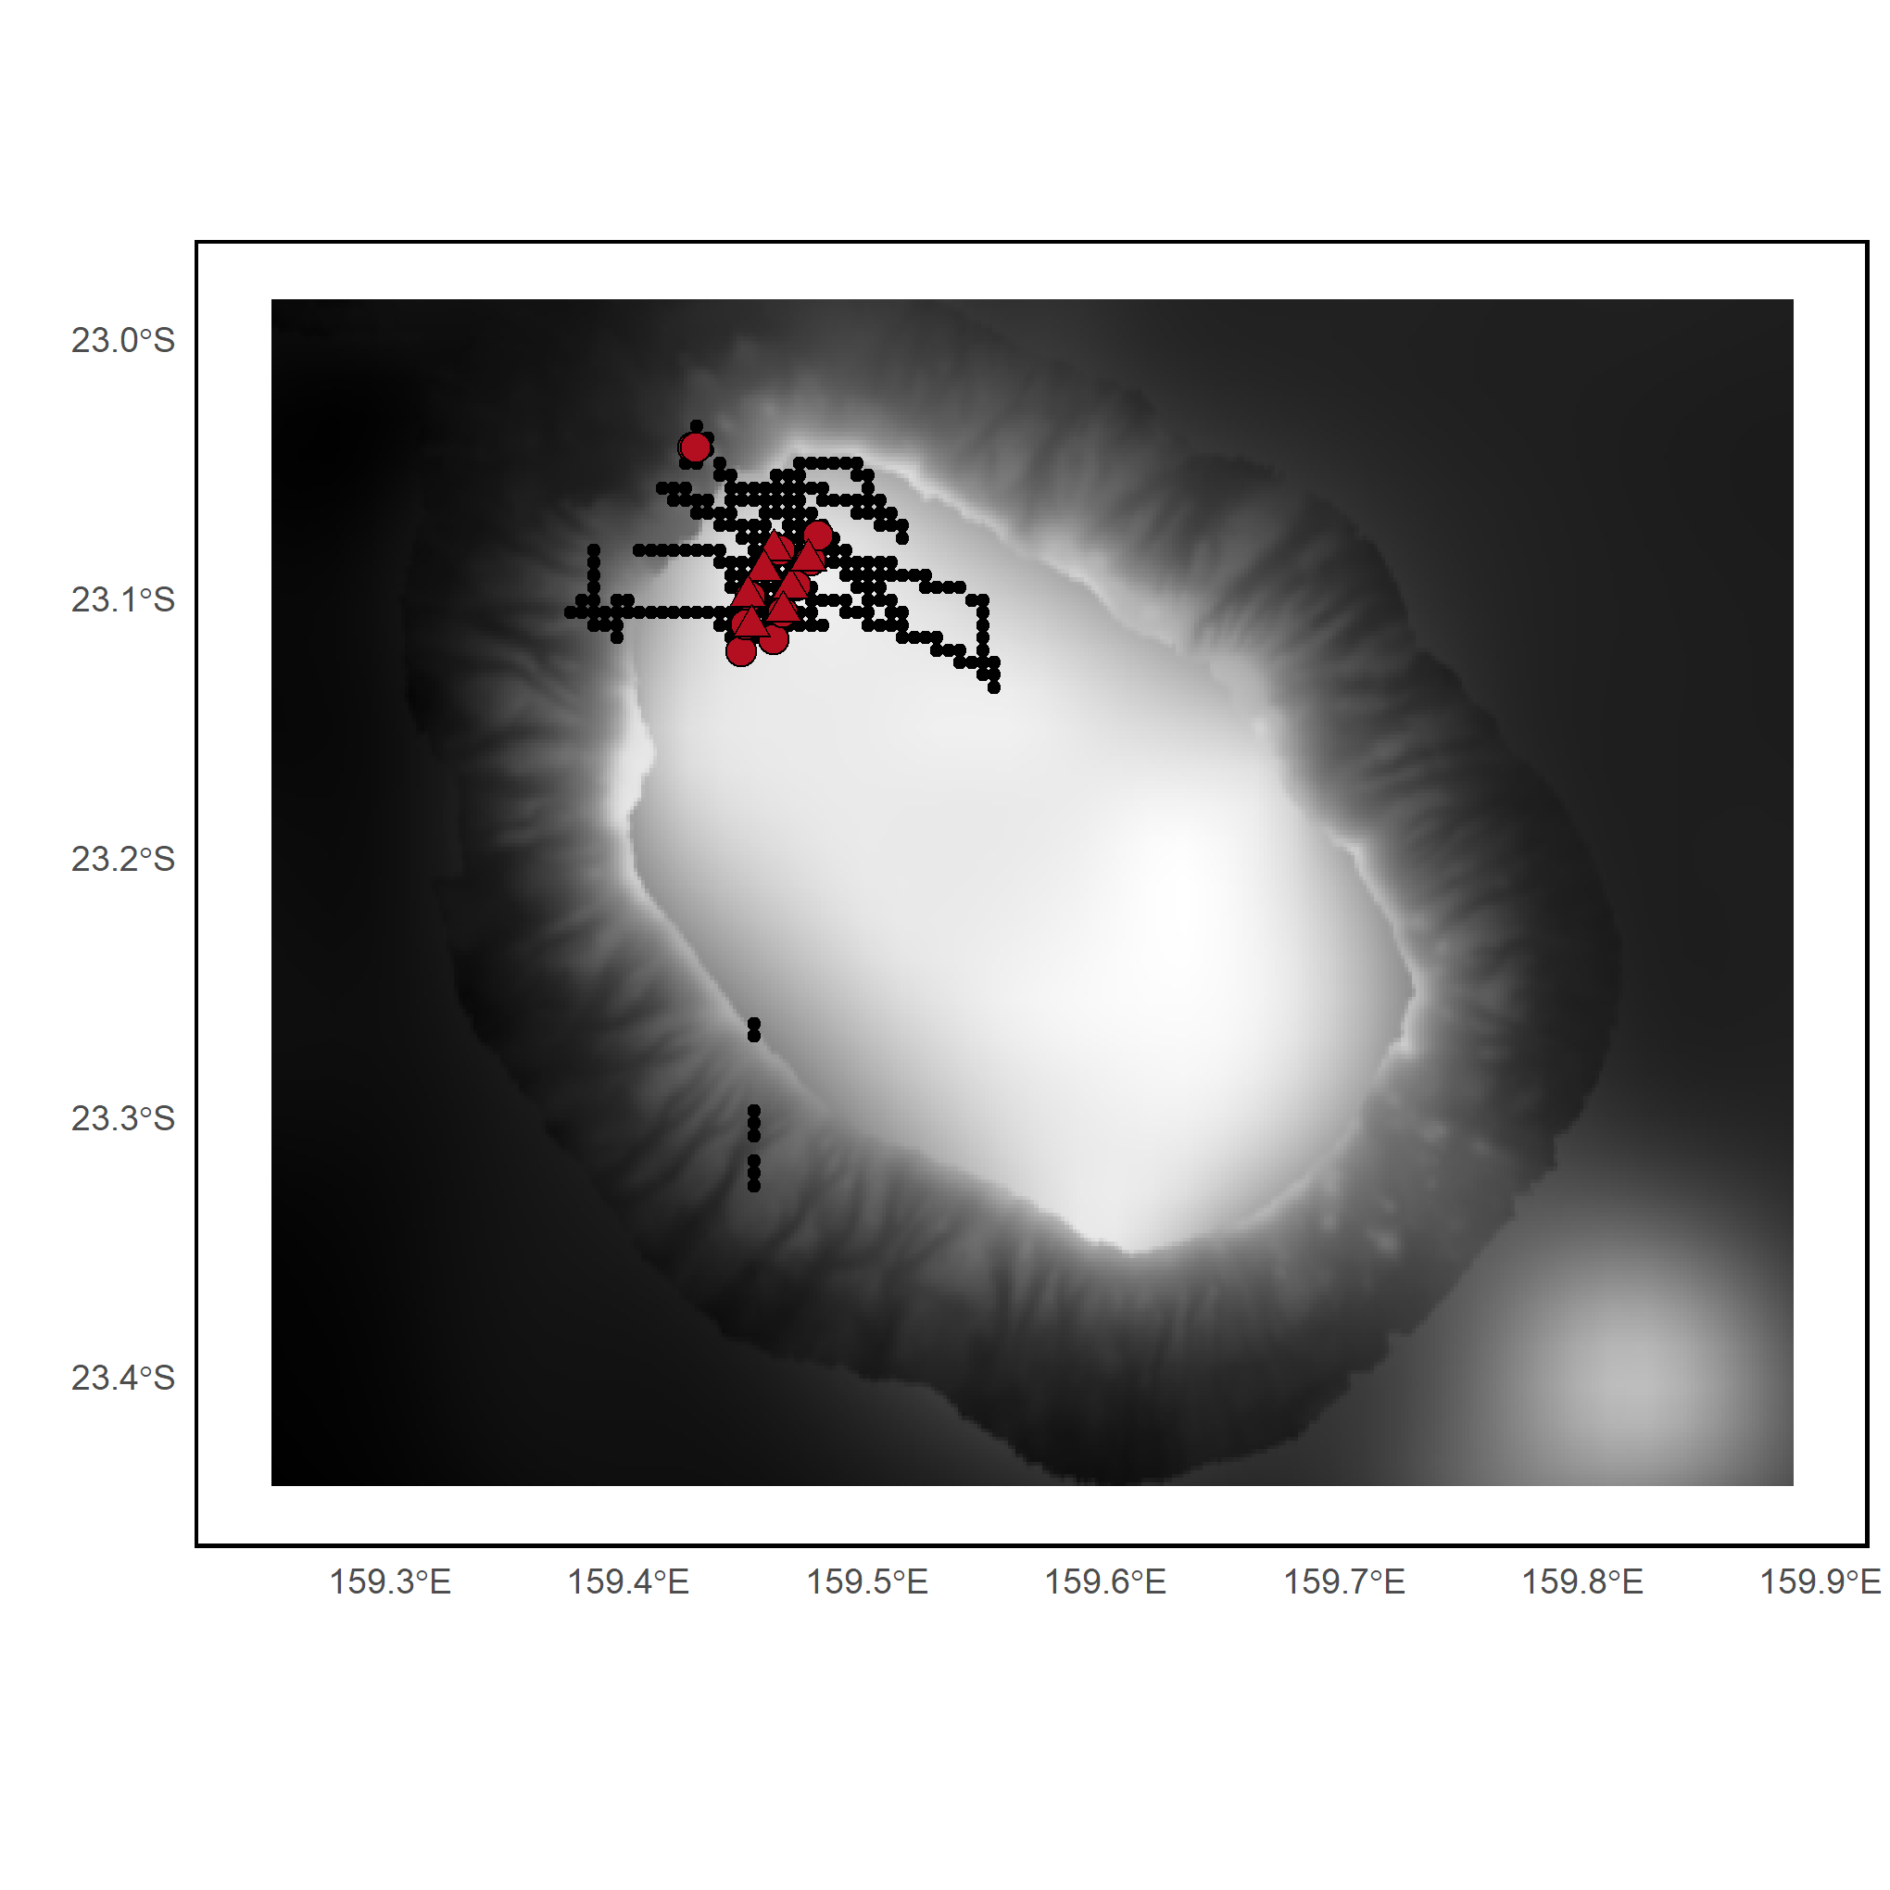

***Appendix S17.*** *Sampling design in site 14 (Argo). Grey shading indicates the depth category. BRUVS sampling stations (triangles), eDNA sampling stations (circles), and acoustic recordings (black dots).*

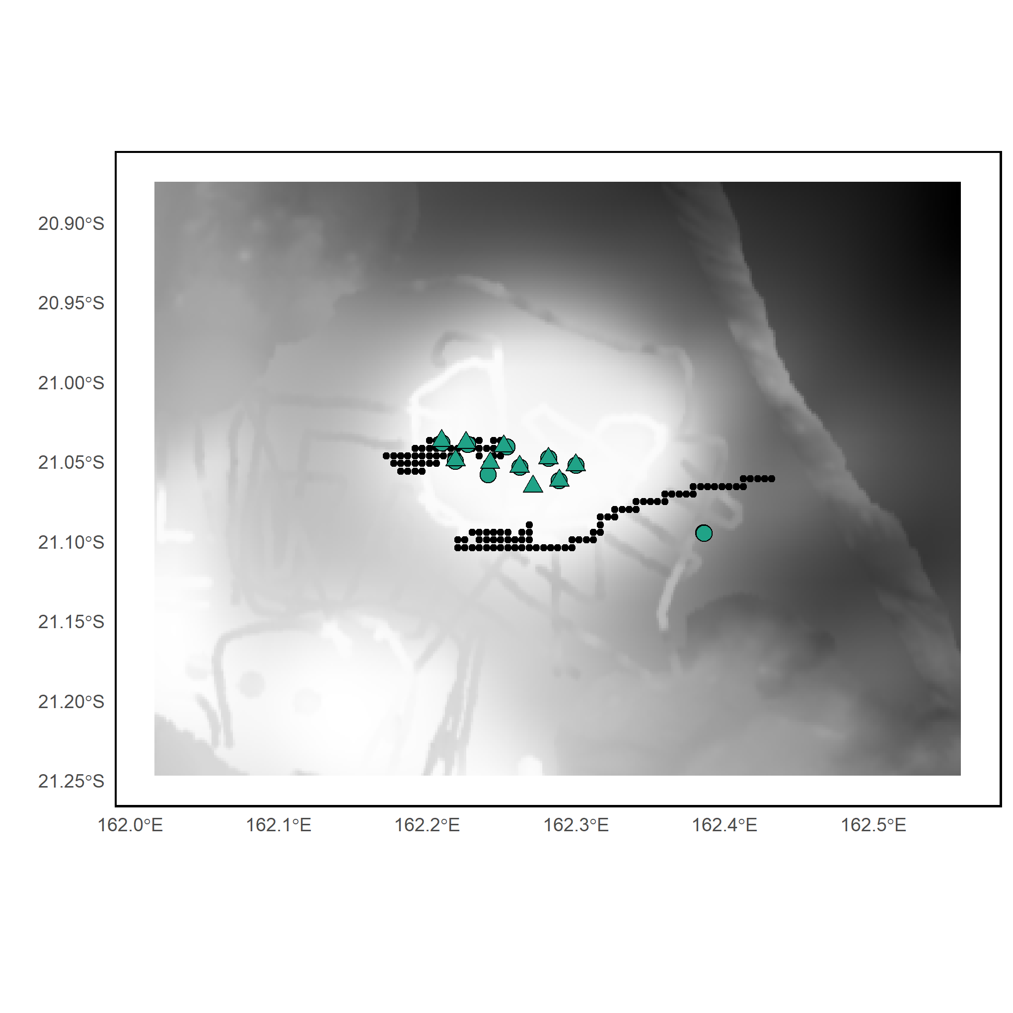

***Appendix S18.*** *Sampling design in site 15 (Fairway). Grey shading indicates the depth category. BRUVS sampling stations (triangles), eDNA sampling stations (circles), and acoustic recordings (black dots).*

***Appendix S19. Values (min, mean and max) of the 7 fish community metrics measured by the 3 sampling methods.***

|  |  |  |  |  |
| --- | --- | --- | --- | --- |
| Method | Metric | Min | Mean | Max |
| BRUVS | Benthic fish richness | 1 | 6.84 ± 8.46 | 42 |
| Benthic fish biomass | 0.180 kg | 113.28 ± 121 | 677 kg |
| Benthic fish abundance | 2 | 35.3 ± 79.9 | 754 |
| eDNA | Benthic MOTU richness | 0 | 13.26 ± 13.35 | 71 |
| Pelagic MOTU richness | 0 | 7.9 ± 7.7 | 42 |
| Acoustic | Benthic biomass | 5.34 | 11.46 ± 19.72 | 29.48 |
| Pelagic biomass | 1.62 | 2.85 ± 5.7 | 4.34 |

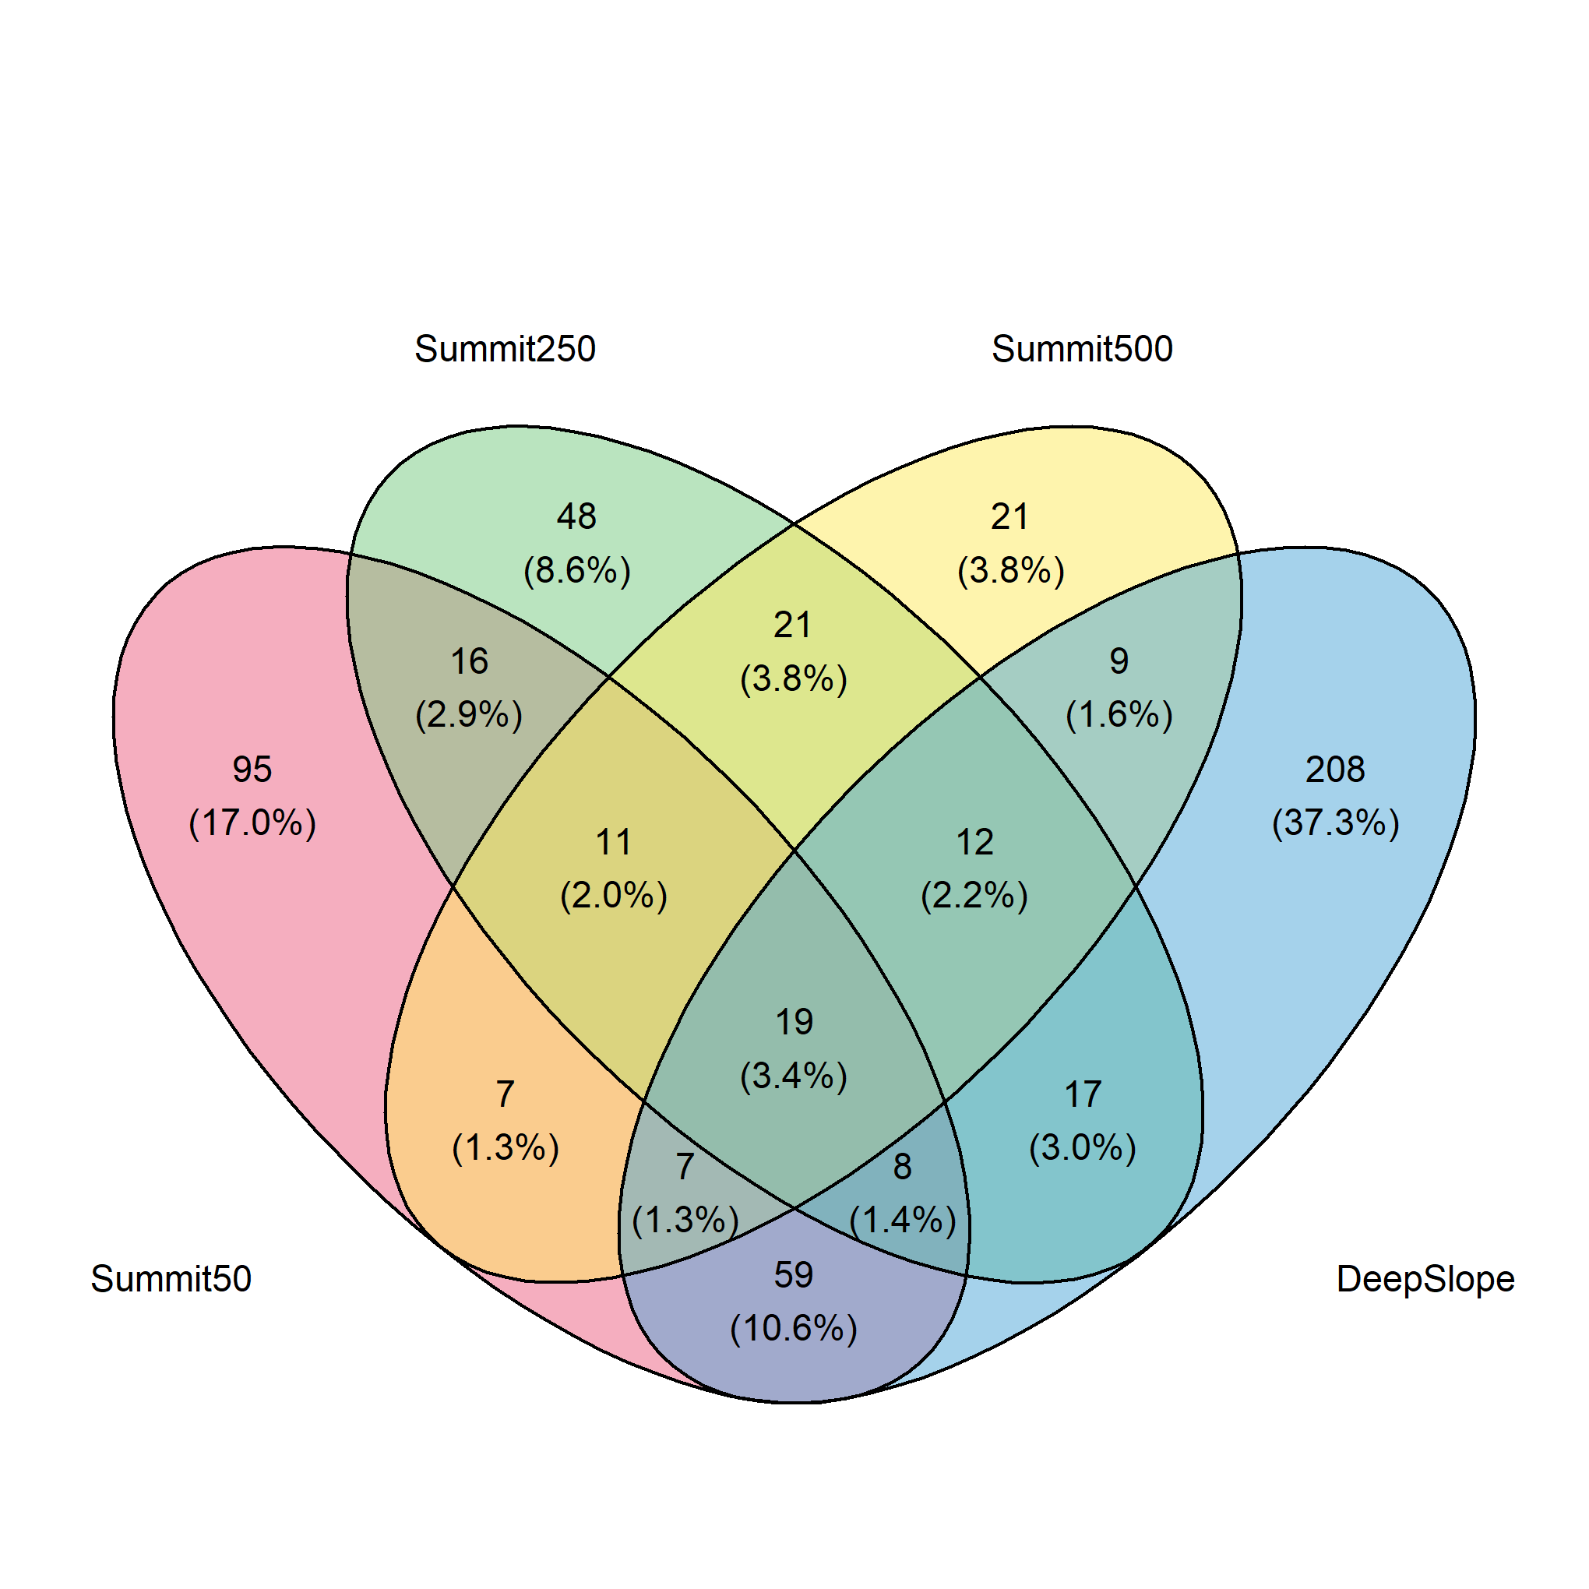 ***Appendix S20. Venn diagram of MOTUs identified with eDNA.*** *Number and percentage of MOTUs unique to each habitat, and shared between two, three or four habitats.*

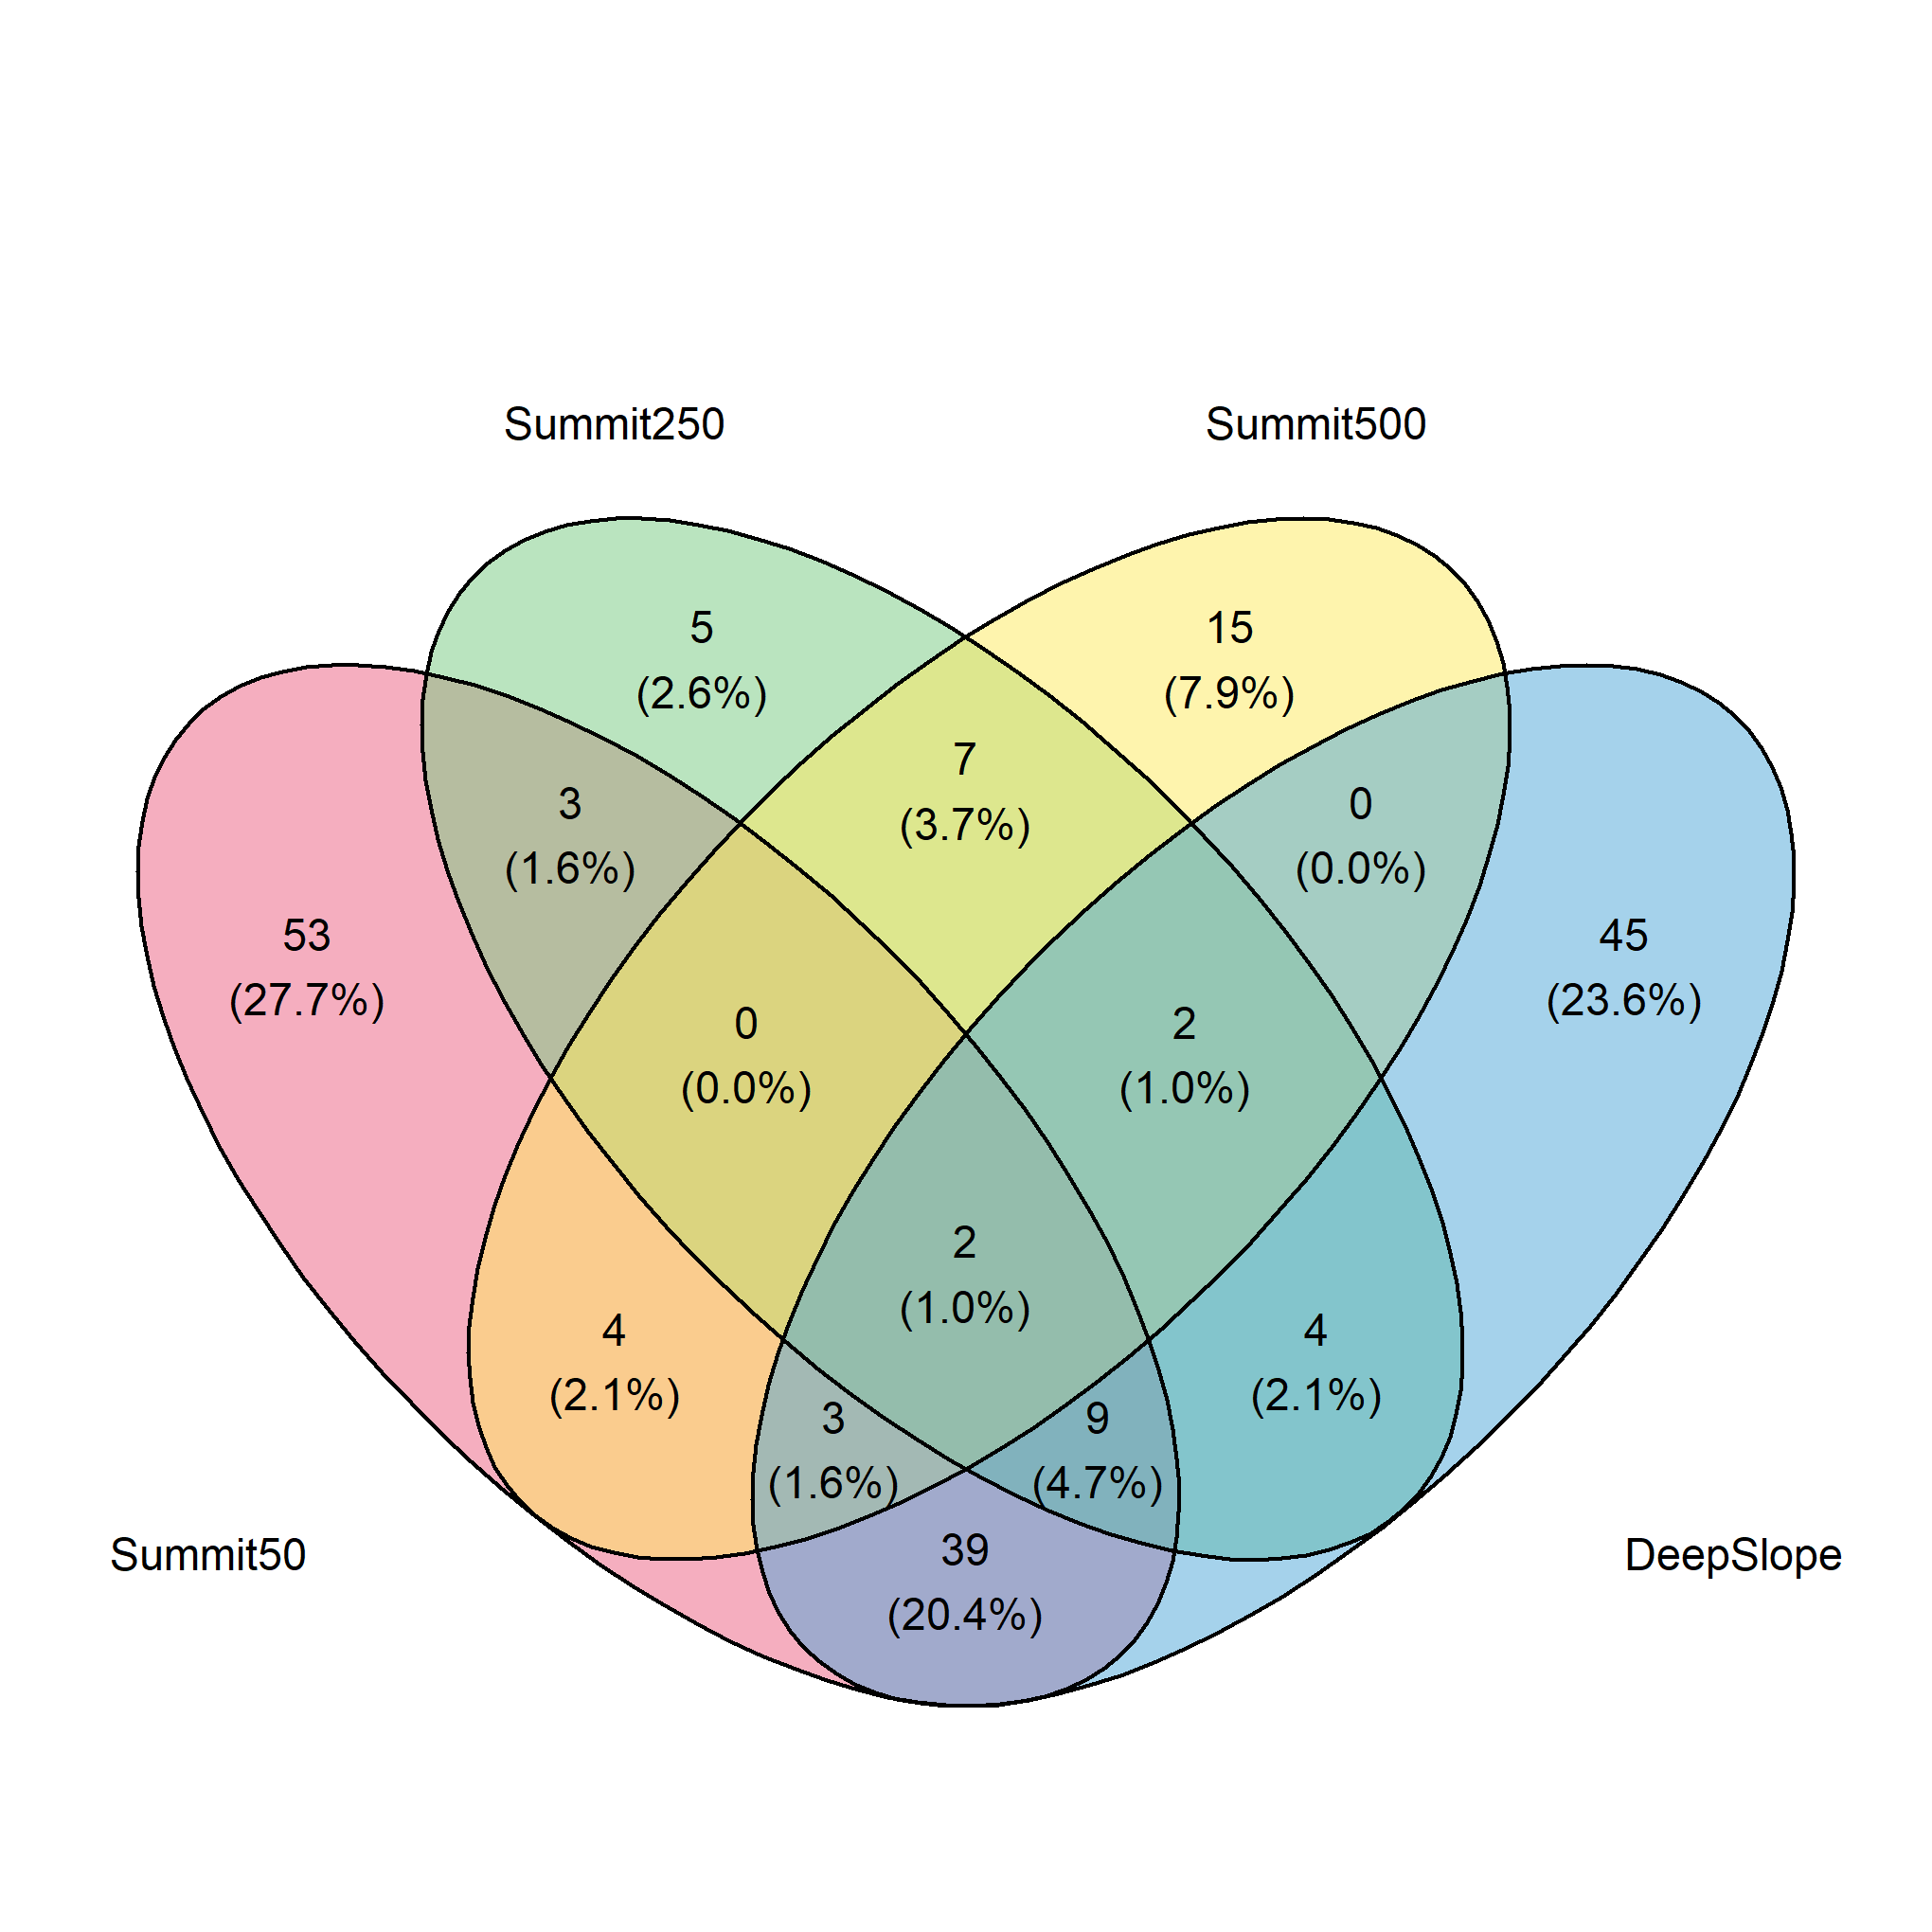

***Appendix S21. Venn diagram of species identified with BRUVS.*** *Number and percentage of species unique to each habitat, and shared between two, three or four habitats.*

***Appendix S22.*** *MOTUs selected for the GJAM model on benthic MOTU read abundance by eDNA*

|  |  |  |  |  |
| --- | --- | --- | --- | --- |
| MOTU | Assignment | Min read number | Max read number | Mean read number |
| 3da8f1176b92c07364bc3896edf66759fb0ab965 | Myctophiformes | 0 | 528526 | 15462.55 |
| 85278160ab227ef795d7d34b3b7f143ce48f85d0 | Myctophidae | 0 | 368637 | 10921.37 |
| d6945c710869f4b37aa5130f8c13f2fffbf7b7d3 | Clupeocephala | 0 | 2264954 | 25560.08 |
| ef40c96064831034fabfc6cf9c0c1e073e3e3515 | Percomorphaceae | 0 | 625223 | 11211.06 |
| 966b82c7f5deb4d86bb7245414bacad68917cfa8 | Diaphus | 0 | 1197125 | 16485.50 |
| 278fada4a105bc0ca041da419686a7486f08a66a | Percomorphaceae | 0 | 458036 | 14024.04 |
| 89237aa306b52b84a560cc510d820aff82bc22aa | Naso | 0 | 940494 | 9741.21 |
| 9eb94e56c2f5b5fadac929dc12d3520f642a1aa1 | Beryx | 0 | 1711722 | 35497.61 |
| 8ad697ca257e80c0e9a1fb4d180766d76fed37fc | Eupercaria | 0 | 266410 | 7169.08 |
| bc50ec564902f2a348db5a327290cdf47bd2ed15 | Diogenichthys | 0 | 299446 | 6718.53 |
| d83357c786e0943ffd8df9fedfb0f11fd5f193cf | Parupeneus | 0 | 97586 | 1843.98 |
| 0a68e7af285e1c8a09c4b3a1d1eb8358ae9993e9 | Scomberomorus | 0 | 672106 | 12110.83 |

***Appendix S23.*** *MOTUs selected for the GJAM model on pelagic MOTU read abundance by eDNA*

|  |  |  |  |  |
| --- | --- | --- | --- | --- |
| MOTU | Assignment | Min read number | Max read number | Mean read number |
| 198f251983a2c07127b0627155c2bfd1cb395018 | Myctophidae | 0 | 74986 | 1726.90 |
| 64bd1d960e40022a1495514b003ec2d6d6eff0d0 | Diaphus | 0 | 63446 | 2158.40 |
| 3ea7ca11fd53b49737dfe737333399f3fd6f3ba5 | Lethrinus | 0 | 138913 | 4381 |
| 88f21a755cd3ada743d261a320b227d3296c497a | Percomorphaceae | 0 | 60721 | 1011.27 |
| 4da9175453088622f374a4c218d51abb164dce98 | Thunnus | 0 | 26575 | 1583.50 |
| 61be9061b5785556dd08d30ea76efb00d167bc3a | Lutjanus | 0 | 46122 | 987.48 |
| 3b0c030da83544658146617d798382ff6ffa1aa0 | Sardina pilchardus | 0 | 78994 | 1638.37 |
| 278fada4a105bc0ca041da419686a7486f08a66a | Percomorphaceae | 0 | 57919 | 2776.81 |
| 4138a9e4b074a38af19d74bfb1035179c89c9ede | Tylosurus | 0 | 14785 | 408.62 |
| 0a68e7af285e1c8a09c4b3a1d1eb8358ae9993e9 | Scomberomorus | 0 | 8024 | 399.70 |

***Appendix S24.*** *Species selected for the GJAM model on individual abundance by BRUVS*

|  |  |  |  |
| --- | --- | --- | --- |
| Species | Min abundance | Max abundance | Mean abundance |
| *Aphareus rutilans* | 0 | 12 | 0.65 |
| *Carcharhinus albimarginatus* | 0 | 6 | 0.616 |
| *Pristipomoides flavipinnis* | 0 | 8 | 0.616 |
| *Pristipomoides filamentosus* | 0 | 26 | 2.116 |
| *Seriola rivoliana* | 0 | 25 | 1.816 |
| *Carcharhinus plumbeus* | 0 | 4 | 0.308 |
| *Gymnosarda unicolor* | 0 | 2 | 0.125 |
| *Lethrinus miniatus* | 0 | 24 | 1.375 |
| *Lethrinus rubrioperculatus* | 0 | 13 | 0.366 |
| *Gymnocranius euanus* | 0 | 13 | 1.208 |
| *Bodianus bimaculatus* | 0 | 3 | 0.116 |
| *Epinephelus chlorostigma* | 0 | 8 | 0.408 |
| *Wattsia mossambica* | 0 | 10 | 0.341 |
| *Aprion virescens* | 0 | 5 | 0.383 |
| *Carangoides orthogrammus* | 0 | 50 | 0.608 |
| *Pseudocaranx dentex* | 0 | 41 | 1.291 |
| *Seriola lalandi* | 0 | 10 | 0.325 |
| *Squalus megalops* | 0 | 10 | 0.866 |
| *Epinephelus morrhua* | 0 | 2 | 0.158 |
| *Etelis coruscans* | 0 | 12 | 0.425 |
| *Pristipomoides argyrogrammicus* | 0 | 4 | 0.325 |
| *Polymixia japonica* | 0 | 5 | 0.225 |
| *Pentaceros richardsoni* | 0 | 3 | 0.075 |

***Appendix S25.*** *Details on boosted regression trees (BRT) model parameters and goodness-of-fit*

|  |  |  |  |  |  |  |
| --- | --- | --- | --- | --- | --- | --- |
| **Response variable** | **Explanatory variables** | **Tree complexity** | **Learning rate** | **Bag Fraction** | **Number of trees** | **Cross-validation correlation** |
| BRUVS species richness | SummitRugosity,  BottomDepth,  SSTmean,  Salinity | 1 | 0.005 | 0.75 | 1050 | 0.70 ± 0.05 |
| BRUVS biomass | TravelTime,  SSTmax,  BottomDepth,  Salinity,  seafloorTemp,  Suspended Particulate Matter | 5 | 0.005 | 0.75 | 1600 | 0.85 ± 0.02 |
| BRUVS abundance | BottomDepth,  SSTmax,  EastwardVelocity | 5 | 0.001 | 0.75 | 2350 | 0.62 ± 0.05 |
| eDNA MOTU richness benthic | TravelTime,  SSTmax,  Salinity,  Chla | 2 | 0.001 | 0.5 | 1425 | 0.42 ± 0.07 |
| eDNA MOTU richness pelagic | SummitRugosity,  EastwardVelocity,  NorthwardVelocity,  Sampling_Depth,  Salinity,  seafloorTemp,  LandMinDist | 2 | 0.005 | 0.75 | 1525 | 0.60 ± 0.09 |
| Benthic acoustic biomass | LandMinDist,  SSTmean,  BottomDepth,  Chla,  EastwardVelocity,  NorthwardVelocity | 5 | 0.01 | 0.5 | 3650 | 0.59 ± 0.01 |
| Pelagic acoustic biomass | Sampling_Depth,  TravelTime,  SSTmean | 5 | 0.01 | 0.75 | 10000 | 0.76 ± 0.001 |

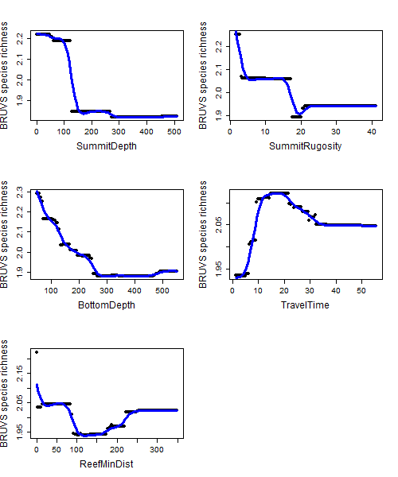

***Appendix S26.*** *Partial relationships between explanatory variables and BRUVS species richness in BRTs.*

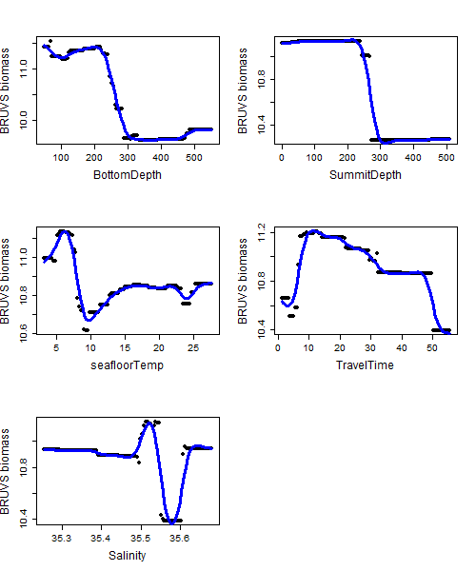 ***Appendix S27.*** *Partial relationships between explanatory variables and BRUVS biomass (log-transformed) in BRTs.*

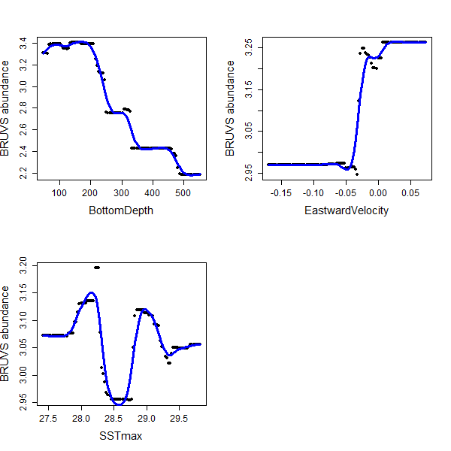

***Appendix S28.*** *Partial relationships between explanatory variables and BRUVS abundance (log-transformed) in BRTs.*

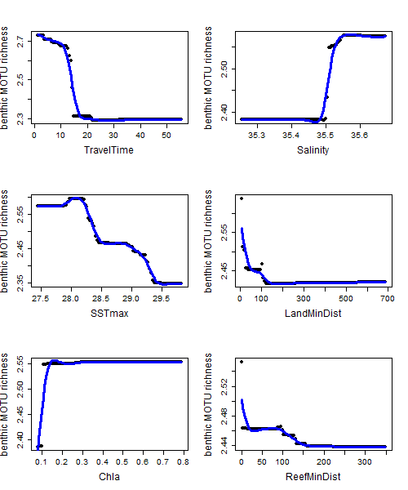

***Appendix S29.*** *Partial relationships between explanatory variables and benthic MOTU richness (log-transformed) in BRTs.*

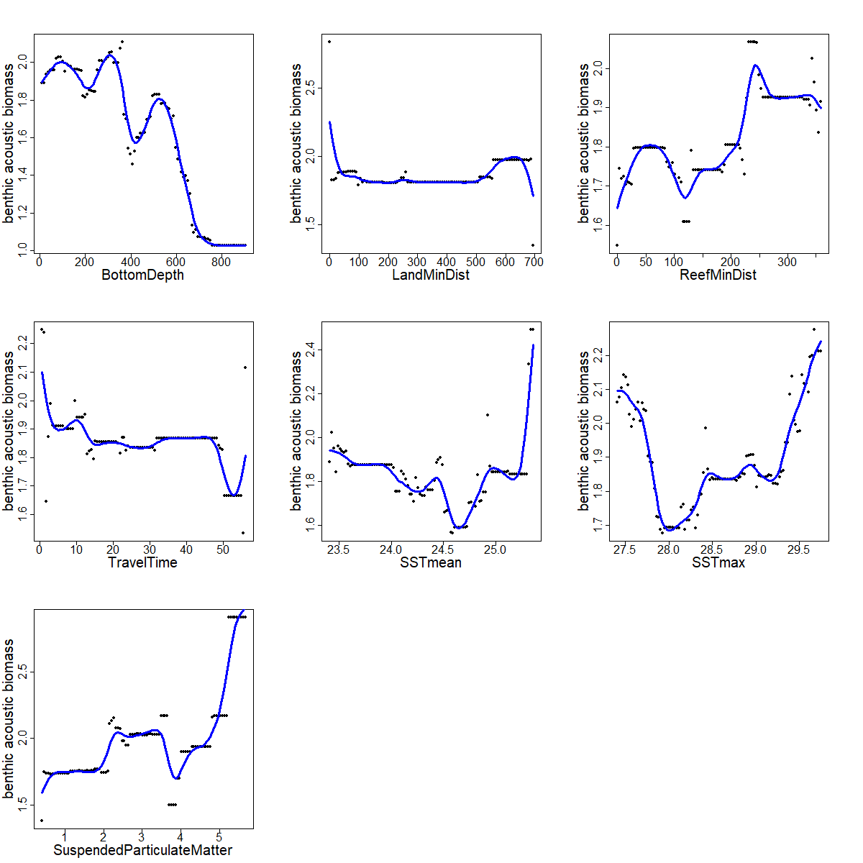

***Appendix S30.*** *Partial relationships between explanatory variables and benthic acoustic biomass (log-transformed) in BRTs.*

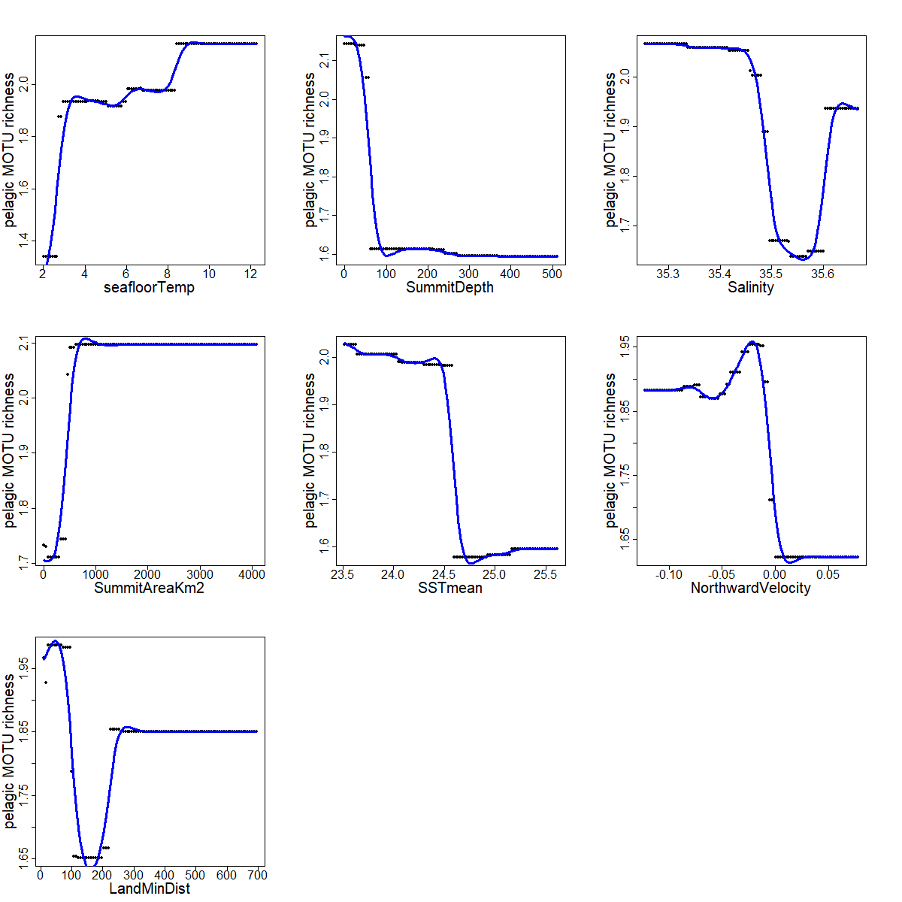

***Appendix S31.*** *Partial relationships between explanatory variables and pelagic MOTU richness (log-transformed) in BRTs.*

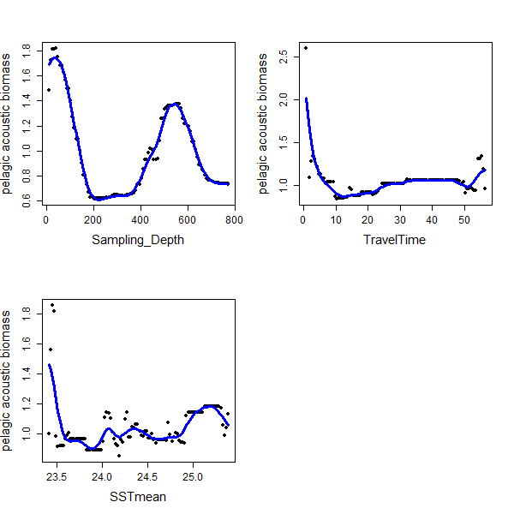

***Appendix S32.*** *Partial relationships between explanatory variables and pelagic acoustic biomass in BRTs.*

***Appendix S33.*** *Details on generalized joint attribute models (GJAM) goodness-of-fit*

|  |  |  |  |
| --- | --- | --- | --- |
| **Response variable** | **Explanatory variables** | **DIC** | **Pearson r** |
| BRUVS species abundances | SSTmean^3,  BottomDepth^2,  EastwardVelocity^3,  LandMinDist^2,  Salinity^2,  TravelTime,  Habitat,  SummitRugosity | 22469 | 0.62 |
| eDNA benthic MOTU read number | SSTmean^2,  BottomDepth^2,  ReefMinDist,  TravelTime,  SuspendedParticulateMatter^2,  Salinity^3,  NorthwardVelocity^3,  Habitat,  SummitRugosity^2 | 4207 | 0.63 |
| eDNA pelagic MOTU read number | SSTmean,  SuspendedParticulateMatter,  Habitat,  Salinity^2,  TravelTime,  ReefMinDist,  seafloorTemp^3,  SummitRugosity^2,  SummitAreaKm²,  NorthwardVelocity^2,  EastwardVelocity,  SamplingDepth,  BottomDepth | 1491 | 0.67 |

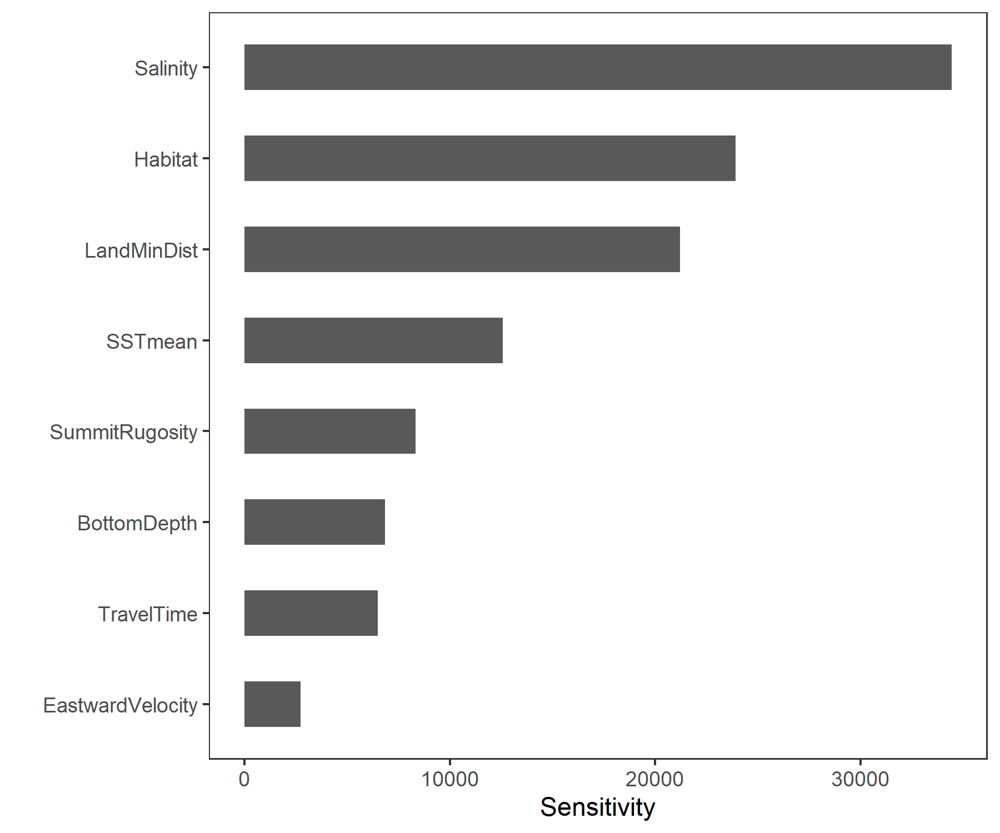

***Appendix S34.*** *Sensitivity of species abundance measured by BRUVS to each variable (sum of linear, quadratic and cubic terms when applicable) in the GJAM model.*

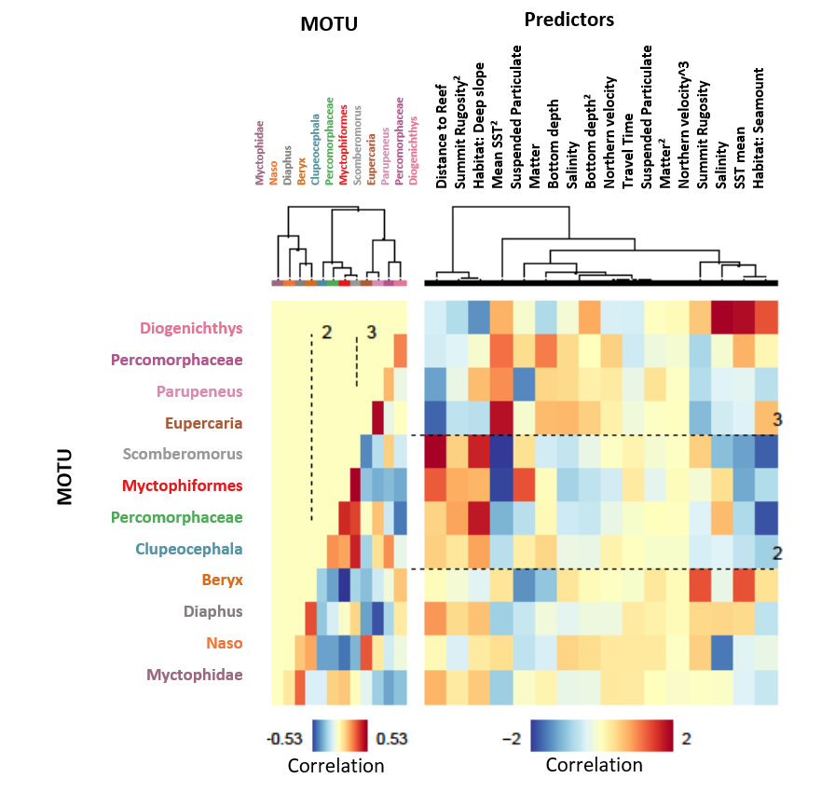

***Appendix S35. Cluster and grid plot of fitted benthic MOTU read number and predictors.*** *Left panel represents correlation among MOTUs in terms of their responses to predictors (with associated correlation scale). Right panel represents the correlation of each MOTU with predictors (with associated correlation scale). Dotted lines represent the distinction between the clusters of MOTUs identified by the model. Red indicates strong positive correlation, and blue indicates strong negative correlation.*

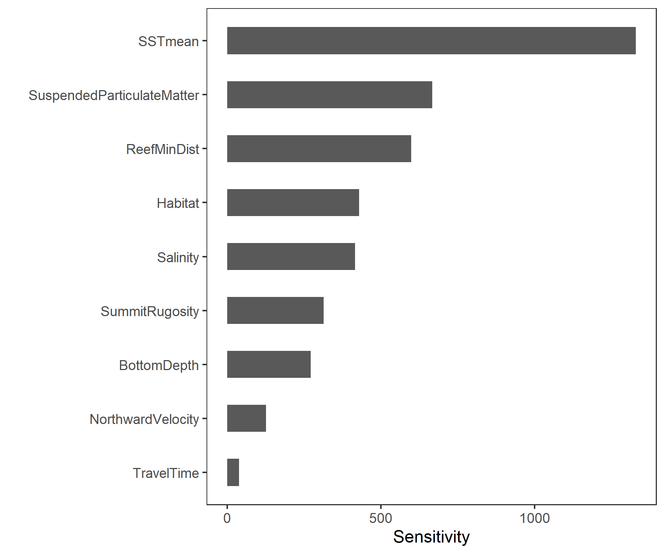

***Appendix S36.*** *Sensitivity of benthic MOTU read number measured by eDNA to each variable (sum of linear, quadratic and cubic terms when applicable) in the GJAM model.*

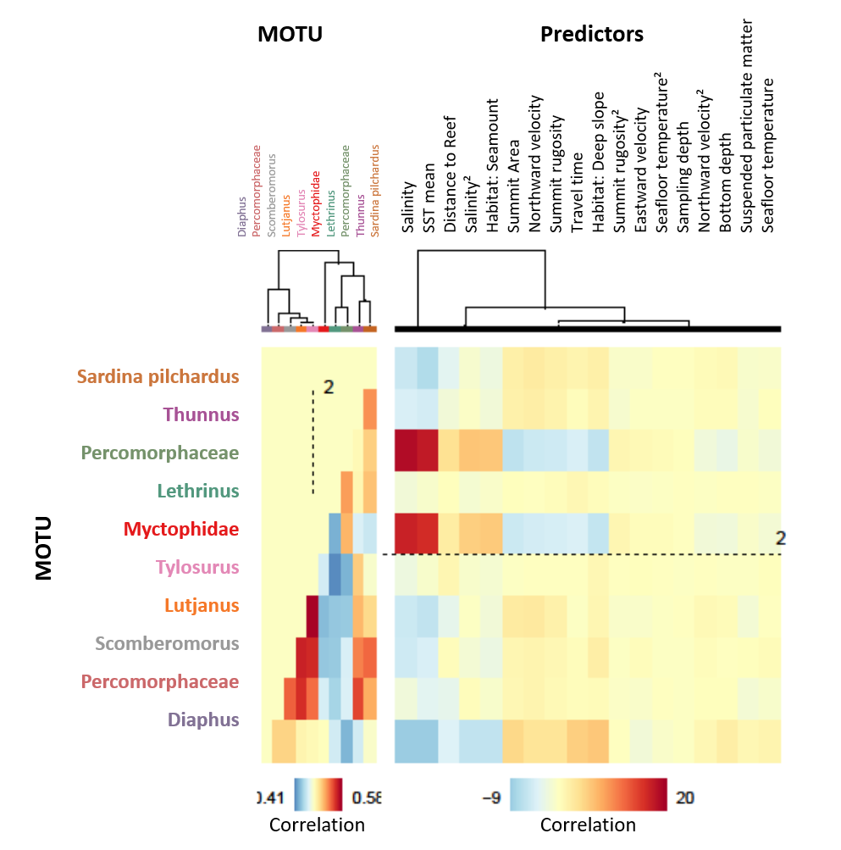

***Appendix S37. Cluster and grid plot of fitted pelagic MOTU read number and predictors.*** *Left panel represents correlation among MOTUs in terms of their responses to predictors (with associated correlation scale). Right panel represents the correlation of each MOTU with predictors (with associated correlation scale). Dotted lines represent the distinction between the clusters of MOTUs identified by the model. Red indicates strong positive correlation, and blue indicates strong negative correlation.*

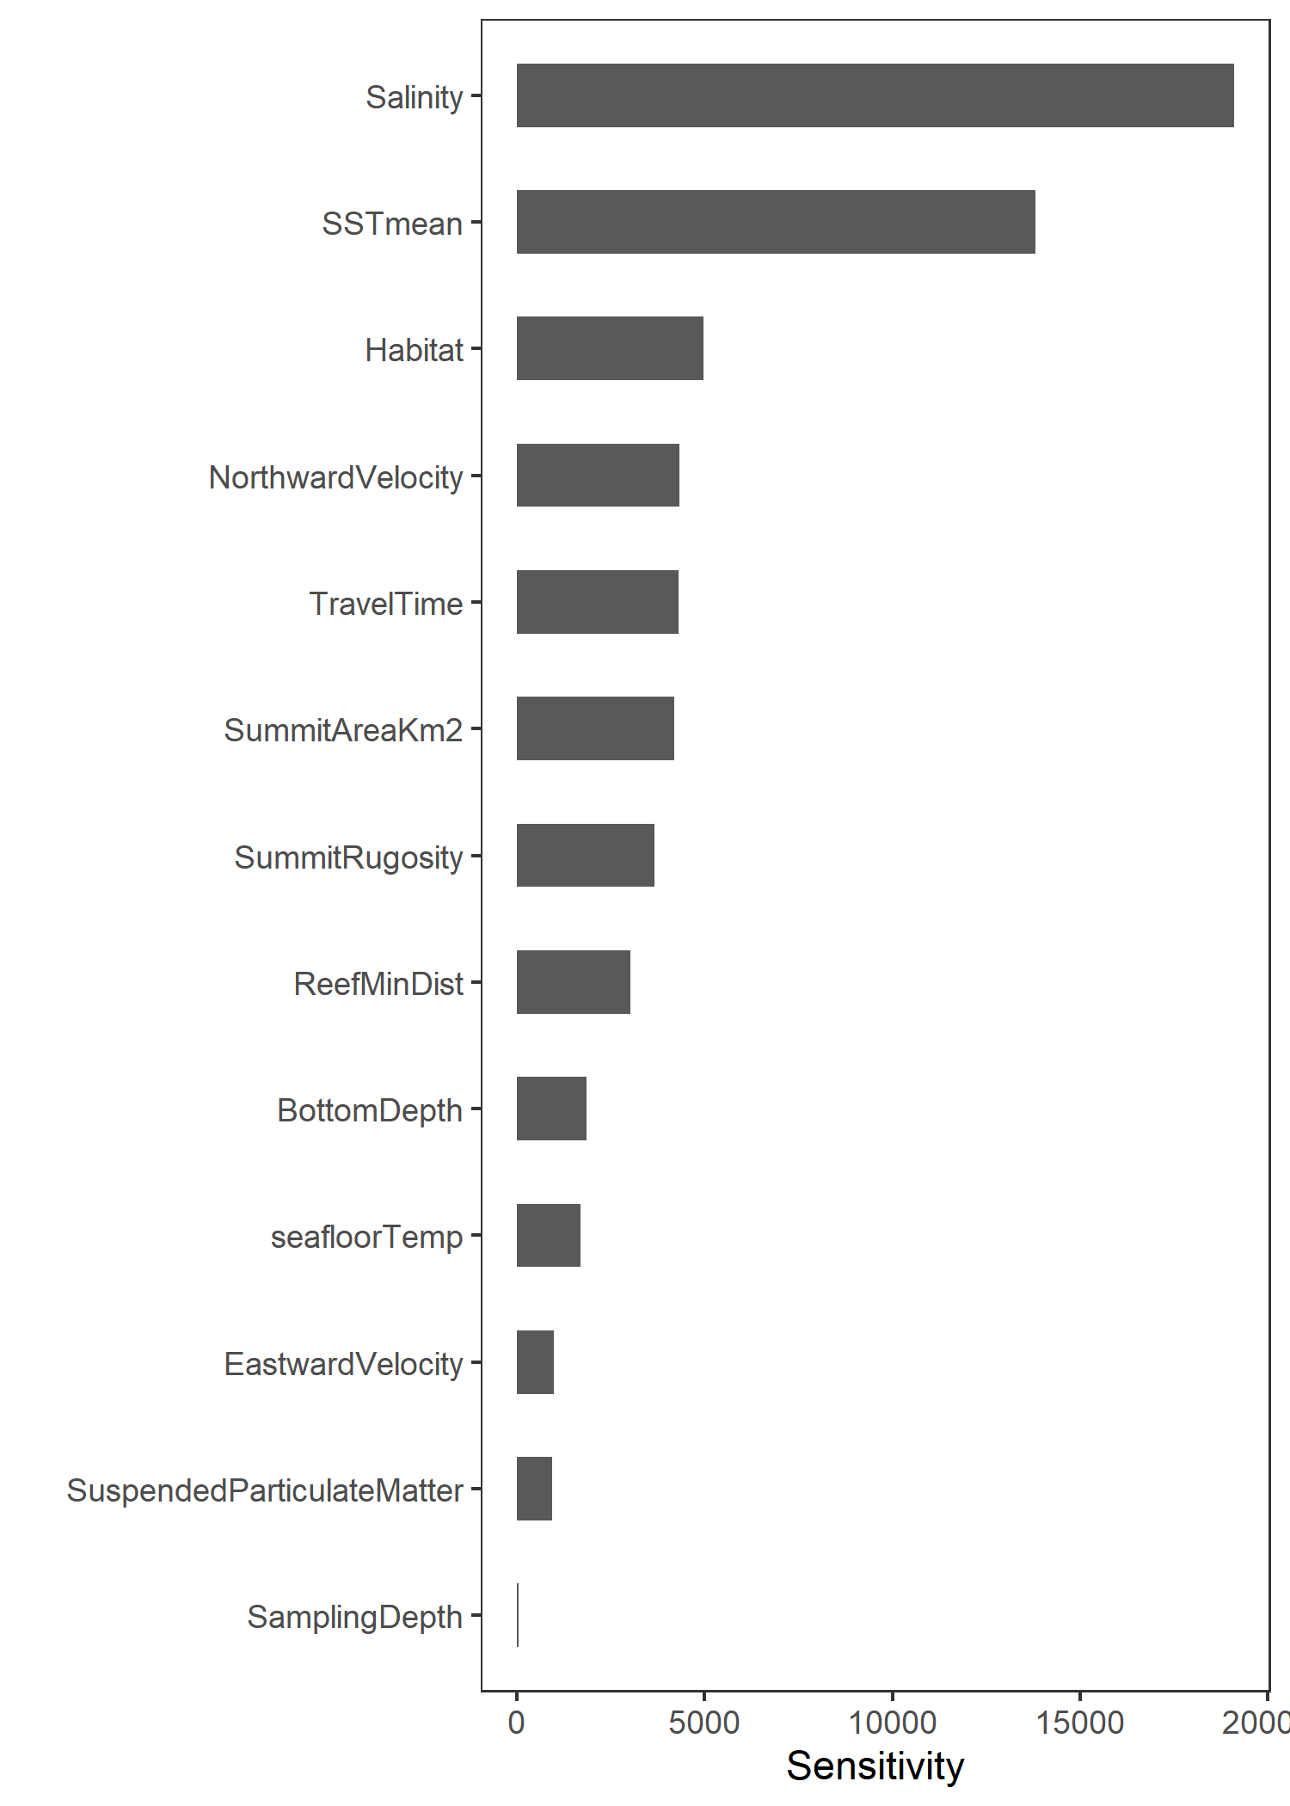

***Appendix S38.*** *Sensitivity of pelagic MOTU read number measured by eDNA to each variable (sum of linear, quadratic and cubic terms when applicable) in the GJAM model.*

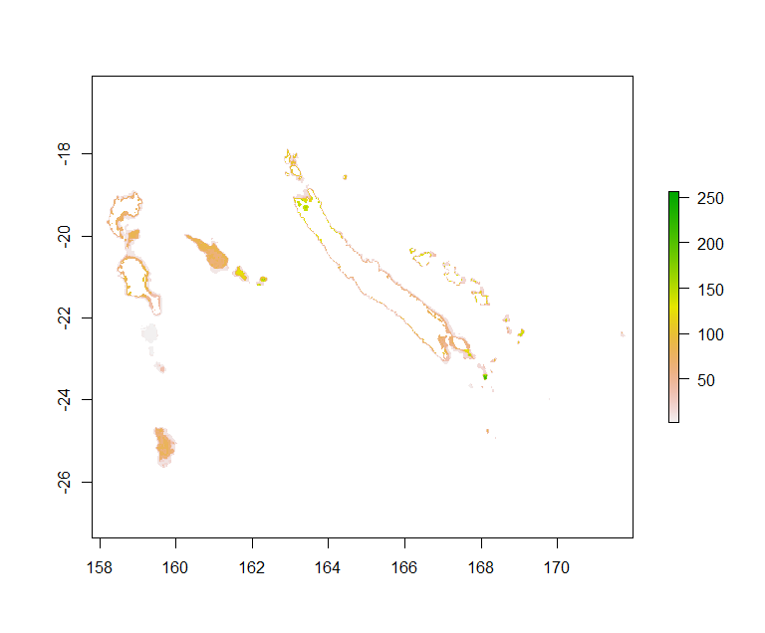

***Appendix S39. Prediction of total fish biomass measured by BRUVS (in Kg),*** *from the fitted values of the BRT model, in all seamounts and deep slopes of the New-Caledonian ZEE, down to 600 m deep.*

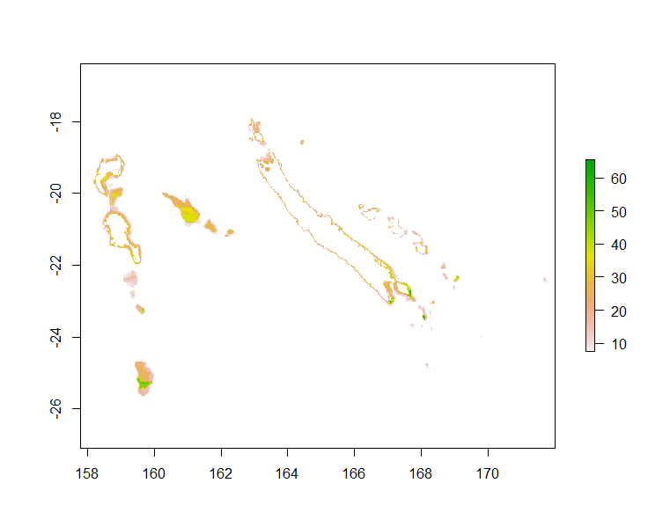

***Appendix S40. Prediction of total fish abundance measured by BRUVS,*** *from the fitted values of the BRT model, in all seamounts and deep slopes of the New-Caledonian ZEE, down to 600 m deep.*

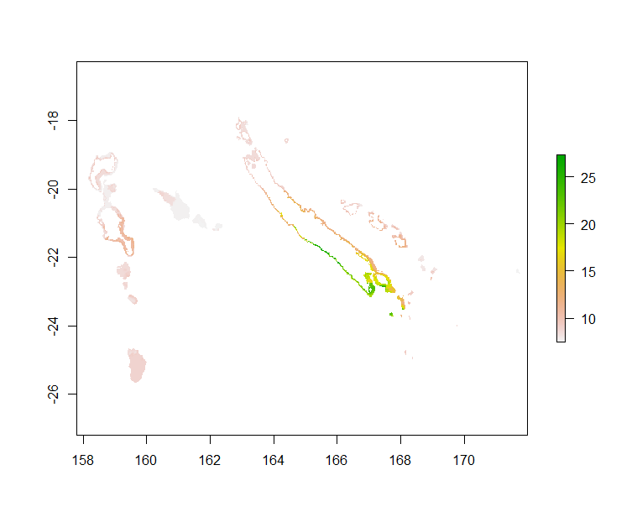

***Appendix S41. Prediction of benthic MOTU richness measured by eDNA,*** *from the fitted values of the BRT model, in all seamounts and deep slopes of the New-Caledonian ZEE, down to 600 m deep.*

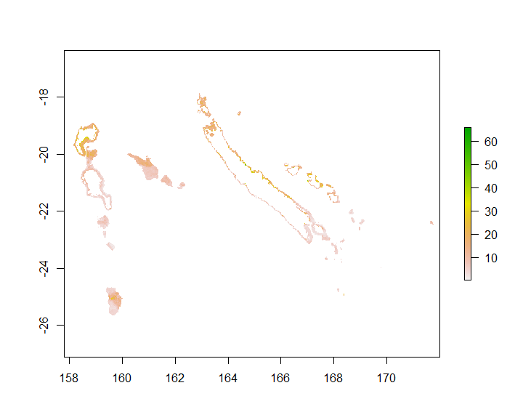

***Appendix S42. Prediction of benthic acoustic biomass,*** *from the fitted values of the BRT model, in all seamounts and deep slopes of the New-Caledonian ZEE, down to 600 m deep.*

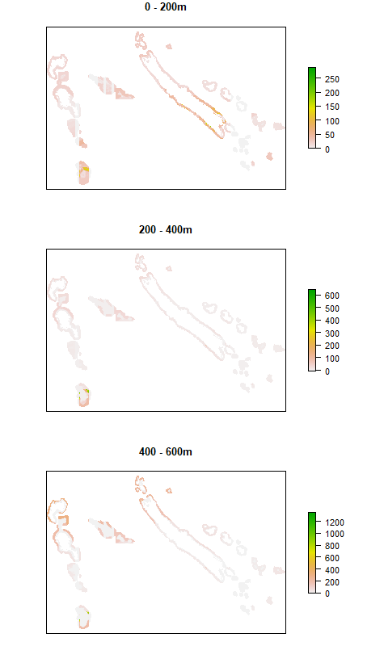

***Appendix S43. Prediction of pelagic acoustic biomass,*** *from the fitted values of the BRT model, in all seamounts and deep slopes of the New-Caledonian ZEE, down to 600 m deep, in the three depth layers: 0-200 m, 200-400 m and 400-600 m.*

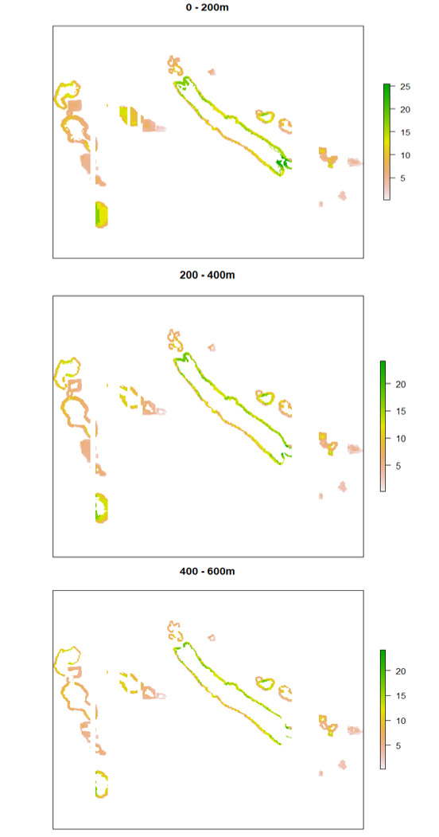

***Appendix S44. Prediction of pelagic MOTU richness,*** *from the fitted values of the BRT model, in all seamounts and deep slopes of the New-Caledonian ZEE, down to 600 m deep, in the three depth layers: 0-200 m, 200-400 m and 400-600 m.*

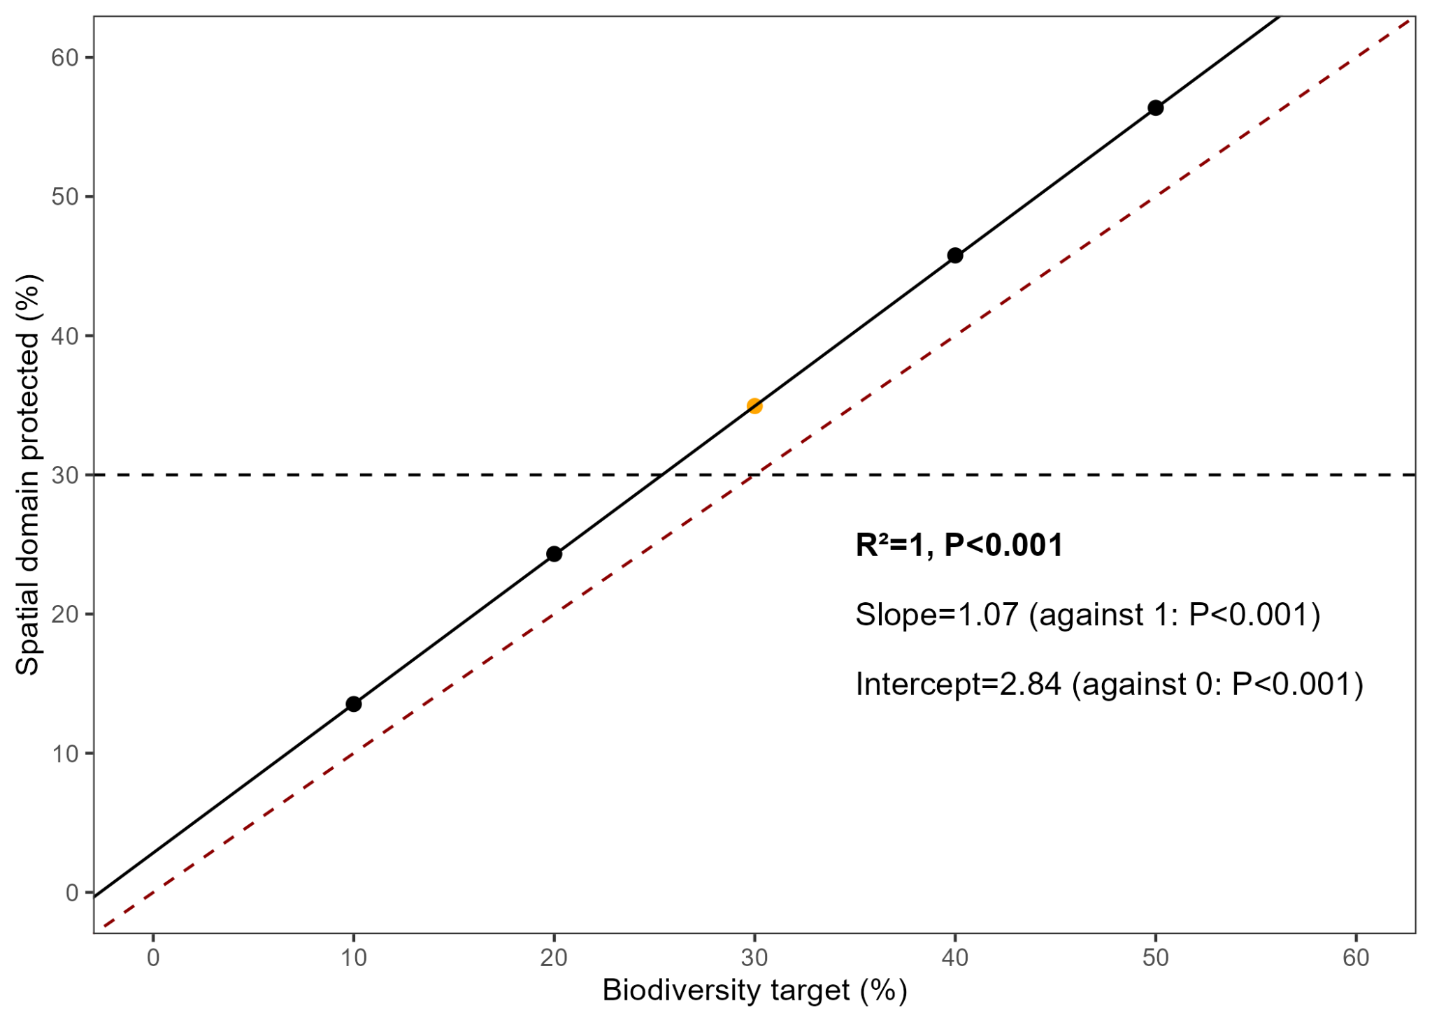 ***Appendix S45. Percentage of the spatial domain protected by the prioritizing solutions with various biodiversity protection targets****, and no penalty on fragmentation (BLM=0). Equation of the regression of spatial domain protected according to biodiversity target. Black line indicates the regression. Red dotted line indicates line 1:1.*

***Appendix S46.*** *Ranking of the different solutions of prioritization computed with different boundary length modifier values (blmval), by the TOPSIS method based on their total cost and total boundary area. Ranking with a wide BLM values range.*

|  |  |  |  |  |
| --- | --- | --- | --- | --- |
| blmval | Total boundary area (km²) | Total cost | score | rank |
| 0 | 51583.76 | 60241 | 0.09155 | 8 |
| 1,00E-04 | 44632.78 | 60273 | 0.34030 | 7 |
| 1,00E-03 | 42315.56 | 60488 | 0.44617 | 6 |
| 1,00E-02 | 41455.75 | 61115 | 0.48427 | 5 |
| 1,00E-01 | 38404.72 | 60932 | 0.62829 | 4 |
| 1 | 31569.01 | 62761 | 0.91294 | 2 |
| 10 | 30557.67 | 63112 | 0.91934 | 1 |
| 100 | 30867.51 | 63539 | 0.90630 | 3 |

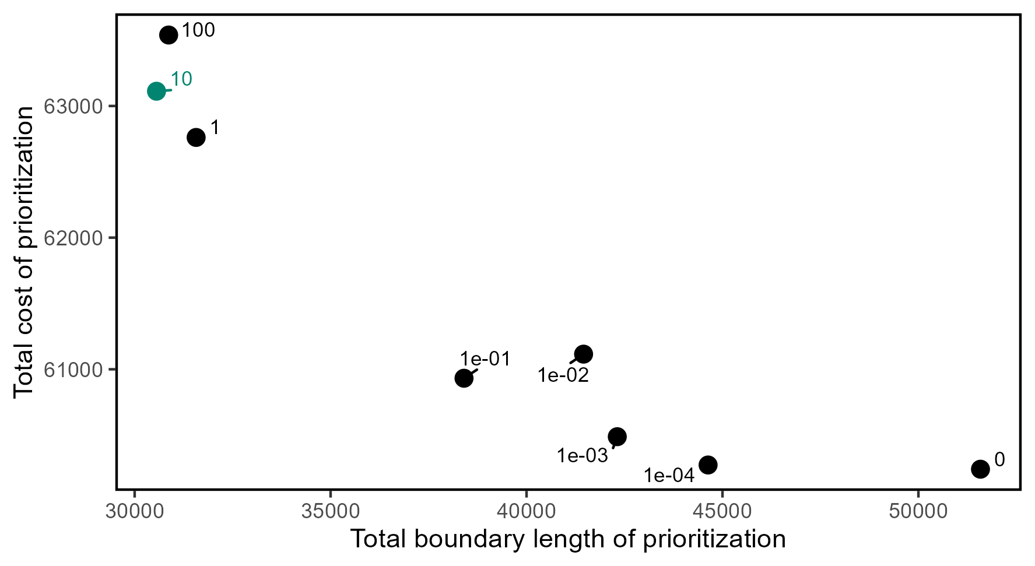

***Appendix S47.*** *Prioritization solutions according to their total cost and total boundary length. Labels indicate the boundary length modifier values (BLM). Green dot indicates the best solution.*

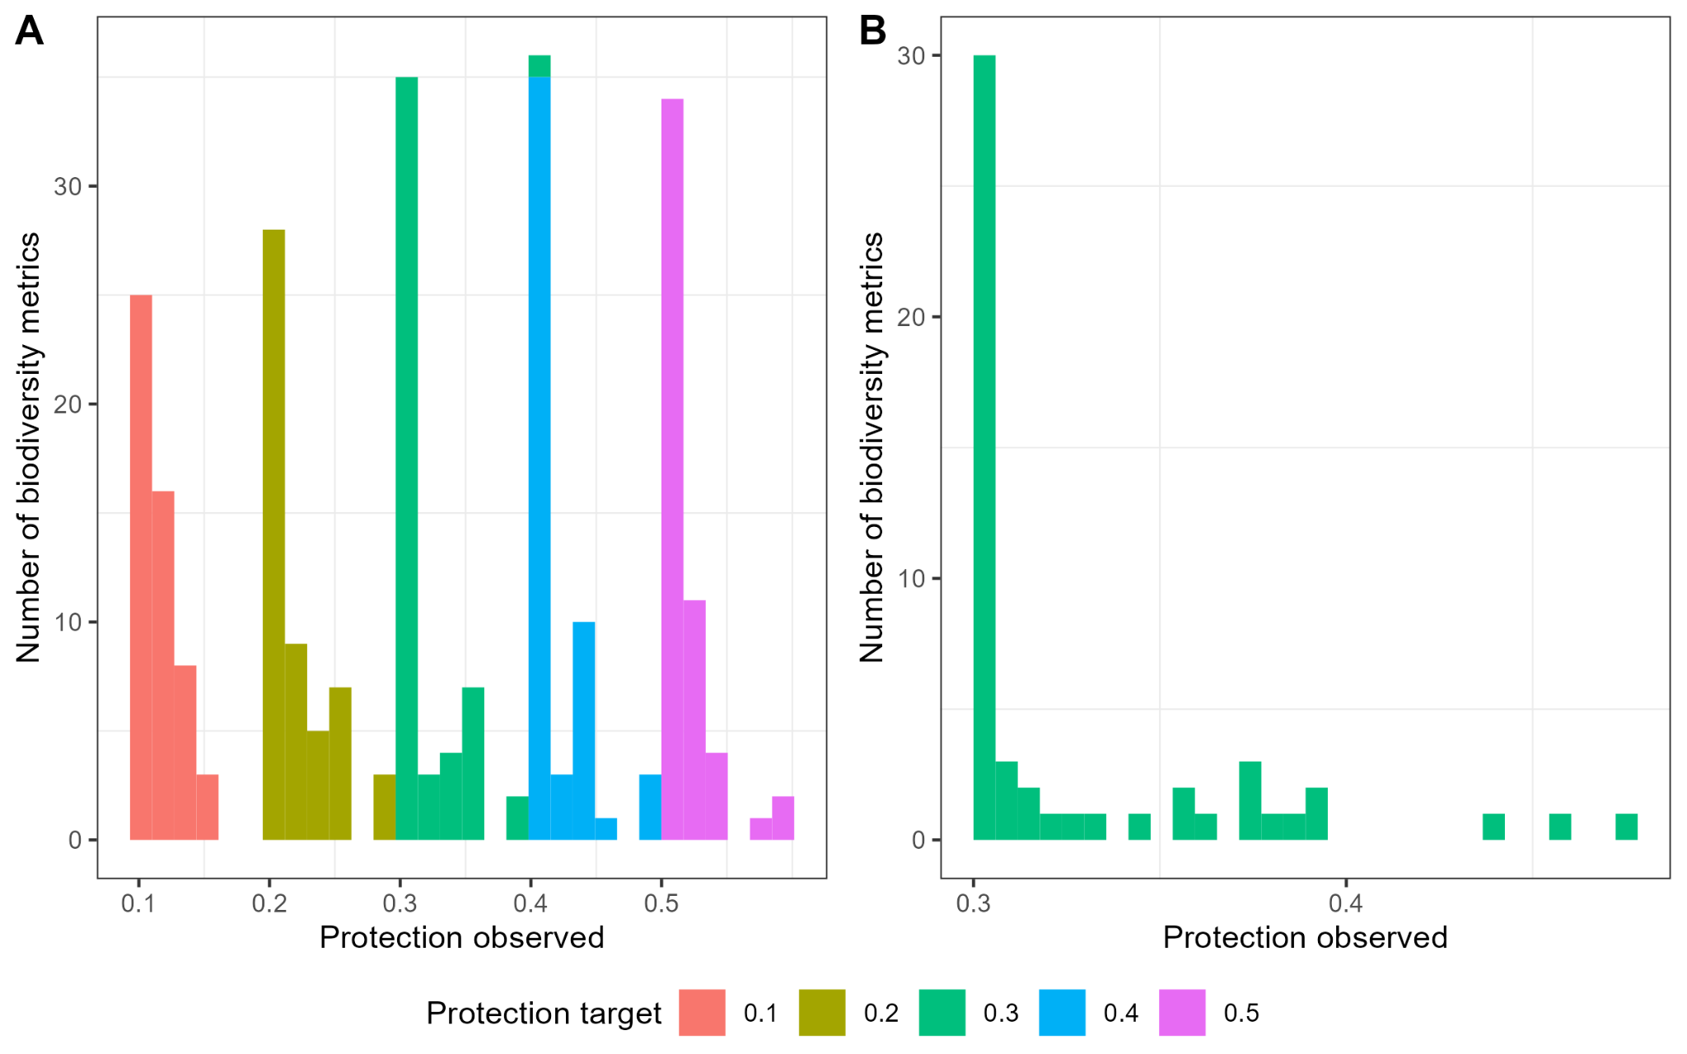

***Appendix S48.*** *(A) Distribution of observed protection for each metric and each target scenario, with no penalty on fragmentation (BLM=0), and (B) distribution of observed protection for each metric in the scenario with a biodiversity target of 0.3 and BLM value of 10.*

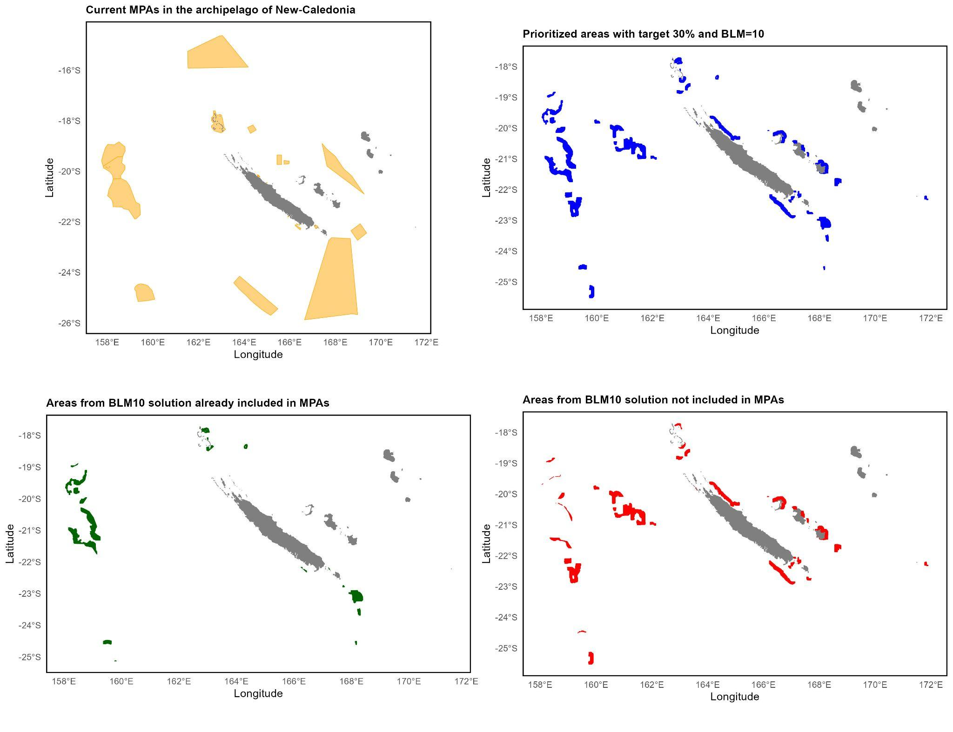

***Appendix S49.*** *Comparison between areas currently protected by MPAs in the archipelago of New-Caledonia (top left), and areas prioritized by our solution with target 30% and BLM=10 (top right). Thirty-six percent of areas of our solution are already included in MPAs (bottom left), while 64% are not included in MPAs (bottom right).*