**Supporting Information for Silicon isotopes reveal the impact of fjordic processes on the transport of reactive silicon from glaciers to coastal regions**

Tong Wang1*, Hong Chin Ng1,2, Jade E. Hatton3, Samantha J. Hammond4, E. Malcolm S. Woodward5, Lorenz Meire6,7, and Katharine R. Hendry1,8

1School of Earth Sciences, University of Bristol, Bristol, UK

2Laboratoire Géosciences Océan, Ifremer - UBO - CNRS, Plouzané, France

3Department of Ecology, Charles University, Prague, Czech Republic

4School of Environment, Earth, and Ecosystem Sciences, The Open University, Milton Keynes, UK

5Plymouth Marine Laboratory, Prospect Place, The Hoe, Plymouth, UK

6Greenland Climate Research Centre, Greenland Institute of Natural Resources, Nuuk, Greenland

7 Department of Estuarine and Delta Systems, Royal Netherlands Institute for Sea Research, Yerseke, The Netherlands

8Polar Oceans Team, British Antarctic Survey, Cambridge, UK

**Corresponding author:** Tong Wang ([tova.wang@bristol.ac.uk](mailto:tova.wang@bristol.ac.uk))

**Contents of this file**

Texts S1 to S2

Table S1

Figures S1 to S4

### **Text S1. Methods – Solid phase extraction (Additional experiment to examine the impact of oven drying on measurements of the concentration and isotopic composition in the Si-HCl and Si-Alk pool in sediments)**

Ward et al. (2022a) employed a sensitivity test experiment for the sequential extraction of reactive Si pools in sediments following Pickering et al. (2020). Their results showed that sample preparation methods (oven drying and grinding) have an impact on the estimated BSi content as well as the isotope composition in operational Si pools. However, the sensitivity test was carried out using sediments collected from a fully marine continental shelf (containing BSi). The influence of oven drying may be associated with the specific properties of diatoms or biogenic silica, for example, frustule breakage at temperatures above 50 ℃ (Flower, 1993), resulting in increased surface exposure of BSi and, so, increased Si-Alk content during Na2CO3 leaching (Ward et al., 2022a). In order to examine the impact of drying on the sequential extraction of sediments characterised by abiogenic amorphous silica, we also carried out an additional sensitivity analysis experiment based on the protocol from Pickering et al. (2020).

Replicate sediment samples at two different depths (shallow depth at 4.5 cm and deep depth around 20 cm) were selected at each site, AM10a and GF-inlet. Samples (approximately 60–90 mg dry weight) were divided into two different groups according to their different preparation techniques: 1) gentle thawing at room temperature (non-drying group); and 2) oven drying at 40 ℃ overnight (drying group). Non-drying and drying group samples were digested in the following sequence: 36 mL 0.1 M HCl (in-house distilled) leaching at room temperature for 18 hours with ultrasonic shaking for the first 30 minutes (Si-HCl pool); 5 mL 10% H2O2 (Romil SpA™) digestion for 30 minutes; 40 mL 0.1 M Na2CO3 (ACROS Organics™) leaching in a 85 ℃ for 5 hours (Si-Alk pool); 10 mL 4 M NaOH (Honeywell Fluka™) leaching for 2 hours in a water bath at 85 ℃ (Si-NaOH pool). After each digestion, the supernatant was removed following the centrifugation (4000 rpm, 10 minutes), and the residual sediments were rinsed with Milli-Q water (18.2 MΩ) 3 times to remove any remaining reagents. For the drying group, samples were oven dried overnight at 40 ℃ after each rinse and cooled down to room temperature before the next reaction step.

Ward et al. (2022a) suggests that the drying process could decrease the estimated BSi content by 54% due the lack of disaggregation caused by the hardness of dried clay-rich sediments (Mortlock & Froelich, 1989). However, our measurements show that oven drying could actually either increase or decrease the content of Si-HCl and Si-Alk (Figure S1). The reproducibility between the non-drying and drying groups, evaluated from the average standard deviation of repeat sample measurements, varies from 3% to 15% in Si-HCl pool and from 1% to 24% in Si-Alk pool. These values are within previously published uncertainties in this sequential extraction protocol, which are around 15% and 25% for Si-HCl and Si-Alk phases, respectively. We therefore suggest that the discrepancy of Si content in reactive pools between non-drying and drying groups are mainly due to the environmental heterogeneity.

In addition, the ultrasonic shaking at the first 30 minutes during HCl digestion helps to separate sediment grains and consequently increases the interaction between particles and solutions, and likely lowers the impact of hardness-derived aggregation. Thus, the drying group does not show significant reduction in Si-HCl contents (Figure S1a). In contrast, our measured Si-Alk content tends to enrich in the drying group, especially for the sample collected from the deep sediment depth at GF-inlet (Figure S1b). One possible reason for this discrepancy is the sample lost at the first 20 minutes during Na2CO3 extraction, when a quarter of leachate (10 mL) was collected for Si isotope analysis. Compared with the non-drying group, oven drying caused fine sediment grains to aggregate and form small clusters, which settled more readily during the short period of the digestion. After the first 20 minutes, there was more suspended sediment in the supernatant of the non-drying group, thus likely resulting in more sample being lost for the continuous Si-Alk extraction, which is consistent with our observations of particulates on the filters left from the non-drying group. In contrast, AM10a is characterized by relatively coarser grain size and lower Si-Alk content, which may help to decrease the impact caused by a small amount of sample loss.

Observed Si isotopic composition in Si-HCl pool (denoted by δ30SiHCl) varies from -0.69 ± 0.06‰ to -0.77 ± 0.05‰ at AM10a and from -0.67 ± 0.13‰ to -0.50 ± 0.01‰ at GF-inlet in the non-drying group, which is slightly more negative than that measured in the drying group (-0.59 ± 0.01‰ to -0.43 ± 0.09‰ at AM10a, and -0.55 ± 0.03‰ to -0.48 ± 0.06‰ at GF-inlet) (Figure S1c). For the Si-Alk pool, the range of measured isotope values (denoted by δ30SiAlk) in the non-drying group is between +0.46 ± 0.08‰ and +0.72 ± 0.02‰ at AM10a and between +0.46 ± 0.02‰ and +0.57 ± 0.08‰ at GF-inlet, while the drying group is generally characterized by slightly heavier δ30SiAlk values (except for the deep sediment at GF-inlet), ranging between +0.81 ± 0.02‰ and +0.84 ± 0.01‰ at AM10a and between +0.48 ± 0.02‰ and +0.63 ± 0.09‰ at GF-inlet (Figure S1d). The overall differences between these two groups average at 0.14‰ and 0.19‰ in Si-HCl pool and Si-Alk pool respectively, which is within previously published reproducibility for sediment leachates (0.001–0.23‰) (Ng et al., 2022; Ward et al., 2022a). In addition, based on ANOVA Test and Related-Samples Wilcoxon Signed Rank Test, this overall difference between the non-drying and drying groups, for both HCl leachate and the Na2CO3 leachate, is not statistically significant either among all samples of the group (ANOVA, *p* = 0.078 in δ30SiHCl and *p* = 0.231 in δ30SiAlk) or between matched sample chosen from the same depth (Related-Samples Wilcoxon Signed Rank Test, asymptotic significances are 0.068 and 0.273 in δ30SiHCl and δ30SiAlk, respectively). We therefore suggest that at our study sites, where the sediment is dominant by abiogenic glacially-derived ASi, the drying process does not have significant influences on the Si isotopic compositions of reactive pools operationally defined from the sequential extraction method following Pickering et al. (2020).

This finding is consistent with Ward et al. (2022a) in their conclusion for the Si-HCl pool, which is that sole oven drying does not impact the Si isotope values of the Si-HCl leachates significantly. However, our sensitivity test experiment does not provide evidence for any enrichment in light Si isotope of the δ30SiAlk of the drying group samples: on the contrary, the δ30SiAlk values in drying group are slightly more positive relative to the non-drying group. As such, we conclude that there are no significant differences in the isotopic composition of extracted Si-Alk phases between non-drying and drying group at our sites.

In summary, we suggest that drying step during the sequential extraction of reactive Si phases in sediments does not have an obvious impact on either concentration or isotope measurements at our study sites. The uncertainties associated with our sensitivity test experiment are mainly due to external issues, such as the environmental heterogeneity.

### **Text S2. Methods - Sample pre-concentration and purification**

Sample preparation was carried out at the Bristol Isotope Group laboratory (University of Bristol, UK), involving Si adsorption to Mg(OH)2 as it precipitated from seawater. A two-step addition of 1 M NaOH , 1.2% v/v and 1% v/v respectively, was carried out on the pH neutral samples for Mg(OH)2 precipitation. After each 1 M NaOH addition, samples were centrifuged and the supernatant was removed. After the second precipitation step, precipitates were rinsed with 0.001 M NaOH three times to remove excess ions, namely Na+, Cl-, SO42-, Ca2+, K+ (Ng et al., 2020). The final precipitates were dissolved by adding a few drops of 6 M HCl and the final solution was diluted with Milli-Q water (18.2 MΩ) for subsequent column chemistry.

Columns were filled with 1.8 ml cation exchange resin (Bio-Rad AG50W X12, 200-400 mesh in H+ form), and before sample loading the resin was sequentially rinsed with distilled HCl solutions of different molarities (3 M, 6 M, 10 M), and then Milli-Q water (18.2 MΩ). Samples and standards were eluted with Milli-Q water to obtain final 0.5-2 ppm Si solutions for subsequent isotope analysis (Ng et al., 2020).

The Si yield of the method was found to be approximately 95%. Note that there were no impacts on the yield measured colorimetrically compared to concentrations measured using the mass spectrometry voltages, indicating that there were no fine colloids present and that fjord waters, pore waters and incubation samples filtered through different filters could be compared.

### **Table S1. Measurements over core incubation experiments in the GF-inlet core.**

|  |  |  |  |  |
| --- | --- | --- | --- | --- |
| Incubation time | Water column height | Subsample volume | Air temperature | DSi concentration |
| hour | cm | ml | ℃ | mmol/m3 |
| 0.00 | 28.0 | 85 | 3.1 | 3.84 |
| 2.08 | 27.0 | 89 | 2.9 | 5.35 |
| 4.00 | 26.0 | 80 | 1.4 | 5.32 |
| 6.00 | 25.5 | 80 | 0.8 | 5.08 |
| 8.00 | 24.5 | 81 | - | 5.31 |
| 10.00 | 23.4 | 80 | - | 5.28 |
| 12.00 | 22.4 | 81 | - | 4.25 |
| 14.17 | 21.0 | 95 | - | 5.44 |
| 16.67 | 19.5 | 81 | 2.2 | 5.60 |
| 18.17 | 18.5 | 90 | 3.4 | 5.44 |
| 20.17 | 17.0 | 90 | 5.6 | 5.58 |
| 22.25 | 16.0 | 90 | - | 5.56 |
| 24.17 | 15.0 | 88 | 5.0 | 4.25 |

Note: Air temperatures were not always measured during the incubation period. Therefore, temperature data is not available at some time intervals, shown as -.



### **Figure S1.** The experiment results of sensitivity test for the impact of drying process on the sequential extraction of reactive Si phases from sediment. Depth profiles of (a) content of HCl-leachable silica (Si-HCl); (b) content of Na2CO3-leachable amorphous silica (Si-Alk); (c) isotopic composition in Si-HCl pool (δ30SiHCl); (d) isotopic composition in Si-Alk pool (δ30SiAlk). Data from non-drying and drying group are labelled as open and solid shapes (AM10a is indicated by circles and GF-inlet is represented as triangles), respectively.

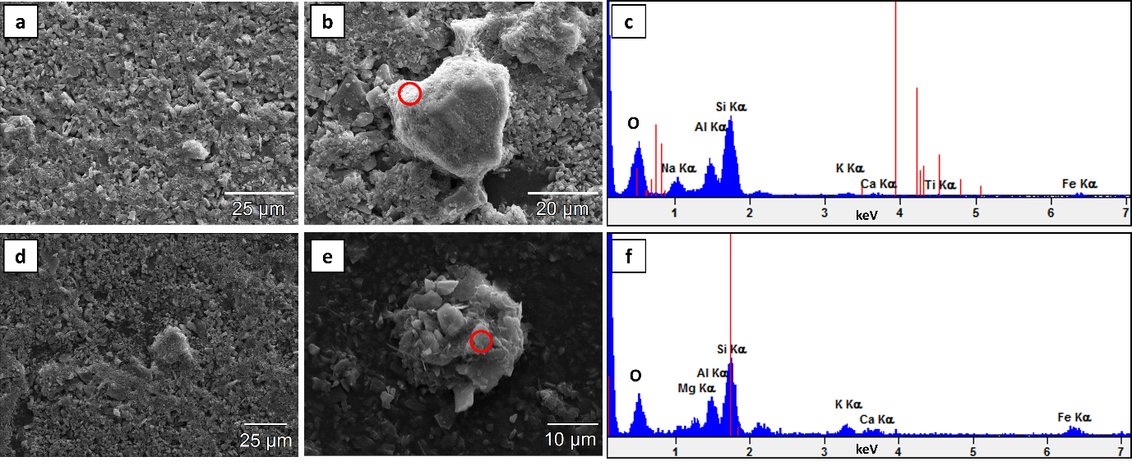

### **Figure S2.** Photomicrographs of fjord sediments. (a) AM10a sediment particles; (b) representative form of ASi at AM10a and (c) EDS spectra acquired in the red circle region in (b); (d) GF-inlet sediment particles; (e) representative form of ASi at GF-inlet and (f) EDS spectra acquired in the red circle region in (e).

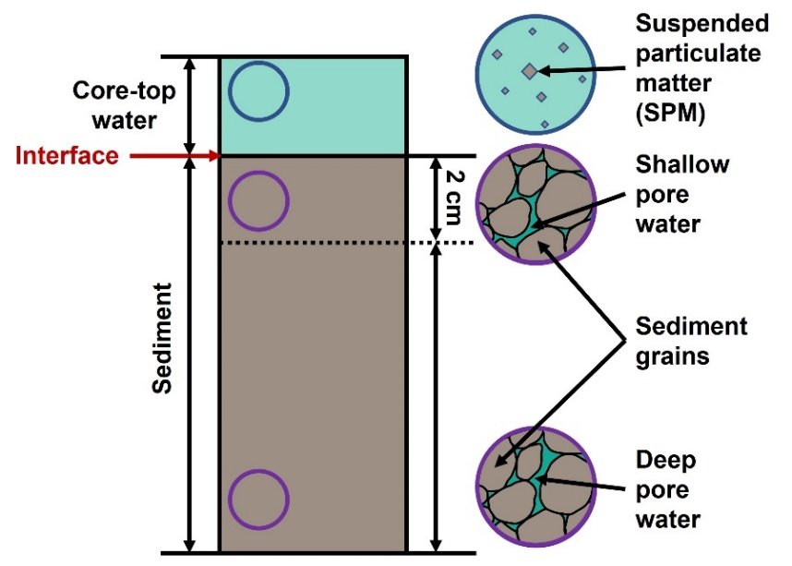

### **Figure S3.** A schematic showing the different reservoirs (core-top water, interface, shallow pore water, and deep pore water) in the sediment core.



### **Figure S4.** Core-top water (a) δ30Si values are displayed against time lapse over the incubation period; (b) the productions of DSi concentration and δ30Si value are plotted against the ratio of incubation time and water column height at GF-inlet. Vertical error bars represent 2 SD of repeat δ30Si measurements (n = 2–4). The horizontal line in (a) indicates the interface δ30Si values measured at GF-inlet. Shaded area in (a) represents 2 SD of repeat δ30Si measurements (n = 2–4) for interface values. The black line in (b) demonstrates the best fit linear regression and blue lines represent the 95% confidence interval, with the Pearson’s r value of 0.40.

**References**

Boudreau, B. P. (1996). The diffusive tortuosity of fine-grained unlithified sediments. *Geochimica et Cosmochimica Acta, 60*(16), 3139-3142. doi:<https://doi.org/10.1016/0016-7037(96)00158-5>

Closset, I., Brzezinski, M. A., Cardinal, D., Dapoigny, A., Jones, J. L., & Robinson, R. S. (2022). A silicon isotopic perspective on the contribution of diagenesis to the sedimentary silicon budget in the Southern Ocean. *Geochimica et Cosmochimica Acta, 327*, 298-313. doi:10.1016/j.gca.2022.04.010

Dixit, S., Van Cappellen, P., & van Bennekom, A. J. (2001). Processes controlling solubility of biogenic silica and pore water build-up of silicic acid in marine sediments. *Marine Chemistry, 73*(3), 333-352. doi:<https://doi.org/10.1016/S0304-4203(00)00118-3>

Flower, R. J. (1993). Diatom preservation: experiments and observations on dissolution and breakage in modern and fossil material. *Hydrobiologia, 269-270*(1), 473-484. doi:10.1007/bf00028045

Geilert, S., Grasse, P., Doering, K., Wallmann, K., Ehlert, C., Scholz, F., . . . Hensen, C. (2020). Impact of ambient conditions on the Si isotope fractionation in marine pore fluids during early diagenesis. *Biogeosciences, 17*(7), 1745-1763. doi:10.5194/bg-17-1745-2020

McManus, J., Hammond, D. E., Berelson, W. M., Kilgore, T. E., Demaster, D. J., Ragueneau, O. G., & Collier, R. W. (1995). Early diagenesis of biogenic opal: Dissolution rates, kinetics, and paleoceanographic implications. *Deep Sea Research Part II: Topical Studies in Oceanography, 42*(2-3), 871-903. doi:10.1016/0967-0645(95)00035-o

Mortlock, R. A., & Froelich, P. N. (1989). A simple method for the rapid determination of biogenic opal in pelagic marine sediments. *Deep Sea Research Part A. Oceanographic Research Papers, 36*(9), 1415-1426. doi:<https://doi.org/10.1016/0198-0149(89)90092-7>

Ng, H. C., Cassarino, L., Pickering, R. A., Woodward, E. M. S., Hammond, S. J., & Hendry, K. R. (2020). Sediment efflux of silicon on the Greenland margin and implications for the marine silicon cycle. *Earth and Planetary Science Letters, 529*. doi:10.1016/j.epsl.2019.115877

Ng, H. C., Hawkings, J. R., Bertrand, S., Summers, B. A., Sieber, M., Conway, T. M., . . . Hendry, K. R. (2022). Benthic Dissolved Silicon and Iron Cycling at Glaciated Patagonian Fjord Heads. *Global Biogeochem Cycles, 36*(11), e2022GB007493. doi:10.1029/2022GB007493

Oksman, M., Kvorning, A. B., Larsen, S. H., Kjeldsen, K. K., Mankoff, K. D., Colgan, W., . . . Ribeiro, S. (2022). Impact of freshwater runoff from the southwest Greenland Ice Sheet on fjord productivity since the late 19th century. *The Cryosphere, 16*(6), 2471-2491. doi:10.5194/tc-16-2471-2022

Pickering, R. A., Cassarino, L., Hendry, K. R., Wang, X. L., Maiti, K., & Krause, J. W. (2020). Using Stable Isotopes to Disentangle Marine Sedimentary Signals in Reactive Silicon Pools. *Geophysical Research Letters, 47*(15). doi:10.1029/2020gl087877

Rebreanu, L., Vanderborght, J.-P., & Chou, L. (2008). The diffusion coefficient of dissolved silica revisited. *Marine Chemistry, 112*(3-4), 230-233. doi:10.1016/j.marchem.2008.08.004

Rickert, D., Schlüter, M., & Wallmann, K. (2002). Dissolution kinetics of biogenic silica from the water column to the sediments. *Geochimica et Cosmochimica Acta, 66*(3), 439-455. doi:<https://doi.org/10.1016/S0016-7037(01)00757-8>

Schulz, H., & Zabel, M. (2006). Marine geochemistry: 2 nd revised, updated and extended edition. In: Germany: Springer-Verlag Berlin Heidelberg. 574p.

Stuart‐Lee, A. E., Mortensen, J., Kaaden, A. S. v. d., & Meire, L. (2021). Seasonal Hydrography of Ameralik: A Southwest Greenland Fjord Impacted by a Land‐Terminating Glacier. *Journal of Geophysical Research: Oceans, 126*(12). doi:10.1029/2021jc017552

Van Cappellen, P., & Qiu, L. (1997). Biogenic silica dissolution in sediments of the Southern Ocean. I. Solubility. *Deep Sea Research Part II: Topical Studies in Oceanography, 44*(5), 1109-1128. doi:<https://doi.org/10.1016/S0967-0645(96)00113-0>

Ward, J. P. J., Hendry, K. R., Arndt, S., Faust, J. C., Freitas, F. S., Henley, S. F., . . . Tessin, A. C. (2022a). Stable silicon isotopes uncover a mineralogical control on the benthic silicon cycle in the Arctic Barents Sea. *Geochimica et Cosmochimica Acta, 329*, 206-230. doi:10.1016/j.gca.2022.05.005

Ward, J. P. J., Hendry, K. R., Arndt, S., Faust, J. C., Freitas, F. S., Henley, S. F., . . . Airs, R. L. (2022b). Benthic silicon cycling in the Arctic Barents Sea: a reaction–transport model study. *Biogeosciences, 19*(14), 3445-3467. doi:10.5194/bg-19-3445-2022