**S5 Testing for collinearity between environmental covariates**

Echo-class 1

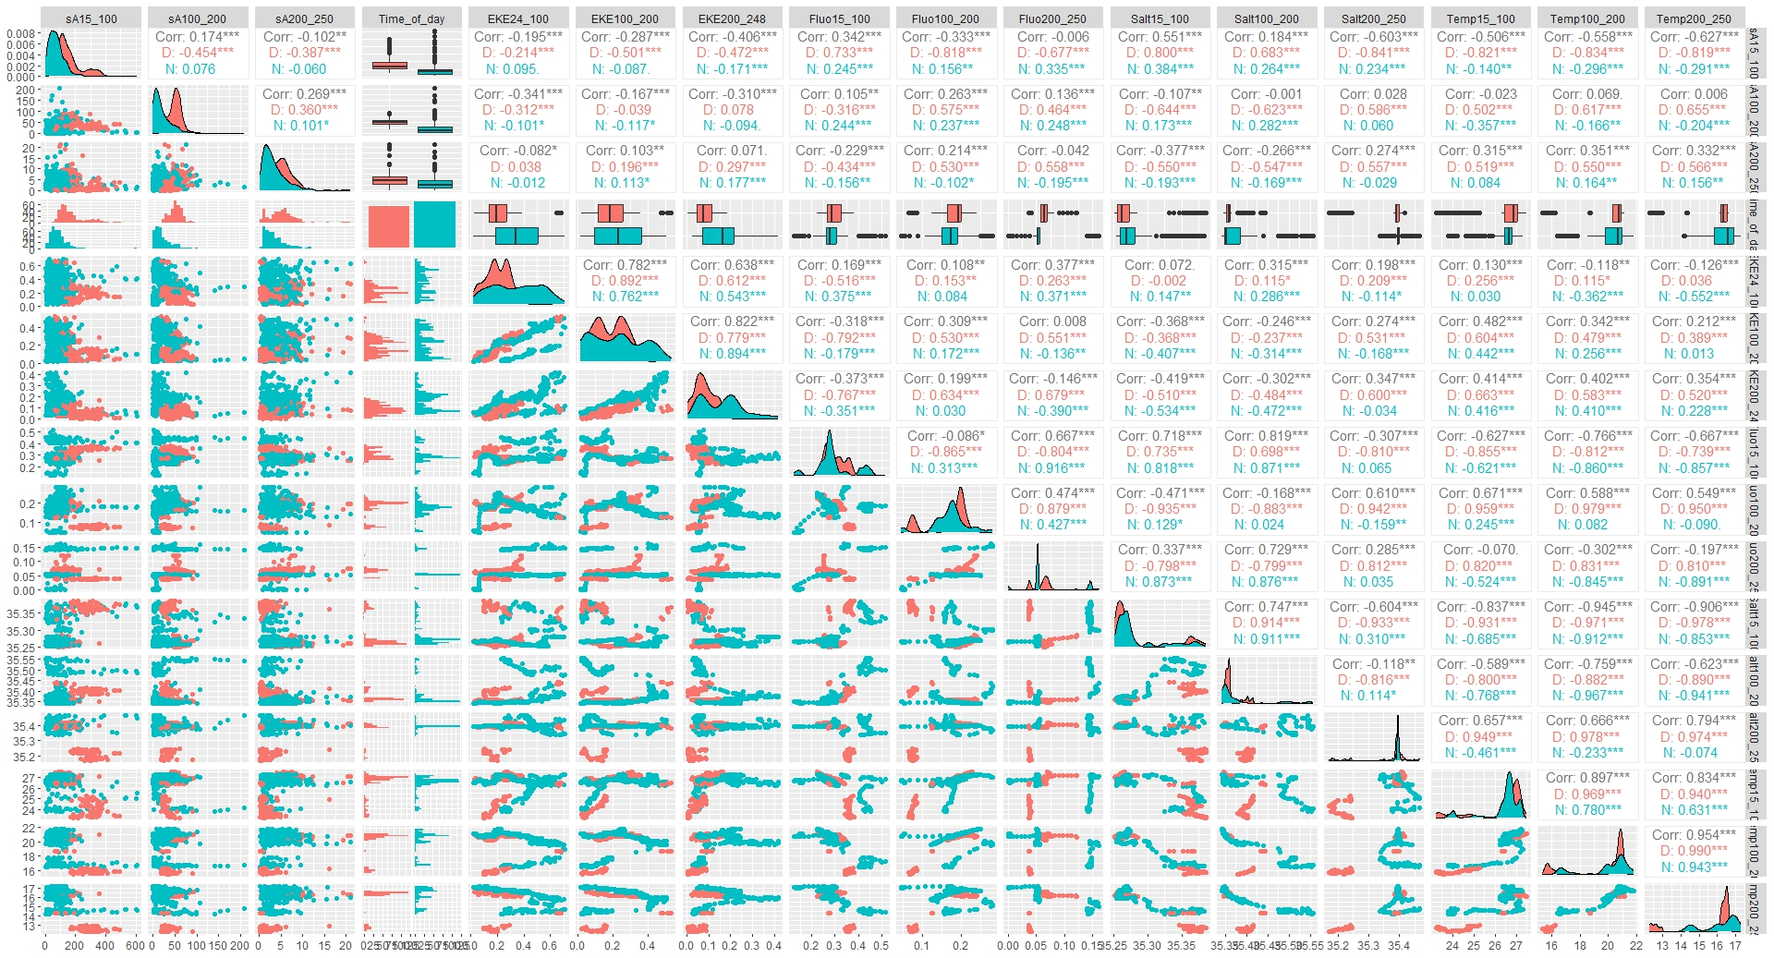

Scatterplot matrix of response variable, sA, and candidate environmental variables during day time (pink color) and night time (blue color) to assess for collinearity. Since several candidate covariates showed correlation coefficients (Corr) > 0.8, out of the two collinear environmental variables, the one which is the most highly correlated to sA was retained in the final models, and the others dropped. Data distributions are shown along the lower diagonal.

Echo-class 2

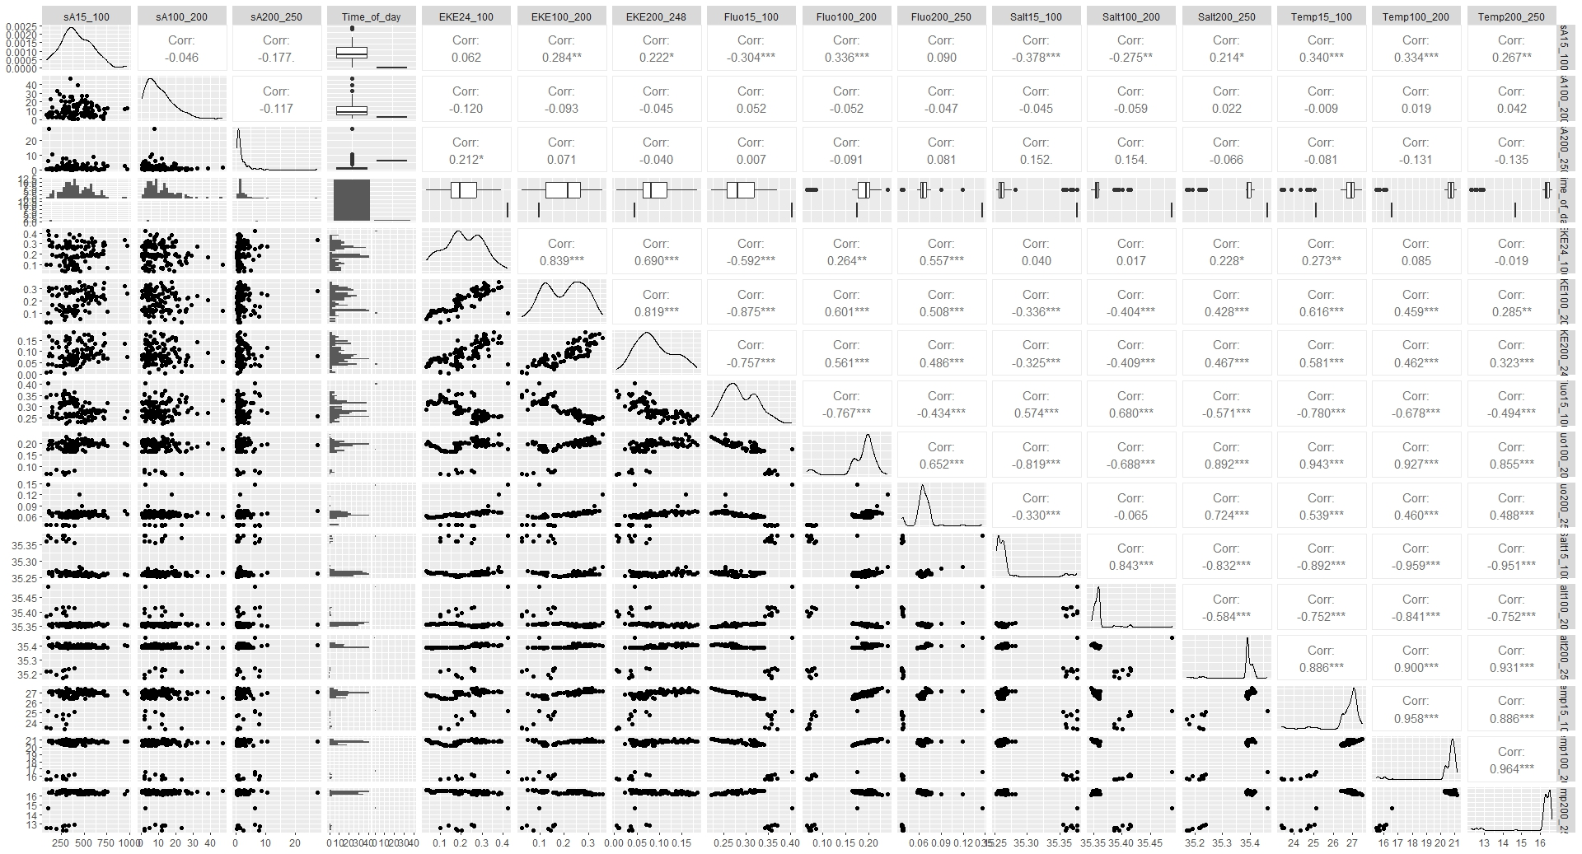

Scatterplot matrix of response variable, sA, and candidate environmental variables to assess for collinearity. Since several candidate covariates showed correlation coefficients (Corr) > 0.8, out of the two collinear environmental variables, the one which is the most highly correlated to sA was retained in the final models, and the others dropped. Data distributions are shown along the lower diagonal.

Echo-class 3

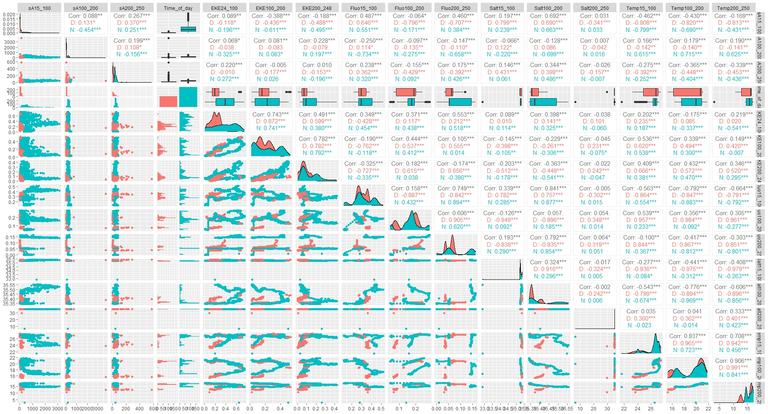

Scatterplot matrix of response variable, sA, and candidate environmental variables during day time (pink color) and night time (blue color) to assess for collinearity. Since several candidate covariates showed correlation coefficients (Corr) > 0.8, out of the two collinear environmental variables, the one which is the most highly correlated to sA was retained in the final models, and the others dropped. Data distributions are shown along the lower diagonal.

Echo-class 4

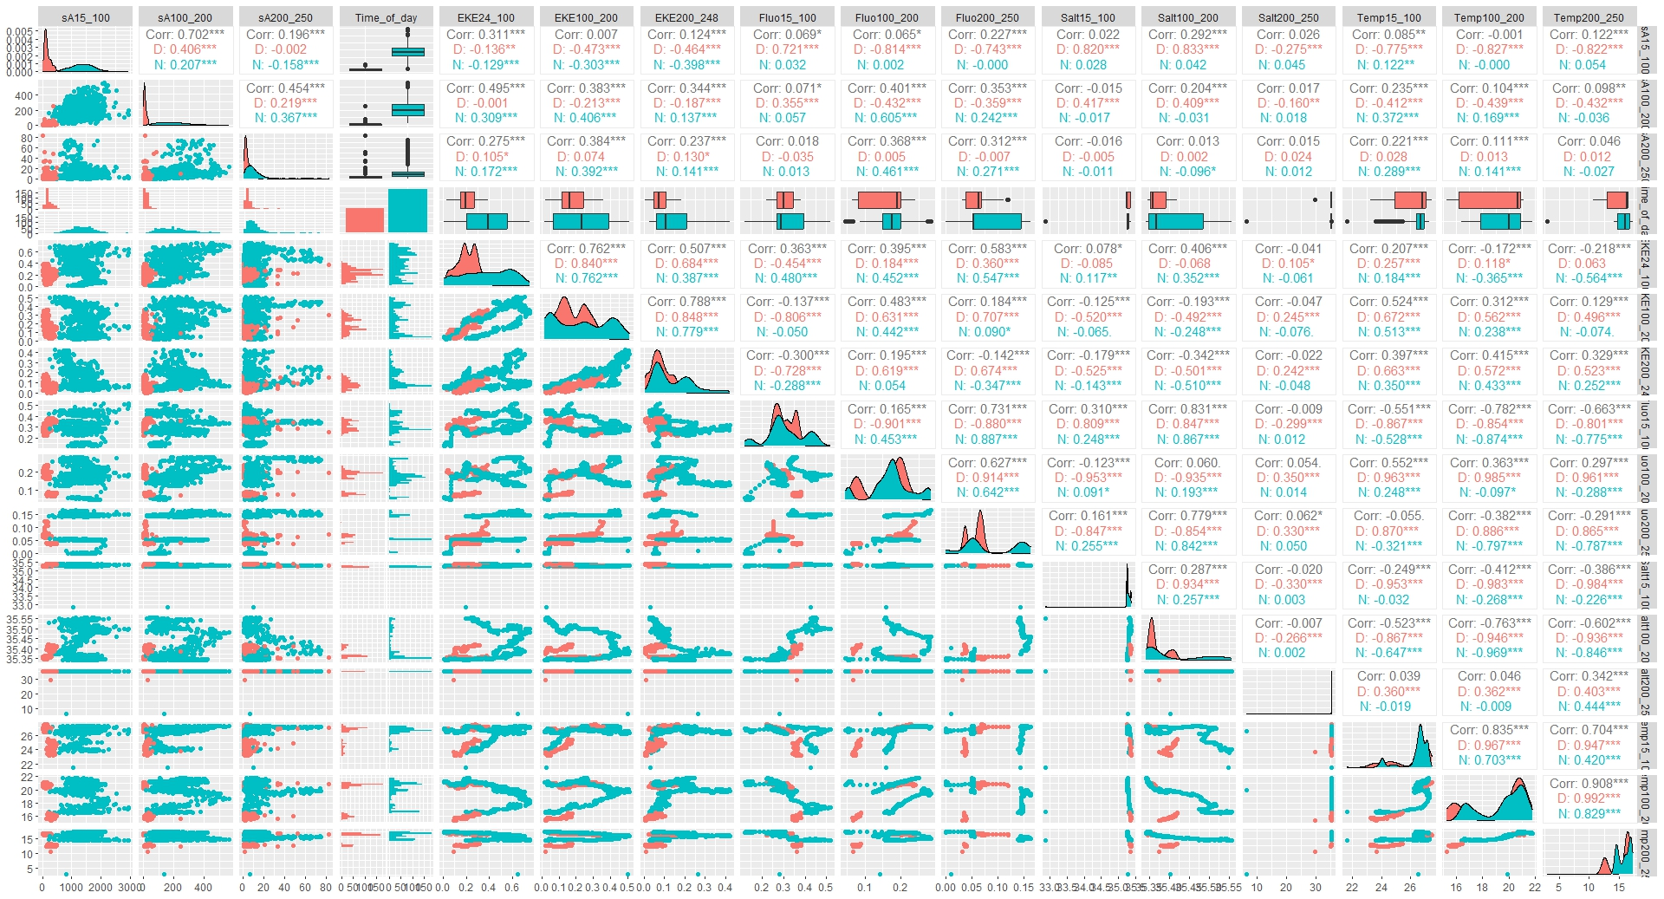

Scatterplot matrix of response variable, sA, and candidate environmental variables during day time (pink color) and night time (blue color) to assess for collinearity. Since several candidate covariates showed correlation coefficients (Corr) > 0.8, out of the two collinear environmental variables, the one which is the most highly correlated to sA was retained in the final models, and the others dropped. Data distributions are shown along the lower diagonal.