**Supplementary Material**

**Table S1.** Environmental characteristics and sampling information for the eight populations surveyed considered in the capture-recapture analyses. Elev = elevation (in meters), Mean_precip = mean annual precipitation for the period 1990-2019, Mean_temp = mean annual precipitation for the period 1990-2019, StDev_precip = standard deviation of annual precipitations calculated for the period 1990-2019, StDev_temp = standard deviation of annual temperature calculated for the period 1990-2019, Survey_period = survey period, Survey_length = survey length in years, Nb_ind = number of individuals surveyed, Nb_capture = number of captures performed during the survey.

|  |  |  |  |  |  |  |  |  |  |  |  |
| --- | --- | --- | --- | --- | --- | --- | --- | --- | --- | --- | --- |
| **ID** | **Elev** | **Latitude** | **Longitude** | **Mean_**  **precip** | **Mean_**  **temp** | **StDev_**  **precip** | **StDev_**  **temp** | **Survey_**  **period** | **Survey_**  **length** | **Nb_**  **ind** | **Nb_**  **capture** |
| BICR | 2485 | 45.1140 | -114.5998 | 1031.03 | 1.89 | 0.69 | 8.48 | 2005-2019 | 14 | 3780 | 7460 |
| DRCR | 1195 | 43.5105 | -117.7068 | 278.99 | 8.35 | 0.61 | 8.42 | 2001-2018 | 17 | 1587 | 2026 |
| GRMO | 2341 | 40.3506 | -115.4970 | 576.57 | 6.10 | 0.60 | 7.98 | 2004-2019 | 15 | 427 | 707 |
| LIRO | 2138 | 46.0090 | -114.3671 | 1696.68 | 2.51 | 0.75 | 8.30 | 2000-2018 | 18 | 2717 | 4830 |
| POCR | 2241 | 41.8997 | -115.0779 | 704.96 | 4.48 | 0.79 | 8.20 | 2005-2019 | 14 | 370 | 756 |
| SANO | 1774 | 42.6247 | -116.5293 | 452.50 | 6.77 | 0.99 | 8.87 | 1997-2012 | 15 | 1464 | 2455 |
| TEGU | 2227 | 41.8021 | -115.6475 | 587.57 | 4.53 | 0.76 | 8.08 | 2004-2019 | 15 | 1473 | 2556 |
| TOIY | 2236 | 38.8079 | -117.4990 | 287.32 | 6.73 | 0.68 | 7.87 | 2004-2019 | 15 | 8215 | 13067 |

**Table S2.** Environmental characteristics and sampling information for the 31 populations considered in the genomic analyses. Elevation = elevation (in meters), Mean_temp = mean annual temperature for the period 1990-2019, N = number individuals genotyped.

|  |  |  |  |  |  |
| --- | --- | --- | --- | --- | --- |
| Population | Longitude | Latitude | Elevation | Mean_temp | N |
| ARDO | -117.36456 | 38.7762521 | 2470.88037 | 5.7 | 12 |
| CACR | -115.08739 | 41.7895772 | 1832.71033 | 5.9 | 12 |
| CLCR | -117.391876 | 38.9376233 | 2334.38599 | 7.2 | 12 |
| COCA | -115.734394 | 41.7302849 | 2045.86511 | 5.8 | 12 |
| COSP | -116.107175 | 40.8980882 | 1745.5863 | 7.7 | 12 |
| CUCR | -115.388487 | 41.5712438 | 1924.48547 | 5.9 | 12 |
| DOGE | -116.055467 | 41.6685947 | 1957.46265 | 5.9 | 12 |
| DRCR | -115.024102 | 41.5252255 | 2220.13867 | 5 | 12 |
| EFBE | -115.545079 | 41.494863 | 1904.75794 | 5.8 | 14 |
| FAPO | -117.501972 | 38.6779837 | 2085.53662 | 7.9 | 12 |
| GRCR | -115.495838 | 40.3496387 | 2383.22022 | 6.1 | 12 |
| HACR | -115.240797 | 41.482243 | 1761.25549 | 6.5 | 12 |
| INVA | -117.502805 | 38.8115962 | 2231.0022 | 6.8 | 12 |
| MACR | -115.909483 | 41.337844 | 1969.98206 | 5.9 | 12 |
| MERL | -115.887257 | 41.9344106 | 1914.83875 | 6.2 | 12 |
| MERU | -115.844184 | 41.8909335 | 2170.37549 | 5.2 | 12 |
| NFHU | -115.911174 | 41.5737347 | 2025.3584 | 5.2 | 12 |
| PEAL | -115.574967 | 40.4936359 | 2193.1438 | 6.3 | 12 |
| POCR | -115.077395 | 41.8975946 | 2238.55054 | 4.5 | 7 |
| RICR | -115.896337 | 41.6575031 | 2153.74463 | 5.6 | 12 |
| RITI | -115.982572 | 41.8166675 | 1793.24524 | 6.6 | 4 |
| SFJA | -115.007206 | 41.5544039 | 2211.40479 | 5.3 | 5 |
| TACA | -116.040664 | 41.2357579 | 1933.50244 | 4.7 | 12 |
| TEGU | -115.643219 | 41.7987584 | 2253.07105 | 4.4 | 12 |
| TRCR | -115.957593 | 41.7376156 | 1771.74085 | 6.2 | 12 |
| UMAG | -116.130459 | 41.0182637 | 1682.14905 | 7.2 | 12 |
| WARN | -117.495309 | 38.8468364 | 2182.25708 | 6.7 | 12 |
| WCSP | -115.754303 | 41.75093 | 2008.5437 | 5.7 | 12 |
| WICR | -116.114092 | 41.787287 | 2217.26196 | 5.7 | 12 |
| WILL | -116.435203 | 41.2299199 | 1702.9491 | 7.8 | 11 |
| WILU | -116.386947 | 41.2085677 | 1762.55554 | 7.5 | 11 |

**Table S3.** Parameter estimates of the Siler model built for the population BICR. *b1* is the senescence rate and *pi* is the recapture rate for a given year.

|  |  |  |  |  |  |  |  |  |  |  |  |  |  |  |  |  |  |  |  |  |  |  |  |  |  |  |  |  |  |  |  |  |  |  |  |  |  |  |  |  |  |  |  |  |  |  |  |  |  |  |  |  |  |  |  |  |  |  |  |  |  |  |  |  |  |  |  |  |  |  |  |  |  |  |  |  |  |  |  |  |  |  |  |  |  |  |  |  |  |  |  |  |  |  |  |  |  |  |  |  |  |  |  |  |  |  |  |  |  |  |  |  |
| --- | --- | --- | --- | --- | --- | --- | --- | --- | --- | --- | --- | --- | --- | --- | --- | --- | --- | --- | --- | --- | --- | --- | --- | --- | --- | --- | --- | --- | --- | --- | --- | --- | --- | --- | --- | --- | --- | --- | --- | --- | --- | --- | --- | --- | --- | --- | --- | --- | --- | --- | --- | --- | --- | --- | --- | --- | --- | --- | --- | --- | --- | --- | --- | --- | --- | --- | --- | --- | --- | --- | --- | --- | --- | --- | --- | --- | --- | --- | --- | --- | --- | --- | --- | --- | --- | --- | --- | --- | --- | --- | --- | --- | --- | --- | --- | --- | --- | --- | --- | --- | --- | --- | --- | --- | --- | --- | --- | --- | --- | --- | --- | --- |
| |  |  |  |  |  | | --- | --- | --- | --- | --- | | Parameter | Estimation | StdErr | 95%CI - | 95%CI + | | a0 | -4.776 | 0.642 | -6.038 | -3.583 | | a1 | 0.565 | 0.807 | 0.002 | 2.727 | | c | 0.010 | 0.009 | 0.000 | 0.034 | | b0 | -2.262 | 0.122 | -2.513 | -2.038 | | b1 | 0.112 | 0.016 | 0.082 | 0.144 | | pi.2005 | 0.607 | 0.028 | 0.553 | 0.662 | | pi.2006 | 0.287 | 0.020 | 0.250 | 0.327 | | pi.2007 | 0.572 | 0.027 | 0.519 | 0.623 | | pi.2008 | 0.082 | 0.010 | 0.064 | 0.101 | | pi.2009 | 0.079 | 0.009 | 0.063 | 0.097 | | pi.2010 | 0.199 | 0.013 | 0.174 | 0.224 | | pi.2011 | 0.519 | 0.016 | 0.486 | 0.551 | | pi.2012 | 0.550 | 0.015 | 0.522 | 0.580 | | pi.2013 | 0.410 | 0.014 | 0.383 | 0.437 | | pi.2014 | 0.422 | 0.014 | 0.394 | 0.449 | | pi.2015 | 0.366 | 0.014 | 0.338 | 0.394 | | pi.2016 | 0.436 | 0.016 | 0.405 | 0.467 | | pi.2017 | 0.466 | 0.016 | 0.436 | 0.498 | | pi.2018 | 0.465 | 0.016 | 0.433 | 0.497 | | pi.2019 | 0.580 | 0.019 | 0.543 | 0.617 | |  |  |  |  |  |  |  |
|  |  |  |  |  |  |  |  |

**Table S4.** Parameter estimates of the Siler model built for the population DRCR. *b1* is the senescence rate and *pi* is the recapture rate for a given year.

|  |  |  |  |  |
| --- | --- | --- | --- | --- |
| Parameter | Estimation | StdErr | 95%CI - | 95%CI + |
| a0 | -5.346 | 0.541 | -6.494 | -4.359 |
| a1 | 1.447 | 0.796 | 0.123 | 3.133 |
| c | 0.001 | 0.001 | 0.000 | 0.004 |
| b0 | -4.156 | 0.272 | -4.746 | -3.690 |
| b1 | 1.506 | 0.069 | 1.380 | 1.650 |
| pi.2001 | 0.509 | 0.077 | 0.362 | 0.662 |
| pi.2002 | 0.503 | 0.074 | 0.367 | 0.651 |
| pi.2003 | 0.300 | 0.051 | 0.205 | 0.406 |
| pi.2004 | 0.352 | 0.046 | 0.267 | 0.446 |
| pi.2005 | 0.280 | 0.035 | 0.215 | 0.353 |
| pi.2006 | 0.274 | 0.030 | 0.219 | 0.335 |
| pi.2007 | 0.322 | 0.026 | 0.272 | 0.374 |
| pi.2008 | 0.412 | 0.025 | 0.365 | 0.462 |
| pi.2009 | 0.478 | 0.024 | 0.431 | 0.526 |
| pi.2010 | 0.810 | 0.027 | 0.758 | 0.864 |
| pi.2011 | 0.211 | 0.020 | 0.173 | 0.251 |
| pi.2012 | 0.265 | 0.026 | 0.218 | 0.317 |
| pi.2013 | 0.387 | 0.036 | 0.319 | 0.461 |
| pi.2014 | 0.404 | 0.040 | 0.330 | 0.485 |
| pi.2015 | 0.310 | 0.041 | 0.234 | 0.393 |
| pi.2016 | 0.271 | 0.045 | 0.189 | 0.365 |
| pi.2017 | 0.533 | 0.061 | 0.417 | 0.658 |
| pi.2018 | 0.757 | 0.064 | 0.630 | 0.880 |

**Table S5.** Parameter estimates of the Siler model built for the population GRMO. *b1* is the senescence rate and *pi* is the recapture rate for a given year.

|  |  |  |  |  |
| --- | --- | --- | --- | --- |
| Parameter | Estimation | StdErr | 95%CI - | 95%CI + |
| a0 | -4.321 | 0.580 | -5.522 | -3.268 |
| a1 | 1.018 | 0.756 | 0.033 | 2.682 |
| c | 0.008 | 0.008 | 0.000 | 0.029 |
| b0 | -2.940 | 0.263 | -3.474 | -2.465 |
| b1 | 0.561 | 0.057 | 0.449 | 0.675 |
| pi.2004 | 0.339 | 0.069 | 0.215 | 0.488 |
| pi.2005 | 0.264 | 0.057 | 0.163 | 0.383 |
| pi.2006 | 0.711 | 0.067 | 0.580 | 0.842 |
| pi.2007 | 0.695 | 0.071 | 0.556 | 0.834 |
| pi.2008 | 0.490 | 0.071 | 0.359 | 0.632 |
| pi.2009 | 0.583 | 0.073 | 0.444 | 0.726 |
| pi.2010 | 0.499 | 0.064 | 0.377 | 0.635 |
| pi.2011 | 0.361 | 0.055 | 0.261 | 0.474 |
| pi.2012 | 0.363 | 0.052 | 0.268 | 0.469 |
| pi.2013 | 0.503 | 0.058 | 0.395 | 0.621 |
| pi.2014 | 0.324 | 0.047 | 0.237 | 0.422 |
| pi.2015 | 0.352 | 0.049 | 0.261 | 0.452 |
| pi.2016 | 0.299 | 0.044 | 0.218 | 0.387 |
| pi.2017 | 0.647 | 0.057 | 0.535 | 0.756 |
| pi.2018 | 0.561 | 0.055 | 0.455 | 0.670 |
| pi.2019 | 0.461 | 0.056 | 0.354 | 0.573 |

**Table S6.** Parameter estimates of the Siler model built for the population LIRO. *b1* is the senescence rate and *pi* is the recapture rate for a given year.

|  |  |  |  |  |
| --- | --- | --- | --- | --- |
| Parameter | Estimation | StdErr | 95%CI - | 95%CI + |
| a0 | -5.254 | 0.513 | -6.310 | -4.321 |
| a1 | 0.907 | 0.842 | 0.008 | 2.786 |
| c | 0.003 | 0.003 | 0.000 | 0.011 |
| b0 | -2.196 | 0.086 | -2.369 | -2.038 |
| b1 | 0.296 | 0.016 | 0.265 | 0.327 |
| pi.2000 | 0.372 | 0.020 | 0.334 | 0.411 |
| pi.2001 | 0.714 | 0.021 | 0.673 | 0.754 |
| pi.2002 | 0.529 | 0.021 | 0.489 | 0.570 |
| pi.2003 | 0.521 | 0.021 | 0.479 | 0.563 |
| pi.2004 | 0.496 | 0.022 | 0.452 | 0.539 |
| pi.2005 | 0.538 | 0.024 | 0.491 | 0.585 |
| pi.2006 | 0.362 | 0.023 | 0.317 | 0.409 |
| pi.2007 | 0.343 | 0.026 | 0.295 | 0.394 |
| pi.2008 | 0.364 | 0.029 | 0.309 | 0.423 |
| pi.2009 | 0.332 | 0.028 | 0.278 | 0.390 |
| pi.2010 | 0.323 | 0.028 | 0.268 | 0.380 |
| pi.2011 | 0.392 | 0.031 | 0.333 | 0.455 |
| pi.2012 | 0.410 | 0.032 | 0.351 | 0.475 |
| pi.2013 | 0.394 | 0.030 | 0.337 | 0.453 |
| pi.2014 | 0.298 | 0.025 | 0.250 | 0.347 |
| pi.2015 | 0.578 | 0.026 | 0.526 | 0.630 |
| pi.2016 | 0.575 | 0.025 | 0.527 | 0.624 |
| pi.2017 | 0.508 | 0.025 | 0.462 | 0.558 |
| pi.2018 | 0.696 | 0.028 | 0.641 | 0.749 |

**Table S7.** Parameter estimates of the Siler model built for the population POCR. *b1* is the senescence rate and *pi* is the recapture rate for a given year. NA correspond to parameters that did not appropriately converged for this population.

|  |  |  |  |  |
| --- | --- | --- | --- | --- |
| Parameter | Estimation | StdErr | 95%CI - | 95%CI + |
| a0 | NA | NA | NA | NA |
| a1 | NA | NA | NA | NA |
| c | NA | NA | NA | NA |
| b0 | -3.653 | 0.941 | -5.509 | -1.901 |
| b1 | 0.051 | 0.050 | 0.002 | 0.185 |
| pi.2005 | 0.697 | 0.155 | 0.431 | 0.959 |
| pi.2006 | 0.829 | 0.056 | 0.705 | 0.905 |
| pi.2007 | 0.835 | 0.049 | 0.726 | 0.909 |
| pi.2008 | 0.873 | 0.118 | 0.621 | 0.987 |
| pi.2009 | 0.771 | 0.100 | 0.553 | 0.901 |
| pi.2010 | 0.266 | 0.067 | 0.149 | 0.407 |
| pi.2011 | 0.444 | 0.087 | 0.282 | 0.613 |
| pi.2012 | 0.431 | 0.090 | 0.262 | 0.610 |
| pi.2013 | 0.275 | 0.083 | 0.131 | 0.453 |
| pi.2014 | 0.320 | 0.095 | 0.151 | 0.516 |
| pi.2015 | 0.657 | 0.114 | 0.419 | 0.861 |
| pi.2016 | 0.672 | 0.142 | 0.387 | 0.925 |
| pi.2017 | 0.501 | 0.133 | 0.254 | 0.761 |
| pi.2018 | 0.514 | 0.164 | 0.216 | 0.831 |
| pi.2019 | 0.640 | 0.205 | 0.244 | 0.981 |

**Table S8.** Parameter estimates of the Siler model built for the population SANO. *b1* is the senescence rate and *pi* is the recapture rate for a given year.

|  |  |  |  |  |
| --- | --- | --- | --- | --- |
| Parameter | Estimation | StdErr | 95%CI - | 95%CI + |
| a0 | -4.722 | 0.554 | -5.858 | -3.707 |
| a1 | 0.783 | 0.776 | 0.010 | 2.688 |
| c | 0.007 | 0.007 | 0.000 | 0.025 |
| b0 | -1.871 | 0.105 | -2.090 | -1.674 |
| b1 | 0.337 | 0.025 | 0.289 | 0.387 |
| pi.1997 | 0.304 | 0.026 | 0.255 | 0.357 |
| pi.1998 | 0.717 | 0.029 | 0.661 | 0.772 |
| pi.1999 | 0.577 | 0.030 | 0.518 | 0.637 |
| pi.2000 | 0.589 | 0.031 | 0.531 | 0.650 |
| pi.2001 | 0.502 | 0.033 | 0.438 | 0.567 |
| pi.2002 | 0.342 | 0.032 | 0.282 | 0.408 |
| pi.2003 | 0.267 | 0.031 | 0.210 | 0.330 |
| pi.2004 | 0.470 | 0.042 | 0.392 | 0.556 |
| pi.2005 | 0.490 | 0.042 | 0.410 | 0.576 |
| pi.2006 | 0.602 | 0.042 | 0.521 | 0.688 |
| pi.2007 | 0.723 | 0.039 | 0.648 | 0.799 |
| pi.2008 | 0.501 | 0.036 | 0.431 | 0.571 |
| pi.2009 | 0.647 | 0.040 | 0.570 | 0.730 |
| pi.2010 | 0.505 | 0.039 | 0.431 | 0.583 |
| pi.2011 | 0.565 | 0.041 | 0.485 | 0.645 |
| pi.2012 | 0.751 | 0.040 | 0.670 | 0.831 |

**Table S9.** Parameter estimates of the Siler model built for the population TEGU. *b1* is the senescence rate and *pi* is the recapture rate for a given year.

|  |  |  |  |  |
| --- | --- | --- | --- | --- |
| Parameter | Estimation | StdErr | 95%CI - | 95%CI + |
| a0 | -4.970 | 0.565 | -6.129 | -3.893 |
| a1 | 1.470 | 0.804 | 0.076 | 3.153 |
| c | 0.002 | 0.002 | 0.000 | 0.007 |
| b0 | -4.250 | 0.307 | -4.908 | -3.692 |
| b1 | 0.346 | 0.034 | 0.280 | 0.414 |
| pi.2004 | 0.137 | 0.021 | 0.098 | 0.181 |
| pi.2005 | 0.337 | 0.030 | 0.280 | 0.397 |
| pi.2006 | 0.370 | 0.030 | 0.313 | 0.433 |
| pi.2007 | 0.433 | 0.031 | 0.372 | 0.497 |
| pi.2008 | 0.487 | 0.032 | 0.425 | 0.551 |
| pi.2009 | 0.377 | 0.029 | 0.323 | 0.435 |
| pi.2010 | 0.217 | 0.022 | 0.176 | 0.261 |
| pi.2011 | 0.129 | 0.017 | 0.098 | 0.165 |
| pi.2012 | 0.153 | 0.018 | 0.120 | 0.189 |
| pi.2013 | 0.210 | 0.019 | 0.174 | 0.249 |
| pi.2014 | 0.282 | 0.021 | 0.241 | 0.324 |
| pi.2015 | 0.295 | 0.021 | 0.256 | 0.336 |
| pi.2016 | 0.220 | 0.017 | 0.187 | 0.255 |
| pi.2017 | 0.330 | 0.019 | 0.292 | 0.369 |
| pi.2018 | 0.505 | 0.022 | 0.463 | 0.550 |
| pi.2019 | 0.387 | 0.021 | 0.348 | 0.429 |

**Table S10.** Parameter estimates of the Siler model built for the population TOIY. *b1* is the senescence rate and *pi* is the recapture rate for a given year.

|  |  |  |  |  |
| --- | --- | --- | --- | --- |
| Parameter | Estimation | StdErr | 95%CI - | 95%CI + |
| a0 | -6.529 | 0.476 | -7.482 | -5.649 |
| a1 | 1.474 | 0.906 | 0.049 | 3.315 |
| c | 0.000 | 0.000 | 0.000 | 0.001 |
| b0 | -3.040 | 0.095 | -3.238 | -2.874 |
| b1 | 0.637 | 0.018 | 0.605 | 0.675 |
| pi.2004 | 0.492 | 0.023 | 0.447 | 0.539 |
| pi.2005 | 0.299 | 0.018 | 0.264 | 0.334 |
| pi.2006 | 0.354 | 0.017 | 0.321 | 0.388 |
| pi.2007 | 0.489 | 0.018 | 0.453 | 0.525 |
| pi.2008 | 0.324 | 0.014 | 0.298 | 0.352 |
| pi.2009 | 0.354 | 0.013 | 0.329 | 0.380 |
| pi.2010 | 0.366 | 0.012 | 0.343 | 0.389 |
| pi.2011 | 0.331 | 0.010 | 0.312 | 0.350 |
| pi.2012 | 0.713 | 0.012 | 0.690 | 0.736 |
| pi.2013 | 0.467 | 0.011 | 0.446 | 0.488 |
| pi.2014 | 0.338 | 0.011 | 0.317 | 0.359 |
| pi.2015 | 0.302 | 0.011 | 0.280 | 0.323 |
| pi.2016 | 0.339 | 0.012 | 0.315 | 0.363 |
| pi.2017 | 0.537 | 0.016 | 0.507 | 0.569 |
| pi.2018 | 0.491 | 0.016 | 0.459 | 0.523 |
| pi.2019 | 0.423 | 0.017 | 0.391 | 0.457 |

**Table S11.** Estimates of Pradel’s model for population for the eight population of *Rana luteiventris*. µ(φ) = mean survival, µ(γ) = mean recruitment, µ(p) = mean recapture, µ(λ) = mean population growth, σ(φ) = annual variance of survival, σ(γ) = annual variance of recruitment, σ(p) = annual variance of recapture, σ(λ) = annual variance of population growth.

|  |  |  |  |  |  |  |
| --- | --- | --- | --- | --- | --- | --- |
| Parameter | mean | sd | 2.50% | 50% | 97.50% | Rhat |
| BICR |  |  |  |  |  |  |
| µ(φ) | 0.785 | 0.014 | 0.758 | 0.785 | 0.814 | 1 |
| µ(γ) | 0.801 | 0.056 | 0.681 | 0.804 | 0.901 | 1.001 |
| µ(p) | 0.386 | 0.047 | 0.295 | 0.385 | 0.484 | 1 |
| µ(λ) | 1.063 | 0.094 | 0.882 | 1.061 | 1.261 | 1.001 |
| σ(φ) | 0.237 | 0.097 | 0.087 | 0.223 | 0.465 | 1 |
| σ(γ) | 1.239 | 0.371 | 0.732 | 1.172 | 2.153 | 1 |
| σ(p) | 0.73 | 0.169 | 0.481 | 0.703 | 1.128 | 1 |
| σ(λ) | 0.311 | 0.077 | 0.199 | 0.298 | 0.496 | 1 |
| DRCR |  |  |  |  |  |  |
| µ(φ) | 0.283 | 0.042 | 0.205 | 0.281 | 0.372 | 1 |
| µ(γ) | 0.263 | 0.035 | 0.196 | 0.263 | 0.334 | 1.001 |
| µ(p) | 0.703 | 0.052 | 0.597 | 0.704 | 0.803 | 1 |
| µ(λ) | 1.067 | 0.153 | 0.8 | 1.055 | 1.403 | 1.002 |
| σ(φ) | 0.754 | 0.183 | 0.475 | 0.728 | 1.18 | 1 |
| σ(γ) | 0.479 | 0.3 | 0.029 | 0.447 | 1.155 | 1 |
| σ(p) | 0.616 | 0.162 | 0.362 | 0.594 | 0.994 | 1 |
| σ(λ) | 0.569 | 0.121 | 0.385 | 0.551 | 0.856 | 1 |
| GRMO |  |  |  |  |  |  |
| µ(φ) | 0.568 | 0.028 | 0.514 | 0.568 | 0.624 | 1 |
| µ(γ) | 0.551 | 0.057 | 0.44 | 0.549 | 0.672 | 1 |
| µ(p) | 0.607 | 0.052 | 0.501 | 0.608 | 0.709 | 1 |
| µ(λ) | 1.083 | 0.093 | 0.91 | 1.077 | 1.285 | 1 |
| σ(φ) | 0.211 | 0.152 | 0.009 | 0.186 | 0.57 | 1 |
| σ(γ) | 0.622 | 0.208 | 0.272 | 0.601 | 1.097 | 1 |
| σ(p) | 0.773 | 0.265 | 0.369 | 0.734 | 1.409 | 1 |
| σ(λ) | 0.294 | 0.112 | 0.101 | 0.283 | 0.549 | 1 |
| LIRO |  |  |  |  |  |  |
| µ(φ) | 0.652 | 0.029 | 0.595 | 0.652 | 0.71 | 1.001 |
| µ(γ) | 0.658 | 0.036 | 0.583 | 0.659 | 0.729 | 1 |
| µ(p) | 0.506 | 0.019 | 0.467 | 0.506 | 0.544 | 1 |
| µ(λ) | 1.004 | 0.065 | 0.883 | 1.001 | 1.139 | 1 |
| σ(φ) | 0.482 | 0.118 | 0.299 | 0.466 | 0.757 | 1 |
| σ(γ) | 0.244 | 0.092 | 0.08 | 0.237 | 0.447 | 1 |
| σ(p) | 0.629 | 0.141 | 0.409 | 0.61 | 0.957 | 1 |
| σ(λ) | 0.264 | 0.059 | 0.17 | 0.256 | 0.4 | 1 |
| POCR |  |  |  |  |  |  |
| µ(φ) | 0.744 | 0.072 | 0.597 | 0.745 | 0.882 | 1 |
| µ(γ) | 0.942 | 0.04 | 0.852 | 0.948 | 0.997 | 1 |
| µ(p) | 0.477 | 0.083 | 0.317 | 0.476 | 0.645 | 1 |
| µ(λ) | 0.768 | 0.107 | 0.568 | 0.761 | 1.004 | 1.001 |
| σ(φ) | 1.253 | 0.506 | 0.604 | 1.144 | 2.548 | 1 |
| σ(γ) | 1.153 | 0.303 | 0.698 | 1.109 | 1.883 | 1 |
| σ(p) | 2.03 | 0.969 | 0.622 | 1.831 | 4.385 | 1 |
| σ(λ) | 0.439 | 0.243 | 0.158 | 0.378 | 1.07 | 1 |
| SANO |  |  |  |  |  |  |
| µ(φ) | 0.526 | 0.03 | 0.468 | 0.525 | 0.588 | 1 |
| µ(γ) | 0.534 | 0.051 | 0.432 | 0.534 | 0.634 | 1.001 |
| µ(p) | 0.757 | 0.038 | 0.676 | 0.759 | 0.827 | 1 |
| µ(λ) | 1.002 | 0.093 | 0.839 | 0.994 | 1.208 | 1.001 |
| σ(φ) | 0.405 | 0.121 | 0.222 | 0.388 | 0.691 | 1 |
| σ(γ) | 0.664 | 0.209 | 0.337 | 0.636 | 1.143 | 1 |
| σ(p) | 0.724 | 0.202 | 0.419 | 0.695 | 1.204 | 1.001 |
| σ(λ) | 0.328 | 0.095 | 0.184 | 0.315 | 0.548 | 1 |
| TEGU |  |  |  |  |  |  |
| µ(φ) | 0.78 | 0.025 | 0.731 | 0.78 | 0.832 | 1 |
| µ(γ) | 0.732 | 0.056 | 0.613 | 0.734 | 0.838 | 1.001 |
| µ(p) | 0.372 | 0.034 | 0.306 | 0.371 | 0.441 | 1 |
| µ(λ) | 1.131 | 0.083 | 0.979 | 1.126 | 1.309 | 1 |
| σ(φ) | 0.428 | 0.209 | 0.07 | 0.405 | 0.903 | 1 |
| σ(γ) | 0.514 | 0.128 | 0.318 | 0.497 | 0.813 | 1 |
| σ(p) | 1.017 | 0.297 | 0.591 | 0.967 | 1.74 | 1 |
| σ(λ) | 0.261 | 0.073 | 0.152 | 0.25 | 0.433 | 1 |
| TOIY |  |  |  |  |  |  |
| µ(φ) | 0.551 | 0.041 | 0.468 | 0.551 | 0.633 | 1.003 |
| µ(γ) | 0.514 | 0.022 | 0.469 | 0.514 | 0.559 | 1.002 |
| µ(p) | 0.574 | 0.034 | 0.502 | 0.575 | 0.639 | 1 |
| µ(λ) | 1.064 | 0.092 | 0.889 | 1.06 | 1.257 | 1.002 |
| σ(φ) | 0.616 | 0.146 | 0.398 | 0.593 | 0.967 | 1 |
| σ(γ) | 0.501 | 0.124 | 0.313 | 0.482 | 0.794 | 1 |
| σ(p) | 0.321 | 0.08 | 0.2 | 0.309 | 0.51 | 1 |
| σ(λ) | 0.319 | 0.073 | 0.211 | 0.308 | 0.492 | 1 |

**Table 12**. $F_{ST}$ values and their 95% CI and associated p-value.

|  |  |  |  |  |  |
| --- | --- | --- | --- | --- | --- |
| Pop1 | Pop2 | CI_low | CI_upper | p-value | $$F_{ST}$$ |
| ARDO | CACR | 0.74953469 | 0.76109833 | 0 | 0.75557535 |
| ARDO | CLCR | 0.05240938 | 0.07095441 | 0 | 0.06118854 |
| ARDO | COCA | 0.63800001 | 0.64469278 | 0 | 0.64147516 |
| ARDO | COSP | 0.74981798 | 0.76040953 | 0 | 0.75539235 |
| ARDO | CUCR | 0.73521003 | 0.74608833 | 0 | 0.74064924 |
| ARDO | DOGE | 0.45419747 | 0.46315505 | 0 | 0.45869156 |
| ARDO | DRCR | 0.83523723 | 0.8442794 | 0 | 0.83979314 |
| ARDO | EFBE | 0.6653701 | 0.67386984 | 0 | 0.66969794 |
| ARDO | FAPO | 0.06028978 | 0.07853917 | 0 | 0.06941664 |
| ARDO | GRCR | 0.80534547 | 0.81539834 | 0 | 0.81059715 |
| ARDO | HACR | 0.7301172 | 0.74066599 | 0 | 0.73576684 |
| ARDO | INVA | 0.02558793 | 0.03903716 | 0 | 0.03249905 |
| ARDO | MACR | 0.60195821 | 0.60964367 | 0 | 0.60573391 |
| ARDO | MERL | 0.77118185 | 0.77557421 | 0 | 0.77348568 |
| ARDO | MERU | 0.78966521 | 0.79390662 | 0 | 0.79181151 |
| ARDO | NFHU | 0.55678009 | 0.56322325 | 0 | 0.56010451 |
| ARDO | PEAL | 0.82946109 | 0.8390166 | 0 | 0.83417706 |
| ARDO | POCR | 0.81413573 | 0.82440472 | 0 | 0.81935871 |
| ARDO | RICR | 0.58044208 | 0.58690074 | 0 | 0.58379188 |
| ARDO | RITI | 0.73461558 | 0.73966583 | 0 | 0.73721713 |
| ARDO | SFJA | 0.82982354 | 0.83962551 | 0 | 0.83493862 |
| ARDO | TACA | 0.61886827 | 0.63014884 | 0 | 0.62460616 |
| ARDO | TEGU | 0.66029571 | 0.66577558 | 0 | 0.66299878 |
| ARDO | TRCR | 0.57838704 | 0.58418136 | 0 | 0.58142137 |
| ARDO | UMAG | 0.70764647 | 0.71882961 | 0 | 0.71352517 |
| ARDO | WARN | 0.01816059 | 0.03057591 | 0 | 0.02408285 |
| ARDO | WCSP | 0.59296887 | 0.59956355 | 0 | 0.59619595 |
| ARDO | WICR | 0.48488685 | 0.49125312 | 0 | 0.48805275 |
| ARDO | WILL | 0.70894007 | 0.72073243 | 0 | 0.71486982 |
| ARDO | WILU | 0.66803685 | 0.6798961 | 0 | 0.67379771 |
| CACR | CLCR | 0.74068783 | 0.75244229 | 0 | 0.74678134 |
| CACR | COCA | 0.53863598 | 0.54638719 | 0 | 0.54265011 |
| CACR | COSP | 0.53884282 | 0.55165205 | 0 | 0.54546439 |
| CACR | CUCR | 0.27030001 | 0.28305087 | 0 | 0.27685954 |
| CACR | DOGE | 0.35854071 | 0.36756172 | 0 | 0.36310926 |
| CACR | DRCR | 0.25368671 | 0.26891 | 0 | 0.26138622 |
| CACR | EFBE | 0.54490577 | 0.55388735 | 0 | 0.5494113 |
| CACR | FAPO | 0.73186485 | 0.74389445 | 0 | 0.73808583 |
| CACR | GRCR | 0.51262098 | 0.52747096 | 0 | 0.52007871 |
| CACR | HACR | 0.26930046 | 0.28212863 | 0 | 0.27592959 |
| CACR | INVA | 0.74614567 | 0.75769205 | 0 | 0.7521629 |
| CACR | MACR | 0.47627484 | 0.48479137 | 0 | 0.4805659 |
| CACR | MERL | 0.71841784 | 0.72353461 | 0 | 0.72091052 |
| CACR | MERU | 0.73690545 | 0.74200535 | 0 | 0.73949291 |
| CACR | NFHU | 0.45096342 | 0.45812788 | 0 | 0.45454551 |
| CACR | PEAL | 0.53650721 | 0.55170026 | 0 | 0.54390743 |
| CACR | POCR | 0.13283974 | 0.14394365 | 0 | 0.13867533 |
| CACR | RICR | 0.49080247 | 0.49840749 | 0 | 0.49471277 |
| CACR | RITI | 0.62240931 | 0.62983085 | 0 | 0.62632103 |
| CACR | SFJA | 0.19058568 | 0.20398566 | 0 | 0.19731314 |
| CACR | TACA | 0.45402092 | 0.46602813 | 0 | 0.45995323 |
| CACR | TEGU | 0.58095459 | 0.58738259 | 0 | 0.58408791 |
| CACR | TRCR | 0.50133865 | 0.50774059 | 0 | 0.50459777 |
| CACR | UMAG | 0.5052567 | 0.51756818 | 0 | 0.51132455 |
| CACR | WARN | 0.75116633 | 0.76262798 | 0 | 0.75712047 |
| CACR | WCSP | 0.51052015 | 0.51779755 | 0 | 0.51426891 |
| CACR | WICR | 0.40757647 | 0.41457044 | 0 | 0.41101892 |
| CACR | WILL | 0.54340457 | 0.5564565 | 0 | 0.54992086 |
| CACR | WILU | 0.51724361 | 0.5294462 | 0 | 0.52295954 |
| CLCR | COCA | 0.62690268 | 0.63340162 | 0 | 0.63018874 |
| CLCR | COSP | 0.74063193 | 0.75160728 | 0 | 0.7464461 |
| CLCR | CUCR | 0.72569868 | 0.73670991 | 0 | 0.73114805 |
| CLCR | DOGE | 0.44137409 | 0.45036314 | 0 | 0.44602057 |
| CLCR | DRCR | 0.82839084 | 0.8376832 | 0 | 0.83319858 |
| CLCR | EFBE | 0.65604643 | 0.66477566 | 0 | 0.66058138 |
| CLCR | FAPO | 0.08407377 | 0.11169849 | 0 | 0.09801329 |
| CLCR | GRCR | 0.79807635 | 0.80830622 | 0 | 0.80348142 |
| CLCR | HACR | 0.72081077 | 0.73130535 | 0 | 0.72643585 |
| CLCR | INVA | 0.07121761 | 0.09571053 | 0 | 0.08318308 |
| CLCR | MACR | 0.59056334 | 0.5982436 | 0 | 0.59433234 |
| CLCR | MERL | 0.76318225 | 0.76756475 | 0 | 0.76546531 |
| CLCR | MERU | 0.78229669 | 0.78664893 | 0 | 0.78444126 |
| CLCR | NFHU | 0.54530232 | 0.5517105 | 0 | 0.54850519 |
| CLCR | PEAL | 0.82336038 | 0.83294681 | 0 | 0.82818772 |
| CLCR | POCR | 0.80648741 | 0.81636531 | 0 | 0.8114949 |
| CLCR | RICR | 0.5690422 | 0.57548993 | 0 | 0.57226591 |
| CLCR | RITI | 0.72134229 | 0.72648147 | 0 | 0.72402773 |
| CLCR | SFJA | 0.82178242 | 0.83156053 | 0 | 0.82687819 |
| CLCR | TACA | 0.60894819 | 0.62027184 | 0 | 0.6147072 |
| CLCR | TEGU | 0.64899434 | 0.65450752 | 0 | 0.65173853 |
| CLCR | TRCR | 0.56660211 | 0.5723361 | 0 | 0.56963923 |
| CLCR | UMAG | 0.6982939 | 0.70962585 | 0 | 0.70417922 |
| CLCR | WARN | 0.06092064 | 0.08392884 | 0 | 0.07179912 |
| CLCR | WCSP | 0.5822236 | 0.58887783 | 0 | 0.58551453 |
| CLCR | WICR | 0.47296235 | 0.47942112 | 0 | 0.47624711 |
| CLCR | WILL | 0.69947542 | 0.71152056 | 0 | 0.70543318 |
| CLCR | WILU | 0.65689567 | 0.6690358 | 0 | 0.66284652 |
| COCA | COSP | 0.5205151 | 0.5278931 | 0 | 0.52442837 |
| COCA | CUCR | 0.53013849 | 0.53755458 | 0 | 0.53402582 |
| COCA | DOGE | 0.27730923 | 0.28438363 | 0 | 0.28071067 |
| COCA | DRCR | 0.53063097 | 0.53848448 | 0 | 0.53470636 |
| COCA | EFBE | 0.36883007 | 0.37742346 | 0 | 0.37303585 |
| COCA | FAPO | 0.60789722 | 0.61469917 | 0 | 0.61155999 |
| COCA | GRCR | 0.58554647 | 0.5929394 | 0 | 0.58919168 |
| COCA | HACR | 0.49901877 | 0.50639028 | 0 | 0.50287222 |
| COCA | INVA | 0.63205034 | 0.6385762 | 0 | 0.63547487 |
| COCA | MACR | 0.27729725 | 0.28462163 | 0 | 0.28087516 |
| COCA | MERL | 0.34506662 | 0.35228971 | 0 | 0.34872927 |
| COCA | MERU | 0.37375587 | 0.38082645 | 0 | 0.37733469 |
| COCA | NFHU | 0.09352418 | 0.09833469 | 0 | 0.09567685 |
| COCA | PEAL | 0.57108114 | 0.57854096 | 0 | 0.57482654 |
| COCA | POCR | 0.49170789 | 0.49914246 | 0 | 0.49549996 |
| COCA | RICR | 0.04911883 | 0.0529941 | 0 | 0.05101947 |
| COCA | RITI | 0.12708826 | 0.13316812 | 0 | 0.13007001 |
| COCA | SFJA | 0.47958344 | 0.48712031 | 0 | 0.48337861 |
| COCA | TACA | 0.43605695 | 0.44398437 | 0 | 0.44011614 |
| COCA | TEGU | 0.10981603 | 0.11494034 | 0 | 0.11225082 |
| COCA | TRCR | 0.10932174 | 0.11377775 | 0 | 0.11159896 |
| COCA | UMAG | 0.50798772 | 0.51553423 | 0 | 0.51174669 |
| COCA | WARN | 0.6389548 | 0.64554499 | 0 | 0.64245693 |
| COCA | WCSP | 0.04684832 | 0.05033809 | 0 | 0.04856859 |
| COCA | WICR | 0.18372305 | 0.18955309 | 0 | 0.18674637 |
| COCA | WILL | 0.48346227 | 0.4913443 | 0 | 0.4873405 |
| COCA | WILU | 0.49341445 | 0.50106125 | 0 | 0.49725766 |
| COSP | CUCR | 0.52638452 | 0.53942489 | 0 | 0.53321288 |
| COSP | DOGE | 0.3050273 | 0.31335055 | 0 | 0.30962639 |
| COSP | DRCR | 0.60475623 | 0.617939 | 0 | 0.61117001 |
| COSP | EFBE | 0.54423561 | 0.55347437 | 0 | 0.54871881 |
| COSP | FAPO | 0.73085791 | 0.74205387 | 0 | 0.73684855 |
| COSP | GRCR | 0.55923542 | 0.57436896 | 0 | 0.56677853 |
| COSP | HACR | 0.51171551 | 0.52463579 | 0 | 0.51843475 |
| COSP | INVA | 0.74638964 | 0.75732281 | 0 | 0.75207705 |
| COSP | MACR | 0.47050579 | 0.47869903 | 0 | 0.47460926 |
| COSP | MERL | 0.70208039 | 0.70724242 | 0 | 0.70465083 |
| COSP | MERU | 0.72312426 | 0.72818819 | 0 | 0.72568349 |
| COSP | NFHU | 0.43857781 | 0.44567813 | 0 | 0.44218914 |
| COSP | PEAL | 0.58149739 | 0.59572781 | 0 | 0.58875396 |
| COSP | POCR | 0.56333184 | 0.57612954 | 0 | 0.56976113 |
| COSP | RICR | 0.47292911 | 0.48011645 | 0 | 0.47683169 |
| COSP | RITI | 0.59130076 | 0.59814687 | 0 | 0.59480458 |
| COSP | SFJA | 0.56735409 | 0.5808576 | 0 | 0.57422859 |
| COSP | TACA | 0.34180094 | 0.35379 | 0 | 0.34813433 |
| COSP | TEGU | 0.558497 | 0.56479024 | 0 | 0.56186423 |
| COSP | TRCR | 0.4765649 | 0.48283441 | 0 | 0.47970606 |
| COSP | UMAG | 0.22647339 | 0.23981747 | 0 | 0.2330313 |
| COSP | WARN | 0.75264716 | 0.76313084 | 0 | 0.75815699 |
| COSP | WCSP | 0.49574338 | 0.50305307 | 0 | 0.49952712 |
| COSP | WICR | 0.37584532 | 0.38278905 | 0 | 0.37950938 |
| COSP | WILL | 0.48592056 | 0.49919741 | 0 | 0.49216423 |
| COSP | WILU | 0.45371853 | 0.46648932 | 0 | 0.46011722 |
| CUCR | DOGE | 0.34809332 | 0.35720532 | 0 | 0.3529213 |
| CUCR | DRCR | 0.37391769 | 0.38891388 | 0 | 0.38161416 |
| CUCR | EFBE | 0.53328647 | 0.54284978 | 0 | 0.53799483 |
| CUCR | FAPO | 0.71501459 | 0.72652193 | 0 | 0.72112062 |
| CUCR | GRCR | 0.50096858 | 0.51510959 | 0 | 0.50830964 |
| CUCR | HACR | 0.14786119 | 0.15747081 | 0 | 0.15282536 |
| CUCR | INVA | 0.7317202 | 0.74247152 | 0 | 0.73704857 |
| CUCR | MACR | 0.46575657 | 0.47429172 | 0 | 0.46998065 |
| CUCR | MERL | 0.71192317 | 0.71707016 | 0 | 0.71454399 |
| CUCR | MERU | 0.73111122 | 0.73591938 | 0 | 0.73359674 |
| CUCR | NFHU | 0.44258329 | 0.44982522 | 0 | 0.4463471 |
| CUCR | PEAL | 0.52481466 | 0.53915468 | 0 | 0.53219912 |
| CUCR | POCR | 0.31617016 | 0.33071662 | 0 | 0.32343881 |
| CUCR | RICR | 0.48309344 | 0.49044811 | 0 | 0.48694012 |
| CUCR | RITI | 0.6091468 | 0.61648121 | 0 | 0.61305469 |
| CUCR | SFJA | 0.31744345 | 0.33258665 | 0 | 0.32435806 |
| CUCR | TACA | 0.44395512 | 0.4561322 | 0 | 0.45017112 |
| CUCR | TEGU | 0.57297225 | 0.57961962 | 0 | 0.57612526 |
| CUCR | TRCR | 0.49316564 | 0.49970252 | 0 | 0.49644217 |
| CUCR | UMAG | 0.49318058 | 0.50620309 | 0 | 0.49976908 |
| CUCR | WARN | 0.73672023 | 0.74736198 | 0 | 0.74221476 |
| CUCR | WCSP | 0.50273362 | 0.50982247 | 0 | 0.50641656 |
| CUCR | WICR | 0.39857371 | 0.40565811 | 0 | 0.40223097 |
| CUCR | WILL | 0.53563216 | 0.54793423 | 0 | 0.54156133 |
| CUCR | WILU | 0.51162646 | 0.52390411 | 0 | 0.51752256 |
| DOGE | DRCR | 0.36473454 | 0.37447713 | 0 | 0.36991165 |
| DOGE | EFBE | 0.34650432 | 0.35479358 | 0 | 0.35062232 |
| DOGE | FAPO | 0.42166981 | 0.43083364 | 0 | 0.42639782 |
| DOGE | GRCR | 0.38387094 | 0.39304318 | 0 | 0.38865865 |
| DOGE | HACR | 0.32227413 | 0.33101478 | 0 | 0.32682948 |
| DOGE | INVA | 0.44876757 | 0.45768326 | 0 | 0.45333028 |
| DOGE | MACR | 0.2690911 | 0.27671302 | 0 | 0.27291649 |
| DOGE | MERL | 0.53461243 | 0.54023742 | 0 | 0.53744932 |
| DOGE | MERU | 0.55704421 | 0.56311677 | 0 | 0.56015673 |
| DOGE | NFHU | 0.22237916 | 0.22849056 | 0 | 0.22549274 |
| DOGE | PEAL | 0.3791924 | 0.3890325 | 0 | 0.38440828 |
| DOGE | POCR | 0.31831101 | 0.32747888 | 0 | 0.32295483 |
| DOGE | RICR | 0.250776 | 0.25703718 | 0 | 0.25388428 |
| DOGE | RITI | 0.30814393 | 0.31544781 | 0 | 0.31197203 |
| DOGE | SFJA | 0.31136662 | 0.32067188 | 0 | 0.3161085 |
| DOGE | TACA | 0.17031733 | 0.17709663 | 0 | 0.17384291 |
| DOGE | TEGU | 0.34613051 | 0.35237252 | 0 | 0.34920024 |
| DOGE | TRCR | 0.25613977 | 0.26181589 | 0 | 0.25902317 |
| DOGE | UMAG | 0.2844411 | 0.29333291 | 0 | 0.28908216 |
| DOGE | WARN | 0.45541011 | 0.46429804 | 0 | 0.45995356 |
| DOGE | WCSP | 0.2863772 | 0.29328449 | 0 | 0.28989922 |
| DOGE | WICR | 0.15332066 | 0.15790371 | 0 | 0.15561626 |
| DOGE | WILL | 0.22982499 | 0.23765225 | 0 | 0.23393391 |
| DOGE | WILU | 0.23204437 | 0.23950868 | 0 | 0.23612745 |
| DRCR | EFBE | 0.55998972 | 0.56938296 | 0 | 0.56466416 |
| DRCR | FAPO | 0.82445403 | 0.83368955 | 0 | 0.82915275 |
| DRCR | GRCR | 0.6020148 | 0.61813018 | 0 | 0.61001185 |
| DRCR | HACR | 0.36584432 | 0.38193881 | 0 | 0.37431093 |
| DRCR | INVA | 0.83329418 | 0.8421487 | 0 | 0.83791132 |
| DRCR | MACR | 0.48175774 | 0.49084017 | 0 | 0.486227 |
| DRCR | MERL | 0.71370857 | 0.71909184 | 0 | 0.71642814 |
| DRCR | MERU | 0.73476515 | 0.73990813 | 0 | 0.73738002 |
| DRCR | NFHU | 0.44490019 | 0.45221484 | 0 | 0.4485781 |
| DRCR | PEAL | 0.63998596 | 0.65584355 | 0 | 0.64779031 |
| DRCR | POCR | 0.33767526 | 0.35568505 | 0 | 0.34710349 |
| DRCR | RICR | 0.48633176 | 0.49379244 | 0 | 0.49025454 |
| DRCR | RITI | 0.61131228 | 0.61875065 | 0 | 0.61517949 |
| DRCR | SFJA | 0.23237629 | 0.24929279 | 0 | 0.24073784 |
| DRCR | TACA | 0.49821381 | 0.51154315 | 0 | 0.50473522 |
| DRCR | TEGU | 0.56803464 | 0.57456277 | 0 | 0.57135915 |
| DRCR | TRCR | 0.49332247 | 0.49990577 | 0 | 0.4966077 |
| DRCR | UMAG | 0.57028406 | 0.58324929 | 0 | 0.57652547 |
| DRCR | WARN | 0.83768627 | 0.84627255 | 0 | 0.84218337 |
| DRCR | WCSP | 0.50702416 | 0.51446989 | 0 | 0.51087397 |
| DRCR | WICR | 0.40231246 | 0.41000764 | 0 | 0.40615203 |
| DRCR | WILL | 0.60527704 | 0.61809326 | 0 | 0.61166372 |
| DRCR | WILU | 0.56911799 | 0.58127866 | 0 | 0.5752845 |
| EFBE | FAPO | 0.64200899 | 0.65103808 | 0 | 0.64663169 |
| EFBE | GRCR | 0.58832448 | 0.59717224 | 0 | 0.5927416 |
| EFBE | HACR | 0.51204933 | 0.5210967 | 0 | 0.51656582 |
| EFBE | INVA | 0.66068746 | 0.66934591 | 0 | 0.66516097 |
| EFBE | MACR | 0.25925887 | 0.26687401 | 0 | 0.26324643 |
| EFBE | MERL | 0.57585272 | 0.58280355 | 0 | 0.57921459 |
| EFBE | MERU | 0.59740538 | 0.60414265 | 0 | 0.600693 |
| EFBE | NFHU | 0.25851542 | 0.26514813 | 0 | 0.26189013 |
| EFBE | PEAL | 0.58270421 | 0.59235138 | 0 | 0.58754027 |
| EFBE | POCR | 0.52067884 | 0.52973257 | 0 | 0.52527559 |
| EFBE | RICR | 0.34160308 | 0.34939029 | 0 | 0.34545704 |
| EFBE | RITI | 0.41968303 | 0.42825814 | 0 | 0.42400087 |
| EFBE | SFJA | 0.51461407 | 0.52379272 | 0 | 0.51935669 |
| EFBE | TACA | 0.47485757 | 0.48434444 | 0 | 0.47962849 |
| EFBE | TEGU | 0.41253911 | 0.42071818 | 0 | 0.41682844 |
| EFBE | TRCR | 0.35787069 | 0.36490587 | 0 | 0.36130366 |
| EFBE | UMAG | 0.52629678 | 0.53566162 | 0 | 0.53100105 |
| EFBE | WARN | 0.66669288 | 0.67540143 | 0 | 0.67112766 |
| EFBE | WCSP | 0.36267062 | 0.37045689 | 0 | 0.36643047 |
| EFBE | WICR | 0.32474427 | 0.33187075 | 0 | 0.32818653 |
| EFBE | WILL | 0.51837879 | 0.52774593 | 0 | 0.52334301 |
| EFBE | WILU | 0.51871063 | 0.52759221 | 0 | 0.52316766 |
| FAPO | GRCR | 0.79254642 | 0.80316563 | 0 | 0.79817239 |
| FAPO | HACR | 0.70936113 | 0.72052083 | 0 | 0.71528879 |
| FAPO | INVA | 0.04107321 | 0.0555878 | 0 | 0.04815719 |
| FAPO | MACR | 0.57251612 | 0.58033429 | 0 | 0.57641921 |
| FAPO | MERL | 0.74917904 | 0.75384673 | 0 | 0.75162246 |
| FAPO | MERU | 0.76927505 | 0.77394757 | 0 | 0.77162727 |
| FAPO | NFHU | 0.52449767 | 0.53119787 | 0 | 0.52789718 |
| FAPO | PEAL | 0.82027205 | 0.8300159 | 0 | 0.82514067 |
| FAPO | POCR | 0.7994632 | 0.80980584 | 0 | 0.80477885 |
| FAPO | RICR | 0.54949645 | 0.55595323 | 0 | 0.55271802 |
| FAPO | RITI | 0.69765031 | 0.7029137 | 0 | 0.70036986 |
| FAPO | SFJA | 0.81592651 | 0.82567338 | 0 | 0.82089148 |
| FAPO | TACA | 0.59511224 | 0.60672252 | 0 | 0.60100414 |
| FAPO | TEGU | 0.62913058 | 0.63472353 | 0 | 0.63198072 |
| FAPO | TRCR | 0.54629118 | 0.55208927 | 0 | 0.54937562 |
| FAPO | UMAG | 0.68805855 | 0.69971774 | 0 | 0.69402155 |
| FAPO | WARN | 0.03760529 | 0.05224026 | 0 | 0.04471045 |
| FAPO | WCSP | 0.56423441 | 0.57095483 | 0 | 0.56753348 |
| FAPO | WICR | 0.45312513 | 0.45966073 | 0 | 0.45649567 |
| FAPO | WILL | 0.68787866 | 0.7000668 | 0 | 0.69406494 |
| FAPO | WILU | 0.64376785 | 0.65642765 | 0 | 0.65010225 |
| GRCR | HACR | 0.49247237 | 0.50656834 | 0 | 0.4996284 |
| GRCR | INVA | 0.80331557 | 0.8133979 | 0 | 0.80860564 |
| GRCR | MACR | 0.52311976 | 0.53127026 | 0 | 0.5271192 |
| GRCR | MERL | 0.74561009 | 0.75043426 | 0 | 0.74810452 |
| GRCR | MERU | 0.76417394 | 0.76895096 | 0 | 0.76653809 |
| GRCR | NFHU | 0.49666254 | 0.50386857 | 0 | 0.500299 |
| GRCR | PEAL | 0.30999899 | 0.32905639 | 0 | 0.3197593 |
| GRCR | POCR | 0.56655365 | 0.58235746 | 0 | 0.57448361 |
| GRCR | RICR | 0.53082914 | 0.53775113 | 0 | 0.53442039 |
| GRCR | RITI | 0.67246347 | 0.67873658 | 0 | 0.67574245 |
| GRCR | SFJA | 0.57422542 | 0.59036279 | 0 | 0.58271355 |
| GRCR | TACA | 0.48172503 | 0.49570732 | 0 | 0.48911412 |
| GRCR | TEGU | 0.62012696 | 0.62616991 | 0 | 0.62319998 |
| GRCR | TRCR | 0.53851152 | 0.54472927 | 0 | 0.54172256 |
| GRCR | UMAG | 0.51505234 | 0.53018963 | 0 | 0.52214975 |
| GRCR | WARN | 0.80754223 | 0.81745277 | 0 | 0.81282492 |
| GRCR | WCSP | 0.55096905 | 0.55823279 | 0 | 0.55459582 |
| GRCR | WICR | 0.44018802 | 0.44754964 | 0 | 0.44377082 |
| GRCR | WILL | 0.59522556 | 0.60799973 | 0 | 0.60144549 |
| GRCR | WILU | 0.55543143 | 0.5676741 | 0 | 0.56162608 |
| HACR | INVA | 0.72642295 | 0.73706236 | 0 | 0.73214411 |
| HACR | MACR | 0.43717197 | 0.44593721 | 0 | 0.44174079 |
| HACR | MERL | 0.69220279 | 0.69760743 | 0 | 0.69498278 |
| HACR | MERU | 0.7129575 | 0.71809632 | 0 | 0.71556783 |
| HACR | NFHU | 0.41137179 | 0.41859467 | 0 | 0.41523323 |
| HACR | PEAL | 0.51197717 | 0.52684062 | 0 | 0.51980778 |
| HACR | POCR | 0.30985871 | 0.32480382 | 0 | 0.31750519 |
| HACR | RICR | 0.4560402 | 0.46334386 | 0 | 0.45981088 |
| HACR | RITI | 0.57232317 | 0.57955035 | 0 | 0.57609574 |
| HACR | SFJA | 0.31550706 | 0.33012859 | 0 | 0.32272252 |
| HACR | TACA | 0.41995 | 0.43237926 | 0 | 0.4261932 |
| HACR | TEGU | 0.5438869 | 0.55034421 | 0 | 0.54714321 |
| HACR | TRCR | 0.4639192 | 0.47038346 | 0 | 0.46717354 |
| HACR | UMAG | 0.4769702 | 0.49002921 | 0 | 0.48375605 |
| HACR | WARN | 0.73188968 | 0.74246863 | 0 | 0.7375055 |
| HACR | WCSP | 0.47839571 | 0.48570602 | 0 | 0.48223613 |
| HACR | WICR | 0.37176946 | 0.37843903 | 0 | 0.37514564 |
| HACR | WILL | 0.51559966 | 0.52861154 | 0 | 0.52193411 |
| HACR | WILU | 0.49144923 | 0.5034453 | 0 | 0.4974316 |
| INVA | MACR | 0.59674533 | 0.60437628 | 0 | 0.60047148 |
| INVA | MERL | 0.76759907 | 0.77199546 | 0 | 0.76990258 |
| INVA | MERU | 0.78617446 | 0.79055673 | 0 | 0.78837263 |
| INVA | NFHU | 0.55092204 | 0.55736155 | 0 | 0.55422983 |
| INVA | PEAL | 0.82770369 | 0.8373045 | 0 | 0.83244657 |
| INVA | POCR | 0.81138375 | 0.82140641 | 0 | 0.81660035 |
| INVA | RICR | 0.57497698 | 0.5814578 | 0 | 0.57837772 |
| INVA | RITI | 0.72883001 | 0.73379682 | 0 | 0.73139719 |
| INVA | SFJA | 0.82779285 | 0.83733663 | 0 | 0.83261287 |
| INVA | TACA | 0.61426291 | 0.62542585 | 0 | 0.62005205 |
| INVA | TEGU | 0.65474029 | 0.66020732 | 0 | 0.65743299 |
| INVA | TRCR | 0.57279798 | 0.57864855 | 0 | 0.57587353 |
| INVA | UMAG | 0.70396123 | 0.71521275 | 0 | 0.70982021 |
| INVA | WARN | 0.00092637 | 0.01025455 | 0.01 | 0.00544145 |
| INVA | WCSP | 0.58791522 | 0.59450553 | 0 | 0.59115284 |
| INVA | WICR | 0.47933136 | 0.48581136 | 0 | 0.48255168 |
| INVA | WILL | 0.70544527 | 0.71716083 | 0 | 0.71137345 |
| INVA | WILU | 0.66322437 | 0.67502925 | 0 | 0.66906056 |
| MACR | MERL | 0.50742501 | 0.51430228 | 0 | 0.51078397 |
| MACR | MERU | 0.53084795 | 0.53761851 | 0 | 0.53409751 |
| MACR | NFHU | 0.15707015 | 0.16236892 | 0 | 0.15987482 |
| MACR | PEAL | 0.51573962 | 0.52423227 | 0 | 0.51994636 |
| MACR | POCR | 0.44195005 | 0.45046735 | 0 | 0.44626173 |
| MACR | RICR | 0.25911414 | 0.26579917 | 0 | 0.26244304 |
| MACR | RITI | 0.32037876 | 0.32861089 | 0 | 0.32458818 |
| MACR | SFJA | 0.43220376 | 0.44076187 | 0 | 0.43643607 |
| MACR | TACA | 0.39855807 | 0.40668327 | 0 | 0.40269149 |
| MACR | TEGU | 0.33246414 | 0.33959993 | 0 | 0.33600574 |
| MACR | TRCR | 0.27326684 | 0.27952072 | 0 | 0.27646151 |
| MACR | UMAG | 0.45784877 | 0.4664124 | 0 | 0.46224264 |
| MACR | WARN | 0.60320093 | 0.6106215 | 0 | 0.60677556 |
| MACR | WCSP | 0.28153673 | 0.28845677 | 0 | 0.28511311 |
| MACR | WICR | 0.25569839 | 0.26238005 | 0 | 0.2588315 |
| MACR | WILL | 0.4484815 | 0.45703707 | 0 | 0.45275716 |
| MACR | WILU | 0.45129878 | 0.45974595 | 0 | 0.45559163 |
| MERL | MERU | 0.09113173 | 0.09610702 | 0 | 0.09352916 |
| MERL | NFHU | 0.38158161 | 0.38838537 | 0 | 0.38508118 |
| MERL | PEAL | 0.73562641 | 0.74037505 | 0 | 0.73802141 |
| MERL | POCR | 0.68199353 | 0.68747459 | 0 | 0.68466508 |
| MERL | RICR | 0.36353442 | 0.37048813 | 0 | 0.36704733 |
| MERL | RITI | 0.25757016 | 0.26437961 | 0 | 0.26105601 |
| MERL | SFJA | 0.67423668 | 0.67975229 | 0 | 0.67698214 |
| MERL | TACA | 0.6587054 | 0.66458133 | 0 | 0.66173477 |
| MERL | TEGU | 0.21941249 | 0.22558582 | 0 | 0.22238751 |
| MERL | TRCR | 0.27599425 | 0.28241442 | 0 | 0.27927452 |
| MERL | UMAG | 0.69639128 | 0.70173278 | 0 | 0.6991223 |
| MERL | WARN | 0.77198542 | 0.77627363 | 0 | 0.77424879 |
| MERL | WCSP | 0.35274273 | 0.35955509 | 0 | 0.35616846 |
| MERL | WICR | 0.38928039 | 0.39547444 | 0 | 0.39222861 |
| MERL | WILL | 0.67830419 | 0.68405884 | 0 | 0.6811344 |
| MERL | WILU | 0.68630942 | 0.69192407 | 0 | 0.68906359 |
| MERU | NFHU | 0.40789614 | 0.41488862 | 0 | 0.41141843 |
| MERU | PEAL | 0.7556686 | 0.7605043 | 0 | 0.75795603 |
| MERU | POCR | 0.70565316 | 0.71093854 | 0 | 0.70841849 |
| MERU | RICR | 0.38893578 | 0.39576169 | 0 | 0.39228239 |
| MERU | RITI | 0.28813118 | 0.2957293 | 0 | 0.29201781 |
| MERU | SFJA | 0.69764075 | 0.70312502 | 0 | 0.70042299 |
| MERU | TACA | 0.68034212 | 0.68634577 | 0 | 0.68337347 |
| MERU | TEGU | 0.25075277 | 0.25727096 | 0 | 0.25407557 |
| MERU | TRCR | 0.30335305 | 0.30988046 | 0 | 0.30659185 |
| MERU | UMAG | 0.71798909 | 0.72298113 | 0 | 0.72044118 |
| MERU | WARN | 0.79034222 | 0.79455995 | 0 | 0.79254155 |
| MERU | WCSP | 0.37965039 | 0.38642086 | 0 | 0.38298888 |
| MERU | WICR | 0.41145172 | 0.41774576 | 0 | 0.41462158 |
| MERU | WILL | 0.70065077 | 0.7064047 | 0 | 0.70353818 |
| MERU | WILU | 0.70625094 | 0.71192789 | 0 | 0.70905141 |
| NFHU | PEAL | 0.48307075 | 0.49035675 | 0 | 0.48692623 |
| NFHU | POCR | 0.40439072 | 0.41160562 | 0 | 0.40803443 |
| NFHU | RICR | 0.08874434 | 0.09283686 | 0 | 0.09067374 |
| NFHU | RITI | 0.15710775 | 0.16347755 | 0 | 0.16033692 |
| NFHU | SFJA | 0.39370517 | 0.40055287 | 0 | 0.39719917 |
| NFHU | TACA | 0.36100271 | 0.36829256 | 0 | 0.36467371 |
| NFHU | TEGU | 0.16638197 | 0.17166957 | 0 | 0.16892104 |
| NFHU | TRCR | 0.13529366 | 0.14004614 | 0 | 0.13773943 |
| NFHU | UMAG | 0.42809267 | 0.43566324 | 0 | 0.43188124 |
| NFHU | WARN | 0.55753902 | 0.56408328 | 0 | 0.56085317 |
| NFHU | WCSP | 0.11995089 | 0.12454011 | 0 | 0.12217474 |
| NFHU | WICR | 0.16450254 | 0.16966748 | 0 | 0.16710129 |
| NFHU | WILL | 0.40855099 | 0.41591127 | 0 | 0.41217817 |
| NFHU | WILU | 0.41832542 | 0.42559009 | 0 | 0.4220091 |
| PEAL | POCR | 0.59086546 | 0.60688687 | 0 | 0.5991313 |
| PEAL | RICR | 0.51765752 | 0.52506395 | 0 | 0.52147965 |
| PEAL | RITI | 0.65532792 | 0.66156978 | 0 | 0.65861078 |
| PEAL | SFJA | 0.60744509 | 0.62404317 | 0 | 0.61589719 |
| PEAL | TACA | 0.49463406 | 0.50789627 | 0 | 0.50152688 |
| PEAL | TEGU | 0.60428796 | 0.61043911 | 0 | 0.60733654 |
| PEAL | TRCR | 0.52340327 | 0.52972697 | 0 | 0.52661604 |
| PEAL | UMAG | 0.53159866 | 0.54674015 | 0 | 0.53890872 |
| PEAL | WARN | 0.83260688 | 0.84206859 | 0 | 0.83732707 |
| PEAL | WCSP | 0.53970871 | 0.54703006 | 0 | 0.5434021 |
| PEAL | WICR | 0.4299734 | 0.4370948 | 0 | 0.43341426 |
| PEAL | WILL | 0.6101302 | 0.62319989 | 0 | 0.61672676 |
| PEAL | WILU | 0.56736855 | 0.58027807 | 0 | 0.57374682 |
| POCR | RICR | 0.44466788 | 0.45229964 | 0 | 0.44867695 |
| POCR | RITI | 0.55958628 | 0.56661832 | 0 | 0.56328042 |
| POCR | SFJA | 0.24142079 | 0.25831176 | 0 | 0.25019268 |
| POCR | TACA | 0.45418191 | 0.46631781 | 0 | 0.46038056 |
| POCR | TEGU | 0.52934843 | 0.53594055 | 0 | 0.53255721 |
| POCR | TRCR | 0.44980672 | 0.45624612 | 0 | 0.45303705 |
| POCR | UMAG | 0.5138019 | 0.52753494 | 0 | 0.52043379 |
| POCR | WARN | 0.81790159 | 0.82760216 | 0 | 0.82290001 |
| POCR | WCSP | 0.46661277 | 0.47384731 | 0 | 0.47033992 |
| POCR | WICR | 0.36458194 | 0.37184373 | 0 | 0.36805125 |
| POCR | WILL | 0.55458166 | 0.56742751 | 0 | 0.56066007 |
| POCR | WILU | 0.52202716 | 0.53514698 | 0 | 0.52847894 |
| RICR | RITI | 0.14421571 | 0.15023586 | 0 | 0.14710786 |
| RICR | SFJA | 0.43503504 | 0.44243794 | 0 | 0.43875161 |
| RICR | TACA | 0.40191683 | 0.40931651 | 0 | 0.40584116 |
| RICR | TEGU | 0.13563714 | 0.14033266 | 0 | 0.13801273 |
| RICR | TRCR | 0.11837133 | 0.12285473 | 0 | 0.12056796 |
| RICR | UMAG | 0.46408177 | 0.47133503 | 0 | 0.46789529 |
| RICR | WARN | 0.58142965 | 0.58781622 | 0 | 0.58471149 |
| RICR | WCSP | 0.08291177 | 0.08663139 | 0 | 0.08478317 |
| RICR | WICR | 0.17431061 | 0.18002048 | 0 | 0.17739878 |
| RICR | WILL | 0.43960702 | 0.4468071 | 0 | 0.44322183 |
| RICR | WILU | 0.44954708 | 0.45671489 | 0 | 0.45314417 |
| RITI | SFJA | 0.54654563 | 0.55345571 | 0 | 0.55007975 |
| RITI | TACA | 0.49323703 | 0.50119115 | 0 | 0.4972474 |
| RITI | TEGU | 0.1186661 | 0.12428166 | 0 | 0.12132187 |
| RITI | TRCR | 0.07848876 | 0.08327206 | 0 | 0.08089222 |
| RITI | UMAG | 0.57172925 | 0.57896508 | 0 | 0.57540366 |
| RITI | WARN | 0.73677295 | 0.74154962 | 0 | 0.73924465 |
| RITI | WCSP | 0.14890536 | 0.15482997 | 0 | 0.15178729 |
| RITI | WICR | 0.1685102 | 0.17436048 | 0 | 0.17136538 |
| RITI | WILL | 0.53645282 | 0.54423803 | 0 | 0.54052012 |
| RITI | WILU | 0.55654948 | 0.56389017 | 0 | 0.56036658 |
| SFJA | TACA | 0.44937524 | 0.46186982 | 0 | 0.45564808 |
| SFJA | TEGU | 0.51629794 | 0.52277758 | 0 | 0.51932819 |
| SFJA | TRCR | 0.43917268 | 0.44550135 | 0 | 0.44231697 |
| SFJA | UMAG | 0.52170797 | 0.53473953 | 0 | 0.52758128 |
| SFJA | WARN | 0.83400532 | 0.84330009 | 0 | 0.83879267 |
| SFJA | WCSP | 0.45703599 | 0.4645381 | 0 | 0.46079767 |
| SFJA | WICR | 0.35064204 | 0.35768915 | 0 | 0.35416057 |
| SFJA | WILL | 0.55626145 | 0.56920129 | 0 | 0.56260329 |
| SFJA | WILU | 0.51974995 | 0.53271775 | 0 | 0.52607082 |
| TACA | TEGU | 0.49188214 | 0.49850466 | 0 | 0.49526377 |
| TACA | TRCR | 0.40894895 | 0.41526892 | 0 | 0.41213537 |
| TACA | UMAG | 0.30701107 | 0.31904628 | 0 | 0.31294709 |
| TACA | WARN | 0.62066241 | 0.63185941 | 0 | 0.62656418 |
| TACA | WCSP | 0.43535757 | 0.4432596 | 0 | 0.43937725 |
| TACA | WICR | 0.28354749 | 0.28989922 | 0 | 0.28699731 |
| TACA | WILL | 0.25885558 | 0.27050832 | 0 | 0.26465614 |
| TACA | WILU | 0.22741789 | 0.23797825 | 0 | 0.23288932 |
| TEGU | TRCR | 0.121712 | 0.12613683 | 0 | 0.12401954 |
| TEGU | UMAG | 0.55032396 | 0.55677527 | 0 | 0.55359867 |
| TEGU | WARN | 0.66118221 | 0.66661556 | 0 | 0.66390437 |
| TEGU | WCSP | 0.14550926 | 0.15032068 | 0 | 0.14789998 |
| TEGU | WICR | 0.22011845 | 0.22586616 | 0 | 0.22298797 |
| TEGU | WILL | 0.52621258 | 0.53266641 | 0 | 0.52936579 |
| TEGU | WILU | 0.53788373 | 0.54449705 | 0 | 0.54119057 |
| TRCR | UMAG | 0.46790439 | 0.47427432 | 0 | 0.47097275 |
| TRCR | WARN | 0.57946323 | 0.58505827 | 0 | 0.58237479 |
| TRCR | WCSP | 0.13326204 | 0.13789815 | 0 | 0.13556764 |
| TRCR | WICR | 0.15874145 | 0.16372418 | 0 | 0.1612436 |
| TRCR | WILL | 0.4402674 | 0.44660871 | 0 | 0.44346184 |
| TRCR | WILU | 0.45300193 | 0.45968059 | 0 | 0.45627537 |
| UMAG | WARN | 0.71084446 | 0.72196678 | 0 | 0.71647511 |
| UMAG | WCSP | 0.48691113 | 0.4944464 | 0 | 0.49063916 |
| UMAG | WICR | 0.36474233 | 0.37128456 | 0 | 0.36795866 |
| UMAG | WILL | 0.43391582 | 0.44794527 | 0 | 0.44077575 |
| UMAG | WILU | 0.40515505 | 0.41852309 | 0 | 0.41174184 |
| WARN | WCSP | 0.59392825 | 0.60048045 | 0 | 0.59715018 |
| WARN | WICR | 0.48563933 | 0.49212969 | 0 | 0.48891439 |
| WARN | WILL | 0.71258921 | 0.72420446 | 0 | 0.71842333 |
| WARN | WILU | 0.670476 | 0.68233782 | 0 | 0.67642535 |
| WCSP | WICR | 0.20399239 | 0.20985564 | 0 | 0.20706619 |
| WCSP | WILL | 0.46547722 | 0.47294133 | 0 | 0.46930032 |
| WCSP | WILU | 0.47498625 | 0.48217482 | 0 | 0.47861908 |
| WICR | WILL | 0.32711017 | 0.33359319 | 0 | 0.33032984 |
| WICR | WILU | 0.3351187 | 0.34147995 | 0 | 0.33842319 |
| WILL | WILU | 0.08274398 | 0.09081165 | 0 | 0.08657515 |

**Table S13.** List of the 148 candidate SNPs detected using both RDA and LFMM2. We provide the SNP ID, the RAD locus ID, the position of the SNP along the RAD locus, and the p-value adjusted from LFMM2.

|  |  |  |  |
| --- | --- | --- | --- |
| SNP_ID | RAD_locus | Position | p.adj |
| 4675_57 | 4675 | 57 | 0.00395527 |
| 9841_72 | 9841 | 72 | 0.00012604 |
| 24713_141 | 24713 | 141 | 0.00067906 |
| 27203_178 | 27203 | 178 | 0.00898902 |
| 27781_148 | 27781 | 148 | 0.00413615 |
| 29493_71 | 29493 | 71 | 0.00226873 |
| 30761_54 | 30761 | 54 | 0.00012604 |
| 37293_119 | 37293 | 119 | 0.00554914 |
| 38775_68 | 38775 | 68 | 0.00185438 |
| 40898_80 | 40898 | 80 | 0.00898902 |
| 41720_31 | 41720 | 31 | 0.00351311 |
| 41994_158 | 41994 | 158 | 0.00012604 |
| 42486_30 | 42486 | 30 | 0.00047798 |
| 42624_126 | 42624 | 126 | 0.00196982 |
| 42879_109 | 42879 | 109 | 0.00951619 |
| 43451_43 | 43451 | 43 | 0.00226847 |
| 45179_144 | 45179 | 144 | 0.00765197 |
| 45248_113 | 45248 | 113 | 0.00556215 |
| 46105_57 | 46105 | 57 | 0.00165456 |
| 46107_158 | 46107 | 158 | 0.00603799 |
| 47437_102 | 47437 | 102 | 0.00029129 |
| 49729_22 | 49729 | 22 | 0.00463763 |
| 52785_116 | 52785 | 116 | 0.00302846 |
| 53364_12 | 53364 | 12 | 0.00782827 |
| 54119_11 | 54119 | 11 | 0.00530715 |
| 56040_73 | 56040 | 73 | 0.00192607 |
| 58104_48 | 58104 | 48 | 0.0098911 |
| 62047_36 | 62047 | 36 | 0.00145802 |
| 62206_32 | 62206 | 32 | 0.00226873 |
| 62857_46 | 62857 | 46 | 0.00148123 |
| 63578_20 | 63578 | 20 | 0.00915323 |
| 65488_81 | 65488 | 81 | 0.00119798 |
| 66477_135 | 66477 | 135 | 0.00398885 |
| 71182_49 | 71182 | 49 | 1.21E-05 |
| 73386_65 | 73386 | 65 | 0.00123607 |
| 73791_103 | 73791 | 103 | 0.00418201 |
| 76428_59 | 76428 | 59 | 0.00185438 |
| 78409_22 | 78409 | 22 | 0.00186968 |
| 79172_43 | 79172 | 43 | 0.00554914 |
| 80381_50 | 80381 | 50 | 0.00031811 |
| 83434_35 | 83434 | 35 | 0.00600604 |
| 83453_31 | 83453 | 31 | 0.00972315 |
| 85515_115 | 85515 | 115 | 0.00512289 |
| 88995_151 | 88995 | 151 | 0.00012604 |
| 88995_170 | 88995 | 170 | 0.0003559 |
| 89117_136 | 89117 | 136 | 0.00334223 |
| 93000_174 | 93000 | 174 | 0.00189861 |
| 94087_158 | 94087 | 158 | 0.00226873 |
| 94310_103 | 94310 | 103 | 0.00076746 |
| 94414_67 | 94414 | 67 | 0.00015012 |
| 98207_144 | 98207 | 144 | 0.00521609 |
| 99435_131 | 99435 | 131 | 0.00226873 |
| 100108_70 | 100108 | 70 | 0.00225366 |
| 100550_135 | 100550 | 135 | 0.00317123 |
| 101317_127 | 101317 | 127 | 0.00652748 |
| 101979_128 | 101979 | 128 | 0.00055832 |
| 102790_35 | 102790 | 35 | 0.00138338 |
| 102815_113 | 102815 | 113 | 0.00048705 |
| 103127_64 | 103127 | 64 | 0.00645665 |
| 107345_145 | 107345 | 145 | 0.00279207 |
| 108005_42 | 108005 | 42 | 0.00395527 |
| 108046_84 | 108046 | 84 | 0.00753961 |
| 108234_127 | 108234 | 127 | 0.00134987 |
| 109607_184 | 109607 | 184 | 0.00479054 |
| 110488_146 | 110488 | 146 | 0.00533174 |
| 111451_38 | 111451 | 38 | 0.00645665 |
| 112549_34 | 112549 | 34 | 0.00600604 |
| 113682_178 | 113682 | 178 | 0.00047798 |
| 117170_146 | 117170 | 146 | 0.00071843 |
| 117359_158 | 117359 | 158 | 0.00012604 |
| 117371_182 | 117371 | 182 | 0.00793689 |
| 117543_32 | 117543 | 32 | 0.00252861 |
| 117887_9 | 117887 | 9 | 0.00119798 |
| 120066_77 | 120066 | 77 | 0.00195558 |
| 120467_40 | 120467 | 40 | 0.00031071 |
| 121217_173 | 121217 | 173 | 0.00044477 |
| 124028_71 | 124028 | 71 | 0.00119798 |
| 124349_34 | 124349 | 34 | 0.00865525 |
| 126006_28 | 126006 | 28 | 0.00012604 |
| 126398_168 | 126398 | 168 | 0.00338632 |
| 127464_145 | 127464 | 145 | 0.00160428 |
| 129156_34 | 129156 | 34 | 0.00499211 |
| 129325_122 | 129325 | 122 | 0.00012604 |
| 130182_151 | 130182 | 151 | 0.00331569 |
| 130700_133 | 130700 | 133 | 0.00645665 |
| 133949_10 | 133949 | 10 | 0.0064038 |
| 135497_155 | 135497 | 155 | 0.00306943 |
| 135591_119 | 135591 | 119 | 0.00038683 |
| 137639_81 | 137639 | 81 | 0.00969509 |
| 138820_6 | 138820 | 6 | 0.00200206 |
| 141134_42 | 141134 | 42 | 0.00226873 |
| 141862_34 | 141862 | 34 | 0.00603799 |
| 146767_30 | 146767 | 30 | 0.00554914 |
| 147371_104 | 147371 | 104 | 0.00939396 |
| 147722_9 | 147722 | 9 | 0.00028 |
| 147931_44 | 147931 | 44 | 0.00302846 |
| 148690_110 | 148690 | 110 | 0.00868683 |
| 150261_58 | 150261 | 58 | 0.0085357 |
| 152236_108 | 152236 | 108 | 0.00512289 |
| 155103_110 | 155103 | 110 | 0.00100869 |
| 155392_46 | 155392 | 46 | 0.00268553 |
| 162348_61 | 162348 | 61 | 0.00012604 |
| 162654_180 | 162654 | 180 | 0.00585989 |
| 164907_72 | 164907 | 72 | 0.00518365 |
| 166409_106 | 166409 | 106 | 0.00192347 |
| 166669_35 | 166669 | 35 | 0.00395527 |
| 166947_151 | 166947 | 151 | 0.00160428 |
| 167209_54 | 167209 | 54 | 0.00870105 |
| 167855_107 | 167855 | 107 | 0.00951619 |
| 168249_32 | 168249 | 32 | 0.00862014 |
| 168639_16 | 168639 | 16 | 0.00012604 |
| 170199_121 | 170199 | 121 | 0.00133312 |
| 172827_144 | 172827 | 144 | 0.00324707 |
| 173474_61 | 173474 | 61 | 0.0001244 |
| 174363_105 | 174363 | 105 | 0.00418201 |
| 174403_76 | 174403 | 76 | 0.00067906 |
| 177044_27 | 177044 | 27 | 0.00047798 |
| 178136_107 | 178136 | 107 | 0.00089022 |
| 178145_12 | 178145 | 12 | 0.00652748 |
| 178150_33 | 178150 | 33 | 0.00275103 |
| 178219_170 | 178219 | 170 | 0.00119798 |
| 180567_145 | 180567 | 145 | 0.00591502 |
| 181275_28 | 181275 | 28 | 0.00237827 |
| 182731_136 | 182731 | 136 | 0.00306943 |
| 184447_34 | 184447 | 34 | 0.00027805 |
| 184925_57 | 184925 | 57 | 0.0010199 |
| 694148_17 | 694148 | 17 | 0.00486937 |
| 955797_82 | 955797 | 82 | 0.00048705 |
| 1770849_112 | 1770849 | 112 | 0.00868683 |
| 1793494_10 | 1793494 | 10 | 0.00196328 |
| 1867330_8 | 1867330 | 8 | 0.00302846 |
| 1920433_83 | 1920433 | 83 | 0.0064279 |
| 2131076_115 | 2131076 | 115 | 0.00081765 |
| 2142921_143 | 2142921 | 143 | 0.00133312 |
| 2173765_7 | 2173765 | 7 | 0.0004094 |
| 2279721_33 | 2279721 | 33 | 0.00275103 |
| 2291144_21 | 2291144 | 21 | 0.00268754 |
| 2386244_68 | 2386244 | 68 | 0.00823315 |
| 2471827_144 | 2471827 | 144 | 0.00048705 |
| 2528882_56 | 2528882 | 56 | 0.00012604 |
| 2572919_140 | 2572919 | 140 | 0.00281198 |
| 2731737_157 | 2731737 | 157 | 0.00133392 |
| 2732460_134 | 2732460 | 134 | 0.00940047 |
| 2777404_22 | 2777404 | 22 | 0.00775834 |
| 2779760_148 | 2779760 | 148 | 0.00211665 |
| 2786826_25 | 2786826 | 25 | 0.00019463 |
| 2796132_137 | 2796132 | 137 | 0.00335547 |
| 2844065_44 | 2844065 | 44 | 0.00029129 |

**Table S14.** BLAST results for candidate SNP associated with temperature.

|  |  |  |  |
| --- | --- | --- | --- |
| RAD_locus | Accession_number | Percent_identity | e-value |
| 27203 | XM_018557267.1 | 98.333 | 2.22E-19 |
| 27781 | LR132055.1 | 83.117 | 7.95E-09 |
| 73386 | EU334946.1 | 90.323 | 3.67E-12 |
| 117543 | XM_032958687.1 | 97.561 | 7.81E-09 |
| 117543 | LR699160.1 | 91.489 | 3.64E-07 |
| 120066 | AF224277.1 | 92.593 | 5.00E-11 |
| 120066 | AF224277.1 | 93.75 | 2.32E-09 |
| 155392 | AY947807.1 | 89.706 | 2.89E-13 |
| 1770849 | EU334946.1 | 91.667 | 1.02E-12 |
| 2279721 | AC152011.2 | 91.781 | 1.03E-17 |
| 2279721 | LR535851.1 | 93.939 | 3.71E-17 |
| 2279721 | CP020638.1 | 90.667 | 3.71E-17 |
| 2279721 | CP020796.1 | 93.617 | 8.09E-09 |
| 2786826 | EU334946.1 | 88.71 | 1.71E-10 |
| 2796132 | GU170813.1 | 97.059 | 1.32E-21 |
| 2796132 | GU013768.1 | 97.059 | 1.32E-21 |
| 2796132 | AB050956.1 | 97.059 | 1.32E-21 |

**Table S15**. Relationships between the normalized read depth and temperature for the 44 candidate CNVs based on linear mixed models. Estimate = coefficient slope, Std.Error = standard error, R2m = marginal R², R2c = global R², CI_2.5. = lower bound of the 95% CI for the slope coefficient, CI_97.5. = upper bound of the 95% CI for the slope coefficient, p.adj = p-value adjusted for multiple testing.

|  |  |  |  |  |  |  |  |  |
| --- | --- | --- | --- | --- | --- | --- | --- | --- |
| locus | Estimate | Std.Error | t.value | R2m | R2c | CI_2.5. | CI_97.5. | p.adj |
| X21298 | 0.221 | 0.035 | 6.355 | 0.107 | 0.158 | 4.310 | 4.539 | 4.23E-07 |
| X46474 | -0.176 | 0.024 | -7.372 | 0.084 | 0.542 | 5.008 | 5.524 | 7.79E-10 |
| X48057 | -0.154 | 0.030 | -5.155 | 0.047 | 0.479 | 4.730 | 5.320 | 2.38E-05 |
| X59977 | 0.134 | 0.035 | 3.826 | 0.028 | 0.433 | 5.175 | 5.821 | 0.002618858 |
| X67422 | -0.124 | 0.021 | -5.914 | 0.056 | 0.524 | 4.724 | 5.173 | 9.10E-07 |
| X75563 | 0.193 | 0.035 | 5.498 | 0.051 | 0.504 | 4.711 | 5.437 | 6.01E-06 |
| X85572 | -0.286 | 0.044 | -6.536 | 0.109 | 0.220 | 4.381 | 4.775 | 4.28E-08 |
| X85765 | -0.052 | 0.014 | -3.830 | 0.009 | 0.811 | 4.746 | 5.344 | 0.002596793 |
| X132359 | -0.141 | 0.021 | -6.891 | 0.109 | 0.313 | 5.247 | 5.500 | 7.09E-09 |
| X148959 | 0.130 | 0.035 | 3.690 | 0.026 | 0.442 | 4.120 | 4.781 | 0.003920004 |
| X154166 | -0.112 | 0.016 | -7.143 | 0.122 | 0.277 | 5.442 | 5.608 | 2.29E-09 |
| X158353 | -0.122 | 0.020 | -6.207 | 0.066 | 0.490 | 5.114 | 5.504 | 2.24E-07 |
| X162346 | -0.135 | 0.022 | -6.018 | 0.036 | 0.711 | 4.553 | 5.289 | 5.23E-07 |
| X1211184 | 0.218 | 0.032 | 6.831 | 0.088 | 0.443 | 4.685 | 5.242 | 9.02E-09 |
| X2141115 | 0.184 | 0.041 | 4.545 | 0.053 | 0.221 | 4.305 | 4.738 | 0.000249605 |
| X2144056 | -0.064 | 0.013 | -4.834 | 0.020 | 0.742 | 5.180 | 5.657 | 8.37E-05 |
| X2218557 | 0.240 | 0.023 | 10.330 | 0.215 | 0.396 | 5.355 | 5.641 | 7.28E-17 |
| X2273073 | -0.099 | 0.019 | -5.309 | 0.043 | 0.546 | 5.017 | 5.439 | 1.26E-05 |
| X2413862 | 0.241 | 0.038 | 6.282 | 0.102 | 0.105 | 4.657 | 4.815 | 1.56E-07 |
| X2765320 | 0.126 | 0.029 | 4.398 | 0.042 | 0.352 | 5.033 | 5.471 | 0.000409241 |
| X2954992 | -0.175 | 0.027 | -6.494 | 0.093 | 0.342 | 4.702 | 5.071 | 6.19E-08 |
| X2963610 | -0.193 | 0.024 | -8.015 | 0.131 | 0.393 | 5.021 | 5.372 | 2.42E-11 |
| X2986467 | 0.165 | 0.033 | 4.967 | 0.061 | 0.261 | 5.641 | 6.033 | 5.40E-05 |
| X2999681 | -0.272 | 0.038 | -7.072 | 0.123 | 0.251 | 5.278 | 5.651 | 3.13E-09 |
| X920467 | -0.198 | 0.036 | -5.566 | 0.084 | 0.141 | 4.726 | 4.967 | 4.33E-06 |
| X2675269 | -0.251 | 0.036 | -6.915 | 0.115 | 0.272 | 5.222 | 5.610 | 7.55E-09 |
| X2797523 | 0.148 | 0.027 | 5.413 | 0.076 | 0.213 | 5.527 | 5.793 | 8.94E-06 |
| X1748 | 0.198 | 0.050 | 3.954 | 0.029 | 0.447 | 5.498 | 6.442 | 0.001805374 |
| X46471 | -0.223 | 0.032 | -7.078 | 0.104 | 0.382 | 5.544 | 6.012 | 3.13E-09 |
| X87586 | 0.163 | 0.026 | 6.251 | 0.045 | 0.660 | 4.975 | 5.725 | 1.74E-07 |
| X169352 | -0.054 | 0.011 | -5.075 | 0.025 | 0.709 | 5.794 | 6.143 | 3.13E-05 |
| X182951 | 0.239 | 0.028 | 8.596 | 0.154 | 0.377 | 5.235 | 5.606 | 1.73E-12 |
| X184067 | -0.233 | 0.032 | -7.213 | 0.112 | 0.353 | 5.280 | 5.719 | 1.83E-09 |
| X1690072 | -0.161 | 0.022 | -7.356 | 0.124 | 0.308 | 5.651 | 5.906 | 9.71E-10 |
| X1866154 | -0.033 | 0.009 | -3.906 | 0.009 | 0.835 | 7.160 | 7.567 | 0.002105479 |
| X2303607 | -0.168 | 0.024 | -6.953 | 0.108 | 0.332 | 6.423 | 6.736 | 5.33E-09 |
| X2329358 | -0.520 | 0.053 | -9.784 | 0.215 | 0.310 | 5.809 | 6.281 | 9.22E-17 |
| X2688238 | -0.105 | 0.016 | -6.700 | 0.070 | 0.538 | 5.894 | 6.234 | 1.75E-08 |
| X2984347 | 0.205 | 0.035 | 5.792 | 0.089 | 0.179 | 6.185 | 6.471 | 1.81E-06 |

**Table S16**. Correspondences between CNVs and DNA repeat of *Rana temporaria* DNA repeat catalog. DNA repeat classes and families are provided.

|  |  |  |  |  |  |  |
| --- | --- | --- | --- | --- | --- | --- |
| Locus_ID | SW_score | perc_div | perc_del | perc_ins | Repeat_class | Family |
| 1211184 | 651 | 10.2 | 0 | 7.1 | DNA | DTA |
| 2273073 | 657 | 6.5 | 0 | 2.2 | DNA | DTA |
| 2329358 | 512 | 3.9 | 8.4 | 7.1 | DNA | DTA |
| 2413862 | 731 | 4 | 0 | 5 | DNA | DTA |
| 2675269 | 410 | 15.9 | 0 | 7.4 | DNA | DTA |
| 2765320 | 623 | 9 | 0 | 3.4 | DNA | DTA |
| 2963610 | 443 | 13.3 | 0 | 4 | DNA | DTA |
| 2986467 | 281 | 18.8 | 0 | 13.2 | DNA | DTA |
| 59977 | 373 | 15.5 | 0.9 | 14 | DNA | DTA |
| 85765 | 581 | 9 | 0 | 3.4 | DNA | DTA |
| 154166 | 232 | 30.5 | 0 | 0 | DNA | DTC |
| 182951 | 275 | 9.5 | 0 | 0 | DNA | DTC |
| 2954992 | 393 | 10.7 | 0 | 6.7 | DNA | DTC |
| 2986467 | 334 | 10.9 | 5.5 | 0 | DNA | DTC |
| 2986467 | 351 | 15.6 | 1.6 | 0 | DNA | DTC |
| 2675269 | 438 | 14.3 | 11.9 | 0 | DNA | DTH |
| 85572 | 557 | 13.3 | 0 | 3.3 | DNA | DTH |
| 1748 | 311 | 27.3 | 0 | 1.1 | DNA | DTM |
| 184067 | 319 | 27.5 | 2.2 | 0 | DNA | DTM |
| 2141115 | 473 | 15.7 | 0 | 3.6 | DNA | DTM |
| 2218557 | 520 | 11.5 | 1.1 | 5.7 | DNA | DTM |
| 2963610 | 646 | 7.2 | 0 | 0 | DNA | DTM |
| 48057 | 566 | 9.9 | 0 | 2.2 | DNA | DTM |
| 148959 | 529 | 10.2 | 4.4 | 2.2 | DNA | Helitron |
| 158353 | 621 | 6.2 | 14 | 3.6 | DNA | Helitron |
| 2144056 | 569 | 7.5 | 0 | 6.4 | DNA | Helitron |
| 2329358 | 362 | 14.9 | 7.5 | 7.5 | DNA | Helitron |
| 2984347 | 748 | 5.6 | 0 | 0 | DNA | Helitron |
| 2688238 | 12 | 12.6 | 0 | 3.7 | Low_complexity | _ |
| 132359 | 252 | 16.3 | 0 | 0 | LTR | Gypsy |
| 162346 | 282 | 25.9 | 0 | 2.5 | LTR | Gypsy |
| 2141115 | 277 | 5.3 | 0 | 0 | LTR | unknown |
| 2303607 | 450 | 26.1 | 0 | 0 | LTR | unknown |
| 2999681 | 459 | 13.3 | 0 | 1.3 | LTR | unknown |
| 2986467 | 312 | 22.4 | 6.6 | 0 | MITE | DTH |

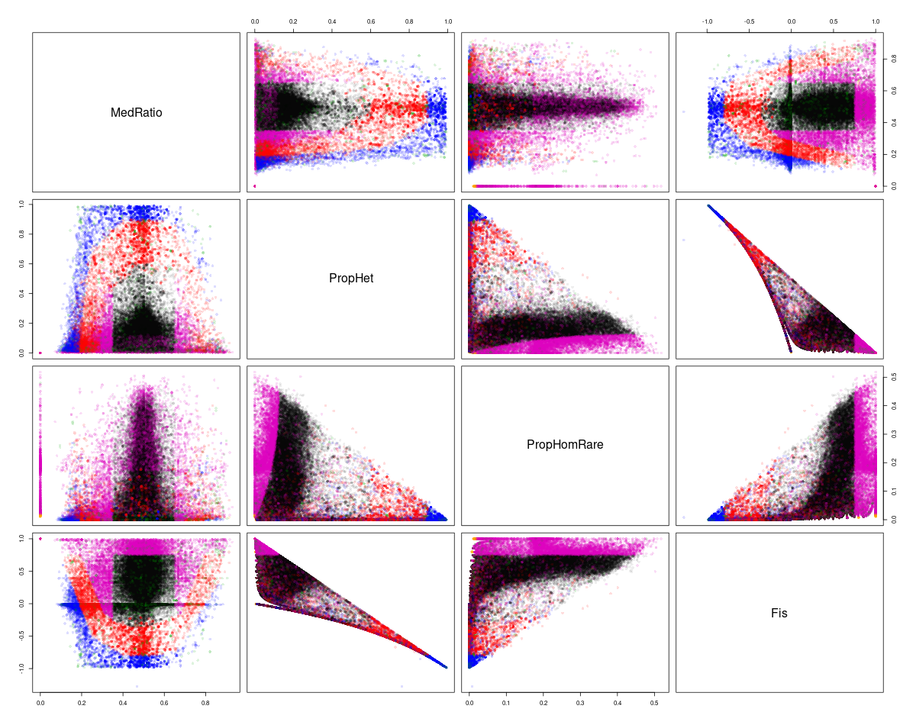

**Figure S1**. Graphical analysis used to detect CNVs in *Rana luteiventris*. The CNV discovery was performed based on four parameters: median of allele ratio in heterozygotes (MedRatio), proportion of heterozygotes (PropHet), proportion of rare homozygotes (PropHomRare), and Fis. Black, red, blue, and magenta points represent singletons, duplicated, diverged and low confidence SNPs, respectively.

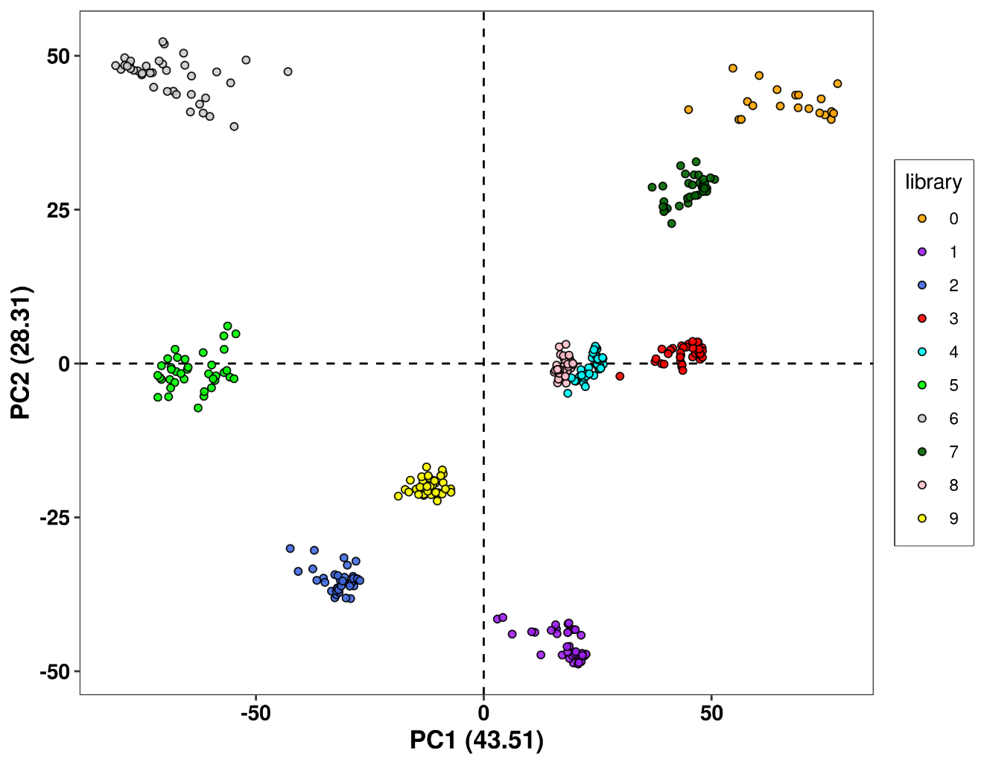

**Figure S2**. Principal Component Analysis showing the batch effect detected in the normalized read depth matrix.

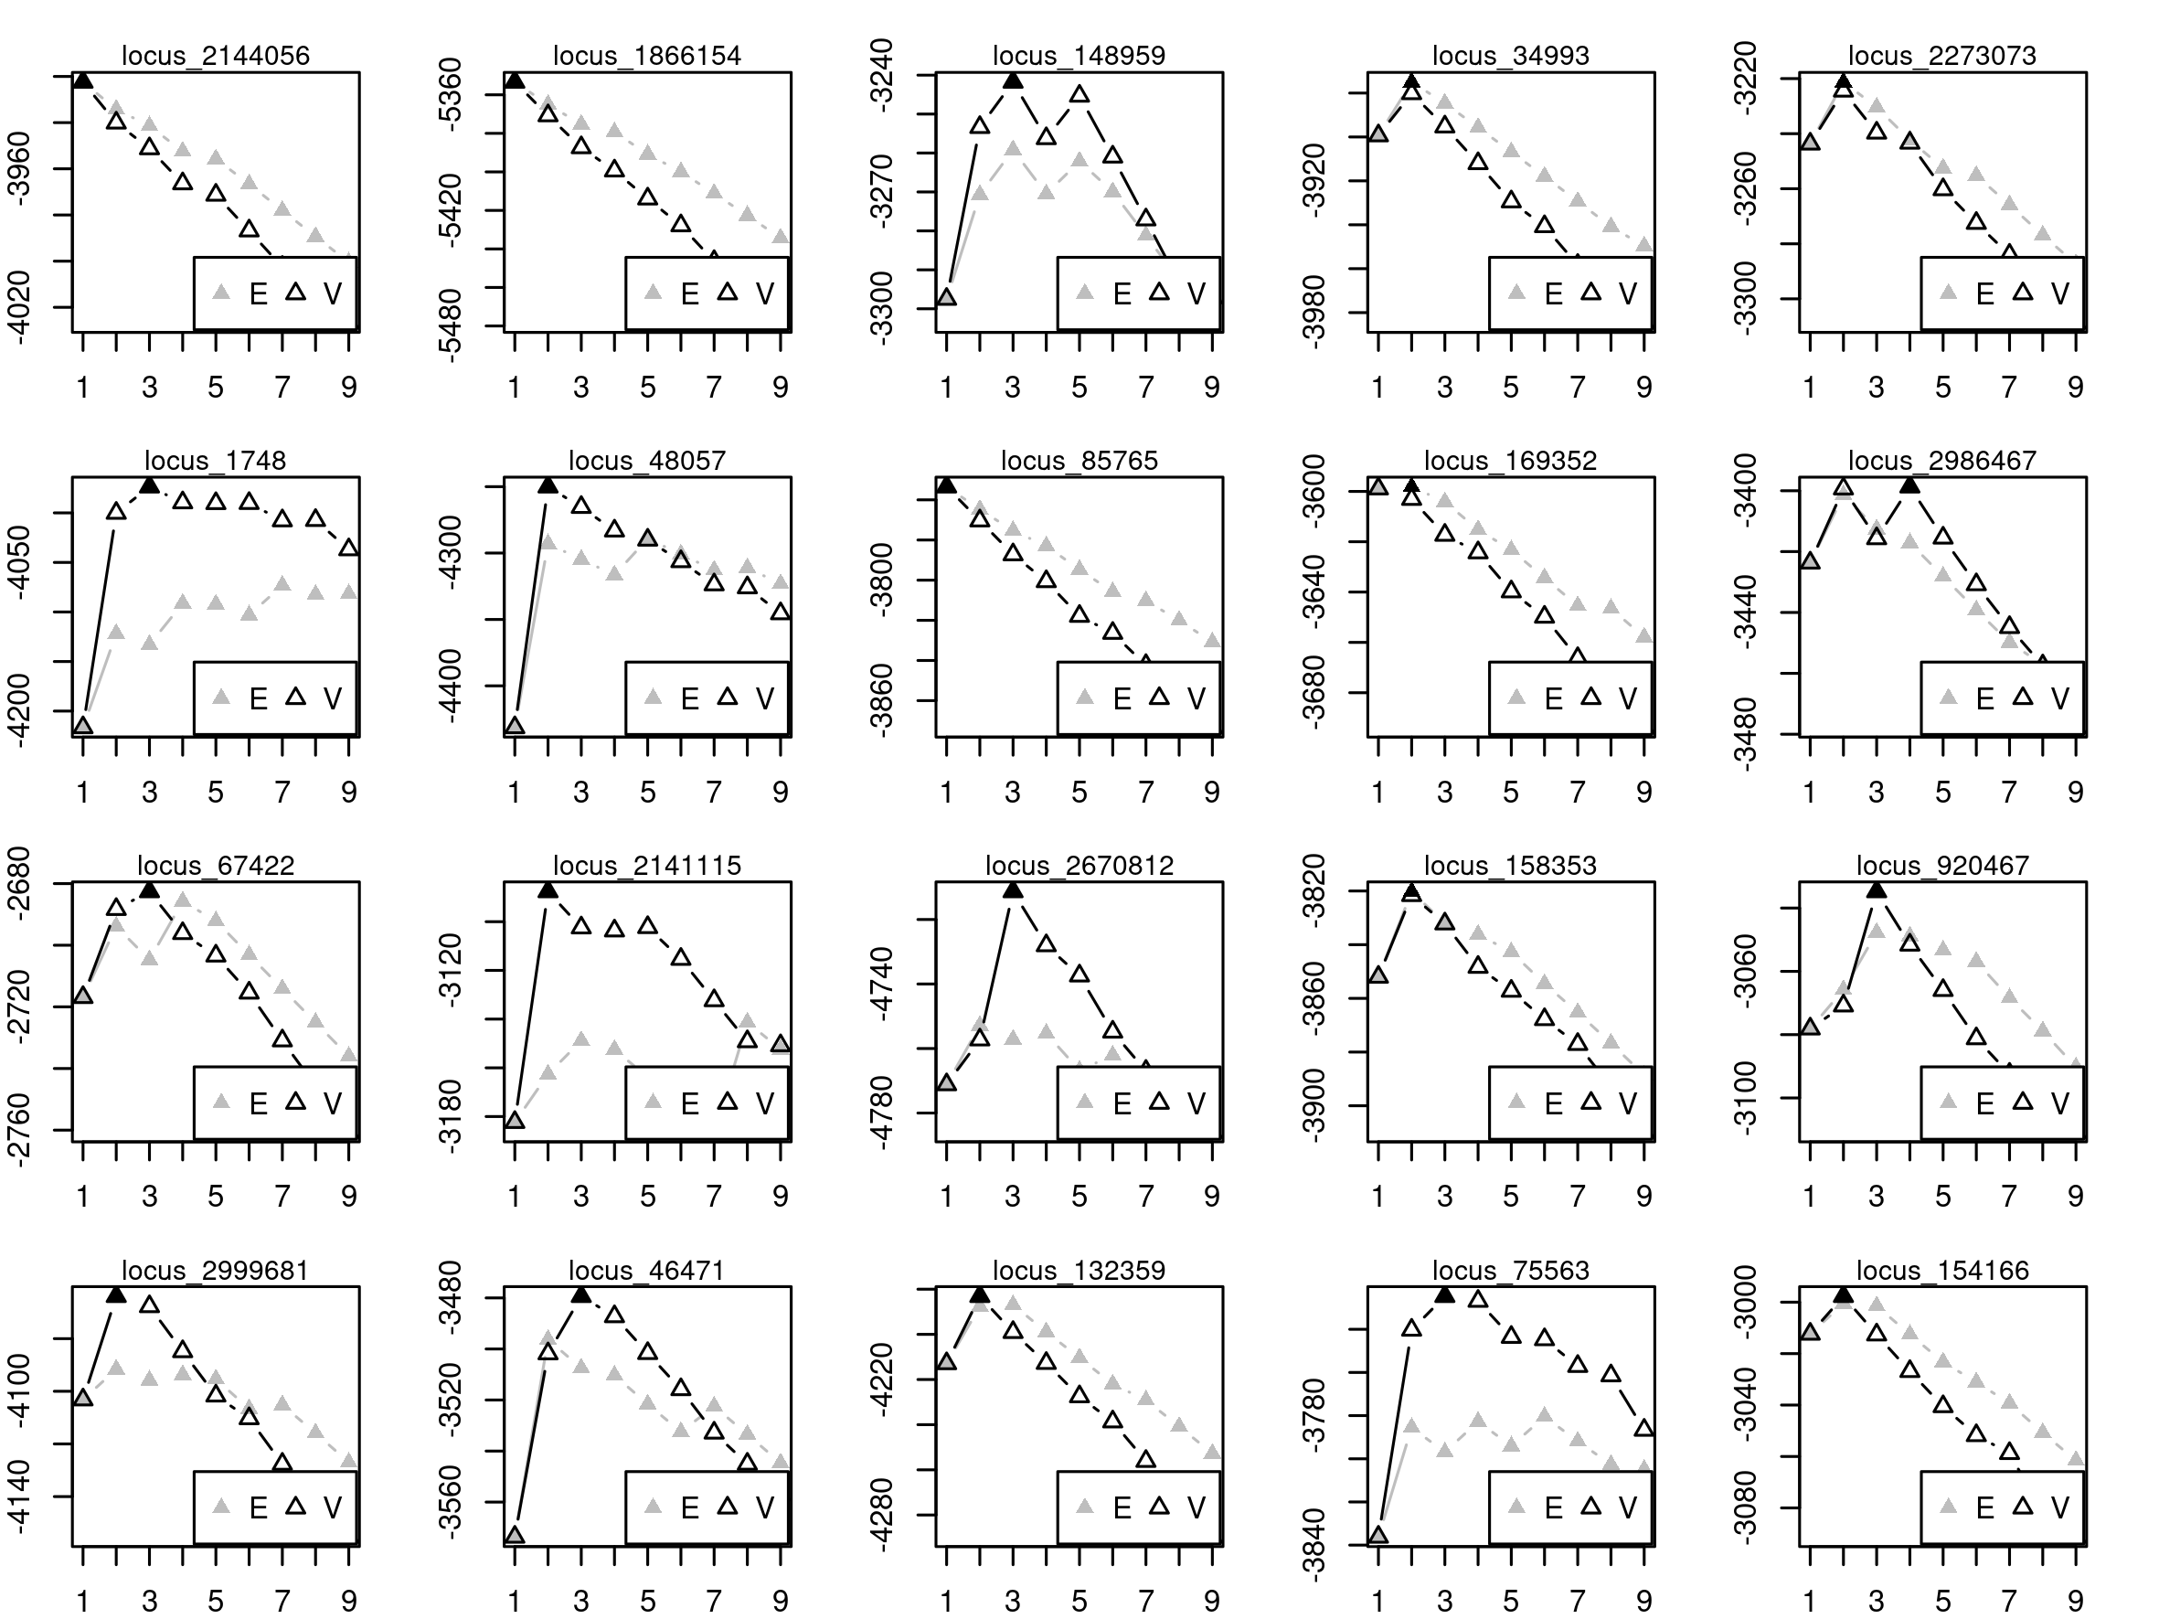

**Figure S3**. Mclust model performance for 20 strong CNV candidates associated with mean annual temperature (those with the highest R²). (E) represents EM algorithm for equal variance (one-dim) and (V) represents EM algorithm for variable/unequal variance (one-dim). The black triangle in each figure illustrates the best model for sample clustering via the BIC (BIC = Bayesian Information Criterion) for up to 9 components.

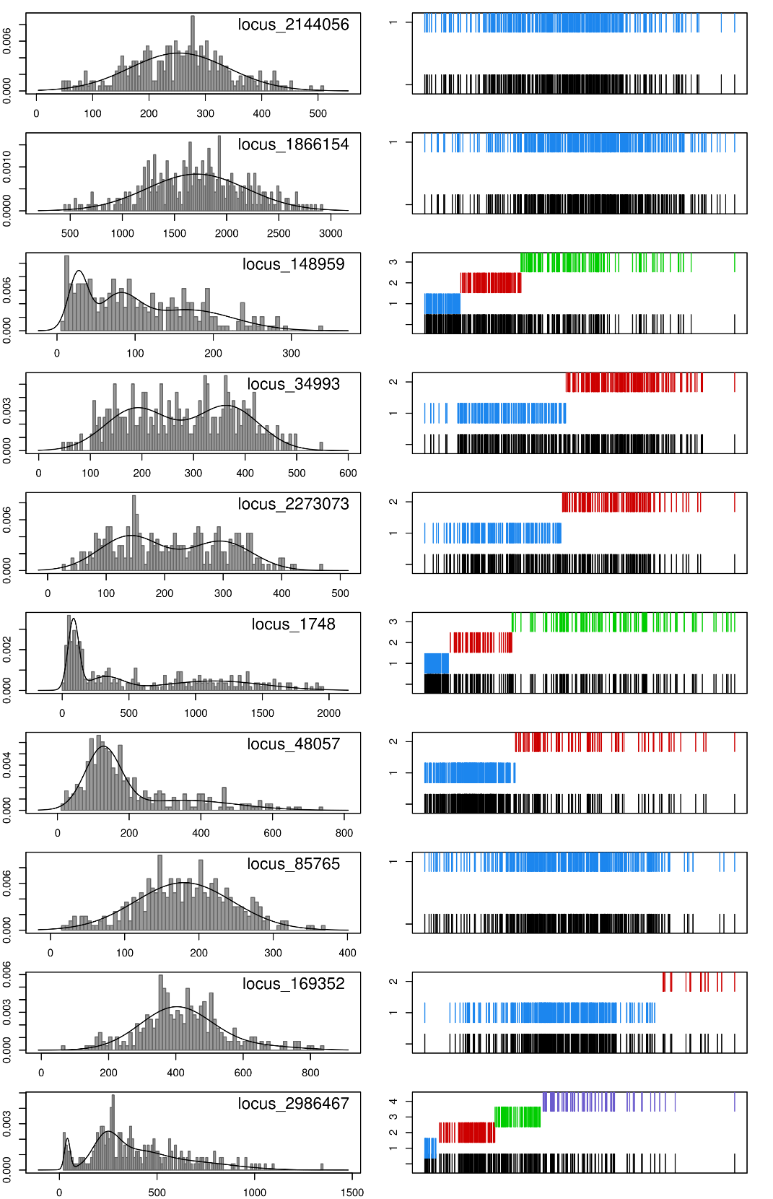

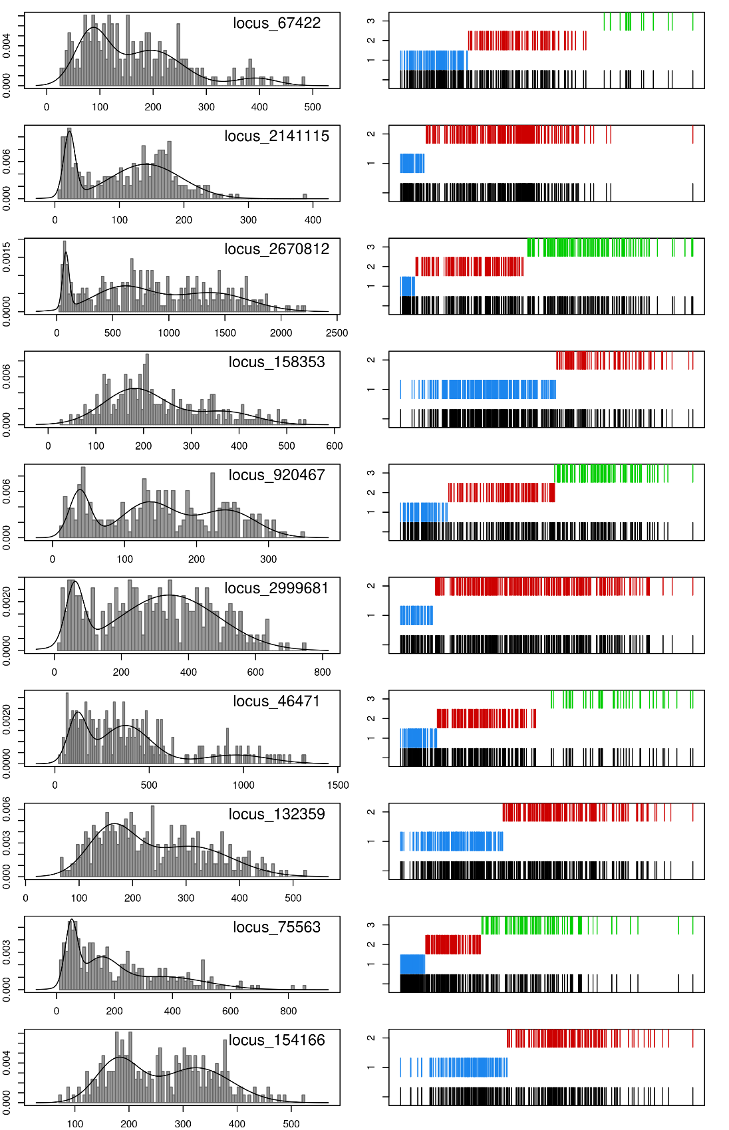

**Figure S4**. Mclust model features for 20 strong CNV candidates associated with mean annual temperature (those with the highest R²). Left: density of normalized read depth distribution (i.e., one-dimensional model). Right: classification plot from the best model (i.e., evaluated by BIC, see **Figure S5**). In the classification plot, all individuals are displayed at the bottom (black bars), with the separated classes shown in different levels above (colored bars).

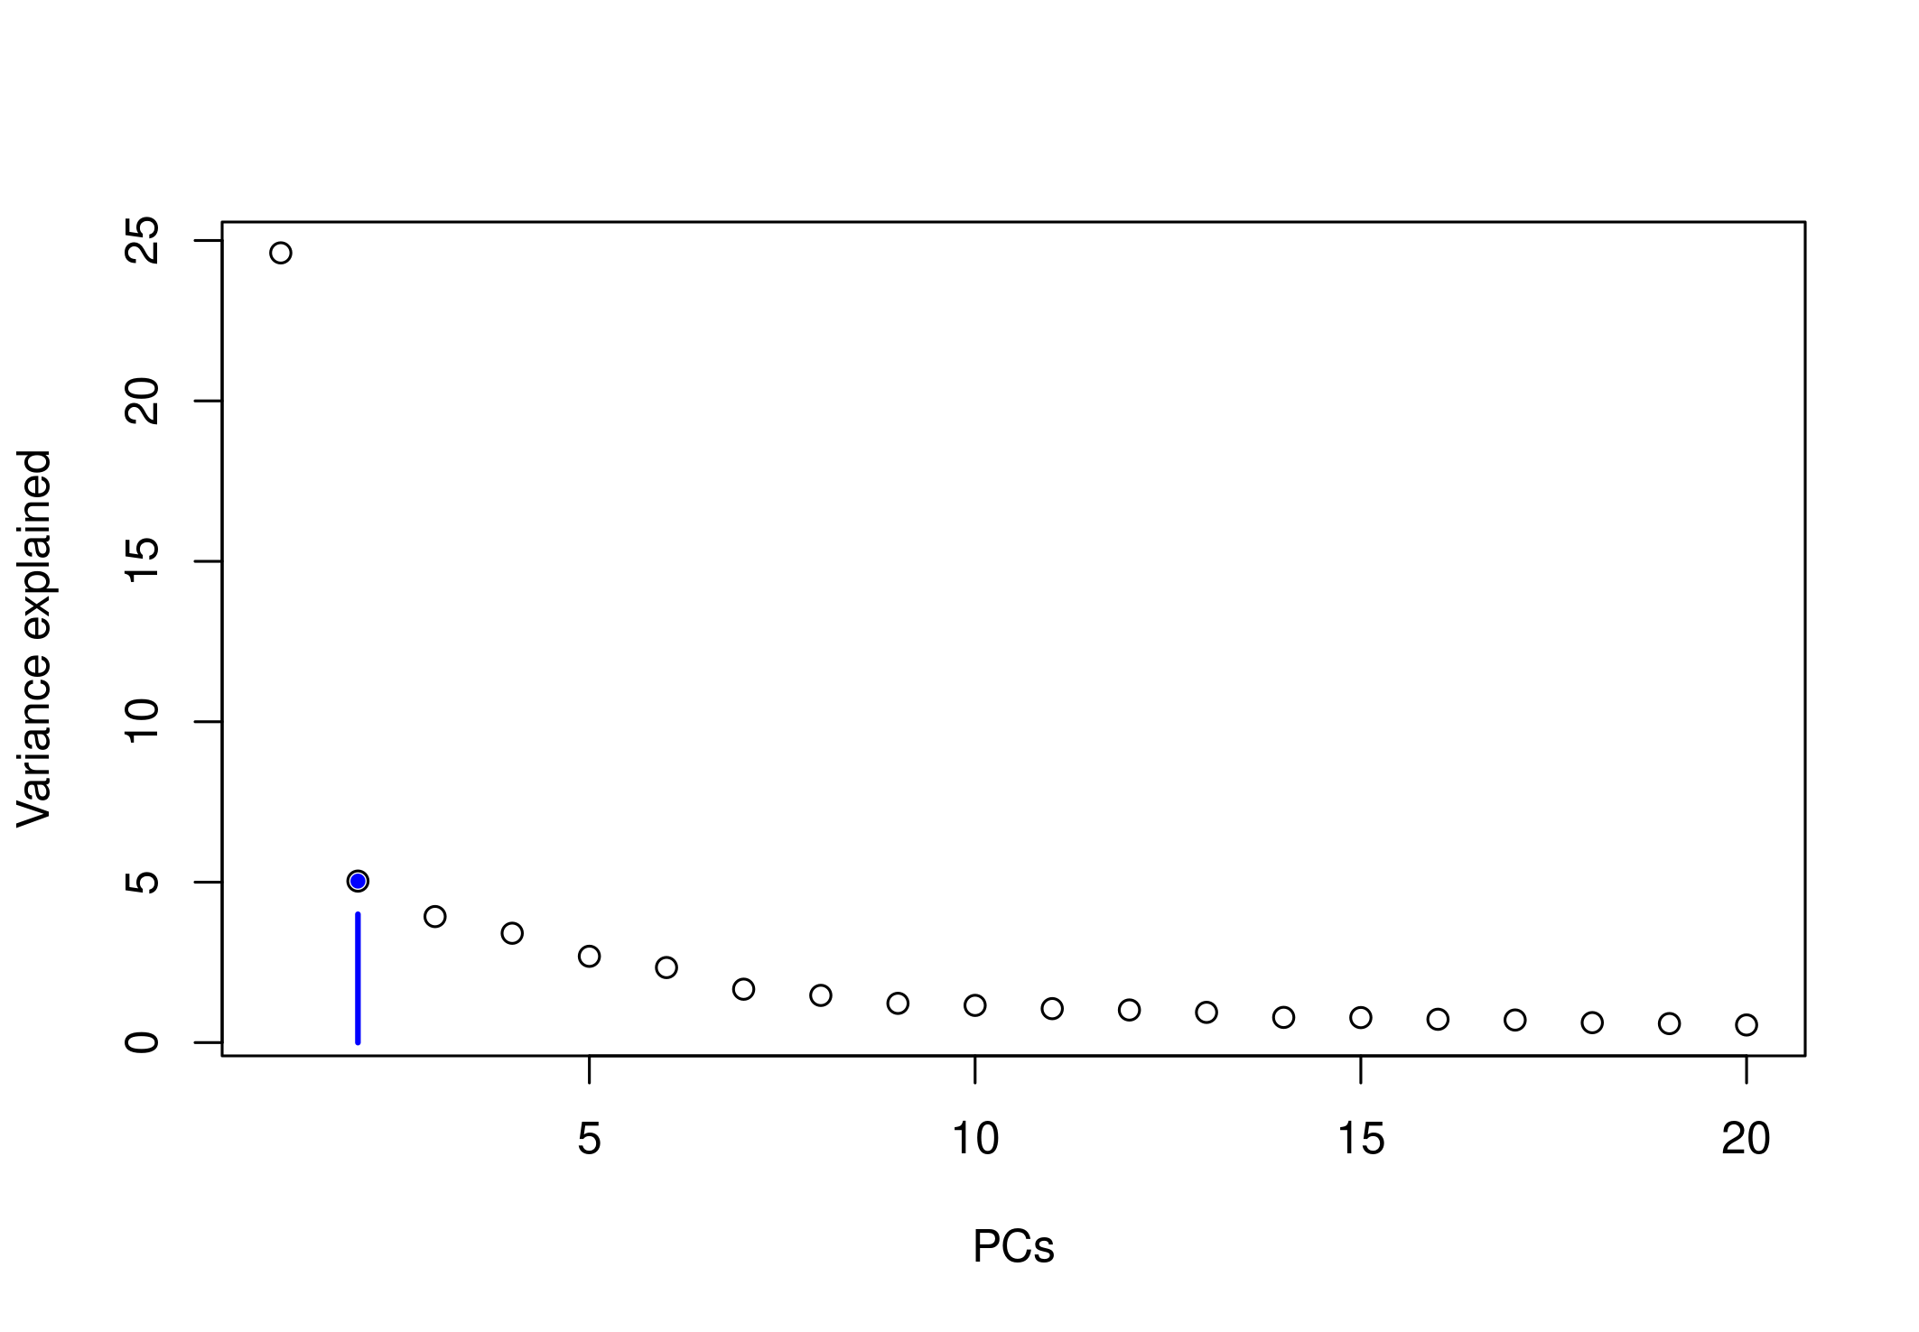**Figure S5.** Screeplot displays in decreasing order the percentage of variance explained by each PC from a Principal Component Analysis of the 352 *Rana luteiventris* SNP genomic data. The blue point at two PCs correspond to population structure which lie on a steep curve and represents the optimal choice for LFMM K parameter.

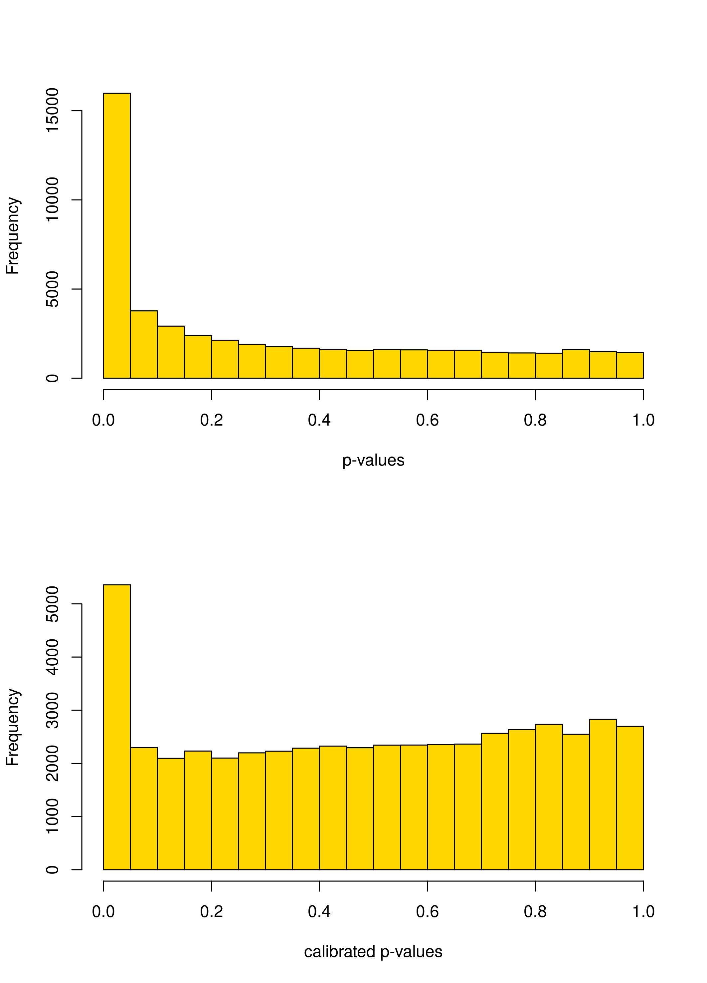

**Figure S6.** Histograms of test significance values (p-values) from LFMM analysis before genomic inflation factor (GIF) calibration (upper panel) and after GIF calibration (lower panel).

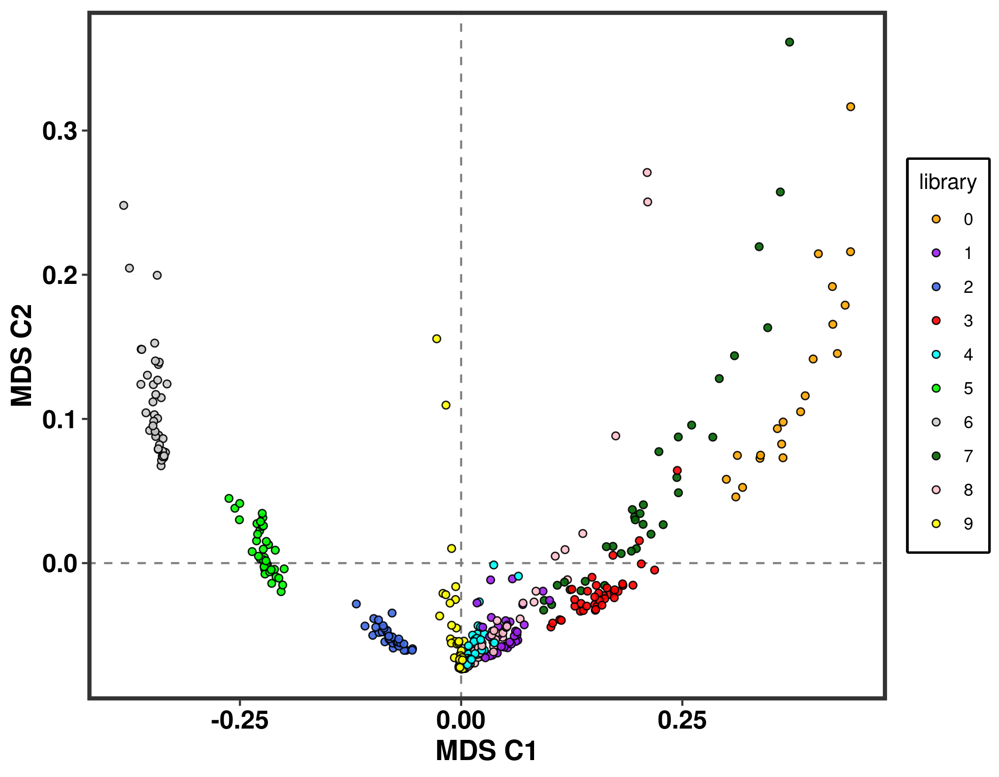**Figure S7.** MDS analysis of identity-by-missingness (IBM) patterns calculated in PLINK. First (x-axis) and second (y-axis) dimensions of 351 samples (31 locations), distributed across 10 sequencing batches and based on IBM analysis over 50,829 SNPs. Each point represents a sample colored according to its sequencing batches libraries membership. This analysis translates putative structure among samples from various sequencing batches derived from missing data patterns.



**Figure S8**. Histogram of Kimura distances for putative CNVs (in blue) matching the *R. temporaria* repeat database and within a set of 50,000 randomly selected RADtags (5 subsets, in grey) from the full catalog (representing a baseline expectation for a given set of RAD tags in the dataset). The distributions of the two sets of Kimura distances were compared using Welch’s t-test for equal means, andKolmogorov–Smirnov (KS) test. All statistical tests were implemented in Scipy v.1.5.1 in Python 3.6.3.



**Figure S9**. Histogram of Kimura distances (same data as in Fig. S8) separated by 14 major repeat families. Putative CNVs (in blue) that matched the R. temporaria repeat database are compared with 50,000 randomly selected RADtags (5 subsets, in grey) from the full catalog (representing a baseline expectation for a given set of RAD tags in the dataset). For each repeat family, the distributions of the two sets of Kimura distances were compared using Welch’s t-test for equal means, and Kolmogorov–Smirnov (KS) test. All statistical tests were implemented in Scipy v.1.5.1 in Python 3.6.3.