SUPPLEMENTAL 1

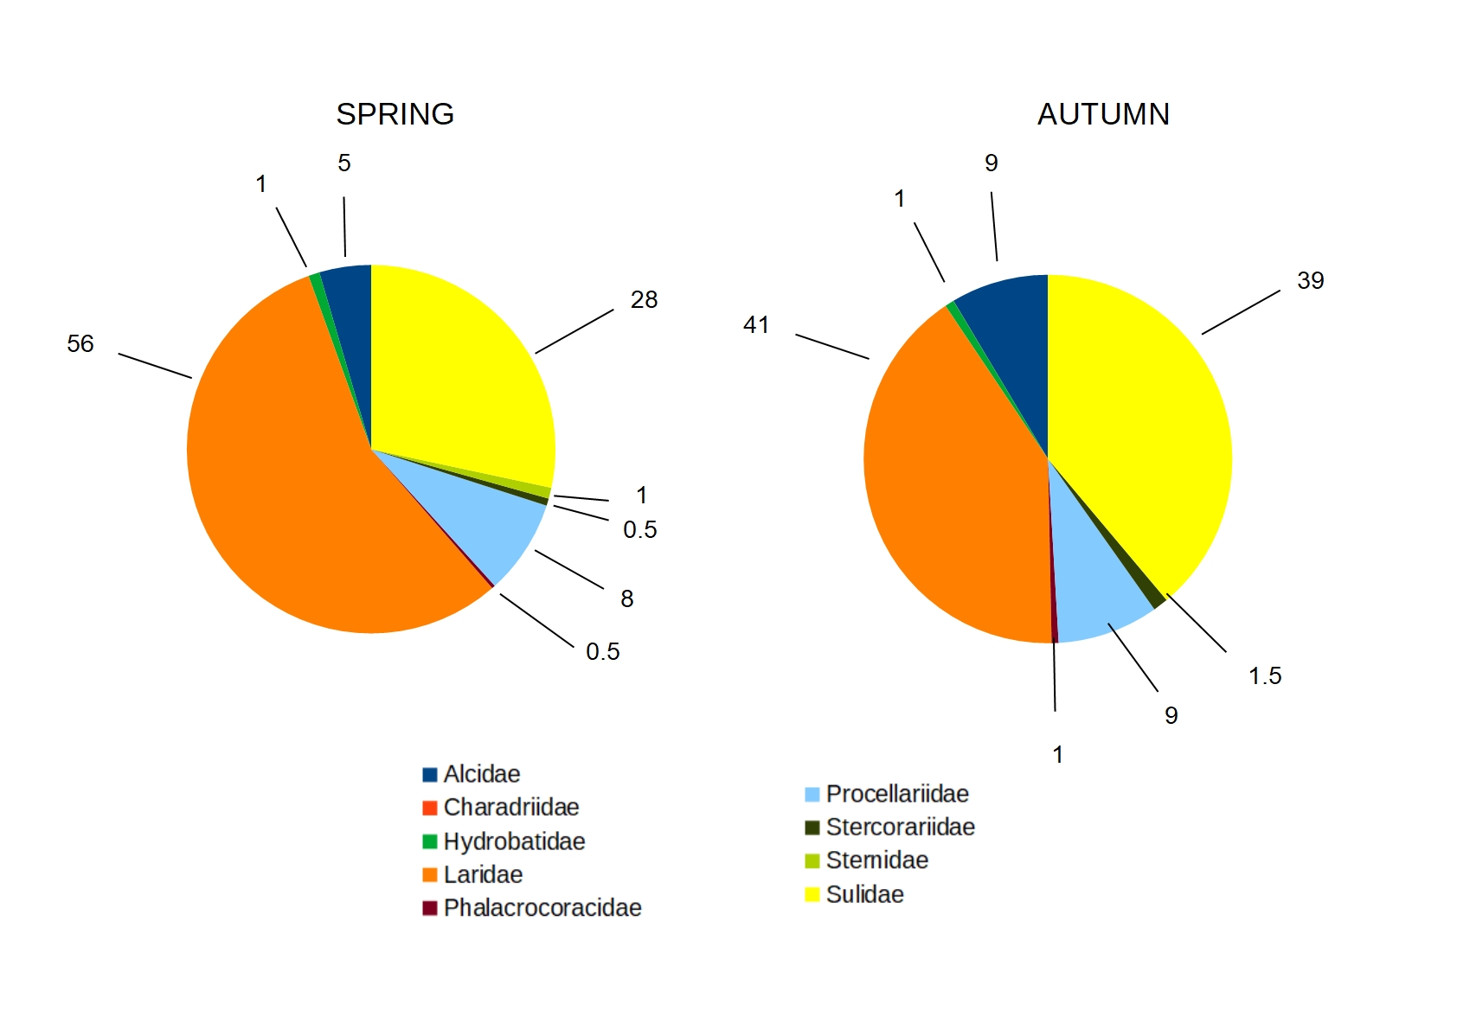  
Proportion (in percentage) of different group of species observed in the Bay of Biscay in spring and autumn during the study period ; Alcidae : alcids ; Charadriidae : waders; Hydrobatidae : Storm petrels ; Laridae : gulls ; Phalacrocoracidae : cormorants ; Procellariidae : shearwaters ; Stercorariidae : skuas and jaeger; Sternidae : terns ; Sulidae : gannets.

SUPPLEMENTAL 2

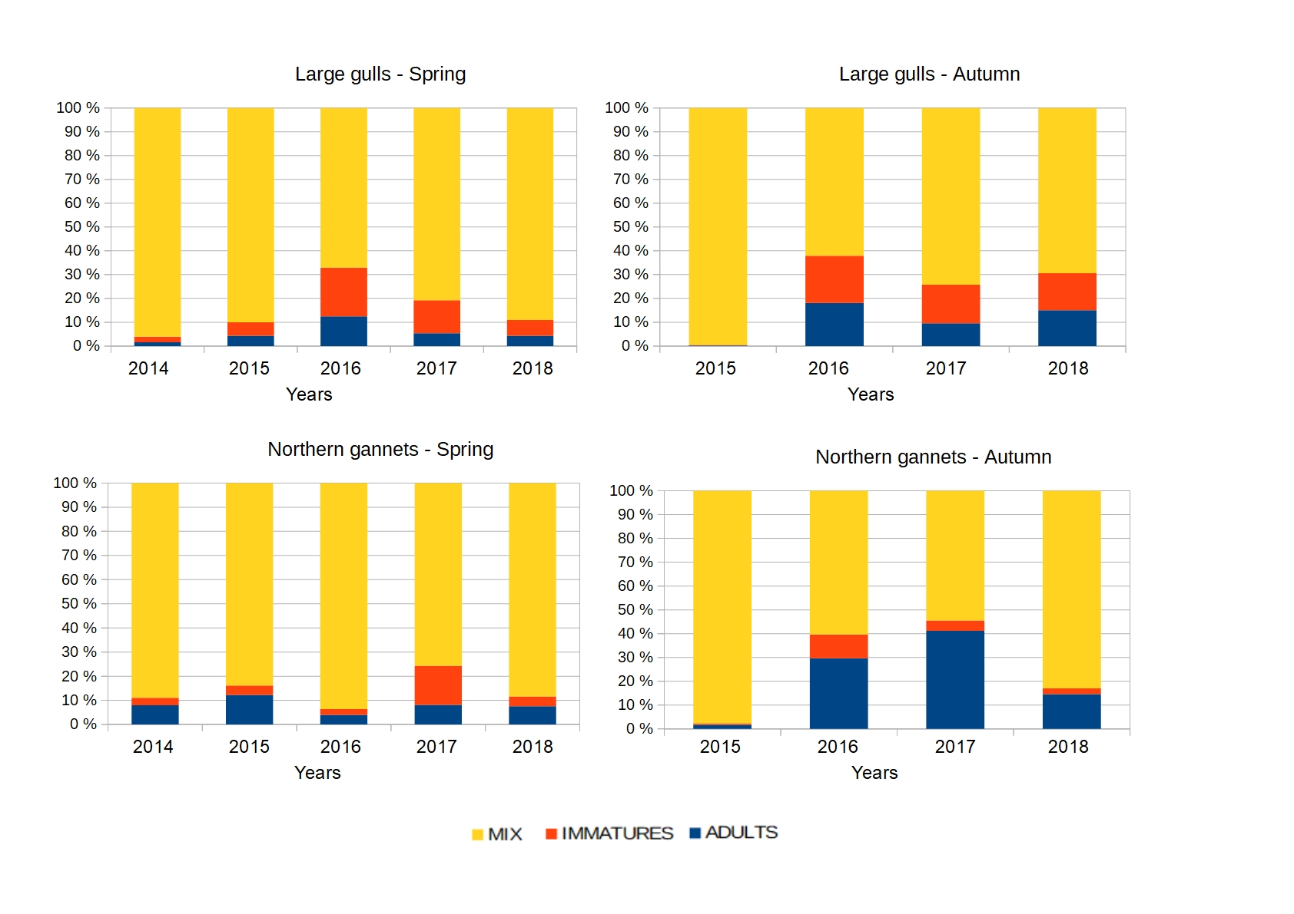  
Distribution of the different stages of maturity for both scavenging seabird groups and seasons. Mix : groups of individuals containing both adults and immatures ; IMMATURES : groups of individuals containing only immatures ; and ADULTS : groups of individuals containing only adults.

SUPPLEMENTAL 3

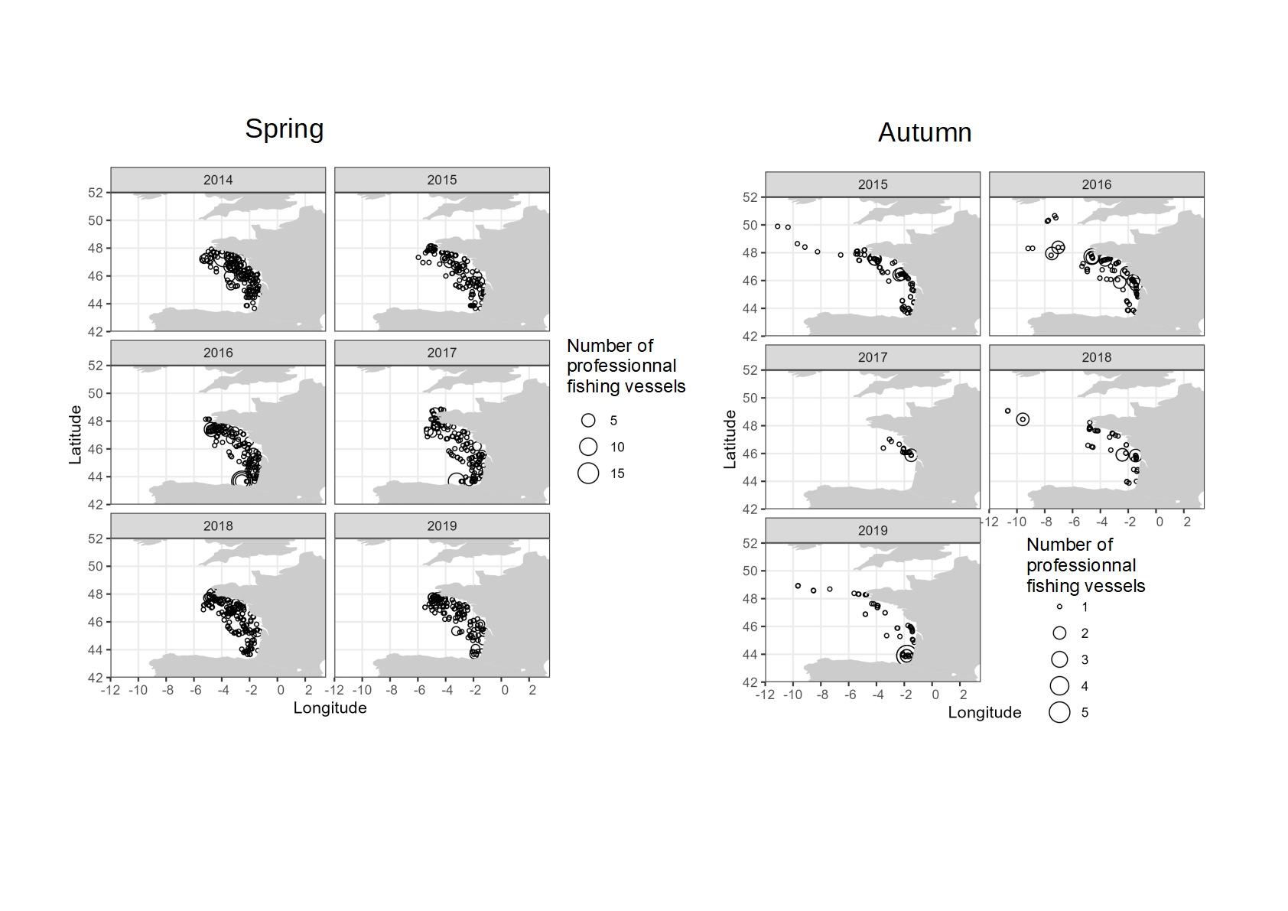

Density of professionnal fishing vessels (i.e. number of fishing boats, all metiers combined) for spring (i.e. Pelgas survey series) and autumn (i.e. Evhoe survey series).

SUPPLEMENTAL 4

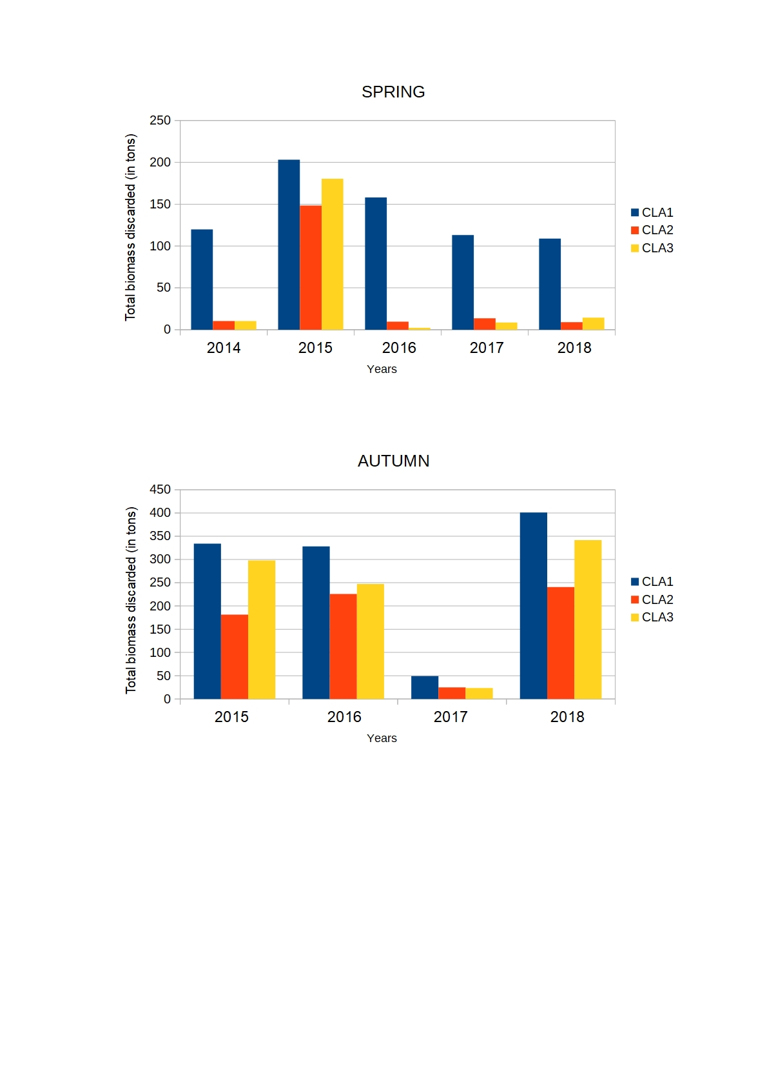

  
Total biomass discarded (in tons) for each class in spring (i.e. Pelgas survey series) and autumn (i.e. Evhoe survey series): CLA1 (discards of class 1); CLA2 (discards of class 2); CLA3 (discards of class 3).