**Figure S1   
  
1) Oceanographic campaigns**

For this study, seven scientific programs were combined. These were the following:

1. “MALIMO program” is located in Madagascar and created by the CETAMADA association and funded by the Western Indian Ocean Marine Science Association (WIOMSA), aiming to establish the first baseline of marine litter beached on the island. Microplastics sampling was carried out on Ste Marie Island (Northeast of Madagascar) in October 2019;
2. “Megafauna and plastic debris monitoring program” is undertaken from visual survey onboard the OSIRIS II vessel every three months in the French exclusive economic zone (EEZ) of the Southwest Indian Ocean (SWIO). This corresponds to a partnership between the Direction de la Mer Sud-Océan Indien and Globice Reunion. Sampling was conducted from 2021 to 2023;
3. “Plast program” is located in Reunion Island created by IRD, to study pathogens fixed on plastic. Sampling was conducted in October 2021;
4. “DEchets MARins Reunion” (DEMARRE) is a quarterly plastic debris monitoring program of the sea surface and on the coastline of Reunion island. Sampling was conducted from 2021 to 2023;
5. “South Indian Ocean Mission 1” (SIOM1) is a program set up by The Ocean Cleanup to collect plastic debris in the SWIO during January 2022;
6. "Ecole Bleue Outre Mer” is a cruise from University of Reunion island, sampling was done in July 2022;
7. “Initiation à l'Océanographie TropicAle” (IOTA) is a cruise from University of Reunion island, sampling was done in October 2022;
8. “Microplastics AnD CorAls PathogenS” (MADCAPS) was a project to study plastic debris pathogens in the SWIO, sampling was done during October-November 2022;

**2) Beach monitoring campaigns**

The programs and monitored uninhabited beaches include:

(i) MALIMO program, with sampling conducted on Ste Marie Island (Ampanihy) and Fort Dauphin (Ampahiry) in Madagascar from 2019 to 2021. It used the marine litter characterization list created by Barnardo et al., 2020;

(ii) The Terres Australes Antarctiques Françaises (TAAF), sampling was done on Tromelin, Grande Glorieuse and Europa every three months between 2020 and 2023. Opportunistic plastic debris sampling was done on Juan de Nova and Lys in July 2021 during the oceanographic cruise OSIRIS II.1. It used the marine litter characterization list created by Marine Strategy Framework Directive (MSFD, OSPAR, 2010; GESAMP, 2019);

(iii) “Plast program”, sampling was done on Tremblet in Reunion Island in October 2021. It used the marine litter characterization list created by Barnardo et al., 2020;

(iv) during the MADCAPS project, marine litter was collected in the Seychelles Archipelagos at Aldabra Atoll in November 2022. It used the marine litter characterization list created by Barnardo et al., 2020;

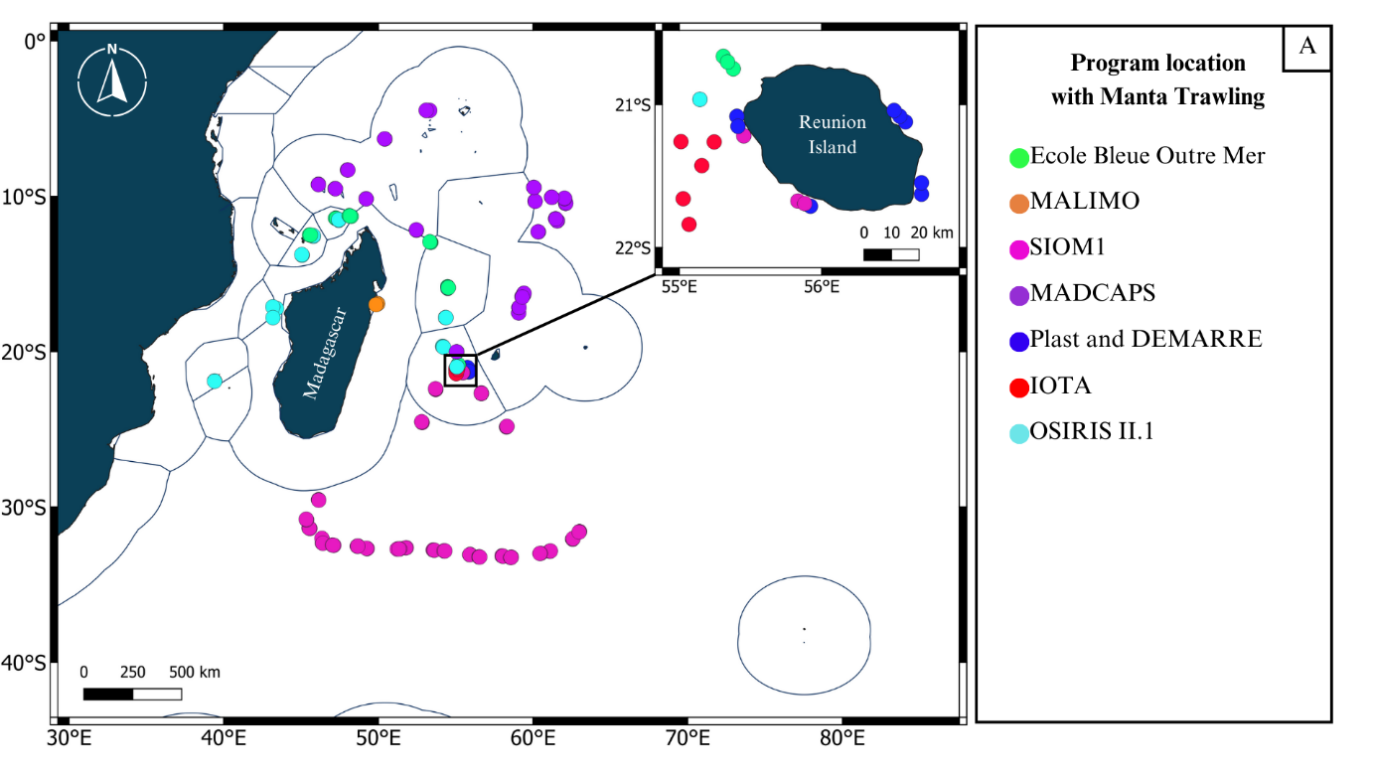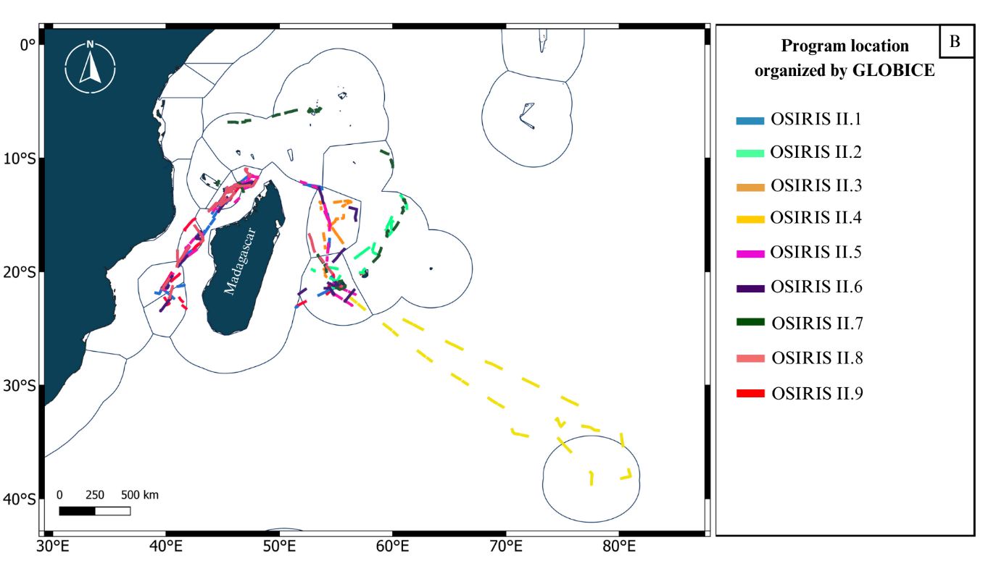

**Figure S2.** Location of all oceanographic campaigns A) with manta trawling and B) organized by the Globice association

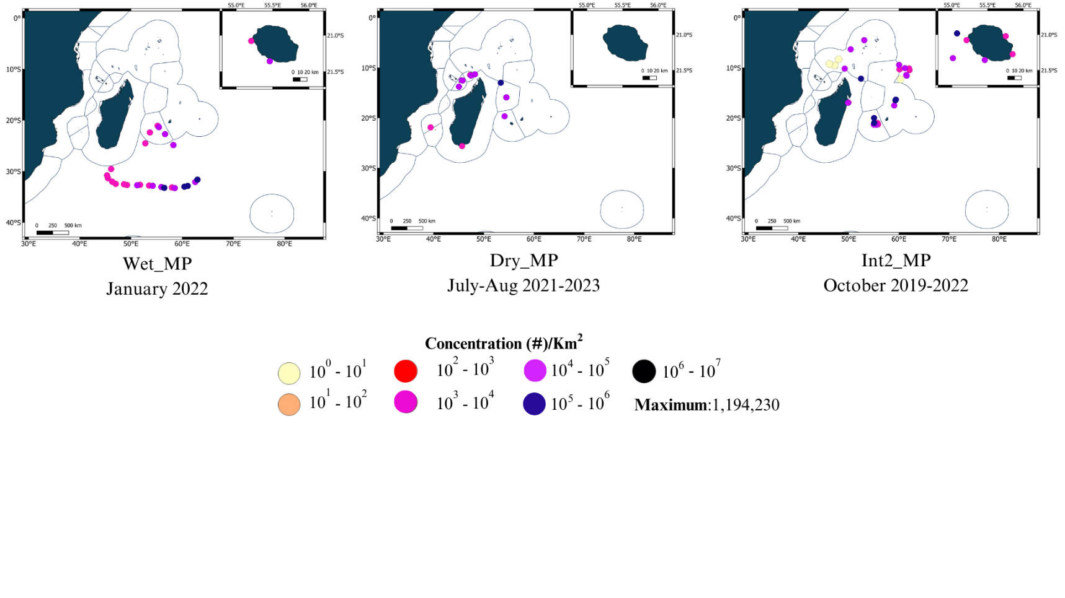

**Figure S3.** Microplastics (500µm-5mm) concentration by season

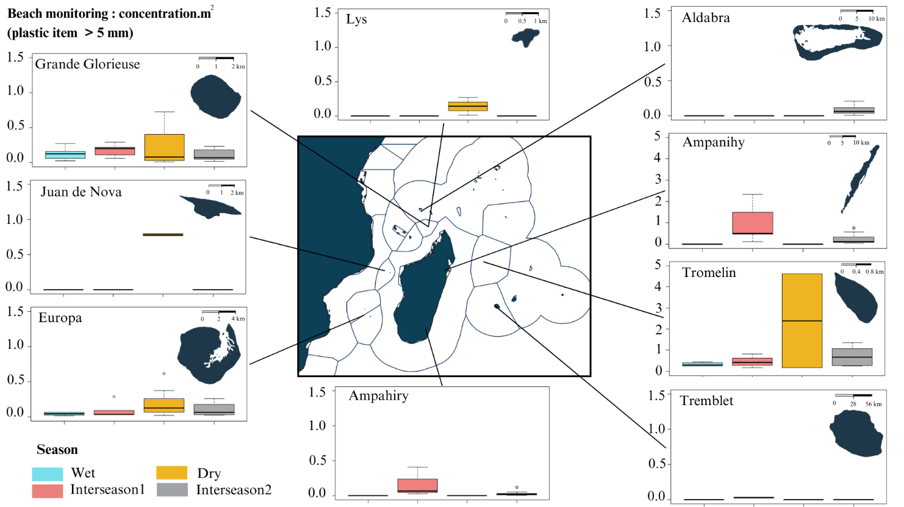

**Figure S4.** Concentration of plastic debris (> 5mm) beached by site and season

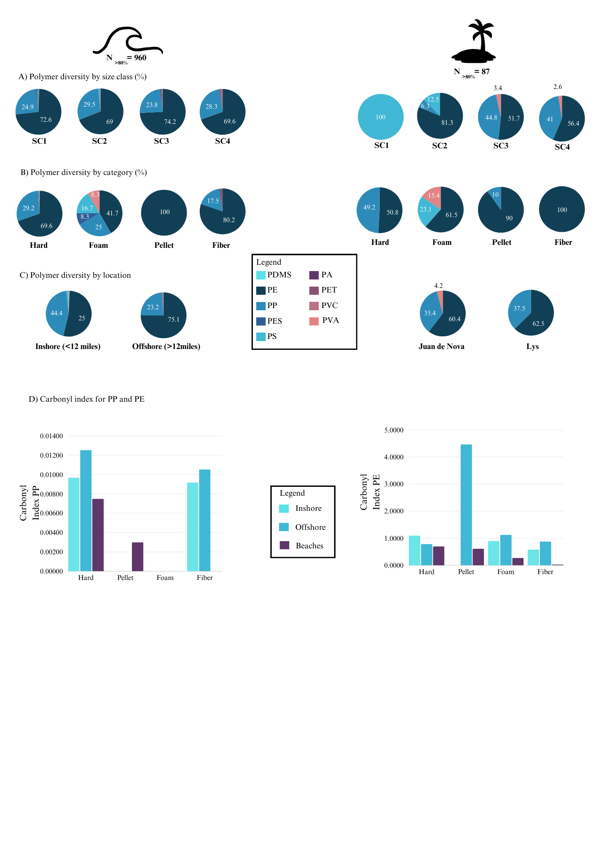

**Figure S5.** Polymer proportion from plastic debris collected by manta sampling (%) by A) size class (cm): SC1 (0.05-0.15 cm), SC2 (0.15-0.5 cm), SC3 (0.5-1.5 cm), SC4 (1.5-5 cm), B) category: Hard, Foam, Pellet, Fiber, C) location: Inshore (< 12 miles), Offshore (>12 miles). D) Carbonyl Index for polypropylene and polyethylene by location and category. PP (polypropylene), PE (polyethylene), PDMS (polydimethylsiloxane), PES (polyester), PS (polystyrene), PA (polyamide), PET (polyethylene terephthalate), PVC (polyvinyl chloride), PVA (polyvinylacetate)