# Supplementary materials

## A Evolution of the morphology of the Loire and Seine estuaries over the last century

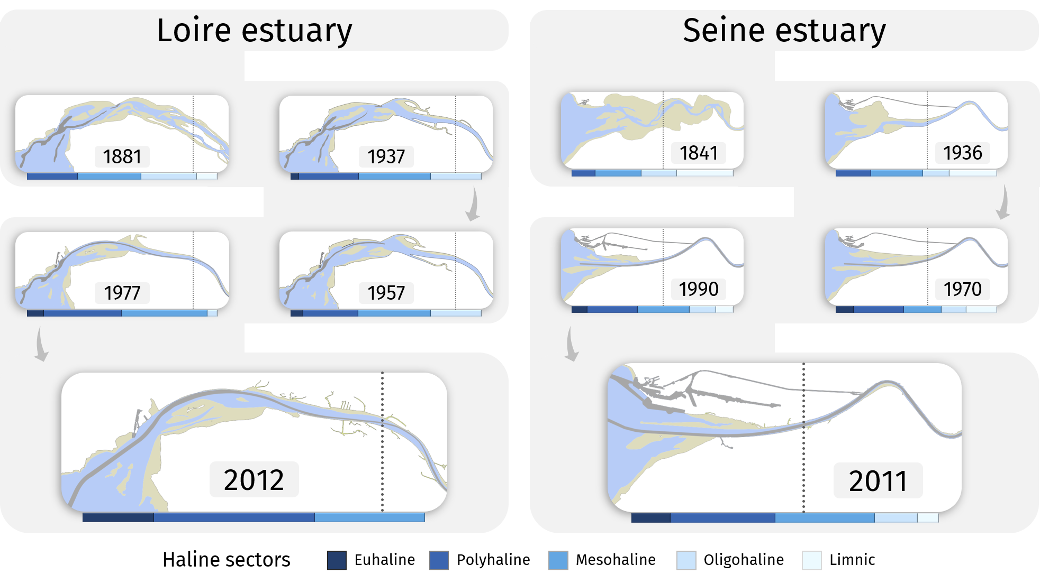

Figure A.1: Geomorphological modifications of the Loire and Seine estuaries over 150 years of industrial and harbor planning. Information on the historical position of the salinity gradient is presented.

## B Details on the sampling design of the macrobenthos datasets for the Loire and Seine estuaries

The sampling design varied across spatial units and between estuaries, leading to unbalanced number of samples. Hypothesis testing was conducted using the permutation-based PERMANOVA procedure (Anderson 2001). Balanced group sizes generally lead to more reliable test results. However, a permutation-based method is well-suited to handle unbalanced designs (McArdle & Anderson 2001). In our study, the differences in sample sizes were not extreme, the standard deviation in group sizes being 5.9 in the Loire and 3.8 in the Seine, minimizing potential issues related to imbalanced designs.

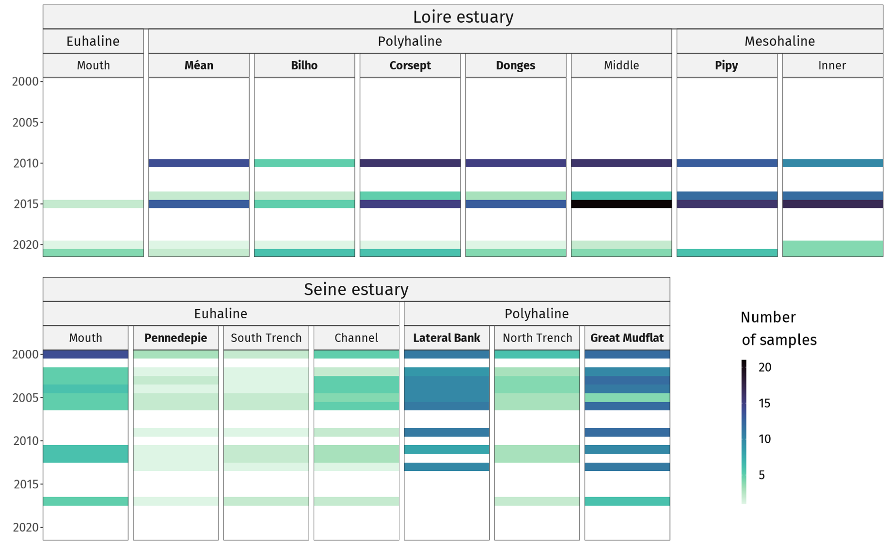

Figure B.1: Number of samples contained in the Loire and the Seine estuaries macrobenthic datasets, per year and per spatial unit. Each sample is replicated at least three times.

## 

## C Complements to the taxonomic $β$-diversity analysis

A hierarchical clustering analysis was conducted on taxonomic dissimilarity calculated for the combined macrobenthic datasets of the Loire and Seine estuaries. This procedure identified five assemblages (Figure 10). The majority of samples per cluster belonged to, from left to right on the dendrogram: the sandy units of the Seine; the intertidal mudflats of the Seine; the downstream units of the Loire; the upstream units of the Loire (characterized by *Boccardiella ligerica*); and a set of intertidal mudflat samples shared between the Loire and the Seine (characterized by *Corophium volutator*). We also computed a measure of how much the average taxonomic composition of each spatial unit contributed to the overall $β$-diversity (LCBD, Legendre 2014) per year. The polyhaline intertidal mudflats—Méan, Bilho, Corsept, and Donges in the Loire, and the Lateral Bank and the Great Mudflat in the Seine—had low contributions on average, whereas the euhaline units of both estuaries and the mesohaline units of the Loire were characterized by higher contributions and, thus, more extreme coordinates on the ordination analysis presented in the Results section of the main manuscript of this article.

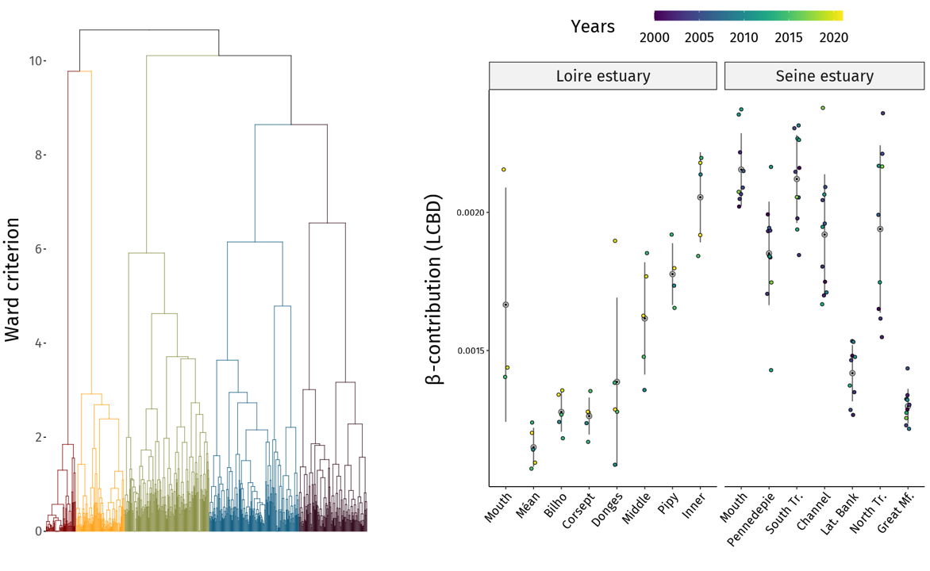

Figure C.1: Left panel: dendrogram produced by a hierarchical clustering analysis (Ward’s method, Ward 1963), revealing five well-differentiated clusters of samples. Right panel: yearly mean contribution of each spatial unit to overall $β$-diversity (LCBD), used in the diversity index analyses in the main manuscript of this article.

## 

## D Relevance of the selected functional indices

Table D.1: List of functional indices investigated and their ecological interpretation regarding production and response to the environment of estuarine macrobenthic communities.

|  |
| --- |
|  |

## E Partial effects of the generalized additive models (GAM)

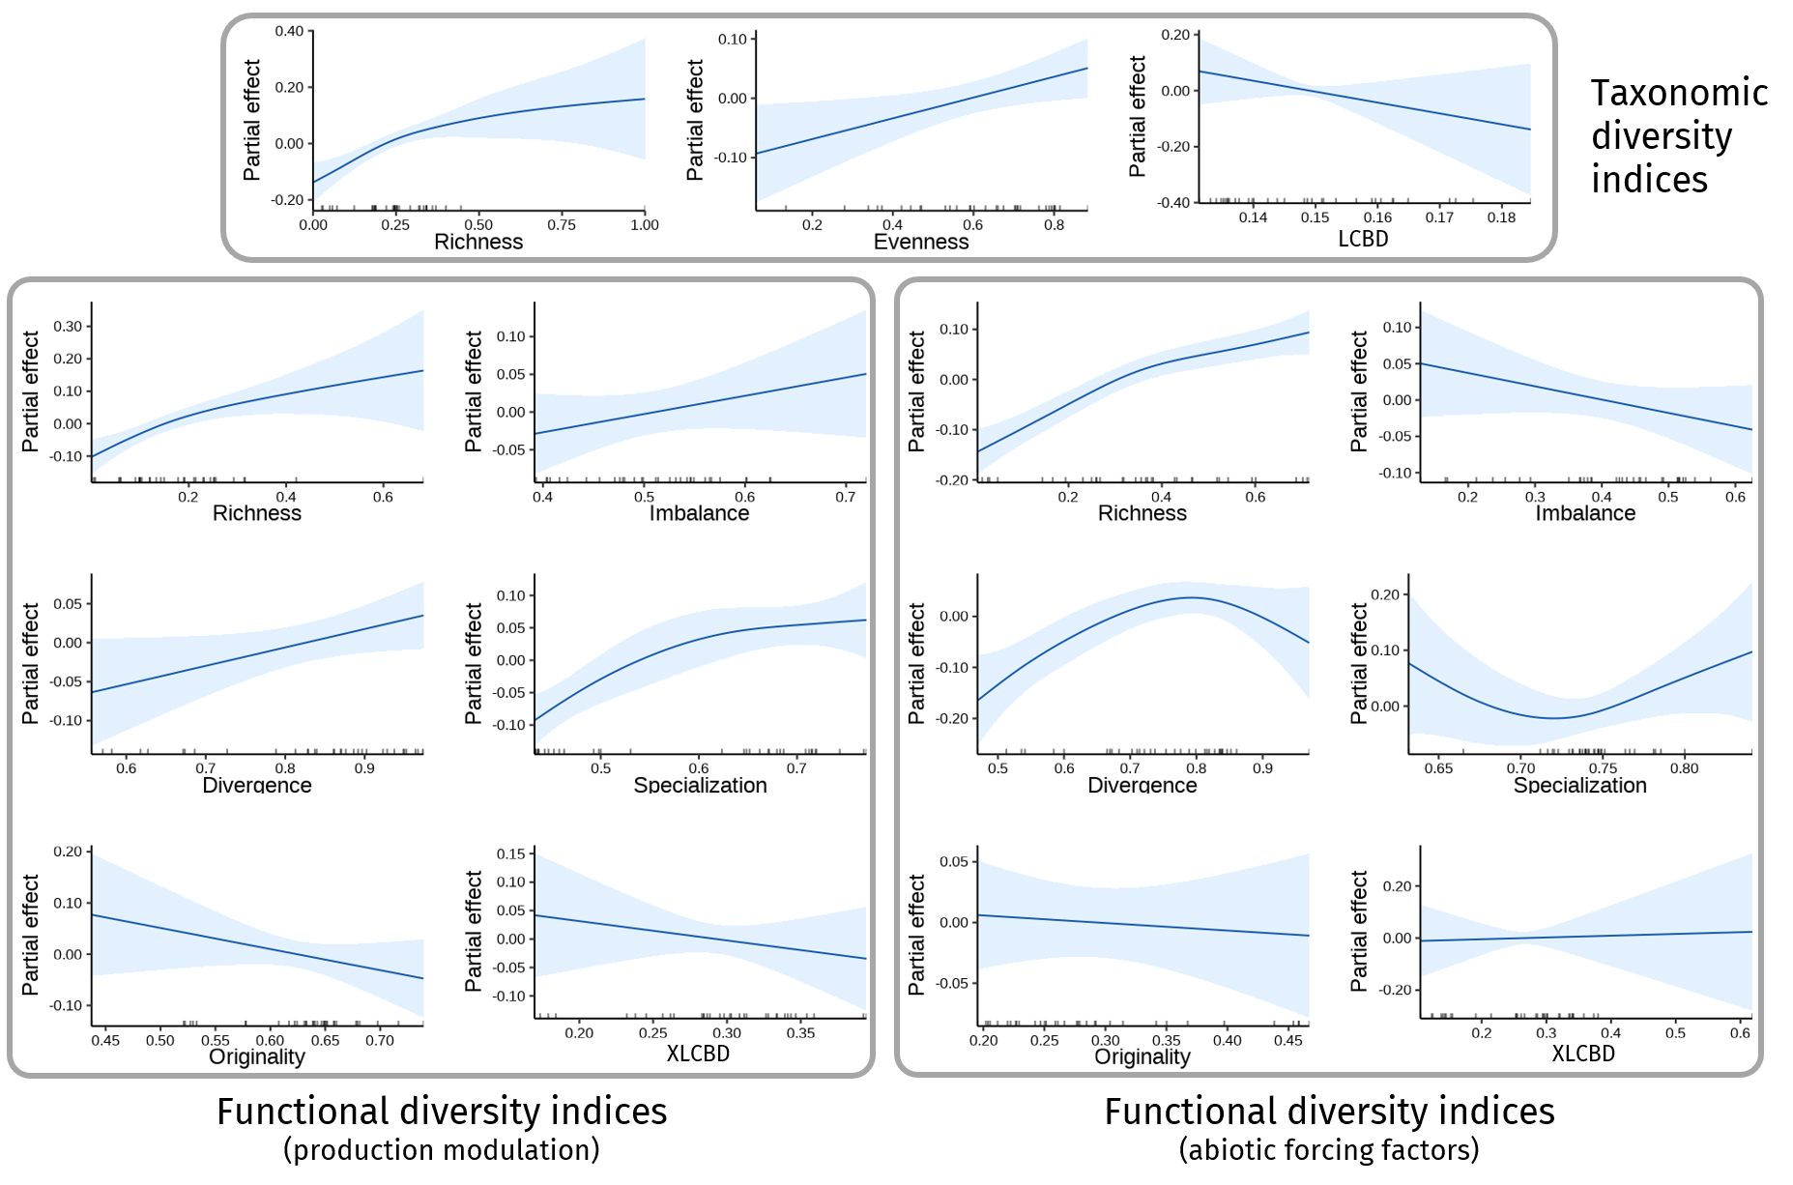

Figure E.1: Results of the GAM models conducted on the Loire estuary macrobenthic community. Partial effect of individual macrobenthic diversity indices on the macrobenthic production were smoothed using thin plate regression splines. Diversity indices were sorted by type into grey boxes. Data points were represented in the form of a rug on the abscissa axis.

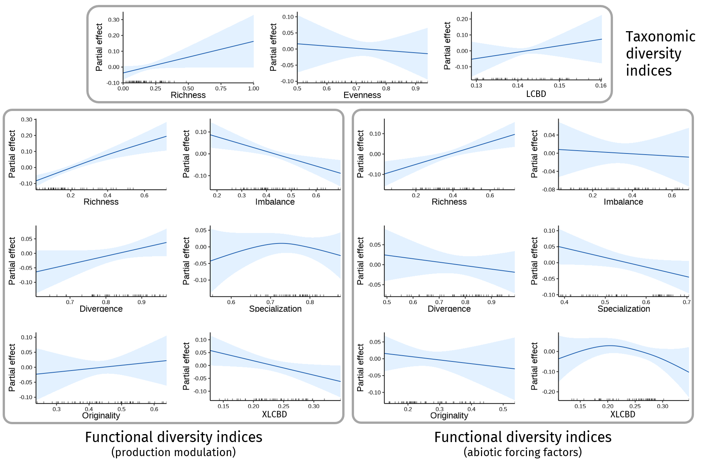

Figure E.2: Results of the GAM models conducted on the Seine estuary macrobenthic community. Partial effect of individual macrobenthic diversity indices on the macrobenthic production were smoothed using thin plate regression splines. Diversity indices were sorted by type into grey boxes. Data points were represented in the form of a rug on the abscissa axis.

# Supplementary references

Anderson M.J. (2001). A new method for non-parametric multivariate analysis of variance. *Austral Ecology* 26 (February): 32–46. doi: [10.1111/J.1442-9993.2001.01070.PP.X](https://doi.org/10.1111/J.1442-9993.2001.01070.PP.X).

Legendre P. (2014). Interpreting the replacement and richness difference components of beta diversity. *Global Ecology and Biogeography* 23 (November): 1324–34. doi: [10.1111/geb.12207](https://doi.org/10.1111/geb.12207).

Mason N.W.H., Mouillot D., Lee W.G. and Wilson J.B. (2005). Functional richness, functional evenness and functional divergence: The primary components of functional diversity. *Oikos* 111 (October): 112–18. doi: [10.1111/J.0030-1299.2005.13886.X](https://doi.org/10.1111/J.0030-1299.2005.13886.X).

McArdle B.H. and Anderson M.J. (2001). Fitting multivariate models to community data: A comment on distance-based redundancy analysis. *Ecology* 82 (January): 290. doi: [10.2307/2680104](https://doi.org/10.2307/2680104).

Mouillot D., Culioli J.M., Pelletier D. and Tomasini J.A. (2008). Do we protect biological originality in protected areas? A new index and an application to the bonifacio strait natural reserve. *Biological Conservation* 141 (June): 1569–80. doi: [10.1016/J.BIOCON.2008.04.002](https://doi.org/10.1016/J.BIOCON.2008.04.002).

Nakamura G., Vicentin W., Súarez Y.R. and Duarte L. (2020). A multifaceted approach to analyzing taxonomic, functional, and phylogenetic beta diversity. *Ecology* 101 (October): e03122. doi: [10.1002/ECY.3122](https://doi.org/10.1002/ECY.3122).

Ricotta C., Bacaro G., Maccherini S. and Pavoine S. (2022). Functional imbalance not functional evenness is the third component of community structure. *Ecological Indicators* 140 (July): 109035. doi: [10.1016/J.ECOLIND.2022.109035](https://doi.org/10.1016/J.ECOLIND.2022.109035).

Schleuter D., Daufresne M. and Massol F. (2010). A user’s guide to functional diversity indices. *Ecological Monographs* 80: 469–84. doi: [10.2307/20787442](https://doi.org/10.2307/20787442).

Villéger S., Mason N.W.H. and Mouillot D. (2008). New multidimensional functional diversity indices for a multifaceted framework in functional ecology. *Ecology* 89 (August): 2290–2301. doi: [10.1890/07-1206.1](https://doi.org/10.1890/07-1206.1).

Villéger S., Miranda J.R., Hernández D.F. and Mouillot D. (2010). Contrasting changes in taxonomic vs. Functional diversity of tropical fish communities after habitat degradation. *Ecological Applications* 20 (September): 1512–22. doi: [10.1890/09-1310.1](https://doi.org/10.1890/09-1310.1).

Ward J.H. (1963). Hierarchical grouping to optimize an objective function. *Journal of the American Statistical Association* 58: 236–44. doi: [10.1080/01621459.1963.10500845](https://doi.org/10.1080/01621459.1963.10500845).