Global characterization of modelled micronekton in biophysically defined provinces.

S. Albernhea, T. Gorguesb, P. Lehodeyc, C. Menkesd, O.Titauda, S. Magon De La Giclaisa, A. Conchona

a  *Collecte Localisation Satellites, 8-10 rue Hermès, Ramonville Sant Agne 31520, France*

b *Univ Brest, CNRS, Ifremer, IRD, Laboratoire d’Océanographie Physique et Spatiale (LOPS), IUEM, F29280, Plouzané, France.*

c *Mercator Ocean International,* [*2 Av. de l'Aérodrome de Montaudran, 31400*](https://www.google.com/maps/place/data=!4m2!3m1!1s0x12aebe7f1146d3c9:0x2dd5b88225ee014b?sa=X&ved=1t:8290&ictx=111)  *Toulouse, France*

d *ENTROPIE, IRD, Univ. de La Réunion, CNRS, Ifremer, Univ. de la Nouvelle-Calédonie, BP A5, 98848 Nouméa, New Caledonia*

# Supplementary Material

**Table S1:** Table of the data used to perform the reference clustering, and the sensitivity analysis. The first two lines are the data we use for the physical forcings of the clustering, the last three lines for the biogeochemical forcings. Highlighted, the data used in the reference clustering.

|  |  |  |  |
| --- | --- | --- | --- |
|  | **Name** | **Description and reference** | **Source** |
| **Physical input data**  Epipelagic temperature and stratification  ¼° monthly resolution | FREEGLORYS | This reanalysis is run by Mercator Ocean International (Lellouche, 2021) using the NEMO ocean circulation model (Madec et al., 2008). It is the twin simulation of GLORYS2V4 reanalysis in a configuration without any data assimilation. | This reanalysis is available upon [request to Mercator Ocean International](https://www.mercator-ocean.eu/en/solutions-expertise/accessing-digital-data/product-details/?offer=4217979b-2662-329a-907c-602fdc69c3a3&system=89090a76-f3e8-36ea-252d-5bb624b22b67). |
| ARMOR3D | Used for 3-D temperature, data derived from an optimal analysis of 3-D observations (Guinehut et al., 2012; Mulet et al., 2012). | This study has been conducted using E.U. Copernicus Marine Service Information: <https://doi.org/10.48670/moi-00052> |
| **Biogeochemical input data**  NPP forcing  ¼° monthly resolution | VGPM (relaxed to high latitudes) | NPP is computed using the Vertically Generalized Production Model (VGPM) of Behrenfeld and Falkowski (1997) which is based on chlorophyll-a satellite observations. During winter seasons, there is no reliable satellite chlorophyll data for latitudes above ~60° due to sun glint, cloud coverage, and low light levels. Hence, the datasets have been relaxed by model outputs at high latitudes to primary production predicted by the biogeochemical product GLOBAL_REANALYSIS_BIO_001_029. | This study has been conducted using E.U. Copernicus Marine Service Information: <https://doi.org/10.48670/moi-00020.>  Resolution 1/4° has been replaced by 1/12° in the platform product. 1/4° available upon request to CLS (Collecte Localisation Satellites). |
| Eppley-  VGPM | Modified version of VGPM model, also estimating NPP from satellite surface chlorophyll-a but using a different temperature function for vertical integration (Behrenfeld and Falkowski 1997, Eppley 1972, Morel 1991) | http://sites.science.oregonstate.edu/ocean.productivity/index.php |
| PISCES | A full biogeochemical model representing carbon fluxes over low trophic levels and organic matter exchanges (Aumont et al., 2015), widely used by the research community. We use PISCES forced by the dynamical fields from the FREEGLORYS ocean simulation | This study has been conducted using E.U. Copernicus Marine Service Information: <https://doi.org/10.48670/moi-00019> |

[two-column fitting table, black and white]

**Figure S1:** Average silhouette score for k-means clusterings with a number of clusters set from 2 to 10. The optimal number of clusters k is the one that leads to the clustering with a high average silhouette coefficient. On the curve displayed hereafter, we don’t necessarily identify k as associated with the maximum silhouette score but with a local maximum. The dashed line highlights the local maximum found to be 6, identified as the optimal number of clusters k.

[single-column fitting image, black and white]

**Figure S2:** Map of reference provinces on 1998-2019 averaged data, obtained from the 6 reference biomes (Figure 3) by hemisphere and basin segmentation. The shades of the same color represent the provinces belonging to the same biome. There are 27 provinces belonging to 6 biomes. Provinces’ nomenclature is based on the biome they belong to. The hundreds digit correspond to the biome’s number.

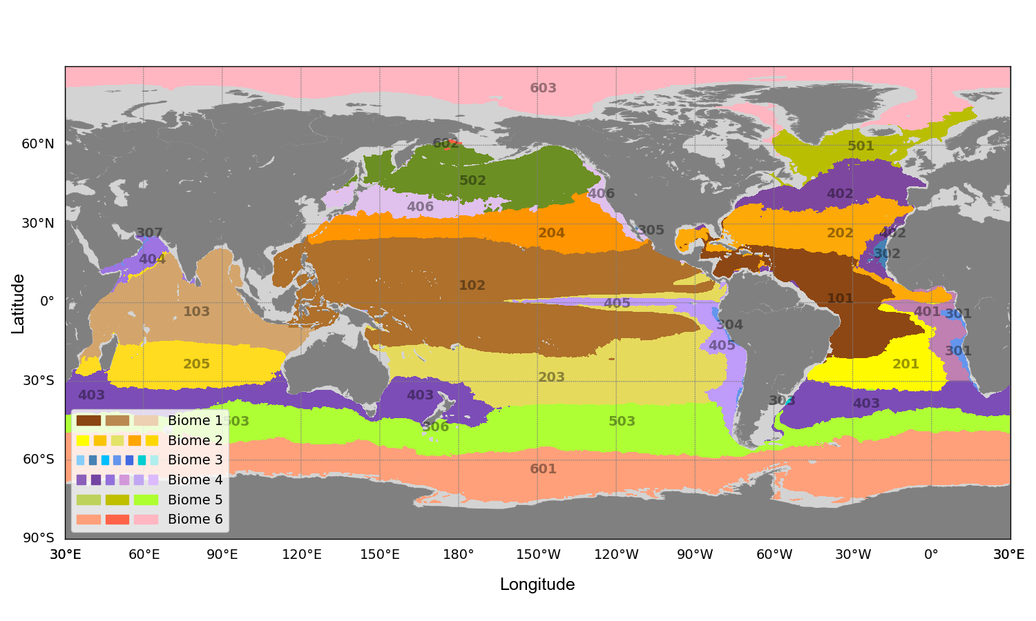

[single-column fitting image, color]

**Table S2:** Biomes characterization with generation time (tG) and maximum lifespan (tmax) in days, computed from monthly temperatures for each biome averaged from 1998 to 2019 (Tavg) in °C

|  |  |  |  |  |
| --- | --- | --- | --- | --- |
| Biome | Layer in SEAPODYM-LMTL | Tavg (°C) | tG (days) | tmax (days) |
| 1 | L1 | 25.53 | 28.47 | 369.79 |
| L2 | 13.98 | 99.97 | 1298.51 |
| L3 | 7.11 | 221.61 | 2878.47 |
| 2 | L1 | 20.48 | 48.71 | 632.69 |
| L2 | 14.36 | 95.71 | 1243.20 |
| L3 | 7.67 | 207.28 | 2692.31 |
| 3 | L1 | 17.80 | 65.23 | 847.29 |
| L2 | 13.66 | 103.71 | 1347.00 |
| L3 | 10.04 | 157.11 | 2040.58 |
| 4 | L1 | 16.46 | 75.72 | 983.52 |
| L2 | 12.97 | 112.10 | 1456.01 |
| L3 | 8.95 | 178.46 | 2317.96 |
| 5 | L1 | 8.09 | 197.38 | 2563.65 |
| L2 | 6.80 | 229.98 | 2987.08 |
| L3 | 5.24 | 277.05 | 3598.45 |
| 6 | L1 | 0.78 | 478.10 | 6209.88 |
| L2 | 1.11 | 458.88 | 5960.18 |
| L3 | 1.09 | 460.08 | 5975.86 |

[single-column fitting table, black and white]

**Table S3:** Detailed information on acoustic data.

|  |  |  |  |  |  |
| --- | --- | --- | --- | --- | --- |
| Data | Calibration | Data processing software name | Noise rejection | Transceiver/Transducer model | Instrument transducer beam angle (degrees) |
| IMOS BA-SOOP (Integrated Marine Observing System, Bio-Acoustic Ships of Opportunity sub-facility) | Standard sphere, in-situ: 113 | Echoview; MATLAB; CSIRO_MATLAB_process_BASOOP; IMOS_MATLAB_Toolbox: 62  process_BASOOP; Matlab; IMOS toolbox; Echoview: 57 | Background noise was estimated and subtracted using methods described by De Robertis and Higginbottom (2007). | Transceiver  ES70: 59  ES60: 57  EK60: 2  ES80: 1  Transducer  ES38B: 42  ES60: 28  ES38-B : 23  ES38-7 386965: 21  ES38-7: 4  ES38-B 312-073992: 1 | Major angle:  6.90: 26  7.10: 25  7.00: 23  7.40: 8  7.20: 3  6.87: 1  7.50: 1  Minor angle:  7.10: 40  6.90: 19  7.60: 8  7.00: 7  6.70: 5  7.20: 3  6.80: 2  7.50: 1  6.97: 1  7.40: 1 |
| British Antarctic Survey (BAS) | Standard sphere, in-situ | BAS-SONA processing suite in Matlab; EchoView | Background noise was estimated and subtracted using methods described by De Robertis and Higginbottom (2007). | Transceiver  EK60  Transducer  ES38 | Major angle:  7.1  Minor angle:  7.0 |
| PIRATA cruises | Standard sphere, in-situ | Ifremer Movies3D, IRD Matecho tool | Background noise was estimated and subtracted using methods described by De Robertis and Higginbottom (2007). | Simrad EK60 (18, 38, 70, 120, 200 and 333 kHz) | Major angle: 6.91  Minor angle: 6.97 |
| Mycto-3D-MAP | Standard sphere, in-situ | Ifremer Movies3D, IRD Matecho tool | Background noise was sub- tracted using a passive recording made every four hours during each survey (Behagle et al., 2016). | Transceiver Simrad EK60 (38, 120kHz)  Transducer  ES38 | ~ 7 |
| NOAA’s TZCF Oceanographic Survey (SE0902L1, EK60) and (SE1102L2, EK60), North Pacific Ocean | 38.1-mm-diameter tungsten carbide sphere and standard methods | A post processing software, BI60, is included in the EK60 system. Pings impacted by cavitation noise and bubble dropout removed using Echoview software. |  | Simrad EK60 (38, 70, & 120 kHz) | 7 |

[two-column fitting table, black and white]

**Video S1: Video animation of the monthly time series of provinces.**

|  |  |
| --- | --- |
|  | This video animation displays the monthly time series of provinces. Each map is provided by the prediction phase of the k-means model applied on monthly data spanning 1998 to 2019 (monthly PCA principal components derived from monthly ¼ degree data). This biophysical biomes’ time series accounts for the seasonal to interannual variability. |

**Table S4:** Total and migrant only micronekton biomasses per province (expressed in million tons of wet weight) estimated from SEAPODYM-LMTL outputs, averaged on 1998-2019.

|  |  |  |  |  |
| --- | --- | --- | --- | --- |
| Biome | Province | Province’s mean **surface area** in million km2  (and % of total) | Province’s mean **migrant biomass** (Million tons WW) | Province’s mean **total biomass**  (Million tons WW) |
| 1 | 101 | 16.8 (5.14%) | 29.99 | 102.19 |
| 102 | 62.2 (19.08%) | 88.26 | 314.64 |
| 103 | 21.2 (6.51%) | 30.66 | 111.03 |
| Sub-total | 100.2 (30.73%) | 148.90 | 527.86 |
| 2 | 201 | 10.3 (3.16%) | 36.33 | 101.27 |
| 202 | 14.4 (4.41%) | 30.03 | 89.58 |
| 203 | 33.1 (10.14%) | 86.69 | 253.53 |
| 204 | 14.9 (4.58%) | 50.81 | 141.88 |
| 205 | 14.3 (4.40%) | 35.87 | 96.70 |
| Sub-total | 87.0 (26.68%) | 239.72 | 682.96 |
| 3 | 301 | 0.79 (0.24%) | 4.21 | 15.32 |
| 302 | 0.46 (0.14%) | 1.82 | 7.45 |
| 303 | 0.28 (0.08%) | 1.39 | 4.26 |
| 304 | 0.48 (0.15%) | 2.29 | 8.55 |
| 305 | 0.17 (0.05%) | 0.86 | 3.01 |
| 306 | 0.14 (0.04%) | 0.46 | 1.45 |
| 307 | 0.41 (0.13%) | 1.13 | 3.94 |
| Sub-total | 2.72 (0.84%) | 12.16 | 43.98 |
| 4 | 401 | 3.05 (0.93%) | 15.72 | 49.46 |
| 402 | 6.65 (2.04%) | 25.68 | 74.34 |
| 403 | 20.1 (6.16%) | 100.36 | 262.45 |
| 404 | 1.90 (0.58%) | 4.65 | 15.80 |
| 405 | 5.88 (1.80%) | 25.85 | 82.01 |
| 406 | 6.47 (1.98%) | 31.38 | 92.29 |
| Sub-total | 44.0 (13.51%) | 203.64 | 576.35 |
| 5 | 501 | 4.60 (1.41%) | 21.03 | 58.96 |
| 502 | 9.15 (2.80%) | 54.39 | 151.01 |
| 503 | 39.5 (12.10%) | 176.32 | 455.25 |
| Sub-total | 53.2 (16.31%) | 251.74 | 665.22 |
| 6 | 601 | 29.5 (9.04%) | 81.25 | 244.33 |
| 602 | 2.82 (0.87%) | 20.24 | 56.39 |
| 603 | 6.62 (2.03%) | 5.69 | 26.51 |
| Sub-total | 38.9 (11.93%) | 107.17 | 327.23 |

[single-column fitting table, black and white]

**Figure S3**: Comparison between biophysical biomes’ boundaries (cf. Figure 3), and the biomass biomes’ boundaries (cf. Figure 7). The boundaries of the biophysical clustering are shown in black, with connections to the nearest boundaries of the biomass clustering indicated in blue.

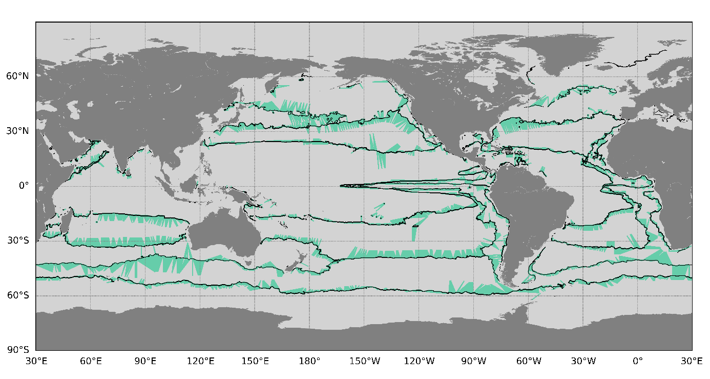

[single-column fitting image, color]