**Supplementary information**

**Table S.1** Form and size distribution of the Diatoms species recorded through the checklist



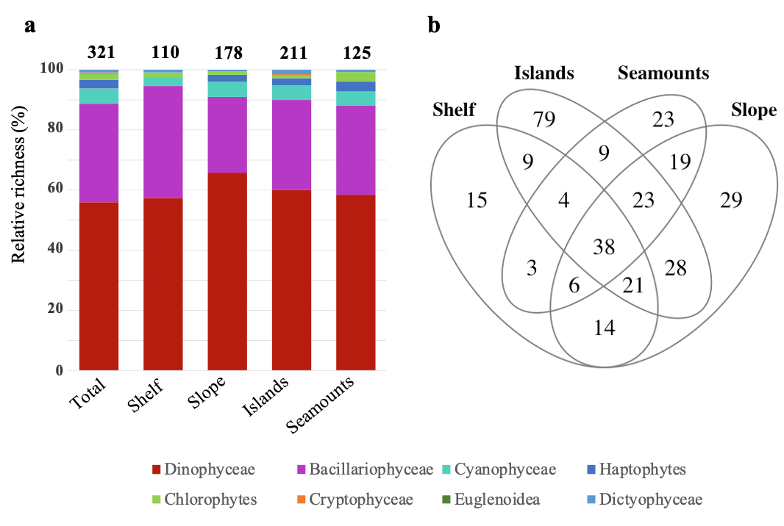

**Fig. S.1** (a) Phytoplankton diversity from the ABRAÇOS surveys by group and area. The bold numbers above each bar indicate the number of taxa recorded. (b) Venn diagram representing the exclusive and common taxa observed in ABRACOS data in the four areas