SM - Supplementary Material

Table S1 – Samples collected in the study
Type | Identification | Catchment | Longitude | Latitude | Season
Sediment profile (0-1 cm) | S1L | Lake Paranoá | 47°50'54"W | 15°45'40"S | Dry
Sediment profile (0-1 cm) | S2L | Lake Paranoá | 47°51'18"W | 15°50'10."S | Dry
Sediment profile (0-1 cm) | S3L | Lake Paranoá | 47°48'25"W | 15°47'23"S | Dry
Sediment profile (0-1 cm) | S4LB | Riacho Fundo | 47°54'13"W | 15°50'37"S | Dry
Sediment profile (0-1 cm) | S4LC | Lake Paranoá | 47°54'23"W | 15°50'32"S | Dry
Sediment profile (0-1 cm) | S4LD | Lake Paranoá | 47°53'57"W | 15°50'23"S | Dry
Sediment profile (0-1 cm) | S4LE | Lake Paranoá | 47°51'41"W | 15°49'24"S | Dry
Sediment profile (0-1 cm) | S5LB | Lake Paranoá | 47°49'26"W | 15°45'18"S | Dry
SPM | P1L | Lake Paranoá | 47°50'52"W | 15°45'41"S | Dry
SPM | P1SA | Bananal | 47°54'37"W | 15°43'42"S | Dry
SPM | P1SBR | Bananal | 47°54'33"W | 15°43'42"S | Wet
SPM | P1SC | Bananal | 47°54'25"W | 15°43'40"S | Dry
SPM | P2L | Lake Paranoá | 47°51'18"W | 15°50'10"S | Dry
SPM | P2SA | Gama | 47°53'46"W | 15°52'21"S | Dry
SPM | P2SAR | Gama | 47°53'46"W | 15°52'21"S | Wet
SPM | P4LA | Lake Paranoá | 47°54'23"W | 15°50'32"S | Dry
SPM | P4LB | Lake Paranoá | 47°51'41"W | 15°49'24"S | Dry
SPM | P4SA | Riacho Fundo | 48° 1'37"W | 15°53'28"S | Dry
SPM | P4SAR | Riacho Fundo | 48° 1'37"W | 15°53'28"S | Wet
SPM | P4SB | Riacho Fundo | 48° 1'23"W | 15°53'47"S | Dry
SPM | P4SBR | Riacho Fundo | 47°57'38"W | 15°52'10"S | Wet
SPM | P4SBR1 | Riacho Fundo | 48° 1'23"W | 15°53'47"S | Wet
SPM | P4SBR2 | Riacho Fundo | 48° 1'23"W | 15°53'47"S | Wet
SPM | P4SC | Riacho Fundo | 47°59'39"W | 15°53'18"S | Dry
SPM | P4SCR1 | Riacho Fundo | 47°59'39"W | 15°53'18"S | Wet
SPM | P4SCR2 | Riacho Fundo | 47°59'39"W | 15°53'18"S | Wet
SPM | P4SD | Riacho Fundo | 47°57'38"W | 15°52'10"S | Dry
SPM | P4SE | Riacho Fundo | 48° 0'11"W | 15°47'9"S | Dry
SPM | P4SER | Riacho Fundo | 48° 0'11"W | 15°47'9"S | Wet
SPM | P4SFR | Riacho Fundo | 47°57'31"W | 15°51'54"S | Wet
SPM | P4SG | Riacho Fundo | 47°58'12"W | 15°49'19"S | Dry
SPM | P4SGR1 | Riacho Fundo | 47°58'12"W | 15°49'19"S | Wet
SPM | P4SGR2 | Riacho Fundo | 47°58'12"W | 15°49'19"S | Wet
SPM | P5L | Lake Paranoá | 47°49'26"W | 15°45'18"S | Dry
SPM | P5SAR | Torto | 47°54'23"W | 15°41'58"S | Wet
SPM | P5SBR1 | Torto | 47°53'32"W | 15°42'23"S | Wet
SPM | P5SBR2 | Torto | 47°53'32"W | 15°42'23"S | Wet
SPM | P5SC | Torto | 47°53'27"W | 15°42'26"S | Dry
Soil | Cx | Riacho Fundo | 47°59'35"W | 15°53'27"S | Dry
Soil | Ox-1 | Torto | 47°51'53"W | 15°41'7"S | Dry
Soil | Ox-2 | Riacho Fundo | 47°48'18"W | 15°42'46"S | Dry
Soil | CF | Riacho Fundo | 47°59'59"W | 15°55'56"S | Dry
Soil | AC | Riacho Fundo | 48° 2'30"W | 15°53'22"S | Dry
Gutter | AU III - SIA | Riacho Fundo | 47°57'50"W | 15°48'19"S | Dry
Gutter | AU II - NB | Riacho Fundo | 47°58'32"W | 15°52'23"S | Dry
Gutter | AU I - PW | Riacho Fundo | 47°58'28"W | 15°53'33"S | Dry
Gutter | G1 | Bananal | 47°55'24"W | 15°44'52"S | Dry
Gutter | G2A | Gama | 47°55'7"W | 15°53'35"S | Dry
Gutter | G2B | Gama | 47°54'29"W | 15°52'25"S | Dry
Gutter | G4A | Riacho Fundo | 48° 0'57"W | 15°53'38"S | Dry
Gutter | G4B | Riacho Fundo | 47°57'44"W | 15°52'5"S | Dry
Gutter | G4C | Riacho Fundo | 48° 2'15"W | 15°48'31"S | Dry
Gutter | G4D | Riacho Fundo | 48° 1'47"W | 15°49'43"S | Dry
Gutter | G4E | Riacho Fundo | 48° 0'38"W | 15°52'36"S | Dry
Gutter | G4F | Riacho Fundo | 47°58'27"W | 15°49'6"S | Dry
Gutter | G5 | Torto | 47°54'43"W | 15°42'12"S | Dry
Table S2 – Concentrations of samples of the major elements and LOI in wt% and trace elements in mg kg⁻¹. *NA (Not Analyzed); <LD (Below detection limit).
Identification | Type | Al₂O₃ | CaO | Fe₂O₃ | K₂O | MgO | Mn₂O₃ | Na₂O | P₂O5 | TiO₂ | SiO₂ | LOI | Cr |  | Ni | Cu | Zn | Zr | As | Rb | Sr | Cd | Pb | Th | ∑REE
Identification | Type | wt% |  |  |  |  |  |  |  |  |  |  |  | mg kg⁻¹
S1L | Sediment profile (0-1 cm) | 22.39 | 0.51 | 6.90 | 1.07 | 0.25 | 0.04 | 0.05 | 0.26 | 1.27 | 31.76 | 35.50 | 82.49 |  | 23.03 | 36.07 | 96.63 | 236.23 | 9.40 | 50.12 | 21.06 | 0.27 | 23.51 | 36.56 | 131.27
S2L | Sediment profile (0-1 cm) | 24.38 | 0.41 | 8.30 | 2.13 | 0.24 | 0.04 | 0.11 | 0.26 | 1.20 | 25.43 | 37.50 | 100.53 |  | 19.05 | 32.31 | 59.01 | 220.44 | 9.99 | 106.42 | 29.50 | 0.15 | 21.23 | 35.53 | 179.95
S3L | Sediment profile (0-1 cm) | 26.25 | 0.30 | 10.53 | 1.70 | 0.27 | 0.03 | 0.09 | 0.27 | 1.16 | 17.90 | 41.50 | 75.45 |  | 17.35 | 43.28 | 84.23 | 149,94 | 9.50 | 90.63 | 26.71 | 0.16 | 23.90 | 30.28 | 166.84
S4LB | Sediment profile (0-1 cm) | 14.69 | 0.51 | 3.93 | 1.23 | 0.23 | 0.02 | 0.08 | 0.21 | 0.87 | 50.73 | 27.50 | 60.40 |  | 10.43 | 24.31 | 50.65 | 234.54 | 5.59 | 60.78 | 27.24 | 0.12 | 18.58 | 24.68 | 155.46
S4LC | Sediment profile (0-1 cm) | 17.86 | 1.09 | 5.77 | 1.06 | 0.41 | 0.01 | 0.11 | 1.92 | 0.90 | 41.37 | 29.50 | 78.92 |  | 18.46 | 40.78 | 314.53 | 207.28 | 7.51 | 44.31 | 40.81 | 0.51 | 28.93 | 18.78 | 127.25
S4LD | Sediment profile (0-1 cm) | 12.89 | 0.58 | 3.66 | 0.01 | 0.21 | 0.01 | 0.01 | 0.16 | 0.71 | 50.28 | 31.50 | NA |  | NA | 27.05 | 69.52 | NA | 6.71 | NA | NA | NA | 19.34 | NA | NA
S4LE | Sediment profile (0-1 cm) | 23.46 | 0.61 | 6.79 | 2.80 | 0.37 | 0.02 | 0.14 | 0.33 | 1.22 | 30.76 | 33.50 | 112.04 |  | 18.49 | 36.57 | 100.23 | 217.37 | 9.07 | 124.29 | 39.48 | 0.29 | 26.55 | 35.76 | 184.58
S5LB | Sediment profile (0-1 cm) | 20.71 | 0.35 | 7.91 | 2.81 | 0.35 | 0.03 | 0.12 | 0.13 | 1.06 | 27.03 | 39.50 | 86.63 |  | 15.60 | 26.01 | 47.46 | 205.47 | 9.07 | 131.98 | 42.93 | 0.19 | 18.33 | 32.45 | 245.62
P1SA | SPM | 16.55 | 13.25 | 12.47 | 0.14 | 1.09 | 0.09 | 1.06 | 2.62 | 0.02 | NA | NA | 188.94 |  | 84.59 | 46.64 | 600.40 | NA | 14.29 | 6.64 | 227.00 | 0.47 | 27.29 | 18.38 | 99.16
P1SBR | SPM | 14.37 | 15.96 | 2.92 | 0.12 | 1.28 | 0.03 | 1.14 | 2.41 | 0.02 | NA | NA | 211.20 |  | 106.30 | 40.90 | 255.83 | NA | 3.90 | 7.78 | 264.90 | 0.30 | 14.49 | 15.40 | 120.10
P1SC | SPM | 38.03 | 17.99 | 15.48 | 1.56 | 1.93 | 0.05 | 1.53 | 22.45 | 0.06 | NA | NA | 311.80 |  | 121.10 | 307.4 | 2120.20 | NA | 12.90 | 26.51 | 409.60 | 1.60 | 50.80 | 27.20 | 226.10
P2SA | SPM | 9.80 | 9.16 | 16.36 | 0.20 | 0.76 | 0.26 | 0.79 | 2.04 | 0.03 | NA | NA | 124.61 |  | 71.710 | 38.78 | 369.26 | NA | 10.24 | 15.60 | 154.76 | 0.19 | 12.43 | 12.36 | 100.87
P2SAR | SPM | 6.81 | 1.88 | 2.35 | 0.16 | 0.16 | 0.01 | 0.23 | 0.53 | 0.02 | NA | NA | 85.20 |  | 23.90 | 13.80 | 21.70 | NA | 2.70 | 14.45 | 37.00 | 0.05 | 8.70 | 8.00 | 73.40
P4SA | SPM | 7.26 | 11.89 | 1.35 | 0.08 | 0.97 | 0.05 | 0.77 | 1.22 | 0.01 | NA | NA | 128.70 |  | 70.50 | 29.00 | 277.10 | NA | 2.50 | 4.34 | 200.70 | 0.20 | 4.40 | 4.90 | 28.30
P4SAR | SPM | 13.75 | 0.93 | 5.84 | 0.12 | 0.21 | 0.02 | 0.03 | 0.22 | 0.04 | NA | NA | 75.10 |  | 14.70 | 44.30 | 240.10 | NA | 7.60 | 9.83 | 27.80 | 0.20 | 35.70 | 11.30 | 123.10
P4SB | SPM | 14.57 | 4.68 | 24.61 | 0.30 | 0.42 | 0.19 | 0.38 | 1.13 | 0.07 | NA | NA | 119.50 |  | 54.20 | 39.20 | 260.00 | NA | 17.40 | 26.46 | 84.80 | 0.40 | 28.70 | 24.20 | 176.20
P4SBR | SPM | 6.28 | 4.7 | 3.75 | 0.15 | 0.40 | 0.05 | 0.43 | 0.86 | 0.03 | NA | NA | 82.20 |  | 33.20 | 25.40 | 110.30 | NA | 4.30 | 9.77 | 85.20 | 0.40 | 13.50 | 9.40 | 56.60
P4SBR1 | SPM | 9.22 | 1.63 | 1.75 | 0.58 | 0.32 | 0.01 | 0.10 | 5.06 | 0.02 | NA | NA | 37.70 |  | 23.50 | 87.30 | 491.90 | NA | 3.10 | 6.71 | 56.50 | 0.40 | 15.50 | 7.10 | 59.10
P4SBR2 | SPM | 9.31 | 0.86 | 3.68 | 0.09 | 0.14 | 0.01 | 0.04 | 0.34 | 0.02 | NA | NA | 58.70 |  | 12.60 | 37.00 | 193.20 | NA | 5.10 | 8.16 | 24.30 | 0.20 | 29.40 | 7.20 | 96.80
P4SC | SPM | 27.16 | 8.07 | 34.41 | 0.45 | 0.75 | 0.32 | 0.64 | 1.74 | 0.12 | NA | NA | 233.40 |  | 82.40 | 81.50 | 380.40 | NA | 30.40 | 50.51 | 148.20 | 0.20 | 46.70 | 41.00 | 313.30
P4SCR1 | SPM | 12.90 | 2.73 | 7.47 | 0.22 | 0.31 | 0.06 | 0.35 | 2.17 | 0.04 | NA | NA | 107.30 |  | 35.20 | 67.20 | 286.70 | NA | 10.00 | 17.56 | 64.40 | 0.40 | 34.70 | 7.50 | 149.80
P4SCR2 | SPM | 10.29 | 3.94 | 4.80 | 0.13 | 0.37 | 0.02 | 0.34 | 1.33 | 0.03 | NA | NA | 85.06 |  | 33.77 | 33.32 | 88.64 | NA | 6.23 | 13.54 | 78.05 | 0.11 | 14.40 | 10.88 | 110.58
P4SD | SPM | 7.92 | 6.41 | 4.55 | 0.11 | 0.52 | 0.08 | 0.53 | 1.42 | 0.02 | NA | NA | 93.00 |  | 43.40 | 26.70 | 236.00 | NA | 4.80 | 10.40 | 117.9 | 0.20 | 13.20 | 8.80 | 67.50
P4SE | SPM | 8.78 | 7.1 | 5.19 | 0.11 | 0.60 | 0.11 | 0.49 | 3.15 | 0.02 | NA | NA | 102.32 |  | 49.37 | 43.86 | 327.27 | NA | 5.67 | 7.02 | 132.06 | 0.29 | 14.36 | 9.72 | 71.66
P4SER | SPM | 11.51 | 3.95 | 8.88 | 0.05 | 0.32 | 0.01 | 0.29 | 0.64 | 0.04 | NA | NA | 101.50 |  | 32.00 | 27.80 | 167.16 | NA | 6.30 | 7.28 | 67.80 | 1.30 | 14.10 | 30.80 | 85.20
P4SFR | SPM | 4.45 | 3.64 | 3.21 | 0.15 | 0.30 | 0.01 | 0.47 | 0.96 | 0.01 | NA | NA | 72.20 |  | 32.30 | 14.80 | 79.15 | NA | 3.00 | 7.51 | 65.60 | 0.10 | 12.94 | 4.90 | 25.00
P4SG | SPM | 21.81 | 17.13 | 25.04 | 0.40 | 1.45 | 0.37 | 1.55 | 9.26 | 0.05 | NA | NA | 251.40 |  | 120.80 | 112.50 | 856.50 | NA | 24.50 | 25.13 | 319.60 | 0.80 | 55.40 | 40.30 | 240.40
P4SGR1 | SPM | 12.02 | 8.03 | 5.87 | 0.46 | 0.68 | 0.07 | 0.80 | 4.32 | 0.02 | NA | NA | 135.20 |  | 57.60 | 58.70 | 317.10 | NA | 6.30 | 11.12 | 188.20 | 0.30 | 20.30 | 9.40 | 127.90
P4SGR2 | SPM | 20.83 | 24.33 | 4.41 | 0.12 | 1.97 | 0.03 | 1.51 | 2.82 | 0.02 | NA | NA | 293.00 |  | 146.70 | 63.80 | 410.85 | NA | 6.90 | 7.07 | 439.60 | 0.40 | 19.64 | 13.00 | 107.00
P5SAR | SPM | 18.94 | 29.6 | 18.98 | 0.17 | 2.38 | 0.07 | 2.41 | 5.77 | 0.03 | NA | NA | 355.80 |  | 188.80 | 67.70 | 437.25 | NA | 13.10 | 14.02 | 501.30 | 0.60 | 30.28 | 37.40 | 109.20
P5SBR1 | SPM | 12.97 | 8.29 | 33.07 | 0.31 | 0.70 | 0.22 | 0.69 | 2.09 | 0.05 | NA | NA | 141.60 |  | 65.10 | 51.70 | 328.94 | NA | 18.00 | 30.47 | 149.00 | 0.50 | 38.68 | 14.50 | 199.80
P5SBR2 | SPM | 10.42 | 7.87 | 11.77 | 0.17 | 0.66 | 0.03 | 0.63 | 1.48 | 0.03 | NA | NA | 126.40 |  | 71.90 | 34.90 | 215.22 | NA | 11.00 | 15.48 | 136.80 | 0.30 | 26.67 | 12.00 | 115.80
P5SC | SPM | 2.73 | 1.89 | 5.96 | 0.02 | 0.15 | 0.07 | 0.20 | 0.51 | 0.01 | NA | NA | 29.80 |  | 13.80 | 7.80 | 84.40 | NA | 3.70 | 0.82 | 31.20 | 0.10 | 5.20 | 3.50 | 26.30
P1L | SPM | 16.20 | 8.64 | 12.53 | 0.69 | 0.78 | 0.07 | 1.03 | 2.28 | 0.08 | NA | NA | 213.60 |  | 92.30 | 48.60 | 307.70 | NA | 12.30 | 31.89 | 149.30 | 0.70 | 26.30 | 19.30 | 118.10
P2L | SPM | 35.01 | 26.84 | 34.19 | 1.83 | 2.20 | 0.24 | 3.09 | 6.72 | 0.15 | NA | NA | 489.86 |  | 252.30 | 112.28 | 475.81 | NA | 31.38 | 120.31 | 470.62 | 10.75 | 68.14 | 49.43 | 400.71
P4LA | SPM | 19.63 | 9.50 | 6.16 | 0.76 | 0.89 | 0.02 | 1.05 | 10.29 | 0.05 | NA | NA | 173.40 |  | 84.50 | 79.60 | 785.90 | NA | 7.70 | 24.04 | 190.80 | 1.10 | 27.70 | 6.80 | 198.40
P4LB | SPM | 17.25 | 8.23 | 8.63 | 0.59 | 0.74 | 0.22 | 0.93 | 2.67 | 0.05 | NA | NA | 170.60 |  | 71.80 | 59.00 | 234.10 | NA | 10.40 | 30.62 | 157.40 | 0.70 | 30.60 | 17.20 | 154.40
P5L | SPM | 7.80 | 4.21 | 6.62 | 0.34 | 0.36 | 0.11 | 0.43 | 0.92 | 0.03 | NA | NA | 84.00 |  | 36.40 | 24.60 | 94.40 | NA | 8.40 | 22.34 | 78.60 | 3.50 | 15.50 | 10.60 | 93.90
Cx | Soil | 21.74 | 0.01 | 5.87 | 0.27 | 0.11 | 0.01 | 0.05 | 0.24 | 0.87 | 56.19 | 14.64 | 39.44 |  | 13.37 | 8.62 | 19.23 | NA | 11.34 | 29.57 | 5.11 | 0.02 | 7.41 | 21.90 | 157.45
Ox-1 | Soil | 23.01 | 0.35 | 31.19 | 0.42 | 0.16 | 0.01 | 0.06 | 0.27 | 1.15 | 24.57 | 18.81 | 84.48 |  | 25.82 | 58.74 | 239.53 | NA | 18.27 | 22.13 | 28.42 | 0.02 | 24.81 | 23.68 | 217.74
Ox-2 | Soil | 33.82 | 0.06 | 12.10 | 0.05 | 0.03 | 0.01 | 0.05 | 0.28 | 1.87 | 31.30 | 20.43 | 103.78 |  | 10.91 | 5.35 | 23.96 | NA | 26.54 | 1.38 | 11.09 | 0.04 | 3.20 | 38.18 | 55.72
CF | Soil | 33.82 | 0.06 | 12.10 | 0.05 | 0.03 | 0.01 | 0.05 | 0.28 | 1.87 | 31.30 | 20.43 | 103.78 |  | 10.91 | 5.35 | 23.96 | NA | 26.54 | 1.38 | 11.09 | 0.04 | 3.20 | 38.18 | 55.72
AC | Soil | 33.82 | 0.06 | 12.10 | 0.05 | 0.03 | 0.01 | 0.05 | 0.28 | 1.87 | 31.30 | 20.43 | 103.78 |  | 10.91 | 5.35 | 23.96 | NA | 26.54 | 1.38 | 11.09 | 0.04 | 3.20 | 38.18 | 55.72
G1 | Gutter | 4.26 | 8.71 | 3.34 | 0.56 | 1.29 | 0.02 | 0.37 | 0.37 | 0.28 | 63.53 | 17.27 | 39.25 |  | 9.85 | 28.35 | 169.83 | NA | 4.90 | 23.76 | 236.58 | 0.09 | 125.01 | 7.51 | 43.84
G2A | Gutter | 13.24 | 4.56 | 7.37 | 0.69 | 0.76 | 0.02 | 0.20 | 0.25 | 0.84 | 51.13 | 20.94 | 81.94 |  | 13.81 | 23.86 | 119.07 | NA | 12.21 | 31.98 | 142.20 | 3.06 | 40.61 | 22.69 | 72.40
G2B | Gutter | 14.08 | 3.12 | 8.39 | 0.40 | 0.38 | 0.02 | 0.11 | 0.15 | 0.98 | 54.47 | 17.90 | 194.62 |  | 14.47 | 39.21 | 142.82 | NA | 18.54 | 18.06 | 121.19 | 0.18 | 28.98 | 24.77 | 73.23
G4A | Gutter | 2.28 | 3.95 | 1.09 | 0.24 | 0.53 | 0.01 | 0.31 | 0.11 | 0.10 | 71.28 | 20.10 | 15.17 |  | 8.48 | 4.91 | 31.40 | NA | 1.71 | 13.82 | 110.48 | 0.05 | 10.09 | 4.48 | 27.32
G4B | Gutter | 2.51 | 6.22 | 3.57 | 0.41 | 0.63 | 0.03 | 0.44 | 0.12 | 0.23 | 66.03 | 19.81 | 128.39 |  | 16.90 | 66.62 | 568.52 | NA | 3.53 | 17.25 | 221.94 | 0.34 | 58.79 | 7.09 | 55.05
G4C | Gutter | 6.39 | 3.27 | 4.68 | 0.73 | 0.37 | 0.01 | 0.23 | 0.30 | 0.43 | 69.56 | 14.03 | 60.71 |  | 7.59 | 21.17 | 87.18 | NA | 6.42 | 29.37 | 99.15 | 0.09 | 56.31 | 10.02 | 41.13
G4D | Gutter | 5.00 | 6.49 | 5.93 | 0.75 | 0.81 | 0.02 | 0.34 | 0.32 | 0.42 | 63.31 | 16.61 | 64.43 |  | 9.55 | 19.96 | 125.86 | NA | 7.61 | 29.97 | 163.44 | 0.19 | 18.35 | 9.95 | 41.02
G4E | Gutter | 4.96 | 3.49 | 4.01 | 0.43 | 0.41 | 0.02 | 0.25 | 0.29 | 0.41 | 73.72 | 12.01 | 60.73 |  | 7.76 | 28.08 | 188.77 | NA | 6.75 | 17.84 | 103.97 | 0.23 | 143.45 | 8.67 | 45.03
G4F | Gutter | 4.42 | 7.59 | 2.99 | 0.45 | 0.94 | 0.02 | 0.26 | 0.39 | 0.38 | 60.11 | 22.45 | 56.91 |  | 7.86 | 24.24 | 138.51 | NA | 4.69 | 16.39 | 153.43 | 2.90 | 95.48 | 6.75 | 31.70
AU III - SIA | Gutter | 2.51 | 6.22 | 3.57 | 0.41 | 0.63 | 0.03 | 0.44 | 0.12 | 0.23 | 66.03 | 19.81 | 128.39 |  | 16.90 | 66.62 | 568.52 | NA | 3.53 | 17.25 | 221.94 | 0.34 | 58.79 | 7.09 | 55.05
AU II - NB | Gutter | 4.42 | 7.59 | 2.99 | 0.45 | 0.94 | 0.02 | 0.26 | 0.39 | 0.38 | 60.11 | 22.45 | 56.91 |  | 7.86 | 24.24 | 138.51 | NA | 4.69 | 16.39 | 153.43 | 2.90 | 95.48 | 6.75 | 31.70
AU I - PW | Gutter | 13.24 | 4.56 | 7.37 | 0.69 | 0.76 | 0.02 | 0.20 | 0.25 | 0.84 | 51.13 | 20.94 | 81.94 |  | 13.81 | 23.86 | 119.07 | NA | 12.21 | 31.98 | 142.20 | 3.06 | 40.61 | 22.69 | 72.40

Table S3 – Mineral constituents of a selection of samples from source and sediment areas.
Mineral |  | KLN |  | GBS |  | ILT |  | QZ |  | GTH |  | HEM |  | RT |  | ANT |  | CAL
Sampling location |  | T | A | T | A | T | A | T | A | T | A | T | A | T | A | T | A | T | A
Soil and gutter samples | Cerrado Field (CF) | M | M | M⁺ | M⁺ | - | - | M | - | t | - | t | - | t | t | t | t | - | -
Soil and gutter samples | Agriculture (AC) | M | M | M⁺ | M⁺ | t | t | M | t | t | t | t | - | t | t | t | t | - | t
Soil and gutter samples | AU I (PW) | M | M⁺ | m | M | m | M | M⁺ | t | - | t | t | - | t | t | t | t | t | t
Soil and gutter samples | AU II (NB) | M | M⁺ | m | M | m | M | M⁺ | m | t | m | t | t | t | t | t | m | t | t
Soil and gutter samples | AU III (SIA) | M | M⁺ | m | M | m | m | M⁺ | m | t | m | t | t | t | t | t | m | t | t
Soil and gutter samples | Oxisol (Ox-2) | m | M | m | M | m | M | M⁺ | t | - | t | t | - | t | t | t | t | - | -
Soil and gutter samples | Inceptisols (Cx) | M | M⁺ | m | M | m | M | M⁺ | m | t | m | t | t | t | t | t | m | - | -
Sediment samples | S4LB/0-1 | M | M⁺ | m | m | m | M | M⁺ | t | t | t | t | t | t | t | t | - | - | -
Sediment samples | S4LB/4-5 | M | M⁺ | m | M | m | M | M⁺ | t | t | t | t | t | t | t | t | - | - | -
Sediment samples | S4LC/0-1 | M | M⁺ | m | m | m | M | M⁺ | t | t | t | t | t | t | t | t | - | - | -
Sediment samples | S4LC/4-5 | M | M⁺ | m | M | m | M | M⁺ | t | t | t | t | t | t | t | t | - | - | -
Sediment samples | S4LD/0-1 | M | M⁺ | m | m | m | M | M⁺ | t | t | t | t | t | t | t | t | - | - | -
Sediment samples | S4LD/4-5 | M | M⁺ | m | M | m | M | M⁺ | t | t | t | t | t | t | t | t | - | - | -
Sediment samples | S1L/0-1 | M | M⁺ | m | m | m | M | M⁺ | m | t | t | t | t | t | t | t | - | - | -
Sediment samples | S1L/4-5 | M | M⁺ | m | M | m | M | M⁺ | m | t | t | t | t | t | t | t | - | - | -
Sediment samples | S3L/0-1 | M | M⁺ | m | m | m | M | M⁺ | m | t | t | t | t | t | t | - | - | - | -
Sediment samples | S3L/4-5 | M | M⁺ | m | M | m | M | M⁺ | m | t | t | t | t | t | t | - | - | - | -

Legend: (AU I) Low density urban area, (AU II) High density urban area, (AU III) Urban area with presence of industries and workshops, (SIA) Industry and Supply Sector, (NB) Núcleo Bandeirante, (PW) Parque Way, (ILT) = ilita, (KLN) = kaolinite, (GBS) = gibbsite, (QZ) = quartz, (GTH) = goethite, (HEM) = hematite, (RT) = rutile, (ANT) = anatase, (CAL) = calcite, (T) = total fraction, (A) = fraction clay, (M +) = predominant major constituent, (M) = major, (m) = minor, (t) = dash, (-) = absent
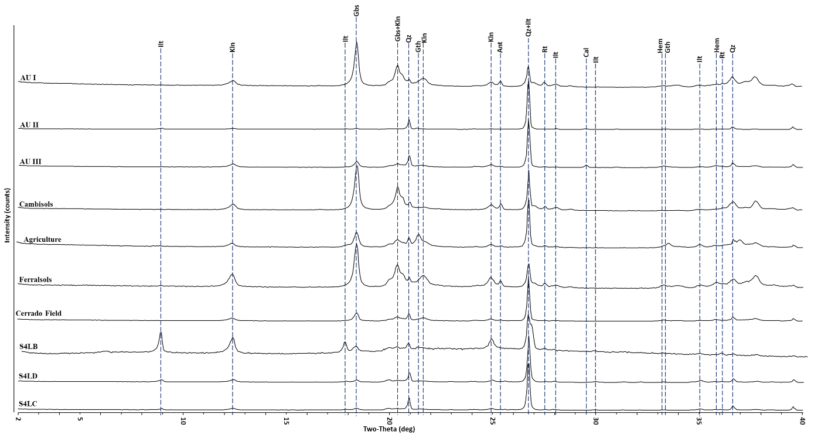
Figure S1: Diffractograms of the total fractions for a selection of soils, gutter and sediments samples. (ILT) = ilite, (KLN) = kaolinite, (GBS) = gibbsite, (QZ) = quartz, (GTH) = goethite, (HEM) = hematite, (RT) = rutile, (ANT) = anatase, (CAL) = calcite
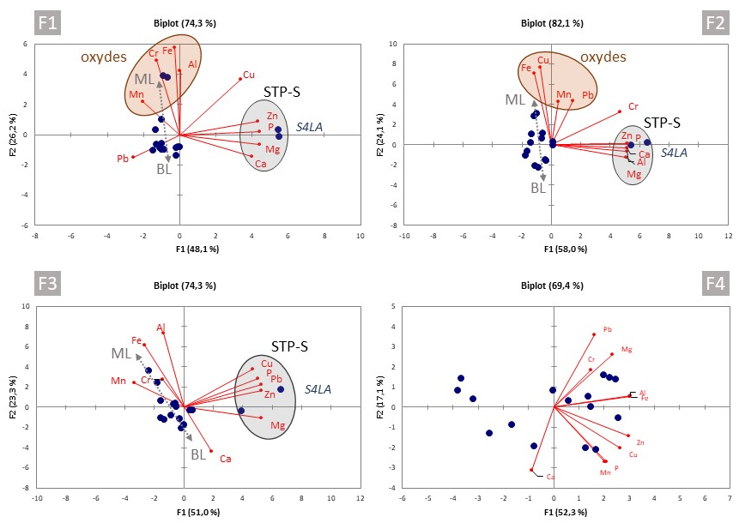
Figure S2: Principal Component Analysis (PCA), not normalized, of each fraction obtained by chemical sequential extraction (BCR) from LP surface sediments. Note the grey arrow representing a trend between samples collected in the four branches of the lake (BL), intermediate samples and samples collected in the middle of the lake (ML).

