Supplementary material

# Appendix 1: đ1 depending of the bottom depth

G:\PREFACE IRD\papier cclme sud\figures\Figures finales\Supplementary material\Appendix2.tiff

Figure S2. Repartition of đ1 the minimal depth of the shallowest sound scattering layer (SSL) depending of the bottom depth.

# Appendix 2: Inter-annual trends of Sa, all

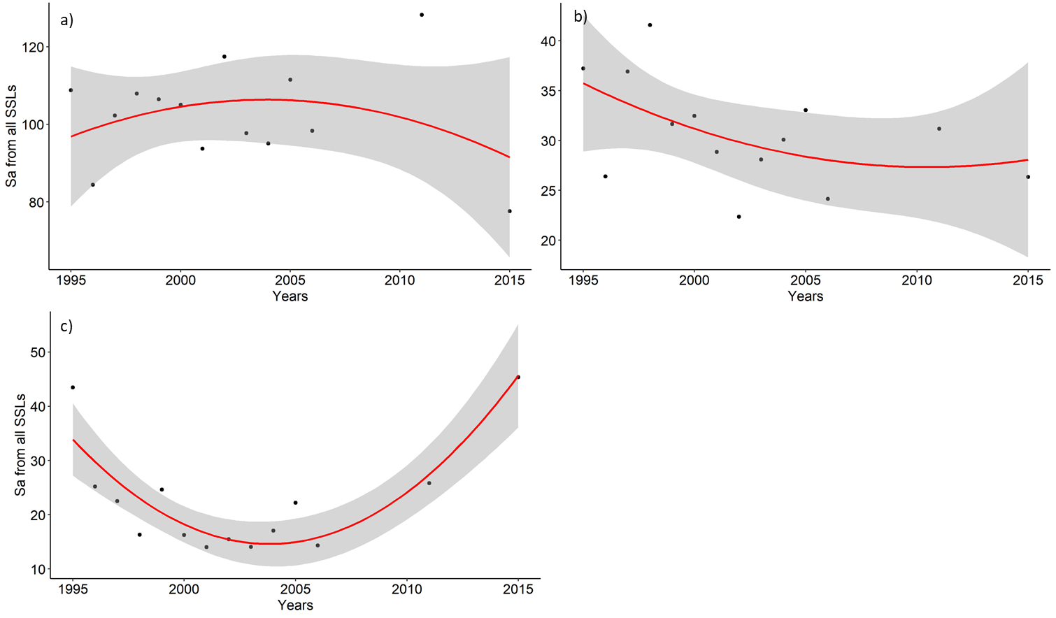

Figure S1. Mean per year over the two decades studied period (1995-2015) mean area backscattering strength Sa from the whole water on a) inshore (bottom depth < 150 m), b) transition (bottom depth in 150-500 m) and c) offshore (bottom depth > 500 m). Red lines represent significant polynomial regressions.