**Assessing seasonal and interannual changes in carbonate chemistry across two time-series sites in the North Western Mediterranean Sea**

**Cathy Wimart-Rousseau1*,*a,*, Thibaut Wagener1, Anthony Bosse1, Patrick Raimbault1, Laurent Coppola2*,*3, Marine Fourrier2, Caroline Ulses4 and Dominique Lefèvre1**

1Aix Marseille Université, Université de Toulon, CNRS, IRD, MIO, UM110, Marseille, France

2 Sorbonne Université, CNRS, Laboratoire d'Océanographie de Villefranche, LOV, F-06230 Villefranche-sur-Mer, France

3 Sorbonne Université, CNRS, OSU Station Marines, STAMAR, Paris, F-75006, France

4LEGOS, Université de Toulouse, CNES, CNRS, IRD, Université Toulouse III - Paul Sabatier, Toulouse, France

aPresent address: ​​ GEOMAR Helmholtz Centre for Ocean Research Kiel, Kiel, Germany

**\* Correspondence:**

Cathy Wimart-Rousseau

cwimart-rousseau@geomar.de

# Supplementary Material

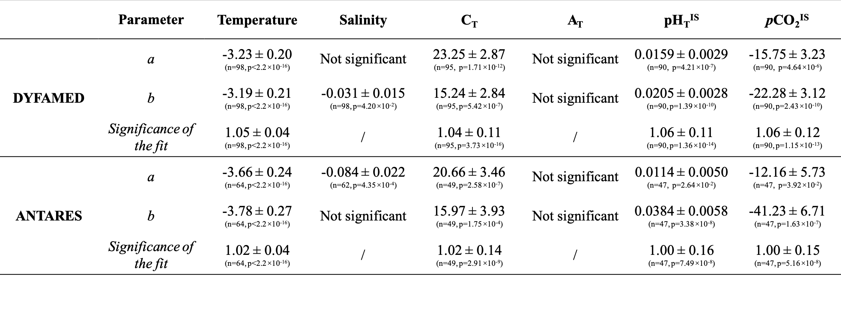**Supplementary Material - Table 1.** Fitting parameters a and b of the harmonic model obtained by a nonlinear least squares estimation.

**Supplementary Material - Figure 1**. Temporal variations from January 2010 to December 2019 in temperature (°C – a and c) and salinity (b and d) at DYFAMED (Panels a and b) and ANTARES (Panels c and d) between the surface and 125 dbar depth. Black contour lines represent the isopycnal horizons based on potential density referenced to a pressure of 0 dbar.

**Supplementary Material - Figure 2.** Temporal variations for nitrate (NO3- – a and c), orthosilicic acid (Si(OH)4 – b and d), phosphate (PO43- – e and g), nitrite (NO2- – f and h), partial pressure of seawater CO2 at *in situ* temperature (*p*CO2IS – i and k) and pHT measured at *in situ* temperature (pHTIS – j and l) at DYFAMED (Two left columns) and ANTARES (Two right columns) within the mixed layer from January 2010 to December 2019. Mixed Layer Depths have been added as a background for each plot.