**Supplementary Information**

**Table 1** Estimators of the number of clusters K from 16 different Structure runs. LOWTN and FULL represent the partial and full datasets respectively (see text). Runs with a reduced alpha are represented by “.2α.” Runs using sampling locations as priors are represented by “LocPrior.” “Corr” and “Ind” indicate runs where allele frequencies were set at correlated and independent, respectively

|  |  |  |  |  |  |  |  |
| --- | --- | --- | --- | --- | --- | --- | --- |
| Analysis | Threshold | MedMedK | MedMeaK | MaxMedK | MaxMeaK | deltaK | Mean LnP(K) |
| LOWTN_Admixture_Corr |  |  | 2 | 4 |
|  | 0.5 | 2 | 3 | 3 | 3 |  |  |
|  | 0.6 | 2 | 2 | 2 | 2 |  |  |
|  | 0.7 | 2 | 2 | 2 | 2 |  |  |
|  | 0.8 | 2 | 2 | 2 | 2 |  |  |
| FULL_Admixture_Corr |  |  |  |  |
|  | 0.5 | 3 | 3 | 3 | 3 | 2 | 6 |
|  | 0.6 | 3 | 3 | 3 | 3 |  |  |
|  | 0.7 | 3 | 3 | 3 | 3 |  |  |
|  | 0.8 | 3 | 3 | 3 | 3 |  |  |
| LOWTN_Admixture_.2α_Corr |  | 2 | 6 |
|  | 0.5 | 3 | 3 | 3 | 3 |  |  |
|  | 0.6 | 2 | 2 | 3 | 3 |  |  |
|  | 0.7 | 2 | 2 | 3 | 3 |  |  |
|  | 0.8 | 2 | 2 | 3 | 3 |  |  |
| FULL_Admixture_.2α_Corr |  |  |  |  |
|  | 0.5 | 3 | 3 | 3 | 4 | 2 | 6 |
|  | 0.6 | 3 | 3 | 3 | 3 |  |  |
|  | 0.7 | 3 | 3 | 3 | 3 |  |  |
|  | 0.8 | 3 | 3 | 3 | 3 |  |  |
| LOWTN_Admixture_LocPrior_Corr |  | 2 | 3 |
|  | 0.5 | 3 | 3 | 3 | 3 |  |  |
|  | 0.6 | 3 | 3 | 3 | 3 |  |  |
|  | 0.7 | 3 | 3 | 3 | 3 |  |  |
|  | 0.8 | 3 | 3 | 3 | 3 |  |  |
| FULL_Admixture_LocPrior_Corr |  |  |  |
|  | 0.5 | 3 | 3 | 3 | 3 | 2 | 3 |
|  | 0.6 | 3 | 3 | 3 | 3 |  |  |
|  | 0.7 | 3 | 3 | 3 | 3 |  |  |
|  | 0.8 | 3 | 3 | 3 | 3 |  |  |
| LOWTN_Admixture_.2α_LocPrior_Corr |  |  |  |
|  | 0.5 | 3 | 3 | 3 | 3 | 2 | 3 |
|  | 0.6 | 3 | 3 | 3 | 3 |  |  |
|  | 0.7 | 3 | 3 | 3 | 3 |  |  |
|  | 0.8 | 3 | 3 | 3 | 3 |  |  |
| FULL_Admixture_.2α_LocPrior_Corr |  |  |  |
|  | 0.5 | 3 | 3 | 3 | 3 | 2 | 6 |
|  | 0.6 | 3 | 3 | 3 | 3 |  |  |
|  | 0.7 | 3 | 3 | 3 | 3 |  |  |
|  | 0.8 | 3 | 3 | 3 | 3 |  |  |
| LOWTN.Admixture_.2α_LocPrior_Ind |  |  |  |
|  | 0.5 | 3 | 3 | 3 | 3 | 2 | 5 |
|  | 0.6 | 3 | 3 | 3 | 3 |  |  |
|  | 0.7 | 3 | 3 | 3 | 3 |  |  |
|  | 0.8 | 3 | 3 | 3 | 3 |  |  |
| FULL_Admixture_.2α_LocPrior_Ind |  |  |  |
|  | 0.5 | 3 | 3 | 3 | 3 | 2 | 4 |
|  | 0.6 | 3 | 3 | 3 | 3 |  |  |
|  | 0.7 | 3 | 3 | 3 | 3 |  |  |
|  | 0.8 | 3 | 3 | 3 | 3 |  |  |
| LOWTN.Admixture_.2α_Ind |  |  |  |
|  | 0.5 | 4 | 3 | 4 | 4 | 2 | 5 |
|  | 0.6 | 2 | 2 | 3 | 3 |  |  |
|  | 0.7 | 2 | 2 | 3 | 3 |  |  |
|  | 0.8 | 2 | 2 | 3 | 3 |  |  |
| FULL_Admixture_.2α_Ind |  |  |  |
|  | 0.5 | 3 | 3 | 4 | 3 | 2 | 4 |
|  | 0.6 | 3 | 3 | 3 | 3 |  |  |
|  | 0.7 | 3 | 3 | 3 | 3 |  |  |
|  | 0.8 | 3 | 3 | 3 | 3 |  |  |
| LOWTN_Admixture_LocPrior_Ind |  |  |  |
|  | 0.5 | 3 | 3 | 3 | 3 | 2 | 3 |
|  | 0.6 | 3 | 3 | 3 | 3 |  |  |
|  | 0.7 | 3 | 3 | 3 | 3 |  |  |
|  | 0.8 | 3 | 3 | 3 | 3 |  |  |
| FULL_Admixture_LocPrior_Ind |  |  |  |
|  | 0.5 | 3 | 3 | 3 | 3 | 2 | 6 |
|  | 0.6 | 3 | 3 | 3 | 3 |  |  |
|  | 0.7 | 3 | 3 | 3 | 3 |  |  |
|  | 0.8 | 3 | 2 | 3 | 3 |  |  |
| LOWTN_Admixture_Ind |  |  |  |  |
|  | 0.5 | 3 | 3 | 4 | 3 | 2 | 4 |
|  | 0.6 | 3 | 3 | 3 | 3 |  |  |
|  | 0.7 | 3 | 3 | 3 | 3 |  |  |
|  | 0.8 | 3 | 3 | 3 | 3 |  |  |
| FULL_Admixture_Ind |  |  |  |  |
|  | 0.5 | 3 | 3 | 4 | 3 | 2 | 4 |
|  | 0.6 | 3 | 3 | 3 | 3 |  |  |
|  | 0.7 | 3 | 3 | 3 | 3 |  |  |
|  | 0.8 | 3 | 3 | 3 | 3 |  |  |

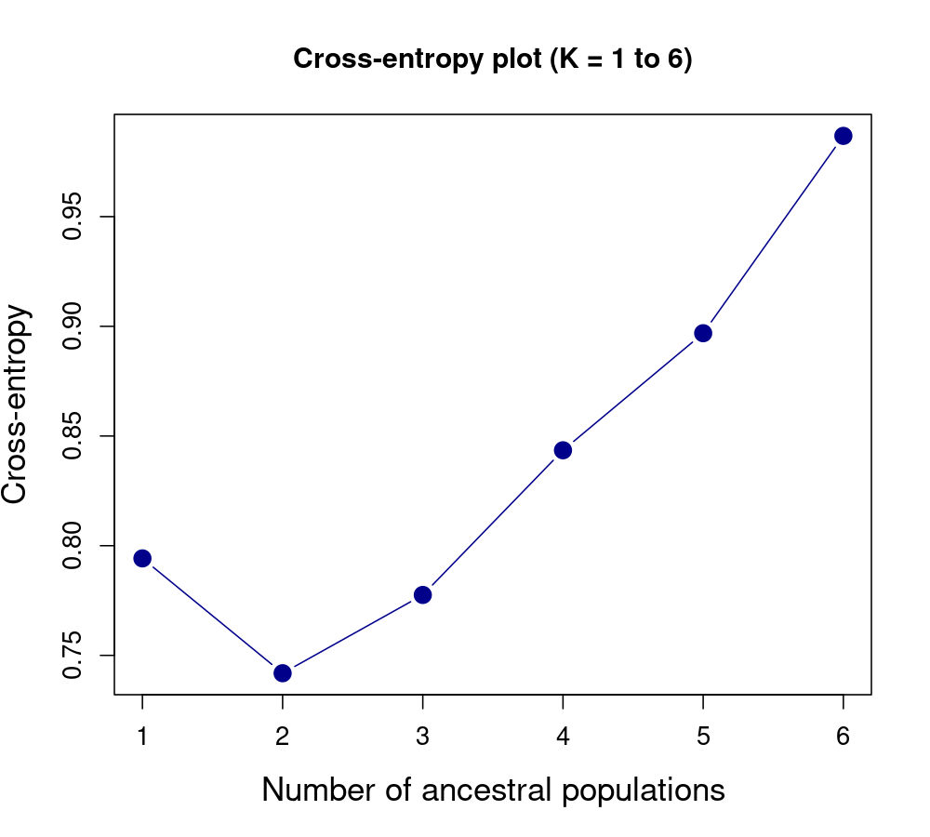

**Figure 1**. Cross-entropy criterion for selecting the optimal number of clusters (K) in the sNMF analysis for a dataset of 5,633 SNPs across 38 individuals.

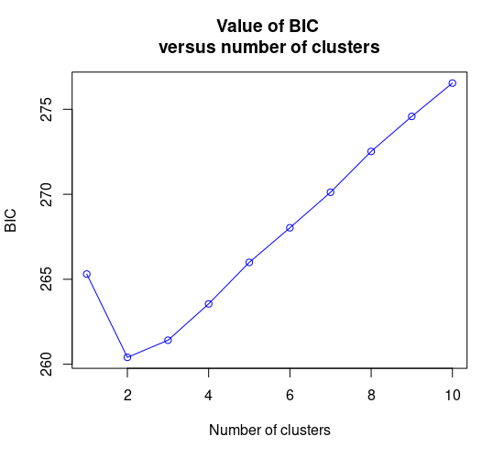

**Figure 2**. Bayesian Information Criterion (BIC) for selecting the optimal number of clusters in the DAPC analysis for a dataset of 5,633 SNPs across 38 individuals.