**Supplementary Figures**

**Figure S1. Details on the study locations**

**Figure S2. Temperature data series obtained from T-MEDNet database**

**Figure S3. Thermotolerance data points obtained for *C. rubrum and P. clavata***

**Figure S4. Photographic sampling design.**

**Figure S5. Silhouette method to determine the optimum number of k clusters (functional groups) in Partition Around Medoids (PAM) clustering analysis**

**Figure S6. Extended representation of the figure 3a-e in which the temporal changes of functional identity are individually shown for each monitored assemblage**

**Figure S7. Temporal trends in mean % of relative abundance ± SD of habitat-forming octocorals (Cluster 8) across the monitored periods.**

**Figure S1. Location of Port Cros and Scandola MPAs in the NW Mediterranean Sea and location and depth of the ecological sampling sites within Port Cros and Scandola, respectively.** Each of the surveyed sites consisted on 24 replicated permanent plots at the same depth (+/- 1 m)

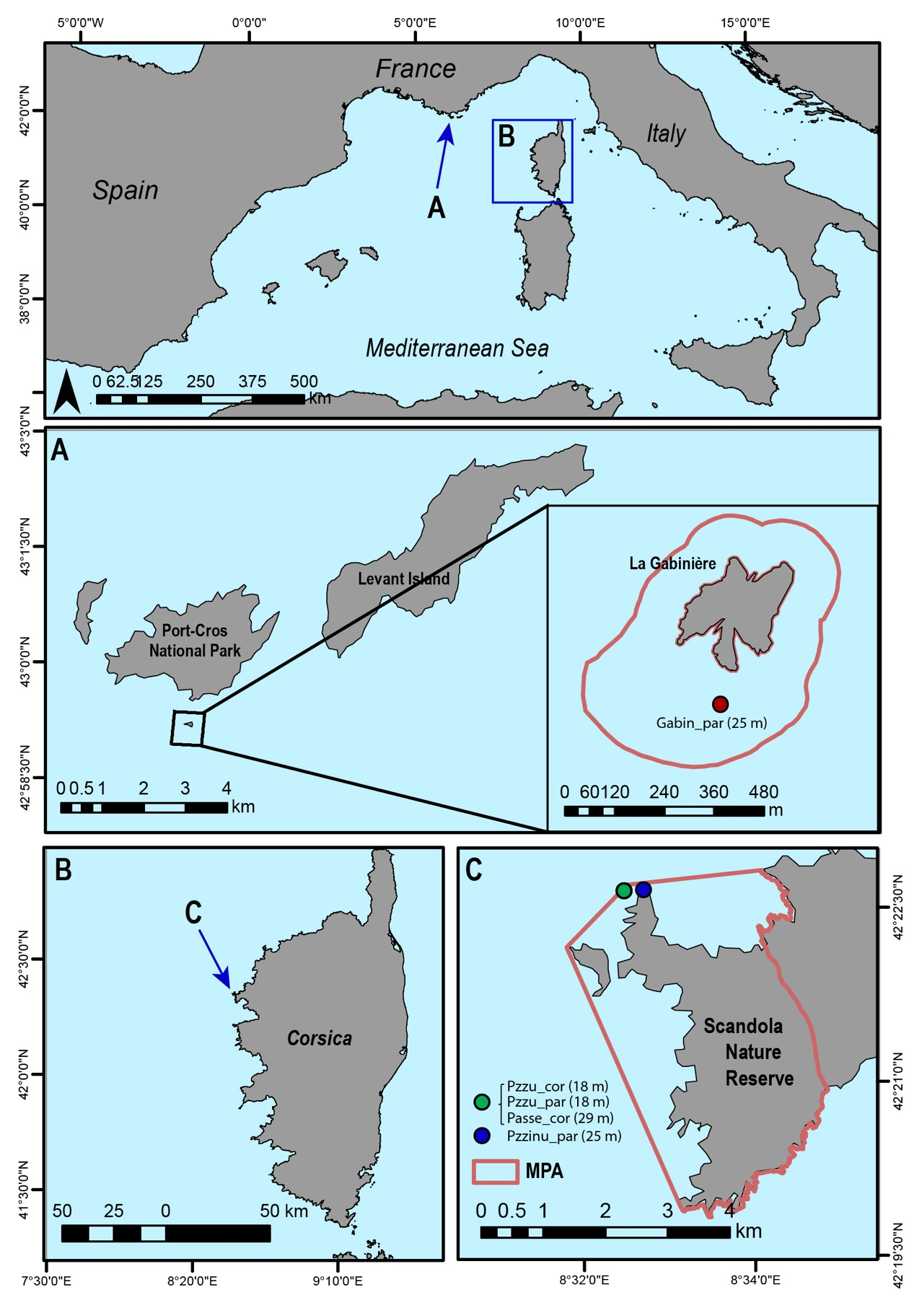

**Figure S2. Temperature data series obtained from T-MEDNet database. (a-c)** Daily average subsurface temperature time series in Port-Cros and Scandola at a depth of (±1 m) with respect to the biological surveys. To obtain the highest quality data for MHW analysis and due to significant T gradients (> 1º C per m) between 15 and 20 m depth at Scandola (see panel e), the data for Pzzu_cor/Pzzu_par 18 m was obtained by linear interpolation between the 15 and 20 m depth data (d).Overall, long sampling period (> 15 years) with high return rate on observations (> 97% on average) allowed a robust estimate of temperature conditions and MHW events over the full-length of the survey (Schlegel et al., 2019).

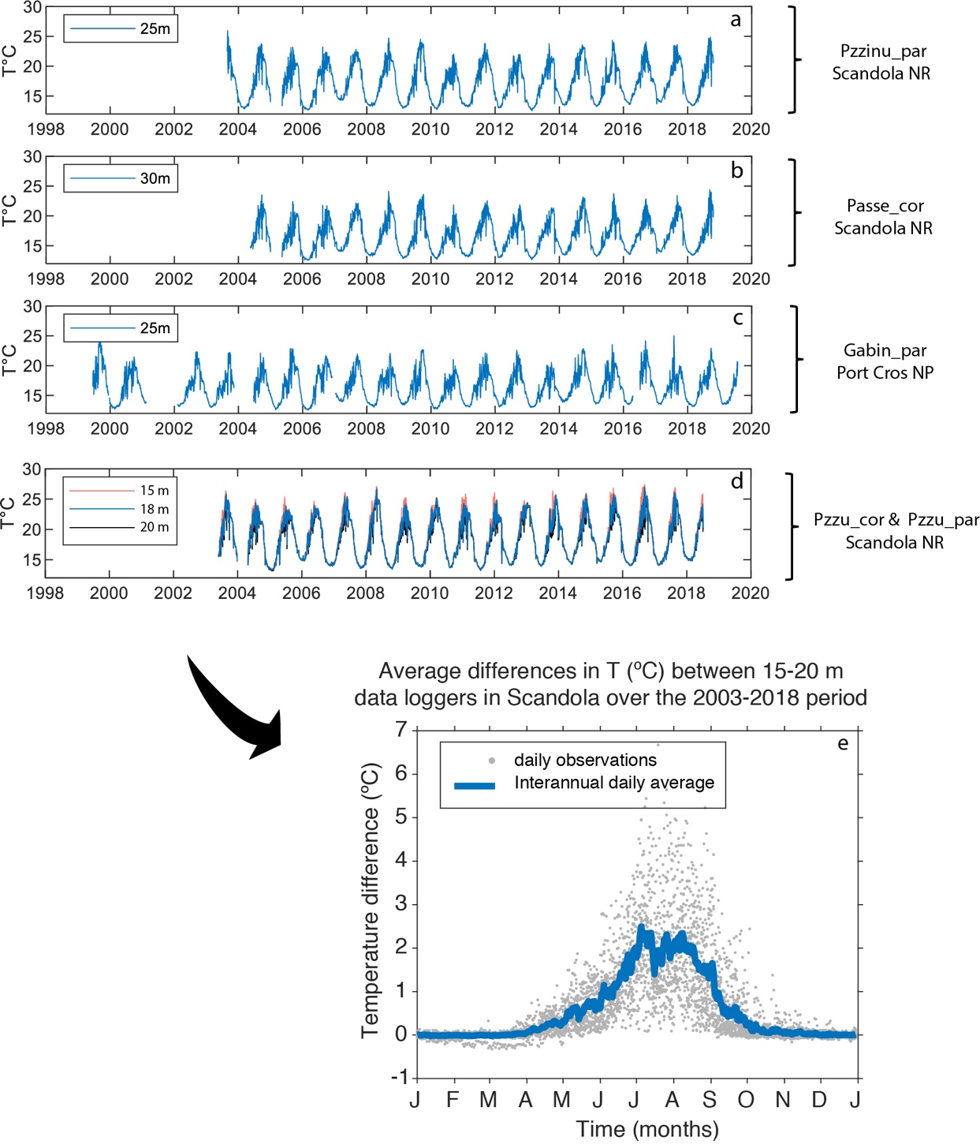

**Figure S3. Thermotolerance data points obtained for *C. rubrum and P. clavata* (mean number of days until the first signs of necrosis at different temperatures ± SE) in previous thermal experiments (i.e., Torrents et al., 2008; Crisci et al., 2017) and used to fit a 5th degree polynomial thermotolerance response curve relevant to asses potential risk of MHW- induced mortality in coralligenous assemblages.**



**Figure S4. Photographic sampling design.** Two *C.rubrum*-dominated assemblages and three *P.clavata-*dominated assemblaes were monitored for more than 10 years. Sites were classified prior to our functional analyses in MHW-impacted and non-impacted sites according to in situ high-resolution temperature data loggers that had been deployed every 5 m from the surface to 40 m depth as a part of the TMEDnet monitoring initiative (see methods section). The years in which each site was photographically sampled are shown in different colors.

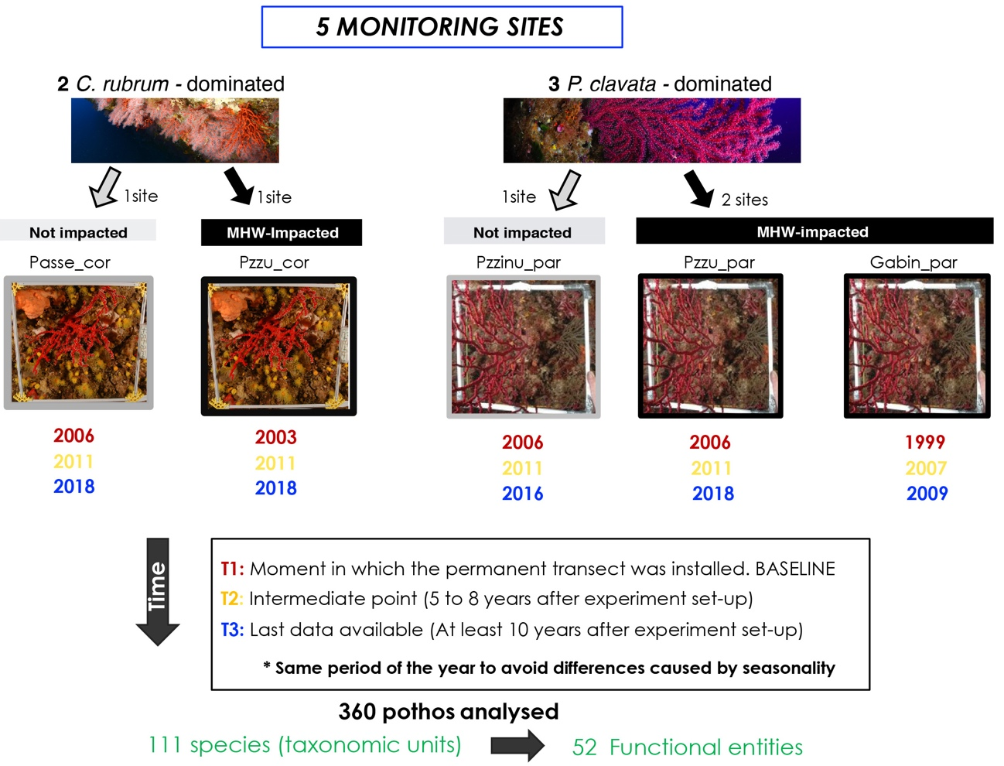

**Figure S5. Silhouette method to determine the optimum number of k clusters (functional groups) in Partition Around Medoids (PAM) clustering analysis.** The Average Silhouette Method (ASM) computes the average silhouette of observations for different values of k (Kaufman & Rousseeuw, 1990). The optimal number of clusters k is the one that maximize the average silhouette over a range of possible values for k. In this case, 20 and 8 clusters gave the best results. However, as we were interested in performing a broad classification, we selected 8 clusters as the optimum number of clusters that represent broad functional composition in coralligenous assemblages.

**Figure S6. (A). Extended representation of the Figure 3a-e in which the temporal changes of functional identity are individually sh**own for each monitored assemblage. For each of the sites, the abundance distribution of functional entities (FEs) at Time 1 (red circles), Time 2 (yellow circles) and Time 3 (blue circles) has been plotted, being the size of the circles directly related to the abundance of each of the FEs in the community at each specific time. *FI* values are represented as a cross in each plot. (**B**) Same figure as Figure 3a-e obtained when combining the above plots in time 1 and 3.

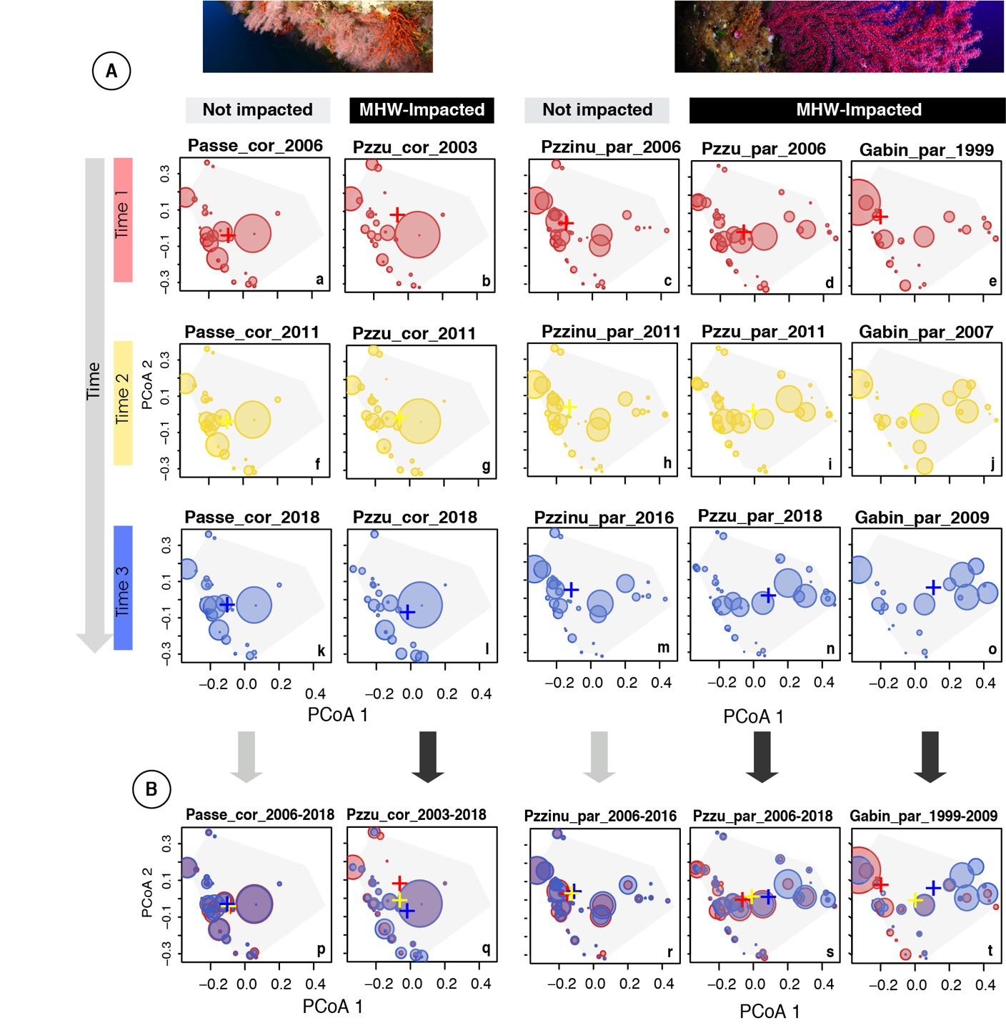

**Figure S7. Temporal trends in mean % of relative abundance ± SD of habitat-forming octocorals (Cluster 8) across the monitored periods.**

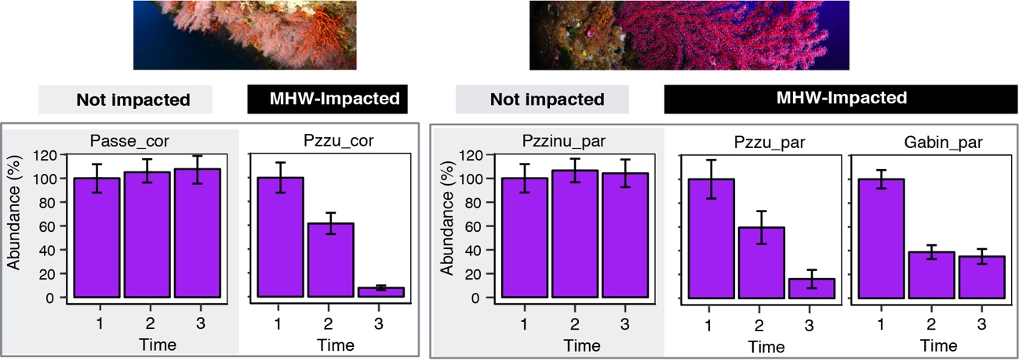

Reference list for Figs. S-S7

Kaufman, L.& Rousseeuw, P.J. (1990). Finding groups in data : An introduction to cluster analysis. *Wiley-Interscience*. p. 87. <https://doi.org/10.1002/9780470316801>

Schlegel, R. W., Oliver, E. C. J, Hobday, A. J., Smit, A. J. (2019). Detecting marine heatwaves with sub-optimal data. *Front. Mar. Sci*. 6:737. https://doi.org/10.3389/fmars.2019.00737

Torrents, O., Tambuté, E., Caminiti, N., & Garrabou, J. (2008). Upper thermal thresholds of shallow vs. deep populations of the precious Mediterranean red coral Corallium rubrum: assessing the potential effects of warming in the NW Mediterranean. *J. Exp. Mar. Biol. Ecol*., 357, 7-19. <https://doi.org/10.1016/j.jembe.2007.12.006>

Crisci, C., Ledoux, J. B., Mokhtar-Jamaï, K., Bally, M., Bensoussan, N., et al. (2017). Regional and local environmental conditions do not shape the response to warming of a marine habitat-forming species. *Sci. Rep.*, 7, 50-69. <https://doi.org/10.1038/s41598-017-05220-4>