Supplementary materials

|  |  |  |  |  |
| --- | --- | --- | --- | --- |
|  | PBS | PHBV | Flax fibres | Makroblend |
| Processing temperature | [160 – 180] °C | [160 – 175] °C |  | [260 – 270] °C |
| Mould temperature | 20°C | 60°C |  | 80°C |
| Drying | 50°C | 9h | 50°C | 9h | 50°C | 9h | 105°C | 3h |

Table S1 : Processing parameters of the materials studied.

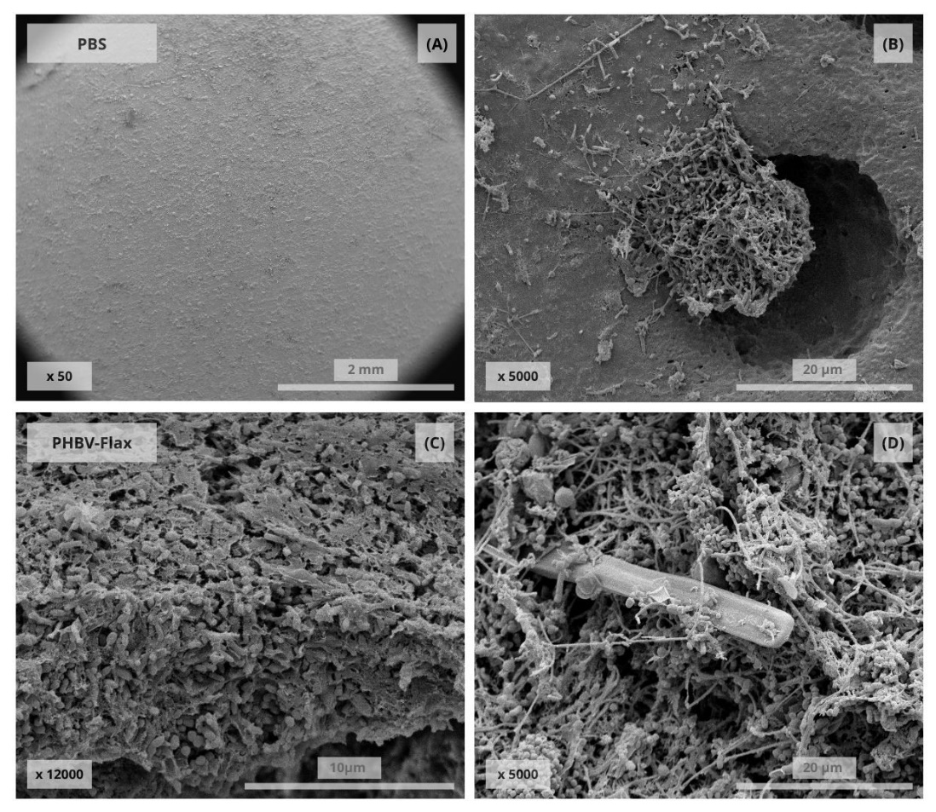

Figure S1 : SEM pictures of fixed biofilmafter ageing.

A-B: PBS, S1-780. C: PHBV-Flax, S1-780. D: PHBV-Flax, S2-1740.

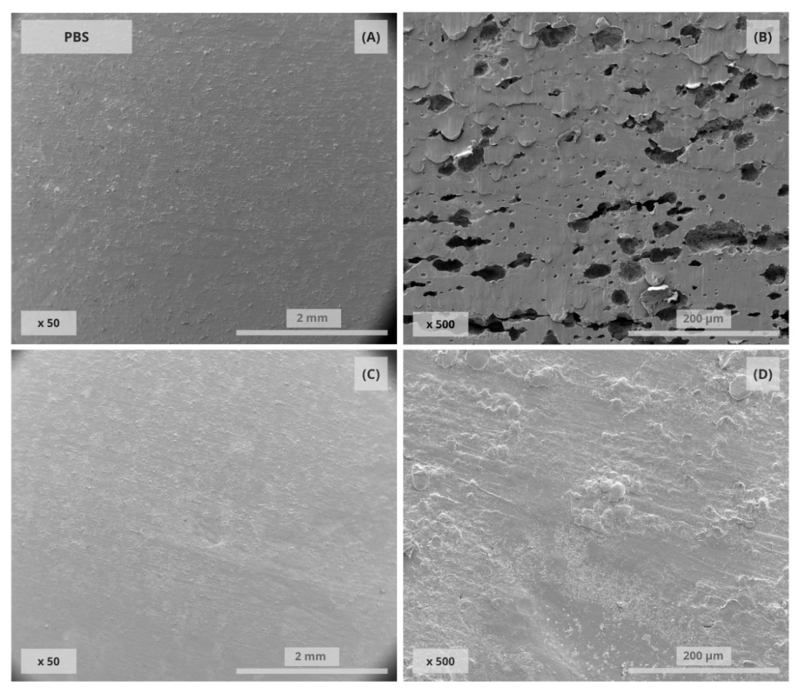

Figure S2 : SEM pictures of PBS after ageing.

A-B: S1-780. C-D: S2-1740.

Holes observed in picture B are very scarce on the overall surface.

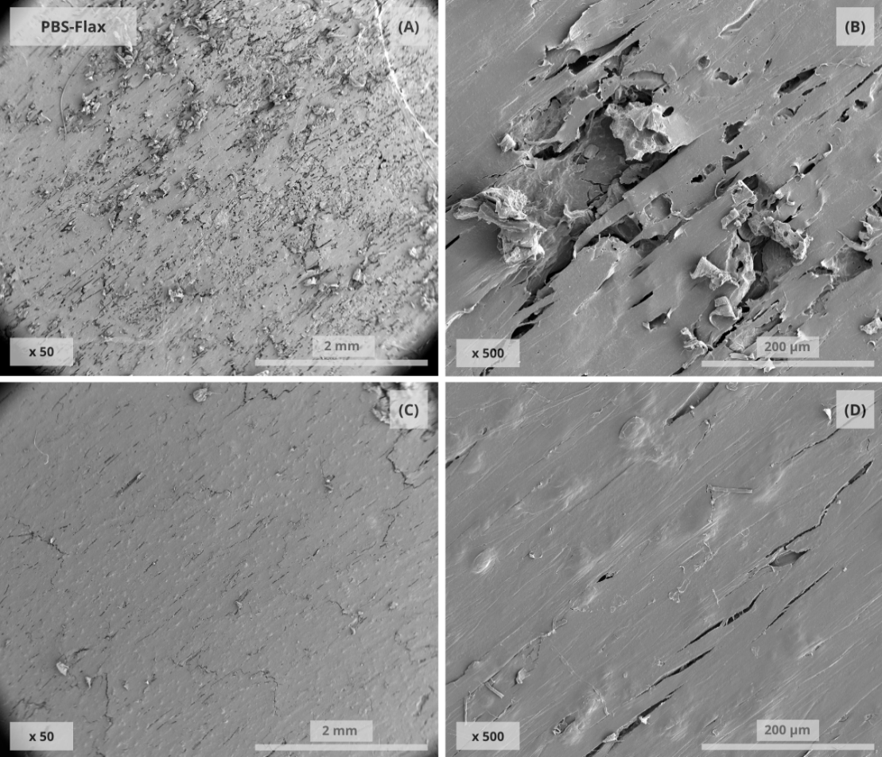

Figure S3 : SEM pictures of PBS-Flax after ageing.

A-B: S1-780. C-D: S2-1740.

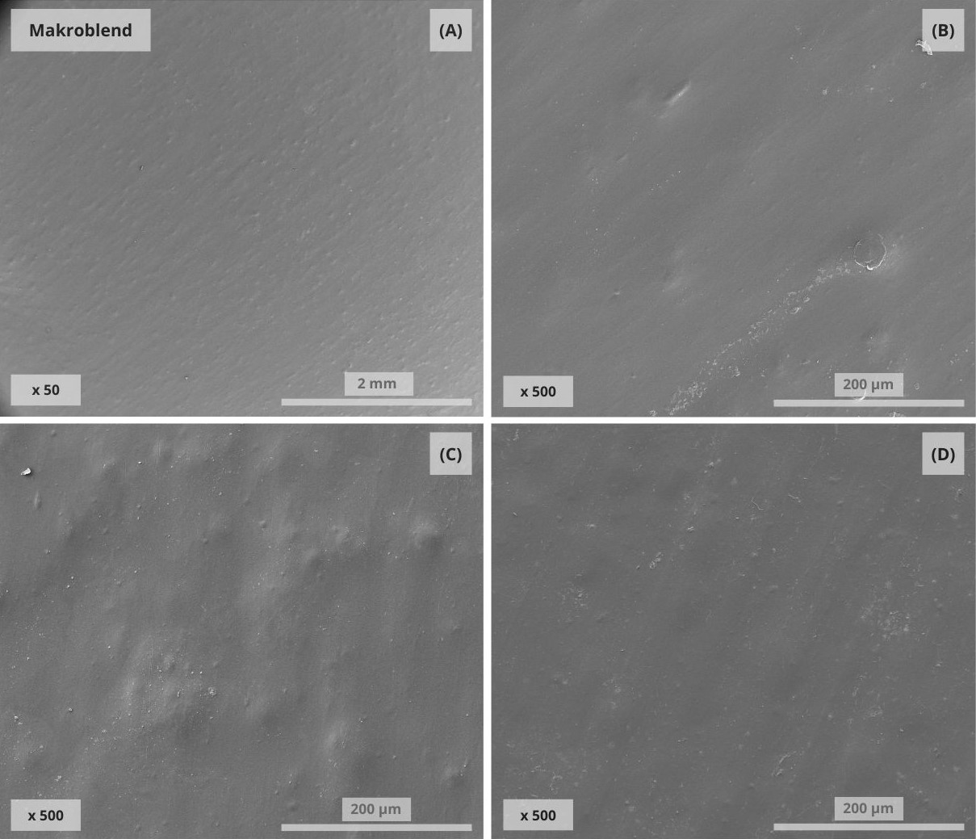

Figure S4 : SEM pictures of Makroblend after ageing.

A-B: Before ageing. C: S1-780. D: S2-1740.

|  |  |  |  |  |
| --- | --- | --- | --- | --- |
|  | | *Strain at break*  *%* | *Stress at break*  *MPa* | *Young’s modulus*  *MPa* |
| *PHBV* | Initial | 0.9 ± 0.1 | 32.2 ± 2.2 | 4422 ± 193 |
| S1-780 | 1.4 ± 0.1  ↗ 58 % | 34.7 ± 0.2  ↗ 7.8 % | 4292 ± 358  ↘ -2.9 % |
| S2-1740 | 1.5 ± 0.1  ↗ 73 % | 34.9 ± 0.6  ↗ 8.3 % | 3866 ± 321  ↘ -13 % |
| L1-Abio | 1.1 ± 0.1  ↗ 26 % | 37.5 ± 0.6  ↗ 17 % | 4410 ± 229  ≈ -0.3 % |
| *PHBV*  *Flax* | Initial | 1.1 ± 0.4 | 26.8 ± 2.4 | 7259 ± 302 |
| S1-780 | 0.7 ± 0.0  ↘ -36 % | 15 ± 2.1  ↘ -44 % | 3240 ± 276  ↘ -55 % |
| S2-1740 | 1.0 ± 0.4  ↘ -7.3 % | 15.4 ± 1.9  ↘ -42 % | 3832 ± 277  ↘ -47 % |
| L1 | 2.0 ± 0.2  ↗ 77 % | 27.66 ± 0.6  ↗ 3.2 % | 4406 ± 418  ↘ -39 % |
| *PBS* | Initial | 136.4 ± 60.3 | 29.4 ± 1.3 | 633 ± 19 |
| S1-780 | 20.0 ± 0.4  ↘ -85 % | 36.0 ± 0.3  ↗ 23 % | 716 ± 50  ↗ 13 % |
| S2-1740 | 17.5 ± 2.6  ↘ 87 % | 36.1 ± 0.1  ↗ 23 % | 656 ± 48  ↗ 3.7 % |
| *PBS*  *Flax* | Initial | 31.52 ± 0.3 | 3.9 ± 0.4 | 2700 ± 132 |
| S1-780 | 22.6 ± 1.1  ↘ -5.9 % | 3.7 ± 0.8  ↘ -28 % | 1873 ± 263  ↘ -31 % |
| S2-1740 | 17.4 ± 1.2  ↘ -31 % | 2.7 ± 0.3  ↘ -45 % | 1841 ± 117  ↘ -32 % |
| *MkB* | Initial | 47.5 ± 0.4 | 127 ± 2.6 | 2145 ± 81 |
| S1-780 | 48.1 ± 0.8  ↗ 1.2 % | 122.4 ± 3.3  ↘ -3.6 % | 1851 ± 89  ↘ -14 % |
| S2-1740 | 45.4 ± 4.3  ↘ -5% | 94.8 ± 47.5  ↘ -25 % | 1738 ± 155  ↘ -19 % |
| L1 | 47.4 ± 2.2  ≈ -0.35 % | 125.2 ± 8.5  ↘ -1.5 % | 1769 ± 182  ↘ -18 % |

Table S2 : Evolution of tensile properties after ageing for all the materials studied

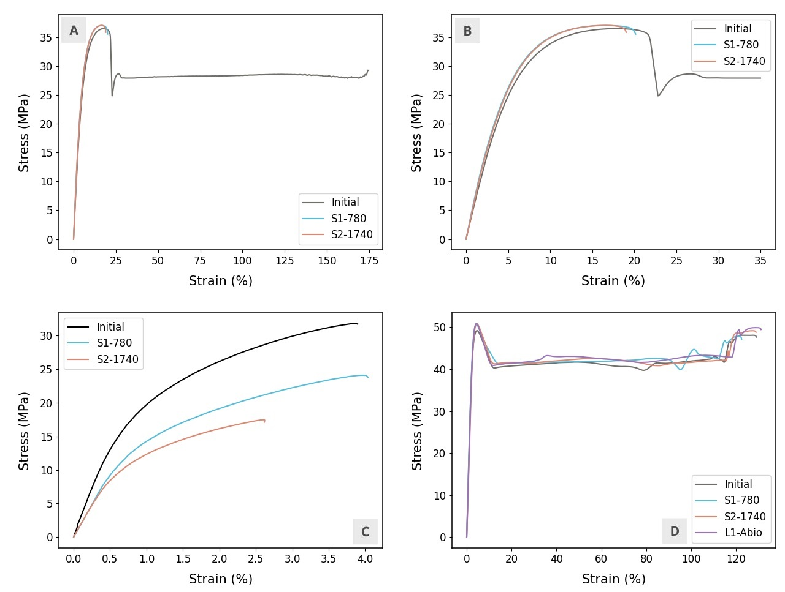

Figure S5 : Tensile curves of the materials studied before and after ageing.

A-B: PBS at high and low deformation. C: PBS-Flax. D: MkB

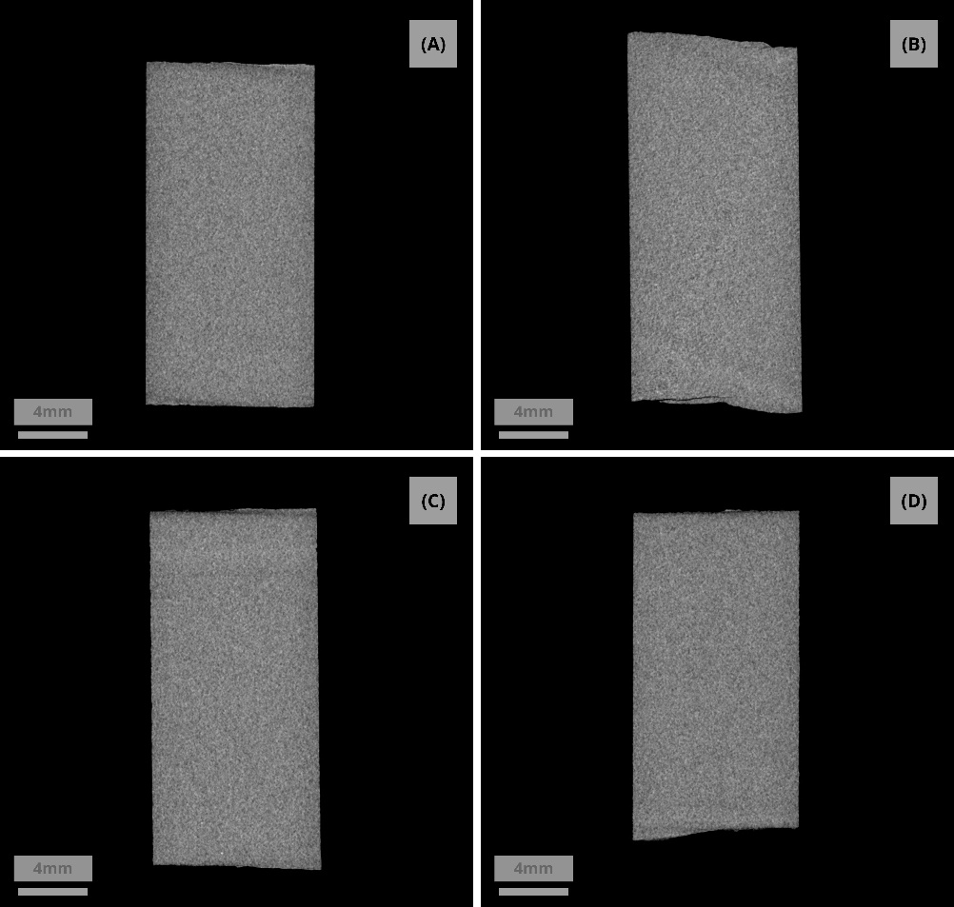

Figure S6 : Tomography of PHBV samples before and after ageing.

(A) Initial (B) L1-Abio (C) S1-780 (D) S2-1740

|  |  |  |  |  |
| --- | --- | --- | --- | --- |
|  |  | Tm (°C) | ΔHm (J.g-1) | χc (%) |
| PHBV | Initial | 174.9 ± 0.1 | 81.8 ± 0.2 | 56.0 ± 0.1 |
| S1-780 | 171.9 ± 1.4 | 87.0 ± 2.1 | 59.6 ± 1.5 |
| **↘ -1.7** | **↗ 6.4** | **↗ 6.4** |
| S2-1740 | 173.1 ± 1.3 | 81.9 ± 1.3 | 56.1 ± 0.9 |
| **↘ -1.1** | **≈ 0.2** | **≈ 0.2** |
| L1-Abio | 174.6 ± 0.4 | 80.5 ± 1.3 | 55.2 ± 0.9 |
| **≈ -0.2** | **≈ -1.5** | **≈ -1.5** |
| PHBV-Flax | Initial | 173.8 ± 0.9 | 52.1 ± 2.6 | 51.0 ± 2.5 |
| S1-780 | 173.1 ± 2.9 | 58.0 ± 0.5 | 56.8 ± 0.5 |
| **≈ -0.5** | **↗ 11.4** | **↗ 11.4** |
| S2-1740 | 169.8 ± 0.4 | 56.2 ± 2.9 | 55.0 ± 2.8 |
| **↘ -2.4** | **≈ 7.9** | **≈ 7.9** |
| L1-Abio | 174.1 ± 0.2 | 59.2 ± 2.1 | 58.0 ± 2.1 |
| **↗ 0.1** | **↗ 13.6** | **↗ 13.6** |
| PBS | Initial | 116.9 ± 0.3 | 64.2 ± 0.8 | 32.1 ± 0.4 |
| S1-780 | 116.6 ± 0.2 | 69.2 ± 2.3 | 34.6 ± 1.2 |
| **≈ -0.2** | **↗ 7.68** | **↗ 7.68** |
| S2-1740 | 116.8 ± 0.2 | 69.8 ± 1.8 | 34.9 ± 0.9 |
| **≈ -0.1** | **↗ 8.72** | **↗ 8.72** |
| PBS-Flax | Initial | 116.7 ± 0.7 | 49.2 ± 2.5 | 35.1 ± 1.8 |
| S1-780 | 116.1 ± 0.0 | 50.4 ± 0.2 | 36.0 ± 0.2 |
| **≈ -0.5** | **≈ 2.45** | **≈ 2.45** |
| S2-1740 | 114.5 ± 0.2 | 62.9 ± 2.2 | 44.9 ± 1.6 |
| **↘ -1.9** | **↗ 28** | **↗ 28** |
| MkB | Initial | 225.3 ± 0.9 | 18.9 ± 1.6 | n.d. |
| S1-780 | 224.8 ± 0.2 | 20.6 ± 1.2 | n.d. |
| **≈ -0.2** | **≈ 9** | X |
| S2-1740 | 224.5 ± 0.6 | 21.8 ± 2.4 | n.d. |
| **↘ -0.4** | **↗ 15.4** | X |

Table S3 : thermal properties of the studied materials during the first scan

|  |  |  |  |
| --- | --- | --- | --- |
|  | Mw  (103g.mol-1) | Mn  (103g.mol-1) | Ip |
| Reference | 154 ± 33 | 23.9 ± 3.6 | 6.2 ± 0.5 |
| S2-1740 | 246 ± 37 | 27.6 ± 10 | 7.6 ± 1.3 |
| S1-780 | 184 | 22 | 8.3 |

Table S4 : Molecular weights measured by Gel Permeation Chromatography on PHBV-Flax specimens before and after aging