**S1 File. Details on tokens and characters of the “geophysics” research team.**

The twelve research teams follow the same template

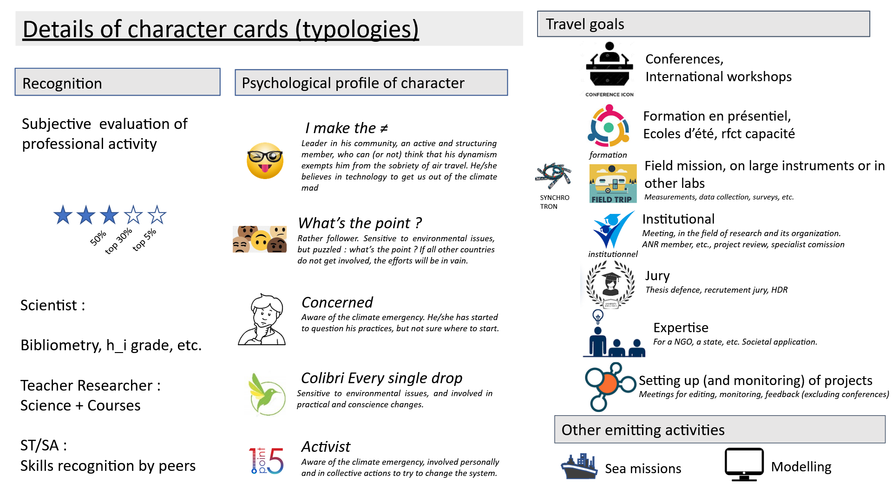

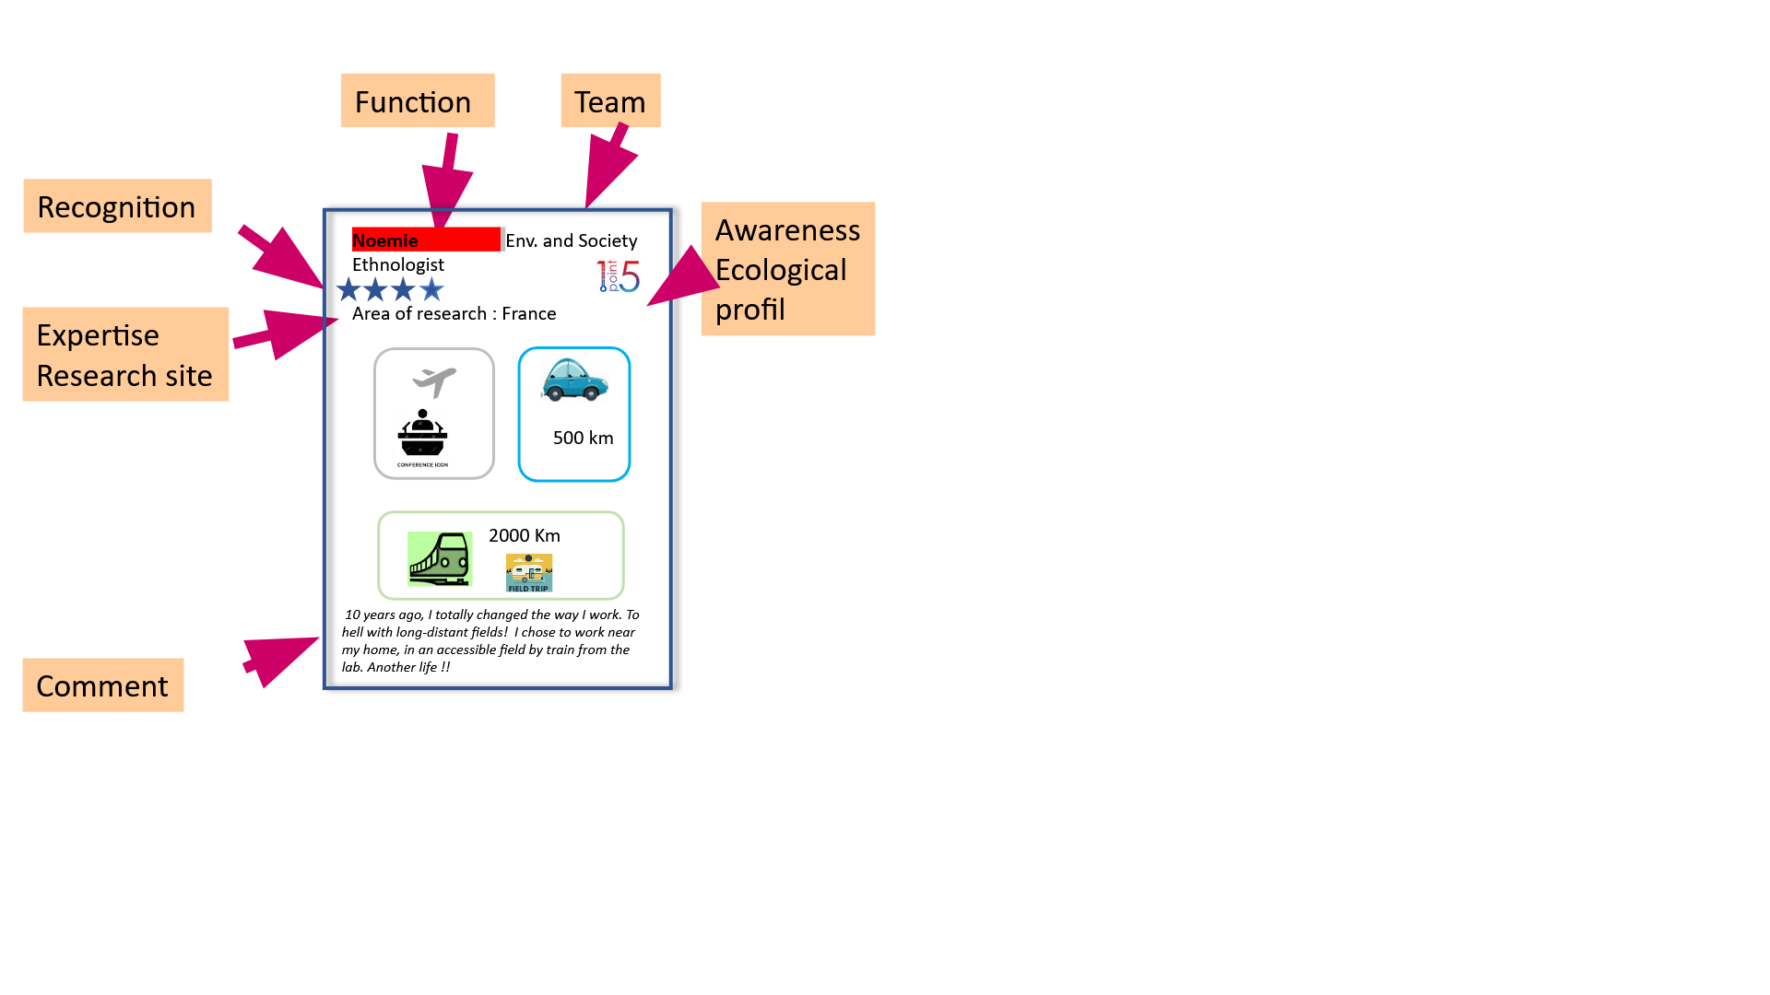

1.5°

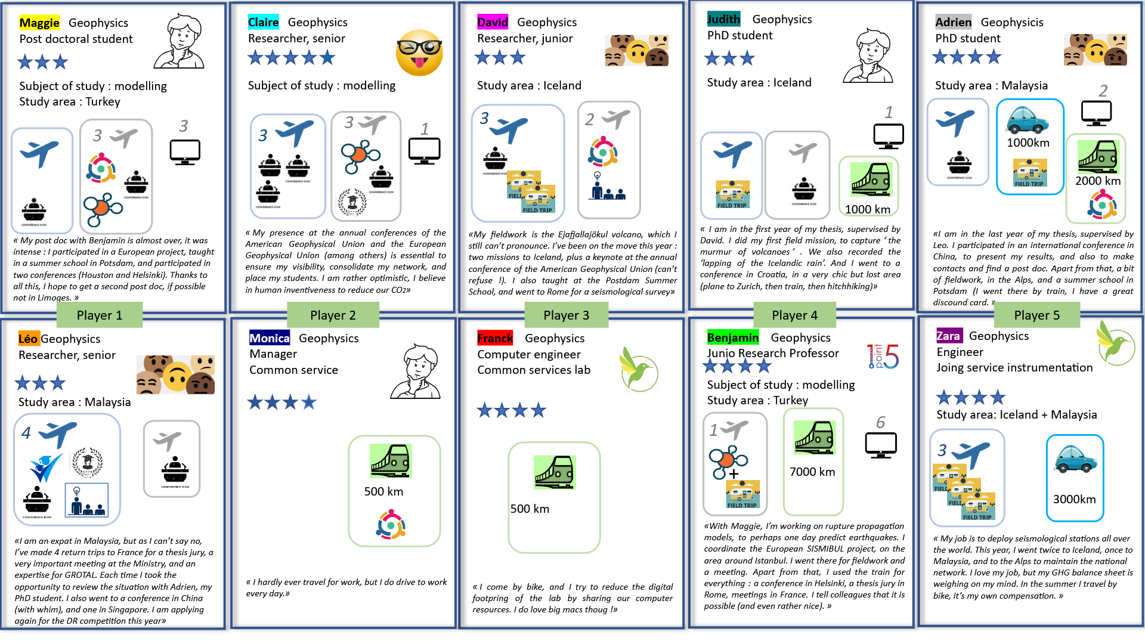

1.5°