SUPPLEMENTAL ONLINE INFORMATION
For publication in conjunction with the following:

Viral dynamics in a high rate algal pond reveals a burst of Phycodnaviridae diversity correlated with episodic algal mortality

Chase EE^{1,2,3}, Pitot T⁴, Bouchard S¹, Triplet S⁵, Przybyla C⁵, Gobet A⁵, Desnues C^{1,2}, and Blanc G¹.

¹ Microbiologie Environnementale Biotechnologie, Institut Méditerranéen d'Océanologie, Campus de Luminy, 163 Avenue de Luminy, 13009 Marseille, France
² Institut hospitalo-universitaire (IHU) Méditerranée infection, 19-21 Boulevard Jean Moulin, 13005 Marseille, France
³ University of Tennessee Knoxville, Department of Microbiology, Ken and Blaire Mossman Bldg, 1311 Cumberland Ave #307, Knoxville, TN 37996
⁴ Department of Biochemistry, Microbiology and Bioinformatics, Université Laval, 2325 rue de l’Université, Québec, QC G1V0A6, Canada
⁵ MARBEC, Univ Montpellier, CNRS, Ifremer, IRD, Sète, France

SUPPLEMENTAL FIGURES
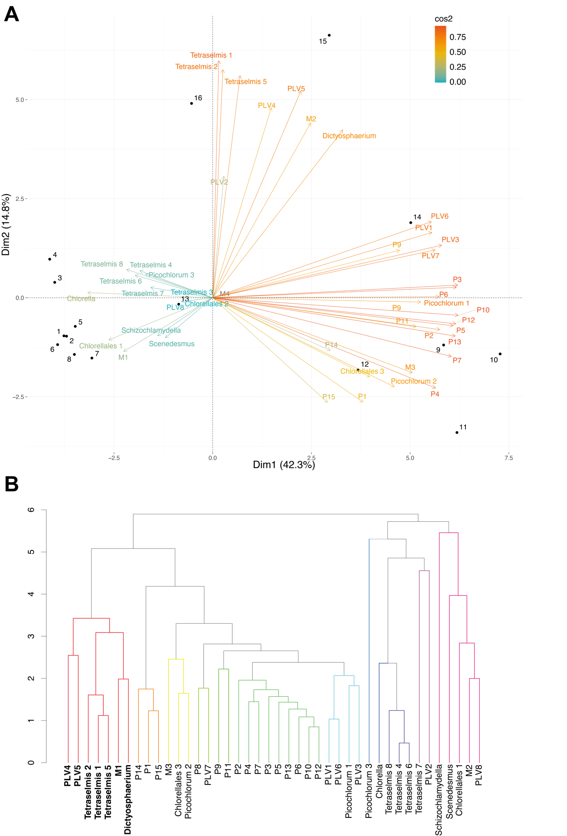
Figure S10. Investigation of Nucleocytoviricota and PLV relationships through (A) principal component analyses using combined and normalised qPCR data and 18S rDNA ASVs (i.e., metabarcoding) on tracked putative viruses and potential alga (Chlorophyta) hosts for Mimiviridae (M), Phycodnaviridae (P), and polinton-like viruses (PLV). Cos2 reports the strength of the principal component for the observations (i.e. virus or potential hosts), where a higher value depicts a stronger relationship between them or a “good representation”. The vector length of each observations represents the contribution they make to the ordination. Dates are represented by numbered objects, where 2017 is composed of 1–5 (April is 1 and 2, May is 3, June is 4 and 5), and 2018 is composed of 6–16 (April is 6, May is 7–9, August is 9, September Is 10–13, and October is 14–16). A second analysis: (B) Hierarchical clustering (SIMPROF, α = 0.1) of potential hosts (Chlorophyta) and viruses of interest, where colours represent different groups clustering at our minimum. Bolded text signifies hosts and viruses mentioned within the manuscript.

Figure S11. Putative Nucleocytoviricota phylogeny based on the DNA polymerase B gene (PolB). Reference sequences were downloaded by NCBI GenBank (accession numbers as indicated) and sequenced recovered from the HRAP are included (in bold). Bootstrap values are indicated by circle size.

