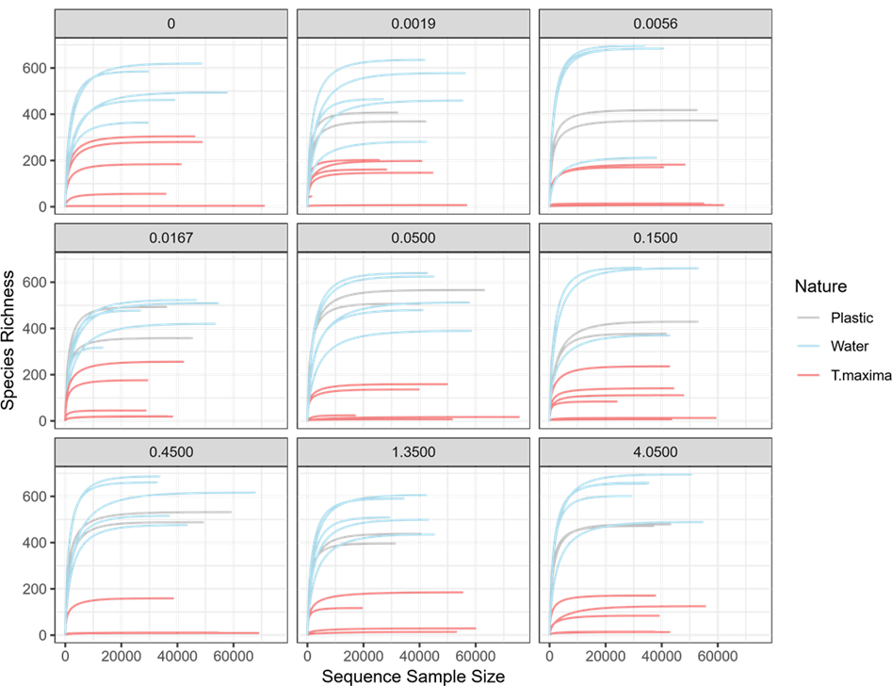

Figure S1. Rarefaction curves as a function of the concentration of plastic (grey: plastic, blue: water, pink: *Tridacna maxima*).

|  |
| --- |
|  |
| Figure S2. Compositional plot of the composition of *T. maxima* bacterial communities at family level. On the left, the composition of the bacterial communities of *T. maxima* sampled at t0 before immersion in plastics. On the right, the composition of the bacterial communities of *T. maxima* sampled after two months of exposure to different concentrations of pearl plastics. |

|  |
| --- |
|  |
| Figure S3. Muscle glycogen concentration per gram of wet weight of *T. maxima* as a function of pearl plastic concentration. |

|  |
| --- |
|  |
| Figure S4. Shell growth rate of the *T. maxima* as a function of pearl plastic concentration. |
|  |
|  |
| Figure S5. Distanced-based redundancy analysis on 104 samples that includes16, 42 and 46 samples of plastic, water and *T. maxima* respectively. |

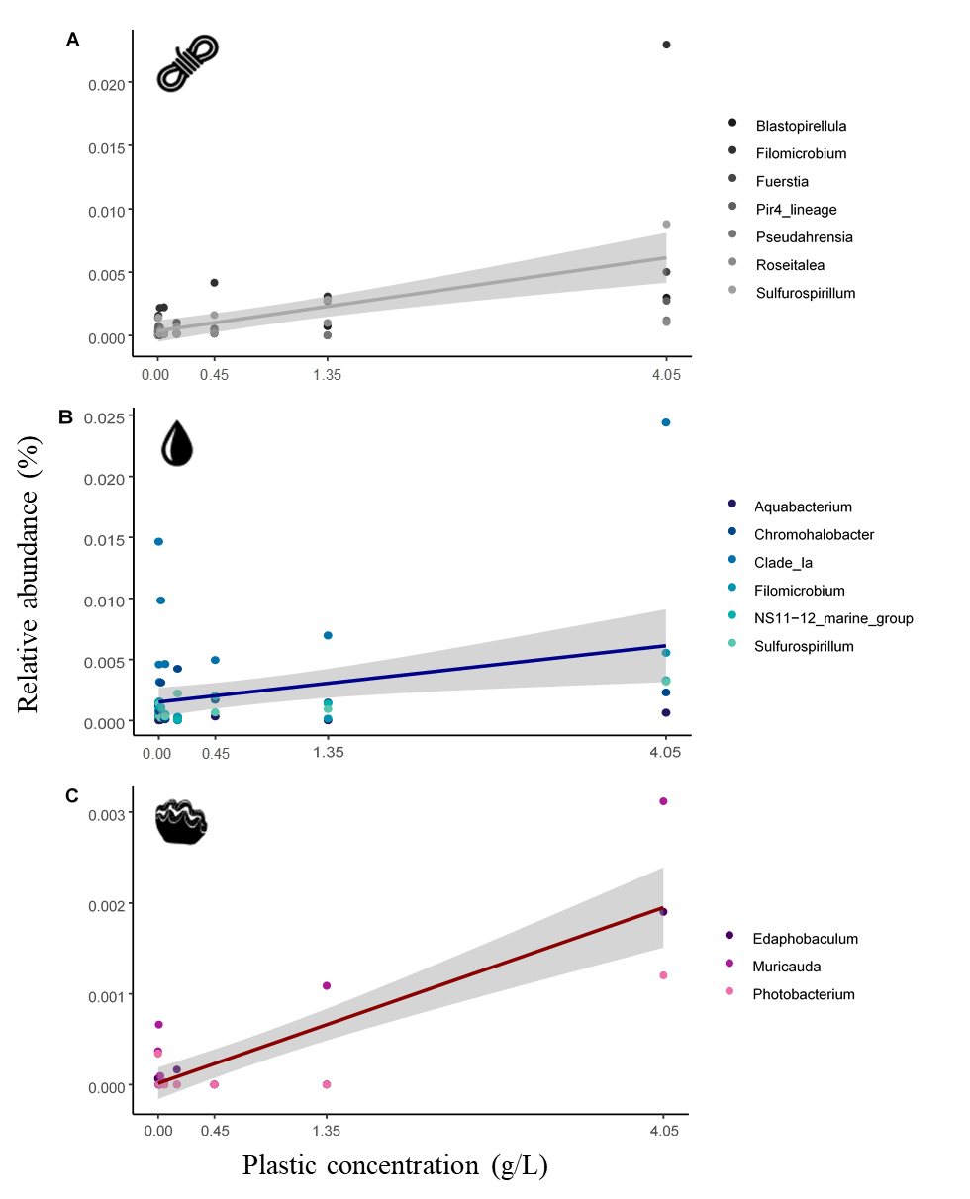

Figure S6. Percentage relative abundances of candidate ASVs as a function of plastic concentration (g/L) for each type of sample. Only ASVs identified up to genus have been represented (A: plastic, B: water, C: *Tridacna maxima*).