Supporting Information

A Year-long Field Study of Buried Plastics Reveals Underestimation of Plastic Pollution on Hawaiian Beaches

Astrid E. Delorme^{1,2,3*}, Olivier B. Poirion⁴, Laurent Lebreton^{3,5}, Pierre-Yves le Gac¹, Kimeona Kāne⁶, Sarah-Jeanne Royer^{2,3}

¹Ifremer RDT, Research and Technology Development Unit, 1625 route de Sainte-Anne, Plouzané, 29280, France
²Hawaiʻi Pacific University, Center for Marine Debris Research, HI, United States of America
³The Ocean Cleanup Foundation, Rotterdam, The Netherlands
⁴The Jackson Laboratory, Farmington, CT
⁵The Modelling House Limited, Raglan, New Zealand
⁶ Community Scholar, Chairperson of the Waimānalo Neighborhood Board, Cultural Practitioner

*email: astrid.delorme@ifremer.fr; Orcid: https://orcid.org/0000-0003-0377-4434

Supporting information content

Number of pages: 15

Number of Tables: 1

Number of Figures: 15

- Field-survey protocol
For each field-day a minimum of 5-10 people is needed and will be divided into Team A and Team B. Each team will have a minimum of 2 people. with at least 1 Lead Scientist and 1 trained MSci student, to supervise the work.
Setting Up
Team A:
- Take note of the time of arrival.
- Place the first quadrat (Q1), with the line of debris running through the middle of the quadrat and take a picture (see fig. 1), make a note of GPS location using maps on phone.

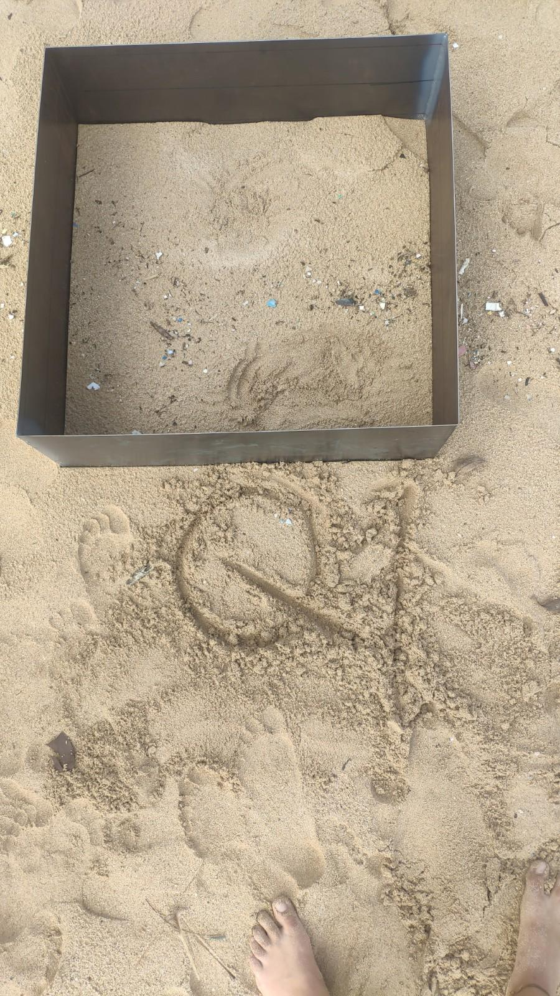
Debris line

Fig. S1: Photo of quadrant one prior to digging procedures.

- Place the second quadrat (Q2), with the line of debris passing through the middle of the quadrat, approximately 10 m from Q1 (measure from and to middle of quadrats). Take a picture and note the GPS location.
- Place the third quadrat (Q3), with the line of debris passing through the middle of the quadrat, approximately 10 m from Q2. Take a picture and note down the GPS location.
Team B:
- Take note of weather conditions and note conditions in the data sheet.
- Rinse buckets and BSD with filtered water (using a 250 µm meshbag to filter the ocean water) and add filtered water to the Buoyancy Separating Device (BSD).
- Set-up table and rinse equipment with filtered water. Place the clean equipment on the table.
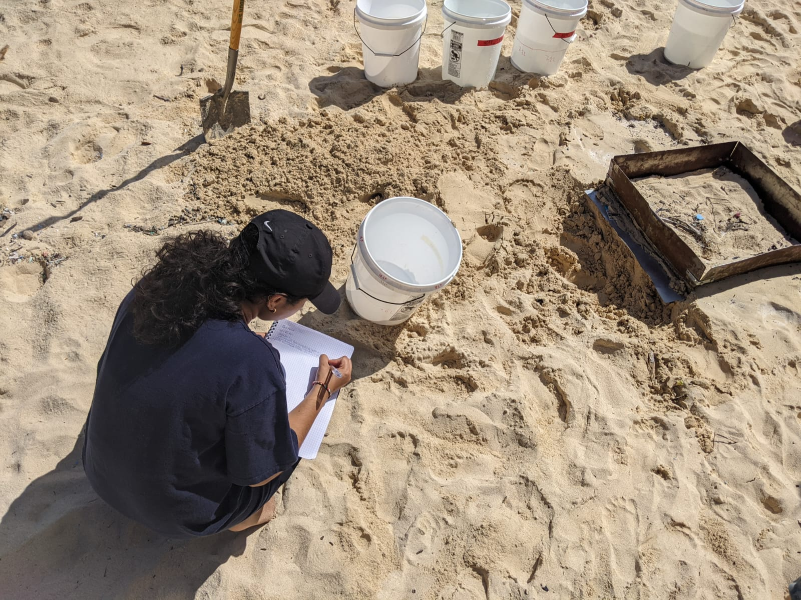
Fig. S2: Noting weather conditions at Kokololio.
Collecting the debris from each layer
Team A
Dedicate one person to be in charge of weighing the buckets and taking moisture and temperature measurements.
Surface Layer (SL): 2 cm
- Make a note of the time of sampling for Q1.
- Push down the metal frame down to the 2 cm marking. Scoop up the sand in the metal frame into a bucket, see fig. 3. Scoop up the sand until the bottom of the frame is reached, using a metal ruler to even out the surface. The first 2 cm layer in the quadrat should yield 7.2 L of sand.

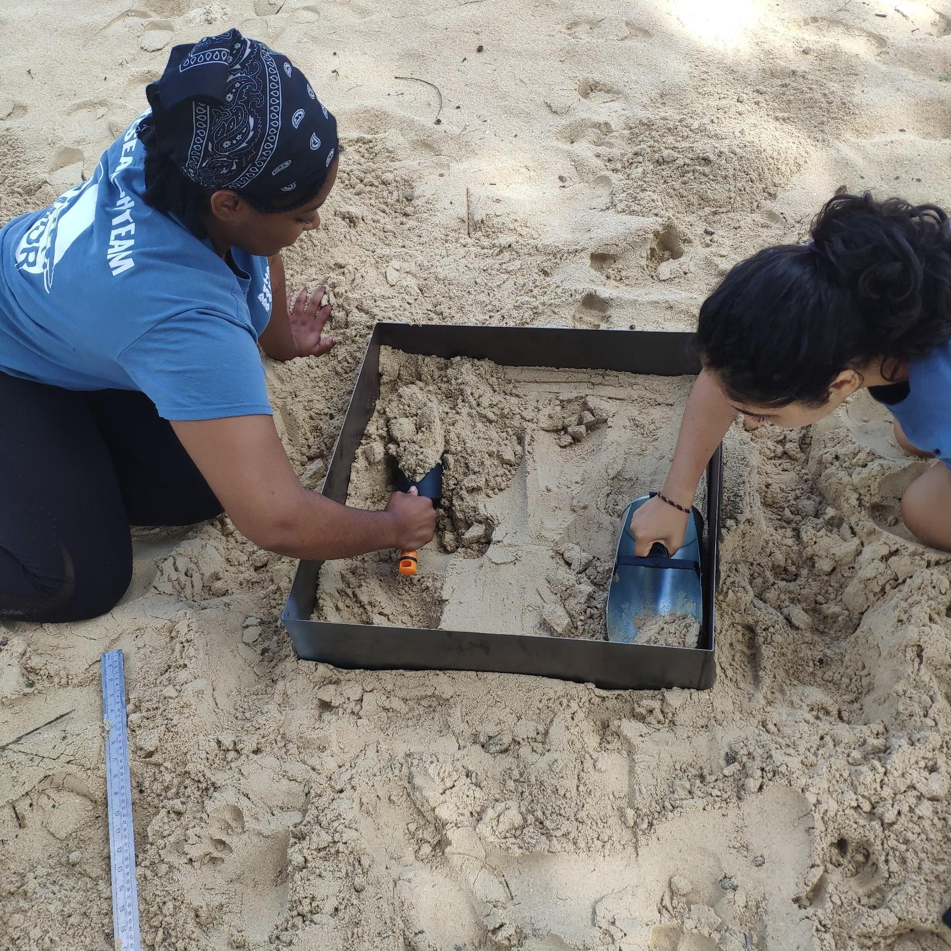
Fig. S3: Scooping sand from the surface layer.

- Weigh the bucket with the sand, measure the moisture and temperature (using moisture meter and standard thermometer) in the middle of the bucket for the 1st quadrat. In the “field survey” paper, fill in the moisture and temperature of Q1SL. See fig. 4.

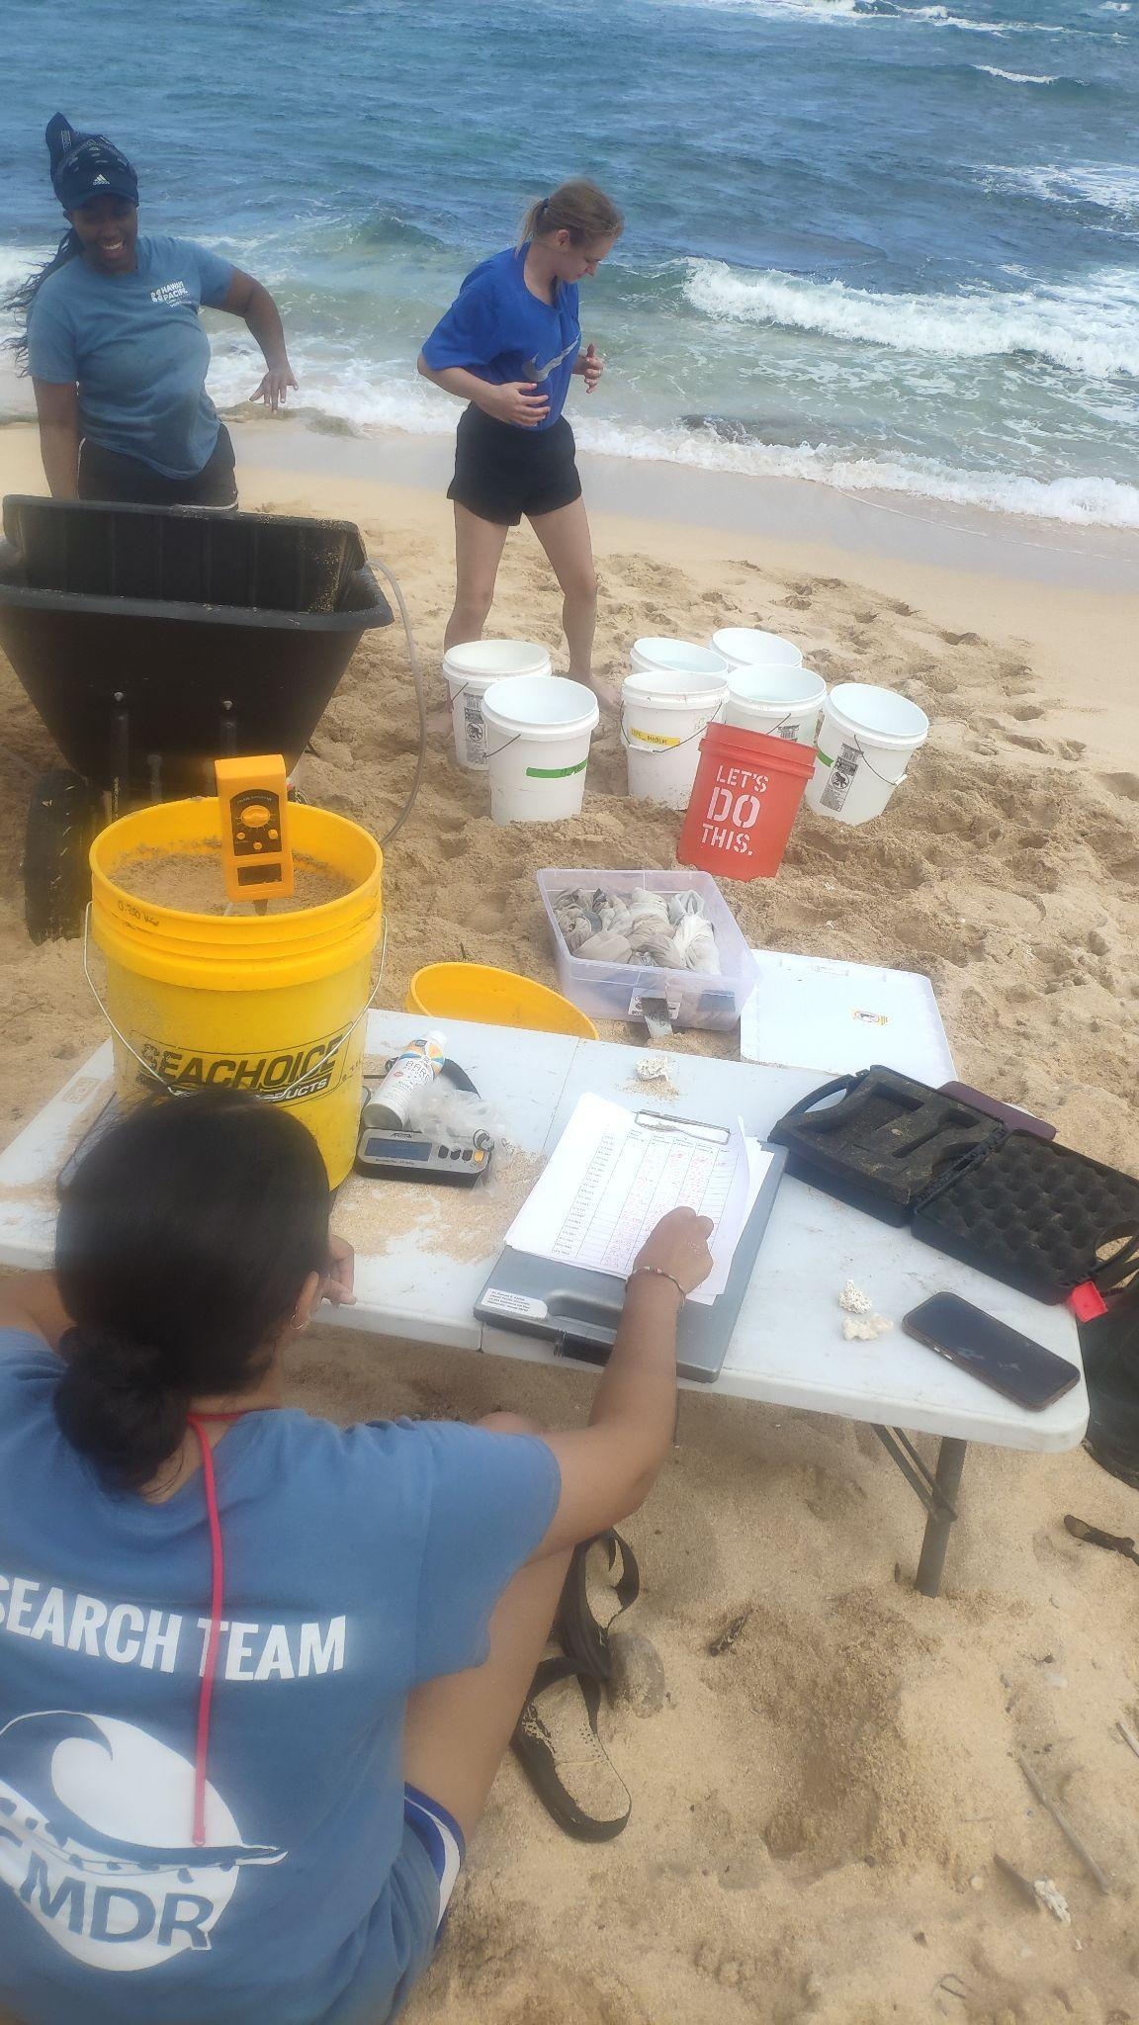
Moisture meter

Fig. S4: Recording moisture content from a sand layer.

- Take the sand bucket containing the first 2 cm of sand to Team B at the BSD.
- Clean shovels with filtered water and bring two new clean sand buckets (cleaned with filtered water).
- Dig around three sides of the box, to avoid that sand fall into the quadrat, see fig. 5.
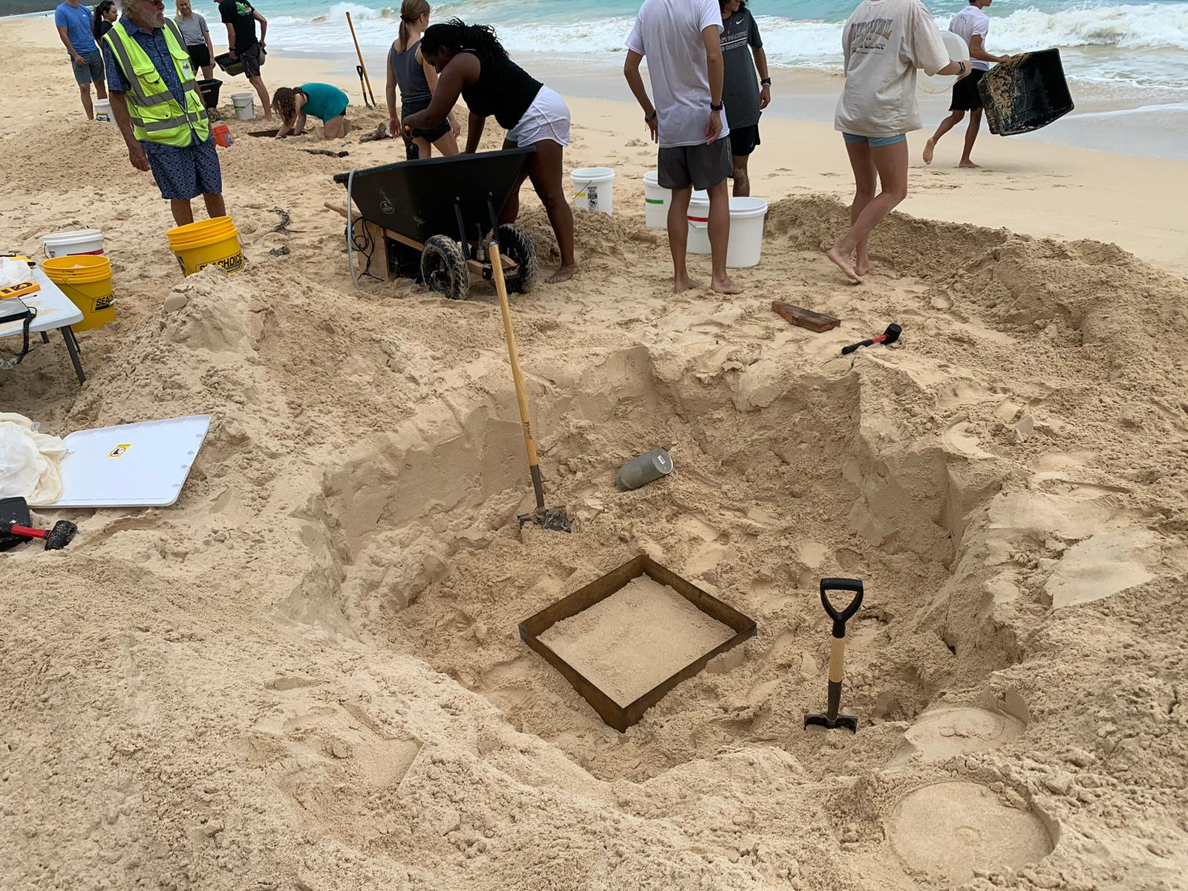
Fig. S5: Quadrat layer with the sand around the

Column Layers (CL): 10 cm
- Using the rubber mallets and wooden blocks (between the hammer and the metal frame), hammer down the metal frame until the surface of the sand inside the quadrat has reached the 10 cm marking, see Fig. 6. Make sure that the sand from outside of the quadrat does not go inside, by digging around the quadrat.
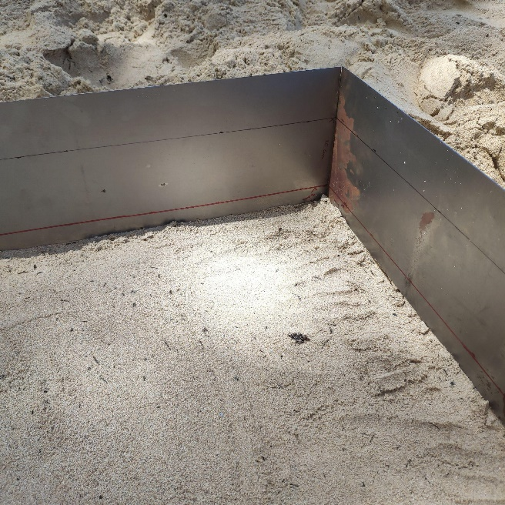
10 cm marking

Fig. S6: Metal frame is hammered down to the 10 cm marking.

- Scoop out the sand inside the quadrat into two buckets until a marking of 18 L is reached for each of the buckets, and the bottom of the metal frame is reached. Use a metal ruler to avoid scooping up sand deeper than the 10 cm layer, see Fig. 7.

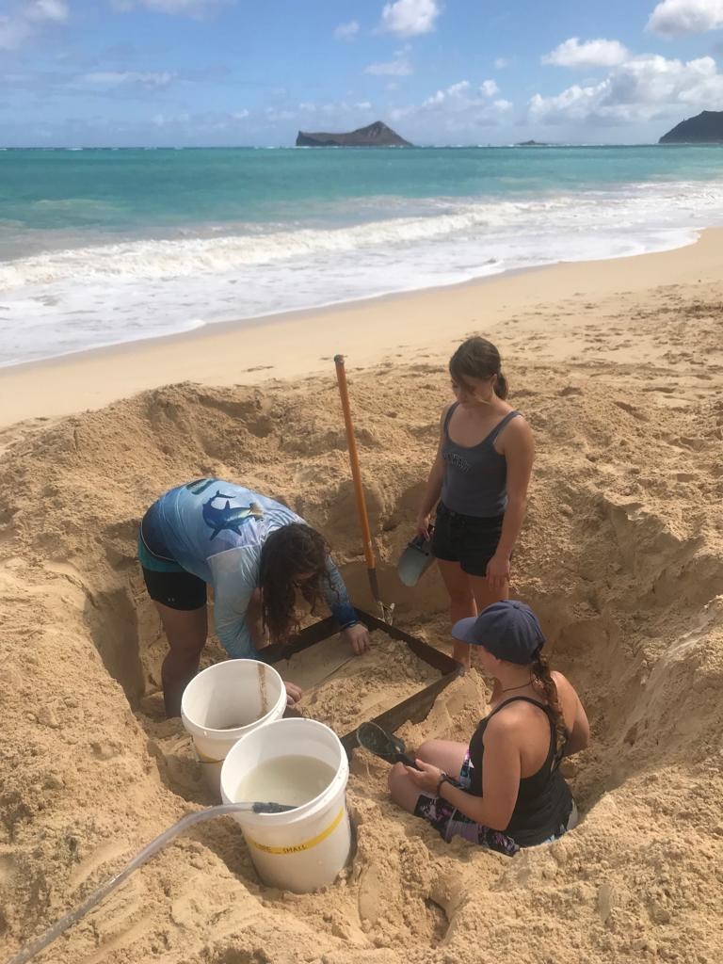
Fig. S7: Using a ruler to level out the sand in a 10 cm layer.

- 10 cm layer in the quadrat should yield 36 litres of sand, weigh the bucket and measure the moisture content in the bucket. Make a note in the field-survey paper for weight, moisture and temperature for Q1CL1.
- Take the two sand buckets containing the Q1CL1 of sand to Team B at the BSD.
- Clean shovels and bring two new clean sand buckets.
- Repeat the CL procedure until 102 cm depth is reached.
BSD Operation
Team B
- Collect the filled sand buckets from Team A and add the sand to the top bin of the BSD. How to use the BSD - check videos on Seed.World
- Stir the sand with the help of the water hoses and let the water flow and bring the floating debris into the 250 µm meshbags. Keep stirring until no more floating debris is observed.

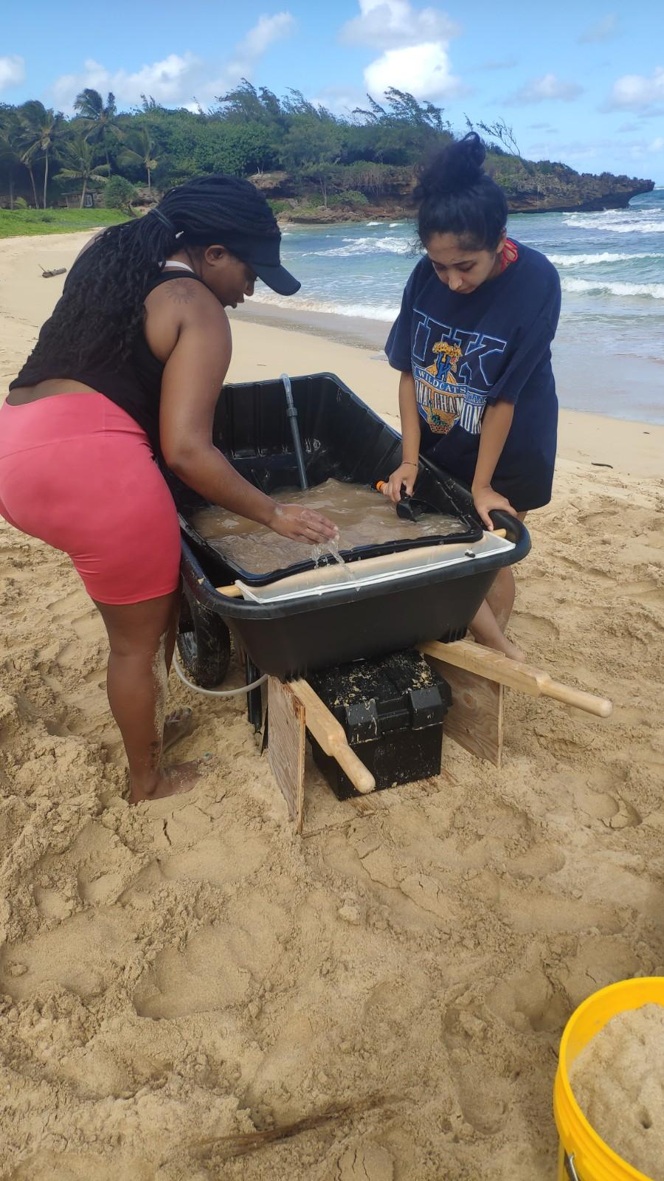
Fig. S8: using the BSD to separate the buoyant debris from the sand and collecting it in the meshbags.
- Remove the meshbag with the collected debris from the sand and then label the mesh bag containing the debris for a layer using ductape and sharpie pen on the drawstring. using the following descriptor:

For Surface Layer: BeachName_Date_Q#SL
For Column Layer: BeachName_Date_Q#CL1

- Fold the bag containing the debris of one layer and store in the container labelled Quadrat 1.
- Empty out the “clean sand” from the top bin.
- Repeat step 1-6. For each layers and quadrats.

- Results
  - Plastic abundance and concentration
Counts of Plastic Particles per Depth Layer
Fig. S9: The average counts of plastic particles along the sand column. The sand column is divided into 11 layers: the first 2 cm corresponds to the surface layer, followed by 10 cm strata extending down to 102 cm. The counts distribution of plastic particle is shown for the three beach sites; Kahuku (red), Kokololio (green), and Waimānalo (blue) and across the six sampling months. The average concentration and standard deviation error are calculated from the three quadrats sampled per sampling day.

Counts per Volume of Sand
Fig. S10: The average concentration of plastic particles, expressed as counts (n) per volume (dm⁻³) of sand, along the sand column. The sand column is divided into 11 layers: the first 2 cm corresponds to the surface layer, followed by 10 cm strata extending down to 102 cm. The vertical distribution of plastic particle concentration is shown for the three beach sites; Kahuku (red), Kokololio (green), and Waimānalo (blue) and across the six sampling months. The average concentration and standard deviation error are calculated from the three quadrats sampled per sampling day.

Mass of Plastic particles per Depth Layer
Fig. S11: The average mass (g) of the total amount of plastic particles collected per layered sample along the sand column. The sand column is divided into 11 layers: the first 2 cm corresponds to the surface layer, followed by 10 cm strata extending down to 102 cm. The vertical distribution of mass of plastic particles is shown for the three beach sites; Kahuku (red), Kokololio (green), and Waimānalo (blue) and across the six sampling months. The average concentration and standard deviation error are calculated from the three quadrats sampled per sampling day.

  - Plastic sizes
Mean Max. Length of Plastic particles per Depth Layer
Fig. S12: Mean plastic particle maximum lengths by depth at each beach. The means are and standard deviations are calculated from the maximum lengths of all particles collected from layered samples within three quadrats, measured using the Segmentation Model. The vertical distribution the plastic particle length is shown for the three beach sites; Kahuku (red), Kokololio (green), and Waimānalo (blue) and across the six sampling months. Error bars represent the overall range of particle sizes.

Mean Max. Length of Plastic particles per Depth Layer without Line
Fig. S13: Mean plastic particle maximum lengths by depth at each beach, excluding the lines depicted by the Segmentation model (accounting for 3% of the detected particles). The means are and standard deviations are calculated from the maximum lengths of all particles collected from layered samples within three quadrats, measured using the Segmentation Model. The vertical distribution the plastic particle length is shown for the three beach sites; Kahuku (red), Kokololio (green), and Waimānalo (blue) and across the six sampling months. Error bars represent the overall range of particle sizes.

Mean Max. Length of Plastic particles Across all Sampling Months with Line
m = 6.6, n= 6
m = 7.5, n = 59
m = 9.1, n = 55
m = 6.6, n = 144
m = 7.3, n = 304
m = 6.7, n = 457
m = 8.1, n = 372
m = 7.0, n = 345
m = 7.6, n = 479
m = 8.0, n = 987
m = 9.5, n = 1061
m = 7.0, n = 1551
m = 7.5, n = 7474
m = 7.8, n = 5565
m = 7.6, n = 4893
m = 7.3, n = 4241
m = 7.6, n = 2285
m = 7.7, n= 5063
m = 7.1, n= 3568
m = 8.0, n = 1484
m = 6.8, n = 2075
m = 7.1, n = 3641
m = 7.9, n = 2560
m = 6.8, n = 3207
m = 6.9, n = 3173
m = 7.5, n = 5443
m = 6.7, n = 2615
m = 6.6, n= 1911
m = 7.0, n = 3435
m = 6.8, n = 2185
m = 6.9, n = 2009
m = 6.3, n = 1949
m = 7.0, n = 2437

Fig. S14: Boxplots represent the distribution of maximum particle lengths in mm showing the mean max. length (m) and number of particles per layer in the sand column (n), including the lines, collected at the three beach sites; Kahuku (red), Kokololio (green), and Waimānalo (blue) and across the six sampling months. Outliers have been removed for clarity (outliers are included in Fig. S12 with the error bars represent the overall range of particle sizes).

  - Sandgrain Size
Table S1: Sand grain size measurements for each of the three beaches - Kahuku, Waimānalo, and Kokololio - collected using the SandSnap platform (https://sandsnap-erdcchl.hub.arcgis.com/). Sand grain size is presented as D50 (median particle diameter in millimeters), representing the size at which 50% of the sand particles are smaller and 50% are larger. Measurements were taken at various depths; however, some data is missing due to the quality of certain uploaded pictures not meeting the necessary standards for analysis.
Beach | Day | Month | Year | Depth, cm | Quadrat | Sandsize, mm
Kahuku | 26 | 11 | 2023 | 12 | 3 | 0.85
Kahuku | 26 | 11 | 2023 | 42 | 3 | 0.85
Kahuku | 26 | 11 | 2023 | 72 | 3 | 0.83
Kahuku | 26 | 11 | 2023 | 52 | 3 | 0.78
Kahuku | 26 | 11 | 2023 | 2 | 3 | 0.67
Kahuku | 26 | 11 | 2023 | 82 | 3 | 0.66
Kahuku | 26 | 11 | 2023 | 32 | 3 | 0.65
Kahuku | 26 | 11 | 2023 | 62 | 3 | 0.63
Kahuku | 26 | 11 | 2023 | 22 | 3 | 0.57
Kahuku | 26 | 11 | 2023 | 92 | 3 | 0.5
Kahuku | 26 | 11 | 2023 | 102 | 3 | 0.48
Kokololio | 19 | 11 | 2023 | 82 | 2 | 0.58
Kokololio | 19 | 11 | 2023 | 102 | 2 | 0.53
Kokololio | 19 | 11 | 2023 | 32 | 2 | 0.47
Kokololio | 19 | 11 | 2023 | 62 | 2 | 0.45
Kokololio | 19 | 11 | 2023 | 92 | 2 | 0.44
Kokololio | 19 | 11 | 2023 | 42 | 2 | 0.43
Kokololio | 19 | 11 | 2023 | 2 | 2 | 0.38
Kokololio | 19 | 11 | 2023 | 12 | 2 | 0.37
Kokololio | 19 | 11 | 2023 | 22 | 2 | 0.35
Kokololio | 19 | 11 | 2023 | 52 | 2 | 0.34
Waimānalo | 12 | 11 | 2023 | 82 | 2 | 0.44
Waimānalo | 12 | 11 | 2023 | 52 | 2 | 0.4
Waimānalo | 12 | 11 | 2023 | 92 | 2 | 0.4
Waimānalo | 12 | 11 | 2023 | 42 | 2 | 0.39
Waimānalo | 12 | 11 | 2023 | 62 | 2 | 0.36
Waimānalo | 12 | 11 | 2023 | 2 | 2 | 0.33
Waimānalo | 12 | 11 | 2023 | 12 | 2 | 0.12
Kahuku | 11 | 2 | 2024 | 22 | 2 | 0.66
Kahuku | 11 | 2 | 2024 | 42 | 2 | 0.6
Kahuku | 11 | 2 | 2024 | 2 | 2 | 0.57
Kahuku | 11 | 2 | 2024 | 12 | 2 | 0.53
Kahuku | 11 | 2 | 2024 | 82 | 2 | 0.5
Kahuku | 11 | 2 | 2024 | 52 | 2 | 0.47
Kahuku | 11 | 2 | 2024 | 22 | 1 | 0.45
Kahuku | 11 | 2 | 2024 | 62 | 2 | 0.44
Kahuku | 11 | 2 | 2024 | 32 | 1 | 0.44
Kahuku | 11 | 2 | 2024 | 72 | 2 | 0.41
Kahuku | 11 | 2 | 2024 | 42 | 1 | 0.41
Kahuku | 11 | 2 | 2024 | 12 | 1 | 0.4
Kahuku | 11 | 2 | 2024 | 82 | 1 | 0.4
Kahuku | 11 | 2 | 2024 | 92 | 1 | 0.34
Kahuku | 11 | 2 | 2023 | 102 | 1 | 0.34
Kokololio | 10 | 2 | 2024 | 92 | 2 | 0.47
Kokololio | 10 | 2 | 2024 | 12 | 2 | 0.4
Kokololio | 10 | 2 | 2024 | 32 | 2 | 0.4
Kokololio | 10 | 2 | 2024 | 42 | 2 | 0.4
Kokololio | 10 | 2 | 2024 | 82 | 2 | 0.39
Kokololio | 10 | 2 | 2024 | 22 | 2 | 0.37
Kokololio | 10 | 2 | 2024 | 52 | 2 | 0.35
Kokololio | 10 | 2 | 2024 | 62 | 2 | 0.35
Kokololio | 10 | 2 | 2024 | 72 | 2 | 0.34
Kokololio | 10 | 2 | 2023 | 102 | 2 | 0.28
Kokololio | 10 | 2 | 2024 | 42 | 2 | 0.27
Kokololio | 10 | 2 | 2024 | 82 | 2 | 0.27
Kokololio | 10 | 2 | 2024 | 12 | 2 | 0.23
Kokololio | 10 | 2 | 2024 | 62 | 2 | 0.22
Kokololio | 10 | 2 | 2024 | 52 | 2 | 0.19
Waimānalo | 4 | 2 | 2024 | 52 | 1 | 0.3
Waimānalo | 4 | 2 | 2024 | 2 | 1 | 0.28
Waimānalo | 4 | 2 | 2024 | 22 | 1 | 0.28
Waimānalo | 4 | 2 | 2024 | 62 | 1 | 0.28
Waimānalo | 4 | 2 | 2024 | 2 | 2 | 0.28
Waimānalo | 4 | 2 | 2024 | 12 | 2 | 0.28
Waimānalo | 4 | 2 | 2023 | 102 | 2 | 0.28
Waimānalo | 4 | 2 | 2024 | 22 | 2 | 0.27
Waimānalo | 4 | 2 | 2024 | 42 | 1 | 0.26
Waimānalo | 4 | 2 | 2024 | 82 | 3 | 0.26
Waimānalo | 4 | 2 | 2024 | 32 | 1 | 0.25
Waimānalo | 4 | 2 | 2024 | 92 | 1 | 0.25
Waimānalo | 4 | 2 | 2023 | 102 | 1 | 0.25
Waimānalo | 4 | 2 | 2024 | 2 | 3 | 0.25
Waimānalo | 4 | 2 | 2024 | 22 | 3 | 0.25
Waimānalo | 4 | 2 | 2024 | 72 | 1 | 0.24
Waimānalo | 4 | 2 | 2024 | 82 | 2 | 0.24
Waimānalo | 4 | 2 | 2024 | 92 | 2 | 0.24
Waimānalo | 4 | 2 | 2024 | 12 | 1 | 0.23
Waimānalo | 4 | 2 | 2024 | 32 | 2 | 0.23
Waimānalo | 4 | 2 | 2024 | 42 | 2 | 0.23
Waimānalo | 4 | 2 | 2024 | 52 | 2 | 0.23
Waimānalo | 4 | 2 | 2024 | 62 | 2 | 0.23
Waimānalo | 4 | 2 | 2024 | 62 | 3 | 0.23
Waimānalo | 4 | 2 | 2024 | 72 | 2 | 0.22
Waimānalo | 4 | 2 | 2024 | 52 | 3 | 0.2

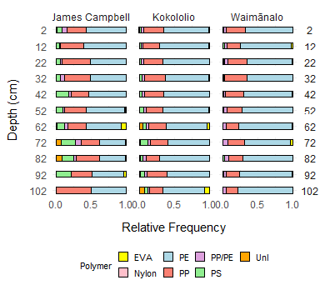
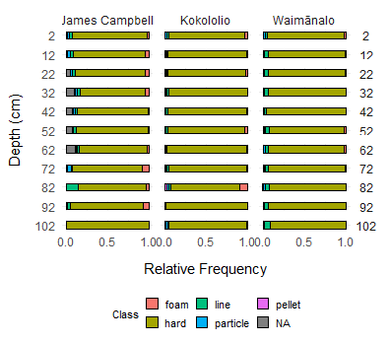
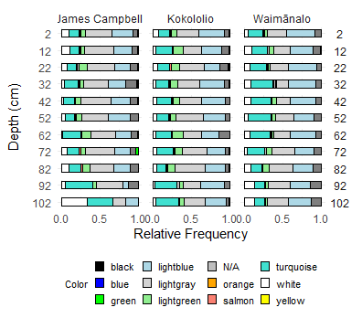
  - Plastic Class, Colour and PolymerID composition
(A)
(C)
Kahuku Kokololio Waimānalo
Kahuku Kokololio Waimānalo
Kahuku Kokololio Waimānalo
(B)

Fig. S15. Relative frequency of (A) class, (B) polymer ID, and (C) color of the total plastic abundance recovered at different depths across the three beaches studied. The class and color compositions reflect the relative abundance of the total abundance of plastic particles sampled during field campaigns, as analyzed using the segmentation model. Polymer compositions were determined from ATR/FTIR analysis of the randomly selected aliquots of plastic particles from each sample collected.

