# Supplementary material

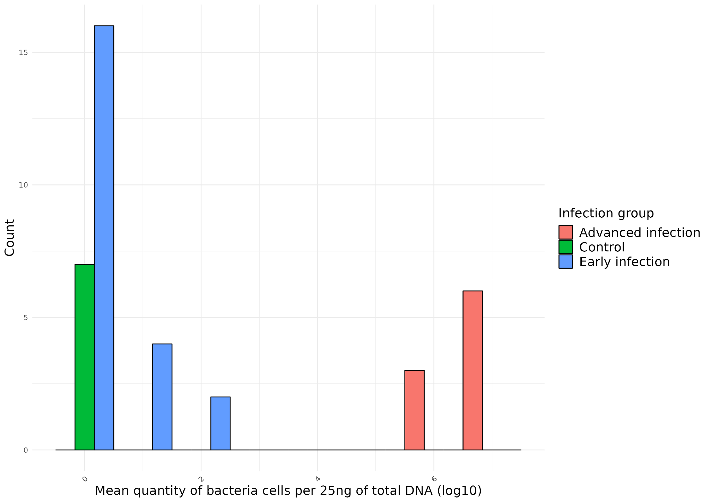

*Figure A: Histogram of bacteria quantity (log10) measured by qPCR by group. All individuals from the control group have a null level of bacteria cells. Individuals from the early infection group range from 0 to 2.9 with most of the samples expressing a level of bacterial infection equal to 0. The level of bacterial infection in the advanced infection group ranged from 1.19 to 17.81. The mean from the control and early infection groups are not significantly different while the mean of the advanced infection group was significantly different from the two other groups (Dunn’s test - p-value < 0.05).*

*Table 3: Supplementary information*

|  |  |  |  |  |  |  |  |  |  |  |
| --- | --- | --- | --- | --- | --- | --- | --- | --- | --- | --- |
| Sample | Code image | Original image | Image with IHC stain bacteria detected | Treatment | Infection status | Mean bacterial quantity (log10) / (sd) | Proportion of tissue infected by IHC-stained bacteria (%) | Colocalization coefficient (Pearson’s correlation value) | Dispersion coefficient (t-test value) | MNN distance value (µm) |
| 16045-1-101002 | I_J1_1 |  |  | Infected J1 | Early infection | 0 (0) | 2.86e-03 | 0.001 | 79.60 | 1681.38 |
| 16045-2-16110141B00901002 | I_J1_2 |  |  | Infected J1 | Early infection | 0 (0) | 2.53e-02 | 0.003 | 128.67 | 189.19 |
| 16045-3-16110141B01001002 | I_J1_3 |  |  | Infected J1 | Early infection | 0 (0) | 1.48e-02 | 0.002 | 86.016 | 766.06 |
| 16045-4-201002 | I_J1_4 |  |  | Infected J1 | Early infection | 2.20 (3.559820e+02) | 1.51e-04 | -0.001 | 77.087 | 3026.11 |
| 16045-5-16110141B01101002 | I_J1_5 |  |  | Infected J1 | Early infection | 0.30 (4.472136e+00) | 4.28e-02 | 0.012 | 137.36 | 154.90 |
| 16045-6-301002 | I_J1_6 |  |  | Infected J1 | Early infection | 0 (0) | 6.54e-05 | 0 | NA | 8342.25 |
| 16045-8-16110141B01201002 | I_J1_8 |  |  | Infected J1 | Early infection | 0 (0) | 2.65e-02 | 0.009 | 149.33 | 206.28 |
| 16045-9-16110141B01301002 | I_J1_9 |  |  | Infected J1 | Early infection | 0 (0) | 3.24e-05 | -0.005 | NA | 3465.50 |
| 16045-10-16110141B01401002 | I_J1_10 |  |  | Infected J1 | Early infection | 0 (0) | 7.73e-05 | 0 | NA | 5748.03 |
| 16045-11-16110141B01501002 | I_J1_11 |  |  | Infected J1 | Early infection | 0 (0) | 2.40e-04 | 0.001 | NA | 3267.29 |
| 16045-13-601002 | I_J1_12 |  |  | Infected J1 | Early infection | 2.11 (2.884528e+02) | 1.25e-04 | 0 | NA | 3166.51 |
| 16045-14-16110141B01601002 | I_J1_13 |  |  | Infected J1 | Early infection | 1.48 (6.209026e+01) | 3.78e-03 | -0.002 | 91.80 | 932.47 |
| 64852 | I_J1_14 |  |  | Infected J1 | Early infection | 0.30 (4.472136e+00) | 1.00e-02 | -0.006 | 147.67 | 250.72 |
| 64853 | I_J1_15 |  |  | Infected J1 | Early infection | 0 (0) | 3.96e-04 | 0 | NA | 1243.77 |
| 16045-16-701002 | I_J4_1 |  |  | Infected J4 | Early infection | 0.83 (1.520526e+01) | 8.32e-02 | 0.013 | 182.89 | 135.35 |
| 16045-17-801002 | I_J4_2 |  |  | Infected J4 | Early infection | 0.96 (1.559487e+01) | 4.92e-02 | 0.011 | 149.59 | 265.76 |
| 16045-18-901002 | I_J4_3 |  |  | Infected J4 | Early infection | 0 (0) | 1.07e-01 | 0.019 | 194.40 | 89.01 |
| 16045-19-1001002 | I_J4_4 |  |  | Infected J4 | Early infection | 1.25 (4.024922e+01) | 2.43e-02 | 0.008 | 150.49 | 172.74 |
| 16045-20-1101002 | I_J4_5 |  |  | Infected J4 | Early infection | 0.34 (4.919350e+00) | 1.25e-01 | 0.022 | 194.69 | 89.50 |
| 16045-21-1201002 | I_J4_6 |  |  | Infected J4 | Early infection | 0 (0) | 1.56e-02 | 0.005 | 111.73 | 162.54 |
| 16045-22-16110141B01701002 | I_J4_7 |  |  | Infected J4 | Early infection | 0.38 (5.366563e+00) | 4.06e-05 | 0 | NA | 2789.74 |
| 16045-23-16110141B01801002 | I_J4_8 |  |  | Infected J4 | Early infection | 0 (4.472136e-01) | 1.60e-04 | 0 | NA | 5256.96 |
| 16045-24-16110141B01901002 | I_J4_9 |  |  | Infected J4 | Advanced infection | 6.93 (4.899656e+06) | 5.74 | 0.267 | 360.66 | 52.93 |
| 16045-25-1301002 | I_J4_10 |  |  | Infected J4 | Advanced infection | 7.15 (9.153557e+06) | 6.76 | 0.305 | 448.62 | 52.23 |
| 16045-28-16110141B02001002 | I_J4_11 |  |  | Infected J4 | Advanced infection | 7.13 (2.617816e+07) | 3.17 | 0.206 | 318.66 | 64.79 |
| 16045-29-16110141B02101002 | I_J4_12 |  |  | Infected J4 | Advanced infection | 6.92 (1.144631e+07) | 1.86 | 0.143 | 281.03 | 62.83 |
| 16045-31-16110141B02201002 | I_J4_13 |  |  | Infected J4 | Advanced infection | 6.39 (2.441083e+06) | 1.29 | 0.157 | 435.73 | 54.39 |
| 16045-32-1701002 | I_J4_14 |  |  | Infected J4 | Advanced infection | 6.01 (1.271880e+06) | 8.36 | 0.322 | 475.14 | 46.81 |
| 64854 | I_J4_15 |  |  | Infected J4 | Advanced infection | 7.12 (1.154655e+07) | 2.17 | 0.163 | 364.20 | 60.30 |
| 64856 | I_J4_16 |  |  | Infected J4 | Advanced infection | 7.09 (8.058702e+06) | 5.31e-01 | 0.074 | 293.61 | 63.33 |
| 64857 | I_J4_17 |  |  | Infected J4 | Advanced infection | 6.38 (4.098913e+06) | 8.77 | 0.356 | 548.69 | 47.50 |
| 16049-2-3101002 | C_J1_1 |  |  | Control J1 | Control | 0 (0) | 1.01e-02 | 0.002 | 96.65 | 570.50 |
| 16049-3-3201002 | C_J1_2 |  |  | Control J1 | Control | 0 (0) | 5.76e-02 | 0.011 | 169.94 | 123.97 |
| 16049-5-16110141B00201002 | C_J1_3 |  |  | Control J1 | Control | 0 (0) | 9.10e-04 | 0 | NA | 8862.10 |
| 16049-6-3301002 | C_J4_1 |  |  | Control J4 | Control | 0 (0) | 1.11e-01 | 0.016 | 155.01 | 82.49 |
| 16049-7-16110141B00301002 | C_J4_2 |  |  | Control J4 | Control | 0 (0) | 2.77e-02 | 0.006 | 134.66 | 243.27 |
| 16049-8-3401002 | C_J4_3 |  |  | Control J4 | Control | 0 (0) | 1.07e-01 | 0.021 | 198.75 | 92.49 |
| 16049-10-16110141B00401002 | C_J4_4 |  |  | Control J4 | Control | 0 (0) | 1.17e-02 | 0 | 96.75 | 712.53 |