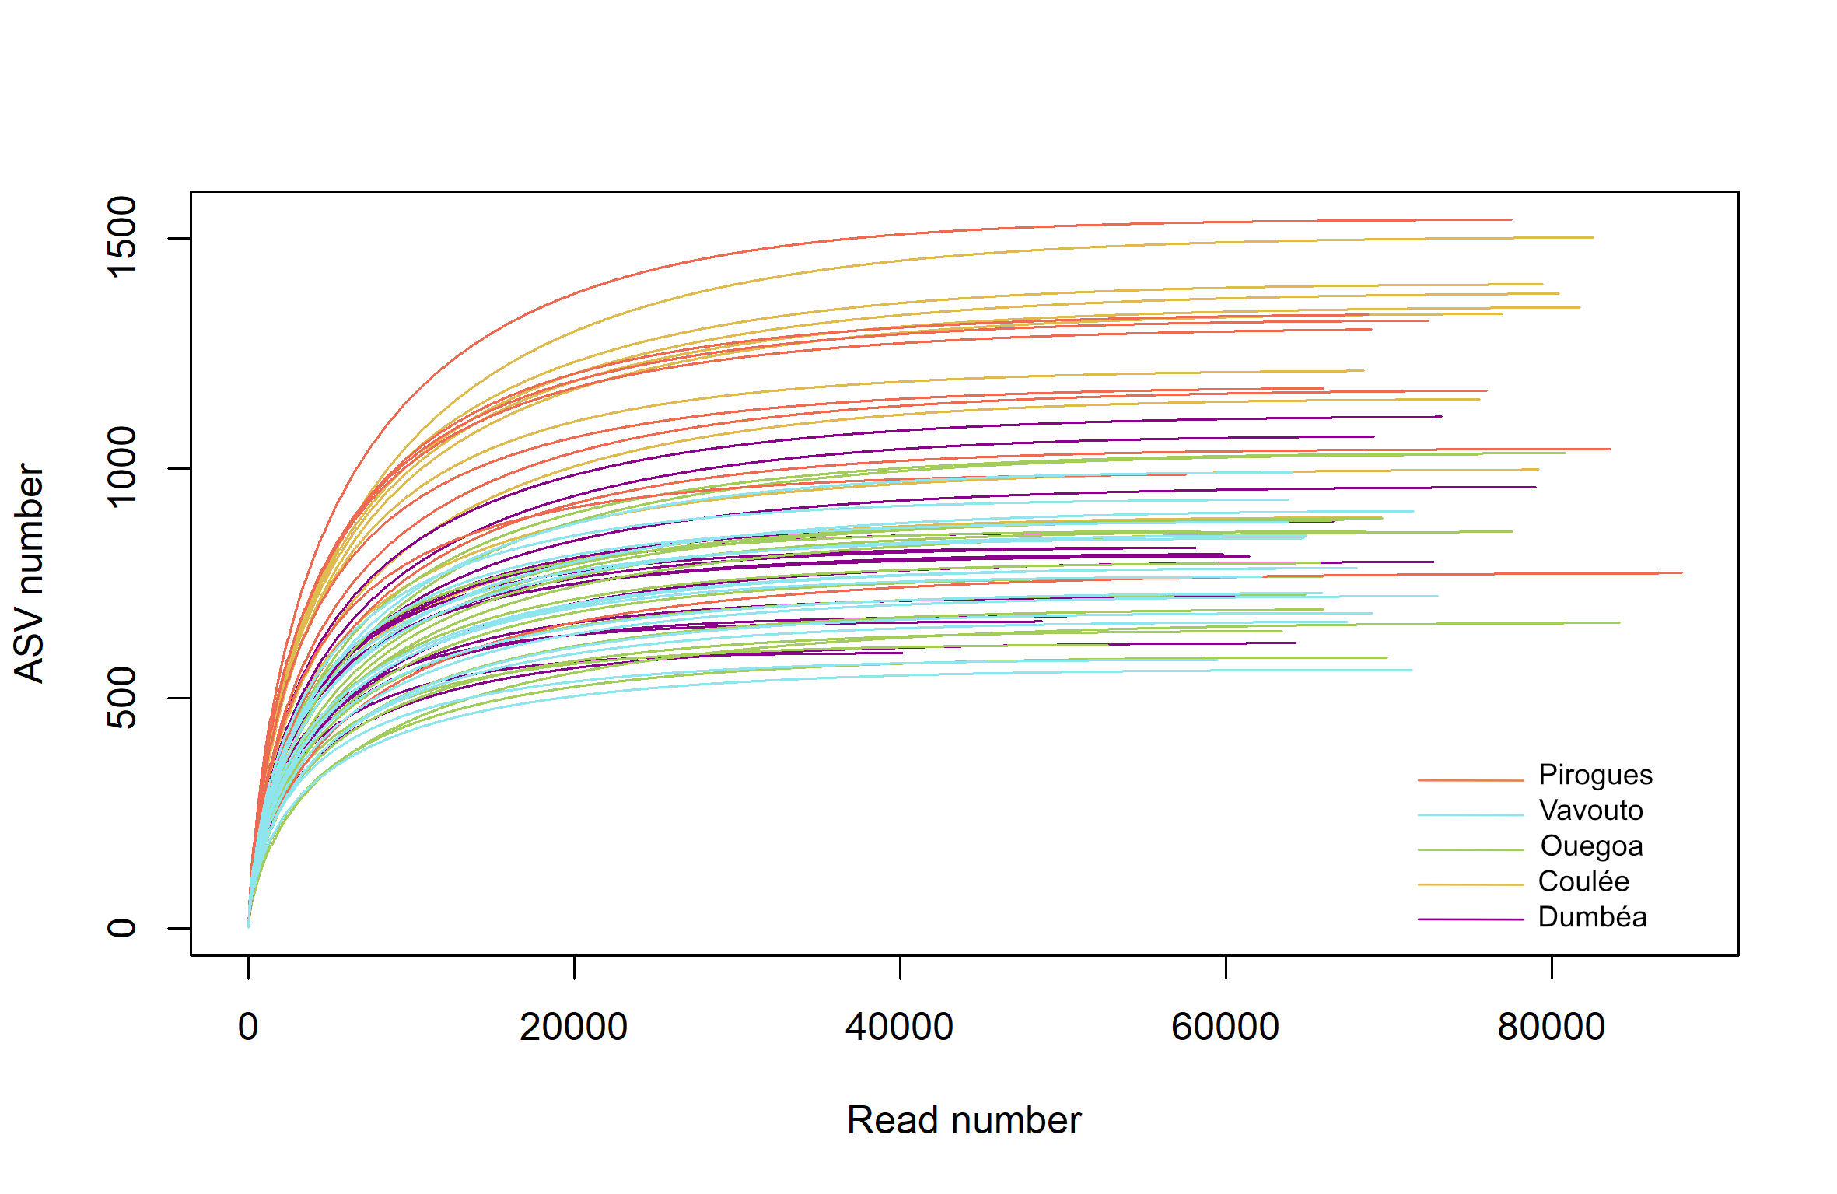

**Fig. S1:** ASV number in function of the read number of each sample after bioinformatics treatment.

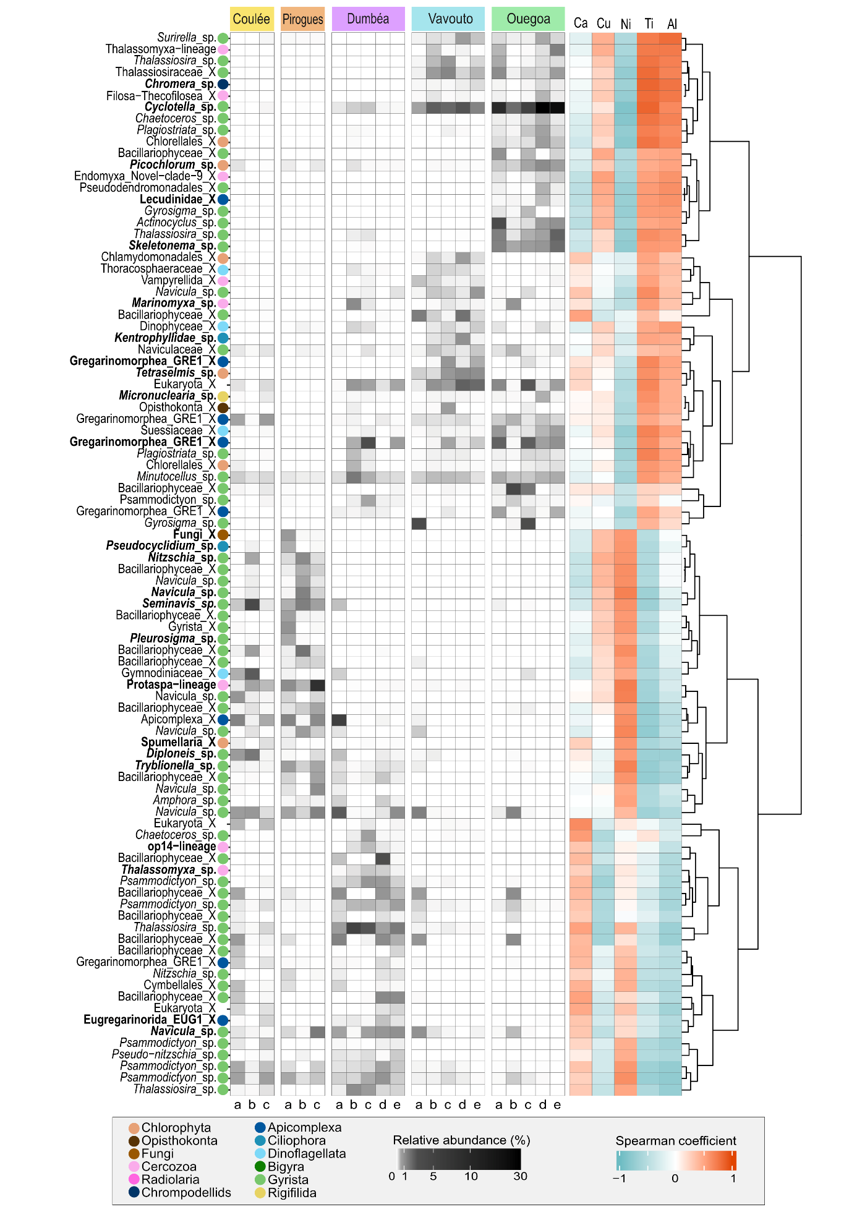

**Fig. S2:** Mean relative abundance per station of the 92 selected ASVs ordered according to a clustering based on their correlation with metal concentrations.

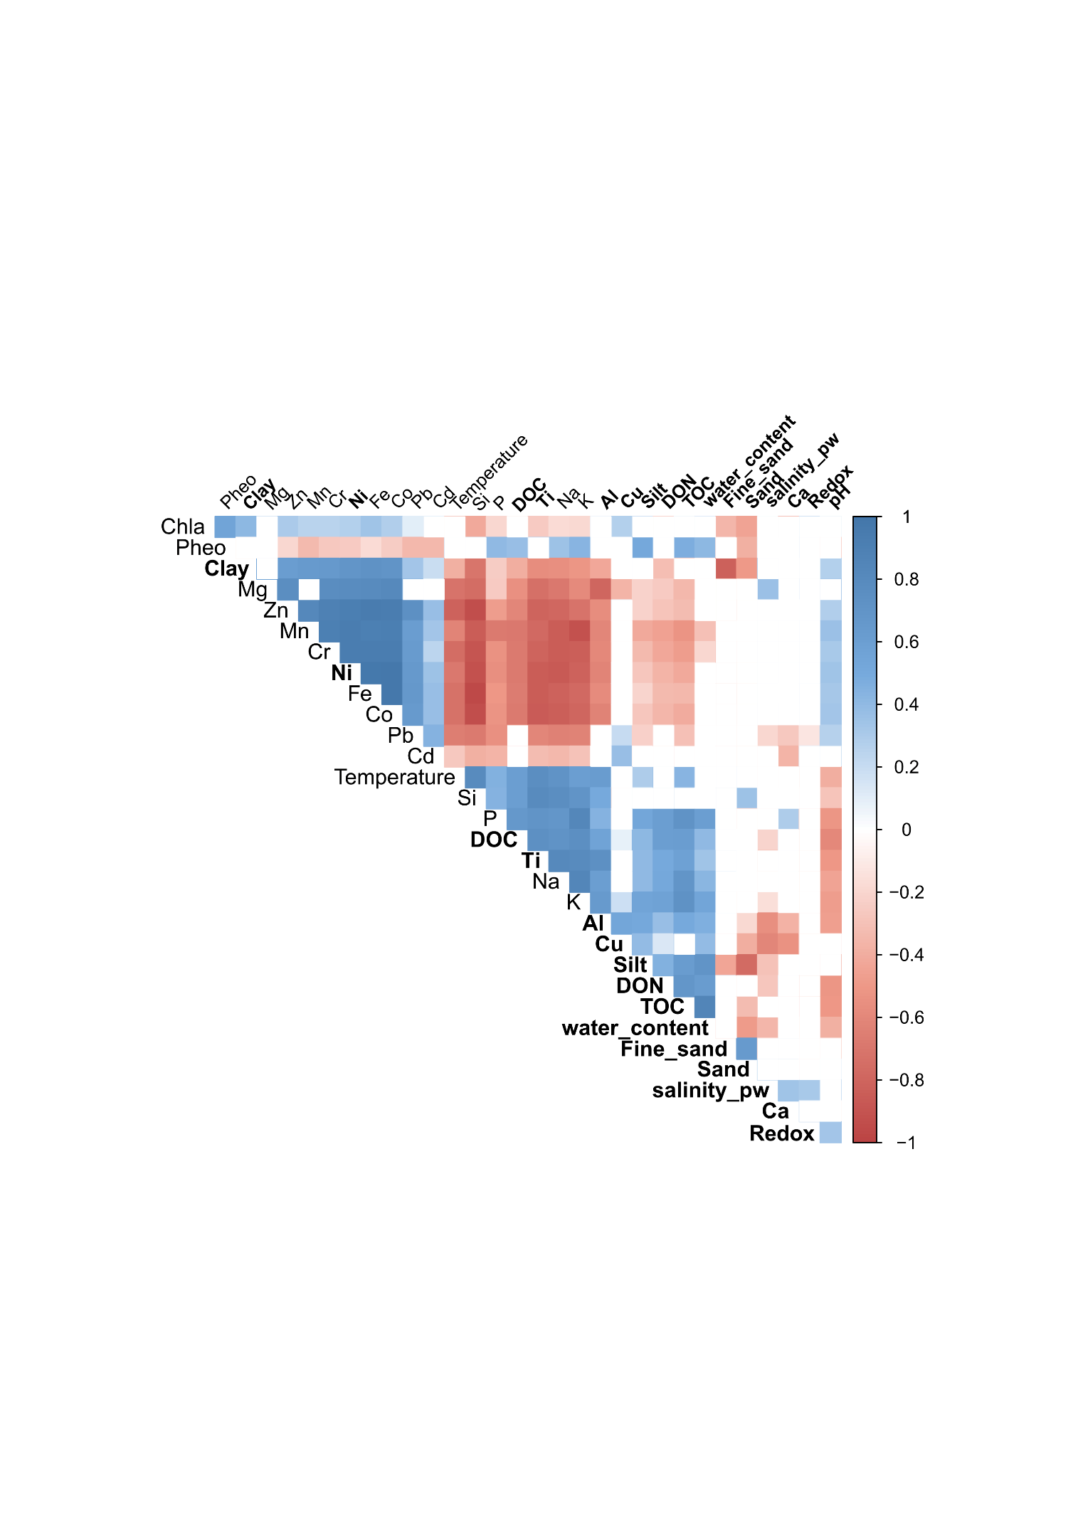

**Fig. S3:** Spearman correlation matrix between 31 environmental parameters measured. Non-significant (p-value >0.05) correlations are hidden with a white box. The 16 chosen parameters are specified in bold.

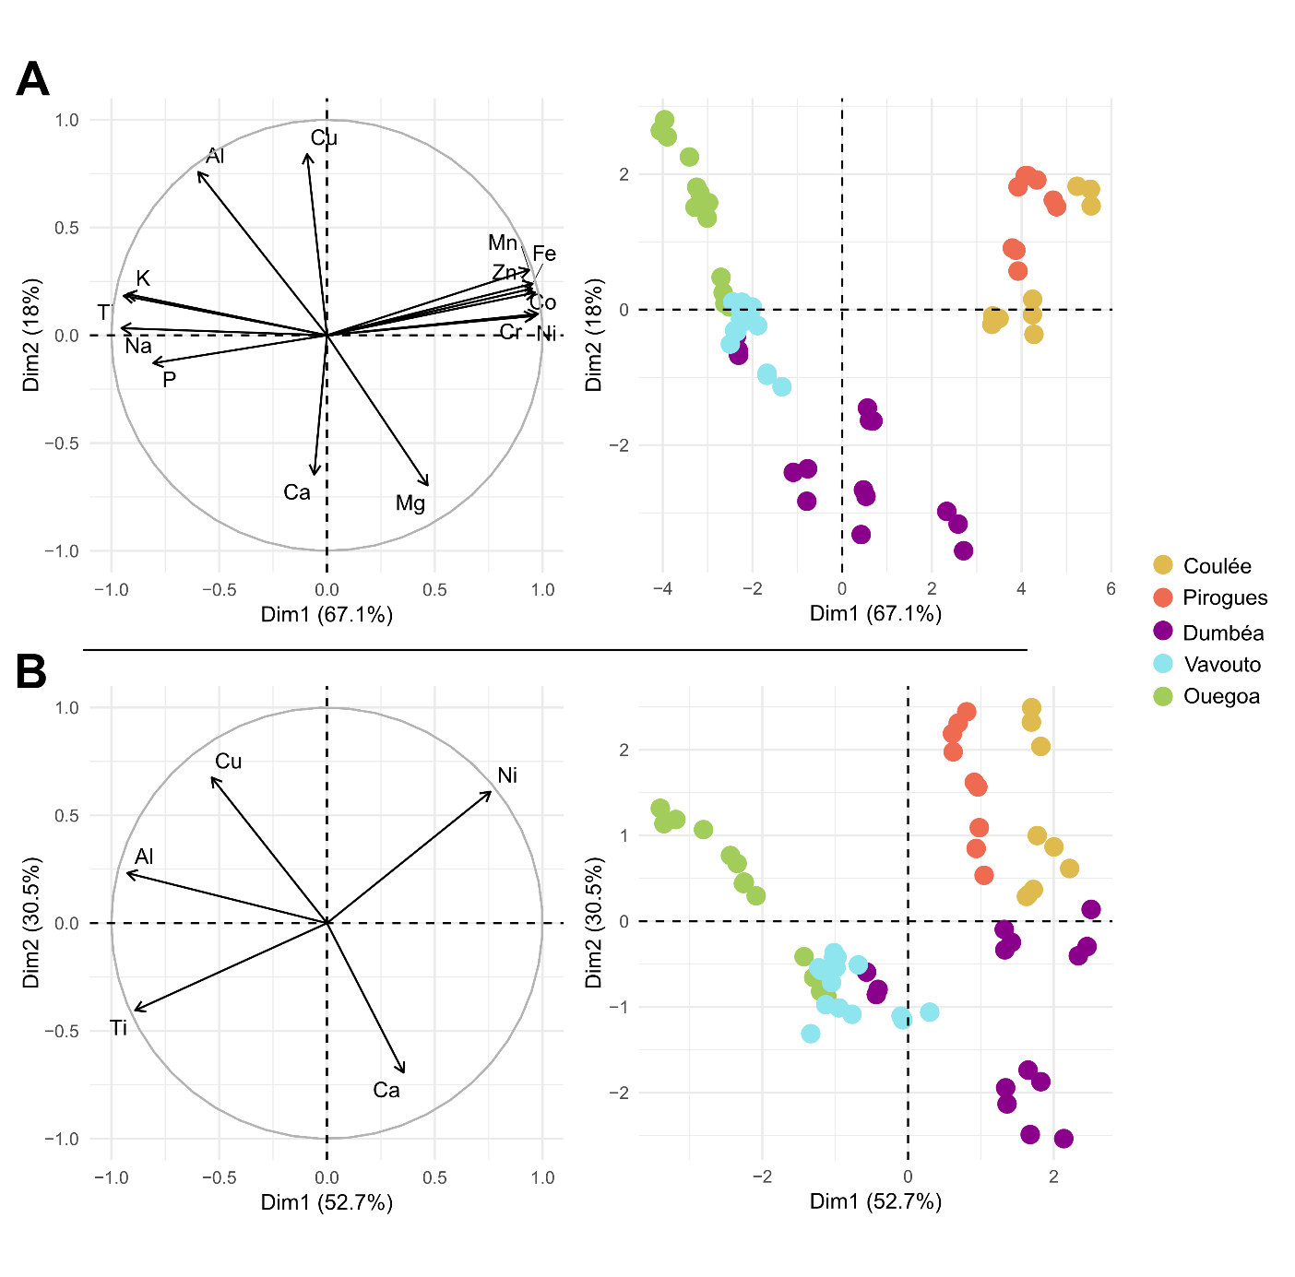**Fig. S4:** Principal component analyses (A) of the 17 measured metal concentrations and (B) of the chosen five metal concentrations

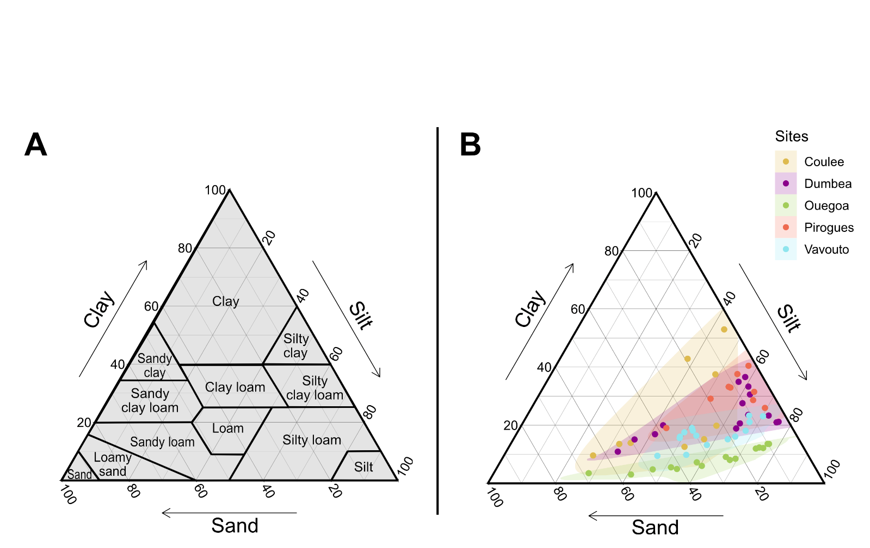.

**Figure S5:** (A) Textural soil classification (USDA, 1987) and (B) proportion of Clay (0-3.9 µm), Silt (3.9-63 µm) and Sand (63-2000µm, gathering Fine_sand and Sand size fraction from Table 2) in our 63 sediment samples.

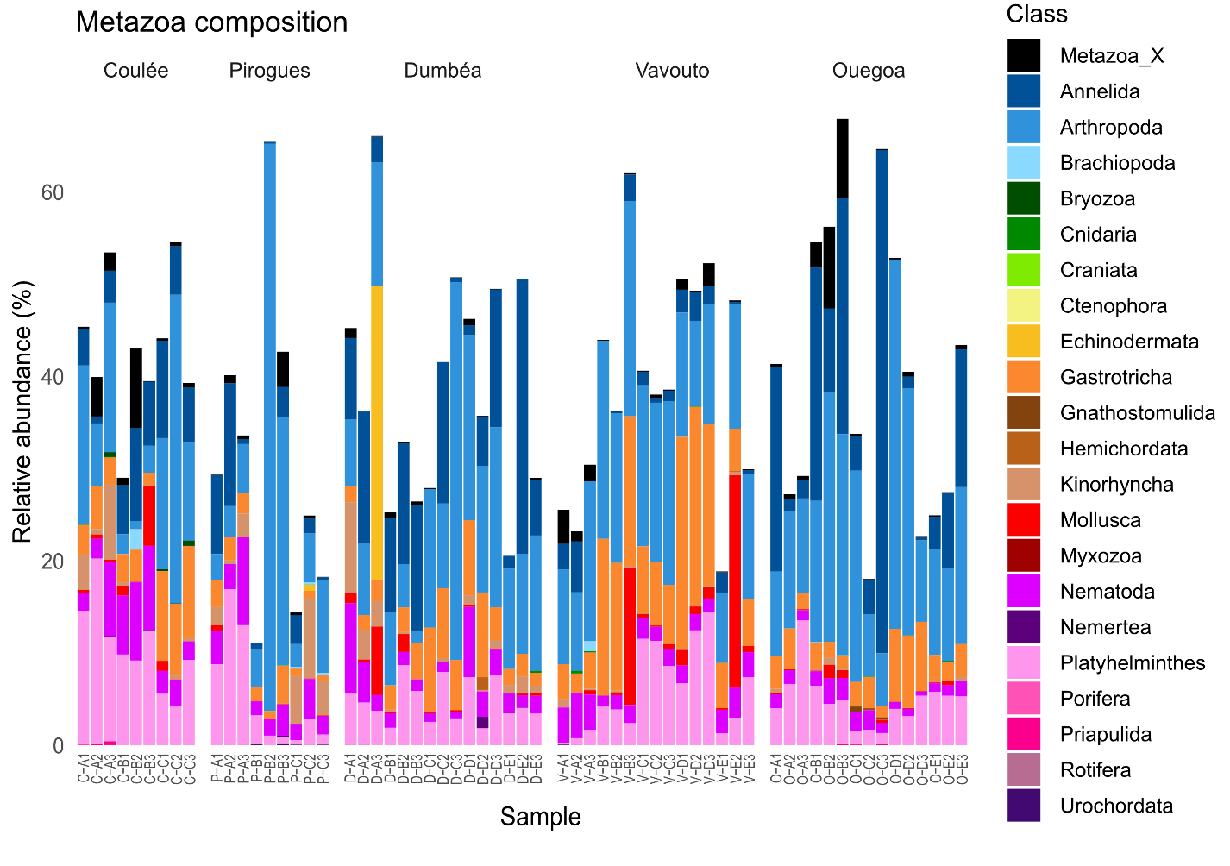

**Fig. S6:** Composition at the Class level of the removed Subdivision Metazoa (666 ASVs).

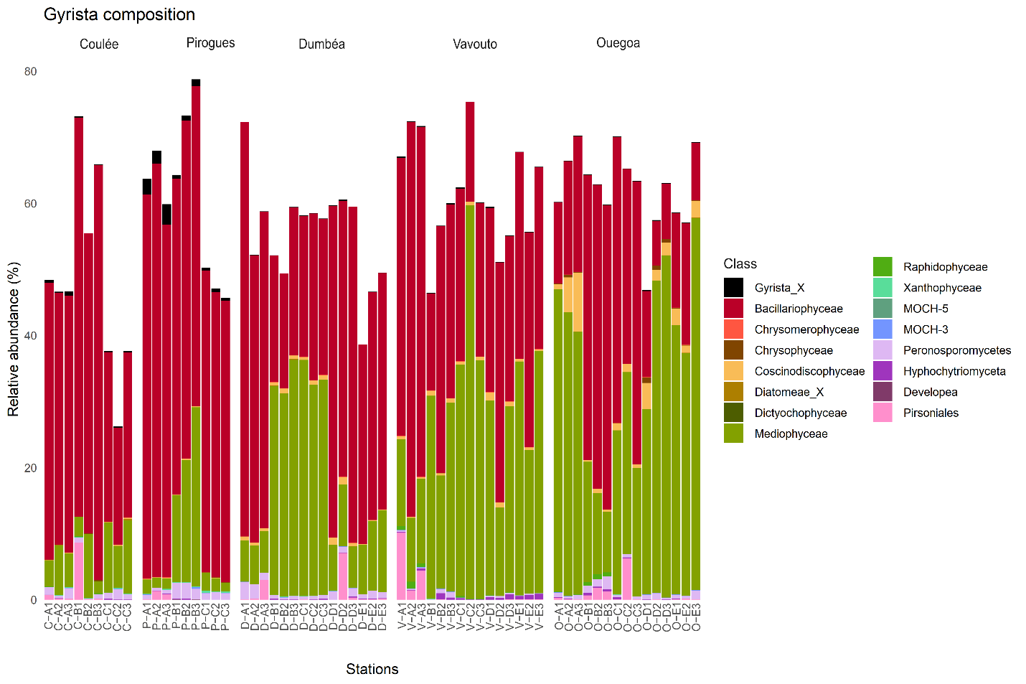

**Fig. S7:** Composition at the Class level of the Subdivision Gyrista (1528 ASVs).

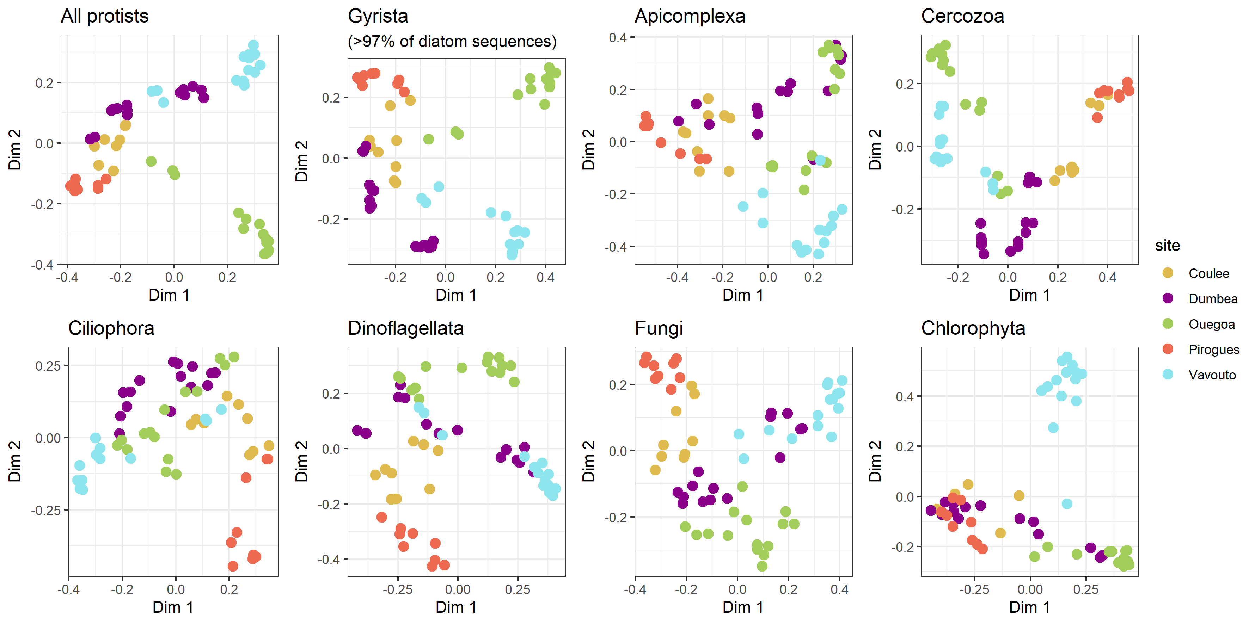

**Fig. S8:** Principal Coordinate Analysis (PCoA) based of amplicon sequencing data on of different protist subdivisions communities.

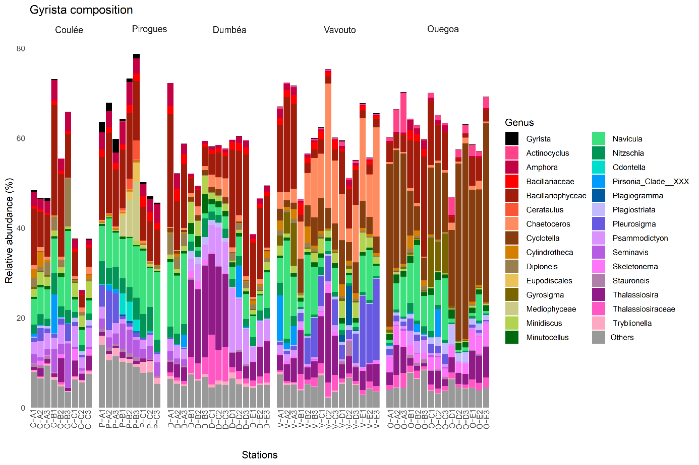**Fig. S9:** Composition of 1528 ASVs assigned to Gyrista (for genera > 2% in at least one sample, the rest of the genera are gathered in the “Others” category)

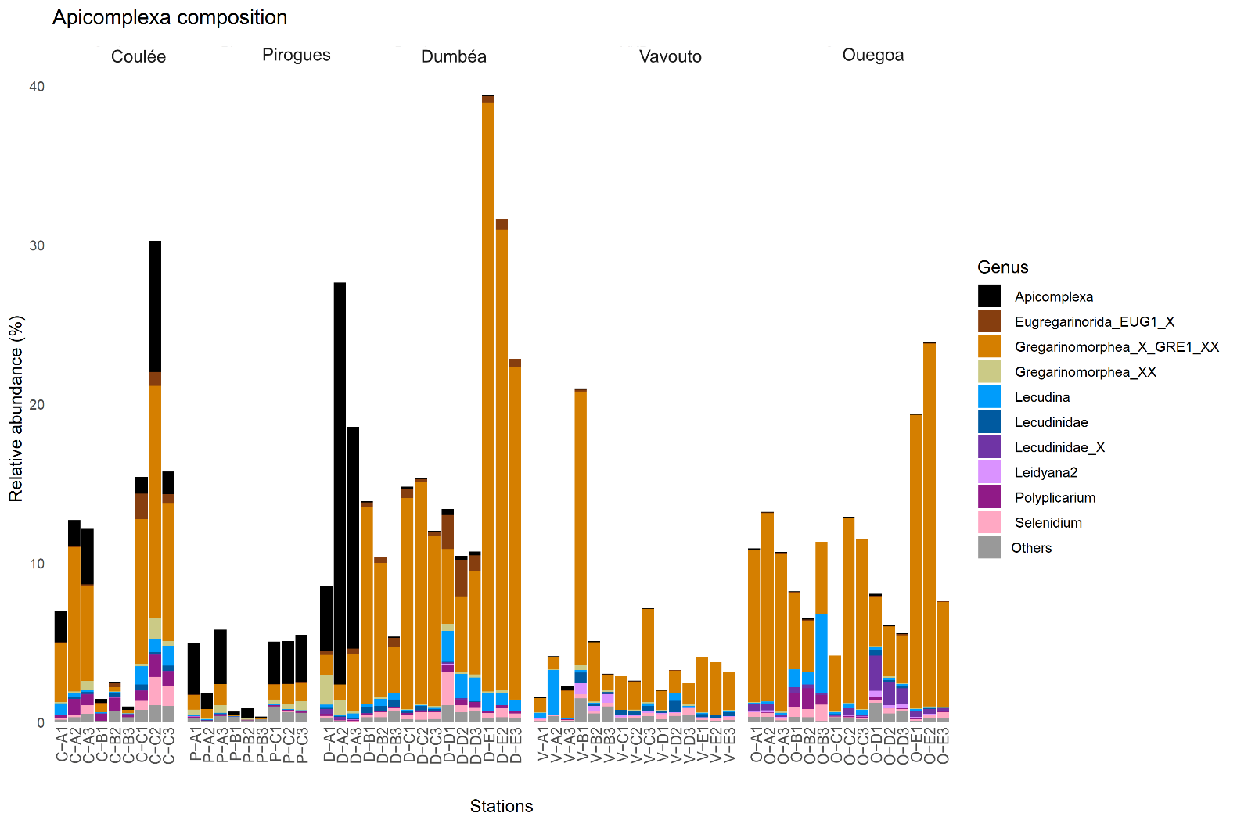

**Fig. S10:** Composition of 292 ASVs assigned to Apicomplexa (for genera > 0.5% in at least one sample, the rest of the genera are gathered in the “Others” category)

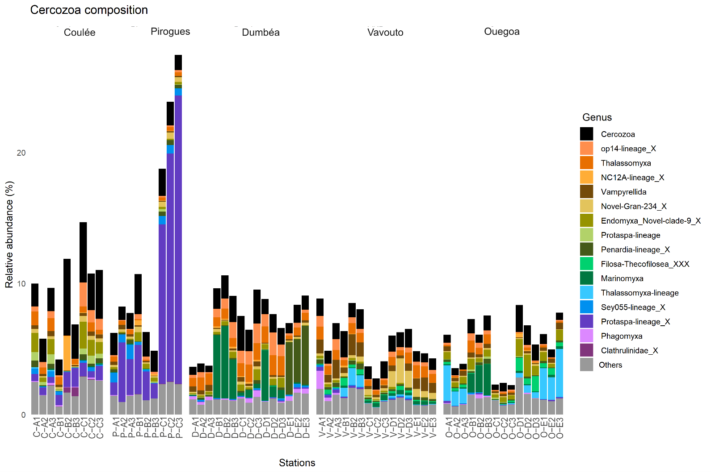**Fig. S11:** Composition of 1171 ASVs assigned to Cercozoa (for genera > 0.5% in at least one sample, the rest of the genera are gathered in the “Others” category)

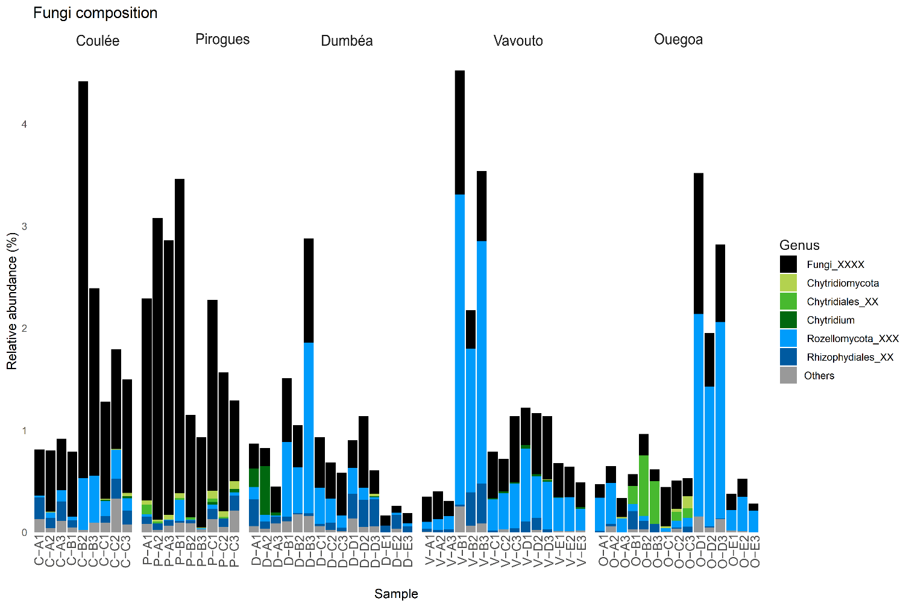**Fig. S12:** Composition of 412 ASVs assigned to Fungi (for genera > 0.1% in at least one sample, the rest of the genera are gathered in the “Others” category)

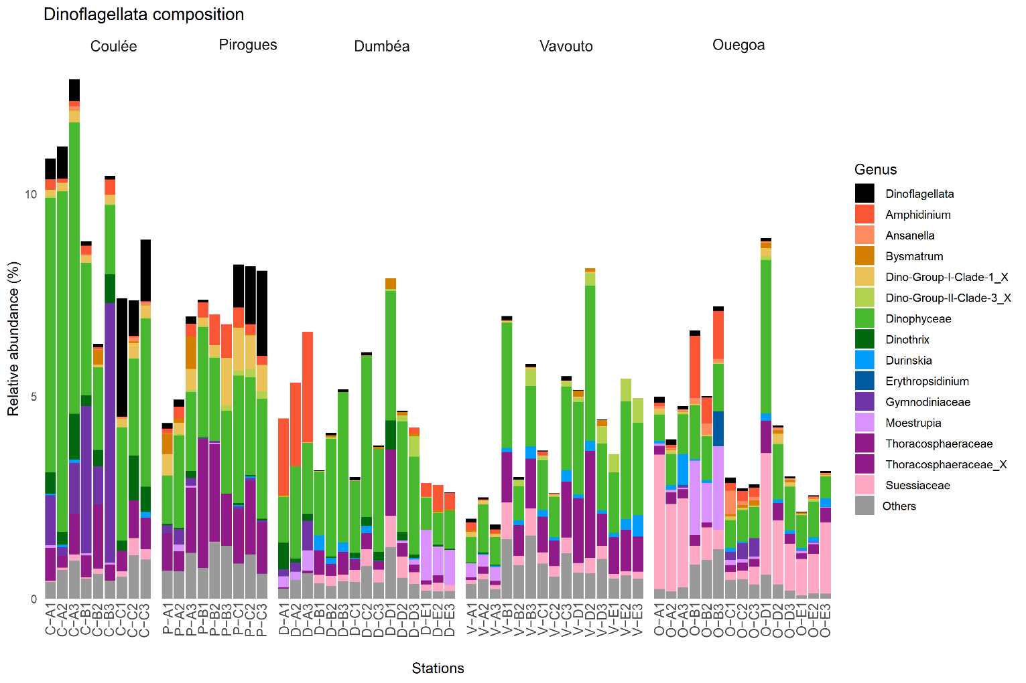

**Fig. S13:** Composition of the 392 ASVs assigned to Dinoflagellata (for genera > 0.5% in at least one sample, the rest of the genera are gathered in the “Others” category)

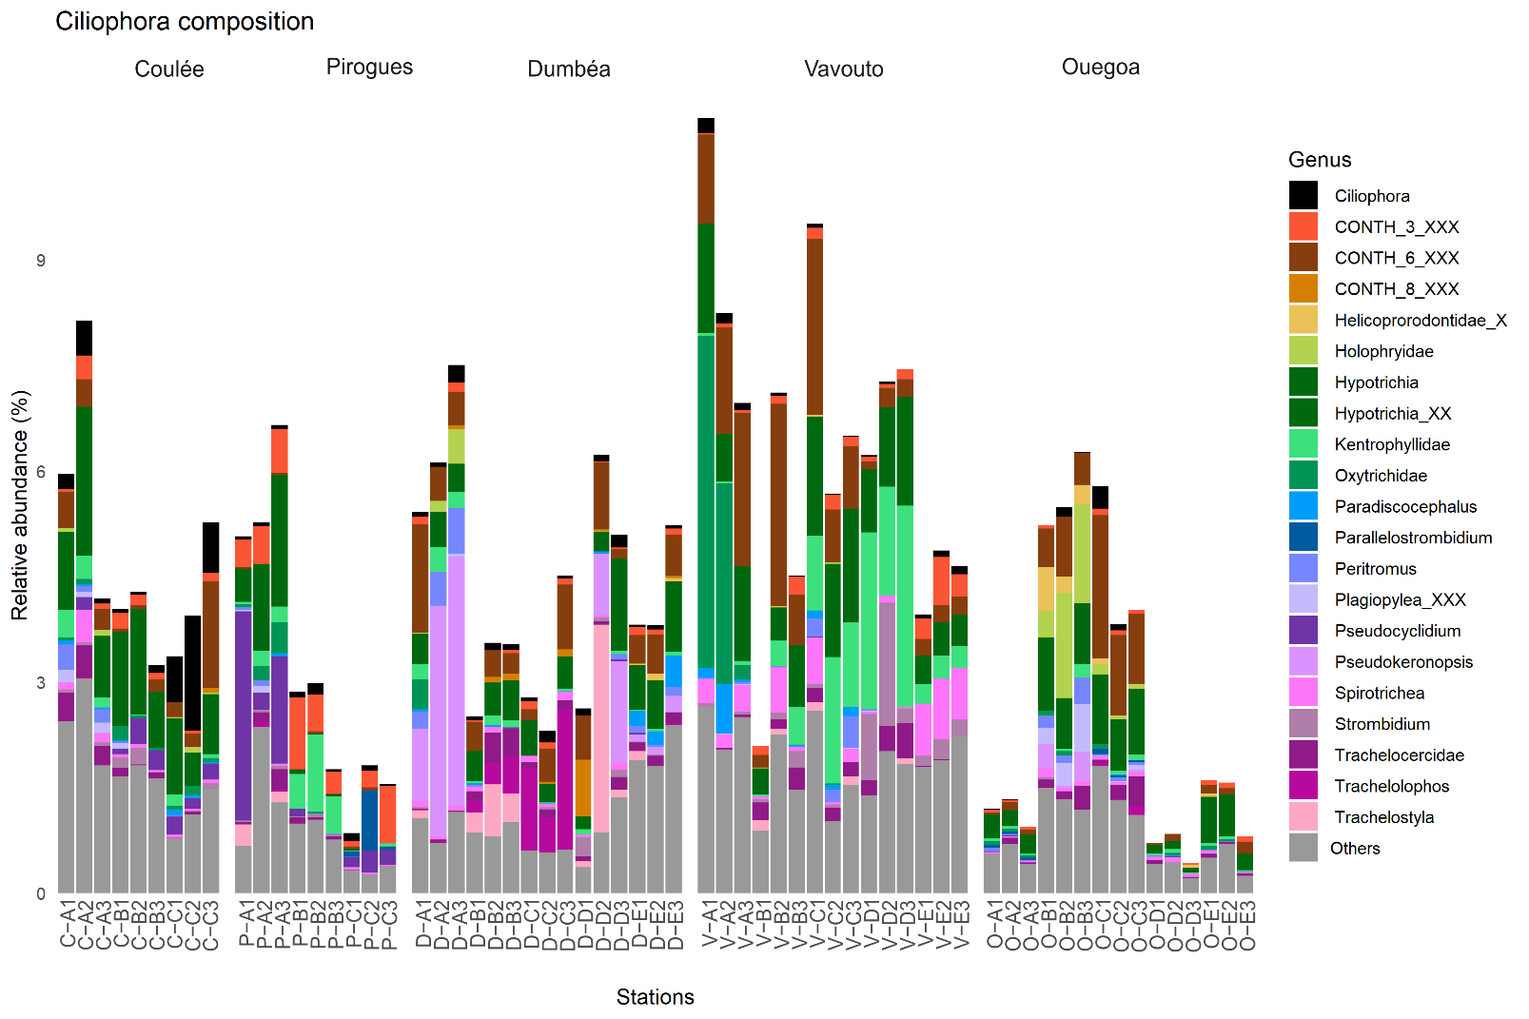**Fig. S14:** Composition of the 587 ASVs assigned to Ciliophora (for genera > 0.5% in at least one sample, the rest of the genera are gathered in the “Others” category)

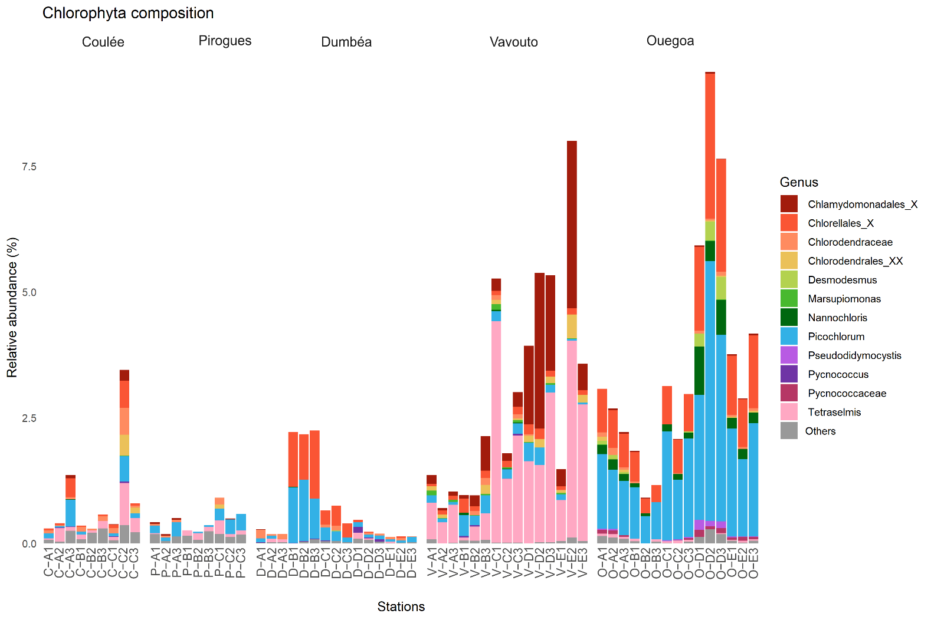**Fig. S15:** Composition of the 71 ASVs assigned to Chlorophyta at the genera level (for species > 0.1% in at least one sample, the rest of the genera are gathered in the “Others” category)

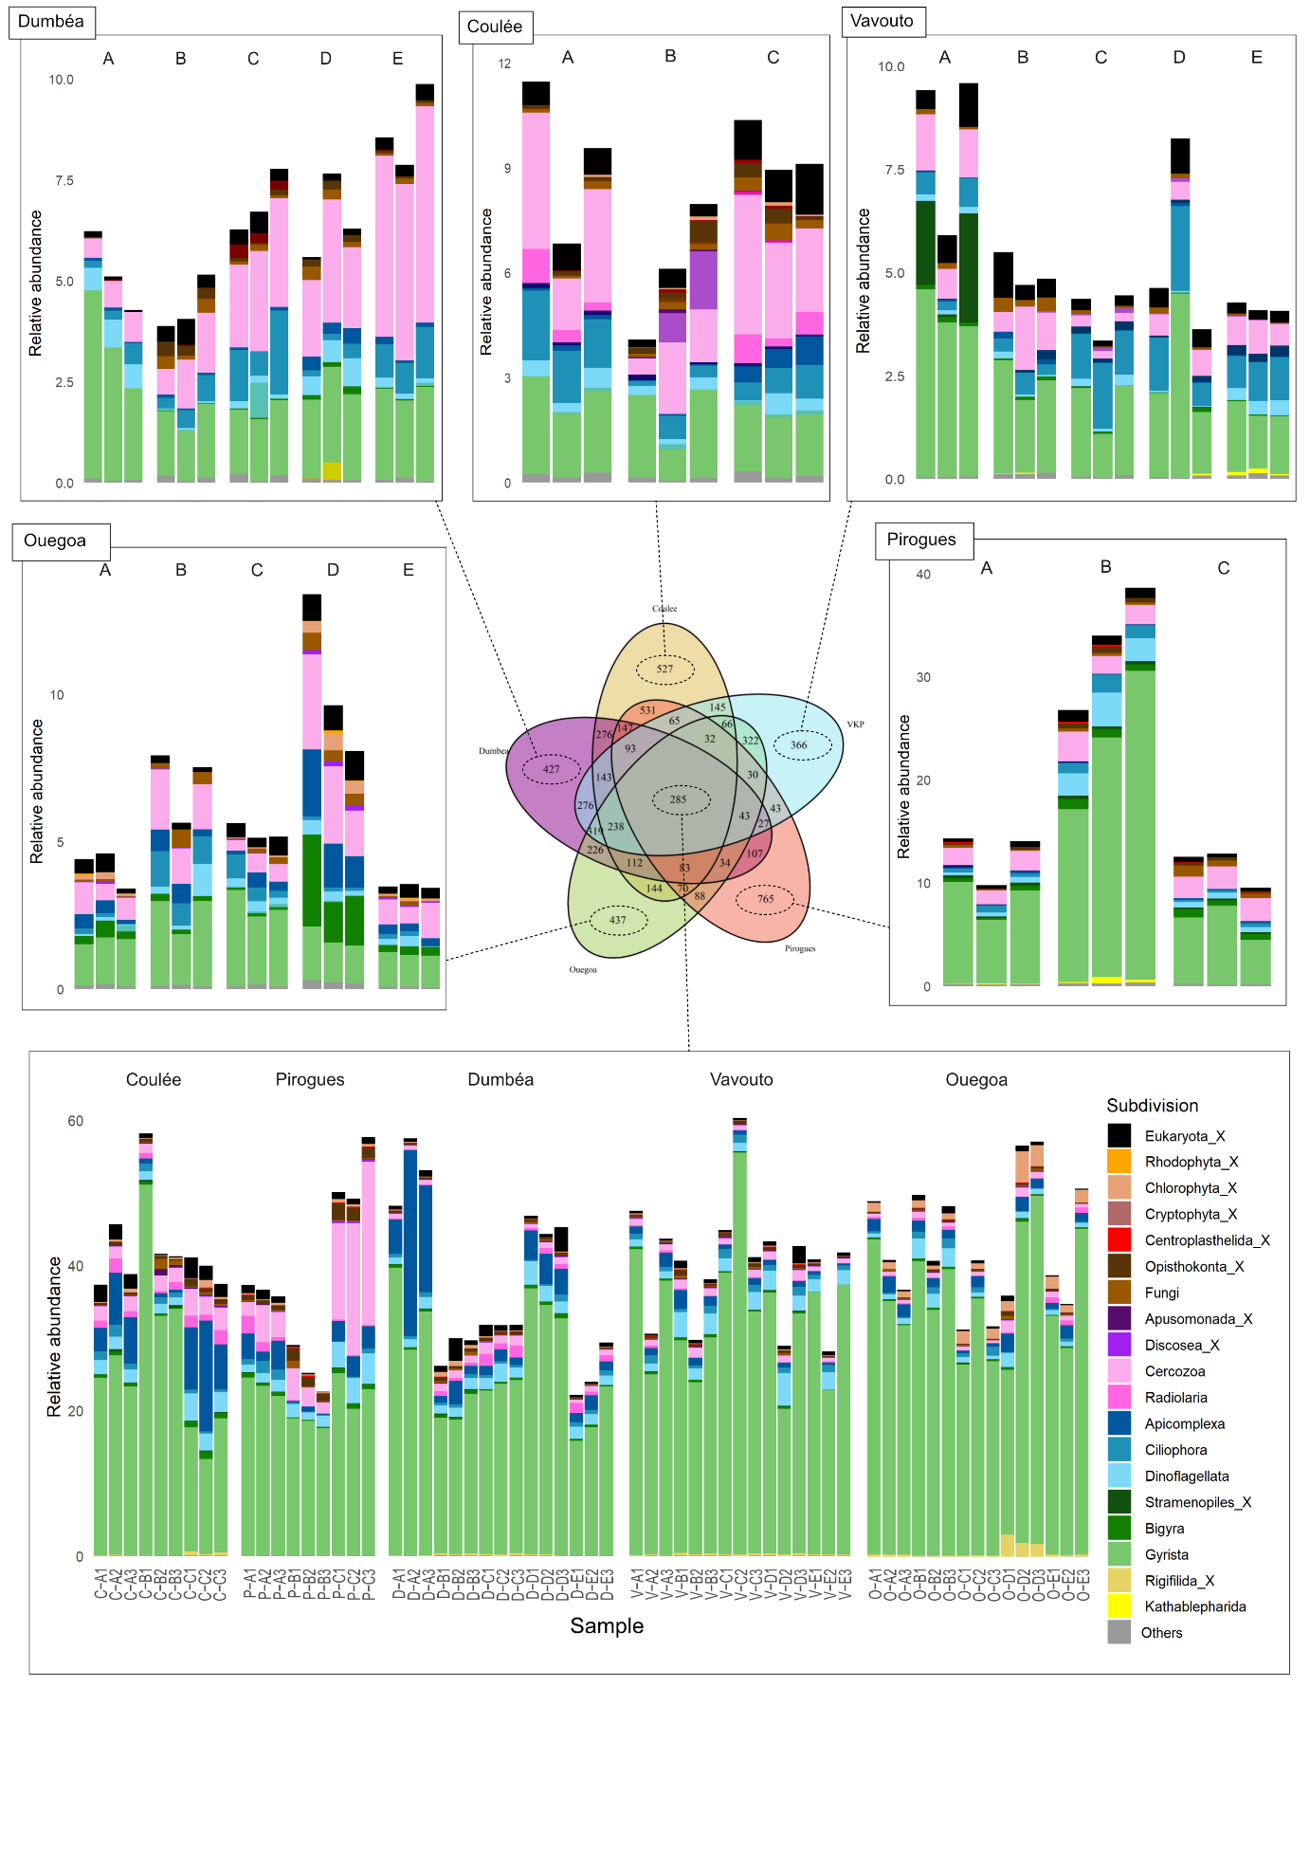**Fig. S16:** Composition of specific and common ASVs among our study sites.

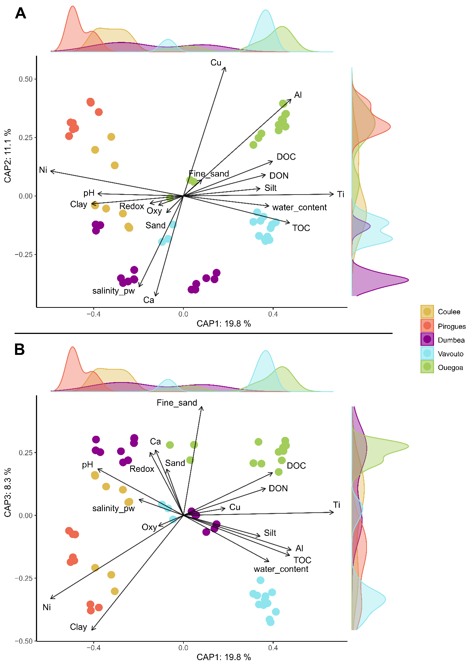

**Fig. S17:** Distanced-based redundancy analyses based on protist distribution calculated with Bray-Curtis dissimilarity constrained with 16 environmental parameters (A: dimension 1 and 2, B: Dimension 1 and 3).