Appendix

- Table A1: List of breeding seabird species from New Caledonia
- Table A2: List of study sites
- Figure A3 : Detailed maps of study sites
- Table A4: data sources for seabird census data and information on invasive rodents
- Table A5: Illustrated list of breeding habitats.
- Table A6: Habitat use per species
- Figure A7: Steps for the characterization of seabird breeding habitat on coral reef islets using high-resolution aerial imagery.
- Table A8: List of 5 original habitat variables, 32 original geography variables and 7 original human variables prior to principal component or multifactorial analysis.
- Figure A9: Pearson’s correlation coefficient measured between PCA (Habitat, Geography) or MFA (Human visitation) axes and original quantitative variables.
- Figure A10: Boxplot of MFA coordinates per category of tourism-related land use and type of terrestrial reserve.
- Figure A11: Cumulative AICc weights of evaluated predictors.
- Figure A12. A: Number of CRIs for each value of species richness and number of breeding sites per species.
- Figure A13: Surface and relative proportion of the original 9 categories of breeding habitat

Table A1: List of breeding seabird species from New Caledonia
Order | Family | Name | Common name | RedList status | Local breeding on CRI
Charadriiformes | Laridae | Anous albivittus | Grey noddy | LC | -
 |  | Anous minutus | Black noddy | LC | Confirmed
 |  | Anous stolidus | Brown noddy | LC | Confirmed
 |  | Gygis alba | White tern | LC | -
 |  | Larus novaehollandiae | Silver gull | LC | Confirmed
 |  | Onychoprion anaethetus | Bridled tern | LC | Confirmed
 |  | Onychoprion fuscatus | Sooty tern | LC | Confirmed
 |  | Sterna dougallii | Roseate tern | LC | Confirmed
 |  | Sterna sumatrana | Black-naped tern | LC | Confirmed
 |  | Sternula nereis | Fairy tern | VU | Confirmed
 |  | Thalasseus bergii | Greater-crested tern | LC | Confirmed
Phaethontiformes | Phaethontidae | Phaethon rubricauda | Red-tailed tropicbird | LC | Confirmed
 |  | Phaethon lepturus | White-tailed tropicbird | LC | -
Procellariiformes | Oceanitidae | Fregetta lineata | New Caledonian storm petrel | DD | -
 |  | Nesofregetta fuliginosa | Polynesian storm petrel | LC | -
 | Procellariidae | Ardenna pacifica | Wedge-tailed shearwater | LC | Confirmed
 |  | Pseudobulweria rostrata | Tahiti petrel | NT | Confirmed
 |  | Pterodroma heraldica | Herald petrel | LC | Suspected
 |  | Pterodroma leucoptera | Gould's petrel | VU | Confirmed
 |  | Pterodroma nigripennis | Black-winged petrel | LC | Confirmed
Suliformes | Fregatidae | Fregata ariel | Lesser frigatebird | LC | Confirmed
 |  | Fregata minor | Great frigatebird | LC | Confirmed
 | Phalacrocoracidae | Microcarbo melanoleucos | Little pied cormorant | LC | -
 |  | Phalacrocorax carbo | Great cormorant | LC | -
 | Sulidae | Sula dactylatra | Masked booby | LC | Confirmed
 |  | Sula leucogaster | Brown booby | LC | Confirmed
 |  | Sula sula | Red-footed booby | LC | Confirmed
Source: Spaggiari et al., 2006, Bretagnolle et al., 2022, this study, BirdLife 2023.

Table A2: List of study sites
Subregion | Site | X | Y | Surface (m²) | Source | Date
Chesterfield | Avon Nord | 158.250042 | -19.511133 | 33758 | ESRI | 2021
 | Avon Sud | 158.237024 | -19.531058 | 25338 | ESRI | 2021
 | Bampton | 158.603516 | -19.121937 | 42847 | Google Earth | 2019
 | Caye du Nord-Est | 158.462376 | -19.868589 | 1659 | Google Earth | 2019
 | Caye du Sud-Est | 158.479246 | -19.910117 | 111 | Google Earth | 2019
 | Caye n°1 | 158.384115 | -19.912565 | 337 | Google Earth | 2019
 | Caye n°10 | 158.457186 | -19.961416 | 122 | Google Earth | 2019
 | Caye n°2 | 158.39529 | -19.918696 | 1340 | Google Earth | 2019
 | Caye n°3 | 158.397892 | -19.920853 | 7389 | Google Earth | 2019
 | Caye n°4 | 158.407751 | -19.925549 | 3692 | Google Earth | 2019
 | Caye n°5 | 158.411279 | -19.929018 | 1102 | Google Earth | 2019
 | Caye n°6 | 158.419093 | -19.931776 | 1250 | Google Earth | 2019
 | Caye n°7 | 158.423997 | -19.934606 | 3820 | Google Earth | 2019
 | Caye n°8 | 158.431084 | -19.939984 | 85 | Google Earth | 2019
 | Caye n°9 | 158.440756 | -19.947374 | 185 | Google Earth | 2019
 | Caye Ouest Bampton | 158.560325 | -19.122519 | 2941 | ESRI | 2021
 | Caye Sud Île Longue | 158.326348 | -19.884134 | 7031 | Google Earth | 2019
 | Caye Sud Reynard | 158.882397 | -19.440092 | 4154 | ESRI | 2021
 | Îlot du Mouillage 1 | 158.470046 | -19.88364 | 22786 | this study | 2022
 | Îlot du Mouillage 2 | 158.472396 | -19.889031 | 17562 | this study | 2022
 | Îlot du Mouillage 3 | 158.474715 | -19.894753 | 18543 | this study | 2022
 | Îlot du Mouillage 4 | 158.476682 | -19.900068 | 5314 | this study | 2022
 | Îlot du Nord-Est | 158.459015 | -19.859901 | 16892 | this study | 2022
 | Îlot du Passage | 158.380382 | -19.910874 | 74468 | Google Earth | 2019
 | Îlot du Sud-Est | 158.478413 | -19.906926 | 12593 | this study | 2022
 | Îlot Nord du Passage | 158.35919 | -19.90262 | 26163 | this study | 2022
 | Îlot Sud Île Longue | 158.33616 | -19.891211 | 20560 | this study | 2022
 | Longue | 158.310881 | -19.869295 | 246694 | this study | 2022
 | Loop | 158.476362 | -19.969085 | 59337 | this study | 2022
 | Reynard | 158.941347 | -19.214781 | 80472 | ESRI | 2021
 | Tortue | 158.331462 | -19.887831 | 11173 | this study | 2022
 | Totof | 158.467302 | -19.878156 | 2085 | Google Earth | 2019
Entrecasteaux | Fabre | 163.009809 | -18.294809 | 133709 | ESRI | 2022
 | Huon | 162.959106 | -18.039329 | 174686 | ESRI | 2021
 | Le Leizour | 163.042552 | -18.284372 | 180759 | ESRI | 2022
 | Surprise | 163.086052 | -18.481155 | 198666 | ESRI | 2021
South-western lagoon | Amédée | 166.468141 | -22.477448 | 54820 | ESRI | 2021
 | Gi | 166.851254 | -22.722562 | 71840 | this study | 2022
 | Iéroué | 166.827052 | -22.603514 | 53485 | this study | 2022
 | Koko | 166.932974 | -22.880821 | 19272 | this study | 2022
 | Kouaré | 166.801459 | -22.776876 | 54702 | this study | 2022
 | M'Bé | 166.561509 | -22.480926 | 11105 | ESRI | 2021
 | M'Boré | 166.916344 | -22.802889 | 9464 | this study | 2022
 | N'Da | 166.877939 | -22.846558 | 51124 | this study | 2022
 | N'Di | 166.851155 | -22.579629 | 775 | ESRI | 2022
 | N'Do | 166.968681 | -22.683851 | 51533 | this study | 2022
 | N'Gé | 166.850645 | -22.693315 | 49274 | this study | 2022
 | Noé | 166.822216 | -22.539441 | 37894 | this study | 2022
 | Petit Koko | 166.943937 | -22.858344 | 2034 | this study | 2022
 | Puemba | 166.829886 | -22.532206 | 72173 | this study | 2022
 | Pûmbo | 166.835734 | -22.520614 | 4143 | this study | 2022
 | Rédika | 166.611158 | -22.515772 | 100322 | this study | 2022
 | Téré | 166.847943 | -22.788756 | 19788 | this study | 2022
 | Totéa | 166.973669 | -22.720437 | 15433 | this study | 2022
 | Ua | 166.811835 | -22.708326 | 52940 | this study | 2022
 | Uatérembi | 166.811411 | -22.678919 | 71566 | this study | 2022
 | Uatio | 166.795599 | -22.710445 | 57589 | this study | 2022
 | Uié | 166.917203 | -22.722679 | 26329 | this study | 2022
 | Vua | 166.747085 | -22.576871 | 63010 | this study | 2022
 | Contrariété | 165.05548 | -21.466188 | 7158 | this study | 2020
 | Goldfield | 166.150515 | -22.141476 | 33192 | this study | 2020
 | Île aux Canards | 166.435492 | -22.312472 | 8944 | this study | 2020
 | Konduyo | 165.781237 | -21.868302 | 22632 | this study | 2020
 | Lange | 166.262045 | -22.17735 | 41857 | Géorep.nc | 2011
 | Larégnère | 166.319626 | -22.327343 | 10861 | Géorep.nc | 2011
 | Maître | 166.409681 | -22.334231 | 67994 | Géorep.nc | 2011
 | M'Ba | 166.202297 | -22.216814 | 318811 | ESRI | 2021
 | M'Bé Kouen | 166.222169 | -22.264827 | 2224 | this study | 2020
 | M'Bo | 166.225838 | -22.243053 | 149452 | Géorep.nc | 2011
 | N'Digoro | 165.733198 | -21.863038 | 1614 | this study | 2020
 | Pandanus | 166.258815 | -22.203222 | 1122 | ESRI | 2022
 | Petit Ténia | 166.026329 | -22.062161 | 43790 | this study | 2020
 | Ronde | 166.240202 | -22.197788 | 44289 | this study | 2020
 | Signal | 166.293013 | -22.296504 | 121471 | this study | 2020
 | Verte | 165.458964 | -21.658797 | 95042 | this study | 2020
Northen lagoon | Bayes | 165.480619 | -20.901732 | 10194 | this study | 2020
 | Boisé | 165.491019 | -20.91193 | 2448 | this study | 2020
 | Camille | 165.147689 | -20.715676 | 101044 | this study | 2020
 | Hienga | 165.051788 | -20.663244 | 102898 | this study | 2020
 | Hiengabat | 164.987033 | -20.645466 | 169305 | this study | 2020
 | Hienghène | 164.937693 | -20.624394 | 212374 | Géorep.nc | 2012
 | Hiengu | 165.090674 | -20.688775 | 67318 | Géorep.nc | 2012
 | Sable | 165.271308 | -20.745621 | 969 | this study | 2020
 | Solitaire | 165.456636 | -20.880985 | 1103 | this study | 2020
 | Thigit | 164.917806 | -20.625402 | 48264 | this study | 2021
 | Tibarama | 165.371317 | -20.920492 | 25818 | Géorep.nc | 2020
 | Carrey | 163.954402 | -20.382998 | 6129 | Géorep.nc | 2020
 | Cayao | 164.315896 | -20.725041 | 5544 | this study | 2022
 | Deverd | 164.325448 | -20.767674 | 33177 | Géorep.nc | 2020
 | Double | 164.128567 | -20.467653 | 50836 | Géorep.nc | 2020
 | Goenghu | 164.114787 | -20.393307 | 31184 | Géorep.nc | 2020
 | Kendec | 164.257012 | -20.667341 | 9164 | Géorep.nc | 2020
 | Magonne | 164.206951 | -20.55447 | 5781 | Géorep.nc | 2020
 | Nana | 164.126031 | -20.427419 | 17337 | Géorep.nc | 2020
 | Ouanne | 164.025269 | -20.346622 | 23515 | this study | 2021
 | Pouh | 164.118783 | -20.510048 | 11593 | Géorep.nc | 2020
 | Tangadiou | 164.223907 | -20.551974 | 58839 | this study | 2021
 | Ti-Ac | 164.083398 | -20.367463 | 101362 | Géorep.nc | 2020
 | Tiam'Bouène | 164.036324 | -20.405598 | 152007 | Géorep.nc | 2020
 | Yan'Dagouet | 164.078527 | -20.456428 | 36273 | this study | 2021

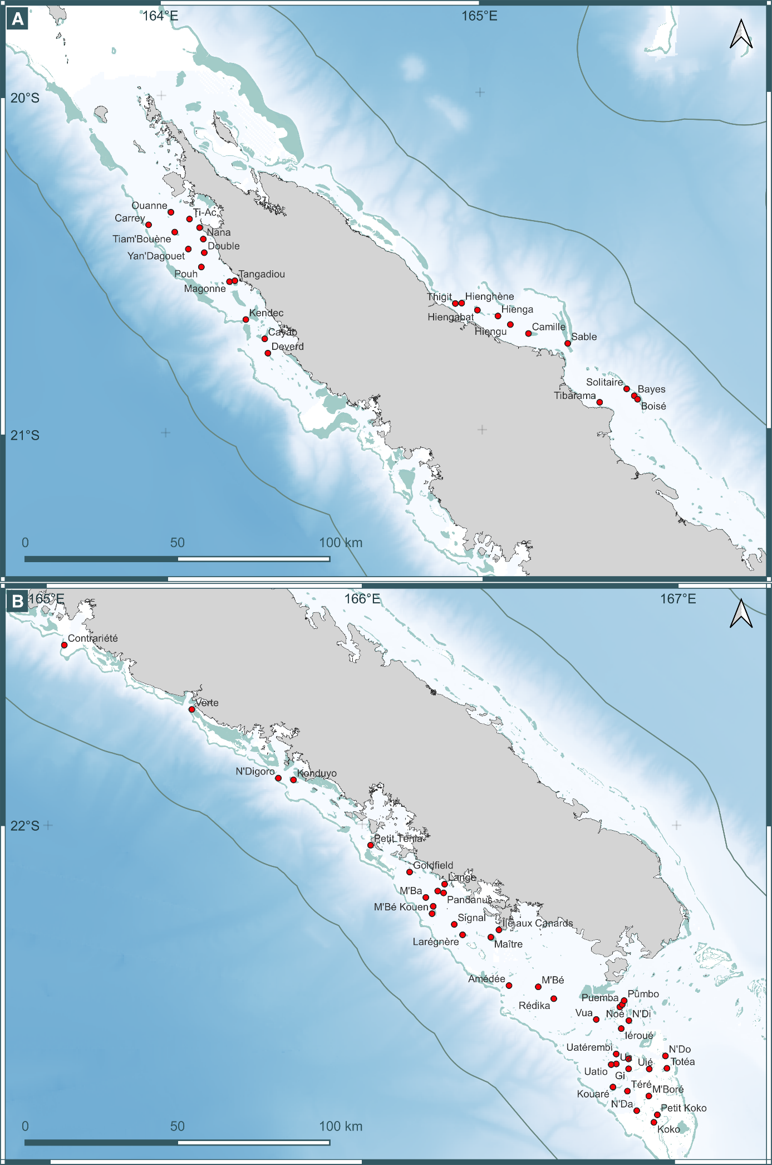
Figure A3: Detailed maps of study sites
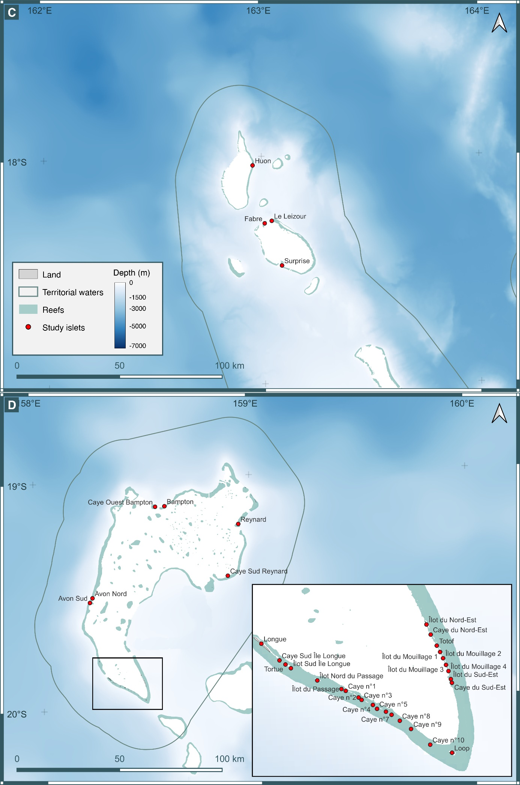A: northern lagoon, B: south-western lagoon; C: d’Entrecasteaux reefs; D: Chesterfield-Bampton
Table A4: data sources for seabird census data and information on invasive rodents
Area | Survey period | Source
Northern lagoon | 2005-2006 | Baudat-Franceschi, 2006
 | 2016-2020 | Provincial rangers, unpublished data
 | 2018-2020 | this study
South-western lagoon | 2009-2011 | Baudat-Franceschi, 2012
 | 2015-2022 | Provincial rangers, unpublished data
 | 2018-2023 | this study
Chesterfield-Bampton | 2001-2009 | Borsa et al., 2010
 | 2010 | Baudat-Franceschi, 2011
 | 2017-2022 | this study
d'Entrecasteaux reefs | 2003-2008 | Philippe-Lesaffre et al., 2023
 | 2007-2015 | Yearly reports, Ornithological Society of New Caledonia¹
 | 2017-2021 | this study
¹Compiled in Borsa et al., 2021

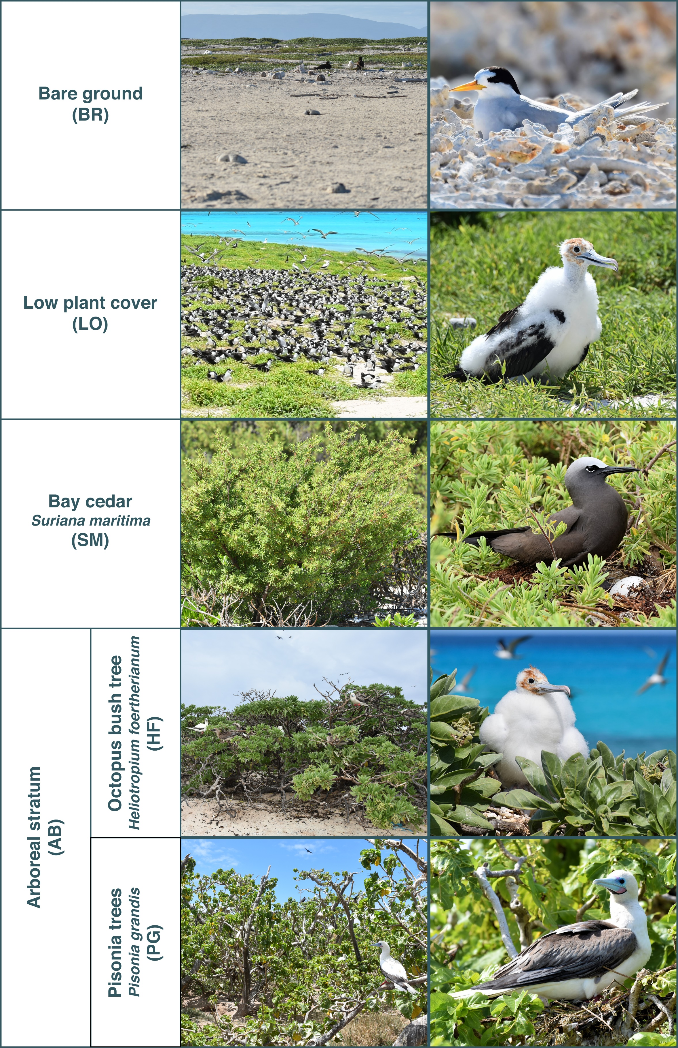
Table A5: Illustrated list of breeding habitats. Pictures ©Tristan BERR-IRD/UNC

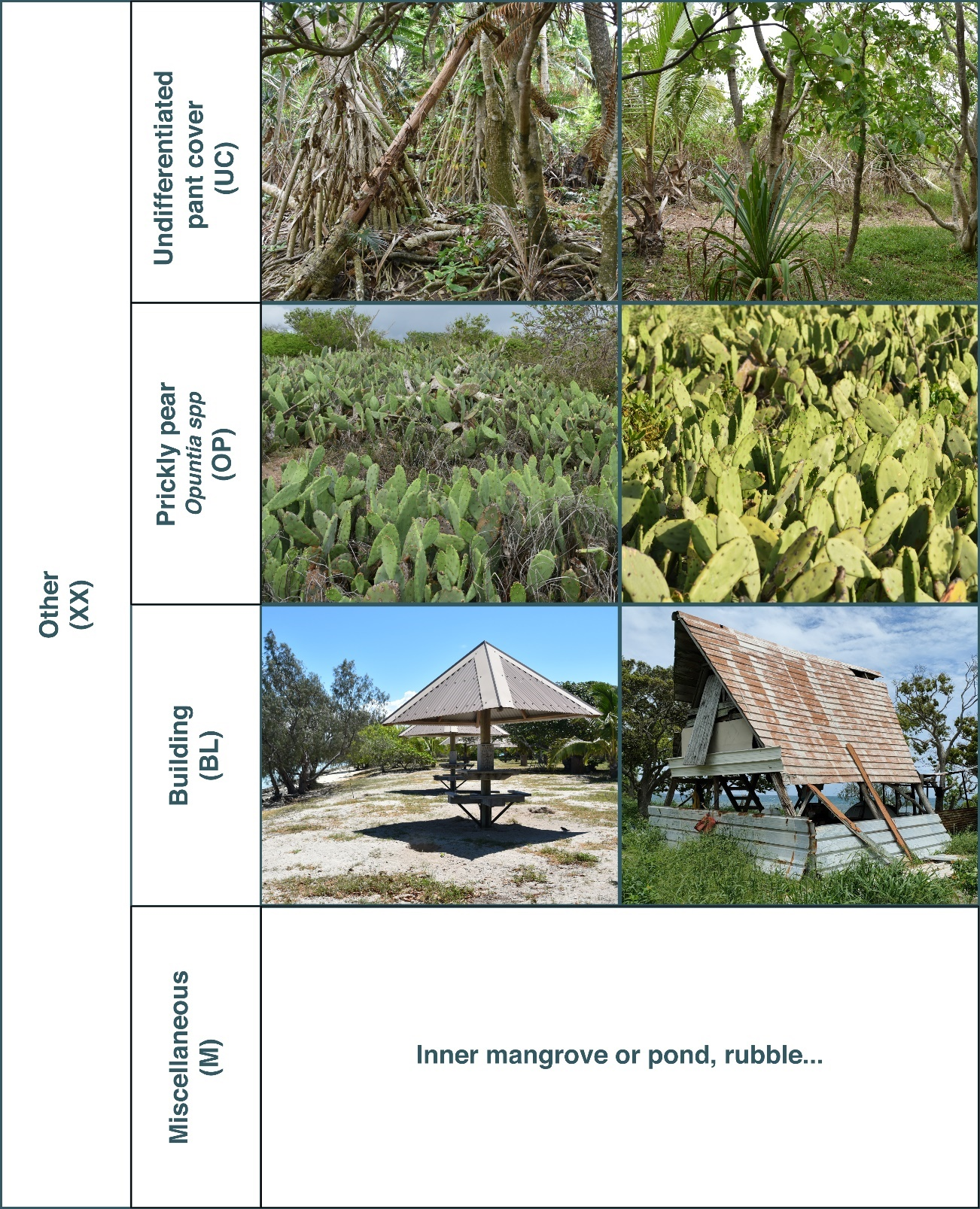

Species | Nesting type | Habitat use
 |  | Bare ground (BR) | Low plant cover (LO) | Bay cedar  Suriana maritima (SM) | Arboreal stratum (AB) |  | Other (XX)
 |  |  |  |  | Octopus bush tree  Heliotropium foertherianum (HF) | Pisonia grandis (PG) | Undifferentiated plant cover (UC) | Building (BL) | Opuntia spp (OP) | Miscellaenous (M)
Black noddy | Arboreal |  |  |  | X | X | o
Brown noddy | Flexible | X | X | X | o | o | o
Silver gull | Epigeous |  |  |  | X | X | X | o | o
Bridled tern | Epigeous |  |  | X | X | X | X
Sooty tern | Epigeous | X | X | o |  |  | o
Roseate tern | Epigeous | X | X
Black-naped tern | Epigeous | X
Fairy tern | Epigeous | X
Greater-crested tern | Epigeous | X | X
Red-tailed tropicbird | Epigeous |  |  |  | o | o | o
Wedge-tailed shearwater | Burrow | X | X | X | X | X | X |  | o
Tahiti petrel | Burrow |  |  |  | o | o | X
Black-winged petrel | Burrow |  |  |  | o | o | X
Lesser frigatebird | Epigeous |  | X
Great frigatebird | Arboreal |  |  |  | X | X
Masked booby | Epigeous | X | X
Brown booby | Epigeous | X | X
Red-footed booby | Arboreal |  |  |  | X | X
Table A6: Habitat use per species
X: breeding commonly observed; o: occasional breeding
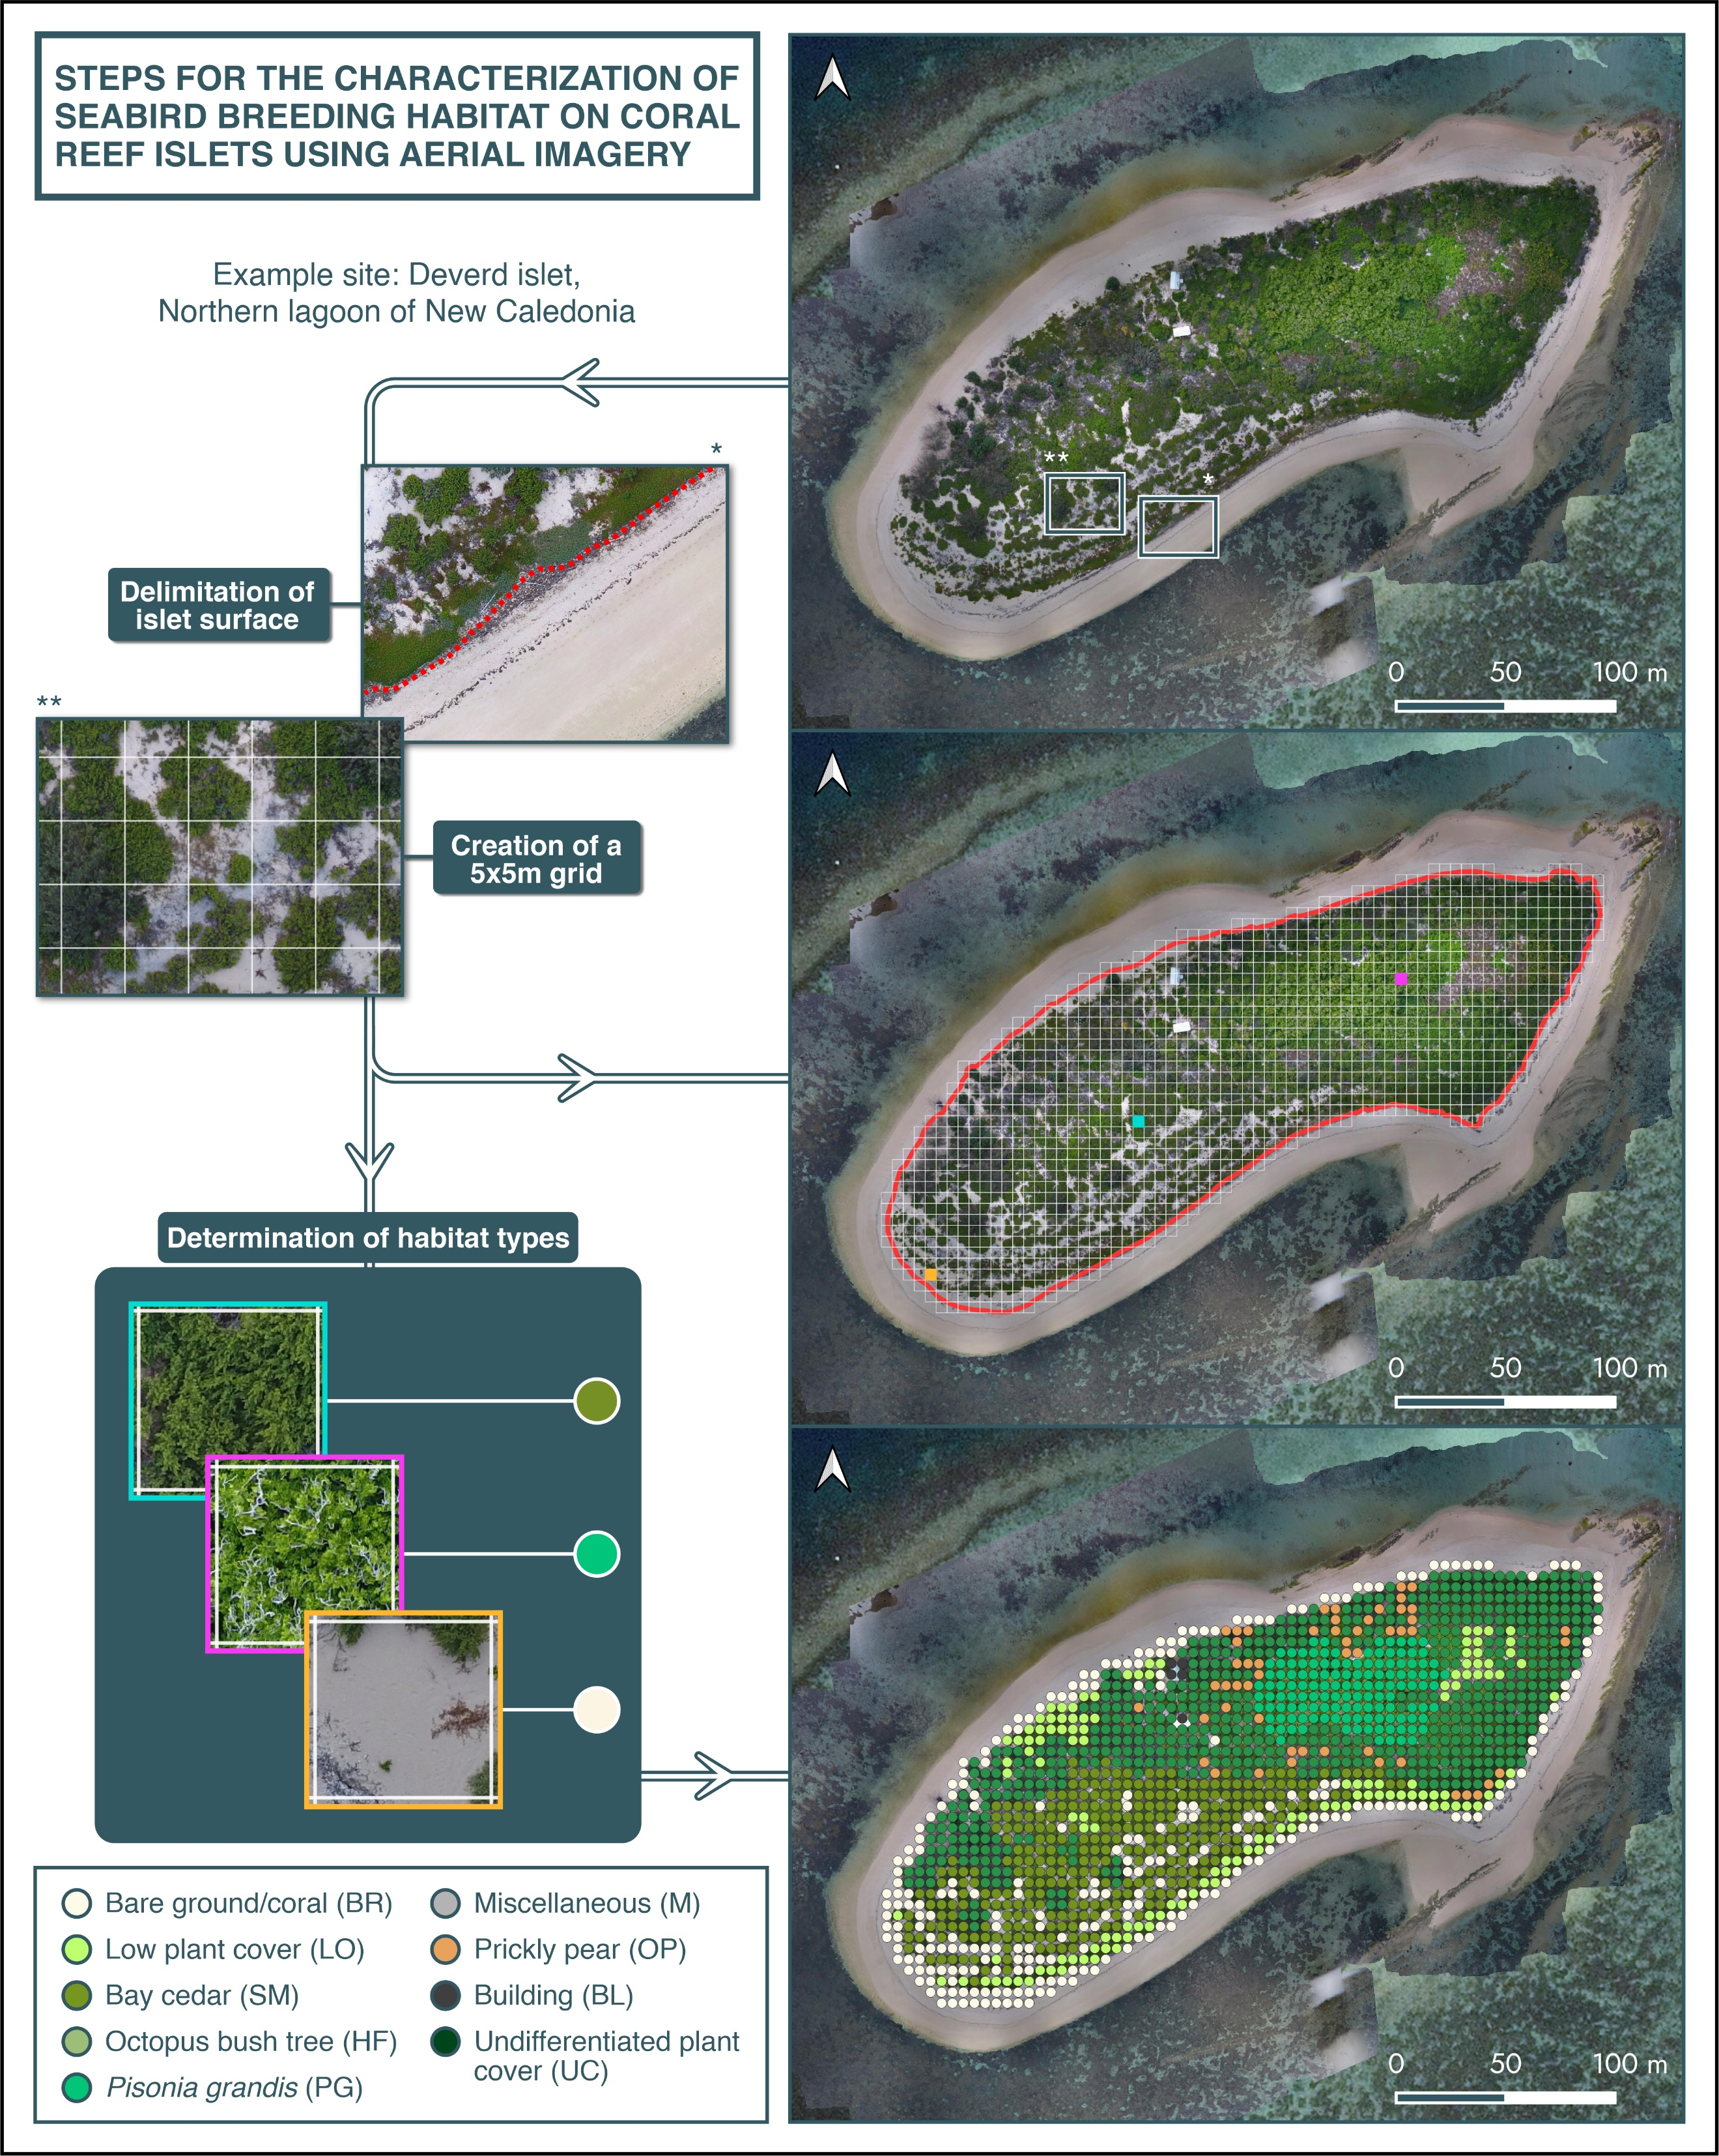
Figure A7: Steps for the characterization of seabird breeding habitat on coral reef islets using high-resolution aerial imagery. Aerial map ©P. Dumas – UNC.

Table A8: List of 5 original habitat variables (A), 32 original geography variables (B) and 7 original human variables (C) prior to principal component (AB) or multifactorial (C) analysis. (D) lists additional drivers that were retained without transformation.
(A) | Name | Description | Units | Mean | Range
 | Bare ground/coral | Proportion of total CRI area covered by each habitat category | - | 0.37 | 0.04-1
 | Low plant cover |  | - | 0.19 | 0-0.91
 | Bay cedar (Suriana maritima) |  | - | 0.03 | 0-0.70
 | Arboreal stratum (Pisonia grandis OR octopus bush tree Heliotropium foertherianum) |  | - | 0.08 | 0-0.62
 | Other (other plant cover, building, prickly pear Opuntia ssp., miscellaneous) |  | - | 0.33 | 0-0.96
(B) | Reef_buffer (8 variables) | Proportion of each category in eight buffers drawn from CRI shoreline (0.5, 1, 5, 10, 50, 100, 150, 200 km) | - | - | -
 | Lagoon_buffer (8 variables) |  | - | - | -
 | Land_buffer (8 variables) |  | - | - | -
 | Pelagic_buffer (8 variables) |  | - | - | -
(C) | log(Distance to Noumea) | log-transformed distance to Nouméa and to the closest harbor* | (original distance in km) | 5.26 | 5.95
 | log(Distance to closest harbor) |  | (original distance in km) | 4.8 | 5.95
 | Nb harbors 10km | Number of harbors in 10 and 60 km buffers drawn from CRI shoreline | - | 0.5 | 16
 | Nb harbors 60km |  | - | 6.33 | 25
 | Source population size | Population size of urban areas from which visitation occur | number of inhabitants | 55 130 | 0-160 672
 | Reserve type | Categorical description of the type of terrestrial reserve: Absent, Adaptive (access restrictions in case of breeding activity), Partial (part of the CRI permanently restricted) and Permanent (whole area restricted from access)
 | Infrastructure / Tourism | Categorical description of tourism-related land-use: high visitation (permanent touristic infrastructure and/or possible daily taxi-boat connexion), medium visitation (traces of occasional visits and camping activity), low visitation (no visible signs of human visitation)
(D) | log(Surface) | log-transformed CRI area | (original area in m²) | 4.67 | 1.92-5.50
 | Roundness | Polsby-Popper score of shape compactness | - | 0.6 | 0.06-0.96
 | Rodent presence | Categorical description of rodent presence: absent, black rat Rattus rattus, Polynesian rat Rattus exulans, domestic mouse Mus musculus, unidentified rodent, multiple species.

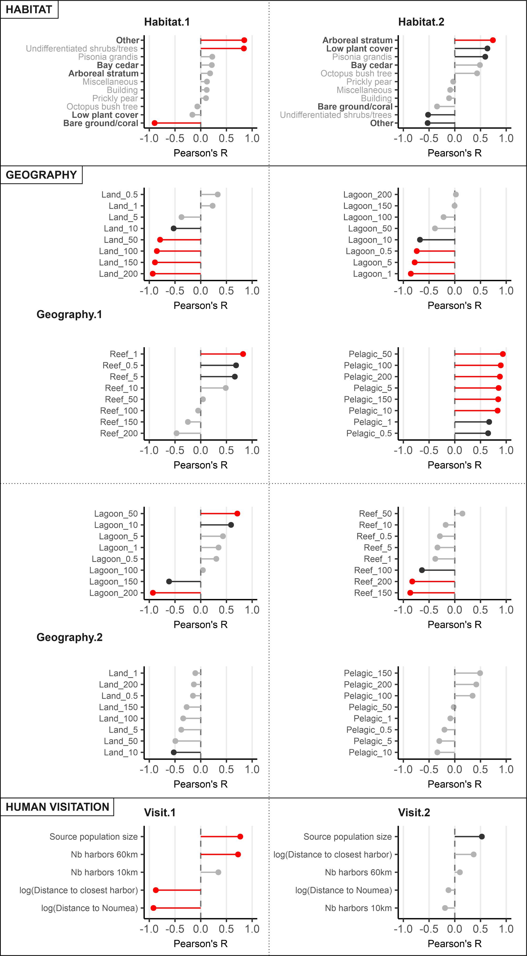
Figure A9: Pearson’s correlation coefficient measured between PCA (Habitat, Geography) or MFA (Human visitation) axes and original quantitative variables. Red indicates R > |0.7| and black indicates R > |0.5|. Habitat variables that were used in the PCA are shown in bold (Habitat box, see Table A6).
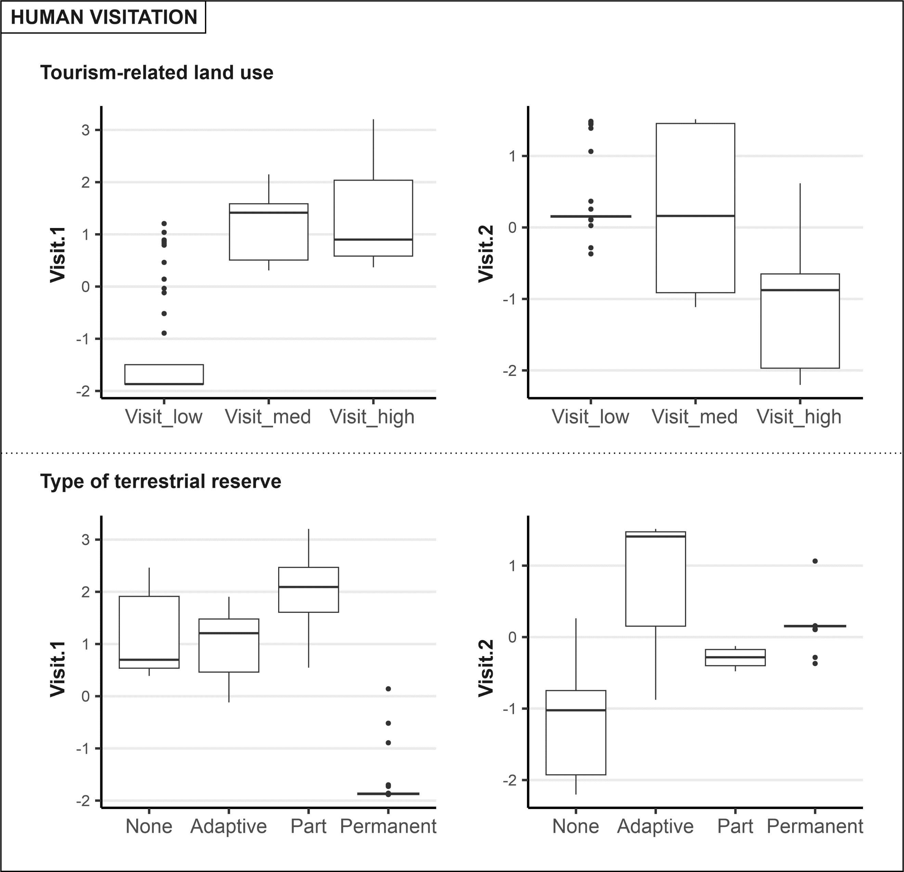
Figure A10: Boxplot of MFA coordinates per category of tourism-related land use (top) and type of terrestrial reserve (bottom).
.
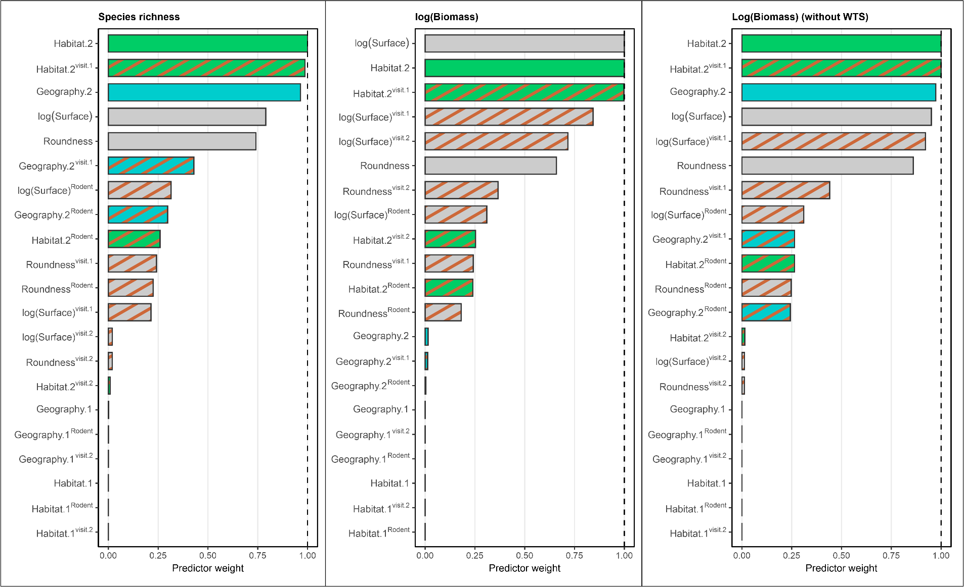
Figure A11: Cumulative AICc weights of evaluated predictors with Species richness (left), log-transformed Biomass (middle), and log-transformed Biomass excluding Wedge-tailed shearwaters (without WTS) (right) as response variables. Superscript text (e.g. ^{visit.1}) and dashed bars indicate interaction with anthropogenic covariates. Numbers next to predictors indicate the corresponding dimensions of respective Principal Component (Habitat, Geography) or Multi-Factorial (Human visitation) Analyses.
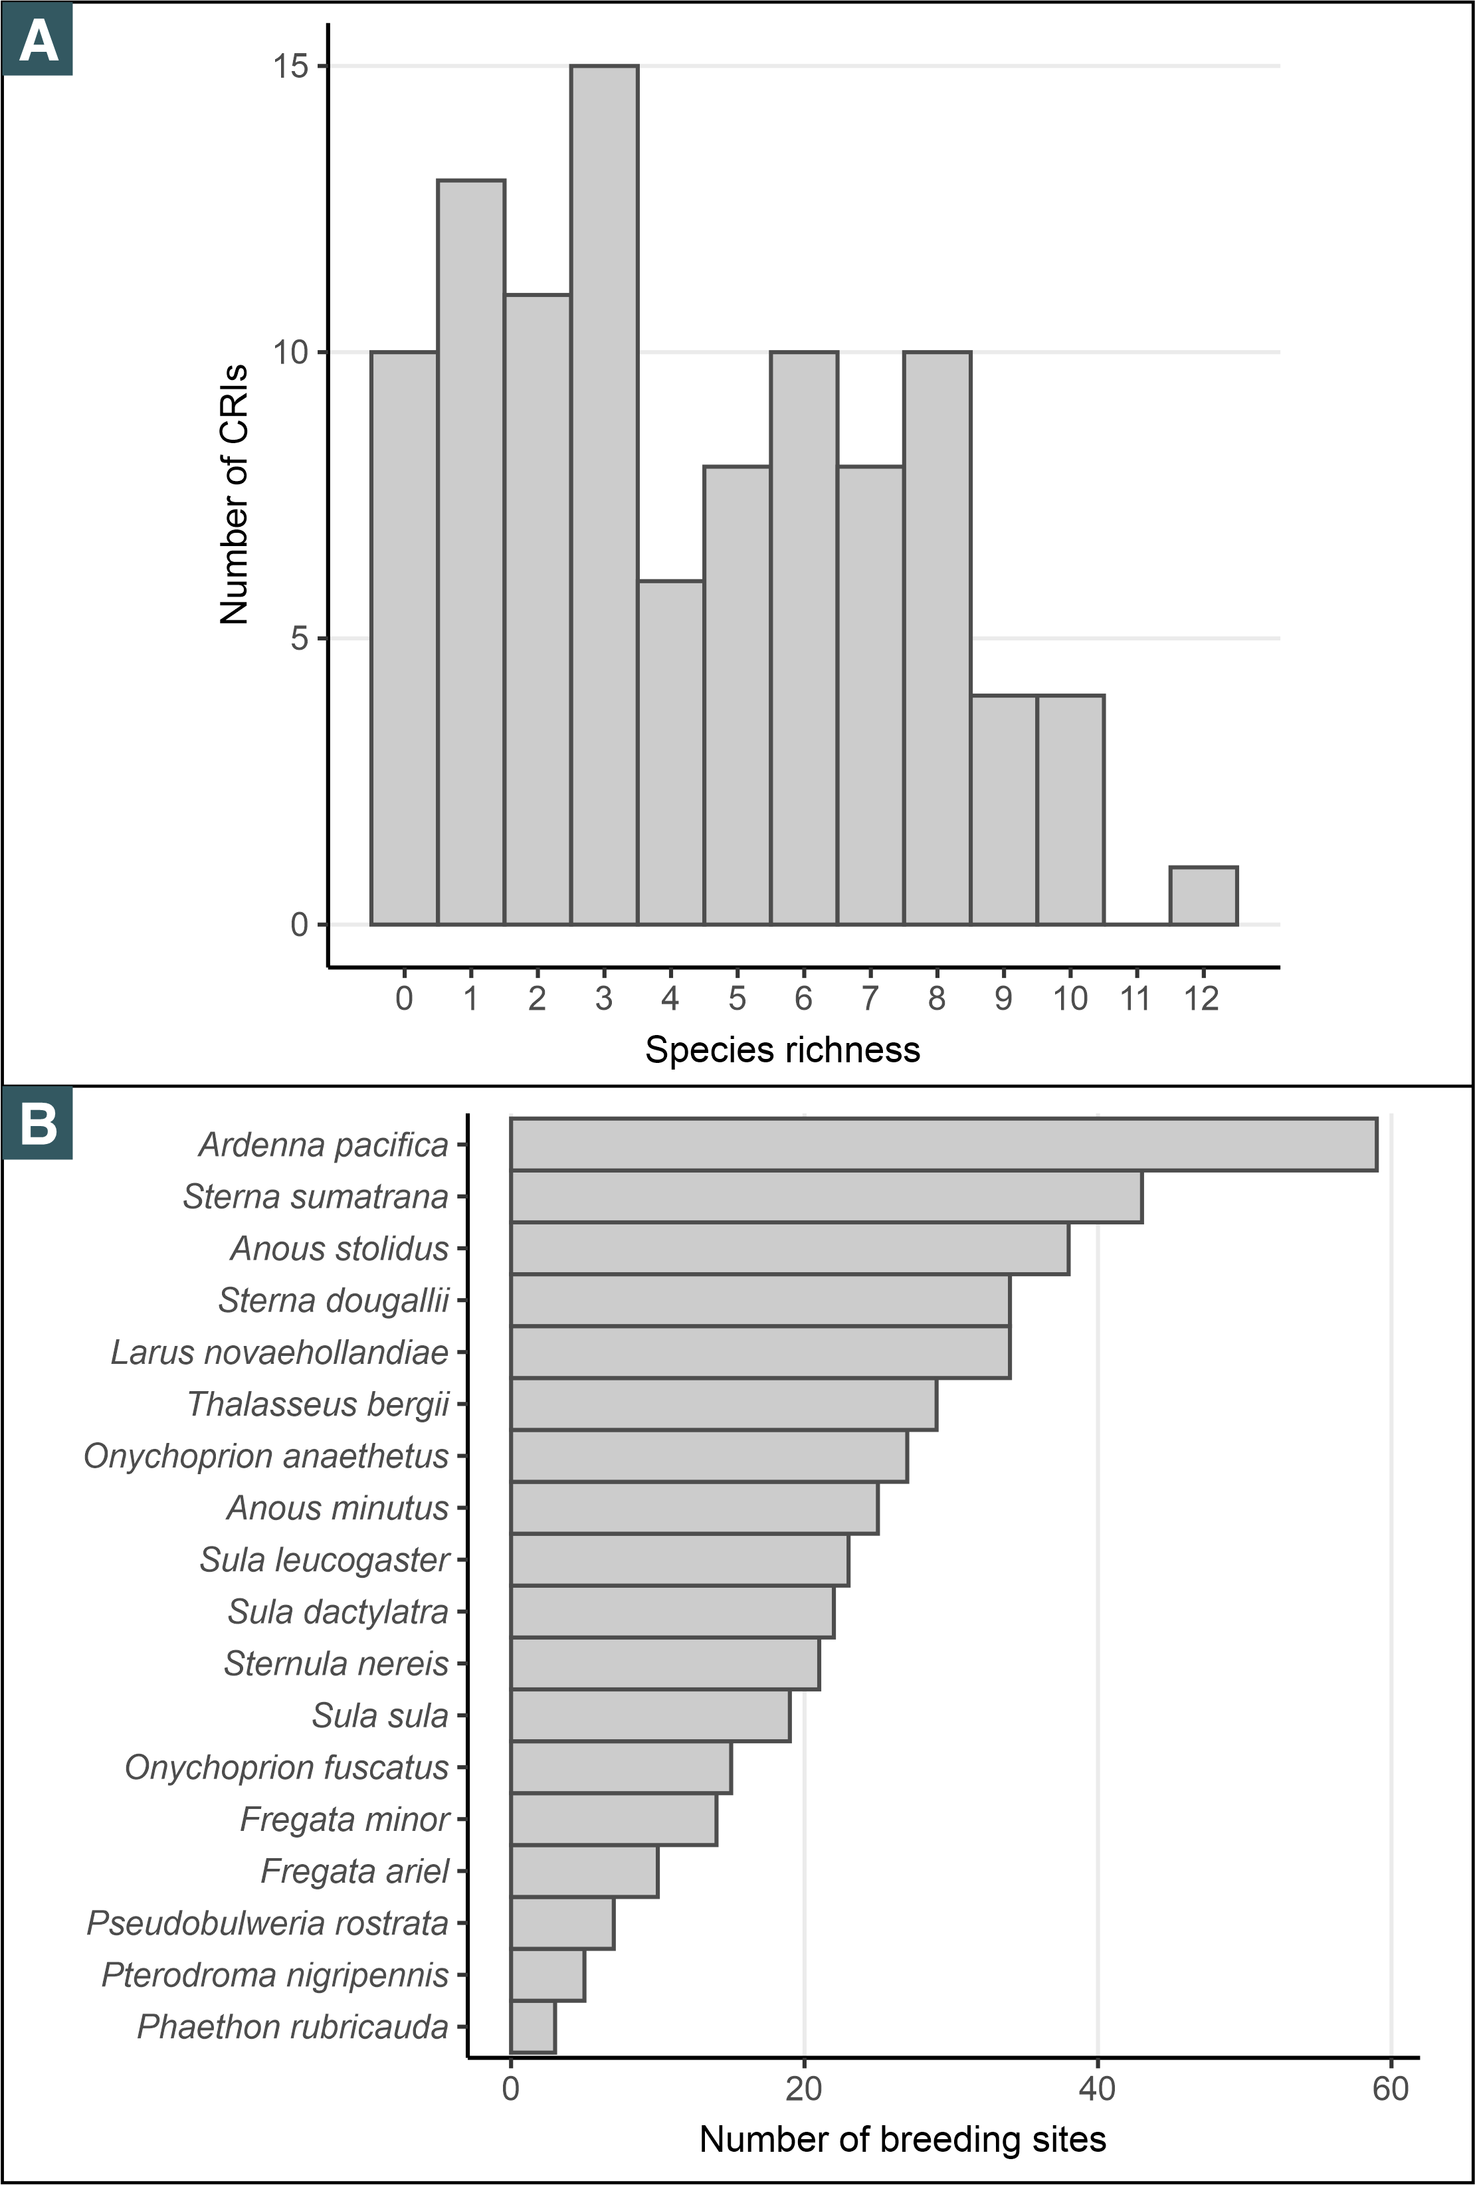
Figure A12. A: Number of CRIs for each value of species richness. B: Number of breeding sites per species.

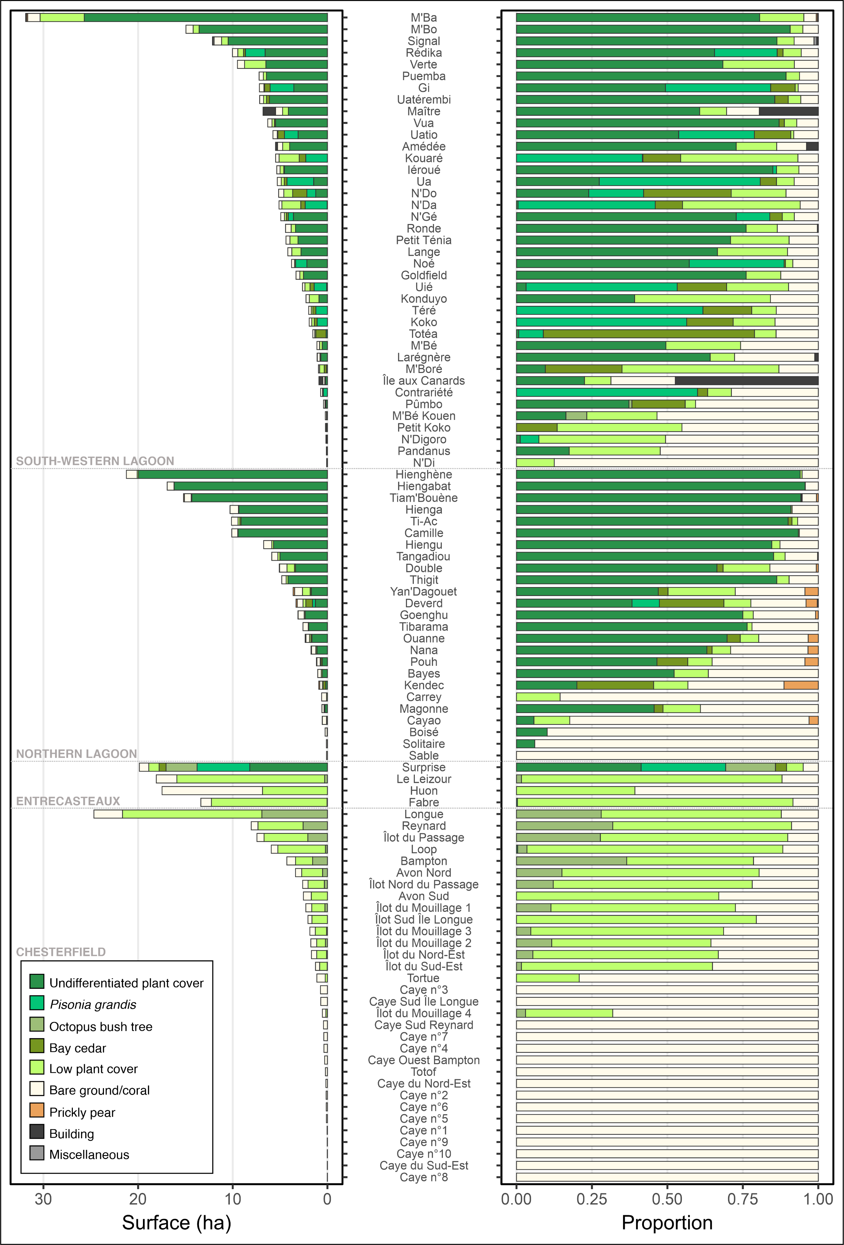
Figure A13: Surface (left) and relative proportion of the original 9 categories of breeding habitats
References
Baudat-Franceschi, J., 2012. État de conservation des oiseaux marins et des rapaces nicheurs du “Grand Lagon Sud” - Contribution au plan de gestion du bien UNESCO “Aire Marine n°1.” SCO - Province Sud, Nouvelle-Calédonie.
Baudat-Franceschi, J., 2011. Oiseaux : diversité spécifique, populations, enjeux de conservation, in: Contribution à l’inventaire Biologique et à l’évaluation Des Ressources Sur Les Récifs Des Chesterfield. SPREP, Nouvelle-Calédonie, pp. 157–180.
Baudat-Franceschi, J., 2006. Oiseaux marins et côtiers nicheurs en Province Nord - Évaluation des populations - Enjeux de Conservation. SCO - Province Nord, Nouvelle-Calédonie.
BirdLife International (2023) IUCN Red List for birds. Downloaded from http://datazone.birdlife.org on 21/06/2023.
Borsa, P., 2021. Avifaune marine des îles Chesterfield (mer de Corail) : richesse spécifique, tailles de population, menaces et tendances sur les trois dernières décennies. Bulletin de la Société zoologique de France 146, 111.
Borsa, P., Pandolfi, M., Andréfouët, S., Bretagnolle, V., 2010. Breeding Avifauna of the Chesterfield Islands, Coral Sea: Current Population Sizes, Trends, and Threats. Pacific Science 64, 297–314. https://doi.org/10.2984/64.2.297
Bretagnolle, V., Flood, R.L., Gaba, S., Shirihai, H., 2022. Fregetta lineata (Peale, 1848) is a valid extant species endemic to New Caledonia. Bulletin of the British Ornithologists’ Club 142, 111-130. https://doi.org/10.25226/bboc.v142i1.2022.a6
Philippe-Lesaffre, M., Thibault, M., Caut, S., Bourgeois, K., Berr, T., Ravache, A., Vidal, E., Courchamp, F., Bonnaud, E., 2023. Recovery of insular seabird populations years after rodent eradication. Conserv Biol e14042. https://doi.org/10.1111/cobi.14042
Spaggiari, J., Barré, N., Baudat-Franceschi, J., Borsa, P., Colin, F., 2006. New Caledonian seabirds, in: Payri, C., Richer de Forges, B. (Eds.), Compendium of Marine Species from New Caledonia, Documents Scientifiques et Techniques. IRD, Nouméa, pp. 371–384.

