**Supplementary Table S1:** Number of each croaker species from Western coast of Africa by each modality (sex, sampling country, sampling location, reproduction period and reproduction period within each sex) (Ind. = indeterminate).

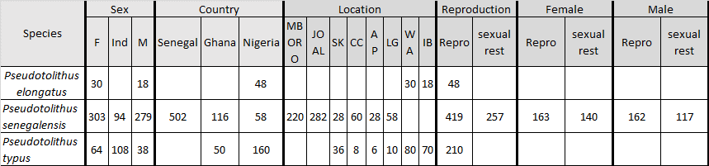

**Supplementary Table S2**: Mean value of condition factor (Kn) of the each croaker species from Western coast of Africa by each modality (sex, sampling country, sampling location, reproduction period and reproduction period within each sex).

