*Paleoceanography and Paleoclimatology*

Supporting Information for

**West Pacific Warm Pool warming and salinity front expansion since 1821 reconstructed from paired coral δ18O, Sr/Ca, and reconstructed δ18Osw**

Sara Todorović 1,2, Henry C. Wu 1, Braddock K. Linsley 3, Henning Kuhnert 4, Christophe Menkes 5, Albina Isbjakowa 1 and Delphine Dissard 6

Affiliations:

1 Leibniz Centre for Tropical Marine Research (ZMT), Bremen, Germany;

2 Faculty of Geosciences, University of Bremen, Bremen, Germany;

3 Lamont-Doherty Earth Observatory of Columbia University, Palisades, NY, USA;

4 MARUM – Center for Marine Environmental Sciences, University of Bremen, Bremen, Germany;

5 ENTROPIE (IRD, University of New Caledonia, University of La Réunion, CNRS, Ifremer), Nouméa, New Caledonia;

6 IRD-Sorbonne Universités, UPMC, Univ Paris 06-CNRS-MNHN, LOCEAN, Paris, France

Correspondence and requests for materials should be addressed to S.T. ([sara.todorovic@leibniz-zmt.de](mailto:sara.todorovic@leibniz-zmt.de)) and H.C.W. ([henry.wu@leibniz-zmt.de](mailto:henry.wu@leibniz-zmt.de))

**Introduction**

The Supporting Information includes additional figures and tables for the results presented in the main text and relating to:

1. Coral core description;
2. Study sites climatology;
3. Coral proxy data to instrumental data regressions;
4. Change point analysis.

# Coral core description

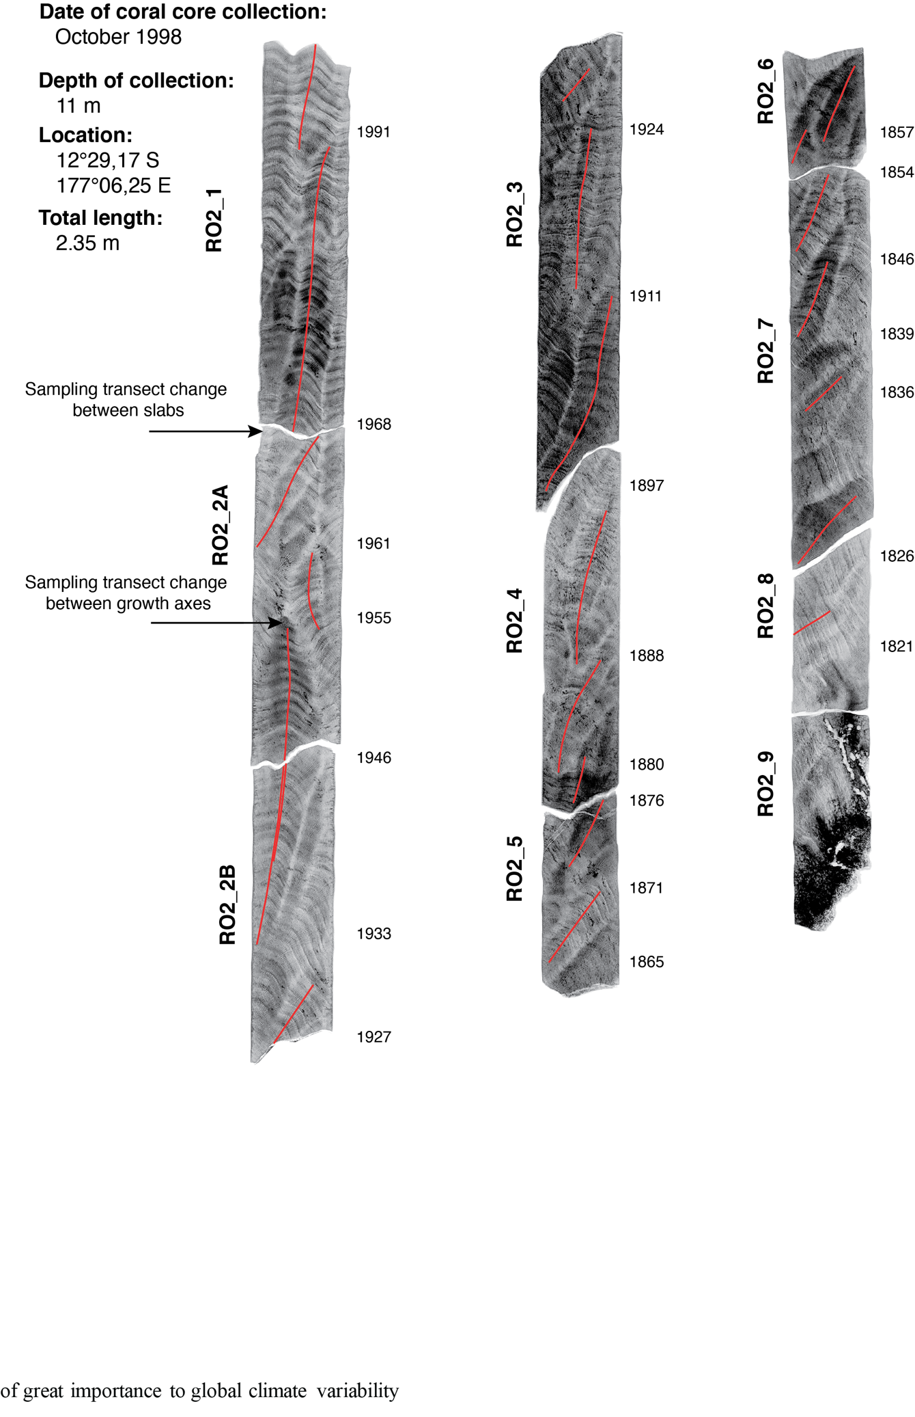

Figure S 1 – RO2 X-ray positives (higher density = darker) showing sampling tracks (red lines), slab breaks and transect jumps. Slab IDs are presented on the left side of each slab. Years determined at each transect jump and slab break are presented on the right side.



Figure S 2 – Linear extension of both corals shows similar variability, despite corals growing in different depths and conditions.

# Study sites climatology

Table S 1 – Gridded instrumental products used in the study and cells they were centered to for each location. PACRAIN data (Greene et al., 2008) was collected from its database based on stations that provided the longest continuous measurements closest to each location. Daily data (OISST 1°X1°v2 0.25°x0.25° and PACRAIN in some cases) was summed into monthly data. All datasets are referenced in the main text.

|  |  |  |  |  |
| --- | --- | --- | --- | --- |
| Location | ERSST 2° v4 2°x2° | OISST v2 1°x1° | OISST v2 0.25°x0.25° | ORA-20C SST 1°x1° |
| Rotuma | 178°E 12°S | 176.5°E 12.5°S | 177°E 12.25°S | 177.5°E 12.5°S |
| Tonga | 176°W 20°S | 174.5°W 19.5°S | 174.5°W 20.25°S | 175.5°W 20.5°S |
| Location | **SODA v2.2.4** | **Delcroix et al. 2011** | **PACRAIN (station)** | **ORA-20C SSS 1°x1°** |
| Rotuma | 177.25°E 12.25°S | 177°E 12°S | 177.05°E 12.5°S (FJ00001) | 177.5°E 12.5°S |
| Tonga | 175.25°W 0.25°S | 174°W 20°S | 174.35°W 19.8°S (NZ78400) | 175.5°W 20.5°S |

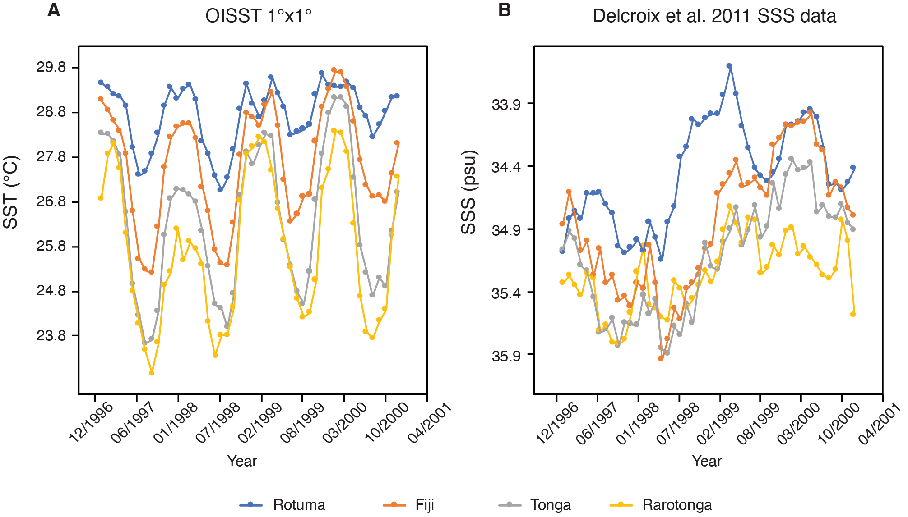

Figure S 3 – Climatology of the study sites and other selected locations along the SPCZ axis, from NE to SW, covering the 5-year period of 1996-2001. A) SST annual cycles. B) SSS annual cycles.

Seasonal SST cycles at all four locations (Figure S2, A) demonstrate the local differences in amplitude and noisiness of data, as we move along the NE-SW axis. Notice the cycle of Rotuma having the smallest amplitude, yet strong evident peaks and dips within years making for the “double peak” in 1999. Similar phenomena can be observed at other locations as well (notice the “double peak” followed by a “double dip” in 1998 in Rarotonga), but given the larger SST amplitudes observed at these other locations, it doesn’t lead to issues with coral recording the seasonal cycle. SSS data (Figure S2, B) demonstrates higher interannual variability compared to seasonal, annual cycles are poorly defined.

Table S 2 – Variability explained between different SST and SSS datasets (gray section) available for the two coral locations from 1981 onwards for all datasets. Data was summed into seasonal (JFM, AMJ, JAS, OND), and austral summer/winter (JFMA, JASO) based on observed seasonality and minima and maxima as well to elucidate effects of temporal resolution smoothing on similarity between the different datasets.

|  |  |  |  |  |  |  |
| --- | --- | --- | --- | --- | --- | --- |
| **Comparison (r^2)** | **Monthly** | | **Seasonal** | | **Biannual** | |
|  | Rotuma | Tonga | Rotuma | Tonga | Rotuma | Tonga |
| OISST 1° ~ ORA20C SST 1° | 0.91 | 0.96 | 0.95 | 0.97 | 0.95 | 0.97 |
| OISST 1° ~ OISST 1/4° | 0.90 | 0.96 | 0.94 | 0.97 | 0.96 | 0.98 |
| OISST 1/4° ~ ORA20C SST 1° | 0.85 | 0.95 | 0.89 | 0.97 | 0.92 | 0.98 |
| ERSST 2° ~ OISST 1° | 0.85 | 0.95 | 0.87 | 0.96 | 0.90 | 0.97 |
| ERSST 2° ~ OISST 1/4° | 0.79 | 0.94 | 0.83 | 0.96 | 0.86 | 0.97 |
| ERSST 2° ~ ORA20C SST 1° | 0.82 | 0.96 | 0.85 | 0.97 | 0.88 | 0.98 |
| D-SSS 1° ~ ORA20C SSS 1° | 0.35 | 0.46 | 0.39 | 0.50 | 0.40 | 0.54 |
| SODA 0.5° ~ D-SSS 1° | 0.27 | 0.24 | 0.36 | 0.30 | 0.32 | 0.33 |
| SODA 0.5° ~ ORA20C SSS 1° | 0.14 | 0.34 | 0.16 | 0.38 | 0.17 | 0.44 |

Instrumental datasets show a lot of divergence between each other for the same location as can be seen by the amount of variance explained between them (Table S2). The SST datasets variance explained varies 4-18% between datasets for the same location. Variance explained is generally higher for Tonga (up to 99%), and as the temporal resolution decreases. With the salinity datasets the variance explained between two datasets in the same location varies by up to 30% depending on the dataset and temporal resolution. Variance explained between any two different datasets is largely much lower than between SST datasets, but overall higher for Rotuma (up to 49%) compared to Tonga (up to 41%). It is especially problematic for SSS highlighting how unreliable instrumental data is, and the need for proxy data.

# Coral proxy data to instrumental data regressions

Table S 3 – Statistics based on period from 1981 until end of each coral record. Values for each month have been averaged over the period, and then minimum and maximum of the annual cycle selected to describe average seasonal variation.

|  |  |  |  |  |  |  |  |  |  |
| --- | --- | --- | --- | --- | --- | --- | --- | --- | --- |
|  | 18O (‰) | | | Sr/Ca (mmol/mol) | | | 18Osw (‰) | | |
|  | min | max | mean | min | max | mean | min | max | mean |
| RO2 | -5.18 | -4.84 | -5.02 | 8.81 | 8.84 | 8.82 | 0.36 | 0.66 | 0.50 |
| TNI2 | -5.07 | -4.45 | -4.77 | 8.83 | 9.10 | 8.97 | 0.60 | 0.74 | 0.66 |

Table S 4 – OLS regressions between coral proxies and all instrumental data. Data in italics is not statistically significant. Slope and intercept have ± 1σ standard error reported (Slope_SE, Intercept_SE). Bootstrapped 95% confidence limits (Slope_Boot_Cl, Intercept_Boot_Cl) are based on 1999 repetitions. All regressions are done for the period from 1981 to 1998 for Rotuma, 2004 for Tonga, for easier comparison between datasets. Longer period regressions were used in the main manuscript results (ERSST: 1950 onwards, D-SSS: 1960 onwards).



Table S 5 – Monthly, seasonal, and biannual (austral summer/winter) interpolated coral proxy to instrumental data OLS regressions. Only the regressions with the strongest relationships for the full duration of the instrumental datasets are presented to illustrate improved relationships when lowering the temporal resolution. Standard errors (± 1σ) are reported in the formula brackets.

|  |  |  |  |  |
| --- | --- | --- | --- | --- |
| **RO2** |  | Formula |  | **r, r2** |
| monthly | Sr/Ca ~ ERSST 2° | -0.026 (± 0.002) x SST +9.641 (± 0.064) | | -0.275, 0.075 |
| seasonal | Sr/Ca ~ ERSST 2° | -0.03 (± 0.004) x SST +9.732 (± 0.119) | | -0.283, 0.08 |
| biannual | Sr/Ca ~ ERSST 2° | -0.027 (± 0.005) x SST +9.646 (± 0.144) | | **-0.297, 0.088** |
| monthly | 18O ~ OISST 1° | -0.158 (± 0.013) x SST -0.503 (± 0.363) | | -0.659, 0.434 |
| seasonal | 18O ~ OISST 1° | -0.169 (± 0.024) x SST -0.177 (± 0.697) | | -0.648, 0.419 |
| bianual | 18O ~ OISST 1° | -0.172 (± 0.028) x SST -0.101 (± 0.811) | | **-0.732, 0.535** |
| monthly | 18O ~ D-SSS 1° | 0.295 (± 0.022) x SSS -15.243 (± 0.781) | | 0.477, 0.228 |
| seasonal | 18O ~ D-SSS 1° | 0.308 (± 0.038) x SSS -15.711 (± 1.329) | | 0.501, 0.251 |
| biannual | 18O ~ D-SSS 1° | 0.435 (± 0.062) x SSS -20.119 (± 2.164) | | **0.581, 0.337** |
| monthly | 18Osw ~ D-SSS 1° | 0.261 (± 0.024) x SSS -8.547 (± 0.832) | | 0.411, 0.169 |
| seasonal | 18Osw ~ D-SSS 1° | 0.275 (± 0.041) x SSS -9.042 (± 1.431) | | 0.432, 0.187 |
| biannual | 18Osw ~ D-SSS 1° | 0.378 (± 0.066) x SSS -12.612 (± 2.300) | | **0.503, 0.253** |
| **TNI2** |  |  |  |  |
| monthly | Sr/Ca ~ OISST 1/4° | -0.066 (± 0.002) x SST +10.664 (± -0.859) | | -0.859, 0.738 |
| seasonal | Sr/Ca ~ OISST 1/4° | -0.069 (± 0.004) x SST +10.73 (± -0.882) | | -0.882, 0.779 |
| biannual | Sr/Ca ~ OISST 1/4° | -0.071 (± 0.004) x SST +10.794 (± -0.948) | | **-0.948, 0.898** |
| monthly | 18O ~ OISST 1° | -0.149 (± 0.005) x SST -0.84 (± -0.863) | | -0.863, 0.745 |
| seasonal | 18O ~ OISST 1° | -0.157 (± 0.009) x SST -0.629 (± -0.874) | | -0.874, 0.765 |
| biannual | 18O ~ OISST 1° | -0.152 (± 0.009) x SST -0.764 (± -0.929) | | **-0.929, 0.863** |
| monthly | 18O ~ D-SSS 1° | 0.4 (± 0.035) x SSS -18.854 (± 0.411) | | 0.411, 0.169 |
| seasonal | 18O ~ D-SSS 1° | 0.405 (± 0.059) x SSS -19.036 (± 0.424) | | 0.424, 0.18 |
| biannual | 18O ~ D-SSS 1° | 0.56 (± 0.089) x SSS -24.489 (± 0.519) | | **0.519, 0.27** |
| monthly | 18Osw ~ D-SSS 1° | 0.083 (± 0.021) x SSS -2.247 (± 0.734) | | 0.154, 0.024 |
| seasonal | 18Osw ~ D-SSS 1° | 0.11 (± 0.034) x SSS -3.205 (± 1.192) | | **0.216, 0.047** |
| biannual | 18Osw ~ D-SSS 1° | 0.092 (± 0.04) x SSS -2.556 (± 1.418) | | 0.215, 0.046 |

With a decrease in temporal resolution, the correlations between coral proxy and instrumental data improve (Table S5), indicating that monthly variability is the least well captured by the corals and partially dependent on other processes outside SST/SSS. Decreasing the temporal resolution to seasonal (JFM, AMJ, JAS, OND) or biannual (austral summer – JFMA, austral winter - JASO), allows us to keep the sub-annual resolution and achieve better regressions with instrumental data. Regressions achieved between coral proxies and instrumental data vary with different datasets used, and here the best correlations only have been summed up. While the Delcroix SSS dataset seems to correlate the best with coral SSS proxy, d18Osw, coral Sr/Ca shows varying stronger correlations with different instrumental SST in different locations.



Figure S 4 – RO2 Sr/Ca to ERSST regressions. A) full dataset OLS and RMA OLS regressions. B) Significantly negatively correlated data from 24 month rolling correlation OLS and RMA OLS regressions. All regressions are for the period since 1950 – 1998.

RO2 Sr/Ca correlates best with ERSST. Here the commonly used OLS regression is presented and compared to RMA regression (Figure S4). Data presented in panel B is only the significantly negatively correlated data from Figure 4 of the main manuscript. All regressions are statistically highly significant (p<0.0001). RMA regressions in both cases presents a better fit in terms of Sr/Ca-SST matching of ERSST variability, minimum, maximum and average value in the regression period. Removing the data impacted by stressful situations (N = 763) leads to a significant (p<0.0001, z-score: 3.65) increase in correlation from r = -0.21 as observed in the full dataset to r = -0.47 (panel B). The regression we use in the main manuscript is the RMA regression on the full dataset, presented in panel A (N = 1738), as the slope and intercept values of the two RMA regressions remain comparable.

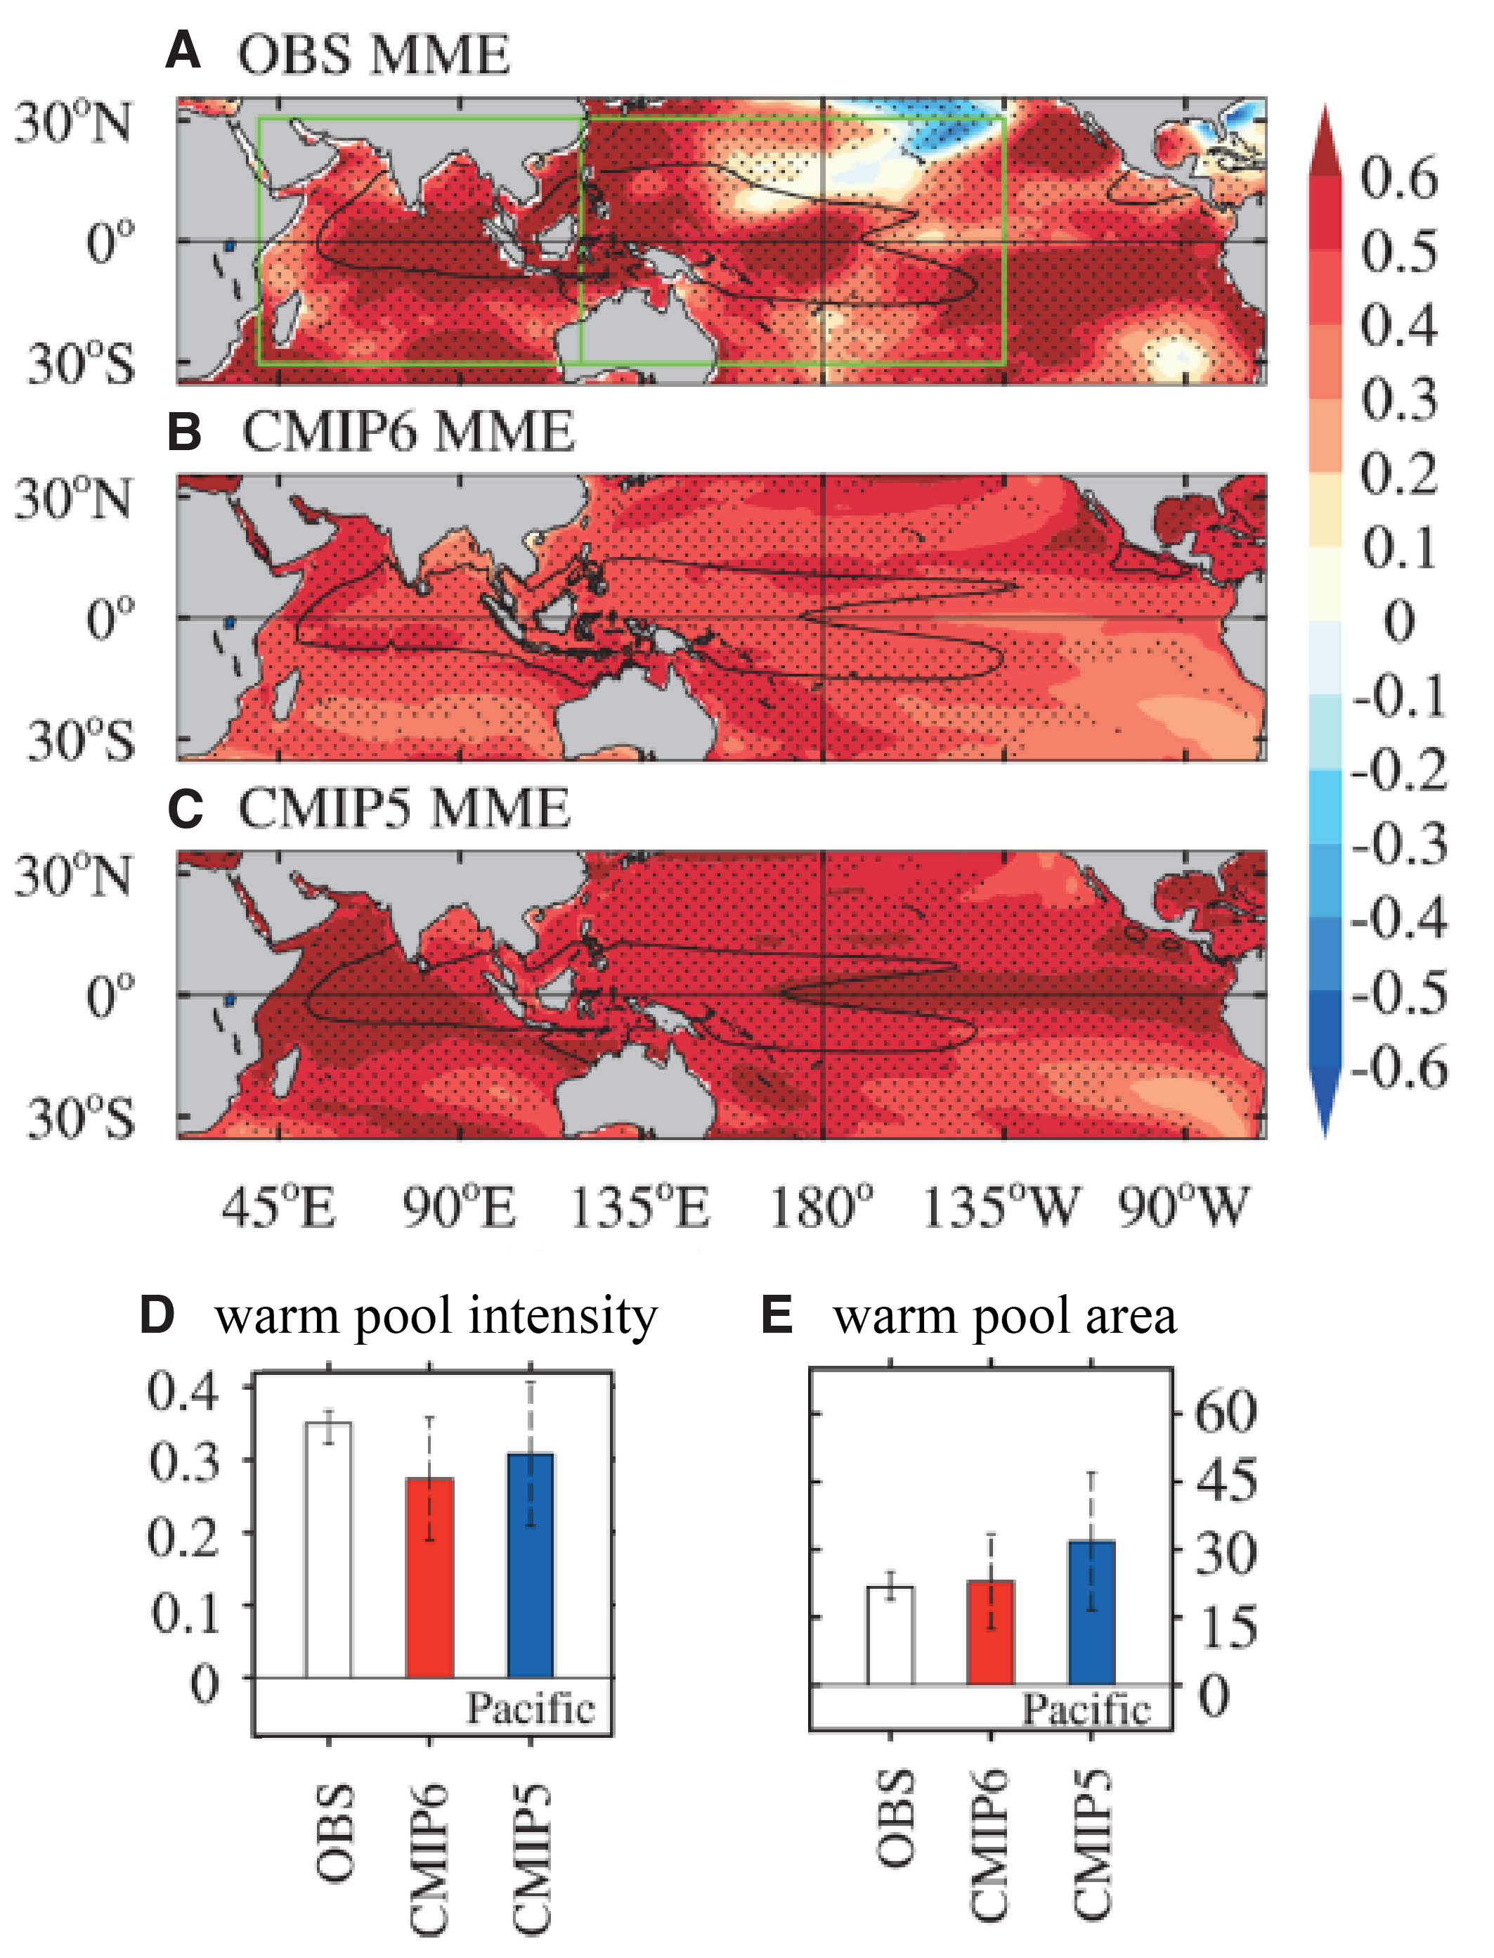

Figure S 5 – Observation data, in comparison with ensemble models such as CMIP5 and CMIP6, shows higher degrees of warming as well as differences in WPWP area during 1961 – 2005 (Figure and description adapted from Bai et al., 2024). Linear trends of annual mean SST (unit: °C/45 yr) in the A) observation SST, B) CMIP6, C) CMIP5 ensemble means. Black contours in A-C represent climatological 28°C isotherms. The solid green lines represent the Indo-Pacific warm pool area (A). Dots represent the trends statistically significant at the 95% level using a student’s t-test (A-C). Linear trends of warm pool intensity (D, unit: °C/45 yr) anomalies (relative to the 1951–2005 climatology) and percentage of the area (E, unit: %/45 yr) anomalies for observations (white), CMIP6 (red), and CMIP5 (blue) multi-model ensemble means for Pacific.

# Change point analysis



Figure S 6 – Change point analysis to identify shifts in mean (horizontal, solid lines) and variance (vertical, dashed lines) of: A) Rotuma Sr/Ca, B) Tonga Sr/Ca, C) Rotuma 18Osw, and D) Tonga 18Osw. Significant (p < 0.001) changepoints are marked with a red star.

Rotuma coral Sr/Ca (Figure S6, A) shows a shift towards more negative values implying warming since 1933. There are multiple shifts in variance detected throughout the timeseries, but when specifying at most one change (AMOC) method (Killick and Eckley, 2014; R Core Team, 2021), we observe a shift towards decreased variance since 1971 (bold blue dashed line). d18Osw (Figure S6, C) shows multiple changes in means and variance concentrated mostly until 1924, and since then we observe decreased variance in this time series defined by the AMOC changepoint at that time (bold blue dashed line). Tonga Sr/Ca data (Figure S6, B) has much less interdecadal variability, in comparison, and variance shifts are present only in the 1880s. There is a shift towards more negative values in 1971. 18Osw (Figure S6, D) shows, similarly to Rotuma, multiple shifts in variance, but less interdecadal variability in mean values, and a significant shift in trend in 1914. A shift towards generally less variance is also observed in this time series and comes a bit later compared to Rotuma, in 1949.

# References

Bai, W., Liu, H., Lin, P., Shen, H., 2024. The simulation of the Indo-Pacific warm pool SST warming trend in CMIP5 and CMIP6. Geosci. Lett. 11, 31. https://doi.org/10.1186/s40562-024-00346-6

Greene, J.S., Klatt, M., Morrissey, M., Postawko, S., 2008. The Comprehensive Pacific Rainfall Database. J. Atmospheric Ocean. Technol. 25, 71–82. https://doi.org/10.1175/2007JTECHA904.1

Killick, R., Eckley, I.A., 2014. **changepoint** : An *R* Package for Changepoint Analysis. J. Stat. Softw. 58. https://doi.org/10.18637/jss.v058.i03

R Core Team, 2021. R Foundation for Statistical Computing.